# 📈 Outsmarting the Market

### A Disciplined Rule-Based SIP Strategy

## 🤯 Markets and Emotions: Not in the Same Boat

Let’s be real — most people don’t just invest, they react emotionally.

* **When the market is high**: Greed kicks in — they buy more.
* **When the market crashes**: Fear takes over — they sell.
* **Result**: Buy high, sell low — the classic investor tragedy.
* And worse — they repeat this cycle endlessly.

But investing doesn’t need to be emotional.  
 It can be simple, systematic, and surprisingly effective.

So we asked:

**Can a rule-based SIP outperform a fixed one — without guessing or timing the market?**

## 📖 A Tale of Two Investors

Meet **Ramesh** and **Priya**.

* **Ramesh** does a standard SIP. ₹1000 every month, no questions asked.
* **Priya** uses a **simple rule** — she tweaks her SIP based on the market’s valuation (P/E ratio).  
  + Overvalued? She invests less.
  + Undervalued? She invests more.

No news. No predictions. Just one monthly rule.

**Who ends up with better returns?** Let’s find out.

## 🔁 A Disciplined, Rule-Based SIP

We use a **valuation-aware SIP strategy** — adjusting monthly investments based on how expensive or cheap the market is.

**Key Inputs**:

* **NIFTY P/E Ratio**
* **3-Year Rolling Average P/E**

**Rules**:

* When the market is **overvalued**, invest less.
* When **undervalued**, invest more.

No emotions. No guesswork. Just discipline.

## 🔢 The P/E-Based Investment Multiplier

python

def get_multiplier(pe, avg_pe):

if pe < 0.85 * avg_pe:

return 5

elif pe < 0.925 * avg_pe:

return 2.5

elif pe < 1 * avg_pe:

return 2

elif pe < 1.125 * avg_pe:

return 1

elif pe < 1.25 * avg_pe:

return 0.75

else:

return 0.5

* avg_pe = 3-year rolling average of NIFTY P/E.
* Higher multiplier when market is cheap, lower when expensive.
* Helps you **buy more when it’s cheap**, and **hold back when it’s costly**.

## 💼 Cash Reserve with Interest

To make the system realistic and safe, we use a **cash reserve**.

* Start with **6 months of SIP** as initial cash.
* When multiplier > 1 → withdraw from reserve.
* When multiplier < 1 → leftover SIP is saved.
* Cash earns **0.5% interest/month** (~6% annually).
* No loans or leverage — invest only what you have.

## 🔬 The Big Test: Backtesting 2000–2025

We rigorously tested the strategy using:

* **Actual NIFTY and P/E data from NSE**
* **200+ rolling start dates**
* Each test run = **6-year investment window**
* Compared Dynamic SIP vs Normal SIP for each case

## 📊 The Results?

We calculate **XIRR** by including both the equity portfolio and the cash reserve.

* **+0.6% average XIRR improvement**
* **85% of the time** it beat standard SIP
* **Max observed gain**: +1.6% XIRR improvement

📌 *This improvement is purely rule-based. No predictions, no timing.  
  
Compare the last 6 years' returns   
  
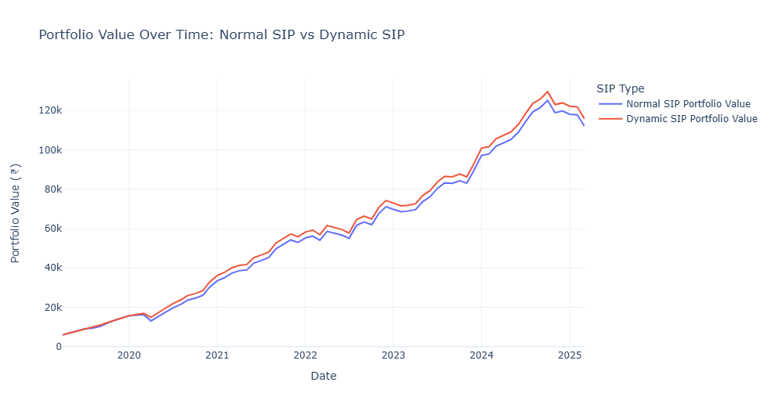*

*Compare 200 experiments on different starting dates and for the duration of 6 years, between 2005 to 2025  
XIRR median difference is around 0.6, and the 6-year absolute additional return is 3.65%*

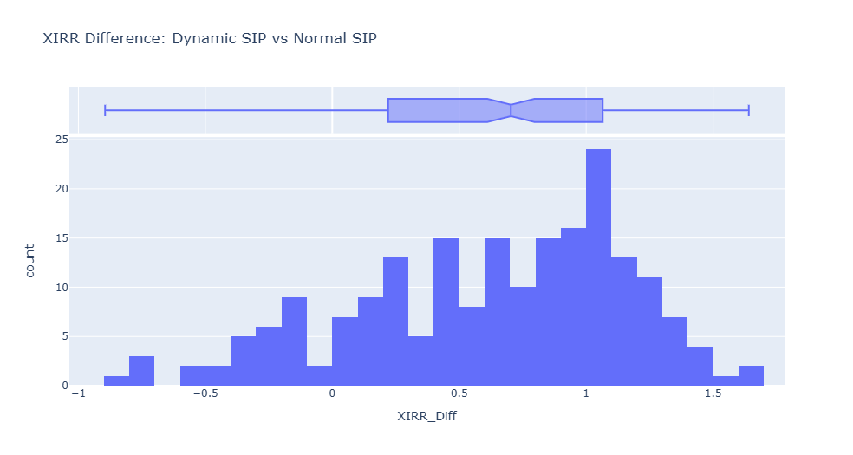

## 💡 What We Learned

* Emotions often lead to bad investment decisions
* Fixed SIP is decent, but doesn’t adapt
* This simple rule-based approach adds intelligent discipline
* You don’t need to predict — just **respond to valuation**

## 🧘‍♂️ Final Thoughts: Let Valuation Guide You

Priya didn’t time the market.  
 She simply followed a rule and stayed calm.

You don’t need a crystal ball — just a clear plan.

Let valuation guide your SIP.  
 And sip your chai in peace. ☕📈

**Discipline beats drama. Always.**

**Note**:

* Code and data are included in the attached notebook
* Data source: [NSE India Website](https://www.nseindia.com)