FinnAI SLM
How we taught a phone-sized model to read bank SMS
FinnDot · 2026
Model — huggingface.co/finndot/finnai-slm-v2
Data — huggingface.co/datasets/finndot/finnai-slm-data
Code — github.com/arunbhatg/finnai-slm

In short
FinnDot reads bank SMS and logs expenses. For banks we already know, we use hand-written parsers. For everything else — new formats, Hindi/Hinglish texts, and “where did my money go?” questions — we needed a small language model that runs on the phone.
We started from an open model (Qwen3, 1.7B parameters) and fine-tuned it on synthetic data only. No real user SMS. On a held-out test, full-field SMS accuracy went from about 28% (untuned) to about 98% (FinnAI v2).
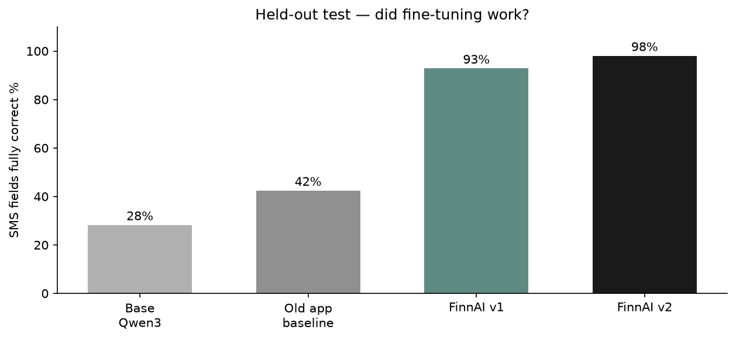
Figure 1. Same test set, four models.

The problem we were solving
A bank text looks like this:
HDFC Bank: Rs.499.00 debited from A/c XX1234 to SWIGGY via UPI. Avl Bal Rs.15000.50
We need this:
{"amount": 499.0, "merchant": "SWIGGY", "type": "EXPENSE", "account": "1234", "balance": 15000.5}
Rules work great when the format is known. They break when the bank changes wording, the message is in another language, or the text is an OTP and should be ignored. Coaching is not a regex problem at all.
Cloud chat APIs could do the job, but bank SMS has balances and account fragments. We did not want that traffic leaving the device for this path. Local model, download once, run offline.

What “fine-tuning” means here
If you only use ChatGPT as a product: fine-tuning is not “make a new ChatGPT.” It is taking a general model that already speaks language, and teaching it one job with many graded examples.
We used QLoRA — keep the big model frozen, train a thin adapter (~67 MB). Cheaper than full retraining, less chance of wiping general ability, fits on a single modern GPU.
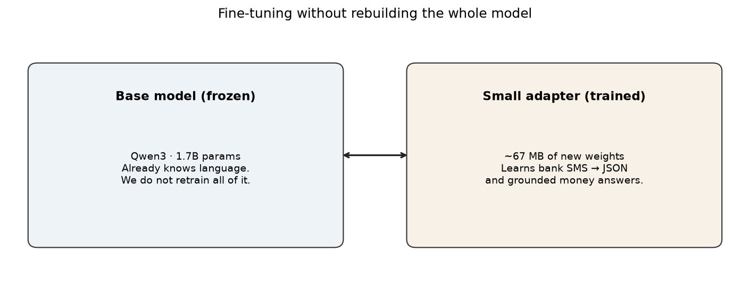
Figure 2. Adapter on top of a frozen base.

Settings that mattered
Choice | What we used | Why
Base | Qwen3-1.7B | Open license, small enough for phones
Method | QLoRA SFT | Specialise without full retrain
LoRA rank | 16 | Enough for JSON style; larger did not help
Epochs | 3 | 16k examples; more started to overfit patterns
Pick checkpoint by | Val SMS exact-match | Loss alone lied to us before
Thinking / chain-of-thought | Off | Phone needs a fast JSON answer

Where it sits in the app
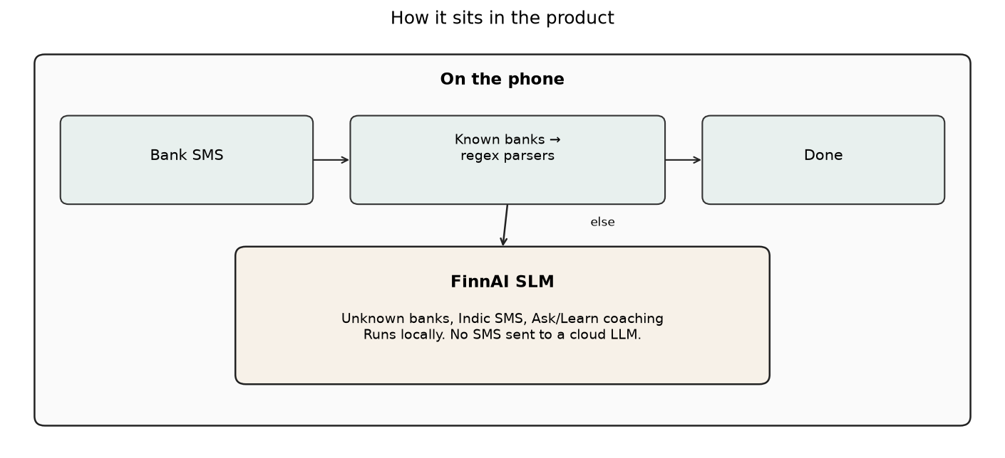
Figure 3. Parsers first. Model for the rest.
We did not throw away the 35+ bank parsers. The model is the long-tail and the coach.

How we did it
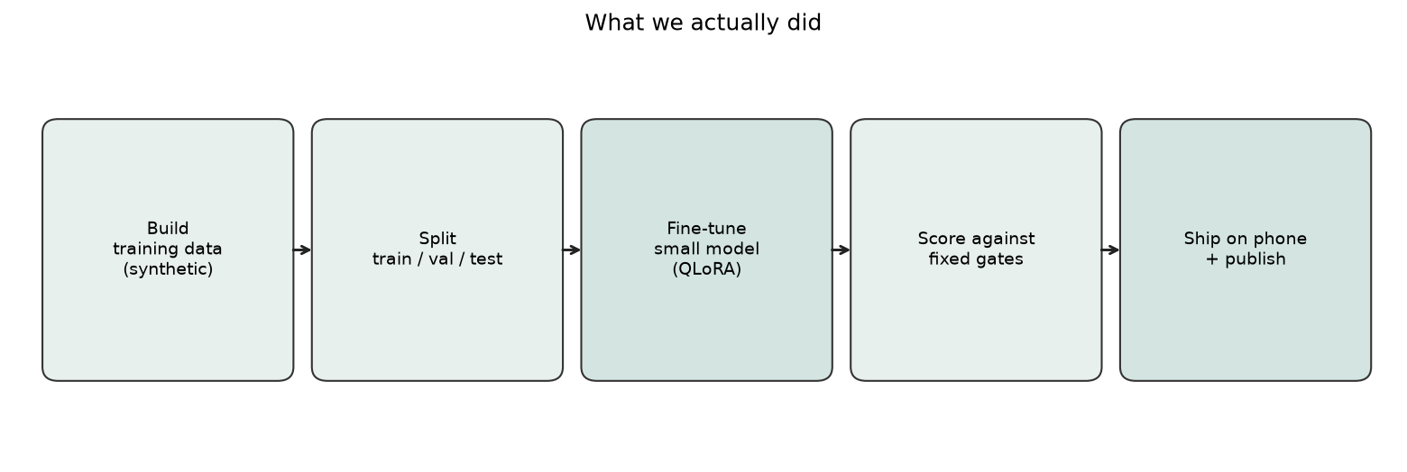
Figure 4. End to end.

Data
All training SMS are synthetic: templates with fake amounts and merchants. We know the correct JSON because we generated the text. Coach answers are tied to fake ledgers so every rupee in the reply must appear in the prompt.
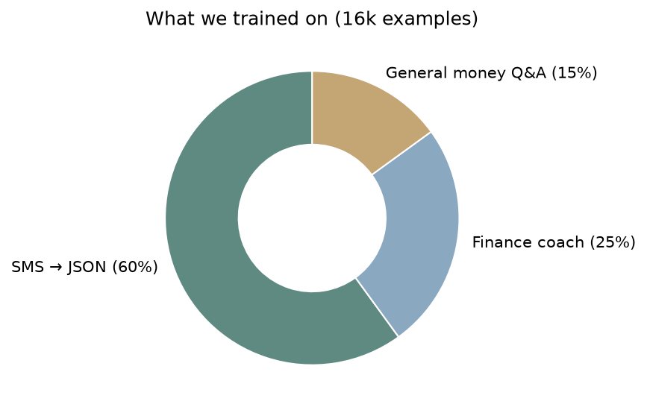
Figure 5. Mix of tasks in training.
Splits are by template family, not by line. If you put paraphrases of the same template in both train and test, you fool yourself. We locked that before scoring.
Indic paraphrases (Hindi, Hinglish, etc.) were generated as surface text only and kept only when amount, merchant, and account digits still matched our labels.

How we decided “good enough to ship”
The pass rules were written before we looked at the final test numbers. Main score: every key field correct (amount, type, merchant, last-4, balance), or empty {} for non-transactions.
Check | Bar | v2
Beat untuned Qwen3 on SMS | +3 points, clear gap | Pass
Do not get worse on amounts | Within 1 point of base | Pass
Coach does not invent numbers | Within 5 points of base | Pass
Valid JSON | ≥ 95% | 100%
Beat old on-device baseline | R-EM ≥ old model | Pass
Phone speed / memory | Comparable to old model | Still to measure on device

Numbers
 | FinnAI v2 | v1 | Untuned Qwen3
SMS fully correct | 98.0% | 92.8% | 28.2%
Amount correct | 99.5% | 94.6% | 82.8%
Merchant correct | 98.2% | 93.1% | 61.3%
OTP/promo wrongly parsed | 0.5% | 28.6% | 100%
Coach grounded in ledger | 68% | 32% | 26%

The false-parse drop matters in product terms: fewer OTPs showing up as spends. Coach groundedness doubled from v1 to v2 — still not perfect, but usable.

Cost
One training run is a few hours on a single GPU — low double-digit dollars for the whole v1→v2 loop including eval and Indic data generation. No annotation vendor. No user inbox dump.
Ongoing: downloading the model once is cheaper than paying per SMS to a cloud API forever.

What we published
Weights, dataset, training/eval code, and this write-up are public (Apache 2.0). Links are on the cover. Others can fine-tune further or copy the approach for other private on-device jobs.

Honest limits
Built for Indian bank SMS. Regex still wins on banks we fully support. Merchant names are the fiddliest field. Coach answers can still paraphrase numbers sometimes. We still need a real-device speed/memory check before calling the phone build fully done.

Next
Finish on-device timing, point the app at the new file when that passes, keep growing templates for new banks and languages — still without training on user SMS.

Glossary
Term | Meaning
LLM / SLM | Large / small language model
Fine-tune | Extra training for one job
QLoRA | Train a small adapter; keep the base frozen
SFT | Learn from input → correct output pairs
R-EM | All key SMS fields match gold
Grounded | Numbers in the answer exist in the ledger prompt

