Dynamic ALV Report

Table for dynamic alv

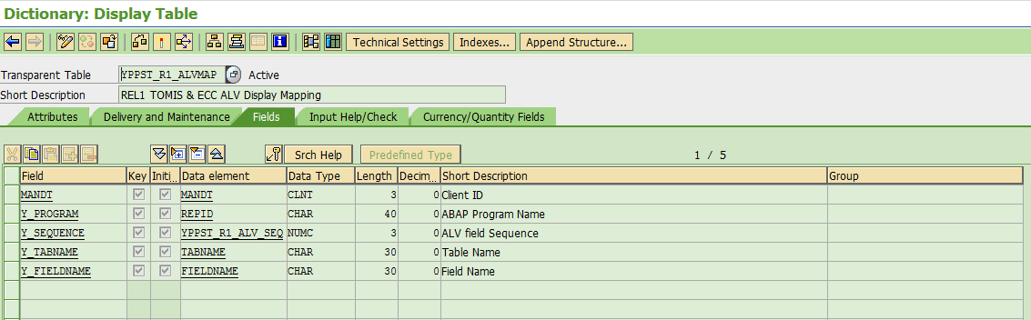

Class

Parameter

  types:  
    tt_ref TYPE STANDARD TABLE OF salv_s_ddic_reference WITH DEFAULT KEY .

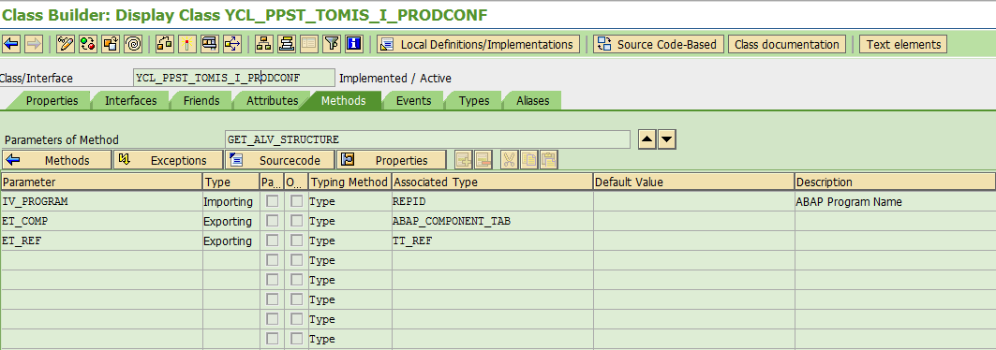

ALV structure call

Data:       gt_comp         TYPE cl_abap_structdescr=>component_table,  
          gt_ref          TYPE STANDARD TABLE OF salv_s_ddic_reference,

    DATA: lo_new_type TYPE REF TO cl_abap_structdescr,  
          lo_new_tab  TYPE REF TO cl_abap_tabledescr,  
          lo_data     TYPE REF TO data,  
          lo_line     TYPE REF TO data.

* ALV Structure  
    ycl_ppst_tomis_i_prodconf=>get_alv_structure( EXPORTING iv_program = sy-repid  
                  IMPORTING et_comp   = gt_comp  
                            et_ref    = gt_ref ).  
    IF  gt_comp[] IS NOT INITIAL.  
      lo_new_type = cl_abap_structdescr=>create( gt_comp ).  
  
      lo_new_tab = cl_abap_tabledescr=>create(  
                   p_line_type  = lo_new_type  
                   p_table_kind = cl_abap_tabledescr=>tablekind_std  
                   p_unique     = abap_false ).  
  
      CREATE DATA lo_data TYPE HANDLE lo_new_tab.  
*  
* 6. New internal table in the fieldsymbols  
      ASSIGN lo_data->* TO <gt_alv>.  
      CREATE DATA lo_line LIKE LINE OF <gt_alv>.  
      ASSIGN lo_line->* TO <gs_alv>.  
    ENDIF.

To Fill AVL

  METHOD fill_alv .  
* Description    : To fill the alv structure  
    FIELD-SYMBOLS <lv_field> TYPE any.  
    IF is_tomis IS NOT INITIAL.  
      MOVE-CORRESPONDING is_tomis TO <gs_alv>.  
      ASSIGN COMPONENT ycl_ppst_tomis_i_prodconf=>c_process_flag OF STRUCTURE <gs_alv> TO <lv_field>.  
      IF sy-subrc EQ 0.  
        <lv_field> = ycl_ppst_tomis_i_prodconf=>c_red.  
      ENDIF.  
      APPEND <gs_alv> TO <gt_alv>.  
    ENDIF.  
    IF is_conf IS NOT INITIAL.  
      READ TABLE <gt_alv> ASSIGNING <gs_alv> WITH KEY (ycl_ppst_tomis_i_prodconf=>c_meldung) = is_conf-y_id_meldung  
                                                  (ycl_ppst_tomis_i_prodconf=>c_vorgang) = is_conf-y_vorgang.  
      IF sy-subrc EQ 0.  
        MOVE-CORRESPONDING is_conf TO <gs_alv>.  
        ASSIGN COMPONENT ycl_ppst_tomis_i_prodconf=>c_process_flag OF STRUCTURE <gs_alv> TO <lv_field>.  
        IF sy-subrc EQ 0.  
          IF is_conf-y_conf_flag EQ ycl_ppst_tomis_i_prodconf=>c_process_y.  
            <lv_field> = ycl_ppst_tomis_i_prodconf=>c_green.  
          ELSE.  
            <lv_field> = ycl_ppst_tomis_i_prodconf=>c_red.  
          ENDIF.  
        ENDIF.  
      ELSE.  
        READ TABLE me->gt_r1_tomis ASSIGNING FIELD-SYMBOL(<ls_tomis>) WITH KEY y_id_meldung = is_conf-y_id_meldung  
                                                                        y_vorgang   =  is_conf-y_vorgang.  
        IF sy-subrc EQ 0.  
          MOVE-CORRESPONDING <ls_tomis> TO <gs_alv>.  
        ENDIF.  
        MOVE-CORRESPONDING is_conf TO <gs_alv>.  
        ASSIGN COMPONENT ycl_ppst_tomis_i_prodconf=>c_process_flag OF STRUCTURE <gs_alv> TO <lv_field>.  
        IF sy-subrc EQ 0.  
          IF is_conf-y_conf_flag EQ ycl_ppst_tomis_i_prodconf=>c_process_y.  
            <lv_field> = ycl_ppst_tomis_i_prodconf=>c_green.  
          ELSE.  
            <lv_field> = ycl_ppst_tomis_i_prodconf=>c_red.  
          ENDIF.  
        ENDIF.  
        APPEND <gs_alv> TO <gt_alv>.  
      ENDIF.  
    ENDIF.  
  
  ENDMETHOD.

To Display ALV

  types:  
    tt_ref TYPE STANDARD TABLE OF salv_s_ddic_reference WITH DEFAULT KEY .

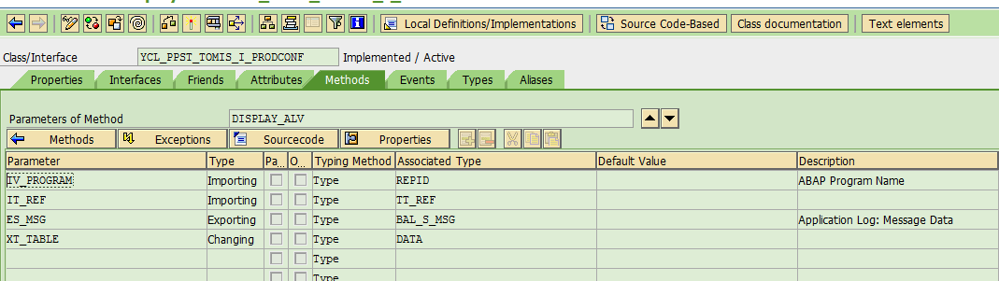

  METHOD display_alv.  
    DATA: lo_sort TYPE REF TO cl_salv_sorts.  
*  Display ALV  
    TRY.  
* Create object for ALV  
        CALL METHOD cl_salv_table=>factory(  
          IMPORTING  
            r_salv_table = DATA(lo_alv)  
          CHANGING  
            t_table      = xt_table ).  
  
******For Sorting the internal Table on 'Y_ID_MELDUNG'  
        lo_sort = lo_alv->get_sorts( ).  
        TRY.  
            CALL METHOD lo_sort->add_sort  
              EXPORTING  
                columnname = c_meldung  
                position   = 1.  
  
          CATCH cx_salv_not_found ##no_handler.  
          CATCH cx_salv_existing ##no_handler.  
          CATCH cx_salv_data_error ##no_handler.  
        ENDTRY.  
* Optimize columns  
        lo_alv->get_columns( )->set_optimize( if_salv_c_bool_sap=>true ).  
        DATA(lo_columns) = lo_alv->get_columns( ).  
        lo_columns->set_key_fixation( value = abap_true ).  
        lo_alv->set_screen_status(  
              pfstatus      =  ycl_ppst_tomis_i_prodconf=>c_yppst_standard  
              report        =  iv_program  
              set_functions =  lo_alv->c_functions_all ).  
  
        IF it_ref  IS NOT INITIAL.  
          LOOP AT it_ref ASSIGNING FIELD-SYMBOL(<ls_ref>).  
            DATA(lo_column) = lo_columns->get_column( <ls_ref>-field ).  
            lo_column->set_ddic_reference( <ls_ref> ).  
          ENDLOOP.  
        ENDIF.  
        lo_columns->set_exception_column( value = c_process_flag ).  
        lo_alv->display( ).  
      CATCH cx_salv_msg INTO DATA(lo_msg).  
  
        DATA(ls_msg) = lo_msg->get_message( ).  
  
        IF ls_msg IS NOT INITIAL .  
          es_msg = ls_msg.  
        ENDIF.  
    ENDTRY.  
  ENDMETHOD.