TITLE
Software Development Company: Git-Based Collaborative Software Development Workflow

Rachit Parsana [92400120672]
Kevin Gajera [92400120212]
Viraj Bodar [92400120300]

DEPARTMENT

COMPUTER ENGINEERING

ACADEMIC YEAR

2026–2027

SEMESTER

5TH

SUBJECT

OPEN SOURCE TECHNOLOGIES (01CE0526)

CLASS
5EV4

BATCH
A
RUBRICS FOR CASE STUDY

Sr. No. | Assessment Criteria | Excellent | Good | Satisfactory | Poor | Marks
1 | Problem Analysis, Cloud Concepts & SDG Mapping | 4 Marks: Clear problem identification, appropriate cloud concepts, and accurate SDG mapping. | 3 Marks: Good analysis with minor gaps in concepts or SDG mapping. | 1–2 Marks: Basic problem understanding with partial cloud concepts or SDG mapping. | 0 Marks: Inadequate or incorrect analysis and no SDG mapping. | 4
2 | Security Analysis & Technical Depth | 4 Marks: Comprehensive security analysis, well-defined architecture, appropriate technologies, and justified solutions. | 3 Marks: Good technical explanation with minor omissions. | 1–2 Marks: Limited security analysis and technical details. | 0 Marks: No meaningful security analysis or technical explanation. | 4
3 | Report Quality & References | 4 Marks: Well-structured report in IEEE format with comprehensive technical content, proper citations, and relevant references. | 3 Marks: Good report structure with minor formatting or referencing issues. | 1–2 Marks: Basic report with limited technical details or incomplete references. | 0 Marks: Incomplete report with poor documentation and missing references. | 4
 | Total |  |  |  |  | 12

Sr. No. | Case Study Title / Problem Statement | COs | Date | R1(4) | R2(4) | R3(4) | Marks (12) | Signature
1 | Software Development Company: Git-Based Collaborative Software Development Workflow | CO2: Version control tools, collaboration

Notes / Instructions
- The case study must be completed in a group of maximum 3 students.
- Students must follow the given submission deadlines.
- The case study report must follow the provided IEEE Conference Paper Template format.
- The final report must be uploaded in DOCX format on Google Classroom, and a hard copy must be submitted as discussed.
- The report should include proper technical analysis, cloud concepts, security aspects, SDG mapping, figures/tables, and IEEE-style references.
- Use only authentic research papers and reliable sources for references.
- All group members must contribute equally and be prepared for presentation and evaluation.
- Remove all template instructions/content before final submission.
- Plagiarism or copied content will not be accepted.

Ms. Priyanka Mangi
Subject Faculty

Software Development Company: Git-Based Collaborative Software Development Workflow

Course Name and Course Name: OPEN SOURCE TECHNOLOGIES (01CE0526)

Co’s Mapped – CO2

SDG’s Mapped - SDG 9 – Industry, Innovation and Infrastructure
SDG 17 – Partnerships for the Goals

Abstract
Keywords

I. Introduction
- Background of the selected case study
- Importance of Open Source Technologies in the selected domain
- Objectives of the case study
- Scope of the study

II. Organization/Application Background
- Overview of the organization/application/system
- Existing software ecosystem
- Business requirements
- Need for adopting Open Source Technologies

III. Problem Analysis
- Problem identification
- Existing challenges
- Engineering requirements
- Functional and non-functional requirements
- Constraints and assumptions

IV. Open Source Solution Analysis
- Selected Open Source technologies/frameworks
- Justification for technology selection
- Open Source license used (GPL, MIT, Apache, BSD, etc.)
- Comparison with proprietary alternatives
- Benefits of adopting OSS

V. System Architecture and Technology Stack
- Overall architecture diagram
- Technology stack
- Version Control System (Git/GitHub/GitLab)
- Web framework (Laravel/Django/Node.js)
- Database (MySQL/PostgreSQL/MongoDB)
- Web Server (Apache/Nginx)
- Development and deployment workflow

VI. Database and Deployment Analysis
- Database design
- CRUD operations
- Database architecture
- Deployment strategy
- Reverse Proxy / Load Balancing (if applicable)

VII. Software Quality and Testing
- Testing strategy
- Unit Testing (PyTest/PHPUnit/JUnit)
- API Testing (Postman)
- Web Testing (Selenium)
- Load Testing (JMeter)
- Security Testing (OWASP ZAP)
- Testing outcomes and observations

VIII. Open Source Community and Licensing Analysis
- Open Source licensing model
- Compliance with license terms
- Community support
- Documentation quality
- Version management
- Contribution opportunities

IX. Technical Analysis
- Working of the proposed solution
- Advantages
- Limitations
- Scalability
- Reliability
- Maintainability
- Performance analysis

X. SDG Mapping and Justification
- Identify the relevant Sustainable Development Goal(s)
- Explain how the proposed Open Source solution contributes towards achieving the selected SDGs
- Justification with real-world impact

XI. Challenges and Recommendations
- Technical challenges
- Security challenges
- Deployment challenges
- Future improvements
- Recommendations for better implementation

XII. Conclusion
- Summary of the case study
- Key technical findings
- Learning outcomes
- Industrial relevance of Open Source Technologies

References
- IEEE Reference Format
- Minimum 5–8 authentic references
- Research papers
- Official Documentation
- GitHub Documentation
- Linux Foundation Documentation
- Books

Appendix (Optional)
- System Architecture Diagram
- Database Schema
- Git Workflow Diagram
- Screenshots
- Test Reports
- Deployment Screenshots
- Configuration Files
- Additional Tables

Software Development Company: Git-Based Collaborative Software Development Workflow

Rachit Parsana  Department of Computer Science and Engineering  Marwadi University  Rajkot, Gujarat, India  rachit.parsana133790@marwadiuniversity.ac.in | Viraj Bodar  Department of Computer Science and Engineering  Marwadi University  Rajkot, Gujarat, India  viraj.bodar128930@marwadiuniversity.ac.in | Kevin Gajera  Department of Computer Science and Engineering  Marwadi University  Rajkot, Gujarat, India  kevin.gajera129209@marwadiuniversity.ac.in

Abstract— Collaborative software development requires a reliable mechanism for managing source-code changes, coordinating developers, reviewing contributions, and maintaining stable releases. In a software development company, the absence of a structured version-control workflow can result in conflicting changes, duplicated work, loss of source-code history, uncontrolled access, and difficulties in maintaining software quality. This case study proposes a Git-based collaborative software development workflow for a representative software development company. Git is used as the central distributed version-control system, while GitHub is proposed as the hosted repository and collaboration platform for pull requests, issues, code reviews, protected branches, and GitHub Actions-based automation. Git provides local repositories, branching, committing, merging, and distributed history management, while the proposed collaboration platform provides mechanisms for structured review and repository management.
The proposed environment uses Node.js and Express.js for application development, PostgreSQL for collaboration and project metadata, Nginx as a reverse proxy, Jest for unit testing, Postman for API testing, Selenium for web testing, Apache JMeter for load testing, and ZAP for security testing. The architecture also considers cloud-based virtual machines or containers, backup storage, monitoring, firewall controls, and optional load balancing. The case study analyses Git workflow, database architecture, CRUD operations, deployment, testing, licensing, repository security, application security, cloud concepts, scalability, reliability, maintainability, and SDG mapping.
The proposed workflow follows requirement identification, feature branching, local development, commits, push operations, pull requests, code review, automated validation, protected main-branch merging, staging, production deployment, monitoring, and maintenance. No claim of actual deployment or numerical testing results is made; the study presents a technically justified representative architecture and defines the validation criteria required before production adoption.
Keywords— Git, GitHub, Distributed Version Control, Feature Branch, Pull Request, Code Review, GitHub Actions, Node.js, PostgreSQL, Cloud Deployment, Software Security, Open Source Technologies

Introduction

Background of the Selected Case Study
Software development is inherently collaborative because modern applications are generally produced through the combined efforts of developers, testers, project managers, system administrators, security engineers, and other technical stakeholders. As the number of contributors and source-code files increases, manually coordinating changes becomes difficult. Developers may work simultaneously on the same modules, create conflicting versions of files, overwrite changes, or lose information about why a particular modification was introduced. A software development company therefore requires a systematic mechanism for recording changes and coordinating contributions throughout the software development life cycle.
Version control addresses this problem by maintaining a history of changes to software artifacts. Git is a distributed version-control system in which developers can maintain complete local repositories and synchronize changes with remote repositories. Git supports commits, branches, merging, repository history and distributed development workflows. Research on Git also identifies local repositories, distributed workflows, and revision management as important characteristics that distinguish Git from traditional centralized version-control approaches [1].
The selected case study considers a representative software development company, rather than a specific real organization. The company is assumed to develop and maintain web-based software applications through a team-based development process. The purpose of the case study is to design a Git-based collaborative workflow that provides controlled source-code management, structured code review, automated validation, secure deployment, and traceability from requirements to releases.
The central concept is Git-based collaborative software development. Git is therefore treated as the actual open-source version-control technology, whereas GitHub is treated as a hosted repository and collaboration platform built around Git. This distinction is important because Git and GitHub are not equivalent technologies: Git provides the distributed version-control mechanism, while GitHub provides hosted collaboration capabilities such as pull requests, repository management and workflow automation.

Importance of Open-Source Technologies in the Selected Domain
Open Source Technologies are particularly relevant to software development because they provide organizations with access to widely adopted development tools, frameworks, databases, testing technologies, servers, and automation platforms. The open-source ecosystem allows development teams to construct technology stacks from components that can be inspected, modified, integrated, and redistributed according to their respective licenses.
Git is especially relevant because distributed version control allows developers to work locally while maintaining a complete repository history and synchronizing work with remote repositories. Research on distributed version control has shown that branching and history-preserving merging can support isolated development tasks while reducing interference between parallel development activities [3].
The use of open-source technologies also encourages interoperability and reduces dependence on a single software-development toolchain. Node.js provides a JavaScript runtime suitable for network applications, Express.js provides a lightweight web framework, PostgreSQL provides a relational database, and Nginx provides web-server, reverse-proxy and load-balancing capabilities.
For collaborative development, the open-source ecosystem is also significant because project repositories can be integrated with testing, security scanning, dependency management and CI/CD workflows. GitHub Actions, for example, provides workflow automation for building, testing and deployment processes.

Objectives of the Case Study
The major objectives of this case study are to:
- Analyze the problems associated with collaborative software development without a controlled Git-based workflow.
- Explain Git as a distributed version-control system for collaborative development.
- Design a structured feature-branch and pull-request workflow.
- Define the role of GitHub in repository hosting, issue tracking, pull requests and collaboration.
- Propose a suitable open-source technology stack for the representative software development environment.
- Design a PostgreSQL-based metadata database for projects, repositories, issues, pull requests, reviews, builds, releases and deployments.
- Analyze cloud deployment concepts, reverse proxy operation and load balancing.
- Define unit, API, web, load and security testing strategies.
- Analyze repository, application, database and cloud security requirements.
- Examine open-source licensing and compliance requirements.
- Evaluate scalability, reliability, maintainability and performance considerations.
- Map the proposed solution to SDG 9 and SDG 17.

Scope of the Study
The scope of the study covers a representative software development company using Git for source-code management and GitHub for hosted collaboration. The study includes repository organization, branch management, commits, pull requests, code review, merge conflict handling, automated CI checks, protected branches, release management and deployment.
The study also covers a proposed Node.js and Express.js application environment, PostgreSQL database architecture, Nginx reverse proxy, cloud deployment, testing tools, security controls and software licensing. The architecture is cloud-provider neutral so that the design can be implemented using virtual machines, containers or equivalent cloud infrastructure according to organizational requirements.
The study does not claim that the proposed system has already been implemented, deployed, load-tested or security-tested. All implementation-specific statements are therefore presented as proposed engineering practices or validation requirements.

ORGANIZATION/APPLICATION BACKGROUND

Overview of the Organization
The case study considers a representative software development company that develops web applications for internal or external users. The organization requires multiple developers to work simultaneously on a shared software product while maintaining a stable production version. The development environment contains source code, configuration files, database scripts, automated tests, documentation and deployment configurations.
The proposed system consists of a source-code repository, collaboration platform, application-development environment, metadata database, CI pipeline, testing environment and deployment infrastructure. Developers maintain local Git repositories and create feature branches for individual tasks. Changes are committed locally and pushed to a remote repository. A pull request is then created for review and automated validation before the changes are merged into a protected main branch.
GitHub pull requests provide a structured location for discussing, reviewing and validating proposed changes before merging them. GitHub documentation identifies pull requests as a mechanism for proposing changes, discussing them, reviewing files and commits, and running automated checks.

Existing Software Ecosystem
The representative organization may have a mixed software-development ecosystem consisting of local development environments, source-code directories, project documentation, issue-management processes, databases, application servers and manually coordinated deployment procedures.
Software Area | Existing Proprietary Approach | Major Concern
Source Code | Shared folders or centralized repositories | Difficult change traceability
Version Management | Manual file versions or centralized control | Limited local flexibility
Collaboration | Email, chat and manual coordination | Information fragmentation
Code Review | Manual review or informal approval | Inconsistent quality control
Issue Tracking | Separate documents or communication channels | Weak traceability
Testing | Manually executed tests | Inconsistent validation
Deployment | Manual server deployment | Higher human-error risk
Security | Separate security activities | Security may occur late
Backup | Periodic manual backup | Recovery uncertainty
Release Management | Manual packaging | Inconsistent release process
The proposed Git-based environment addresses these weaknesses by connecting requirements, source-code changes, reviews, testing and releases through a common workflow.

Business Requirements
The representative software development company requires a software-development environment that supports reliable collaboration without losing control of the production codebase. The environment should allow multiple developers to work simultaneously while preserving the history of modifications.
The organization requires source-code traceability so that each change can be associated with a commit, branch, pull request and issue. It also requires controlled code review, automated testing, secure deployment, backup and recovery, and access control.
The proposed environment should further support scalable development. As the number of developers, repositories, applications and deployments increases, the architecture should allow additional application servers, CI runners, database capacity and monitoring components to be introduced without redesigning the complete workflow:

Need for Adopting Open-Source Technologies
A Git-based open-source workflow is relevant because source-code management is a core requirement of software engineering. Git provides distributed repository management, while the surrounding open-source ecosystem provides frameworks, databases, testing tools and infrastructure components.
The objective is not simply to avoid proprietary software. The technology selection should be based on technical requirements, compatibility, security, licensing, organizational skills, support requirements and operational constraints. Open-source adoption still creates responsibilities for maintenance, security updates, dependency management, licensing compliance and technical support.
A structured Git workflow can also improve collaboration by defining how developers create branches, commit changes, submit pull requests, perform reviews and integrate approved changes. Research on Git workflows emphasizes that workflows define how branches, local clones, integration and quality gates are used in collaborative development [2].

PROBLEM ANALYSIS

Problem Identification
The primary problem addressed by this case study is:
How can a software development company establish a secure and technically controlled collaborative development workflow using Git-based version control while maintaining source-code traceability, software quality, deployment reliability and protection of the production codebase?
Without a standardized workflow, developers may overwrite changes, create inconsistent versions, merge incomplete code, introduce vulnerabilities, or deploy untested changes. When source-code history is poorly maintained, identifying the origin of a defect or reverting a problematic change becomes more difficult.
The problem is therefore not limited to version control itself. It involves the complete path from requirement identification to production maintenance.

Existing Challenges

The major challenges are parallel development, merge conflicts, uncontrolled changes, inadequate review, inconsistent testing, unauthorized repository access, accidental exposure of secrets, vulnerable dependencies and deployment errors.

Another important challenge is workflow consistency. A team may use Git but still obtain poor results if developers follow different branching, merging and release practices. Academic research on Git workflows demonstrates that different workflows emphasize different branching and integration strategies and that workflow selection should be aligned with development requirements [2].

Security is also a major challenge. A Git repository can contain sensitive source code, configuration files and deployment information. Committing passwords, database credentials, API keys or tokens can expose organizational resources. GitHub documentation specifically recommends using secure secret mechanisms rather than hardcoding credentials into code or logs.

Engineering Requirements
The proposed system should satisfy the following engineering requirements:
- Secure user authentication and authorization.
- Role-based repository access.
- Distributed version control using Git.
- Feature-based branch isolation.
- Pull-request-based code review.
- Protected production branches.
- Automated CI validation.
- Automated unit and integration testing.
- API and web testing.
- Security testing.
- Secure database architecture.
- Backup and recovery.
- Deployment automation.
- Monitoring and logging.
- Dependency and vulnerability management.
- Controlled release management.
- Scalable application infrastructure.
- Traceability between requirements, code changes and releases.

Functional Requirements
The proposed environment should provide the following functionality.
- User Management: The system should support user registration or administrator-controlled account creation, authentication and role assignment.
- Project Management: Users should be able to create and manage software projects according to their permissions.
- Repository Management: Projects should be associated with Git repositories.
- Branch Management: Developers should create feature branches without directly modifying protected production branches.
- Commit Management: Developers should commit changes with meaningful messages and maintain source-code history.
- Pull Requests: Developers should submit changes for review before merging.
- Code Review: Authorized reviewers should comment, approve or request changes.
- Issue Tracking: Requirements, defects and tasks should be represented as issues.
- Automated Validation: Pull requests should trigger automated build and test workflows.
- Release Management: Approved versions should be tagged and associated with releases.
- Deployment Management: Validated releases should progress through staging and production environments.
- Auditability: Repository and application activities should be recorded for traceability.

Non-Functional Requirements
Requirement | Description
Security | Protect source code, credentials, user accounts and infrastructure.
Reliability | Maintain dependable service and recover from failures.
Scalability | Support increasing repositories, developers and application workloads.
Performance | Provide acceptable application, API, database and CI response characteristics.
Maintainability | Allow software and infrastructure to be updated systematically.
Availability | Minimize unnecessary service interruption.
Integrity | Prevent unauthorized or inconsistent modification of source and metadata.
Usability | Provide understandable workflows for developers and reviewers.
Compatibility | Support standard Git, HTTP, database and development interfaces.
Auditability | Maintain traceability of changes, reviews, releases and deployments.

Constraints and Assumptions
This case study assumes a representative software development company with suitable network connectivity and technical personnel capable of administering the proposed environment. The company is assumed to require collaborative development but does not have a fixed cloud-provider requirement.
The architecture is proposed rather than implemented. Therefore, actual performance, availability, load capacity, cloud cost and security findings cannot be stated without an implemented test environment.
The organization must also consider the licensing conditions of every dependency. Git, Node.js, Express.js, PostgreSQL, Nginx, Jest, Selenium, JMeter and ZAP do not all use the same license, and license obligations must therefore be tracked independently.

OPEN SOURCE SOLUTION ANALYSIS

Selected Open-Source Technologies
The proposed technology stack is:
Requirement | Proposed Technology | Purpose
Version Control | Git | Distributed source-code management
Repository/Collaboration | GitHub | Hosted repositories, issues, pull requests and collaboration
CI/CD | GitHub Actions | Automated build, test and deployment workflows
Runtime | Node.js | Server-side JavaScript runtime
Web Framework | Express.js | Web/API application development
Database | PostgreSQL | Relational project and collaboration metadata
Reverse Proxy | Nginx | HTTP delivery, reverse proxy and load balancing
Unit Testing | Jest | Automated application testing
API Testing | Postman | REST/API validation
Web Testing | Selenium | Browser automation
Load Testing | Apache JMeter | Load and performance testing
Security Testing | ZAP | Web application security assessment
Infrastructure | VM / Docker | Application isolation and deployment

Node.js is an asynchronous event-driven JavaScript runtime

suitable for network applications, while Express.js is a web
framework for Node.js.

PostgreSQL is an open-source relational database system released under the PostgreSQL License.

Nginx provides HTTP-server, reverse-proxy and load-balancing functionality and is distributed under a 2-clause BSD license.

Justification for Technology Selection

Git

Git is selected because the central case-study requirement is distributed version control. Git provides local repositories, commits, branches and merging and allows developers to synchronize work with remote repositories.

GitHub

GitHub is selected as the proposed hosted collaboration platform because it provides repository hosting, pull requests, reviews, issues and integration with GitHub Actions. It should not be described as the open-source VCS itself; Git is the VCS. GitHub provides the collaboration layer around Git.

Node.js and Express.js

Node.js and Express.js are proposed because they provide a lightweight server-side environment for REST APIs and web applications. Node.js is designed for network applications and supports concurrent connections through its event-driven model.

PostgreSQL

PostgreSQL is selected because the proposed collaboration application requires structured relational data, constraints, transactions and relationships between users, projects, repositories, issues, pull requests and deployments. PostgreSQL provides a suitable relational foundation for this metadata.

Nginx

Nginx is selected because it can operate as a reverse proxy and can distribute traffic when multiple application instances are deployed.

Jest, Postman, Selenium, JMeter and ZAP

Jest, Postman, Selenium, JMeter and ZAP provide complementary testing capabilities covering application logic, APIs, browser behavior, performance and security. Jest supports JavaScript testing, Selenium provides browser automation, and JMeter is designed for load and performance testing.

Open-Source Licensing
The case study does not assign an open-source license to the student's own proposed project because no such license has been selected.
Instead, the licenses of the proposed third-party technologies are considered individually:
Component | Applicable License | Compliance Consideration
Git | GNU GPL v2.0 | Preserve applicable license and copyright notices.
Node.js | MIT | Preserve applicable copyright/license notice.
Express.js | MIT | Preserve applicable copyright/license notice.
PostgreSQL | PostgreSQL License | Preserve applicable notices and license conditions.
Nginx | 2-clause BSD | Follow applicable copyright and license conditions.
Jest | MIT | Preserve applicable notices.
Selenium | Apache 2.0 | Preserve notices and comply with Apache terms.
Apache JMeter | Apache 2.0 | Preserve notices and license information.
ZAP | Apache 2.0 | Preserve applicable license and third-party notices.

Git is officially released under GPLv2. Node.js is MIT licensed, Express.js is MIT licensed, PostgreSQL uses the PostgreSQL License, Nginx uses a 2-clause BSD license, Selenium uses Apache 2.0, and ZAP uses Apache 2.0.
The faculty template refers to the security-testing tool as OWASP ZAP. For current technical accuracy, the project now identifies itself as ZAP by Checkmarx and states that it is no longer an OWASP project. The report should therefore write “ZAP (formerly referred to as OWASP ZAP in the faculty template)” where clarification is useful..

Comparison with Proprietary Alternatives
Parameter | Proprietary/Centralized Approach | Proposed Git-Based Workflow
Source History | Depends on selected platform | Git maintains distributed history
Local Repository | May be limited by platform | Complete local Git repository
Branching | Platform dependent | Native Git branching
Collaboration | Depends on vendor tools | Git + GitHub pull requests
Code Review | May require separate tools | Pull-request-based review
Automation | Depends on selected platform | GitHub Actions can automate CI/CD
Flexibility | Controlled by vendor ecosystem | Multiple open-source components can be combined
Deployment | Vendor/platform dependent | Can be implemented on VMs or containers
Integration | Depends on proprietary APIs | Standard Git and open technologies
Governance | Vendor/platform policies | Organization-defined workflow rules

The comparison does not establish that one approach is universally superior. Technology selection should consider organizational requirements, security, governance, skills, support, infrastructure, compliance and operational constraints.

Benefits of Adopting OSS
The proposed environment can provide several technical benefits. Git provides distributed source-code management, while the surrounding open-source stack provides flexibility in application development, database selection, testing and deployment.
The organization can combine different technologies according to requirements rather than being forced to use a single integrated proprietary ecosystem. The use of open standards can also simplify interoperability between components.
Another benefit is technical learning and community participation. Open-source projects commonly provide documentation, issue tracking, source repositories and contribution mechanisms. Selenium, for example, documents community contribution and maintains its project openly.

SYSTEM ARCHITECTURE AND TECHNOLOGY STACK

Overall Architecture
The proposed architecture contains developers, Git repositories, collaboration services, CI automation, application services, database services and cloud infrastructure:
Fig.1. Proposed Git-Based Collaborative Software Development Architecture
The diagram should contain the following blocks:
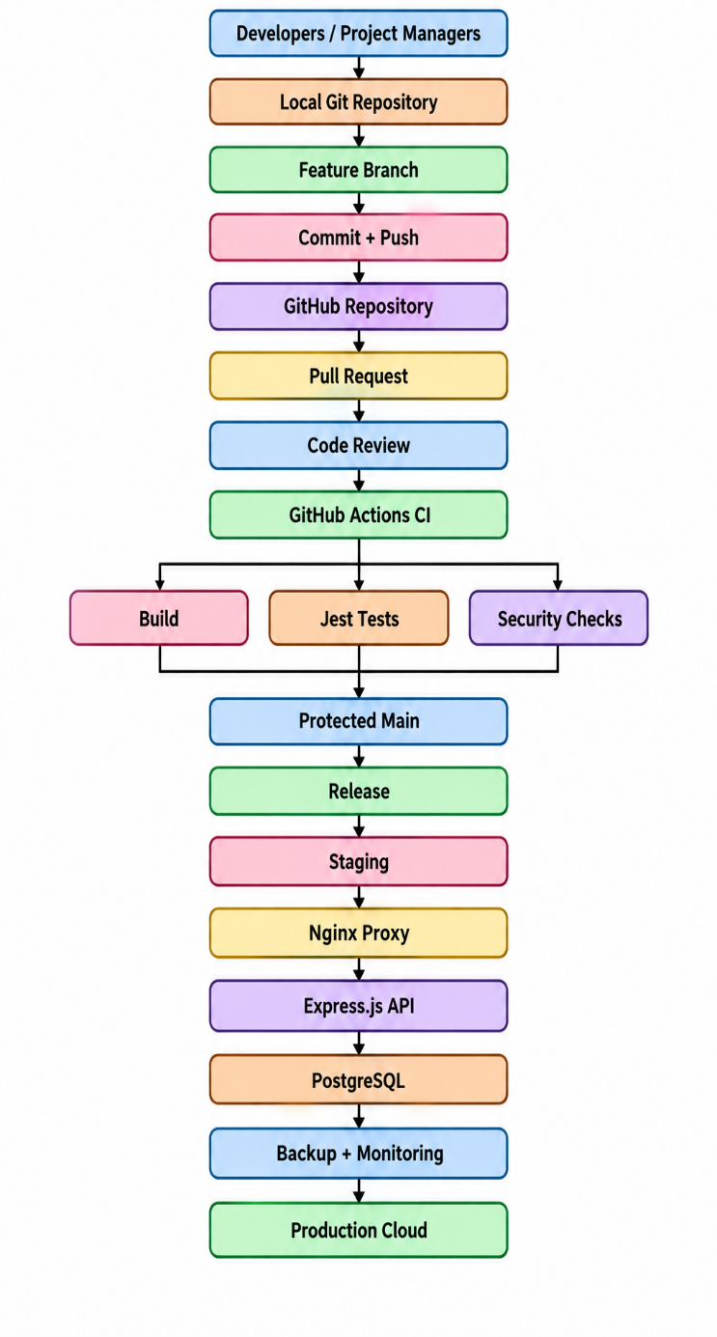

Technology Stack
The proposed stack consists of Git for distributed version control, GitHub for repository hosting and collaboration, GitHub Actions for CI/CD, Node.js and Express.js for application services, PostgreSQL for structured metadata, Nginx for reverse proxy and load balancing, and testing tools for quality assurance.
The cloud infrastructure may use virtual machines or containers. A provider-neutral design is preferred because the case study does not specify a particular cloud provider.

Version Control System
Git is the central technology of the case study. Each developer can clone the repository locally and work on a feature branch. Changes are recorded as commits before being pushed to the remote repository. Git supports branch creation and merging, allowing different development tasks to remain isolated until they are ready for integration.
A proposed branch structure is:
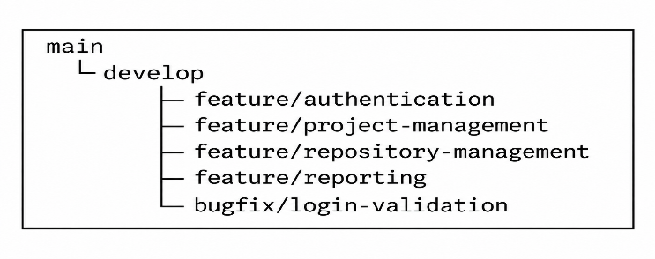
The exact branch model can be adapted to project size. The important requirement is that production code remains protected and changes are introduced through controlled review and validation.

Development and Deployment Workflow

The proposed workflow is:
- Requirement / Issue
- Feature Branch
- Local Development
- Commit
- Push
- Pull Request
- Code Review
- Automated CI Checks
- Testing / Security Validation
- Protected Main Branch
- Release
- Staging
- Production / Cloud Deployment
- Monitoring
- Maintenance
GitHub documentation describes pull requests as a mechanism for proposing, discussing, reviewing and merging changes, while GitHub Actions can automate build, test and deployment processes.
Protected branches should require appropriate reviews and automated status checks before production code is merged. GitHub supports requirements such as required pull-request reviews, status checks and other branch restrictions.
A pull request should therefore contain a meaningful description, linked issue, summary of changes and relevant test information. Reviewers should inspect the changed files, assess functionality and security implications, and either approve the change or request modifications.

DATABASE AND DEPLOYMENT ANALYSIS

Database Design
Git itself does not require PostgreSQL for normal version-control operation. Git maintains its repository data using its own distributed repository model. PostgreSQL in this case study is instead proposed for the collaboration application's metadata, such as users, projects, repositories, issues, pull requests, reviews, builds, releases and deployments.
The proposed entities are:
Entity | Important Attributes
User | User_ID, Name, Email, Password_Hash, Role
Project | Project_ID, Name, Description, Owner_ID
Repository | Repository_ID, Project_ID, Name, Remote_URL
Branch | Branch_ID, Repository_ID, Branch_Name, Protection_Status
Commit | Commit_ID, Repository_ID, Branch_ID, Author_ID, Commit_Hash, Message
Issue | Issue_ID, Project_ID, Created_By, Title, Status, Priority
Pull Request | PR_ID, Repository_ID, Source_Branch, Target_Branch, Author_ID, Status
Review | Review_ID, PR_ID, Reviewer_ID, Decision, Comment
Build | Build_ID, PR_ID, Status, Started_At, Completed_At
Release | Release_ID, Repository_ID, Version, Commit_Hash
Deployment | Deployment_ID, Release_ID, Environment, Status, Deployed_At
Relationships should be implemented through primary and foreign keys. For example, one project may contain multiple repositories, one repository may contain multiple branches and commits, and one pull request may contain multiple reviews and builds.

CRUD Operations
The proposed application should support standard CRUD operations.:

Create

Create operations can add users, projects, repositories, issues, pull requests and deployment records.

Read

Read operations can retrieve repository metadata, project information, issue status, pull-request history, review results and deployment records.

Update

Update operations can modify project descriptions, issue status, review status, deployment status and other permitted metadata.

Delete

Delete operations should be controlled carefully because repository and audit information may be legally or operationally important. Soft deletion may be preferable for selected metadata where auditability is required.
All CRUD operations should pass through authorization checks. A normal developer should not be allowed to modify administrative records simply by changing an API parameter.

Database Architecture
The database should not be directly exposed to the public Internet.
Fig. 2. Proposed Database and Deployment Architecture
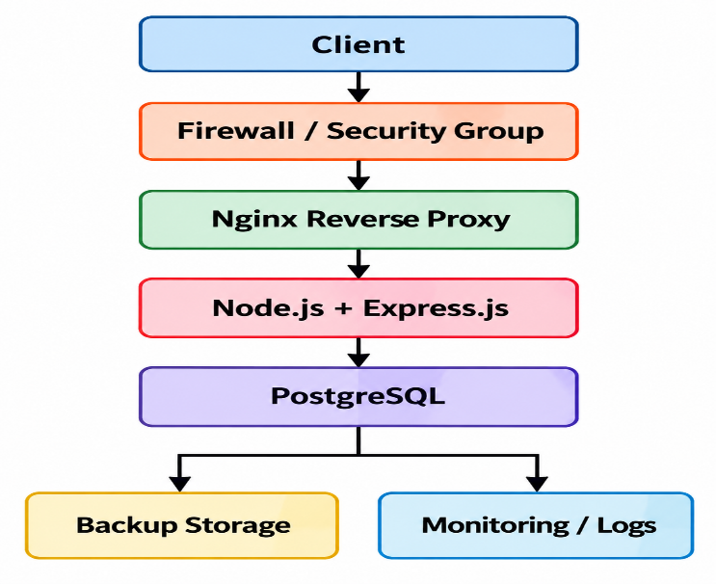

The application server should communicate with PostgreSQL through a restricted network path. Database credentials should be stored outside source code, and database permissions should follow least-privilege principles.

Deployment Strategy
A staged deployment strategy is recommended:

Development Environment

Developers create and validate changes locally.

Testing Environment

Automated and manual tests are executed against a controlled environment.

Staging Environment

The release candidate is deployed using a configuration that closely represents production.

Production Environment

Only approved and validated releases are deployed.

This separation reduces the possibility that an unfinished development change will directly affect production.

Cloud Deployment
Cloud infrastructure can provide virtualized compute, networking, storage, backup, monitoring and scalable application infrastructure. The proposed system may use virtual machines, containers or a combination of both.
A provider-neutral cloud deployment can contain:
- Application virtual machine or container.
- PostgreSQL server or managed PostgreSQL service.
- Nginx reverse proxy.
- Firewall/security groups.
- Backup storage.
- Monitoring and logging.
- CI/CD runner infrastructure.
- Optional load balancer.
- Separate staging and production environments.
Horizontal scaling can be introduced by running multiple application instances behind a load balancer. Database scaling should be planned separately because adding application servers does not automatically solve database bottlenecks.

Reverse Proxy and Load Balancing
Nginx can operate as a reverse proxy between clients and application servers. In a single-server deployment, it can terminate HTTPS traffic and forward requests to the Express.js application.
For higher workloads, multiple application servers can be placed behind the reverse proxy or load-balancing layer:
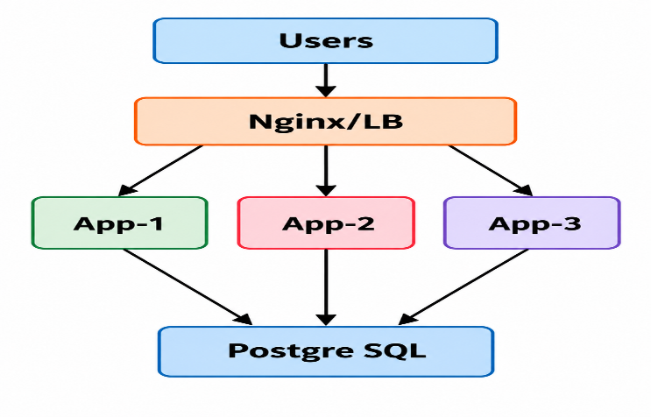
Nginx officially provides reverse-proxy and load-balancing functionality.

SOFTWARE QUALITY AND TESTING

Testing Strategy
Testing should be integrated into the Git workflow rather than treated as an activity performed only immediately before deployment. The proposed strategy includes unit testing, integration testing, API testing, web testing, load testing and security testing.
The expected sequence is::
- Code Change
- Unit Tests
- Build
- API Tests
- Web Tests
- Security Checks
- Pull Request Review
- Staging Validation
- Production Release
GitHub Actions can be configured to trigger workflows when pull requests are opened or updated, allowing build and test processes to be automated.

Unit Testing
Jest is proposed for unit testing Node.js and Express.js application logic. Unit tests should verify individual functions and modules independently.
Testing should cover:
- Authentication logic.
- Authorization functions.
- Input validation.
- Business rules.
- Repository-service functions.
- Database-service functions.
- Error handling.
- Utility functions.
Jest provides a JavaScript testing framework and supports automated test execution through standard project scripts.

API Testing
Postman can be used to validate REST API endpoints.
The proposed API test set should include::
- GET requests.
- POST requests.
- PUT/PATCH requests.
- DELETE requests.
- Authentication.
- Authorization.
- Invalid input.
- Missing parameters.
- Unauthorized requests.
- Error responses.
- HTTP status codes.
- Boundary conditions.
API testing should confirm that the application does not only return technically valid responses but also enforces business and security rules.

Web Testing
Selenium should be used for browser-level validation of the web application.
Important scenarios include::
- Login.
- Logout.
- Navigation.
- Project creation.
- Repository creation.
- Issue creation.
- Pull-request-related views.
- Form validation.
- Search.
- Update.
- Delete.
- Error handling.
- Role-based UI behavior.
Selenium WebDriver provides browser automation across major browsers and is designed for automated web application testing.

Load Testing
Apache JMeter can be used to evaluate application behavior under controlled workloads. JMeter supports load and performance testing of web applications and other services.
The proposed tests should measure:
- Response time.
- Throughput.
- Concurrent users.
- Error rate.
- CPU utilization.
- Memory utilization.
- Database query performance.
- Behavior under increasing load.
- Recovery after workload reduction.
No numerical response-time or concurrent-user result is claimed in this case study because the proposed system has not been experimentally deployed and measured.

Security Testing
The faculty template specifies OWASP ZAP. For current terminology, the proposed security-testing tool is ZAP.
Security testing should examine:
- Authentication.
- Session management.
- Authorization.
- Input validation.
- Injection.
- Cross-site scripting.
- Security headers.
- Configuration weaknesses.
- Exposed endpoints.
- Error messages.
- Access-control failures.
The current OWASP Top 10:2025 identifies Broken Access Control, Security Misconfiguration, Software Supply Chain Failures, Cryptographic Failures, Injection and Authentication Failures among the major web-application security risks.
ZAP provides web-application scanning functionality and supports passive and active scanning.

Testing Outcomes and Observations
Because this is a representative proposed case study, actual numerical testing outcomes are not claimed.
The proposed environment should be considered technically validated only when:
- Required functionality passes functional testing.
- Unit tests meet the project's defined pass criteria.
- API endpoints return expected results.
- Browser workflows complete successfully.
- Security testing identifies no unresolved critical vulnerabilities.
- Load testing confirms that the selected infrastructure satisfies defined requirements.
- Database backup and restoration are verified.
- Deployment and rollback procedures are tested.
- Protected-branch rules operate correctly.
- CI checks execute successfully before approved merges.
Actual response-time, throughput, vulnerability counts or availability values should be recorded only after tests are executed using a documented test environment.

OPEN SOURCE COMMUNITY AND LICENSING ANALYSIS

Open-Source Licensing Model
The proposed environment contains components with different open-source licenses. Consequently, license compliance should be handled through an organized software inventory rather than assuming that every component uses the same license.
Git uses GPLv2, Node.js and Express.js use MIT, PostgreSQL uses the PostgreSQL License, Nginx uses a 2-clause BSD license, Selenium uses Apache 2.0, and ZAP uses Apache 2.0.

Compliance with License Terms
The organization should maintain an Open Source Software inventory containing:
- Component name.
- Version.
- License.
- Source repository.
- Copyright information.
- License notice requirements.
- Modification status.
- Distribution status.
- Dependency relationships.
- Compliance review status.
Before adding a dependency, developers should review its license and security status. Dependency review can also help identify insecure dependencies and licensing information.

Community Support
Open-source communities provide documentation, issue tracking, development discussions, examples and contribution mechanisms. These resources can reduce the difficulty of learning and maintaining technology components.
However, an organization should not assume that community support replaces professional operational responsibility. Critical production systems still require internal ownership, monitoring, security procedures, backup and recovery planning.

Documentation Quality
Documentation should be maintained for:
- Repository structure.
- Branching strategy.
- Commit conventions.
- Pull-request process.
- Installation.
- Environment configuration.
- Database configuration.
- Deployment.
- Testing.
- Security.
- Backup.
- Recovery.
- Troubleshooting.
- Release procedures.

Version Management
Version management should use Git commits, branches and tags. Releases should be associated with identifiable commits.

A proposed repository structure is:
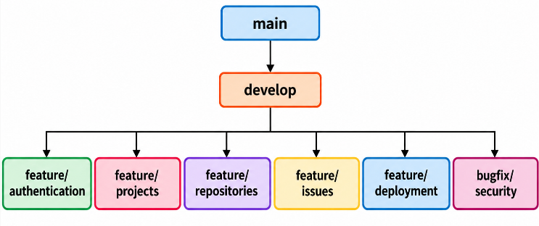
A release should be generated only after the corresponding pull request has passed required checks and reviews.

Contribution Opportunities
Team members can contribute to the broader open-source ecosystem by:
- Reporting bugs.
- Improving documentation.
- Creating reproducible issue reports.
- Reviewing open-source projects.
- Submitting patches where appropriate.
- Improving translations.
- Participating in technical discussions.
- Contributing test cases.
- Sharing improvements through appropriate contribution channels.
The Selenium project, for example, explicitly maintains community-oriented contribution mechanisms and documentation.

TECHNICAL ANALYSIS

Working of the Proposed Solution
The proposed workflow begins when a requirement or defect is recorded as an issue. A developer creates a feature or bug-fix branch from the appropriate development point. The developer then clones or updates the local repository, implements the change and creates one or more meaningful commits.
After local validation, the branch is pushed to the remote GitHub repository. A pull request is created against the protected target branch. Reviewers inspect the changed files and associated commits and provide comments or approval.
Automated CI checks then build the application and execute unit tests and other defined validation activities. Security and dependency checks may also be included in the pipeline. Only after the required reviews and status checks pass should the change be merged.
The resulting main-branch version can then be packaged as a release candidate and deployed to staging. After staging validation, the approved release can be deployed to production. Monitoring and logging continue after deployment so that operational problems can be identified.
GitHub Actions supports workflows that can build and test pull requests and deploy changes following repository events.

Advantages

The proposed architecture provides several technical advantages:

Traceability: Each change can be connected to a commit, branch and pull request.

Parallel development: Feature branches isolate development tasks.

Code review: Pull requests provide a structured review mechanism.

Automated validation: CI workflows can automatically execute tests.

Controlled production code: Protected branches reduce direct uncontrolled modifications.

Reproducible releases: Releases can be associated with specific commits.

Flexibility: The organization can combine Git with open-source application, database, server and testing technologies.

Scalability: Application instances can be increased behind a reverse proxy or load balancer.

Maintainability: Source history and documented workflows make future changes easier to trace.

Limitations

The proposed approach also has limitations:
- Developers require knowledge of Git commands and branching.
- Poor branch management can create merge conflicts.
- Long-running branches can increase integration complexity.
- CI pipelines require maintenance.
- Open-source components require regular security updates.
- License compliance must be managed.
- GitHub introduces dependence on a hosted collaboration platform even though Git itself is distributed.
- Cloud deployment creates infrastructure and operational responsibilities.
- Automated testing cannot guarantee the absence of every defect.
- Security tools may generate false positives or fail to detect certain vulnerabilities.

Scalability

The Application scalability can be improved by deploying multiple Express.js instances behind Nginx or another load-balancing layer. Stateless application design can simplify horizontal scaling.

Database scalability requires independent analysis because PostgreSQL may become a bottleneck even when application servers scale horizontally. Appropriate indexing, query optimization, connection management, caching and, where justified, replication can be considered.

CI scalability can be achieved through appropriate runner capacity and parallel jobs. GitHub Actions workflows can execute independent jobs concurrently where the workflow design permits it.

Reliability

Reliability can be improved through:
- Automated backups.
- Tested restoration.
- Redundant application instances.
- Health checks.
- Monitoring.
- Controlled releases.
- Rollback procedures.
- Database recovery planning.
- Separate staging and production environments.
Backup procedures should be tested rather than merely configured. A backup that has never been restored cannot be assumed to provide reliable recovery.

Maintainability

Maintainability depends on consistent coding practices, documentation, source-code organization, automated tests, dependency management and version control.

The proposed Git workflow supports maintainability by preserving the history of modifications and providing a structured mechanism for introducing future changes. A new developer can inspect repository history, issues, pull requests and documentation to understand the evolution of the system.

Performance Analysis

Performance should be evaluated using measurable indicators rather than assumed values.

Important indicators include:
- API response time.
- Average response time.
- Peak response time.
- Requests per second.
- Error rate.
- Database query time.
- CPU utilization.
- Memory utilization.
- Concurrent-user capacity.
- CI pipeline execution time.
Apache JMeter can be used to create controlled workloads and measure application behavior.
No numerical performance result is claimed in this report because no actual deployment and load-testing experiment has been performed..

SDG MAPPING AND JUSTIFICATION

Relevant SDGs
The official case-study list maps this case study to:
- SDG 9 – Industry, Innovation and Infrastructure
- SDG 17 – Partnerships for the Goals.

SDG 9 Mapping
SDG 9 focuses on building resilient infrastructure, promoting inclusive and sustainable industrialization, and fostering innovation.
The proposed Git-based development environment contributes to this objective through digital software infrastructure. Git repositories, automated CI workflows, cloud application infrastructure, databases, testing environments and deployment systems form part of the digital infrastructure required for modern software engineering.
The architecture also supports technological innovation because developers can experiment through isolated feature branches without directly modifying the protected production code. Automated testing and continuous integration create a repeatable engineering infrastructure for software development.
The cloud component further supports scalable digital infrastructure by allowing application resources, storage and monitoring capacity to be increased as requirements change..

SDG 17 Mapping
SDG 17 focuses on strengthening the means of implementation and revitalizing global partnership for sustainable development.
The proposed workflow supports collaboration through remote Git repositories, pull requests, code reviews, issue discussions and shared documentation. Developers can collaborate asynchronously while maintaining a common source-code history.
Pull requests are particularly relevant because they provide a structured mechanism for discussion and peer review before code is merged.
Open-source communities extend this collaboration beyond the organization's internal team by providing opportunities for developers to report issues, contribute improvements, share documentation and learn from other technical communities..

SDG Mapping Table
SDG | Connection With Case Study | Technical Contribution
SDG 9 | Digital infrastructure and software innovation | Git repositories, CI/CD, cloud infrastructure, databases, testing and scalable deployment
SDG 17 | Collaborative software development | GitHub repositories, pull requests, reviews, issues, documentation and open-source community participation

The mapping is therefore directly connected to the engineering design rather than being a generic association with technology.

CHALLENGES AND RECOMMENDATIONS

Technical Challenges

Merge Conflicts

Multiple developers may modify related files simultaneously. Conflicts can occur when Git cannot automatically combine the changes.

Recommendation: Developers should frequently synchronize their branches, keep feature branches reasonably focused, communicate about shared files and resolve conflicts before submitting final changes.

Inconsistent Git Practices

Different developers may use different branch names, commit styles or merge procedures.

Recommendation: Define a documented branching policy, commit-message convention and pull-request procedure.

CI Pipeline Complexity
Automated workflows can become difficult to maintain as the project grows.

Recommendation: Divide workflows into understandable jobs, maintain configuration in version control, monitor failed jobs and avoid unnecessary pipeline duplication.

Dependency Management
Node.js applications may depend on numerous external packages.

Recommendation: Maintain lock files, review dependencies before introduction, monitor vulnerabilities and use automated dependency-management mechanisms. GitHub provides dependency-review and Dependabot capabilities for identifying and addressing vulnerable dependencies.

Security Challenges

Credential Exposure

Developers may accidentally commit passwords, API keys or database credentials.

Recommendation: Never store secrets directly in source code. Use environment-specific secret stores or GitHub secrets. GitHub's secret-security documentation identifies API keys, tokens and passwords as sensitive information that should not be hardcoded into repositories..

Unauthorized Repository Access

An incorrectly configured repository can expose source code or allow unauthorized modification.

Recommendation: Apply role-based access, least privilege, protected branches and periodic access reviews..

Vulnerable Dependencies
A project may depend on vulnerable third-party packages.

Recommendation: Use dependency review, Dependabot or equivalent dependency-security mechanisms, and review security updates before merging them.

Application Vulnerabilities
Web applications may be affected by broken access control, injection, security misconfiguration, authentication failures and other vulnerabilities.

Recommendation: Apply secure coding practices, server-side authorization, input validation, secure configuration, security testing and continuous vulnerability management. OWASP Top 10:2025 provides a current reference for major web-application security risks.

Deployment Challenges
Deployment problems may occur because of incorrect configuration, incompatible dependencies, insufficient resources or network failures.
Recommendation: Use development, testing, staging and production environments; automate deployments where appropriate; maintain rollback procedures; monitor deployment health; and retain reliable backups.

Future Improvements

Future improvements may include:
- Containerized deployment using Docker.
- Infrastructure as Code.
- Automated database migration management.
- Advanced centralized monitoring.
- Automated vulnerability scanning.
- Automated secret detection and push protection.
- Multi-instance application deployment.
- Database replication where justified.
- Disaster-recovery automation.
- More advanced CI/CD pipelines.
- Automated release management.
- Improved developer analytics and engineering metrics.

Recommendations for Better Implementation

A practical implementation should follow these recommendations:
- Define repository and project ownership.
- Establish the Git branching strategy before development begins.
- Protect the main production branch.
- Require pull-request review.
- Require automated status checks before merging.
- Use meaningful commit messages.
- Link pull requests to issues.
- Never commit passwords, API keys or database credentials.
- Maintain dependency and license inventories.
- Automate unit and integration testing.
- Perform API and browser testing.
- Perform load testing in a controlled environment.
- Conduct security testing before production release.
- Use staging before production deployment.
- Maintain backups and test restoration.
- Monitor production systems continuously.
- Document deployment and recovery procedures.
- Periodically review repository permissions.
- Keep dependencies and infrastructure components updated.
- Perform periodic review of the overall Git workflow.

CONCLUSION

Summary
This case study presented a proposed Git-based collaborative software development workflow for a representative software development company. The primary objective was to establish a controlled development process in which source-code changes can be isolated, reviewed, tested and integrated without directly compromising the production codebase.

Git was selected as the central open-source distributed version-control system. GitHub was positioned as the hosted repository and collaboration platform rather than incorrectly treating GitHub itself as the open-source VCS. The proposed workflow uses feature branches, commits, pull requests, code review, automated CI checks, protected branches, releases and controlled deployment.

Key Technical Findings
The analysis demonstrates that effective version control depends not only on Git commands but also on organizational workflow. A technically useful Git environment requires defined branching practices, review policies, automated testing, protected production branches and traceability.

The proposed Node.js, Express.js, PostgreSQL and Nginx stack provides a suitable representative application environment, while Jest, Postman, Selenium, JMeter and ZAP provide complementary testing capabilities. The database design separates Git's own repository mechanism from the proposed application's PostgreSQL metadata database.

Cloud infrastructure can provide scalable application hosting, storage, networking, backup and monitoring. Nginx can act as a reverse proxy and load-balancing layer when multiple application instances are required.

Learning Outcomes
The case study provides understanding of distributed version control, Git repositories, branching, commits, merge conflicts, pull requests, code review, repository protection and automated CI/CD workflows. It also develops understanding of relational database design, CRUD operations, cloud deployment, reverse proxy architecture, load balancing, software testing, security, dependency management and open-source licensing.

The study also demonstrates that security must be considered throughout the development lifecycle rather than being added only after application development. Repository security, application security, database security and deployment security must be treated as connected engineering responsibilities.

Industrial Relevance of Open Source Technologies
Open-source technologies are highly relevant to modern software engineering because they provide a broad ecosystem for development, testing, deployment, infrastructure and collaboration. Git provides the foundational version-control capability, while complementary technologies can be selected according to project requirements.

The proposed workflow is therefore not simply a source-code management mechanism. It represents an integrated engineering process connecting requirements, development, collaboration, testing, security, release management, deployment and maintenance.

The case study directly supports SDG 9 through digital infrastructure, technological innovation and scalable software engineering infrastructure, and SDG 17 through collaborative development, knowledge sharing, remote repositories, code reviews and open-source participation.

Overall, the proposed Git-based workflow provides a structured foundation for collaborative software development when supported by appropriate governance, security controls, testing, cloud infrastructure, documentation, licensing compliance and continuous maintenance.

REFERENCES
[1] D. Spinellis, “Git,” IEEE Software, vol. 29, no. 3, pp. 100–101, 2012, doi: 10.1109/MS.2012.61.
[2] J. C. Cortés Ríos, S. M. Embury, and S. Eraslan, “A unifying framework for the systematic analysis of Git workflows,” Information and Software Technology, vol. 145, Art. no. 106811, May 2022, doi: 10.1016/j.infsof.2021.106811.
[3] E. T. Barr, C. Bird, P. C. Rigby, A. Hindle, D. M. German, and P. Devanbu, “Cohesive and Isolated Development with Branches,” in Fundamental Approaches to Software Engineering, Springer, 2012, pp. 316–331.
[4] Y. Yu, H. Wang, G. Yin, and T. Wang, “Reviewer recommendation for pull-requests in GitHub: What can we learn from code review and bug assignment?” Information and Software Technology, vol. 74, pp. 204–218, 2016, doi: 10.1016/j.infsof.2016.01.004.
[5] Git Project, “Git Documentation,” Git SCM, accessed Sep. 20, 2026.
[6] GitHub, “Pull Requests Documentation,” GitHub Docs, accessed Sep. 20, 2026.
[7] GitHub, “Understanding GitHub Actions,” GitHub Docs, accessed Sep. 20, 2026.
[8] PostgreSQL Global Development Group, “PostgreSQL Documentation and License,” PostgreSQL, accessed Sep. 20, 2026.
[9] Node.js, “About Node.js,” Node.js, accessed Sep. 20, 2026.
[10] Express.js, “Express.js Documentation and Project Repository,” accessed Sep. 20, 2026.
[11] NGINX, “nginx: HTTP Server, Reverse Proxy and Load Balancer,” NGINX, accessed Sep. 20, 2026.
[12] Jest Project, “Jest Documentation,” accessed Sep. 20, 2026.
[13] Selenium Project, “Selenium Documentation,” accessed Sep. 20, 2026.
[14] Apache Software Foundation, “Apache JMeter,” Apache JMeter Documentation, accessed Sep. 20, 2026.
[15] ZAP by Checkmarx, “ZAP Documentation,” accessed Sep. 20, 2026.
[16] OWASP Foundation, “OWASP Top 10: 2025,” accessed Sep. 20, 2026.
[17] GitHub, “Secret Scanning,” GitHub Docs, accessed Sep. 20, 2026.
[18] GitHub, “Dependency Review and Dependabot,” GitHub Docs, accessed Sep. 20, 2026.
[19] United Nations, “The 17 Sustainable Development Goals,” United Nations Sustainable Development, accessed Sep. 20, 2026.

Appendix

Security Challenges
Fig. A1. Proposed Git-Based Collaborative Software Development Architecture:
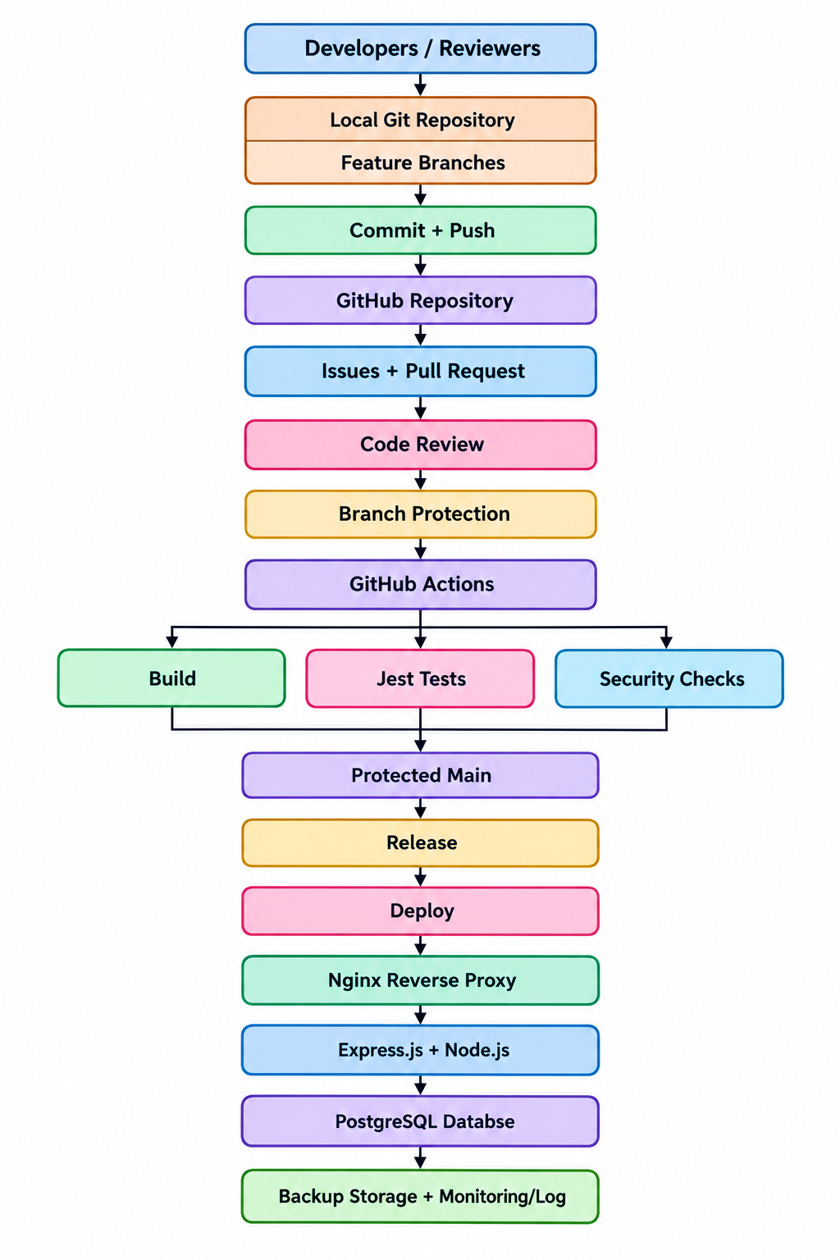

GIT Workflow Diagram
Fig. A2. Proposed Git Branch and Pull Request Workflow:
