HR ANALYTICS PROJECT REPORT
Adviti Pvt. Ltd.

Employee Attrition | Employee Engagement | Training Effectiveness
Dataset: 423 Employees | Tool: MySQL | 25 SQL Queries across 3 Phases

1. Executive Summary
Problem
Adviti Pvt. Ltd. is experiencing very high employee attrition (~48%), which increases hiring costs, disrupts teams, and impacts productivity. This analysis was conducted using SQL on the company's HR dataset of 423 employees to identify where attrition is concentrated, why it is happening, and what actions can reduce it.

Key Findings
- Attrition is concentrated in the first 1-2 years of employment (70% attrition in this group). Once employees cross 3 years, retention improves significantly.
- Low engagement is the strongest indicator of attrition — every low-engagement employee (score 1-2) in the dataset has exited.
- Dissatisfaction is highest around management support, compensation fairness, and work-life balance.
- Training exposure is a major retention lever — employees with 20+ training hours show near-zero attrition.
- Career growth matters — promoted employees leave at half the rate (30%) of non-promoted employees (60%).
- Salary alone does not explain attrition — growth, learning, and work environment have a stronger impact than pay by itself.

What This Means
Attrition at Adviti is not random. It is driven by early employee experience, lack of growth clarity, insufficient training, and engagement gaps. Retention improves when employees feel supported, developed, and see a future at the company.

Recommended Actions
- Focus retention efforts on employees in their first two years.
- Ensure minimum structured training for all employees, especially early tenure.
- Make career paths and promotion criteria transparent.
- Improve manager effectiveness and feedback culture.
- Treat engagement and satisfaction as leading indicators, not lagging metrics.

Expected Impact
- Reduced early-tenure attrition
- Higher engagement and productivity
- Lower rehiring and onboarding costs
- Stronger long-term workforce stability

2. Business Context & Objectives

2.1 Business Context
Employee attrition is a critical challenge for organizations, as it leads to increased hiring and training costs, loss of experienced talent, and reduced team productivity. For a growing, knowledge-driven organization like Adviti Pvt. Ltd., retaining skilled employees is essential to maintain service quality and operational stability.

Adviti has observed a high number of employee exits over recent years, particularly among early-career employees. At the same time, concerns around employee engagement, job satisfaction, and the effectiveness of training programs have emerged. To address these challenges, Adviti initiated an HR analytics project to use data-driven insights to better understand workforce behavior — moving beyond assumptions to identify measurable patterns that explain attrition, engagement levels, and the role of training in retention.

2.2 Objectives of the Analysis
The analysis was conducted with three objectives:
- Understand drivers of employee attrition — Identify which employee groups are most likely to leave and uncover key factors associated with higher attrition, such as tenure, role, engagement, satisfaction, and work conditions.
- Measure employee engagement and job satisfaction — Analyze engagement scores and satisfaction dimensions to understand how employees feel about their work environment and how these factors relate to retention.
- Evaluate training effectiveness — Assess whether training hours and learning opportunities are associated with improved engagement, career progression, and lower attrition.

3. Data Overview & Preparation

3.1 Data Overview
The dataset contains employee-level information for 423 employees covering demographics, job roles, compensation, tenure, performance, training, engagement, benefits, and attrition status. Each row represents a unique employee record, including both current and former employees. The raw table hr_data_updated was imported into the MySQL database project_hr_analytics.

3.2 Data Preparation and Feature Engineering
A cleaned working table adviti_hr_data_final was created from the raw data. The following steps were performed:
- Standardization of categorical fields — Job titles ('Account Exec.', 'AccountExecutive' merged into 'Account Executive'), gender values ('M'/'F' converted to 'Male'/'Female'), and NULL departments filled as 'Management'.
- Creation of analytical buckets — Age, salary, training hours, absenteeism, distance from work, and years of service were grouped into meaningful ranges (e.g., AgeGroup, Salary_Buckets, Training_Hours_Buckets).
- Derivation of tenure metrics — Years_of_Service calculated using TIMESTAMPDIFF(YEAR, HireDate_dt, IFNULL(ExitDate_dt, CURDATE())) so active employees use today's date and leavers use their exit date.
- Composite score creation — JobSatisfaction_rate and EmployeeBenefit_Satisfaction_rate calculated by averaging five binary satisfaction indicators each and converting to a percentage.
- Verification — Row counts, DISTINCT value checks on Gender and Position confirmed the cleaning was successful with all 423 rows intact.

4. Phase 1 — Workforce Overview (Who Works Here?)
The objective of this phase is to understand the overall workforce composition at Adviti before analyzing attrition. This establishes a baseline across demographics, compensation, tenure, work patterns, engagement, and satisfaction. Understanding what is 'normal' in the workforce is essential before identifying deviations related to attrition.

1.1 Gender Distribution

Gender | Employees | Percentage
Male | 220 | 52.01%
Female | 203 | 47.99%
Insight: The workforce shows a nearly balanced gender distribution with a slight male majority. This indicates that attrition patterns observed later are unlikely to be driven purely by gender imbalance and should be examined in relation to other factors such as role, tenure, and engagement.

1.2 Age Distribution

Age Group | Employees | Percentage
31-35 | 176 | 41.61%
26-30 | 127 | 30.02%
36-40 | 94 | 22.22%
21-25 | 26 | 6.15%
Insight: The majority of employees fall within the 26-35 age range, indicating a young and early-to-mid career workforce. This age profile suggests higher career mobility and ambition, which can naturally contribute to higher attrition if growth and development expectations are not met.

1.3 Department Distribution

Department | Employees | Percentage
Finance | 99 | 23.40%
IT | 82 | 19.39%
Marketing | 80 | 18.91%
Sales | 74 | 17.49%
HR | 73 | 17.26%
Operations | 13 | 3.07%
Management | 2 | 0.47%
Insight: Most employees are concentrated in Finance, IT, Marketing, Sales, and HR, indicating a knowledge-intensive organization. Operational and management roles form a very small portion of the workforce, suggesting retention challenges are more likely to arise from professional and specialist roles.

1.4 Position Distribution
Insight: The organization has a wide variety of roles with no single role dominating the workforce. This long-tail role distribution implies that attrition analysis at the individual job title level would be less effective — role grouping (Individual Contributor, Management, Leadership, Interns) provides more meaningful insights, which is used in Phase 2.

1.5 Education Level Distribution

Education Level | Employees | Percentage
Bachelor's | 112 | 26.48%
Diploma | 112 | 26.48%
Master's | 100 | 23.64%
PhD | 99 | 23.40%
Insight: The workforce is academically diverse with a relatively even distribution across diploma, bachelor's, master's, and doctoral qualifications. This diversity suggests varied expectations regarding compensation, growth, and role complexity, which may influence engagement and retention differently across education levels.

1.6 Salary Distribution

Salary Bucket | Employees | Percentage
10L - 20L | 207 | 48.94%
< 10L | 166 | 39.24%
20L - 30L | 40 | 9.46%
> 50L | 5 | 1.18%
30L - 40L | 4 | 0.95%
40L - 50L | 1 | 0.24%
Insight: Most employees fall within the lower to mid salary ranges (88% earn below 20L), with a relatively small proportion earning higher salaries. This suggests a mid-market compensation structure. While salary is important, it may not fully explain attrition on its own and should be analyzed alongside growth and engagement indicators.

1.7 Years of Service Distribution

Service Bucket | Employees | Percentage
1-2 years | 238 | 56.26%
3-5 years | 131 | 30.97%
6-10 years | 53 | 12.53%
10+ years | 1 | 0.24%
Insight: A large proportion of employees (56%) have less than three years of service, indicating a workforce with short tenure. The limited presence of long-tenured employees suggests potential challenges in retaining talent beyond the early stages of employment — a hypothesis Phase 2 tests directly.

1.8 Performance Rating & Promotion Distribution

Performance Rating | Employees | Percentage
1 | 79 | 18.68%
2 | 123 | 29.08%
3 | 108 | 25.53%
4 | 54 | 12.77%
5 | 59 | 13.95%

Promotion | Employees | Percentage
Yes (Promoted) | 260 | 61.47%
No (Not Promoted) | 163 | 38.53%
Insight: Performance ratings are spread across low to mid ranges, with fewer employees receiving top ratings. Nearly 39% of employees have not received a promotion — highlighting the importance of understanding whether limited promotion opportunities are affecting motivation and long-term commitment.

1.9 Training Hours Distribution

Training Bucket | Employees | Percentage
10 - 20 Hours | 156 | 36.88%
< 10 Hours | 126 | 29.79%
40+ Hours | 51 | 12.06%
20 - 30 Hours | 50 | 11.82%
30 - 40 Hours | 40 | 9.46%
Insight: Training exposure varies widely, with a significant proportion (67%) receiving fewer than 20 training hours. Uneven access to training may affect skill development, engagement, and perceived career growth opportunities — Phase 3 tests this relationship directly.

1.10 Engagement Score & Absenteeism

Engagement Score | Employees | Percentage
1 (Very Low) | 120 | 28.37%
2 (Low) | 85 | 20.09%
3 (Medium) | 71 | 16.78%
4 (High) | 80 | 18.91%
5 (Very High) | 67 | 15.84%
Insight: The average engagement level is relatively low, with 48% of employees (205 people) reporting low engagement scores of 1-2. This indicates potential disengagement across the workforce and highlights engagement as a key area of concern before attrition is even measured. Absenteeism levels vary widely across the workforce, with many employees taking moderate to high leave days.

1.11 Overall Attrition Baseline

Attrition | Employees | Percentage
No (Active) | 218 | 51.54%
Yes (Left) | 205 | 48.46%
Insight: Adviti experiences a very high overall attrition rate of 48.46% — nearly one in two employees has left. Industry norm for consulting is 10-15%, meaning Adviti is roughly 3x above the healthy benchmark. This reinforces the need to examine attrition drivers across multiple dimensions.

Phase 1 Summary
Insight: The workforce at Adviti is young, moderately compensated, and shows low average engagement and job satisfaction. Most employees are in their first 1-2 years. These baseline characteristics suggest that retention challenges are likely driven by early-career experience, growth opportunities, and work environment factors rather than demographics alone.

5. Phase 2 — Attrition Distribution (Where Is Attrition High?)
The objective of this phase is to understand who is leaving the organisation and where attrition is most concentrated. Building on the Phase 1 baseline, this section examines attrition patterns across demographic, role-based, engagement, training, and growth dimensions to identify high-risk employee groups.

2.1 Attrition by Age Group
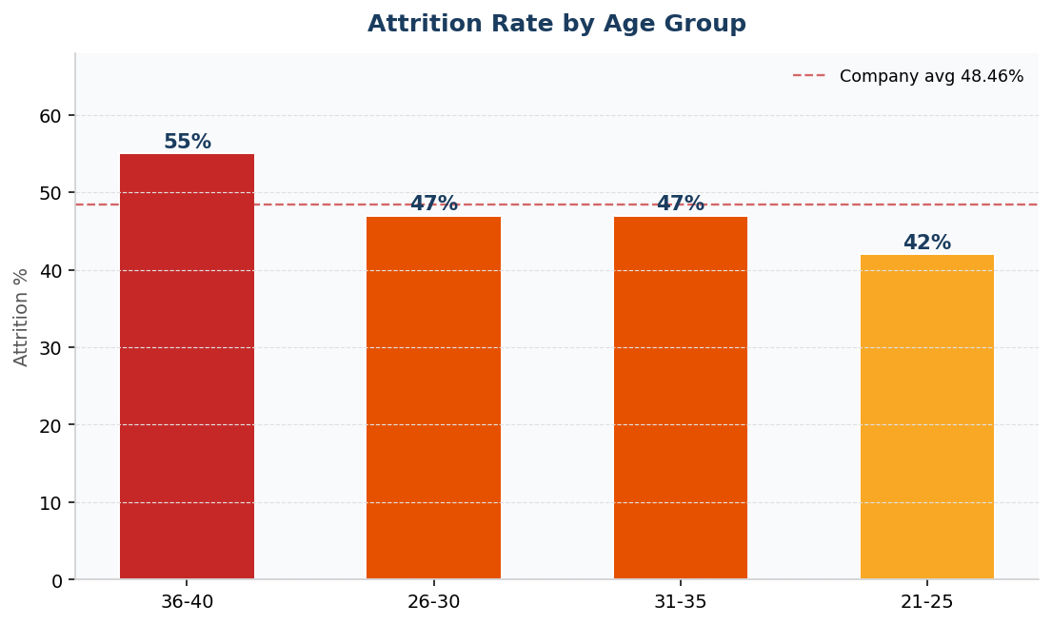
Age Group | Total Employees | Leavers | Attrition %
36-40 | 94 | 52 | 55%
26-30 | 127 | 60 | 47%
31-35 | 176 | 82 | 47%
21-25 | 26 | 11 | 42%
Insight: Attrition is not limited to the youngest employees. While younger groups show high exits, attrition remains elevated across multiple age ranges — suggesting that career stage and expectations play a stronger role than age alone.

2.2 Attrition by Years of Service
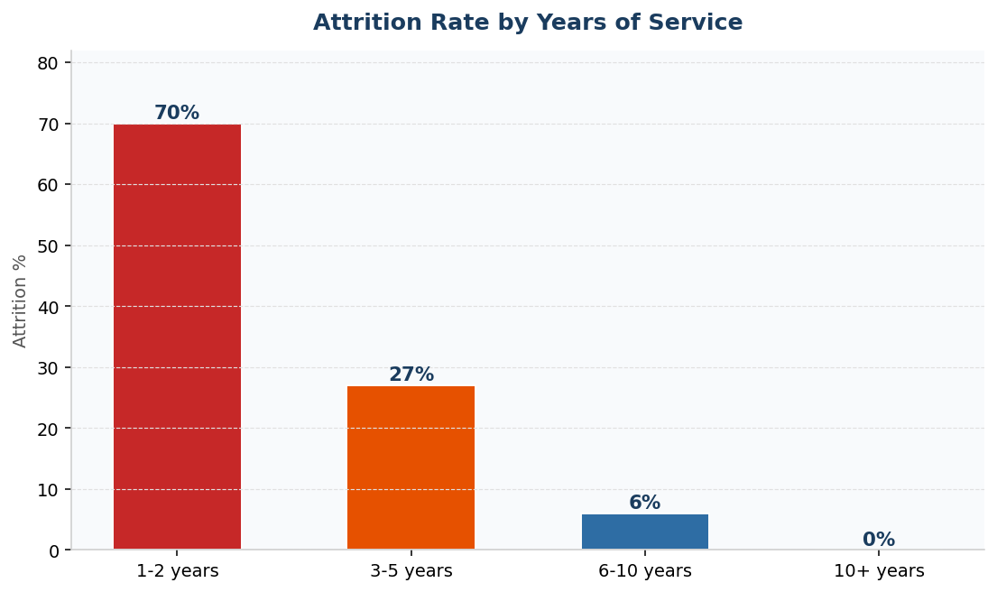
Service Bucket | Total Employees | Leavers | Attrition %
1-2 years | 238 | 166 | 70%
3-5 years | 131 | 36 | 27%
6-10 years | 53 | 3 | 6%
10+ years | 1 | 0 | 0%
Insight: This is the most critical Phase 2 result. Attrition is heavily concentrated among employees with one to two years of service (70%). Once employees cross the three-year mark, attrition drops sharply to 27% and then 6%. This indicates that early tenure is the most critical period for retention and highlights gaps in onboarding, early engagement, and career clarity.

2.3 Attrition by Department
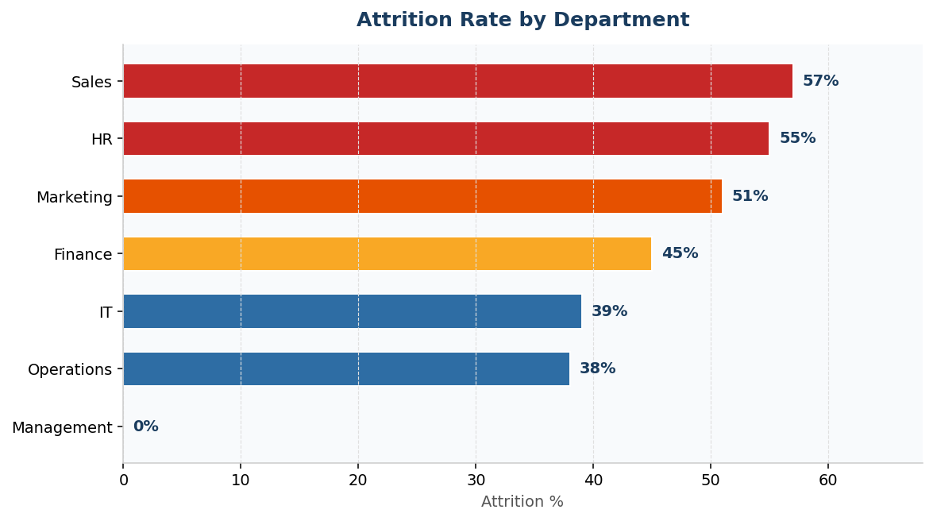
Department | Total Employees | Leavers | Attrition %
Sales | 74 | 42 | 57%
HR | 73 | 40 | 55%
Marketing | 80 | 41 | 51%
Finance | 99 | 45 | 45%
IT | 82 | 32 | 39%
Operations | 13 | 5 | 38%
Management | 2 | 0 | 0%
Insight: Attrition varies significantly across departments. People-facing and target-driven departments — Sales, HR, and Marketing — show higher attrition compared to technical or operational teams. This suggests role-specific pressures and expectations that require tailored retention strategies rather than one generic policy.

2.4 Attrition by Position Group
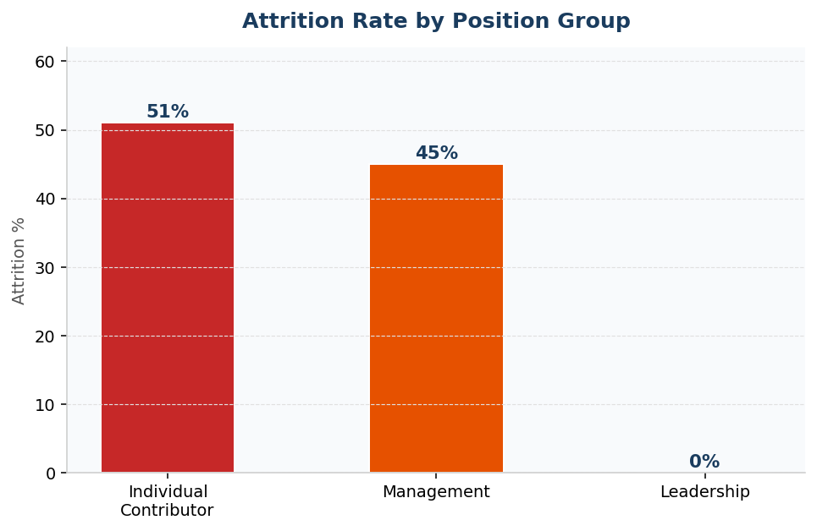
Position Group | Total Employees | Leavers | Attrition %
Individual Contributor | 303 | 155 | 51%
Management | 111 | 50 | 45%
Leadership | 9 | 0 | 0%
Insight: Attrition is highest among Individual Contributors and lowest among Leadership roles. This pattern indicates attrition is primarily a bottom-heavy issue — affecting employees with fewer decision-making powers and limited visibility into long-term growth paths.

2.5 Attrition by Engagement Score
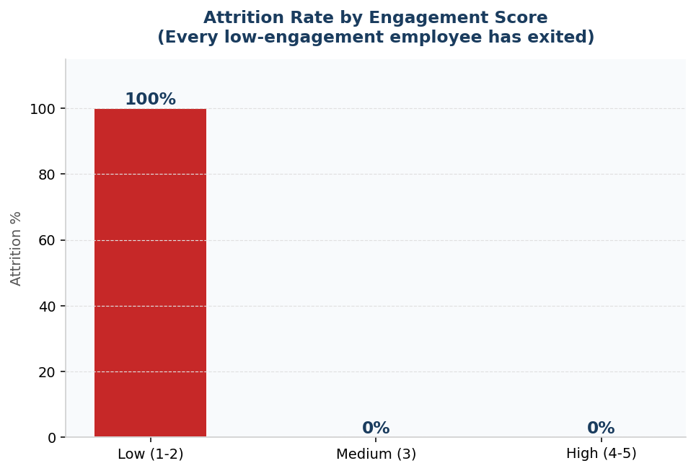
Engagement Bucket | Total Employees | Leavers | Attrition %
Low (1-2) | 205 | 205 | 100%
Medium (3) | 71 | 0 | 0%
High (4-5) | 147 | 0 | 0%
Insight: This is the most dramatic result in the entire analysis. Every employee with low engagement (score 1-2) has exited — a 100% attrition rate — while employees with medium or high engagement rarely exit. Engagement clearly emerges as the single strongest indicator of retention risk and should be monitored proactively as an early warning system.

2.6 Attrition by Job Satisfaction, Promotion, Training & Salary
By Job Satisfaction
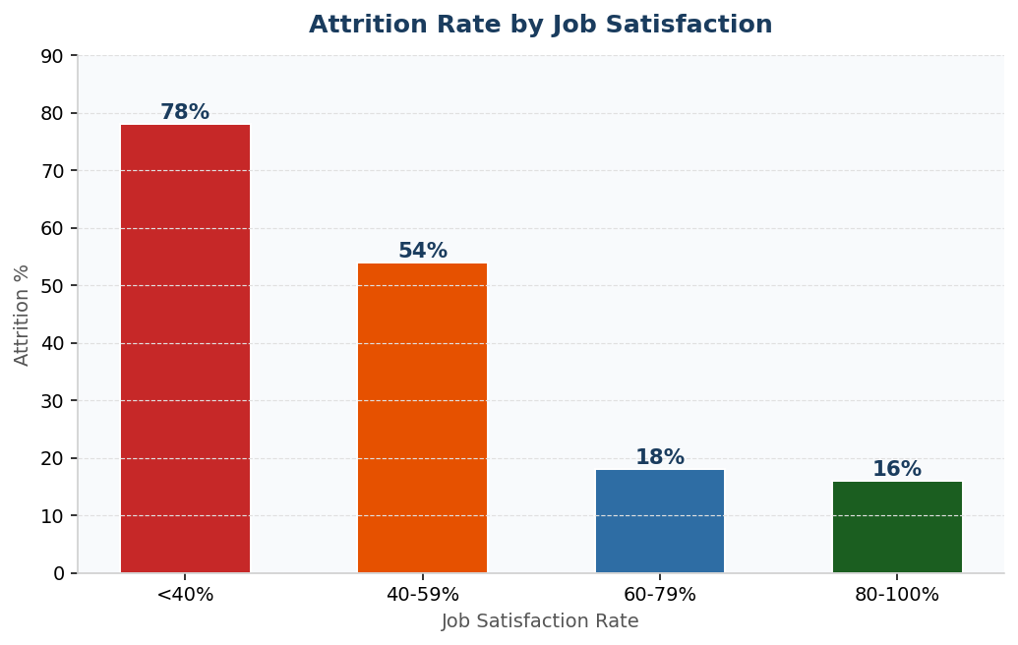
Job Satisfaction Bucket | Total Employees | Leavers | Attrition %
<40% | 152 | 118 | 78%
40-59% | 112 | 61 | 54%
60-79% | 56 | 10 | 18%
80-100% | 103 | 16 | 16%

By Promotion
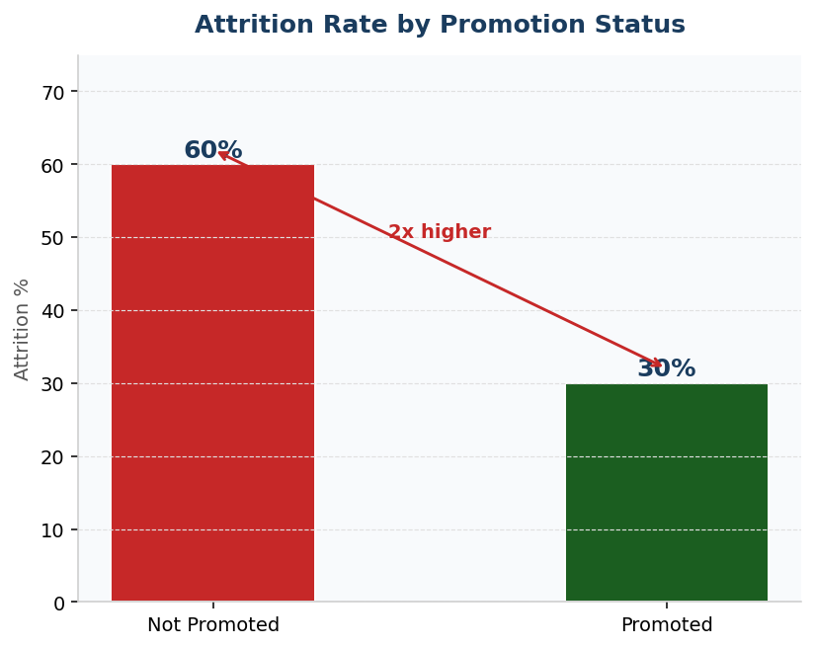
Promotion | Total Employees | Leavers | Attrition %
No | 260 | 156 | 60%
Yes | 163 | 49 | 30%

By Training Hours
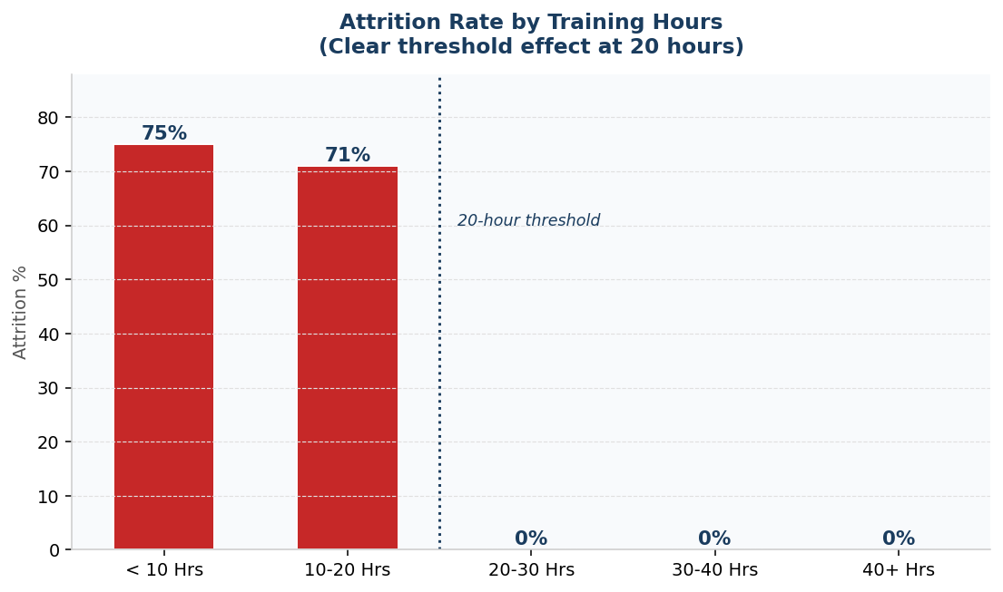
Training Bucket | Total Employees | Leavers | Attrition %
< 10 Hours | 126 | 95 | 75%
10 - 20 Hours | 156 | 110 | 71%
20 - 30 Hours | 50 | 0 | 0%
30 - 40 Hours | 40 | 0 | 0%
40+ Hours | 51 | 0 | 0%

By Salary Bucket
Insight: Attrition decreases steadily as job satisfaction improves — employees with satisfaction below 40% show 78% attrition versus just 16% for the most satisfied group. Non-promoted employees leave at double the rate (60%) of promoted employees (30%). Training shows a dramatic threshold effect: employees with fewer than 20 training hours show 71-75% attrition, while those with 20+ hours show near-zero attrition. Salary bands show smaller differences by comparison — confirming that growth, learning, and engagement are stronger retention levers than pay alone.

Phase 2 Summary
Insight: Attrition at Adviti is not evenly distributed. It is concentrated among early-tenure employees (70%), low-engagement groups (100%), low-satisfaction employees (78%), non-promoted staff (60%), and those with limited training exposure (71-75%). These findings provide clear direction for the deep-dive relationship analysis in Phase 3.

6. Phase 3 — Deep-Dive Analysis (Why Is Attrition Happening?)
The objective of this phase is to move beyond surface-level patterns and understand how multiple factors interact to influence attrition. While Phase 2 identified where attrition is highest, this section explores combined relationships to uncover root causes and actionable levers for retention.

3.1 Years of Service × Department
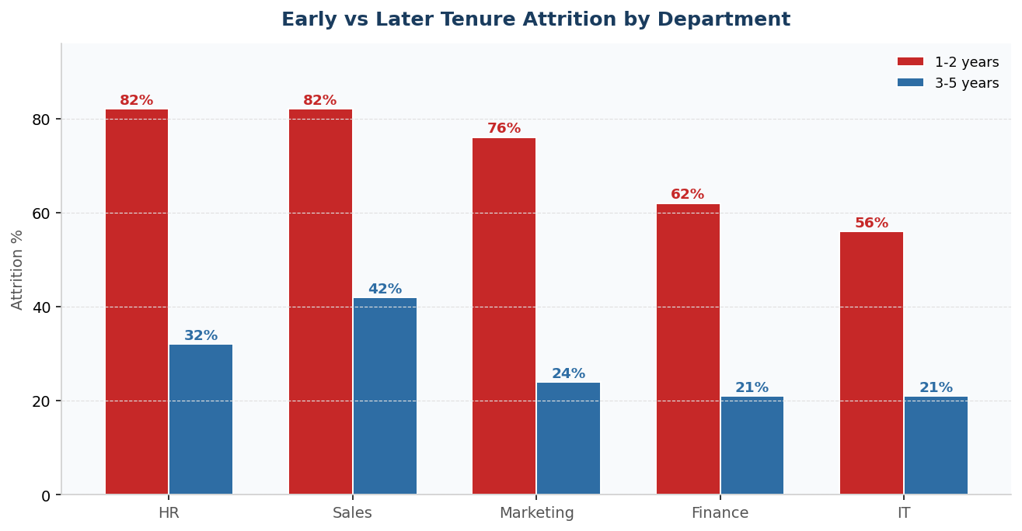
Service | Department | Total | Leavers | Attrition %
1-2 years | HR | 39 | 32 | 82%
1-2 years | Sales | 38 | 31 | 82%
1-2 years | Marketing | 46 | 35 | 76%
1-2 years | Finance | 61 | 38 | 62%
1-2 years | IT | 45 | 25 | 56%
3-5 years | Sales | 26 | 11 | 42%
3-5 years | HR | 25 | 8 | 32%
3-5 years | Marketing | 25 | 6 | 24%
3-5 years | IT | 28 | 6 | 21%
3-5 years | Finance | 24 | 5 | 21%
6-10 years | Finance | 14 | 2 | 14%
Insight: Attrition is highest in the first one to two years across nearly all departments, with particularly severe attrition in HR (82%) and Sales (82%). This indicates that early-tenure challenges are organisation-wide rather than isolated to a single function. Retention efforts must focus on early employee experience across departments — with HR and Sales as the priority starting points.

3.2 Training Hours × Promotion
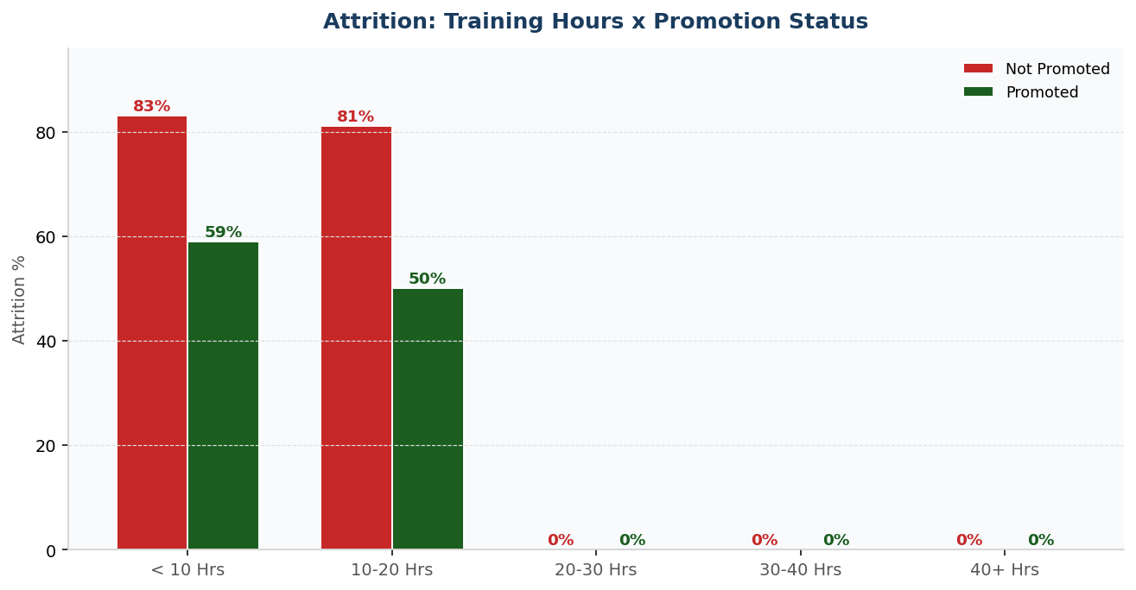
Training Bucket | Promotion | Total | Leavers | Attrition % | Avg Training Hrs
< 10 Hours | No | 87 | 72 | 83% | 7
< 10 Hours | Yes | 39 | 23 | 59% | 7
10 - 20 Hours | No | 104 | 84 | 81% | 13
10 - 20 Hours | Yes | 52 | 26 | 50% | 14
20 - 30 Hours | No | 28 | 0 | 0% | 24
20 - 30 Hours | Yes | 22 | 0 | 0% | 24
30 - 40 Hours | Both | 40 | 0 | 0% | 35
40+ Hours | Both | 51 | 0 | 0% | 45-46
Insight: Employees who receive higher training exposure and promotions show the lowest attrition. In contrast, employees with limited training and no promotion experience the highest exits (83%). Notably, even promoted employees with low training still show 50-59% attrition — training and career progression must work together, not separately.

3.3 Training Hours × Engagement
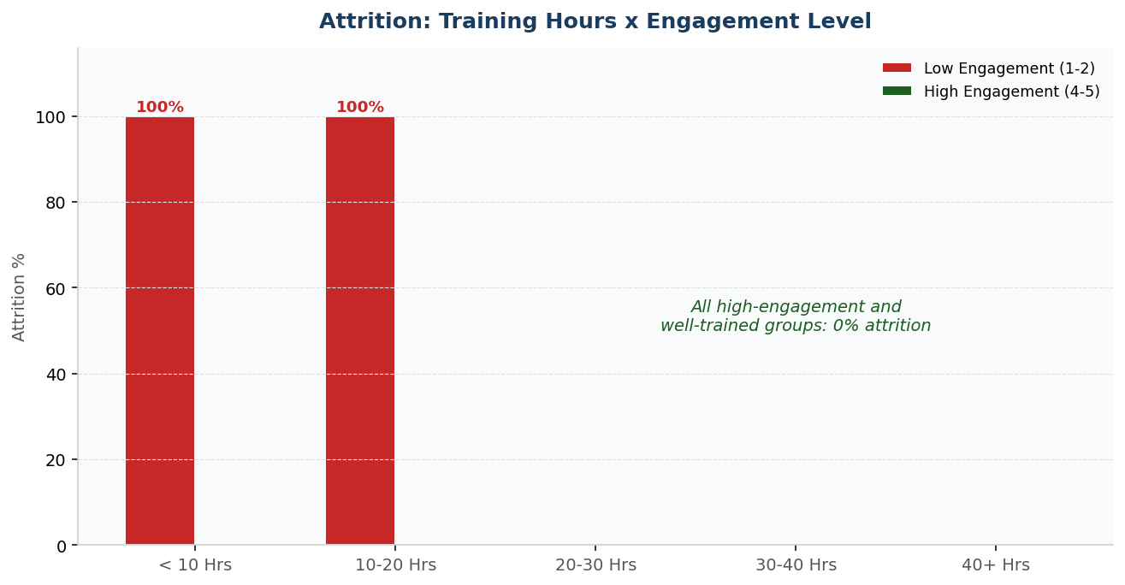
Training Bucket | Engagement | Total | Leavers | Attrition %
< 10 Hours | Low (1-2) | 95 | 95 | 100%
< 10 Hours | High (4-5) | 22 | 0 | 0%
10 - 20 Hours | Low (1-2) | 110 | 110 | 100%
10 - 20 Hours | High (4-5) | 27 | 0 | 0%
20 - 30 Hours | High (4-5) | 34 | 0 | 0%
30 - 40 Hours | High (4-5) | 29 | 0 | 0%
40+ Hours | High (4-5) | 35 | 0 | 0%
Insight: Training and engagement reinforce each other. Employees with low training exposure and low engagement are certain to leave (100%), while those with sufficient training and higher engagement show complete retention. Training appears to play a critical role in sustaining engagement over time — it is an engagement tool, not just a skill tool.

3.4 Satisfaction Dimensions × Attrition
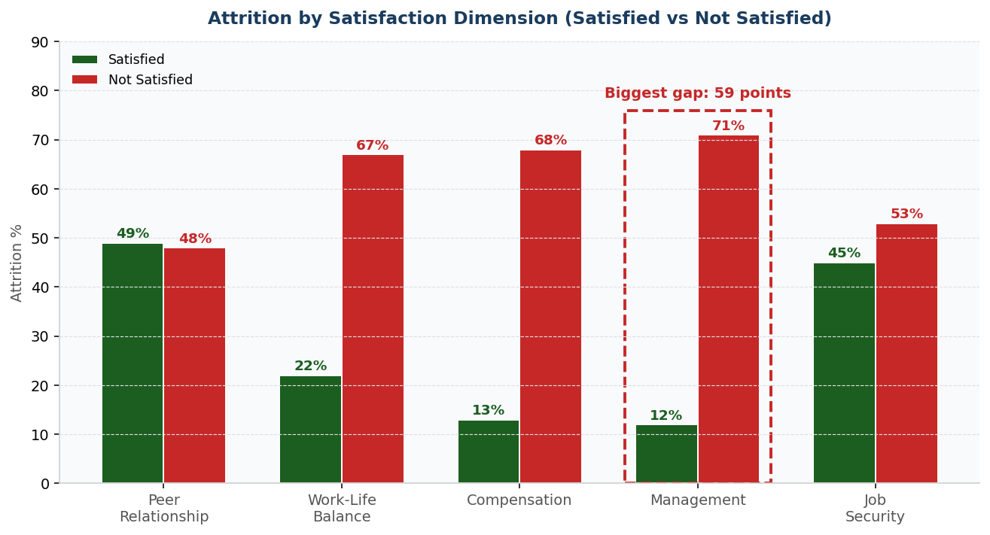
Dimension | Satisfied | Not Satisfied | Attrition % If Satisfied | Attrition % If Not Satisfied
Peer Relationship | 236 | 187 | 49% | 48%
Work-Life Balance | 176 | 247 | 22% | 67%
Compensation | 151 | 272 | 13% | 68%
Management | 160 | 263 | 12% | 71%
Job Security | 255 | 168 | 45% | 53%
Insight: Dissatisfaction with management support (12% vs 71% — a 59-point gap), compensation (55-point gap), and work-life balance (45-point gap) is strongly associated with attrition. In contrast, peer relationships and job security show weak links to exits. This proves that leadership behavior and workload management play a more critical role in retention than social or structural stability — statistically confirming that people leave managers, not companies.

3.5 Absenteeism × Engagement
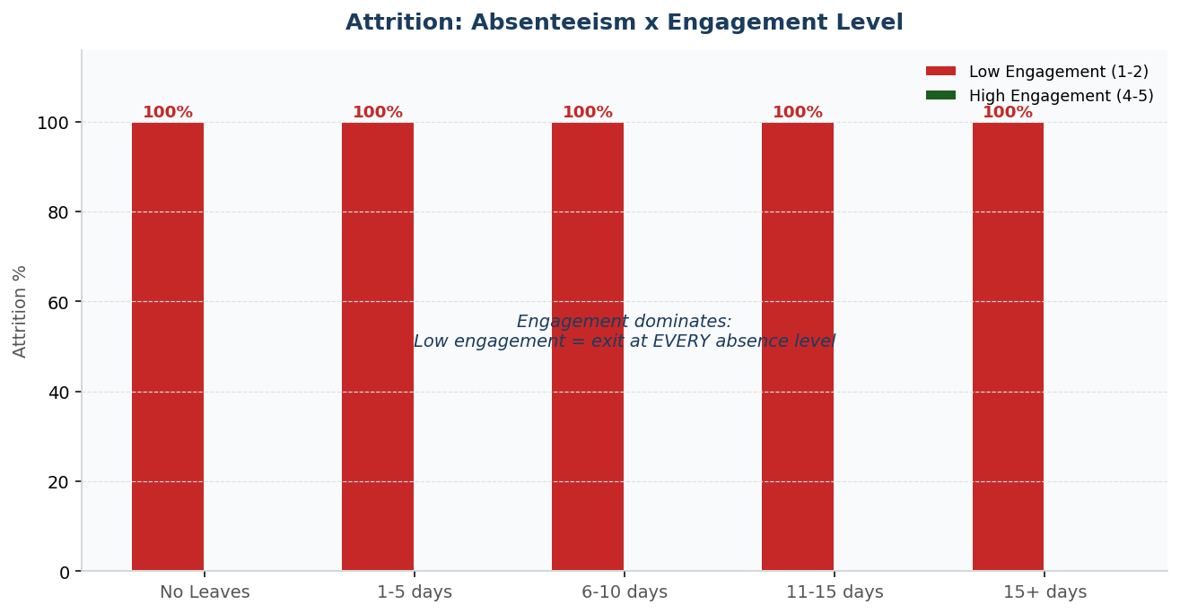
Absenteeism | Engagement | Total | Leavers | Attrition %
1-5 days | Low (1-2) | 51 | 51 | 100%
1-5 days | High (4-5) | 37 | 0 | 0%
6-10 days | Low (1-2) | 47 | 47 | 100%
11-15 days | Low (1-2) | 45 | 45 | 100%
15+ days | Low (1-2) | 51 | 51 | 100%
15+ days | High (4-5) | 39 | 0 | 0%
No Leaves | Low (1-2) | 11 | 11 | 100%
Insight: Engagement dominates the relationship between absenteeism and attrition. Employees with low engagement exit regardless of absenteeism levels (100% at every band), while engaged employees stay even with high absenteeism. This confirms engagement as a far stronger retention indicator than attendance patterns — and validates using engagement score as the primary early warning metric.

Phase 3 Summary
Insight: The deep-dive analysis reveals that attrition at Adviti is driven by a combination of early tenure challenges, limited training exposure, lack of clear growth opportunities, low engagement, and dissatisfaction with management and work-life balance. These factors interact rather than operate independently — effective retention strategies must address multiple dimensions simultaneously.

7. Phase 4 — Key Insights
This section highlights the most important findings from the analysis in plain business language. These insights explain where attrition is high, which employee groups are most affected, and which factors are strongly linked to employees leaving.

Insight 1: Attrition is highest in the first 1-2 years
70% of employees in the 1-2 year tenure band have left. Attrition reduces sharply once employees stay beyond three years (27%) and nearly disappears after six years (6%).
Why this matters: The early period of employment is the most critical time for retention. If employees are not supported well during this phase, they are likely to leave before the company recovers its hiring and training investment.

Insight 2: Low engagement is the single strongest attrition predictor
Every employee with a low engagement score (1-2) has exited — 205 out of 205. Employees with medium or high engagement rarely leave.
Why this matters: Engagement can be used as an early warning signal to identify at-risk employees before they resign. It is measurable, trackable, and actionable.

Insight 3: Management dissatisfaction drives the biggest satisfaction gap
Employees dissatisfied with management show 71% attrition versus only 12% for those satisfied with management — a 59-point gap, the largest of all five satisfaction dimensions. Compensation (68% vs 13%) and work-life balance (67% vs 22%) follow.
Why this matters: Improving specific problem areas — starting with manager quality — is far more effective than trying to improve satisfaction in general.

Insight 4: Training exposure is a powerful retention lever
Employees with fewer than 20 training hours show 71-75% attrition. Employees with 20 or more training hours show near-zero attrition. The threshold effect is dramatic and consistent.
Why this matters: Providing structured training early in an employee's career directly reduces early exits and signals investment in the employee.

Insight 5: Career growth supports retention — but is not enough alone
Promoted employees leave at half the rate (30%) of non-promoted employees (60%). However, promoted employees with low training still show 50-59% attrition.
Why this matters: Employees need both growth opportunities and development support to stay long term. Promotion without learning, or learning without promotion, produces incomplete results.

Insight 6: Sales and HR have the most severe early attrition
In the 1-2 year band, HR shows 82% attrition and Sales shows 82% — the worst combinations in the analysis. Marketing follows at 76%.
Why this matters: Onboarding and early-career programs must be rolled out in these departments first for maximum impact.

Insight 7: Salary alone does not explain attrition
While pay levels differ across employees, salary by itself does not fully explain why employees leave. Engagement (100% vs 0%), management satisfaction (71% vs 12%), and training (75% vs 0%) all show far larger attrition gaps than any salary comparison.
Why this matters: Retention efforts should not focus only on salary increases — the higher-ROI levers are engagement, manager quality, training, and career clarity.

Insight 8: Attrition is driven by multiple factors together
Attrition is highest when several risk factors combine — low engagement with limited training (100%), no promotion with low training (83%), early tenure in high-pressure departments (82%).
Why this matters: Reducing attrition requires addressing multiple areas at the same time, not fixing one issue in isolation.

8. Phase 5 — Recommendations & KPI Framework

8.1 Recommendations

Recommendation 1: Build a Structured First-Year Onboarding & Retention Program
Given that early-tenure exits (70% in the 1-2 year band) are the highest risk, Adviti must invest in a structured 90-day onboarding program followed by quarterly check-ins for all new employees. Assign mentors from senior staff for the first six months. Priority rollout: HR and Sales departments first (82% early attrition each). Priority: CRITICAL.

Recommendation 2: Use Engagement Score as an Early Warning System
Since low engagement perfectly predicts attrition (100% exit rate), Adviti should implement monthly engagement pulse surveys. Any employee dropping to a score of 2 or below triggers an automatic manager check-in within one week. This converts engagement from an annual lagging metric into a real-time leading indicator. Priority: CRITICAL.

Recommendation 3: Launch a Manager Quality Improvement Initiative
Management dissatisfaction shows the largest attrition gap (71% vs 12%). Introduce 360-degree feedback for all managers collected from direct reports, mandatory management training every 6 months, and a manager effectiveness scorecard tracked quarterly by HR. Priority: HIGH.

Recommendation 4: Set a Minimum Training Floor of 20 Hours Per Employee Per Year
The data shows a clear threshold: employees with 20+ training hours show near-zero attrition. Adviti should guarantee a minimum of 20 structured training hours annually for every employee, prioritizing early-tenure staff and the Sales/HR departments. Priority: HIGH.

Recommendation 5: Create Transparent Promotion Pathways
Non-promoted employees leave at double the rate. Define and publish promotion criteria for every role. Every employee should know within their first 30 days what skills, performance levels, and timelines lead to their next promotion. Introduce a minimum annual promotion review for all employees with 1+ years of service. Priority: HIGH.

Recommendation 6: Treat Satisfaction Dimensions as Targeted Fix Areas
Rather than generic satisfaction programs, focus on the three dimensions with proven attrition links: management support, compensation fairness communication, and work-life balance. Peer relationships and job security are already relatively healthy and need less investment. Priority: MEDIUM-HIGH.

8.2 KPI Framework — What Leadership Should Track

# | KPI | Definition | Why Track It | Target Direction
1 | Early-Tenure Attrition Rate | % of employees with 2 or fewer years of service who exit | Early tenure is the single largest attrition risk period | Decrease over time
2 | 12-Month Retention Rate | % of employees still employed 12 months after joining | Measures onboarding effectiveness | Increase over time
3 | Average Engagement Score | Average engagement score across all employees | Strongest leading indicator of attrition risk | Increase and stabilize
4 | % Low-Engagement Employees | Employees scoring 1-2 divided by total employees | Growing low-engagement population signals future attrition | Decrease over time
5 | Overall Job Satisfaction Index | Average JobSatisfaction_rate across employees | High-level view of employee experience quality | Increase over time
6 | Management Satisfaction Rate | % of employees satisfied with management support | Strongest satisfaction-linked attrition driver | Increase consistently
7 | Work-Life Balance Satisfaction | % of employees satisfied with work-life balance | Directly linked to workload stress and burnout | Increase or stay stable
8 | Avg Training Hours per Employee | Total training hours divided by total employees | Training acts as a retention and engagement lever | Minimum 20 hours/year
9 | Training Coverage Rate | % of employees receiving 20+ training hours annually | Ensures training is not limited to a small subset | Increase toward 100%
10 | Promotion Rate | Employees promoted in a year divided by total employees | Promotion significantly improves retention | Increase gradually
11 | Early-Tenure Promotion Rate | % of employees with 3 or fewer years promoted | Directly addresses early attrition risk | Increase carefully
12 | Overall Attrition Rate | % of total employees who left in last 12 months | The headline metric this project aims to reduce | Reduce below 15%
13 | Department Attrition Rate | Attrition % tracked per department monthly | Sales and HR need targeted monitoring | No dept above 20%
14 | Avg Absenteeism Days | Total absent days divided by total employees | Context on workload stress and well-being | Stable or decreasing
15 | Low-Performance Ratio | Employees with lowest ratings divided by total | Identifies skill gaps and training needs early | Decrease via development

9. Appendix — SQL Query Index
All 25 SQL queries used in this analysis are contained in the submitted SQL file (project_sql.sql). The queries are organized by phase as listed below. The data cleaning script (CREATE TABLE adviti_hr_data_final) precedes all analysis queries.

Query # | Phase | Analysis
1.1 | Phase 1 | Gender Distribution
1.2 | Phase 1 | Age Distribution (summary + age groups)
1.3 | Phase 1 | Department Distribution
1.4 | Phase 1 | Position Distribution
1.5 | Phase 1 | Education Level Distribution
1.6 | Phase 1 | Salary Distribution (summary + buckets)
1.7 | Phase 1 | Years of Service Distribution (summary + buckets)
1.8 | Phase 1 | Performance Rating + Promotion Distribution
1.9 | Phase 1 | Training Hours Distribution
1.10 | Phase 1 | Engagement Score + Absenteeism Distribution
1.11 | Phase 1 | Overall Attrition Baseline
2.1 | Phase 2 | Attrition % by Age Group
2.2 | Phase 2 | Attrition % by Years of Service
2.3 | Phase 2 | Attrition % by Department
2.4 | Phase 2 | Attrition % by Position Group
2.5 | Phase 2 | Attrition % by Engagement Score
2.6 | Phase 2 | Attrition % by Job Satisfaction, Promotion, Training, Salary
3.1 | Phase 3 | Tenure x Department (early attrition location)
3.2 | Phase 3 | Training x Promotion (growth lever analysis)
3.3 | Phase 3 | Training x Engagement (engagement driver analysis)
3.4 | Phase 3 | Satisfaction Dimensions x Attrition (5-in-1 UNION query)
3.5 | Phase 3 | Absenteeism x Engagement (early warning signal)

HR Analytics Project Report — Adviti Pvt. Ltd.
5 Phases | 25 SQL Queries | 8 Key Insights | 6 Recommendations | 15 KPIs

