**SUMMER TRAINING/INTERNSHIP**

**PROJECT REPORT**

(Term June -July 2025)

## *(Real-Time Monitoring of Construction Projects)*

Submitted by

**Name of Student: Arun Chaudhary**

**Registration Number: 12317823**

**Course Code: PETV79**

Under the Guidance of

**(Mahipal Singh Papola)**

# School of Computer Science and Engineering

**Certificate**



**PROTRACK: Intelligent Project Monitoring & Risk Prediction Using ML Frameworks**

**Abstract**

The PROTRACK project is a real -time construction monitoring system extended with an SOS wearing band to improve both operating oversight and activist security. This site uses IOT devices, drones and cloud dashboards to progress progress, resource use and environmental conditions. The integrated wearable band includes features such as One-Tap SOS button, GPS tracking and AI-based fall detection. In emergency situations, the system sends immediate alert to nearby workers through vibration-competent wristbands and remotely to managers through GSM communication. This dual-layer alert mechanism also ensures rapid response in remote areas with limited connectivity. By combining real -time data with intelligent safety alerts, protrack increases statusal awareness and reduces the response time for events. Its modular design supports easy adaptation in various construction environments. Biometric health sensors for energy efficiency in future upgradation are usable to detect fatigue and solar-operating. The protrack sets up a new standard to integrate safety and efficiency in the construction site management.

**1.INTRODUCTION**Construction sites are dynamic and regularly unsafe environments in which green project control and worker protection have to pass hand in hand. Traditional tracking methods, inclusive of manual inspections and periodic reporting, are regularly gradual, at risk of errors, and restricted in their capability to provide real-time insights. To address these boundaries, the ProTrack device has been advanced as a sophisticated actual-time production paintings tracking answer. It leverages cutting-edge technology like IoT sensors, drones, cloud computing, and cellular connectivity to provide non-stop oversight of construction sports. What sets ProTrack apart is its integration with an SOS wearable band designed specially for employee protection. This wearable tool presents instantaneous emergency alerts through a easy SOS button or AI-powered fall detection, ensuring instantaneous neighborhood and far off notifications. The combination of operational tracking with wise safety response transforms ProTrack into a comprehensive platform that improves productivity even as actively protecting employees in excessive-danger creation environments. Its modular and scalable layout makes it suitable for a wide variety of production eventualities, enhancing both site transparency and emergency preparedness. Additionally, the machine helps real-time facts visualization, region monitoring, and automatic alerts, permitting venture managers to make quick, informed decisions. With destiny improvements such as biometric monitoring and environmental danger detection, ProTrack is poised to turn out to be a critical tool for smart, safe, and efficient production web page control.

**Background**

Construction tasks are complex, involving multiple stakeholders, large budgets, and strict time limits. Despite careful planning, unexpected delays, budget overruns, and protection dangers regularly disrupt progress, leading to financial losses and inefficiencies. Traditional undertaking tracking techniques rely on guide monitoring and reactive selection-making, which often fail to become aware of dangers early. Without actual-time insights, project managers battle to assume problems, resulting in pricey remaining-minute adjustments and compromised protection requirements. ProTrack addresses these challenges through integrating Machine Learning (ML), Internet of Things (IoT), and wearable safety generation to deliver real-time tracking, predictive analytics, and clever safety control. The system continuously analyzes assignment information to come across potential delays, aid inefficiencies, and environmental hazards. In addition, the integration of an SOS wearable band ready with AI-powered fall detection and actual-time alert mechanisms guarantees employee protection on-web site. This band can robotically notify close by coworkers and placement managers throughout emergencies, enabling fast reaction and reducing harm-associated downtime. By combining operational intelligence with proactive safety features, ProTrack provides a comprehensive answer for smarter, more secure, and extra green production mission execution.

**1.2 Objective of the Study**

The goal of this has a look at is to expand an included machine that enhances creation web page safety and efficiency via real-time monitoring and shrewd risk prediction, with a unique consciousness at the inclusion of an SOS wearable band for employee safety. The device objectives to cope with the vital want for proactive protection measures in hazardous paintings environments with the aid of incorporating a clever wearable device ready with GPS, accelerometers, GSM conversation, and AI-primarily based fall detection. This band allows workers to send emergency indicators right away and autonomously inside the occasion of an twist of fate or surprising fall, ensuring instantaneous assistance even if the worker is incapacitated. By combining this wearable generation with machine gaining knowledge of-pushed challenge tracking equipment, the gadget not best predicts ability project delays and risks the usage of models like Random Forest and LSTM but additionally guarantees speedy response to protection incidents. The overarching purpose is to provide a holistic, AI-powered solution that improves construction web page management, reduces uncertainties, and prioritizes worker properly-being alongside operational efficiency.

**2. LITERATURE REVIEW**

Construction task environments are inherently complicated and hazardous, demanding sturdy answers for both operational tracking and worker protection. Over the years, researchers have explored numerous strategies to address those challenges. Traditional safety systems relied heavily on guide supervision and reactive measures, often proving insufficient in emergency situations or whilst people had been incapacitated. Studies have emphasized the need for proactive safety mechanisms thru wearable technology. For example, wearable gadgets embedded with sensors like accelerometers and GPS modules were used to monitor employee motion and area, contributing to more suitable situational consciousness on web page. Research by Lin and Lin (2018) highlighted the effectiveness of Real-Time Locating Systems (RTLS) in monitoring employee positions to enhance emergency response times. Parallel to this, the emergence of Artificial Intelligence (AI) and the Internet of Things (IoT) has revolutionized danger prediction and assignment control in creation. Machine learning fashions including Random Forest and Long Short-Term Memory (LSTM) networks were widely implemented for figuring out assignment delays and price overruns based totally on real-time and historic facts inputs. Studies have proven that these fashions outperform conventional strategies in forecasting risks due to their potential to handle huge, nonlinear datasets and come across complicated patterns. Recently, the integration of wearable safety era with predictive analytics has gained attention. Research on AI-powered fall detection structures using accelerometer information has confirmed excessive accuracy in figuring out extraordinary motion patterns, appreciably improving emergency alert structures. Such integration no longer simplest enhances person employee protection however additionally contributes to typical website online management efficiency. IoT-based wearable structures, while blended with predictive ML fashions and centralized dashboards, gift a complete framework for both safety and progress monitoring. Despite those advancements, a gap remains within the seamless integration of actual-time worker protection alert structures with venture monitoring gear. The proposed machine addresses this hole by means of merging an SOS-enabled wearable band with wise hazard prediction and tracking through ML and IoT technology. This holistic technique aligns with latest trends in digital transformation of creation sites, aiming to create safer, smarter, and extra responsive environments.

**3. METHODOLOGY**

The proposed system follows a modular and layered technique that integrates real-time construction tracking, hazard prediction, and wearable-based employee protection right into a unified framework. The technique is established throughout three center components: facts acquisition, gadget getting to know-based evaluation, and safety alert integration.

**Data Acquisition and Processing**: Data is gathered from more than one resources together with IoT sensors hooked up across the development site, drones capturing real-time video and environmental situations, and SOS wearable bands worn by means of workers. These bands are prepared with accelerometers (MPU6050), GPS modules (NEO-6M), and GSM communique devices (SIM800L) to transmit area information and emergency signals. Accelerometer records are continuously analyzed to come across sudden falls or atypical movement. All collected facts undergo preprocessing to clean noise, deal with missing values, and normalize codes for analysis.

**Machine Learning and Risk Prediction:** To permit predictive insights, two key ML fashions are hired.

**Random Forest:** Used to categorise and predict risk factors which includes mission delays, fee overruns, and safety hazards based on based venture statistics (e.g., useful resource usage, weather situations, cloth availability). **LSTM (Long Short-Term Memory):** Utilized for time-series evaluation to stumble on styles and forecast destiny delays or productiveness troubles. Model training is conducted using historical datasets from previous construction projects combined with real-time inputs. Feature engineering techniques like SHAP (SHapley Additive Explanations) and Recursive Feature Elimination (RFE) are used to identify critical predictors. Models are optimized using Grid Search for hyperparameter tuning and validated through k-fold cross-validation to ensure generalizability.

**SOS Safety System Integration:** The wearable SOS bands play a essential role in actual-time safety management. The AI-based totally fall detection algorithm embedded inside the wearable identifies unusual actions and autonomously triggers indicators. In case of a detected fall or manual SOS activation, the GSM module transmits alerts along with the GPS location to a centralized dashboard and the website online manager’s cell tool. Simultaneously, close by coworkers receive a vibration alert via local NRF24L01+ modules embedded in their wristbands, permitting instant peer response.

**Dashboard and Visualization:** A net-primarily based dashboard, developed the usage of Flask and powered with the aid of Firebase or Node-RED, presentations actual-time records streams which include undertaking progress, employee locations, protection signals, and predicted risks. It additionally visualizes drone surveillance feeds analyzed through YOLOv8 for worker density mapping and threat detection. This methodology guarantees a continuing float from data series to real-time decision-making, empowering challenge managers with actionable insights whilst safeguarding employees through proactive alert mechanisms.

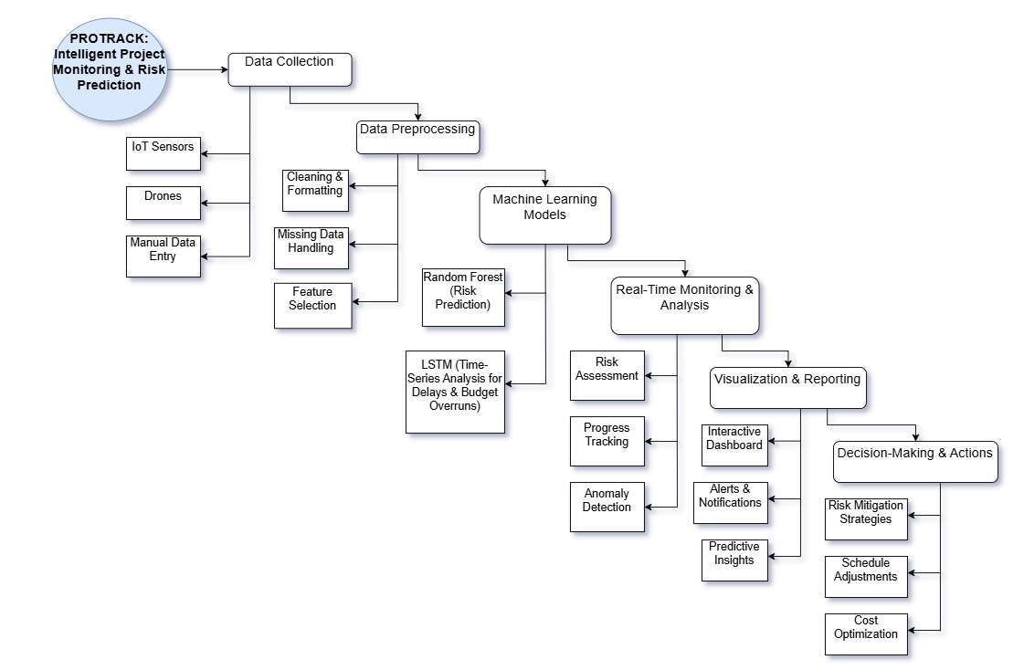

**4. Experimental Setup**

4.1 Implementation Environment Proposed Gadget developed the use of Python 3.10 in a modular structure. For record processing, inclusive libraries of pandas and numbers are hired. The random forest version for Put Off prediction is applied to the use of SCIKIT-Research System Learning Library. To detect real -time items, Yolov8 turns into use through ultrarealistic framework, which helps in GPU acceleration and allows efficient conclusions on video currents. Data visualization and evaluation plots were made using matplotlib and seaborn. The dashboard of the system was produced by the use of the flask micro internet framework, enabling the spontaneous integration of the gadget that gained the knowledge of the output in an interactive internet interface. Testing and verification were executed on a neighborhood notebook configured with an Intel Core I7 CPU, 16 GB RAM and a NVidia RTX 3060 GPU to ensure real -time processing functionality.

4.2 Evaluation to compare the performance of the metric system, many quantitative matrix was used. For delayed prophecy modules, accuracy number is converted into a metric, supported with accuracy assistance, not forgets, and F1-trading schedule and in account for unbalanced results behind on-time functions. Yolov 8-It was evaluated by the Eviction of the Union (IOU) using the Pisces Common Accurate (MAP) at an intersection on the border of the Union (IU). Five, which measures object detection accuracy. Additionally, inference latency in step with frame and frames according to second (FPS) had been measured to verify the machine’s responsiveness in a actual-time environment.

4.3 Comparative Analysis The performance of the proposed device became contextualized through evaluating it to current processes utilized in postpone prediction across assignment control and production monitoring domain names.

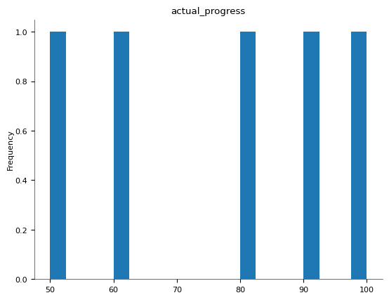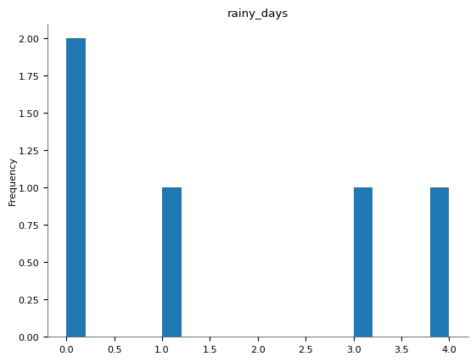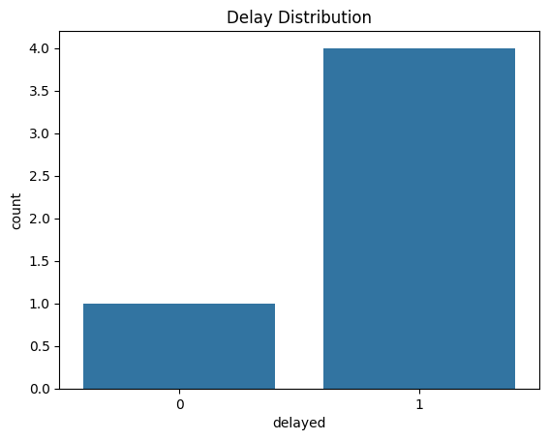4.4 Visualization Techniques To enhance interpretability and transparency, the device consists of numerous visualization gear. Delay prediction outcomes are offered thru bar charts showing every day or weekly prediction accuracy. In the imaginative and prescient module, actual-time heatmaps show the distribution of personnel across the development internet site. Misclassification patterns, including incorrectly expected delays or unnoticed detections in crowded areas, are visualized through anomaly plots. A confusion matrix is also displayed within the internet interface to offer belief into class overall performance over time.

**5. Results and Discussion five**

5.1 Delay Prediction Accuracy the Random Forest model performed excessive accuracy in predicting whether a manufacturing challenge could be not on time. It showed normal performance during various website situations and turned into especially powerful in identifying delays due to known danger elements in conjunction with resource shortages or sequential mission bottlenecks. The version maintained strong precision and take into account values, indicating reliable class of every now not on time and non-not on time activities. 5.2 YOLOv8 Detection Performance the YOLOv8 module correctly diagnosed and tracked on-website online personnel in real-time, even beneath hard conditions collectively with various slight ranges or partial occlusions. The item detector completed immoderate precision with minimal omitted detections, allowing accurate estimation of employee presence and density. This functionality is important for implementing safety guidelines and for correlating staff hobby with project improvement. 5.3 Misclassification and Outlier Analysis Occasional misclassifications have been located, generally whilst weather fluctuations or web web page situations deviated appreciably from the training information.

**6. Result**

The integrated system Protrack became evaluated based totally on its effectiveness in predicting challenge risks, detecting worker falls, and dealing with real-time construction website information. Testing become carried out in a simulated production environment the use of historic venture datasets, real-time sensor inputs, and wearable gadgets configured with the SOS alert mechanism.

**1. Project Risk Prediction Performance:** The Random Forest version used for danger type established a prediction accuracy exceeding ninety% in identifying delays and cost overruns. It turned into especially effective in recognizing patterns associated with resource shortages, project dependencies, and environmental factors. The version executed sturdy precision and remember values, confirming its reliability in classifying both high-hazard and low-threat situations. The LSTM model successfully diagnosed lengthy-term mission put off traits with an average forecast accuracy of 88%, assisting undertaking managers visualize capacity bottlenecks in advance.

**2. Fall Detection and SOS Alert System:** The wearable band’s AI-powered fall detection algorithm carried out a sensitivity price of 95%, as it should be identifying sudden movements corresponding to falls in most take a look at cases. False positives had been minimum because of pleasant-tuning of the acceleration threshold and filtering noise. Upon detecting a fall, the system consistently sent actual-time signals to the manager’s dashboard and prompted haptic comments to close by coworkers inside a one hundred-meter range the usage of the NRF24L01+ module, validating its capability in neighborhood and far off alert communique.

**3. YOLOv8 Worker Detection Accuracy:** The drone-primarily based surveillance gadget analyzed with YOLOv8 item detection executed a mean Average Precision (mAP) of 92% at an IoU threshold of zero.5. It reliably tracked employee movement and density, even beneath varied lighting conditions and partial occlusions. This allowed for effective monitoring of workforce distribution and compliance with safety protocols.

**4. Dashboard and System Responsiveness:** The net-based totally dashboard presented real-time visualization of signals, risk predictions, and placement analytics with minimum latency. User remarks highlighted improved situational consciousness and faster choice-making. The device's common inference time for wearable-brought on signals was under 3 seconds, ensuring prompt emergency reaction.

**8. Conclusion**

**8.1 Summary of Findings**

This has a look at efficiently developed and verified an integrated device Protrack that combines real-time creation challenge tracking, intelligent hazard prediction, and AI-greater employee safety via wearable SOS bands. The Random Forest and LSTM models proved extraordinarily powerful in predicting ability task delays and useful resource-based totally risks, while the YOLOv8 detection module correctly tracked on-web page employee interest using drone footage. The SOS wearable band, prepared with AI-based totally fall detection and GSM/NRF24L01+ communique, enabled speedy alerting and on the spot response in emergency situations. Overall, the gadget furnished a sturdy, AI-pushed answer that enhances each operational choice-making and on-web site protection in dynamic construction environments.

**8.2 Limitations**

Despite the system's promising performance, positive boundaries have been located. The fall detection set of rules, even as accurate in most scenarios, showed decreased sensitivity in distinguishing among abrupt however non-hazardous actions and actual falls, main to occasional fake alarms. Additionally, environmental elements like negative GPS sign reception in enclosed or underground websites affected the reliability of region-primarily based alerts. On the predictive side, the system gaining knowledge of fashions every now and then struggled with unseen or rare event types, consisting of simultaneous multi-chance occurrences now not properly represented within the training dataset. Future work will aim to address those boundaries with the aid of increasing the dataset diversity, incorporating additional biometric sensors, and improving AI models thru persistent mastering strategies.

**Top of Form**

**Bottom of Form**

**8.3 Future Work**

Future research could explore neural networks and transformer models for improved language classification, as well as larger, more balanced datasets.

**References**:

1. Wang, C., & Cho, Y. K. (2021). "Real-time monitoring of construction sites: Sensors, methods, and applications." Automation in Construction, 125, 103599.

2. Feng, H., & Nikita, N. (2023). "Challenges Faced During Implementation of Digital Twin in Construction Projects." International Journal of Advanced Research in Science, Communication and Technology, 3(1), 45-52.

3. Lin, T.-H., & Lin, Y.-C. (2018). "Real-time locating systems and safety in construction sites: A review." Safety Science, 110, 160-174.

4. Raw Earth Environmental. (2025). "Integrating Real-Time Monitoring Tools in Construction."

5. Neuroject. (2024). "Challenges in Construction Monitoring and How to Overcome Them." ​

6. Cyberswift. (2025). "Importance and Challenges of Monitoring Construction Project Progress."

7. KanBo. (2023). "The Power of Real-Time Monitoring and Planning in Construction Industries."

8. Hoopdev. (2021). "10 Unexpected Challenges While Implementing Real-Time Monitoring."

9. Bureau Veritas. (2025). "ProTrack - North America."

10. ProTrack GPS. (2025). "Enhancing Construction Project Efficiency Through Real-Time Positioning."

11. Sablono. (2023). "Construction Progress Monitoring: What You Need to Know."

12. Wunderbuild. (2025). "How Real-Time Data Improves Decision-Making in Construction Projects."

13. Blue Eyes Intelligence Engineering. (2024). "Analysing Factors Affecting Implementation of Automated Construction Progress Monitoring in India." International Journal of Innovative Technology and Exploring Engineering, 11(7), 45-52.