**Programme: PACE_Phase 2**

**Storyboard: Lesson**

**File name: Navigation and New Templates**

**Title: The Gold Rush (Sprint - 2)**

# Storyboard Instructions *

|  |  |
| --- | --- |
| **Mandatory field** | To be discussed and finalized |
| **Any field with no info** | Add “**NA”** in case there is no information |
| **Media files allowed** | .png, .jpeg/.jpg,mp3 and mp4 |

*Will keep adding the instructions during the development stage

# Storyboard Metadata

|  |  |
| --- | --- |
| **Type** | Lesson |
| **File_name** | PACE_HIST07_T12_L07 |
| **Version** | 1.0 |
| **Title** | The Gold Rush |
| **Brief_description** | The discovery of gold in the 1850s sparked immigration from around the world, expanded the Australian economy, and led to the emergence of a new national identity. |
| **Long_description** | The discovery of gold in the 1850s started a series of rushes that transformed the Australian colonies.    The first discoveries of payable gold were at Ophir in New South Wales and then at Ballarat and Bendigo Creek in Victoria.    In 1851 gold-seekers from around the world began pouring into the colonies, changing the course of Australian history.    The gold rushes greatly expanded Australia’s population, boosted its economy, and led to the emergence of a new national identity. |
| **Learning_intention** | NA |
| **Success_criteria** | NA |
| **Subject** | History |
| **Year level** | 7 |
| **Course** | NA |
| **Unit** | NA |
| **State** | Vic |
| **AC_code** | NA |
| **AC_descriptor** | NA |
| **Learning_intention** | NA |
| **Estimated_time** | NA |

# Screen 1 - This is the title1 (This will be used as breadcrumb and Navigation)

|  |  |  |
| --- | --- | --- |
| **TemplateID** | **Text_001** | |
| **TemplateName** | **Text** | |
| **Template Description** | **Text and headings** | |
| **Title** | **Metallic bonding (This is options)** | |
| **Main-text** | **Text_Heading** | **The metallic bonding model – H1** |
| **Text_Text** | **Explore the way that triangles form patterns.**  Remember to **enterprise** the problem from various directions. How many triangles are required to ensure you have listed every possibility? |
|  | **Text_Heading** | **The bonding model – H1** |
|  | **Text_Text** | **In the news: Tongan Volcanic Eruption**  Tongan geologists watched a massive plume of ash rise in the sky during a continuous eruption of the Hunga Tonga-Hunga Ha’apai volcano on Jan. 14.  While watching this video, recall the three main types of rock produced in a volcanic eruption, and explain which one would be associated with this eruption. |
| **Teacher only** |  | |
| **Discoverable** |  | |
| **Notes** |  | |

|  |  |
| --- | --- |
| **TemplateID** | **TextandGr_001** |
| **TemplateName** | **Graphic & text** |
| **Template Description** | **An image/graphic with or without text & title** |
| **Title** | **Introduction – This is conversion Utility** |
| **Main-text** | **The discovery of gold in the 1850s started a series of rushes that transformed the Australian colonies.**  The first discoveries of payable gold were at Ophir in New South Wales and then at Ballarat and Bendigo Creek in Victoria.  In 1851 gold-seekers from around the world began pouring into the colonies, changing the course of Australian history.  **Table 1.1 - This is table Caption**   |  |  |  |  |  | | --- | --- | --- | --- | --- | | **This is row head** | | | **This is row head** | **This is row head** | | Text with Col span 3 | | | Normal text | Text with Row span | | Normal text 1 | Text with Row span 2 | Normal text 3 | Normal text | | Text with Row span 1 | Normal text 3 | Normal text | | Text with Col span 2 | | | Normal text | | Normal text 1 | Normal text 2 | Text with Col span 3 | | |   The gold rushes greatly expanded Australia’s population, boosted its economy, and led to the emergence of a new national identity. |
| **Graphic** |  |
| **FFN** | FFN_PACE_HIST07_T12_L07_dummy001.jpg |
| **Caption** | *‘Deep Sinking’, Bakery Hill, Ballarat, 1853* by ST Gill |
| **Acknowledgements** | National Museum of Australia |
| **Alt text** | NA |
| **Media position (top/bottom/left/right)** | Top |
| **Teacher only** | NA |
| **Discoverable** | NA |
| **Notes** | NA |

# Screen 2 - This is the title2 (This will be used as breadcrumb and Navigation)

|  |  |
| --- | --- |
| **TemplateID** | **Widget_001** |
| **TemplateName** | **Widget and Text** |
| **Template Description** | **An HTML widget with or without text & title** |
| **Title** | **Exploring patterns - trianges** |
| **Main-text** | Explore the way that triangles form patterns and **franchise**. Remember to approach the problem from various **enterprise**. How many triangles are required to ensure you have listed every possibility?   |  |  |  | | --- | --- | --- | | Organelle: nucleus | | Organelle: nucleolus | | Structure:   * membrane-bound: double membrane * contains DNA | | Structure:  • made up of proteins and RNA | | Function:   * contains genetic information (used for the synthesis of proteins) * directs activities of the cell | | Function:  • responsible for formation of incomplete ribosomes | | Present in plants: Yes | | Present in plants: Yes | | Present in animals: Yes | | Present in animals: Yes | |  |  |  | | Coloured scanning electron micrograph (SEM) of a section through a liver cell showing the nucleus (pink) and the nuclear envelope with its many pores (tiny circles). | Coloured SEM of the external surface of a nuclear envelope in an onion root tip cell. The envelope consists of a double membrane (purple), with nuclear pores (black circles). Contained within the nucleus are the chromatin fibres (yellow and orange). | Coloured SEM of a section through cells in leaf tissue from an Aconitum sp. plant. At centre is a cell nucleus with its nucleolus (red). | | Organelle: rough endoplasmic reticulum (RER) | Organelle: ribosome | Organelle: Golgi apparatus (also known as Golgi body, Golgi complex) | | Structure:  • membrane-bound  • composed of a network of membranous tubules and sacs (called cisternae)  • ribosomes bind to the membrane | Structure:  • composed of proteins and ribosomal RNA  • found free in the cytoplasm or attached to endoplasmic reticulum | Structure:  • membrane-bound  • stack of cisternae that are not connected to each other | | Function:  • synthesises and processes proteins (often by adding carbohydrates to proteins produced by the ribosomes to form glycoproteins) | Function:  • synthesise proteins (translate messenger RNA into proteins)  • RER-bound ribosomes synthesise proteins for export from the cell | Function:  • further processes and packages proteins into vesicles for export from the cell (except lysosomes, which remain in the cell) | | Present in plants: Yes | Present in plants: Yes | Present in plants: Yes | | Present in animals: Yes | Present in animals: Yes | Present in animals: Yes | |  |  | HB12_5e_02_S01_22.ti | | Coloured SEM of endoplasmic reticulum in an olfactory epithelium supporting cell. On the surface of some of the ER membranes are ribosomes (yellow spheres). | Coloured SEM of rough endoplasmic reticulum in an olfactory bulb mitral cell. On the surface of the ER membrane are numerous ribosomes (small spheres). | Coloured SEM of a pancreatic cell, showing the Golgi apparatus and vesicles. | | Organelle: lysosome | Organelle: smooth endoplasmic reticulum (SER) | Organelle: mitochondrion | | Structure:  • membrane-bound  • vesicle containing digestive enzymes | Structure:  • membrane-bound  • network of cisternae | Structure:  • membrane-bound: double membrane; the inner membrane is highly folded  • contains DNA | | Function:  • digest waste and foreign material | Function:  • synthesis of lipids | Function:  • release energy from organic compounds | | Present in plants: No | Present in plants: Yes | Present in plants: Yes | | Present in animals: Yes | Present in animals: Yes | Present in animals: Yes | |  | HB12_5e_02_S01_24.tif |  | | Coloured SEM of two lysosomes in a pancreatic cell. Lysosomes (green) are small spherical vesicles bound by a single membrane (clearest on right lysosome). Left lysosome is shown in cross-section. | Coloured SEM showing smooth (top right) and rough (bottom centre) endoplasmic reticulum (light pink) inside a cell. Lipid droplets (round blue structures) and mitochondria can also be seen in this image. | Coloured SEM of a single mitochondrion (pink, centre) in the cytoplasm of an intestinal epithelial cell. |   Before you begin, download the laboratory notes. <download|prac_1_lab_notes.pdf|Lab notes!> |
| **Alt text** | NA |
| **FFN** | <https://pacepoc.blob.core.windows.net/assets/html_widgets/7_6_exploring_patterns_triangle/index.html> |
| **Teacher only** | NA |
| **Discoverable** | NA |
| **Notes** | NA |

|  |  |
| --- | --- |
| **TemplateID** | **Learnosity_001** |
| **TemplateName** | **Learnosity and Text** |
| **Template Description** | **A Learnosity Activity with or without text & title** |
| **Title** | **Lesson review** |
| **Main-text** | As Hitler became **innovation** increasingly militant in Germany throughout 1930s, the rest of Europe worked hard to avoid war. Germany’s invasion of Poland on 1 September 1939 brought these attempts to an end. Britain and France declared war on Germany , **franchise**.   |  |  |  | | --- | --- | --- | | Results of the ability of cell cultures to absorb serine following various treatments | | | | Culture | Treatment | Result | | A | radioactive serine solution only | radioactive serine found in the cells | | B | mercury solution (damages protein carriers and channels) and radioactive serine solution | no radioactive serine in the cells | | C | ATPase inhibitor and radioactive serine solution (ATPase catalyses the formation of ATP from ADP and Pi) | radioactive serine found in the cells |   Answer the questions in the following activity. |
| **ActivityID** | PEAR_8952ed5a-c82d-4009-a62c-9e1924b12c2a |
| **FFN** | https://assessment.pearsonplaces.com.au/content/review/HB02_LBS_VIC_CH06_M01 |
| **Teacher only** |  |
| **Discoverable** |  |
| **Notes** | https://author.learnosity.com/org/765/v1/item/editornew/?ref=PEAR_8952ed5a-c82d-4009-a62c-9e1924b12c2a |

# Screen 3 - This is the title1 (This will be used as breadcrumb and Navigation)

|  |  |  |
| --- | --- | --- |
| **TemplateID** | **Glossary_001** | |
| **TemplateName** | **Glossary List** | |
| **Template Description** | **A List of Glossary words with definitions** | |
| **Title** | **Glossary** | |
| **Main-text** | **Glossary_Term** | enterprise |
| **Glossary_definition** | ready to undertake difficult or challenging projects; energetic and daring |
| **Glossary_Term** | franchise |
| **Glossary_definition** | Where a parent business (franchisor) sells permission to independent people (franchisee) to use their business systems, sell their products and use their name for a certain period of time |
| **Glossary_Term** | innovation |
| **Glossary_definition** | A new product, service, idea or way of doing something better |
| **Teacher only** |  | |
| **Discoverable** |  | |
| **Notes** |  | |

**Output**

There will be 2 outputs

**Output 1:** A dedicated page need to be created for glossary similar to the below

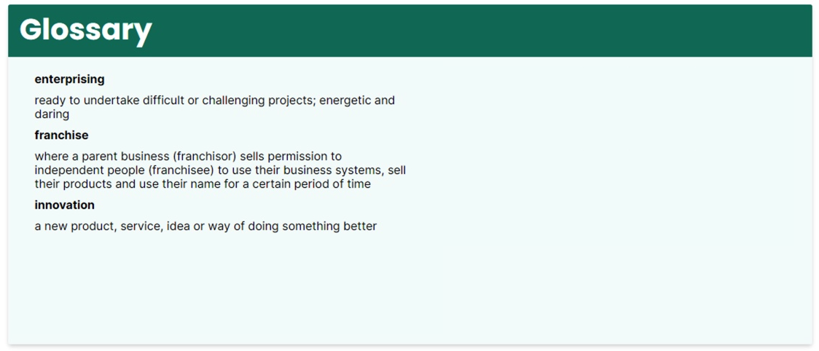

The **Glossary_Term** need to be linked in the other template and below is the output

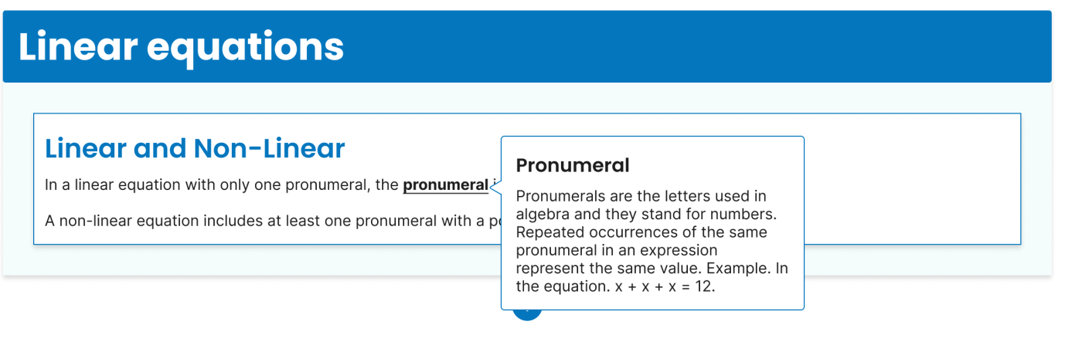

**Glossary**

<span data-glossary= **‘Glossary_definition**' class='global-glossary'> **Glossary_Term**</span>

<span data-glossary='A new product, service, idea or way of doing something better' class='global-glossary'> innovation</span>

**Complex Table HTML**

<table border="1" cellpadding="5" width="100%" style="color: #000000;">

<caption></caption>

<tr>

<td colspan="3">Text with Colspn 3</td>

<td>Normal text</td>

<td rowspan="3">Text with rowspan 5</td>

</tr>

<tr>

<td>Normal text 1</td>

<td rowspan="2">Text with rowspan 2</td>

<td>Normal text 3</td>

<td>Normal text 4</td>

</tr>

<!-- Row C -->

<tr>

<td rowspan="2">Text with rowspan 1</td>

<td>Normal text 3</td>

<td>Normal text 4</td>

</tr>

<!-- Row D -->

<tr>

<td colspan="3">Text with colspan 2</td>

<td>Normal text 5</td>

</tr>

<!-- Row E -->

<tr>

<td>Normal text 1</td>

<td>Normal text 2</td>

<td colspan="3">Text with colspan 3</td>

</tr>

</table>

</table>