CI (Continuous Integration) and CD (Continuous Delivery/Continuous Deployment) Explained
- Continuous Integration (CI):
  - CI is the practice of automatically integrating code changes into a shared repository frequently (often multiple times a day).
  - It involves running automated tests after each change to ensure that new code doesn’t break the existing codebase.
Example: A developer commits code to a Git repository. A CI tool like Jenkins or GitHub Actions runs automated tests to ensure the new code doesn't introduce errors.
- Continuous Delivery (CD):
  - CD refers to automatically deploying code to a staging environment after it has passed CI tests. The focus is on ensuring that the code is always ready for production, but it might require a manual approval to go live.
Example: After passing CI tests, the application is automatically deployed to a staging environment. A QA team might check the changes, and then, after approval, the code is deployed to production manually.
- Continuous Deployment (CD):
  - This is an extension of Continuous Delivery, where the code is automatically deployed to production without manual approval. Every change that passes automated tests is directly deployed to production.
Example: After the CI tests pass, the code is automatically deployed to production without any human intervention.

Differences Between Continuous Delivery and Continuous Deployment
- Continuous Delivery:
  - Code is automatically pushed to a staging environment after tests pass.
  - A human is required to approve and push the code to production.
- Continuous Deployment:
  - Code is automatically pushed to both staging and production environments.
  - There is no manual approval required; the deployment happens automatically.

Scenario Example (Simplified):
Scenario: Let's say we are working on an online shopping website.
- Continuous Integration:
  - A developer makes a change, like fixing a bug in the checkout process.
  - The code is pushed to the Git repository.
  - A CI tool like Jenkins runs automated tests to check if the bug fix works and if no other parts of the website are broken.
  - If the tests pass, the code is merged into the main branch.
- Continuous Delivery:
  - After passing CI, the code is automatically deployed to a staging environment where testers or QA teams check if the fix works properly.
  - Once they approve the changes, the code is manually pushed to the production environment.
- Continuous Deployment:
  - The same process as Continuous Delivery, but once the code passes CI tests, it is automatically deployed to production without waiting for human approval.

Quick Recap:
- CI: Automatically integrate and test code.
- CD (Delivery): Automatically deploy code to staging; manual production deployment.
- CD (Deployment): Automatically deploy code to both staging and production without human intervention.
################################################################################
################################################################################
2.
Certainly! If you're moving the code once a week, that likely means you have a manual or semi-automated deployment process. Below is a step-by-step guide, broken down with questions and answers for moving the code from the developer's machine to production.

1. How does the development process begin?
Answer: The development process begins when the developer writes code for a feature, fix, or improvement.
- The developer works in a local development environment (e.g., their laptop or a dev machine).
- The developer writes code, runs tests locally, and ensures it's working as expected.

2. What happens after the developer finishes writing code?
Answer: Once the code is written, the developer commits the code to a Version Control System (like Git).
- The developer creates a Git branch (e.g., feature/checkout-bugfix) to work on a specific task.
- After writing the code, they commit their changes to the branch and push it to a remote repository (like GitHub or GitLab).

3. How does the code get reviewed?
Answer: Once the code is pushed to the repository, the next step is code review.
- A peer or team lead reviews the code to ensure quality and adherence to coding standards.
- This step may involve a pull request (PR) where team members leave comments and suggest changes.

4. How is the code integrated into the main codebase?
Answer: After the code review is approved, the next step is merging the code.
- The developer or a team member merges the feature branch into the main branch (often main or master).
- This may involve rebasing to ensure the feature branch has the latest code from the main branch before merging.

5. What happens after the code is merged?
Answer: After merging, the code should undergo automated testing (via Continuous Integration, or CI).
- A CI tool (like Jenkins, CircleCI, GitHub Actions) runs the tests on the new code to ensure it doesn’t break anything.
- This typically involves unit tests, integration tests, and sometimes end-to-end tests.

6. What if the tests pass?
Answer: If the tests pass successfully, the code is ready to move to the staging environment.
- The code gets deployed to staging automatically or manually depending on the process.
- QA (Quality Assurance) or Testing teams test the application in staging to ensure it works as expected in an environment similar to production.

7. What if the code passes the QA tests in staging?
Answer: If the code is verified and passes testing in the staging environment, it’s now ready for production deployment.
- This typically requires approval from a release manager or product owner, depending on your process.
- The final production deployment may be a manual process (e.g., using a deployment script or an orchestrator like Jenkins).

8. How is the code deployed to production?
Answer: The deployment to production could involve different techniques, such as:
- Using deployment tools like Ansible, Chef, or Terraform to automatically deploy the code to the production servers.
- Or it could be a manual process using scripts or CI/CD pipelines.
Some common deployment practices are:
- Blue/Green Deployment: Two identical environments (blue and green), where one is live, and the other is a copy for testing the new version before switching.
- Canary Releases: Slowly rolling out the new version to a small subset of users before full deployment.

9. What do we do after the code is deployed to production?
Answer: After deployment, the code is live, and the monitoring and logging tools come into play.
- Monitoring tools (e.g., Prometheus, Grafana, New Relic) track the application’s performance and health.
- Logging tools (e.g., ELK stack, Splunk) gather logs and help diagnose issues.
- If any problems are found, the team might rollback the deployment or hotfix the issue.

10. What happens if there's an issue in production?
Answer: If an issue arises, the team quickly responds by:
- Using rollback strategies (e.g., rolling back to a previous stable version) to fix the issue.
- If it's a critical issue, developers may create a hotfix and deploy it immediately.

Step-by-Step Summary:
- Developer writes code → Works in local environment.
- Code committed to Git → Developer pushes changes to the repository.
- Code Review → Code is reviewed by peers and approved.
- Code Merged to Main Branch → Feature branch is merged after review.
- CI Testing → Automated tests are run to ensure the code doesn’t break anything.
- Deploy to Staging → Code is deployed to a staging environment.
- QA Testing → QA verifies the functionality and stability in staging.
- Production Deployment → After approval, the code is deployed to production.
- Monitoring and Logs → Tools track the health of the application post-deployment.
- Issue Response → Rollback or hotfix if there’s a production issue.

In your case (deploying once a week):
- Automate as much as possible, especially in the CI/CD process, even if you're deploying manually.
- You could still follow the same process but reduce the frequency of deployments to once per week for production. The key is to ensure that testing and quality checks happen after each code change and before moving to production.
################################################################################################################################################################

1. Different Types of CI/CD Tools
Continuous Integration (CI) and Continuous Deployment/Delivery (CD) tools are used to automate the software development lifecycle, specifically the build, test, and deployment stages. Here are some common types of CI/CD tools:
- Jenkins: Open-source, widely used for automating builds and deployments.
- CircleCI: Cloud-based CI/CD tool with easy integrations and scalability.
- Travis CI: Cloud-based CI tool with simple setup and integration with GitHub.
- GitLab CI: Part of GitLab's DevOps platform, providing integrated CI/CD pipelines.
- Bamboo: Developed by Atlassian, integrates well with other Atlassian tools like Jira.
- TeamCity: A JetBrains product that offers powerful CI/CD pipelines with robust support for many languages.
- Codeship: Provides simple and fast cloud-based CI/CD pipelines.
- Azure DevOps (formerly VSTS): Microsoft’s solution for DevOps, which includes CI/CD tools, version control, and project management features.
- AWS CodePipeline: Amazon's cloud-native CI/CD service for automating workflows on AWS infrastructure.
- GitHub Actions: A CI/CD and automation tool built directly into GitHub, which enables you to automate workflows directly from your repositories.

2. Does the Cloud Provide CI/CD?
Yes, most major cloud providers offer CI/CD solutions integrated with their platform to automate the software development lifecycle.
- AWS: AWS CodePipeline, CodeBuild, and CodeDeploy provide CI/CD capabilities for AWS-hosted applications.
- Azure: Azure DevOps provides a full CI/CD pipeline, including build, release, and deployment tools.
- Google Cloud: Google Cloud Build and Cloud Deploy provide CI/CD services tailored for Google Cloud infrastructure.
Cloud-based CI/CD tools are often favored for their scalability, ease of integration with cloud services, and reduced need for managing infrastructure.

3. Why Are Most Companies Using Jenkins?
Jenkins is one of the most popular CI/CD tools, and many companies use it for several reasons:
- Open Source and Free: Jenkins is free and open-source, making it an attractive option for businesses looking to avoid licensing costs.
- Wide Plugin Ecosystem: Jenkins supports thousands of plugins, which means it can integrate with virtually any tool in the software development lifecycle.
- Flexibility and Customization: Jenkins is highly customizable, allowing teams to configure and tailor it according to their needs.
- Community Support: As an open-source project, Jenkins has an active community, which provides valuable resources, plugins, and support.
- Mature Ecosystem: Jenkins has been around for a long time, which means it’s a well-established and reliable tool with extensive documentation.

4. How Jenkins Differs from Other CI/CD Tools
Jenkins differs from other CI/CD tools in several key ways:
- Plugin Ecosystem: Jenkins is highly extensible with thousands of plugins to support a wide range of tools and workflows.
- Open-Source Nature: Unlike some other tools that are either closed-source or require paid plans for full functionality, Jenkins is completely free.
- Self-Hosting: Jenkins can be self-hosted, giving companies full control over their CI/CD infrastructure, whereas other tools may require cloud-hosting.
- Complexity: While Jenkins provides great flexibility, it can be more complex to set up and manage compared to other tools with more user-friendly interfaces.
- Scalability: Jenkins can be set up to scale across multiple nodes, making it suitable for large teams and complex pipelines.

5. Why Are People Using GitHub Actions Instead of Jenkins?
GitHub Actions is becoming increasingly popular, especially for projects hosted on GitHub, due to several benefits over Jenkins:
- Integrated with GitHub: GitHub Actions is fully integrated into GitHub, making it easier to set up CI/CD workflows directly from the GitHub interface, without needing to manage external tools.
- Ease of Use: GitHub Actions is simpler to set up and configure, especially for GitHub users. You can define workflows in .yml files within your repository.
- Cost: GitHub Actions is free for public repositories, and the pricing for private repositories is relatively competitive, with a generous amount of free minutes for many users.
- Less Maintenance: Unlike Jenkins, which often requires setup, maintenance, and scaling, GitHub Actions is a cloud-based service managed by GitHub, so teams don’t need to worry about infrastructure management.
- Native Integration with GitHub Repositories: Since GitHub Actions is built into GitHub, it's easier to automate tasks, trigger actions based on events (e.g., pull requests, issues), and access repository data without needing external integrations.
- Scalability: GitHub Actions can scale easily without requiring complex configuration for different environments, as it automatically provisions the necessary runners.

Summary:
- CI/CD Tools: Jenkins, CircleCI, Travis CI, GitLab CI, Bamboo, and others.
- Cloud Providers and CI/CD: AWS, Azure, Google Cloud offer integrated CI/CD tools.
- Jenkins Popularity: It's free, open-source, flexible, and has an extensive plugin ecosystem.
- Jenkins vs Other Tools: Jenkins is highly customizable but can be complex. Tools like GitHub Actions offer easier integration and maintenance for GitHub users.
- GitHub Actions Advantage: Simplicity, integration with GitHub, lower maintenance, and good scalability, which makes it appealing for teams using GitHub as their code repository.
Many teams are moving towards GitHub Actions due to its simplicity and seamless integration, especially when their code already lives on GitHub.
################################################################################################################################################################

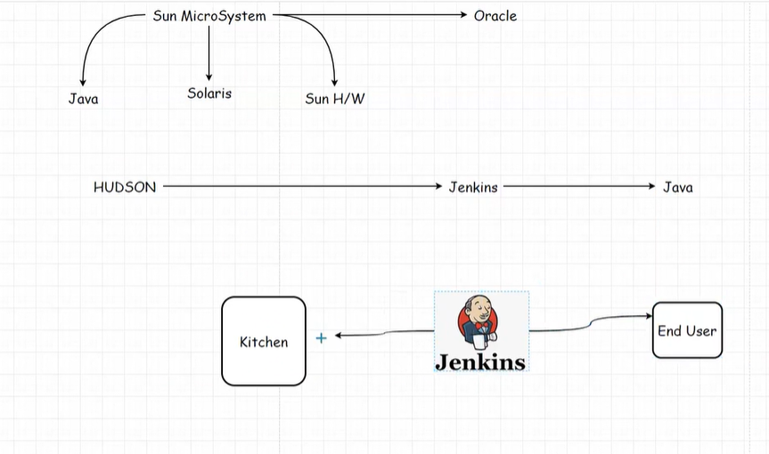

Simple Explanation:
- Sun Microsystems created:
  - Java: A programming language. Java is a product only
  - Solaris: An operating system.
  - Sun H/W: Hardware systems.
- Later, Oracle acquired Sun Microsystems.
- Hudson was the original tool that evolved into Jenkins, a software used for automating tasks (like building and testing Java applications).
- Jenkins acts like a kitchen that prepares and delivers the software to the end user after completing all processes.
Jenkins is written in the java. Symbol is “butler”

Background on Jenkins
- Origin: Jenkins started as a fork of Hudson, developed by Kohsuke Kawaguchi in 2011.
- Purpose: It is an open-source automation server primarily used for Continuous Integration (CI) and Continuous Delivery (CD).
- CI/CD Role: Jenkins automates the process of building, testing, and deploying software, allowing teams to integrate code changes frequently and deploy updates faster.

2. How Jenkins Connects to Java and Sun Microsystems
- Java-Based: Jenkins is built in Java, leveraging the rich ecosystem and portability of the Java Virtual Machine (JVM).
  - Sun Microsystems: Origin of Java, which Oracle acquired in 2010. As a result, Jenkins benefits from Oracle's ongoing Java advancements.
####################################################################################################################################################
use the digital oceanblog for all.
https://www.digitalocean.com/community/tutorials/linux-commands
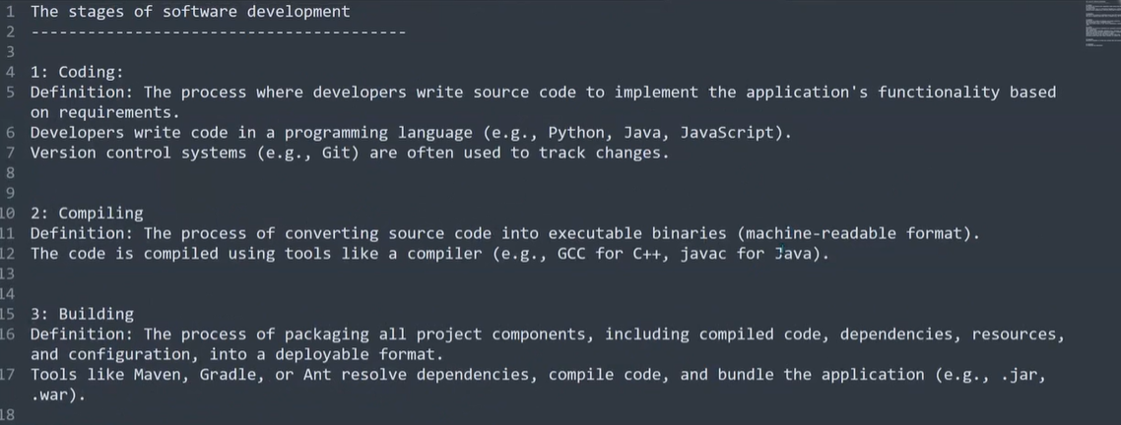

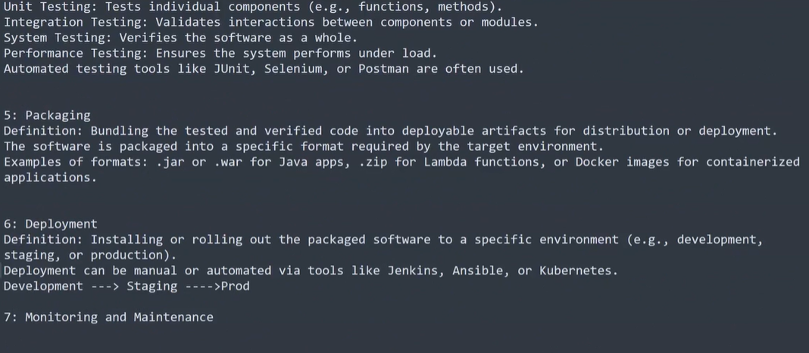
https://www.digitalocean.com/community/tutorials/linux-commands

use the digital oceanblog for all.
Ansible ensures idempotency by checking the system state before performing actions, and only making changes if needed
Shell scripts, without explicit checks, may perform the same actions repeatedly, potentially causing unintended side effects or redundant operations.
in our project we are using the jar and war with jenkins can we achive by this in docker images (convert war into jar because its taking more time)?
Jenkins 18 th vidio: start from 52 min

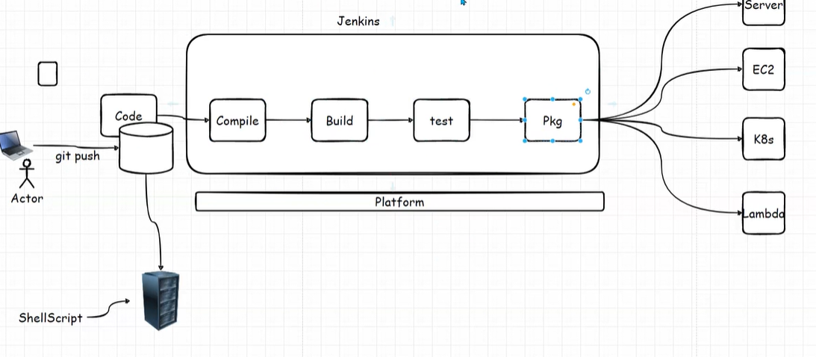
jenkins: maven is using build automation tool.
Given by apache
for java we are using the pom.xml maven we are using
because maven is suitable for java based application.
- in compilation maven will go and read the pom.xml (developer will right and give) whatever they mentioned library, dependency, binaries those all download from “MAVEN CENTRAL LI?BRARY” and copile and build respectively.
- maven is written in java (intsall java then install maven )
---------------------------------------------------------------------------------------------------------------------

What is Maven?
Maven is a build automation and project management tool primarily used for Java projects. It simplifies the build process by managing dependencies, compiling code, running tests, packaging the application, and deploying it. Maven follows the convention over configuration principle, meaning it provides default project structure and lifecycle.

Why Use Maven for Java Applications?
- Dependency Management: Maven downloads and manages external libraries (dependencies) required for your project.
- Standardization: It provides a consistent build system with a predefined directory structure and lifecycle.
- Build Automation: Automates tasks like compiling, testing, packaging, and deploying.
- Plugin Ecosystem: Supports a wide variety of plugins for additional functionalities, such as testing, reporting, and deployment.
- Integration: Integrates easily with CI/CD tools like Jenkins and version control systems like Git.
- Reproducibility: Ensures consistent builds across different environments by storing dependencies in a central repository.

Tools for Other Applications (e.g., Python, Node.js)
- Python: For Python, tools like pip, pipenv, and poetry are used for dependency management and virtual environments. Build automation can be handled by tools like setuptools or tox.
- Node.js: For Node.js, npm (Node Package Manager) or yarn is used for dependency management. Build tools like Webpack, Gulp, or Grunt are used for tasks such as bundling, compiling, and testing.

What is pom.xml?
- pom.xml (Project Object Model) is the central configuration file in a Maven project. It defines the project's dependencies, plugins, build configurations, and more.
- It is written in XML format.

Who Writes pom.xml, and How?
- Who writes it?
  - Typically, the developer or project maintainer writes and maintains the pom.xml.
  - For enterprise projects, it might be pre-configured by a team lead or DevOps engineer.
- How is it written?
  - The structure of pom.xml is dictated by the Maven POM schema. It usually includes:
    - Project Information: Basic details like project name, version, and description.
    - Dependencies: Specifies libraries required by the project.
    - Build Plugins: Configures plugins for compilation, testing, packaging, etc.
    - Build Profiles: Optional configurations for different environments (e.g., dev, test, prod).
    - Repositories: Defines where to fetch dependencies (e.g., Maven Central, custom repositories).

Example of pom.xml
<project xmlns="http://maven.apache.org/POM/4.0.0"
xmlns:xsi="http://www.w3.org/2001/XMLSchema-instance"
xsi:schemaLocation="http://maven.apache.org/POM/4.0.0
http://maven.apache.org/xsd/maven-4.0.0.xsd">
<modelVersion>4.0.0</modelVersion>

<groupId>com.example</groupId>
<artifactId>my-app</artifactId>
<version>1.0.0</version>

<dependencies>
<!-- Example Dependency -->
<dependency>
<groupId>org.springframework.boot</groupId>
<artifactId>spring-boot-starter-web</artifactId>
<version>2.6.3</version>
</dependency>
</dependencies>

<build>
<plugins>
<!-- Compiler Plugin -->
<plugin>
<groupId>org.apache.maven.plugins</groupId>
<artifactId>maven-compiler-plugin</artifactId>
<version>3.8.1</version>
<configuration>
<source>11</source>
<target>11</target>
</configuration>
</plugin>
</plugins>
</build>
</project>

Scenarios for Writing pom.xml
The contents of pom.xml are influenced by the project's requirements:
- Building: Specify plugins like maven-compiler-plugin for compiling Java code.
- Testing: Add dependencies like JUnit and configure test-related plugins.
- Packaging: Define how to package the application (e.g., JAR or WAR).
- Dependency Management: Include external libraries needed for development.
- Environment Profiles: Create profiles for different environments (e.g., development, production).
- Deployment: Configure plugins for deployment to servers or repositories.
If you want detailed guidance on writing pom.xml for a specific purpose, let me know!
################################################################################################################################################################

Prerequisites for Jenkins Installation
- Operating System:
  - Jenkins is platform-independent and can run on Linux, Windows, or macOS.
  - Ensure you have admin/root privileges for installation.
- Java:
  - Jenkins requires Java (Java 8 or 11, depending on the Jenkins version).
  - Verify Java is installed by running:
bash
CopyEdit
java -version
  - If not installed, download and install the Java Development Kit (JDK).
- Hardware Requirements:
  - At least 1 GB of RAM and 50 GB of disk space (for larger setups, increase these values).
- Network:
  - Ensure port 8080 or another desired port is open for Jenkins to run.
- Optional:
  - A web browser for accessing the Jenkins UI.
  - Tools like Git, Docker, or Maven if required for your pipelines.
Installtion:steps
- update pkges:
sudo apt update
sudo apt upgrade
- install java:
sudo apt install openjdk-11-jdk -y
- add jenkins repo:
curl -fsSL https://pkg.jenkins.io/debian-stable/jenkins.io-2023.key | sudo tee \
/usr/share/keyrings/jenkins-keyring.asc > /dev/null
echo deb [signed-by=/usr/share/keyrings/jenkins-keyring.asc] \
https://pkg.jenkins.io/debian-stable binary/ | sudo tee \
/etc/apt/sources.list.d/jenkins.list > /dev/null
- install jenkins:
sudo apt update
sudo apt install jenkins -y
- start and enable jenkins:
sudo systemctl start jenkins
sudo systemctl enable jenkins
################################################################################
install jenkins>give 8080 inbond defult port >publlicip:port>install suggested pluggin
discover-devops/jenkinsmaven /java-tomcat-sample/pom.xml– github tool
maven clean
clean is pluggin
################################################################################################################################################################

-----------------------------------------------------------------------------------------------------------------------
CREATE ONE JOB GIT AND MAVEN + TOOLS CONFIGURED AND SET PATH IN LINUX SERVER
if you run anything in linux like ls it will show list but all are srore in the some path “echo $PATH”
if ou install jdk manually and added in the jenkens tools section menas it will hsow command not found because we didnt set the path.
- git also we dind set – see git is alaready stored in the user/local/bin;usr/local/sbin some of path set by default.
- if you insall java, it will install /user/lib/jvm so this paath we need to set. So see the below image
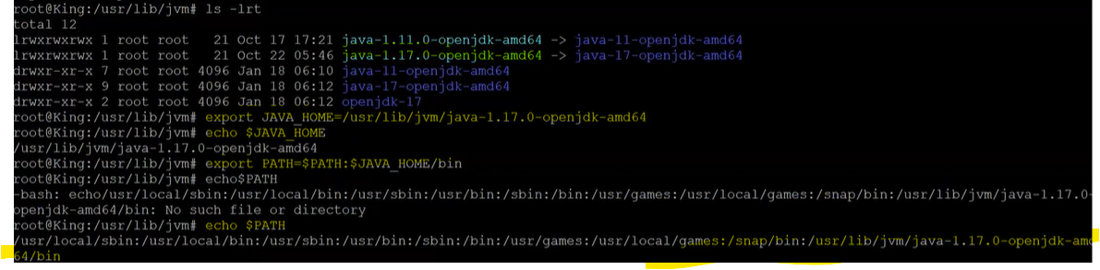
addressbook git url use for crete simple project build 2 jobs with only git and maven
*/branchname
build-lifecycle of maven read
prompt:
PS1=”Jenkins $ “
- inside target .calss file are compiled
-----in jenkins job we are seeing the time is different like UTC formta so that linux server time
connect linux server- date (UTC)
------------------------------------------------------------------------------------------------------------------------BUILD TRIGGER CONCEPT
build periodical- dont care about the changes in the github files or svn just you run the job whatever time we have mentioned
where as “pollscm” – it will also doing the same job but respective of commited something in the github (if you set every 4 hors menas every 4 hours poll scm will go check if any changes are committed ok trigger job suppose 8 am will go check nothing delta(new changes) then it will check 12 pm and 3pm as same like that.
see below image:

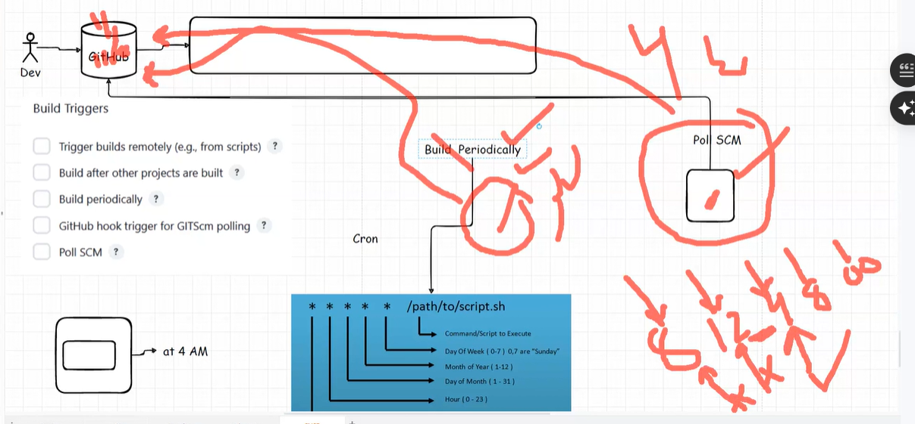
periodcal and poll scm insted of this we are using the “githubwebhook”
jenkins: check github webhook under build trigger section
github- go too that directory(related to code )>setting>webhook>
payload url- https://jenlinsip:port/github-webhook/
enable ssl certificate (if https where as http SSL not required)
poll will trigger job – when is there any trigger
build periodical – irrespective of committed changes to github jobs will trigger based on time.
Build after project are built:
hear we will get upstream and downstream project.
I created one compile job (mvn which name i setted in tool- software>mvn compile)
compile, test , install, vlidate all are maven build life cycle and pluggins.
Under built after projetc: i added one job that is test job so after compilation of this jobit will create test job so “compilation job – test job is downstream project and vice-versa.
Please refer ss:
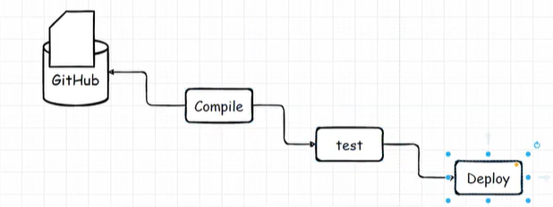
Implement the below thing in our project:
Add Jobs:
- In the "Projects to build" field, add the names of the downstream jobs.
- Use commas (,) to separate multiple jobs if you want them to execute concurrently. Example: Job2, Job3
- If you want them to execute sequentially, use multiple "Build Other Projects" entries, adding one job per entry.
Build after project run:
Nb,csps
Let’s clarify how upstream and downstream job triggering works in Jenkins when Job A (upstream) triggers downstream jobs (Job B, Job C, and Job D):

Triggering Behavior (Parallel or Sequential)
- Parallel Triggering:
  - If Job A is configured to trigger multiple downstream jobs (e.g., Job B, Job C, Job D) in the same post-build action, Jenkins triggers them in parallel.
  - Example:
    - In Job A, under Post-build Actions → Build other projects, list:
CopyEdit
JobB, JobC, JobD
This configuration starts all three jobs simultaneously, assuming Job A completes successfully.
- Sequential Triggering:
  - If you need sequential execution, you need to:
    - Configure Job B to trigger Job C as a downstream job.
    - Configure Job C to trigger Job D as a downstream job.
  - This creates a chain where:
css
CopyEdit
Job A → Job B → Job C → Job D

Behavior When Job A Fails
If Job A fails, downstream jobs (Job B, Job C, and Job D) will not be triggered.
- This is the default Jenkins behavior because downstream jobs are triggered only on a successful completion of the upstream job.
If You Need Downstream Jobs to Trigger Despite Failures:
- You can override this behavior using "Trigger even if the build fails" options available in plugins like:
  - In Job A, configure Post-build Actions → Build Other Projects.
* Check the option "Trigger even if the build is unstable or failed."
-------------------------------------------------------------------------------------------------------------
PRACTICAL ON UPSTREAM AND DOWNSTREAM PROJECT
i want to see all my upstream and downstream project in the graphical way :
so install plug-in : “BUILD PIPELINE”
refer ss:
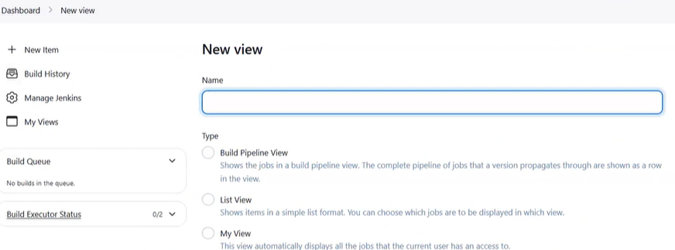
- Earlier only showing list and my view now we can able to see the build pipeline.
Yellow – running job
blue – waiting
green- build success
red: job failes
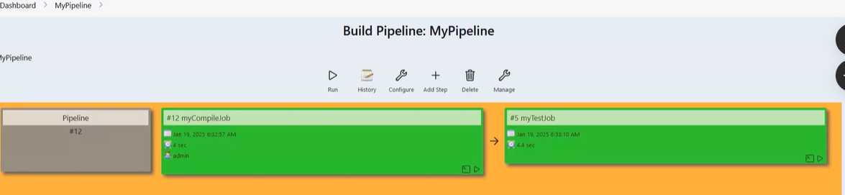
- ---------------------------------------------------------------------------------------------------------------MASTER AND SLAVE ARCHTECTURE
What is Jenkins Master and Slave Architecture?
Jenkins follows a master-slave (or controller-agent) architecture to distribute build workloads across multiple machines.

Master (Controller):
- The master is the main Jenkins server that:
  - Manages configurations, plugins, and user interactions.
  - Schedules and delegates build jobs to slaves (agents).
  - Monitors the build execution results and logs.
- The master is primarily responsible for orchestration, not executing builds directly (although it can, if needed).

Slave (Agent):
- Slaves are machines (physical or virtual) connected to the master.
- They perform the actual build tasks delegated by the master.
- A slave can have specific configurations and environments, such as specialized tools, operating systems, or software dependencies.

Why Use Master-Slave Architecture?
- Distributed Workload:
  - The architecture allows the distribution of build jobs to multiple machines, avoiding bottlenecks on the master.
- Scalability:
  - By adding more slaves, Jenkins can handle a large number of parallel builds.
- Environment-Specific Builds:
  - Slaves can be configured with different operating systems, libraries, and tools to test and build across diverse environments.
- Resource Optimization:
  - The master offloads resource-intensive tasks to slaves, ensuring the master remains responsive.
- Parallel Builds:
  - Multiple jobs can run in parallel across different slaves, improving build efficiency.

Advantages of Master-Slave Architecture
- Improved Performance:
  - By offloading build tasks to slaves, the master can focus on orchestration and avoid resource contention.
- Scalability:
  - You can add more slaves to scale Jenkins as the workload grows.
- Environment Diversity:
  - Allows testing and building applications on different operating systems and configurations.
- Cost-Effective Resource Management:
  - Use cloud-based or on-demand resources for slaves, reducing infrastructure costs.
- High Availability:
  - Distributing jobs across multiple slaves ensures that a failure in one slave doesn't halt the entire CI/CD process.

Disadvantages of Master-Slave Architecture
- Increased Complexity:
  - Setting up and maintaining the master-slave configuration can be complex.
- Network Dependency:
  - The master and slaves communicate over the network; any network issue can disrupt the build process.
- Single Point of Failure (Master):
  - If the master goes down, the entire Jenkins system becomes non-functional. (This can be mitigated with a high-availability setup.)
- Resource Overhead:
  - Maintaining multiple machines (slaves) can lead to additional infrastructure and operational costs.
- Security Concerns:
  - If a slave is compromised, it might be used as an attack vector to access the master or other resources.

When to Use Master-Slave Architecture?
- Large-scale CI/CD pipelines with many builds.
- Builds requiring multiple platforms or environments.
- Teams or projects with a need for parallel job execution.
- Resource-intensive builds that could slow down the master if run locally.
---------------------------------------------------------------------------------------------------------------
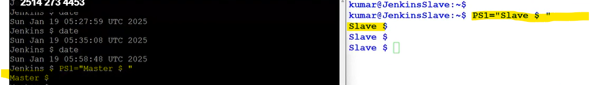
- 1. Password less authentication:
in master : ssh-keygen -t rsa under /home/app_user path
it will create - .ssh folder (/home/app_user/.ssh)
note: .ssh already created by defult it will create pub and private key (authorized key alaredy should be there)
id_rsa- private key id_rsa_pub is pubic key .
Slave: by default .ssh is created in root user and any user like app_user, readonly so
cd .ssh> authorized_key (add the public key of master jenkins )
manually you copy and paste every slave or “ssh-copy-id user@remote_host”
cd .ssh and cd ~/.ssh bothe are same once you are in root directory
please refer ss:
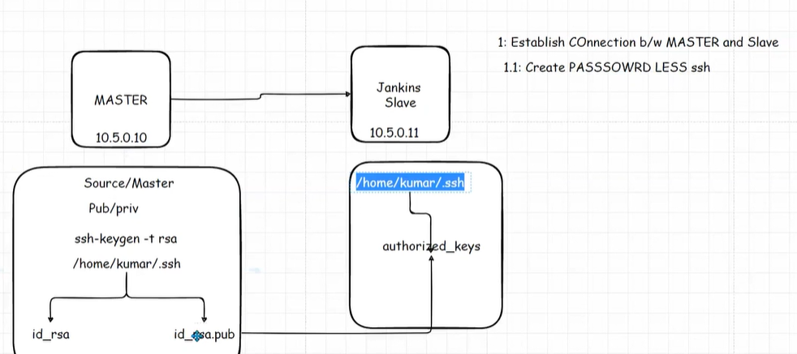
- earlier it was asking password everytime when ssh jenkinsslave@123.333.33 after password less authentication it will ask only forst time for fingerprint, next ssh directly it will go
troubleshoot:
- Rerunning ssh-keygen creates a new key pair consisting of a private key and a public key. It does not create or modify the authorized_keys file on its own.
Manually need to connect every slave machine authorization key and add the public key over there or use “ssh-copy-id user@ip”.
Before Using ssh-copy-id:
  - The ~/.ssh/authorized_keys file on the slave machine is:
    - Empty, if no public key has been added for the user.
    - Nonexistent, if no SSH configuration has been set up for the user.
- After Using ssh-copy-id:
  - The authorized_keys file on the slave machine contains the public key from the master machine.
  - If there were already keys in the file, the new key is appended, preserving the existing keys.
---------------------------
Can we achive password less authetication irrespective AZ, region and VPC:?
Different AZs/Regions: Yes, you can connect the master and slave servers if they are in different Availability Zones or regions, as long as network connectivity is established (e.g., via VPC peering, Transit Gateway, or VPN).
- Different VPCs: Yes, instances in different VPCs can communicate through VPC peering, Transit Gateway, or a VPN connection.
2. add the node or salve in the jenkins mastert
- remote dirctory: where all jobs are stored –by default it will store “/var/lib/jenkins/workspace” so you can change this place.
- Ip addr show – etho ip you can copy and paste in the while during the node creation
plese referss:

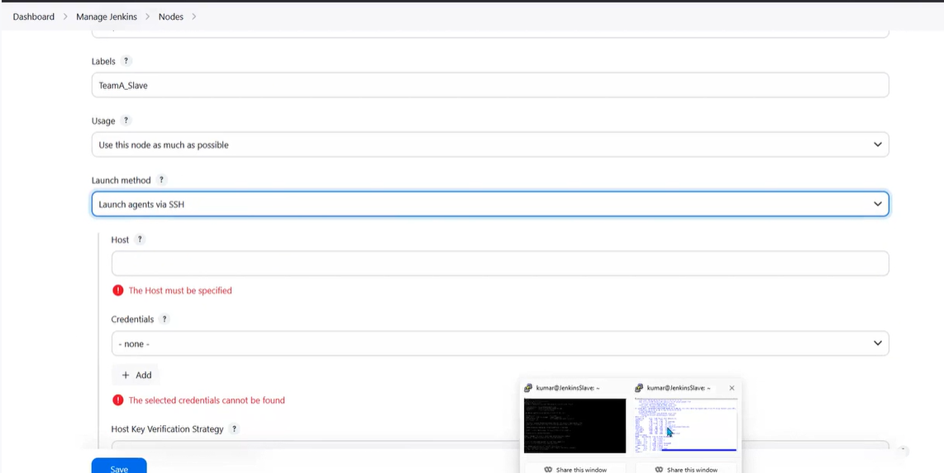
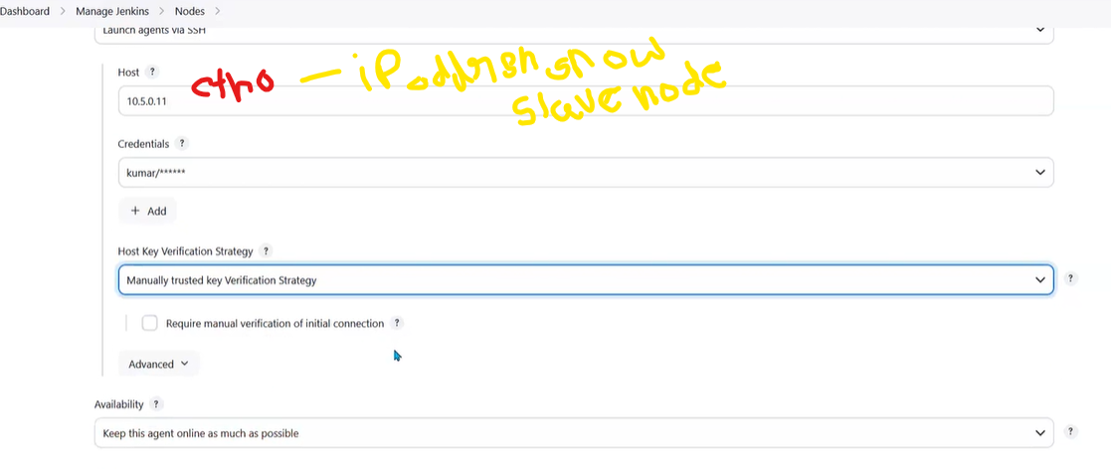

in slave /destination node : install java , no need to install jenkins
if java is is not there connection closed error will come
after java installed in salve : agent succesfully connected and online
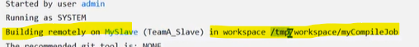
in general “ restrict where this project can run” – here you type label what you give there while creating the job
:
This is thermote directory here only all will store
This is label name which we have mentioned in the node

troubleshoot:
Use Public IP if connecting from outside the VPC (e.g., from your local machine or a d ifferent VPC/region).
- Use Private IP if both instances are within the same VPC, or if you're connecting from another internal resource in the same network.
- eth0 IP is typically the private IP used for communication within the VPC, and you’d use this IP if the master node is in the same VPC as the slave node.
###################################################################################################################################################
Pipline as code next concept
start with 02:50 – jenkins 19/01/2025---------------

