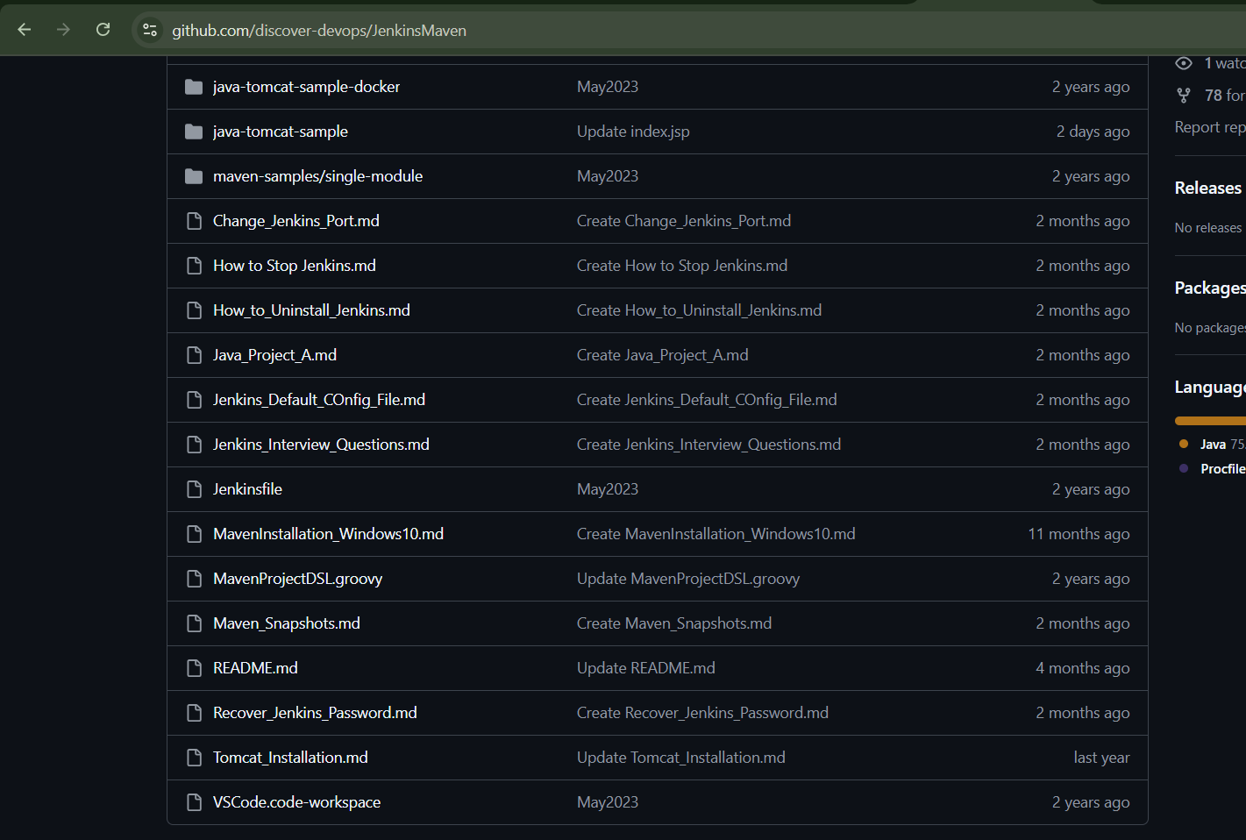
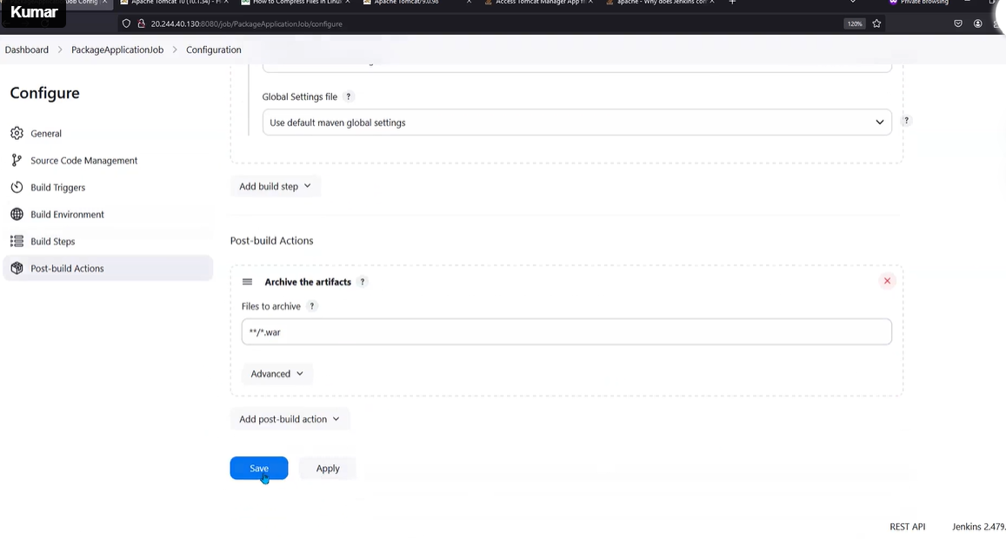
You can do teh setup of jenkins

crete 1 instance - master
1 instance- slave

master- install jenkins and java
slave - java only you install

do connection between master and slave
master - ssh -keygen -t rsa and move public key to authorization file in slave

in jennkis ui - add node (give label , keep this node online as much as possible)
- connect from ssh (ip -private ip- username and passwd (app/usr/root)
create node

in slave install - tomcat install from chrome-take link copy ( wget <https://tomcatinstalltion> )
/opt/soarestart
wget <link>
tar -xzvf *.zip
ll
rm -rf <dfdfd.gz>

create soft link (ln -s <full path of link> /usr/local/bin/tomcatup
tomcatup - start
- but check the echo $PATH

it will show the all path- if we run the any command it will check first in this path )
ip: 8080
we can see the view on browser (make sure 8080 port open or not in sg as inbond roule)

by default tomcat accessble only from ip (wherever tomcat installed)
contex.xml we can change

find / -name contex.xml
whaever there in the exmples ad d docs folder you nglect that one.
<!--

--> tomcat is not goimg to read commented file
if we commented one value in context.xml in two path so in mange app (tomcat ui) we can able to caeess asking username and passwd but earlier it was showing the 403 error and its showed context.xml
- so we fond the file and did the some changes post tomcatup and tomcatup and access now its ok.
host-manager/Mets-INF-config.xml and manager/Mets-INF/config.xml folder need to change

2. in conf/tomcat-users.xml - we need to set the username and passwd

3. tomcat port need to change
inside conf/server.xml
connectoror port - 8080 to 8000 i did and restarted the tomcat servers
in - browser- ip:8080

repo path:jenkinMaven path

https://github.com/discover-devops/JenkinsMaven/blob/main/Recover_Jenkins_Password.md

project 1 :
https://github.com/discover-devops/JenkinsMaven.git
git – mentiom the path (git url)
archive artifact: **/*.war
maven ant we are using (maven default )

copy-artifacts – pluggin iintsall
in build steps: copy artifacts fromanother projects((cd job)) we can see
after tomcat install:
create one ci project
create one cd project (from which job build – copy from war, jar to container )
ci job:
* packageapplicationjob -job name
* git : url (jekinsmaven.git )
check branch name – master or main branch based on change
* buid steps: invike top-level maven targets
maven choose
goal – clean package
advance- mention the pom.xml path (after the git path directory/sample-javamaven
* post-build action: files to archive
**/*.war (astris astris)

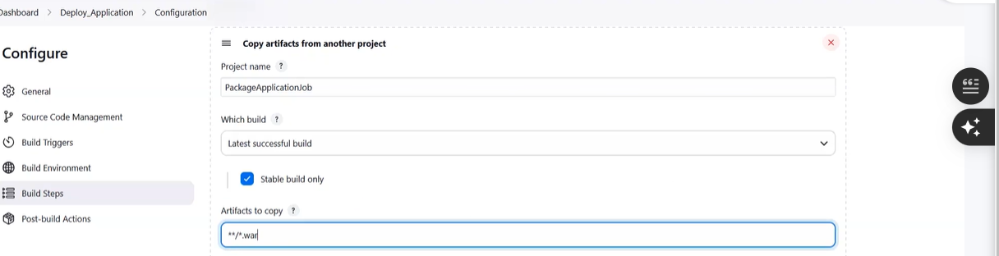
general:
* check the “restrict where this project can run “
label exprission : label name you mentin
you mention the slave node path (while creating the node only we mentioned the remote directory path as /tmp
so (in console showing /tmp/workspcae/all code related)
cd job:
* deploy_application - name
freestyle project
restrict project where we can run (label you select)
not required source code (git) just war you take from last job
* build steps: copy artifacts from other project
- install “copy artifact pluggin”
f

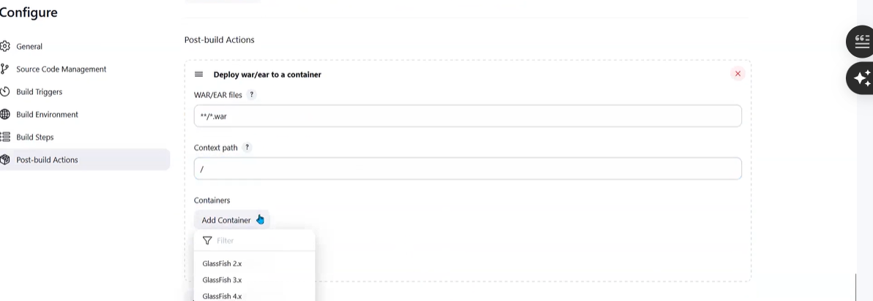
* post-build action:deploy war/ear to conatiner
install “deploy to container” pluggin
start from 02:15 start – jenkins 26/01/2025

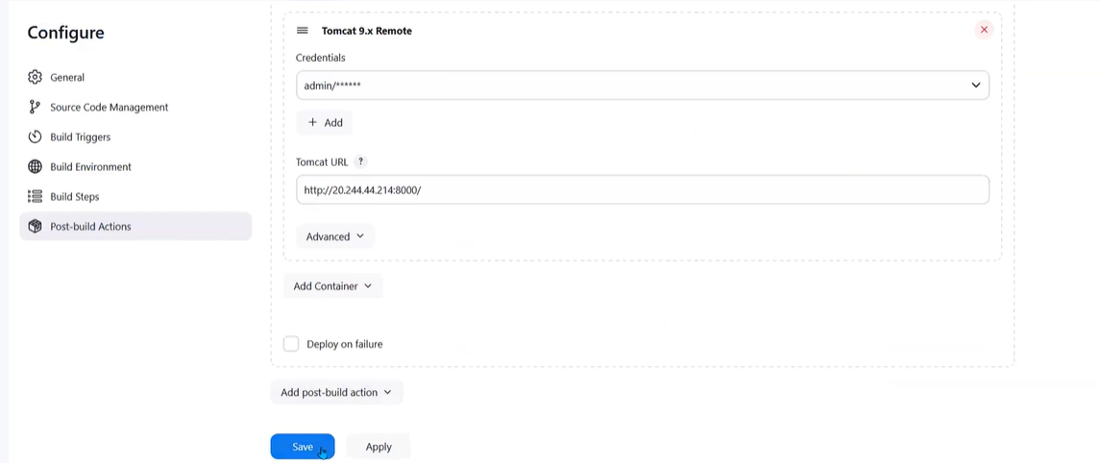

craet one project>gitadd>toplevelmaven>archive artifacts
copy archive artifacts from ci job and post-build-action=deploywar/ear to container
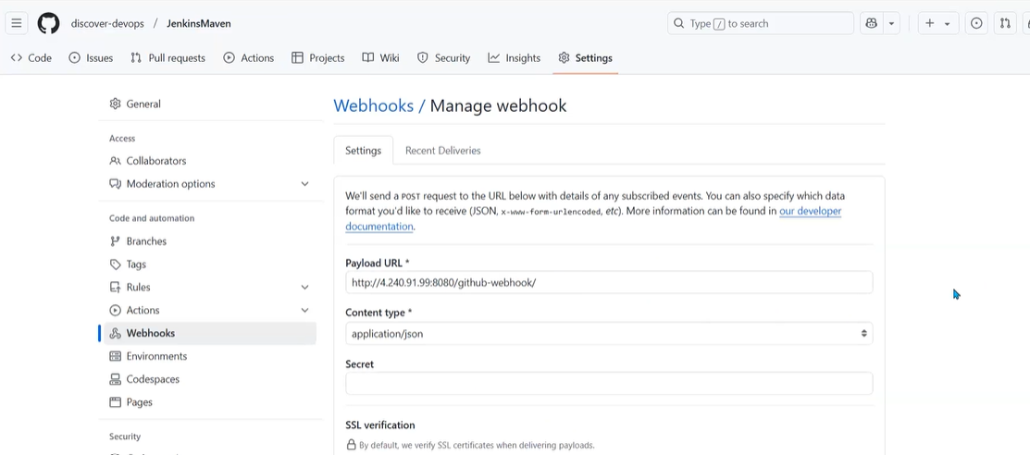

- after githubconfiguration:
in package application >github hook you configure
- deploy_application project. (build after other project run)- select package application

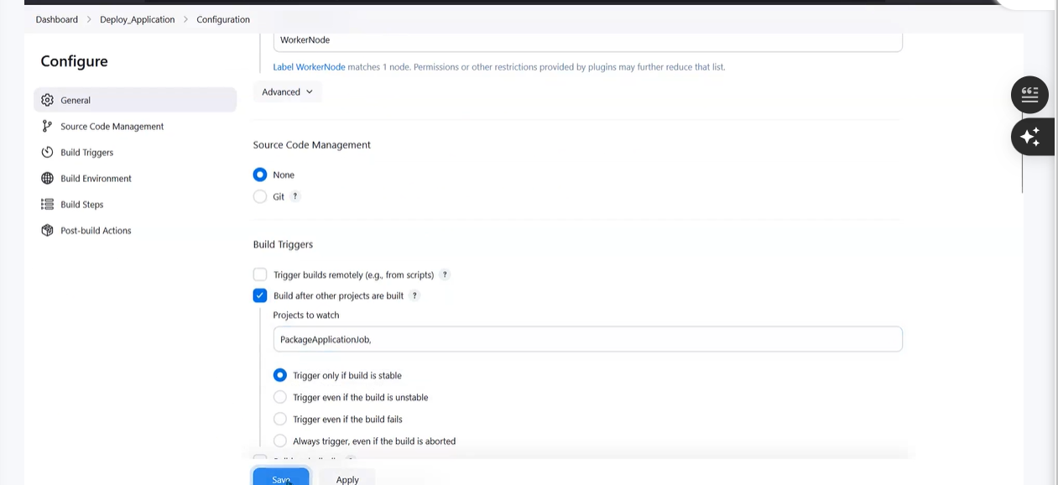
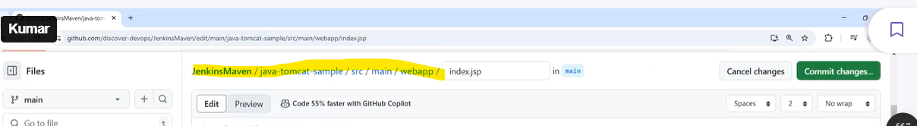
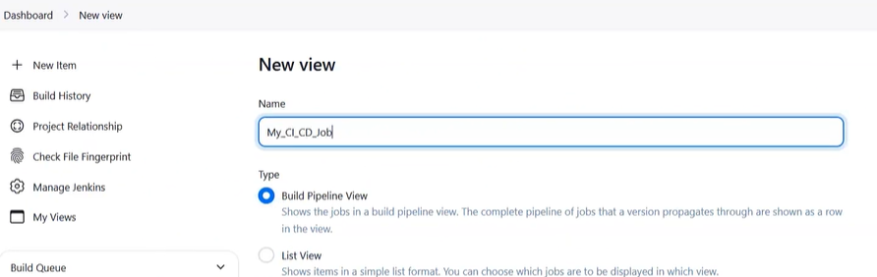
in above thing only we need to update code
install build pipeline – pluggin
do one job:

