Use the : 2 repo
https://github.com/discover-devops/EKS_K8S/tree/main/Assignments
and kuberenets-workshop
Minikube-install
prerequetsics:
1. install docker
2. install kubectl
3. install minikube and start the minikube
link:
https://github.com/discover-devops/kubernetes_workshop/blob/main/minikube_Installtion_2025.md
1. install docker.
PS1="DOCKER $"
- sudo yum update -y
- sudo yum install -y docker
- docker version
- systemctl status docker
- systemctl start docker
- systemctl enable docker
DOCKER $systemctl enable docker
Created symlink /etc/systemd/system/multi-user.target.wants/docker.service → /usr/lib/systemd/system/docker.service.

- systemctl status docker
- docker ps
in root ok but in other user we are getting error :
permission denied while trying to connect to the Docker daemon socket at unix:///var/run/docker.sock: Get "http://%2Fvar%2Frun%2Fdocker.sock/v1.44/containers/json": dial unix /var/run/docker.sock: connect: permission denied

so – added user into docker group and restartd
- sudo usermod -aG docker $USER
- newgrp docker
- docker ps (yes o/p comming )
2 and 3 in docs .
Minikube start
minikube requres atleast 2 cpu else not able to start
so i stooped and change the instance type from the t2.micro to medium (2 cpu)
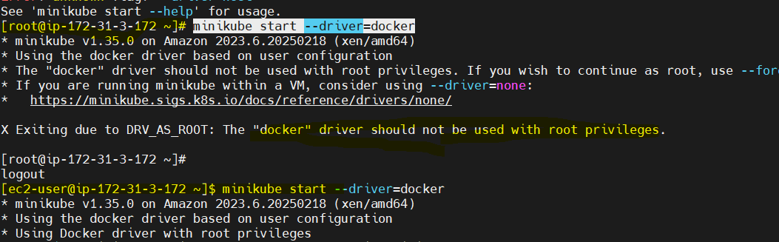

mi

minikube stop/status

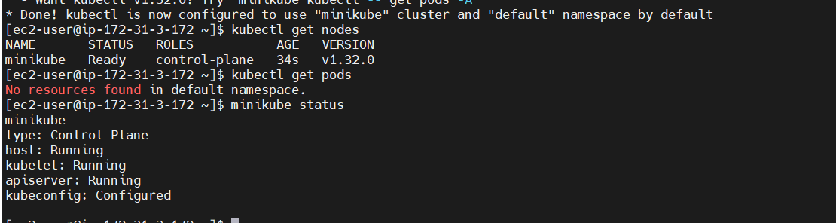

pod.yaml----------------------------------------------------------------------------------------------------

minkube installed:

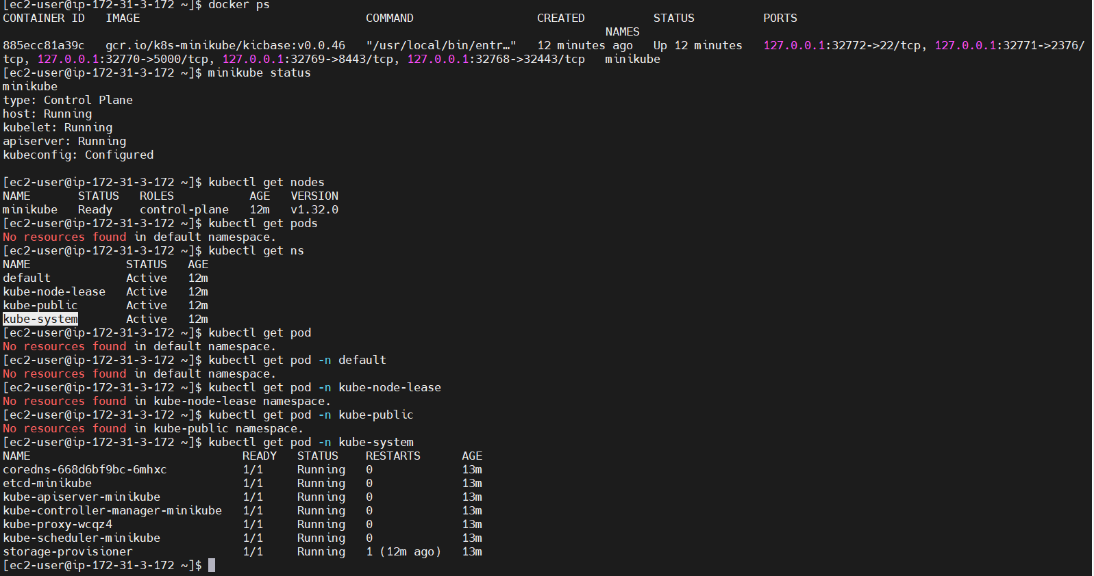
apiVersion: v1
kind: Pod
metadata:
name: first-pod
spec:
containers:
- name: my-first-container
image: nginx

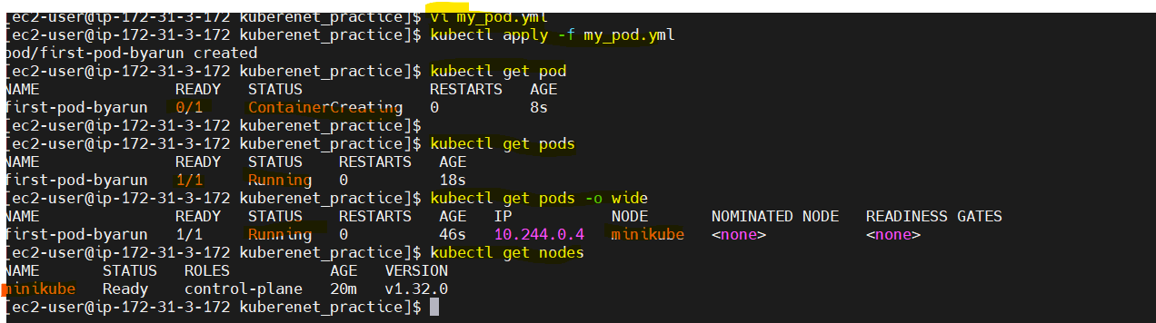

kubectl delete replicaset --all -n my-namespace
kubectl delete replicaset --all
kubectl delete rs nginx-replicaset
kubectl delete deployment --all
kubectl delete replicaset –all
deployment will crete rs- rs will craete pods
[ec2-user@ip-172-31-3-172 kuberenet_practice]$ kubectl get pods
NAME READY STATUS RESTARTS AGE
nginx-replicaset-2gnst 1/1 Running 0 110s
nginx-replicaset-m9z96 1/1 Running 0 110s
nginx-replicaset-x2mtn 1/1 Running 0 110s
[ec2-user@ip-172-31-3-172 kuberenet_practice]$ kubectl delete pod nginx-replicaset-2gnst
pod "nginx-replicaset-2gnst" deleted
[ec2-user@ip-172-31-3-172 kuberenet_practice]$ kubectl get pods
NAME READY STATUS RESTARTS AGE
nginx-replicaset-m9z96 1/1 Running 0 2m3s
nginx-replicaset-x2mtn 1/1 Running 0 2m3s
nginx-replicaset-zs4lf 0/1 ContainerCreating 0 3s
[ec2-user@ip-172-31-3-172 kuberenet_practice]$ kubectl get pods
NAME READY STATUS RESTARTS AGE
nginx-replicaset-m9z96 1/1 Running 0 2m9s
nginx-replicaset-x2mtn 1/1 Running 0 2m9s
nginx-replicaset-zs4lf 1/1 Running 0

----------------------
- kubectl edit rs <replicaset name>
- kubectl get pods –watch
just you change save it will reflect no need to apply once again
you change replicaset 4 in vi replicaset.yml – apply
where as edit just scaleup/down in the rs in edit and just save no need to apply like declarative chnage.

Rolling update :
i have created the the rs with image after 1 week i nned to deploy new image so need to chnage image name in rs.yaml file and need to create so for this downtime requred to avoid this we are using the rooling update .
- i will create new pods with new image (if new pod created 1 old pod is delete(old image included pod) .so no downtime . (means first new pod created then old pod will delete to ensure keep maintan the desired state and current state of pod.)
Rolling update is not there in the replicaset so its there in the deployment so we need to craete the deployment.yml
deployment will create rs- rs will create pods
-------deployment – rooling update fetaure is ther

DEPLOYMNTS:
object:
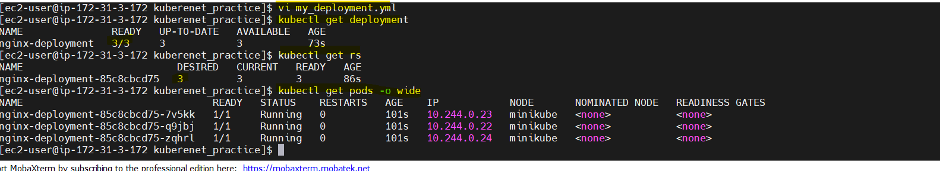
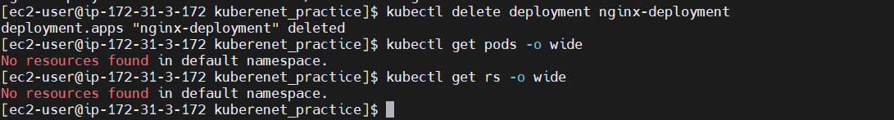
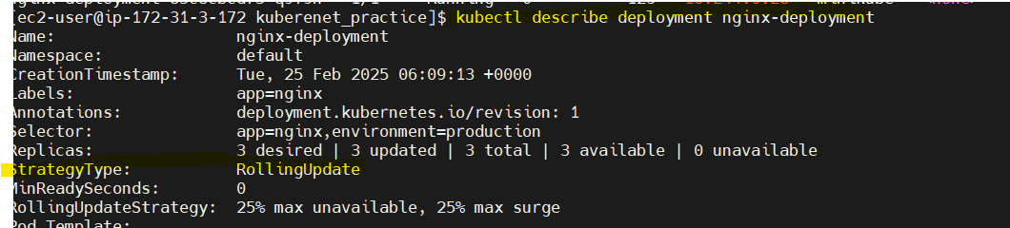
if you delete rs it will create 3 rs (3 pods )
if you describe the replicaset you can able to see this replicaset (no downtime if we are using the deployment )
When you update the image in a Kubernetes Deployment, it follows a rolling update strategy to ensure zero downtime.
25% max unavailable and 25 % max surge

1. Kubernetes creates maxSurge new Pods (2 extra Pods) using the updated image.
2️. Once the new Pods are running, Kubernetes terminates maxUnavailable old Pods (2 Pods).
3. It repeats this process until all 10 Pods are replaced with the new version.
maxUnavailable | Controls how many Pods can be down at a time (ensures app availability)
maxSurge | Controls how many extra Pods can be created during the update (ensures smooth rollout)
25% 10= 25/100*10 = 2.5 (so 2 pods )
first it will craete 2 pods then terminate
Before Update | 10 | 0 | 10
Step 1 | 10 | 2 (new created) | 12
Step 2 | 8 (2 old removed) | 2 | 10
Step 3 | 8 | 4 (2 new added) | 12
Clear the space:
#!/bin/bash

echo "🚀 Starting System Cleanup..."

# 1️⃣ Check disk usage before cleanup
echo "🔍 Disk usage before cleanup:"
df -h /

# 2️⃣ Clean Docker system (Remove unused images, containers, and volumes)
echo "🛠️ Cleaning up Docker..."
docker system prune -a -f --volumes

# 3️⃣ Clean system logs
echo "🗑️ Clearing old logs..."
sudo journalctl --vacuum-time=5d
sudo journalctl --vacuum-size=500M

# 4️⃣ Remove unnecessary packages & cache
echo "📦 Removing unused packages..."
sudo apt autoremove -y
sudo apt clean

# 5️⃣ Identify large files (manually review before deleting)
echo "🔎 Large files in the system (above 500MB):"
find / -type f -size +500M -exec ls -lh {} \; | awk '{print $9, $5}'

# 6️⃣ Clean Minikube & Kubernetes cache (if installed)
echo "🔥 Removing Minikube data..."
minikube delete
rm -rf ~/.minikube
kubectl cache prune || echo "⏩ Skipping Kubernetes cache cleanup (kubectl not found)"

# 7️⃣ Remove old kernels (for Ubuntu/Debian users)
echo "🔄 Removing old kernels..."
sudo dpkg --list | grep linux-image
sudo apt-get autoremove --purge -y

# 8️⃣ Check disk usage after cleanup
echo "✅ Cleanup Completed! Disk usage now:"
df -h /

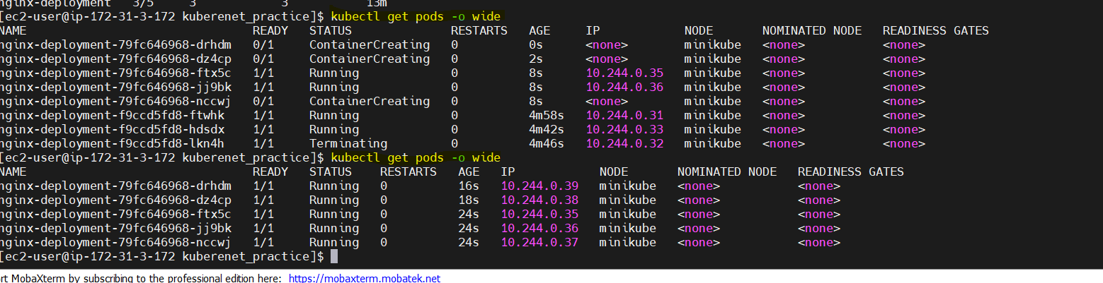
how rolling update happen in deployment?
Change the image name in deployment file
nginx:latest to 1.42.1 so earlier 3 pods – craete 1 new container >creting container , after new terminate one old pod with old image.
Earlier in deployment.yaml is 3 replica i edited as 5 by kubectl edit deployment <deployment_name>
see now total 8 – showing in first command (createing container , running, terminate the one old pod like this move one )
ok in second command we can able to see 5 pods are running (get rs – desired also 5 and current 5)
if delete one pod ammong 5 – deployment will check 5 rs so it will create 5 pods automaticaly.
[ec2-user@ip-172-31-3-172 kuberenet_practice]$ kubectl delete pod nginx-deployment-79fc646968-drhdm
Error from server (NotFound): pods "nginx-deployment-79fc646968-drhdm" not found
- pod name will also change once delete and created one new pod menas

[ec2-user@ip-172-31-3-172 kuberenet_practice]$ kubectl delete pod nginx-deployment-79fc646968-9c4bw
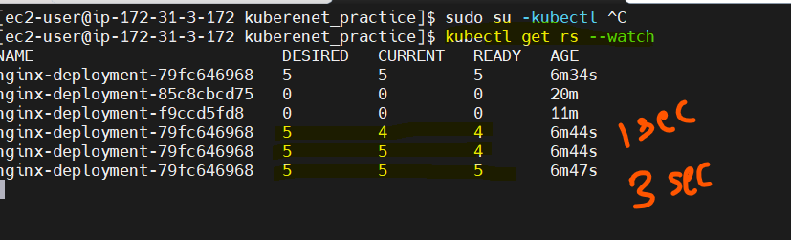
difference:::
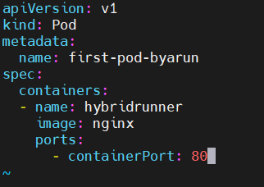

pod: spec about containers only where as rs and deployment spec about the replicas

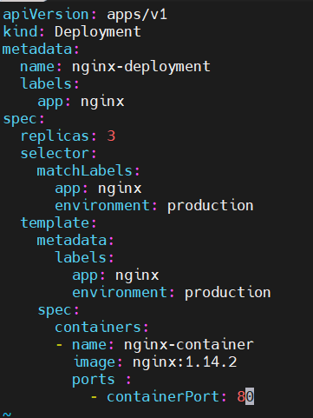
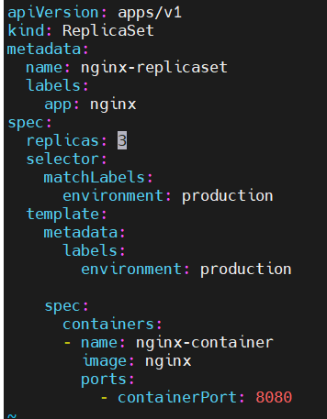

finaly what is the difference – what need to update evry time- when to use what ?
Differance:
note: Object names (kind) are in PASCAL CASE
eature | Pod (pod.yaml) | ReplicaSet (replicaset.yaml) | Deployment (deployment.yaml)
Purpose | Runs a single Pod | Ensures a specific number of Pods are running | Manages ReplicaSets and rolling updates
API Version | apiVersion: v1 | apiVersion: apps/v1 | apiVersion: apps/v1
Kind | kind: Pod | kind: ReplicaSet | kind: Deployment
Replica Count | ❌ (No replicas) | ✅ spec.replicas: N | ✅ spec.replicas: N
Self-healing | ❌ (If pod crashes, it won’t restart) | ✅ (Ensures a fixed number of pods) | ✅ (Manages pod updates & scaling)
Rolling Updates | ❌ No update strategy | ❌ No update strategy | ✅ Rolling update using strategy:
Template Section | ❌ Not needed | ✅ Required (spec.template) | ✅ Required (spec.template)
Selector Needed? | ❌ No selector | ✅ Needs a selector (spec.selector) | ✅ Needs a selector (spec.selector)

what need to update evry time
Update Scenario | What to Modify? | Which File?
Increase/decrease replicas | spec.replicas | replicaset.yaml or deployment.yaml
Update container image | image: new-version | deployment.yaml
Add environment variables | env: inside spec.containers | pod.yaml, replicaset.yaml, or deployment.yaml
Rolling update strategy | spec.strategy: | deployment.yaml
Pod labels | metadata.labels | pod.yaml, replicaset.yaml, or deployment.yaml
when to use what
pod.yaml → Only for testing a single Pod.
- replicaset.yaml → Ensures availability but not recommended for production.
- deployment.yaml → Best practice for managing applications in Kubernetes (auto-scaling, updates, rollbacks).

Cluster ip service what?

Option 2: Directly Accessing a Pod’s IP in Kubernetes
Each pod in Kubernetes gets a unique internal IP address assigned by the cluster's CNI (Container Network Interface). You can use this Pod IP to access the application within the cluster, but not from outside.

1️⃣ Steps to Access a Pod's IP Directly

🔹 Step 1: Get Pod IP
List all pods and their IPs:
kubectl get pods -o wide
Example output:
NAME READY STATUS IP NODE
nginx-6f58958dc8-abc 1/1 Running 192.168.1.10 ip-172-31-0-5
nginx-6f58958dc8-xyz 1/1 Running 192.168.1.11 ip-172-31-0-6
👉 Pod IPs: 192.168.1.10 and 192.168.1.11

🔹 Step 2: Test Access from Another Pod
If you have another pod running in the same cluster, you can access the pod directly using its IP.

🔸 Method 1: Using kubectl exec (From an Existing Pod)
If you already have a running pod (e.g., my-app), you can exec into it and test access:
kubectl exec -it my-app -- /bin/sh
Inside the shell, use curl or wget:
curl http://192.168.1.10
1.10 is also target port

🔸 Method 2: Using a Temporary Debug Pod
If you don’t have an existing pod, start a temporary one:
kubectl run -it --rm --image=alpine debug-pod -- /bin/sh
Inside the pod:
apk add --no-cache curl # Install curl if needed
curl http://192.168.1.10

2️⃣ Why Pod IP Access is Not Reliable?
- Pods are ephemeral: If a pod restarts or scales down/up, its IP will change.
- Not load-balanced: If multiple pods exist, you need a Service (ClusterIP, NodePort, or LoadBalancer) to manage traffic properly.
💡 Best Practice: Instead of using Pod IPs, use Service DNS names (my-service.default.svc.cluster.local).

🚀 Summary
Task | Command
Get Pod IP | kubectl get pods -o wide
Exec into a Running Pod | kubectl exec -it my-app -- /bin/sh
Start a Temporary Debug Pod | kubectl run -it --rm --image=alpine debug-pod -- /bin/sh
Access Another Pod via IP | curl http://<POD_IP>
Let me know if you need further clarification! 🚀

C:\Users\arunc\OneDrive\Desktop\devops\k8s\k8s - eksctl steps
practicle
in another region i created on cluster. my_eks cluster
1. aws cli installed by defult so install eksctl, kubetctl, command to crete cluster
- EC2

2. Instances>i-048b4>75b3d0224dbd>modify_iam_role>assin role
9crete role and add permission ec2 administration acces
IAM user should have access to
IAM
EC2
VPC
CloudFormation (eksclt creation helpfull )
i gave administration acces.

note: attch aws admin role whi;e instance running only (crete one role and select ec2 and choose administration policy)

[root@ip-172-31-3-172 ~]# PS1="EKS $"
EKS $
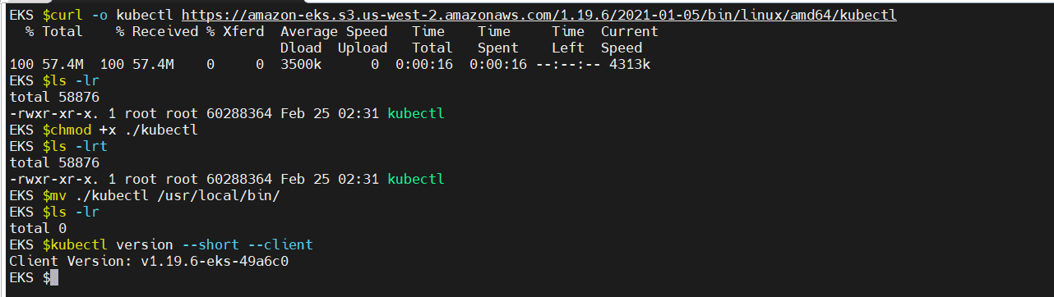
2. kubectl install
3. install eksctl :
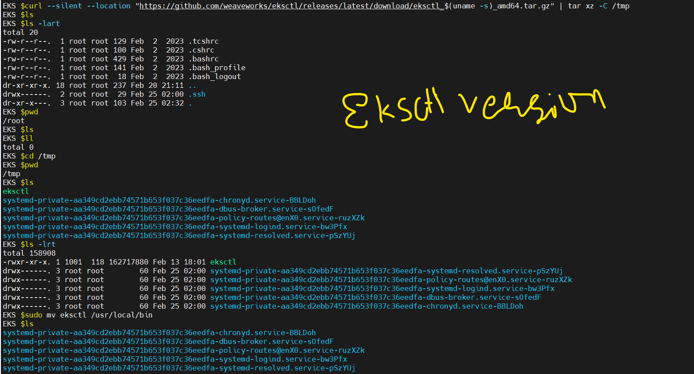
4. create cluster
eksctl create cluster --name my-lab-cluster --region us-east-1 --node-type t2.medium
--make autcomletion..
- source <(kubectl completion bash)
this is temprory enable completion in currect session.

- echo "source <(kubectl completion bash)" >> ~/.bashrc
- source ~/.bashrc
5. varify: Kubectl get nodes
EKS $kubectl get nodes
NAME STATUS ROLES AGE VERSION
ip-192-168-17-194.ec2.internal Ready <none> 9m38s v1.30.9-eks-5d632ec
ip-192-168-46-199.ec2.internal Ready <none> 9m38s v1.30.9-eks-5d632ec
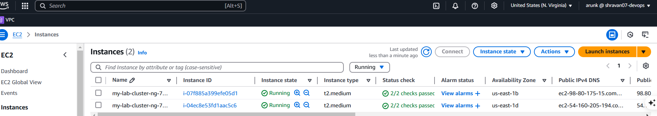
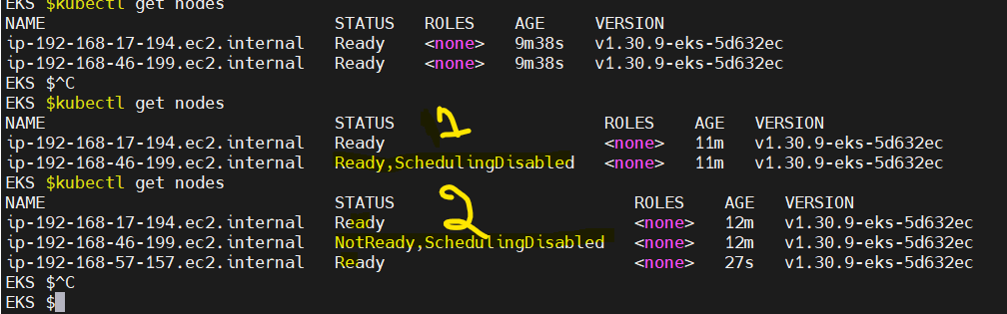
EKS $
note: if you stop/ delete manually or crash automaticaky another nde will create :

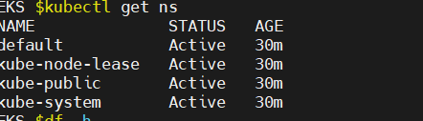
h

labels in deplloyment under template section and selector in service both showuld same
so that traffic will go from service to pods.
Actually traffic will go from ip (via packets traffic will go )- ep will take care , ep willl track all ip address.
- template hash will create once you applied the deployment (trafiic based on template hash also (if i deployed 3 replicaset with labesls for that deployment all 3 pods tepmaplet hash will same )
another person craete deployment file with same name for him also he will get the template hash is diffrent based on templaate hash also flow will go.

If pod ip change (pod delete, crash, restart ) by using the services and epp we can track and send traffic to respective pods.
Pod itself it will craete container )in k8s
-----------------------------------------------------------------------------------------
services practicle
Ah, I see what you're referring to! In EKS with eksctl, while worker nodes automatically join the cluster when you create a node group
error:
The error "Unable to connect to the server: dial tcp 192.168.49.2:8443: connect: no route to host" suggests that your kubectl client cannot communicate with the Kubernetes API server.
- aws eks describe-cluster --name my-lab-cluster --region us-east-1 --query 'cluster.status'

An error occurred (ResourceNotFoundException) when calling the DescribeCluster operation: No cluster found for name: my-lab-cluster.
I dleted cluster- and trying to execute kubectl get nodes so kubectl is not communicating with api servers

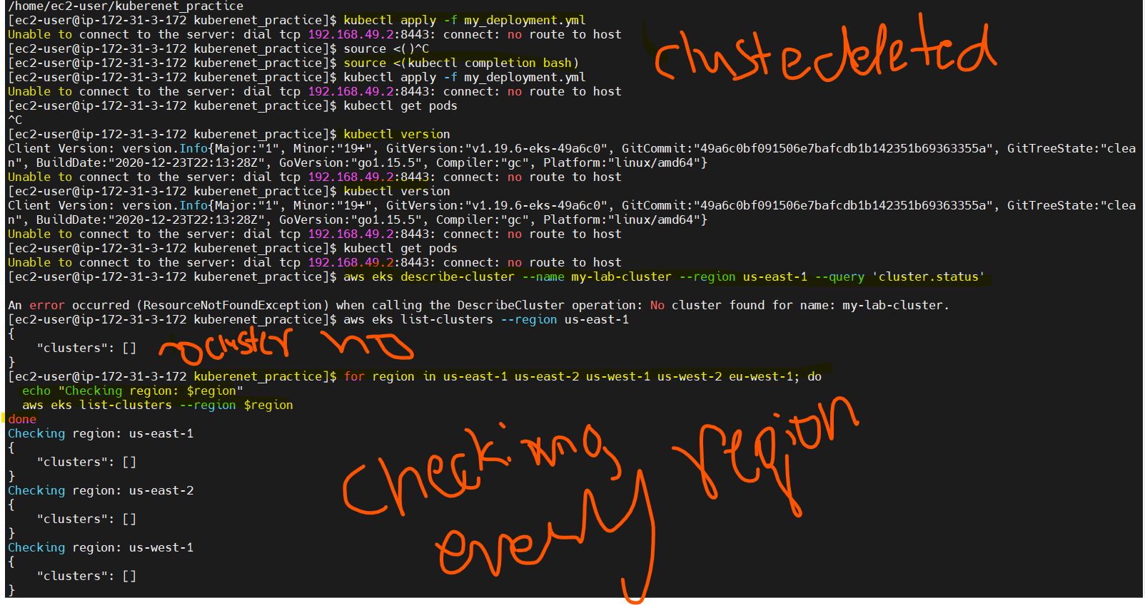

before applying .yaml use the syntax and indentaion:
Use yamllint (Best for Syntax & Indentation Checks)
install based on os – yamllint <file_name>
install :
For Amazon Linux, CentOS, RHEL
- sudo yum install -y epel-release
- sudo yum install -y yamllint
For Ubuntu/Debian:
- sudo apt install -y yamllint
---------------------------------------------------
- kubectl apply --dry-run=client -f your-file.yaml
This checks for Kubernetes-specific syntax errors without actually applying the changes.
enable the numbers
:set number
:set nonumber to remove then
go directly line no
8G 0r :8
-----------------------------------------------------------------------------------------------------------------------
create node port service to expose nginx
to expose all 3 pods (in deloyment 3 rs we declare )
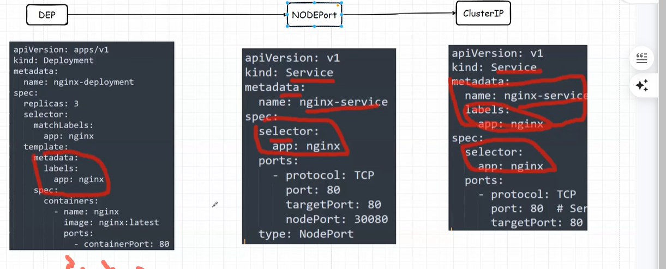

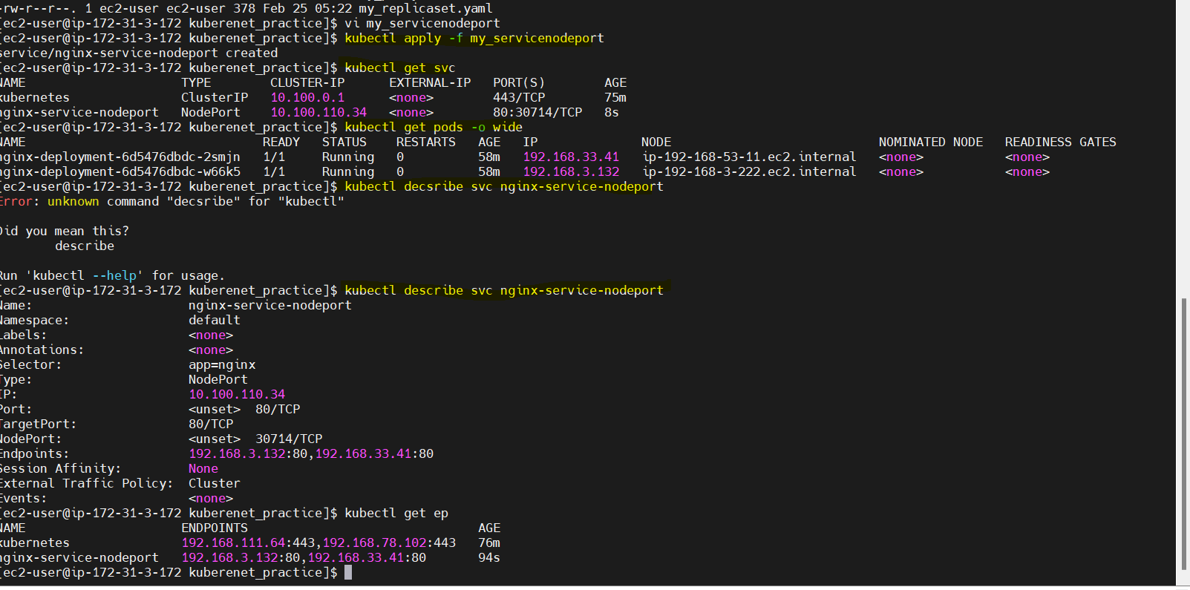
203.101

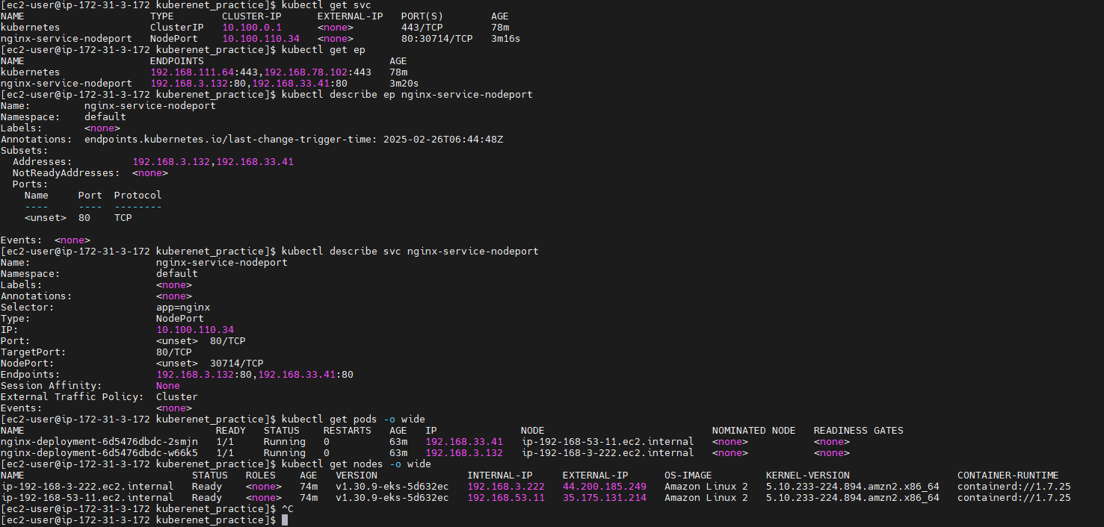

check the nodeport : inside svc and open the port in the SG.
Publicip:nodeport
o/p – welcome to nginx
disadvantage: we nned to open the port i sg of each node servers sg
- every time access applictaion via publicip:port )this public ip will change if its restart crash)

30000 – 32767 like in the port need to open the port in sg (where as container port will no need to add just you add listner
comparision with deploymnet and service(clusterip, nodeport)

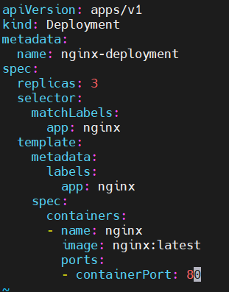
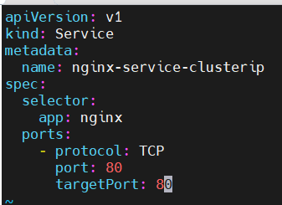
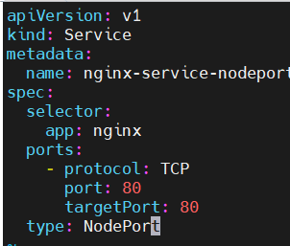
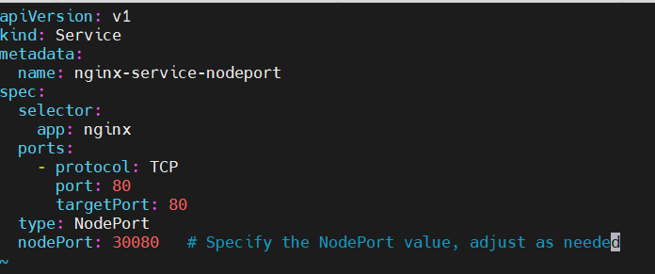

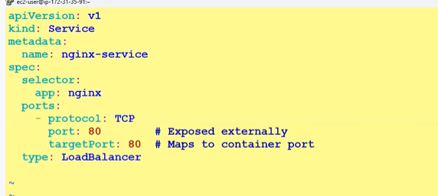
kuberenets 11/00/2025 start fro config-map and secrete key
load balancer service:

use same deployment an duse above service.
i am not open the any port opening at node level (security group)
i am not giving any ip:node port in the browser for accessing the application.
No i just use the load balancer (external ip) kubectl get svc – undert external ip and in aws console DNS name.
So this is advanatage of loadbalancer.
NOTE:
if you craete service and apply means aws will create the loadbalancer with one neame and you can see the node ip address in the target group.
Use the this dnc to convert the name (bookmy.show with route 53 service )
config map and secraete:

pass the info while creating the deploment , if db password chnage no need to hardcode that value in any common-property file and create the code and crete dockerfile and build the image and run the container is not good thing.
- password or some variable not add in code or hardcoded that is not good practice.
- configmap and secret both are same configmap pass the non sensitive info where as secrete pass the sensitive info (db passwd, ssh key, token all comes under secreate)
- config map = env=production
- secrete= passwd=King@123@7760
in config map it will show the value secrete will show encoded format – we can check all these from below figure.(encrypted format)
craete config map from impertive way:
- kubectl create configmap app-config –from-literal=app_name=arun_app –from-literal=app_port=8080
from literal means from keyboard take value
this value need to set it in the deployment file. Or pod.yaml
- create config map
- kubectl get configmap
- kubectl describe configmap <app-config>
use this info in pod.yaml or deployment.yaml just you add envForm add in the pod.yml below image name.
- kubectl get pods
- login pod and check the value what we added
- kubectl exec -it <nameofpod> -- env
you can able to see app_name and port
- kubectl exec -it nginx-pod – sh
inside container type env we will get same output
--------troubleshoot about minikube ----

issue:
The connection to the server localhost:8080 was refused" usually means that kubectl cannot connect to the Kubernetes API server
minikube is not strated or eksctl cluster is not there measn kubectl is not communicating with apiservers
- minikube is controal plane eksctl take care about the controal plane (4 componet)

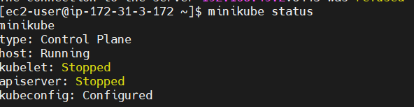

kubelet and api servers running after only – use the commands
(execute all commands – ouside root not in the root)
- check the cpu and memory (requred 2 cpu and 2200Mb memory
- check docker service is running or not if no start or restart
sudo systemctl status docker
- try to delete and recret the minikube ( for mr its worked)
minikube delete
minikube start --driver=docker
still issue : Since the errors involve storage-provisioner and default-storageclass,
- try starting Minikube without addons: after minikube start enable addons
minikube start --driver=docker --addons=default-storageclass=false –addons=storage- provisioner=false

minikube addons enable default-storageclass
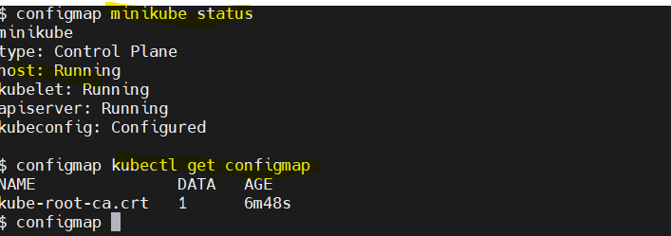
minikube addons enable storage-provisioner
after:

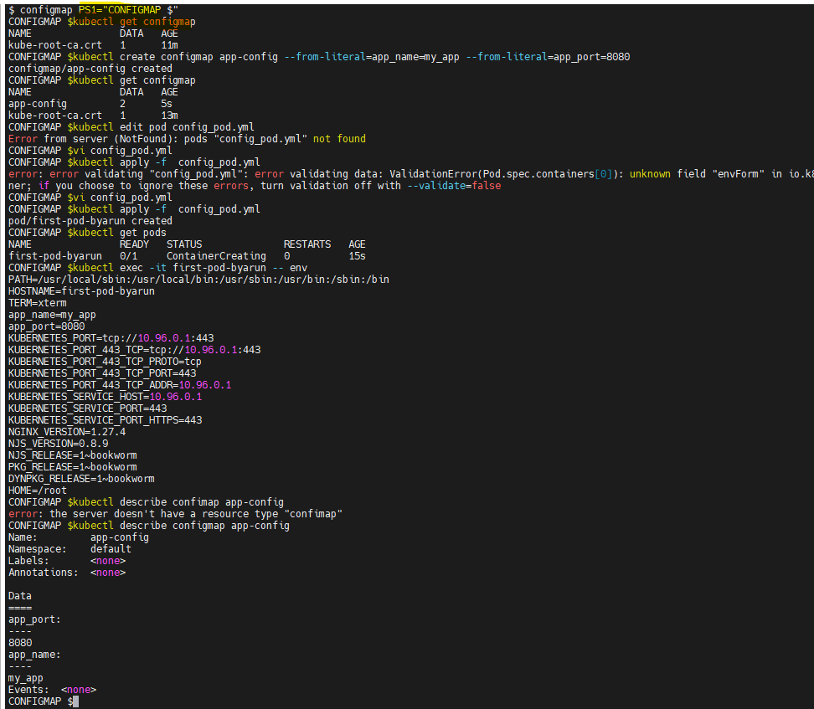
---trobleshooting complete for minkube -----------
configmap continue...........
set the path
- list teh config list
- craete the cmap by comm
- varify
- edit not working because not applied.
- in pod.yml added the envFrom and apply.
- check the env varibale inside pod or go insde container and type env and check.

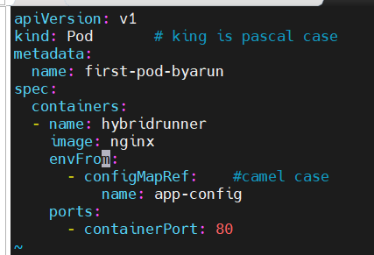

Added the configMapRef in pod.yaml and give the same name which one i gave while craeting the configmap.
- below image just i added configMapRef same pod only

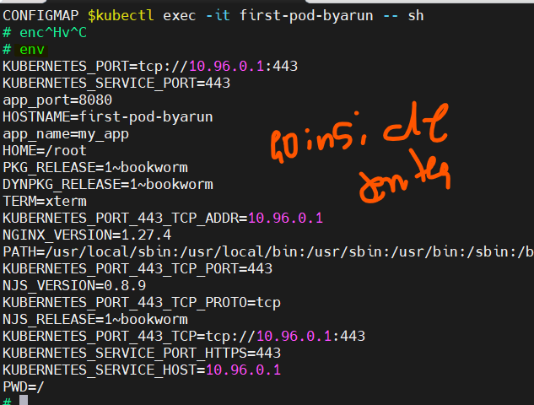

config map completed
secret start -------------------------------------------------------
kubectl create secret generic db-credentials --from-literal=username=admin --from-literal=password=admi@123
- if only one dash miss also it will show error:
- paswword you can see inside configuration(describe pod or go insed and ebetr env) not idf describe sercert means it wil show like 8 byte 5 byted but config map was shows tha value.
- craete srcrete and get and describe and add secrete inside po/deployment.yaml and apply.
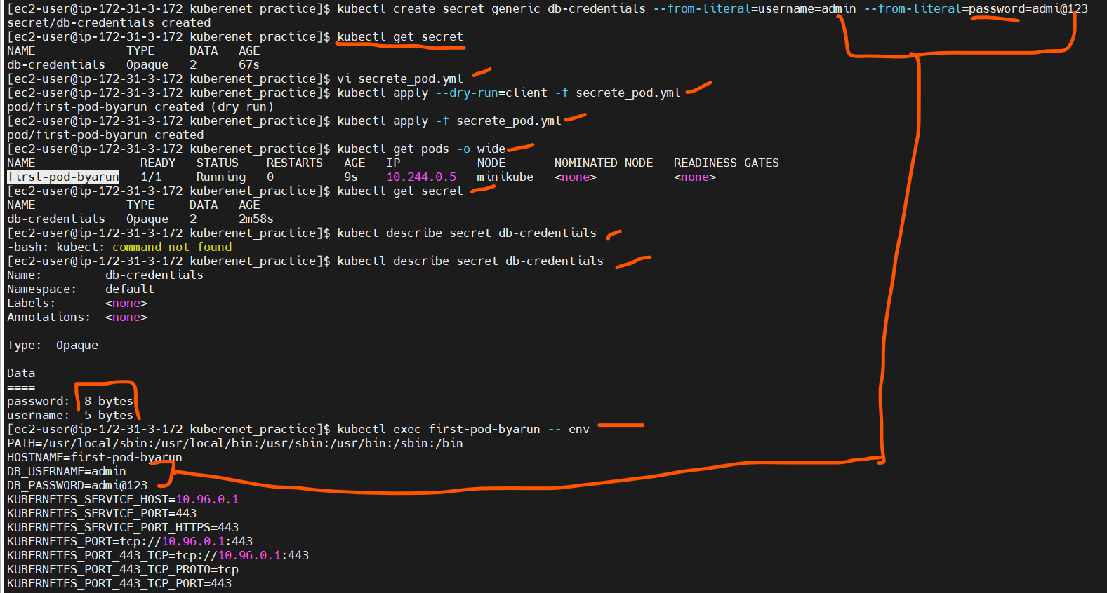
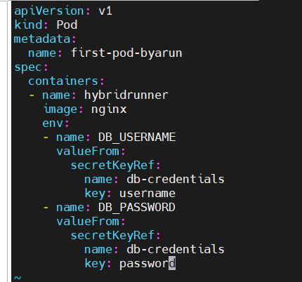
Kubectl craete if miss any – also will give error
- create secrete and add secretKeyRef in pod.yaml for both enviornmnetal variable under image (mention env and add secrrte keyref name and key – no value )
- apply secrte and describe secret you can able to see the username and password if exec and pass env or inside po/container you can able to see the username and passwd (see above)

configmap -envFrom: configmapRef and name mention
secret- env – name of secret valueFrom-secretKeyRef- name and key mention
its is not mandtory if you want to pass env variable at the time of launch (at th etime of pod/deployment file creation)
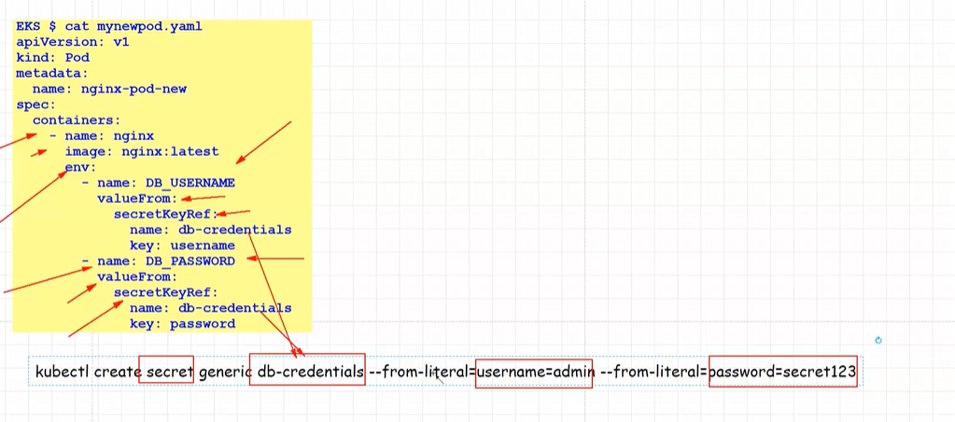

db-credentials is secret name :
valuefrom- secretKeyRef -db-credintials is secreteKeyRef
secret is completed-----------------------------------------------------------------------------------
go to k8s eployment- copy and paste or wget <https://>
------------------------------start---------------------------------------------------
--------------------------------------------------------------------------------------------------------
NAMESPACE-SERVICE ACCOUNT-ROLE>ROLE binding -cluster role>cluster role binding
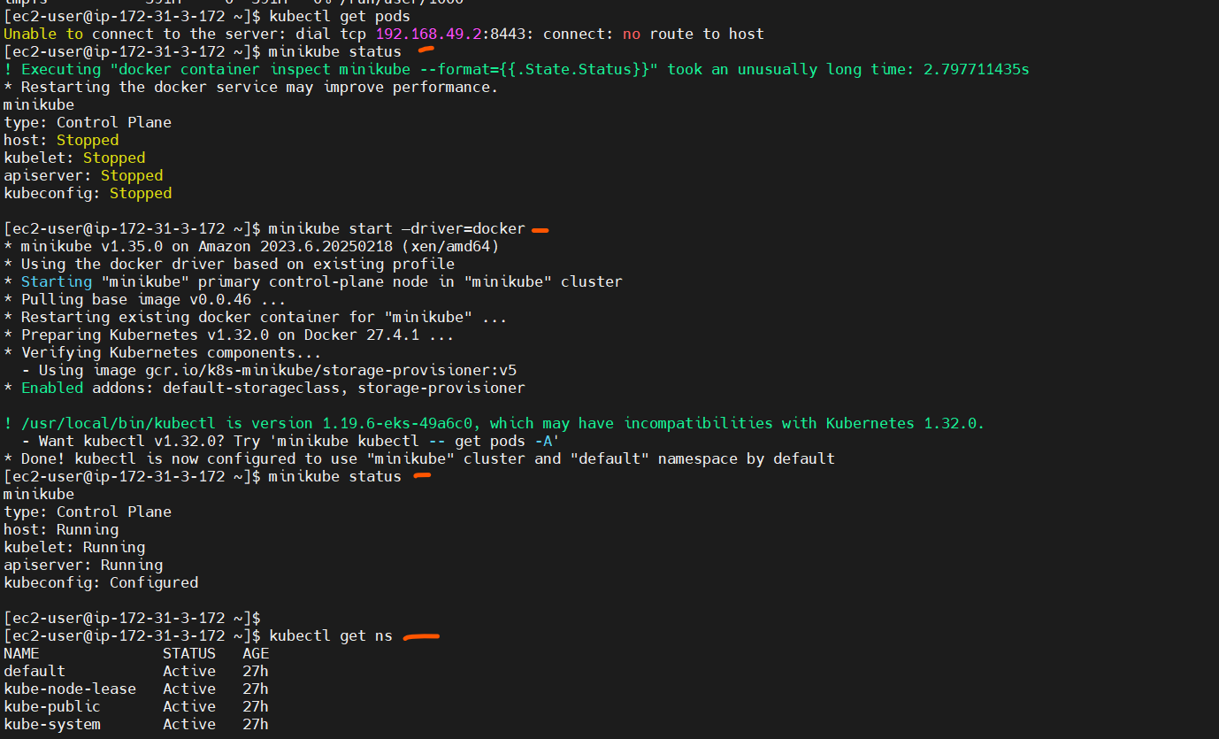
Minikube is in stopped condiation so kubelet is not communincating with api server of contraol plane (minikube)

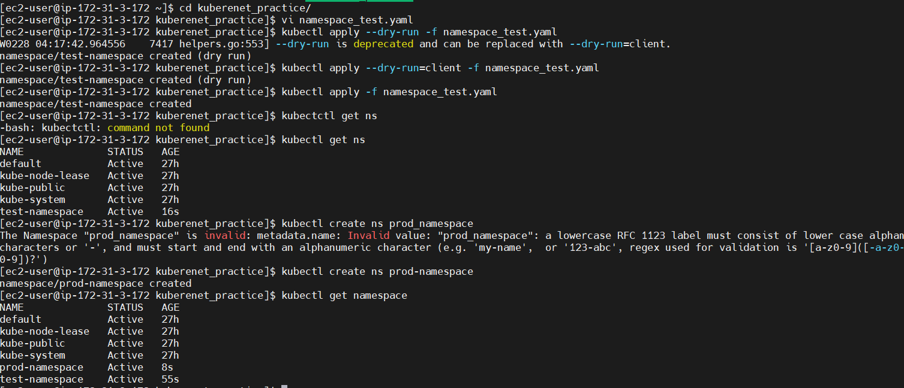

# test namespace
apiVersion: v1
kind: Namespace
metadata:
name: test
namespace craeted.
role have limitation have namespace level
cluster role is entire cluster(all namespace in cluster) roles we mentioned -action <CRUD> operation we mwntioned in cluster role binding then binde this cluster role to serviecaccount
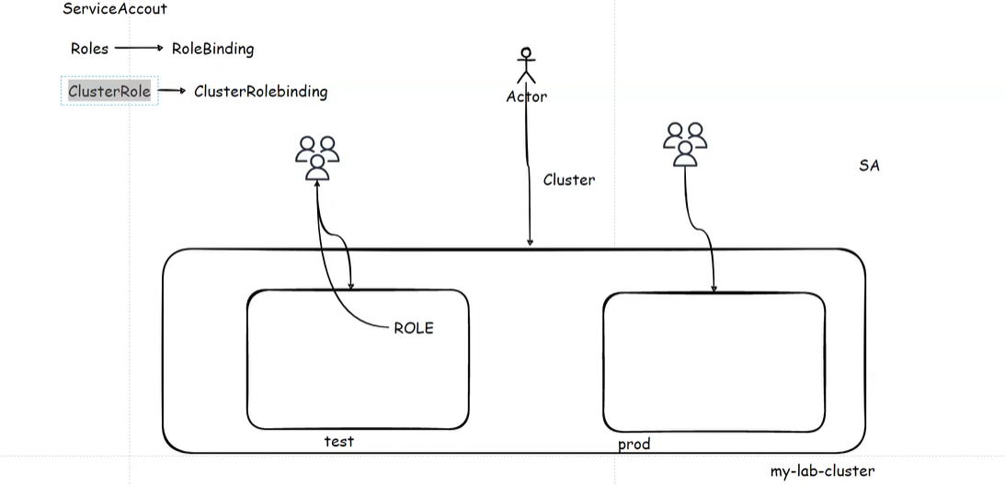
Admin

Service account
Service account

namespace
namespace
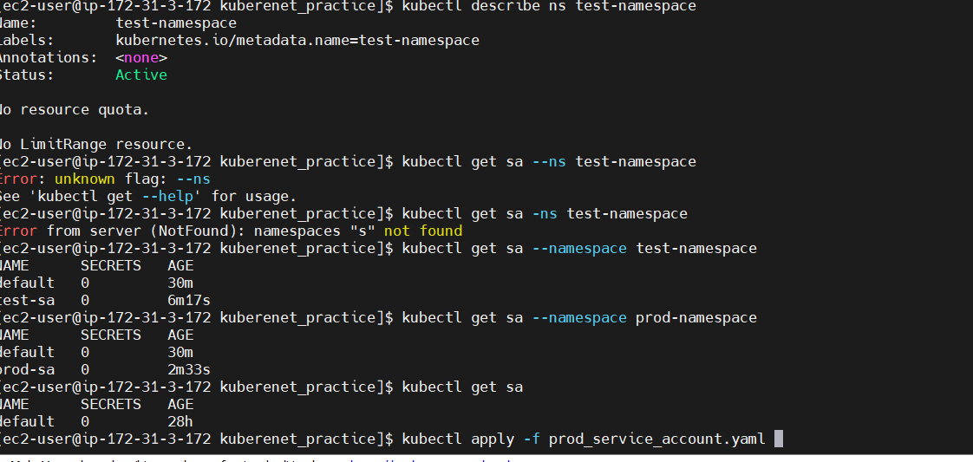

# Service Account for test namespace
apiVersion: v1
kind: ServiceAccount
metadata:
name: test-service-account
namespace: test
service account created completed----------------------------
role start----------------
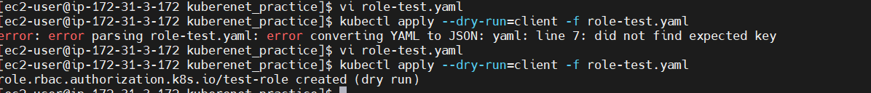
for Role king not v1
apiversion is “rbac.authorization.k8s.io/v1 (above steps i missed v1)
line no 7:7 in vi ediator i missed – apiGroups under Rules: section after adding it works
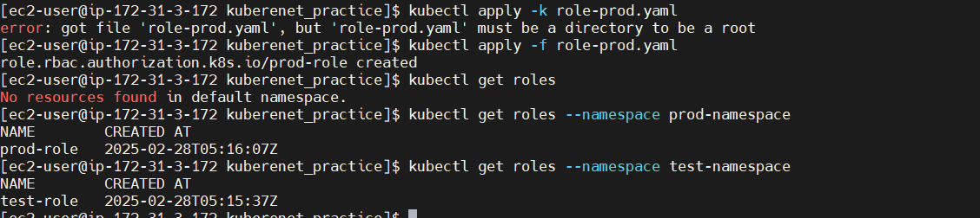
kubectl get role – it’s show empty because default namespace dosent have any role
- kubectl get role -n prod-namespace
it willl show the role (namespace+rules)
role is nothing but policy in the IAM (AWS)
# Role for test namespace
apiVersion: rbac.authorization.k8s.io/v1
kind: Role
metadata:
namespace: test
name: test-role
rules:
- apiGroups: [""]
resources: ["pods"]
verbs: ["get", "list", "create", "delete"]

role binding--------------------------------------------------
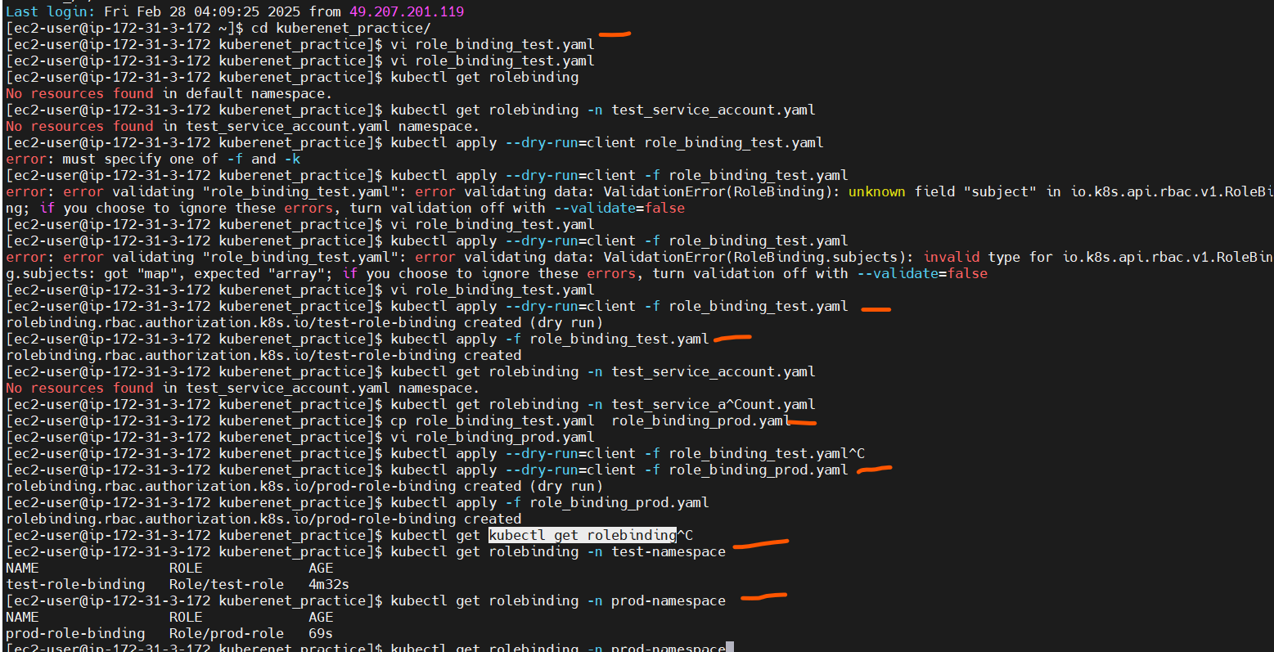
you go to – k8s RBAC and copy and paste
serviecaccount also craeted so need to check – no varify that test name and service accountv have specific role only – accessing only related pod right ?
So create deployment and mention the sa / namespace in that (replicas, kind)

link : https://kubernetes.io/docs/reference/kubectl/generated/kubectl_auth/kubectl_auth_can-i/
deployment created with replicas: 2(2 pods will craete) - cluster 2 nodes are tegrer so 2 pods will create in one node or each pod in one nodes – based on the resources
in deployment:
specify – kind , name odf eployment, replica, template, selector, container anem, image and service account (under spec befor contianer section)
my command:
kubectl auth can-i create pods --as=system:serviceaccount:test-namespace:test-sa -n test-namespace
kubectl auth can-i <verbs> <kind/objects> --as=systemserviceaccount:<namespace>:<service-account_name> -n <namespace_name>
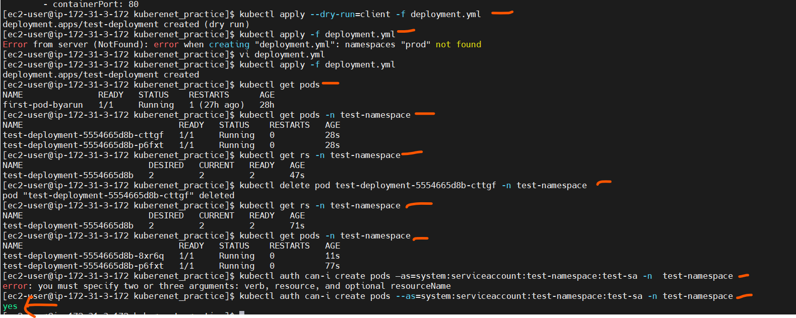
some command to get the roles which if you describe role with namespace it will show .
Based on that you can use auth-can-i
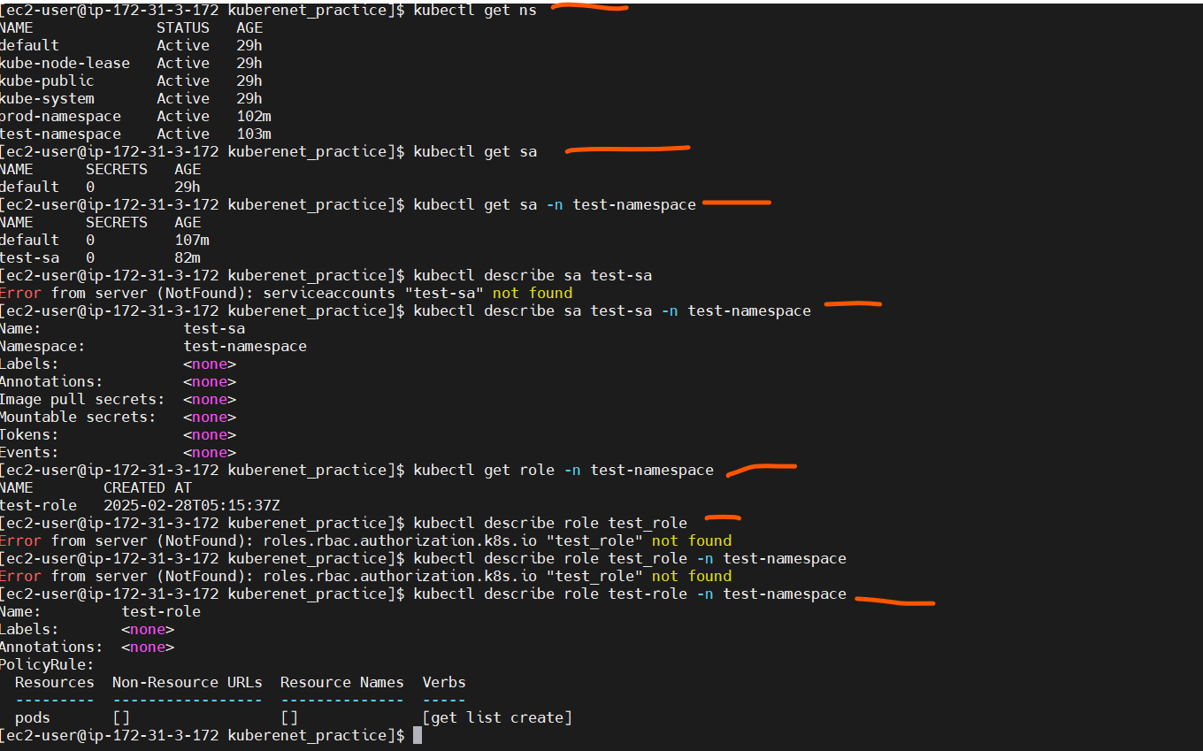

test-namespace only get list craete only- see below
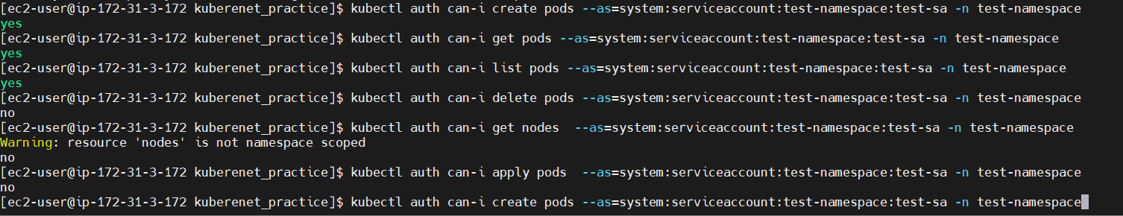
prod namespace get list craete delete for only pod objects.

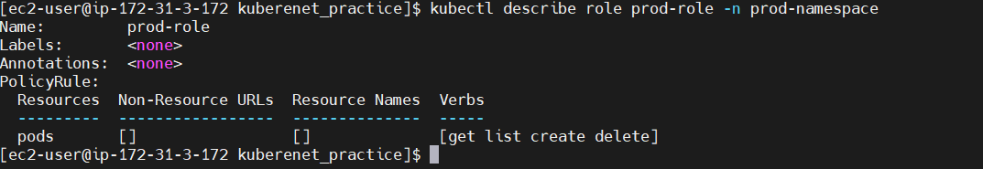
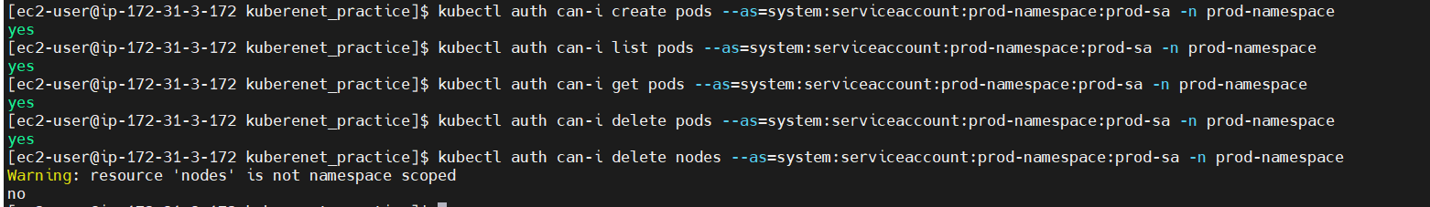
Varify:

imp:
delete pods in testnamespaec – no but in prod namespce yes because role is attch
- you connected testnamespace and try to get pods of prod namespace – is it possible
no its not possible

every time nned to enter namespace to avoid this set the namespace in the kubeconfig:
kubectl config set-context --current --namespace=test-namespace
by this namespace i can able to dleete pod also
kubectl config get-contexts

CURRENT NAME CLUSTER AUTHINFO NAMESPACE
* minikube minikube minikube default
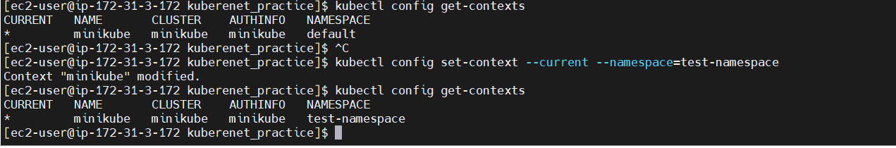
it will show which namespace you are in. Check ns and set teh ns:

Issue:
You created an RBAC Role for the test-namespace with only get, list, create permissions for Pods. However, after restarting Minikube, you are still able to delete Pods in test-namespace. This means some other permission is granting you delete access.
Soluation:
. Minikube’s Default User Might Have Extra Permissions
By default, Minikube runs as a user with admin privileges. Even if you create a Role, your main user may still have full access.
To test this, check who you are authenticated as:
kubectl auth can-i delete pods -n test-namespace --as=system:serviceaccount:test-namespace:test-sa
o/p:
-------------------completed----------
namespace, role,service-account-creation-rolebinding to role to serviceaccount, below some yaml(test namespace only)
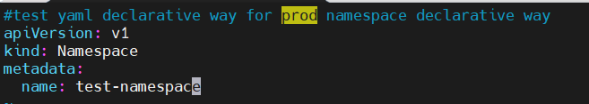

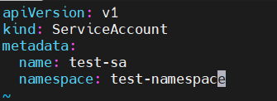

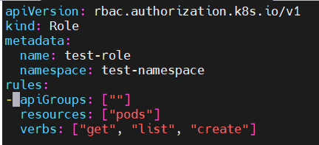
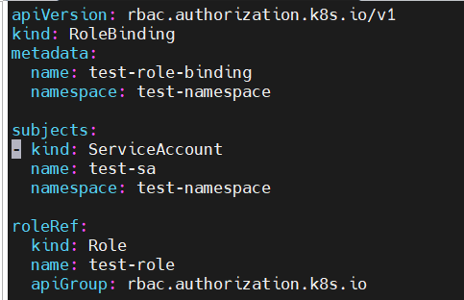
use some auth can-i for varify

above are role for particular namespace now -
cluster role – for entire cluster (whatever inside namespace are there all are getting the acces whatever mentined in the role)
- cluster role dont need to spsecify namespace

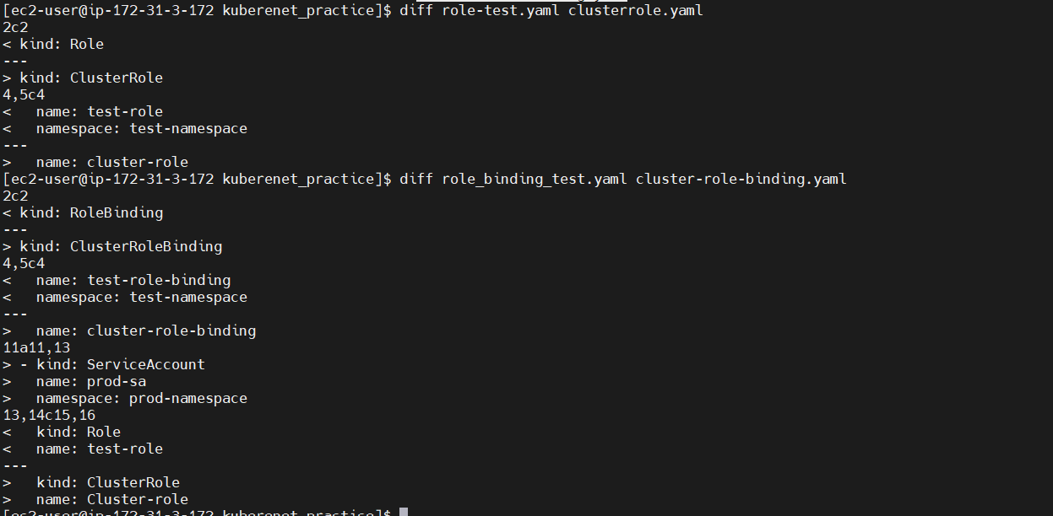

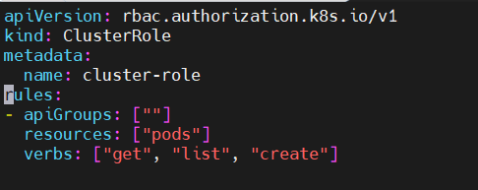
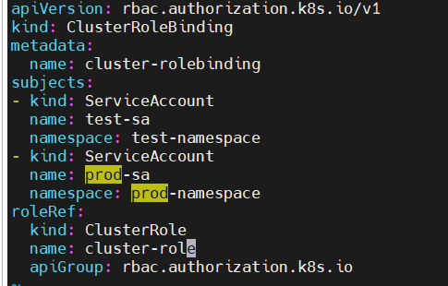

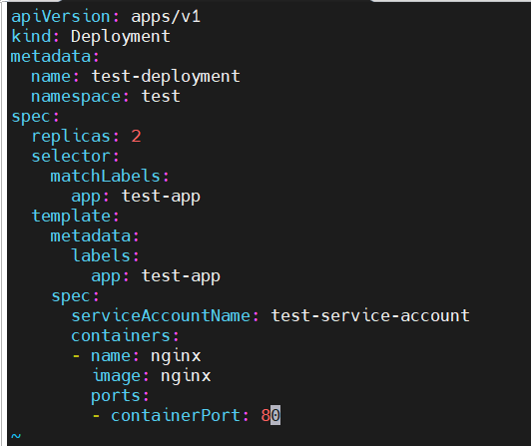
one deployment :

clusrer role have some issue in minikube:
solu:
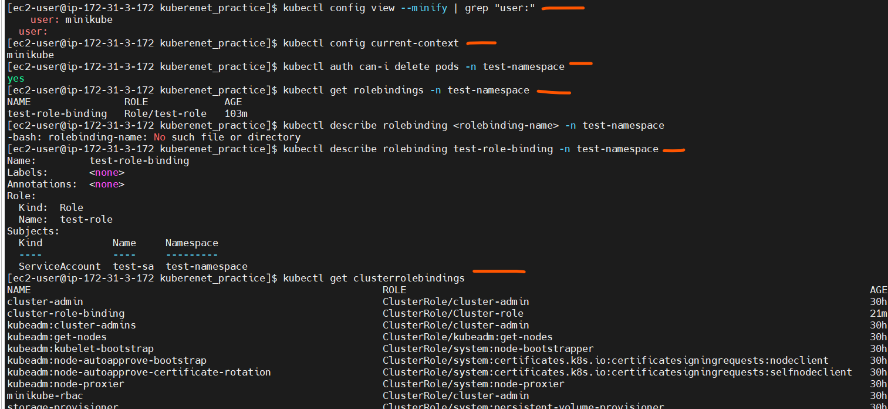
Check Who You Are Logged In As :
Check Who You Are Logged In As
you are using the Minikube admin user, which may have delete permissions
Check Current Context , you are minikube admin

cluster role binding completed-----------------------------------------------

------------------------------end---------------------------------------------------
--------------------------------------------------------------------------------------------------------

eks it has ec2 private ip address
2nd ip address – networking ip kuberenet will crete for interanl comminication
first ip (private ip : main ip assined by VPC for communicate within inside VPC
second ip- kuberenet will assine this ip (k8s CNI to assin multiple private ip (each pod in one node have specific ip address(private).
AWS Fargate is a serverless compute engine for containers that lets you run applications without managing EC2 instances. It works with Amazon ECS (Elastic Container Service) and Amazon EKS (Elastic Kubernetes Service).
No, you cannot replace EKS with Fargate, but you can use Fargate to run Kubernetes Pods inside EKS
One Private IP = EC2 node’s main IP.
- Extra Private IPs = AWS VPC CNI assigns them for Kubernetes Pods.
- More than one ENI = High availability or more network capacity.

storage-ingress(networking)-efk stack (demon set and Statefull set)

Kuberenets storage -----------
Types of Storage in Kubernetes
Kubernetes storage is mainly classified into two types:

1️⃣ Ephemeral Storage (Non-Persistent)
- Data is lost when the Pod restarts or is deleted.
- Used for temporary data, logs, and caches.
📌 Examples:(emphmeral types )
- EmptyDir → Temporary storage inside a Pod.
- ConfigMap & Secret → Stores configuration and sensitive data.
- HostPath → Uses the node’s local filesystem.

2️⃣ Persistent Storage (Stateful)
- Data is retained even if the Pod restarts or is deleted.
- Used for databases, logs, and long-term storage.
📌 Examples:
- Persistent Volume (PV) & Persistent Volume Claim (PVC) → Standard way to request storage in Kubernetes.
- Storage Classes → Dynamic provisioning of storage.
- CSI (Container Storage Interface) → Third-party storage integrations.

🔹 Why Are Different Storage Types Required?
Different applications have different storage needs:
Scenario | Best Storage Type
Temporary data (e.g., logs, cache) | emptyDir, hostPath
Configuration & secrets | ConfigMap, Secret
Database (e.g., MySQL, PostgreSQL) | Persistent Volume (PV)
Cloud storage (AWS EBS, Azure Disk, GCP PD) | StorageClass
Shared storage across multiple pods | NFS, GlusterFS, CephFS

Temproray storage: start
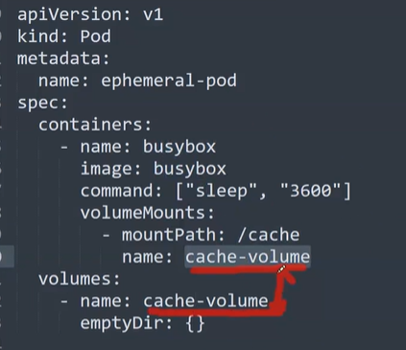

Continuosly run 1 hours of container then remove

volumeMounts(camelcase)
name of volume and mountPath

what i sthe emphemeral type
the above thing shame for all wheteher pod or deployment
volumeMounts: name of volumemount and name of volume should same elase we will get volume nt fount message will come.
- it will show creating creating – in the event we will see the volume not found meassge in the event op the pod.
docker run --rm alpine sleep 3600
after one hour stop cntainer once stop the container remove this container.
-----what will happen this sleep 3600
After 1 hour, the container exits (Pod status changes to Completed).
4️⃣ Pod remains in the cluster but does not restart automatically.
5️⃣ You can manually restart the Pod if needed.
- after 1 hour, the container exits, and the Pod status changes to Completed (not Exited, since Exited is a Docker-specific term
-----------------------------
kubectl get events –sort-by=.metadata.creationTimestamp
check events also .

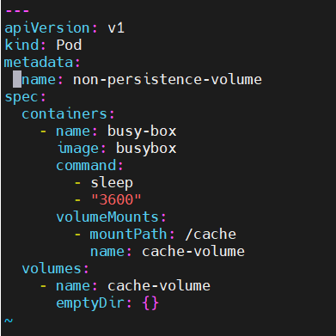
Digram – create one container inside container create the emphemeral staorage (emtydir) and mount that empimeral volume on /cache mount-point
mount-point(like c-drive create mount point and add 20 gb memory)
- When the Pod is deleted, all data inside /cache is lost.

Command: [“sleep”,”3600”] both are same

I created pod-applied-went inside pod- cheked disk spaces(df -h)-went insode /cache mount directory-created one file – exited from that pod and removed the pod- after that created pod with same configuration-after I cheked that file is not there (so its temperory/non persistencer)
- if pod removed data will also removed .
- k8s doesn’t have stop pause directly
------------------------------------------------------------------------
Temproray storage: completed

::::::::::::::::::::::::::::::PV, Pvc pod start(persistence storage start):::::::::::::::::::::::::::::::::::::::::::
procees with persistance storage…………………….(pv- create volume pvc- attach that volume to
pv – size of the volume
it will create the (/mnt/nginx) any one of the directory -hostpath
hostpath: create a directory in any nodes (eks 2 nodes)
choose any one of node and create /mnt/dat/nginx directory (api servers will take care create directory if its not there)
pvc- mention the access modes resouces allocate storage(less tha what we mentioned in the pv.yaml), mention the storage class path
deploment:create pod with storage
persistance volume :::::::::::::::::::::::
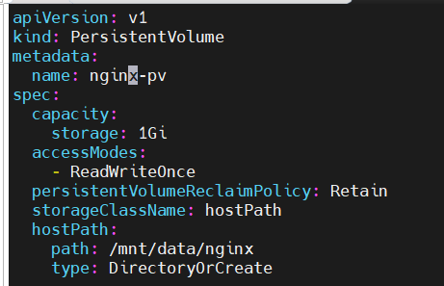
kubectl explain pv means it will show grous & version
what I sthe kind or object

name of the PersisentVolume
name of pv

how much storage we are creating. PersistentVolume (PV) with 20 GiB storage but your host machine has only 5 GiB free space, you will face storage allocation issues when Kubernetes tries to bind the PV to a PersistentVolumeClaim (PVC).
Error: no space left on device
AccesModes:
ReadWriteOnce (RWO) -Allows only one node to read/write at a time. Ex: databse workload
- The ReadWriteOnce (RWO) access mode allows only one node to mount the volume in read/write mode
ReadWriteMany (RWX)- multiple nodes ex: NFS based storage
ReadWriteOncePod (RWOP)- Only one Pod can access the volume at a time, even across nodes. Ex: statefull workload
ReadOnlyMany (ROX)
---
storageClassName is just a label that Kubernetes uses to match PersistentVolumeClaims (PVCs) with PersistentVolumes (PVs)
use /mnt/data/nginx on nodelocal filesystem as storage if dir doent exists k8s create the directory

in above digram you remove storageClassName hostPath to manual and apply
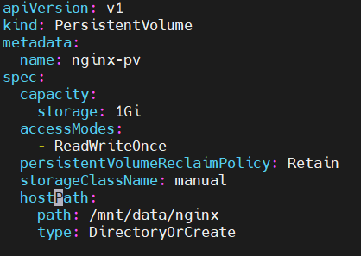
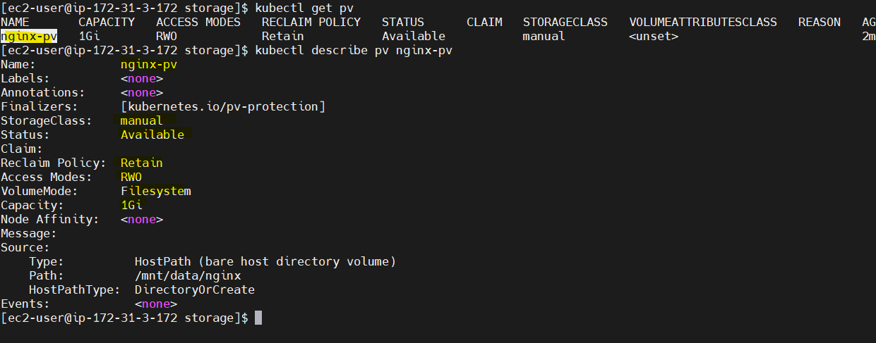
just change hostPath to manual because I got the error:

status is : available before claim volume
in volume – in-use and avilable in aws volumes

create pvc:::: for this pv::::::::::::::::::::::
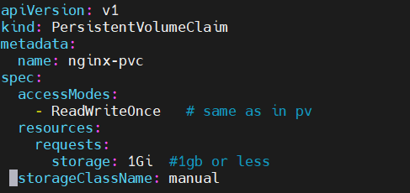

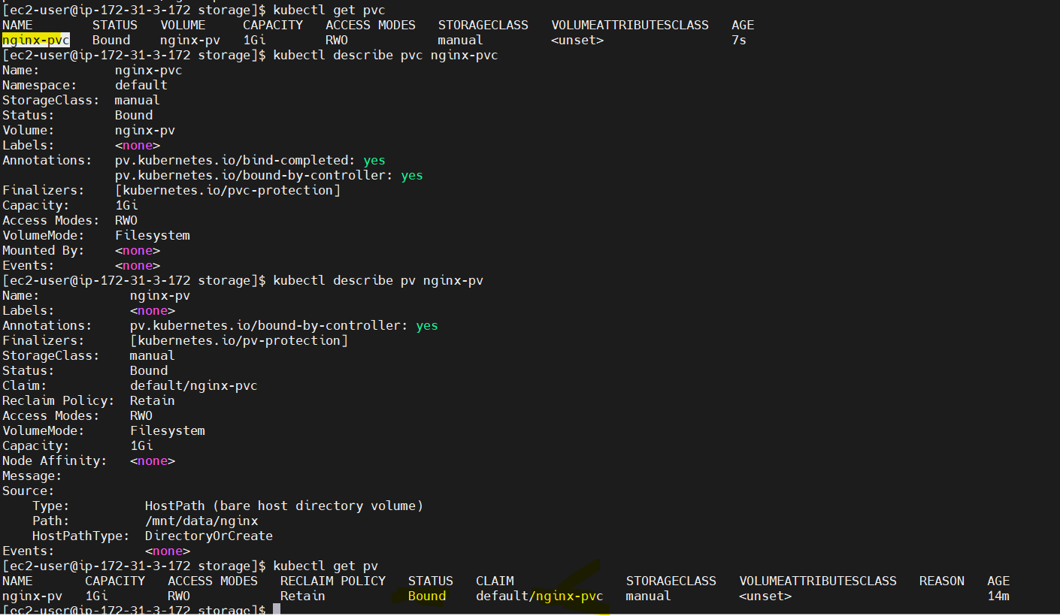

see the pv status as change from available to bound , use theindentation storage classname is not under resources its under accessmodes
create pod/deployment to use above created volume ::::: :::::::::::::::::::::::::::::::::::::::::::::::::and do activity
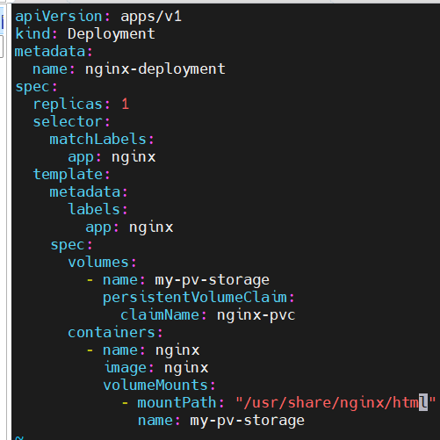

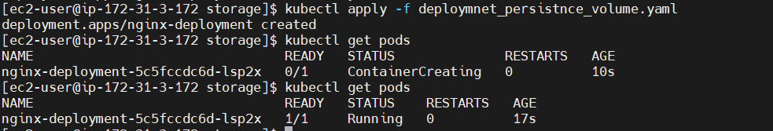
IMP:
inside the pv path and deployment volumemount is different:
df -h in the pods (every pods) means you can able to see the /usr/share/nginx/html mount point
/mnt.dat.nginx directory created somewhre any one pod pod
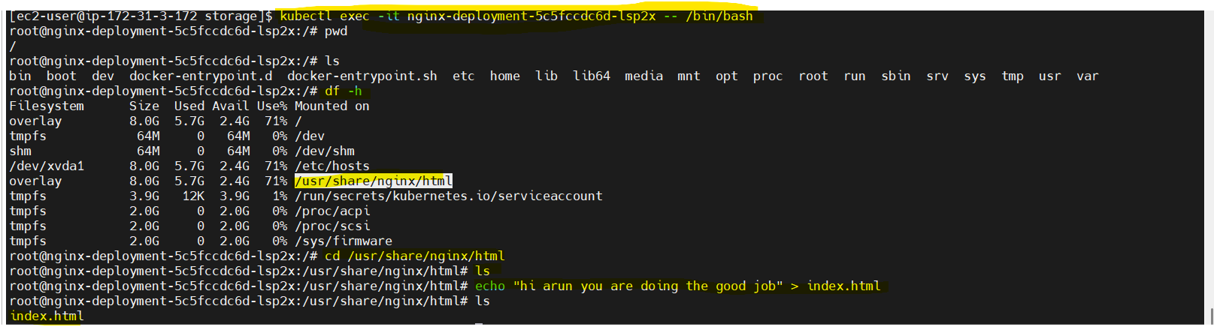

there (pod deleted)

exit and delete and recreate and check index.html file is
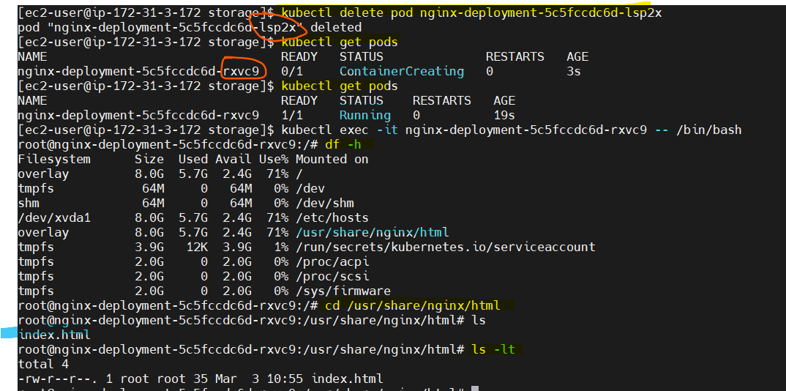

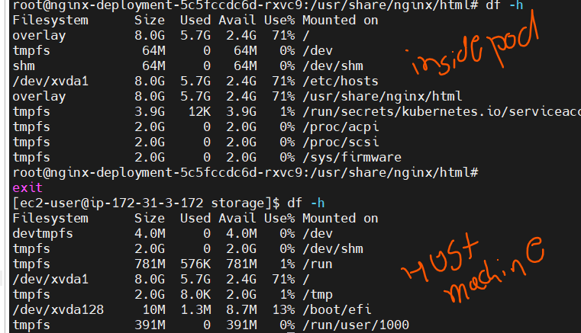
All ok but where the directory created?
Default some mount point will not show when df -h /usr/nginx.html it will show why?
You are in host machine and executing the df -h (you are not seeing the /usr/share/nginx/html mount path because this k8s/docker mounted this mount-point inside container not on host machine :
df -h /usr/nginx/html : it will show but not only df -h (in host machine) – if you want go indside pod and type df -h it will show

* hostpath map directory to directory of host nodes filesystem
we cant able to see the directory

scanario:
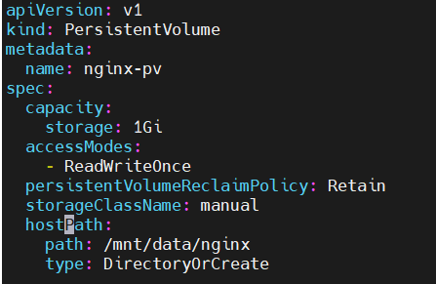
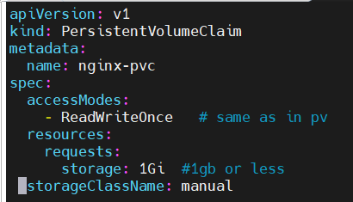
even pod get deleted volume there? Yes from hostpath
Even node deleted volume is ther? No
Even cluster deleted volume is the? No
We can use EBS in aws for achiving above 3 scanario
So hostpath is not good for so for above 3 scanrio
Please find the difference between the PV , PVC, deployment below.

My data is stored inside the /mnt/data/nginx directory alawasys if pod deleted also it will not affect after adding pod this volume claim to that pod so go inside pod and check mount point where we mentioned inside PVC

Comparision:
1. AccessMode should be same:
2.Storage inside pvc 1 gib that is lesser than or eqqual to storage under capacity block in perisistentVolume
3. storageClassName shold be same and this you mention unnder resources not inside requests.
- volumereclaimpolicy – Reatin so that claim will delete also we can retain the data (delete mensa gone case.
::::::::::::::::::::::::::::::PV, Pvc pod completed(persistence storage start):::::::::::::::::::::::::::::::::::::::::::
basen on my create stoarge need to craete no need to match pv and pvc how what I best doluation
called as dynamic provising.
So use the dynamic provisioning .so “container storage interface” CNI
storage class is driver – create the cni for ebs, efs, nfs particulary and go thought h same steps
to handle the multiple storage on commaon ground so need to use CNI.
- Dynamic provisioning – what type of storage want to use according to that install storage class.
Start: delete all pv, pvc, deployment.
::::::::::::::::::::::::::::::::::::::::::::Dynamic provisioning start::::::::::::::::::::::::::::::::::::::::::::::::::
scnario will ok) pod deleted -node deleted(ec2 instance)- cluster delated volumes should be there in volume section in aws (where as hostpath only 1st point will follow)
AWS EBS dynamic provisiong:
use: https://github.com/discover-devops/EKS_K8S/blob/main/07_EKS_Storage_02.md
link : https://docs.aws.amazon.com/eks/latest/userguide/ebs-csi.html
eks workshop use: https://www.eksworkshop.com/docs/introduction/navigating-labs

Creation of EBS CSI Driver for Kubernetes Storage on EKS
- all same insted of pv craete one storage class pvc, deploymet all same
prereq
1.a- create iam policy for the amzon ebs CSI driver
1.b- attach that policy to role (if you describe kube-system ns yu will role)-aws use that role and attch
1.c- install aws ebs csi driver – what ever i sthere in above link that i snot working.
- so that install helm package from helm package install aws ebs csi driver after check kubectl get pods -n kube-system
(using helm we install ebs csi not kubectl apply)
2. create storage class for EBS (not pv)
then create the pvc and create deployment yaml based on that (pod or deployment)
what i sthe differnace between the hostpath and ebs csi ?
In hostpath- /mnt/data/nginx – is directory its created any one of node in the kuberenets cluster.
Take snapshot- crete in bucket use that in diffrent region
note:
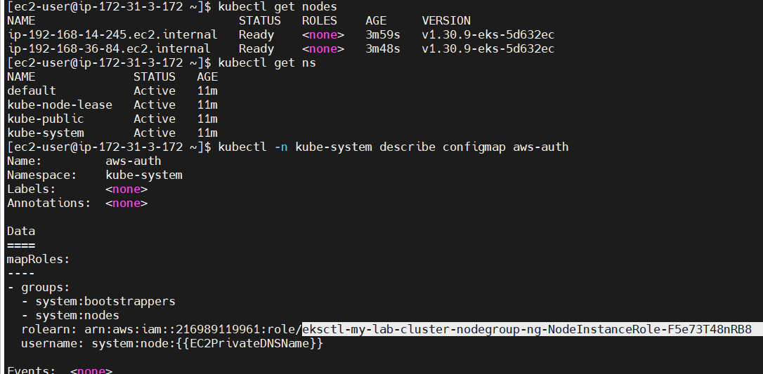
The aws-auth ConfigMap is specific to Amazon EKS (Elastic Kubernetes Service) and is not available in Minikube because Minikube is a local Kubernetes environment that does not integrate with AWS IAM. SO uaing EKS

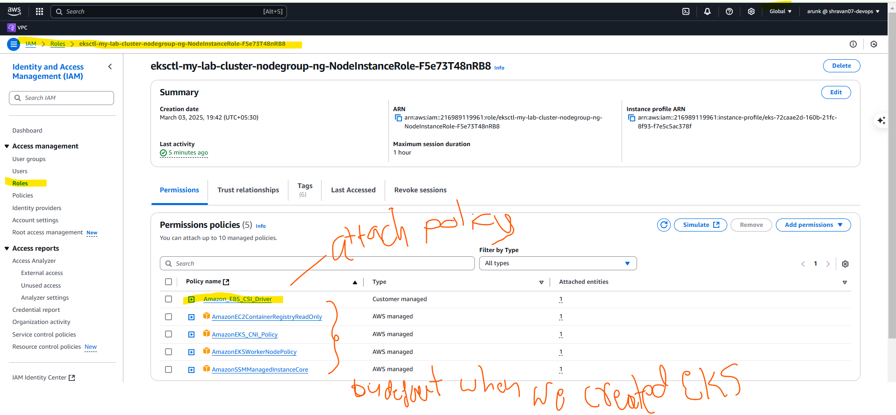
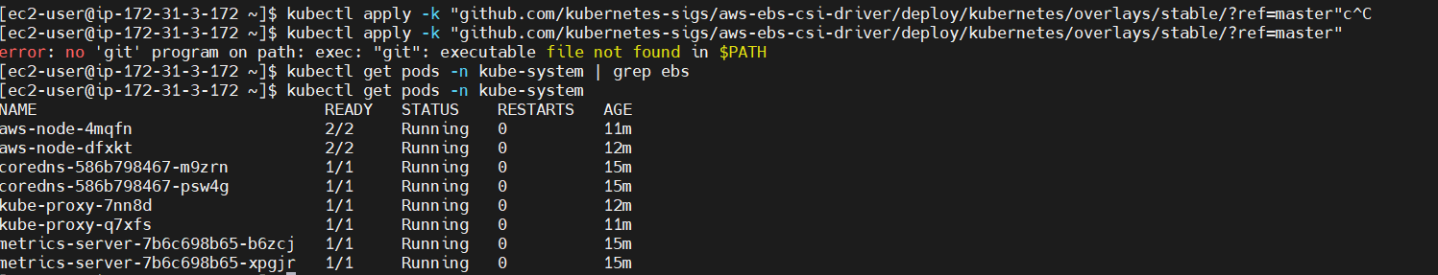
created eks- checked the role of kube-system – created one policy and attched that policy to role
create/deploy the mazon EBS csi driver: mentioned git repo not working so we are installing ebs- csi- driver via helm.
See: in pods we are not getting any ebs related pods so we are moving to helm (k8s package)
- by default helm is not installed so install helm and add the ebs CSI driver to hekm repo finaly install EBS CSI driver. And check or varify wit grep
alll there in link : https://github.com/discover-devops/EKS_K8S/blob/main/07_EKS_Storage_02.md
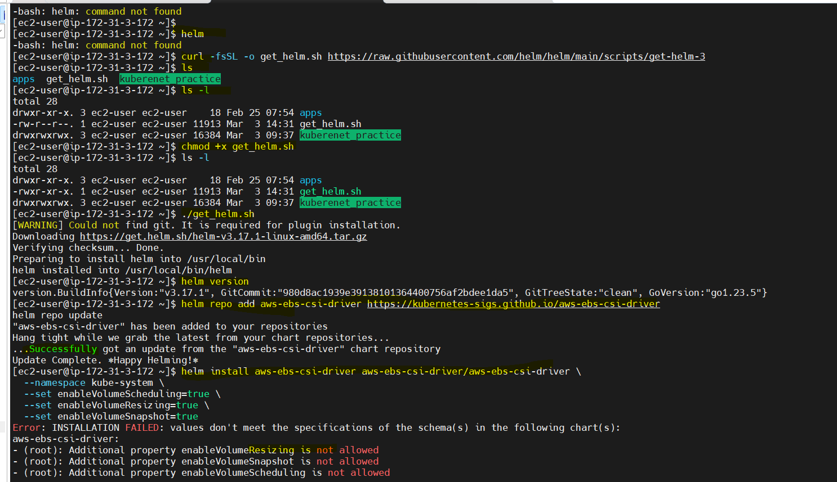
-----

error:
It looks like you installed Helm correctly, but the AWS EBS CSI driver Helm chart may not support the parameters you're trying to set (enableVolumeScheduling, enableVolumeResizing, and enableVolumeSnapshot).
Run the following command to list the available configurable values in the Helm chart: and add according to that.
- helm show values aws-ebs-csi-driver/aws-ebs-csi-driver
1. check the helm instlled correctly
for this issue i checked and added 3 parameters under the controller and passed that yaml still same errorwhile creation helm its not working see below:
[ec2-user@ip-172-31-3-172 ~]$ helm uninstall aws-ebs-csi-driver -n kube-system
release "aws-ebs-csi-driver" uninstalled
[ec2-user@ip-172-31-3-172 ~]$ helm list -n kube-system
NAME NAMESPACE REVISION UPDATED STATUS CHART APP VERSION
[ec2-user@ip-172-31-3-172 ~]$ helm install aws-ebs-csi-driver aws-ebs-csi-driver/aws-ebs-csi-driver -n kube-system -f values.yaml
Error: INSTALLATION FAILED: values don't meet the specifications of the schema(s) in the following chart(s):
aws-ebs-csi-driver:
- controller: Additional property enableVolumeResizing is not allowed
- controller: Additional property enableVolumeSnapshot is not allowed
- controller: Additional property enableVolumeScheduling is not allowed

helm installtion commands:
helm install aws-ebs-csi-driver aws-ebs-csi-driver/aws-ebs-csi-driver --namespace kube-system --set controller.serviceAccount.create=true
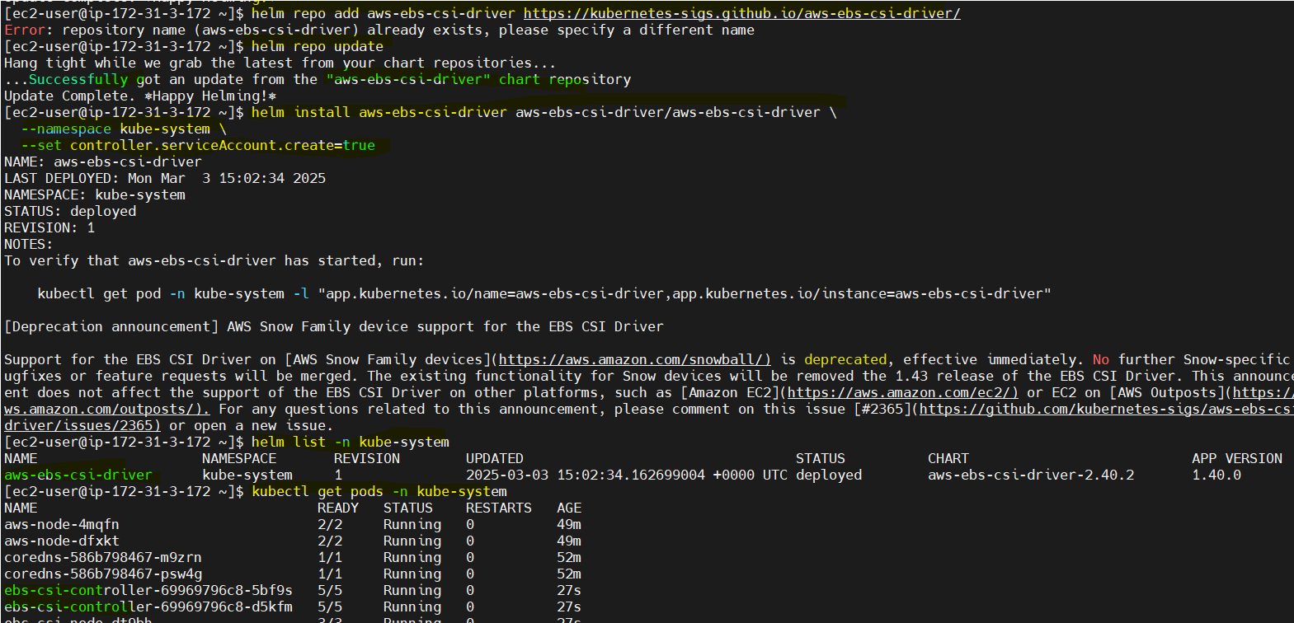

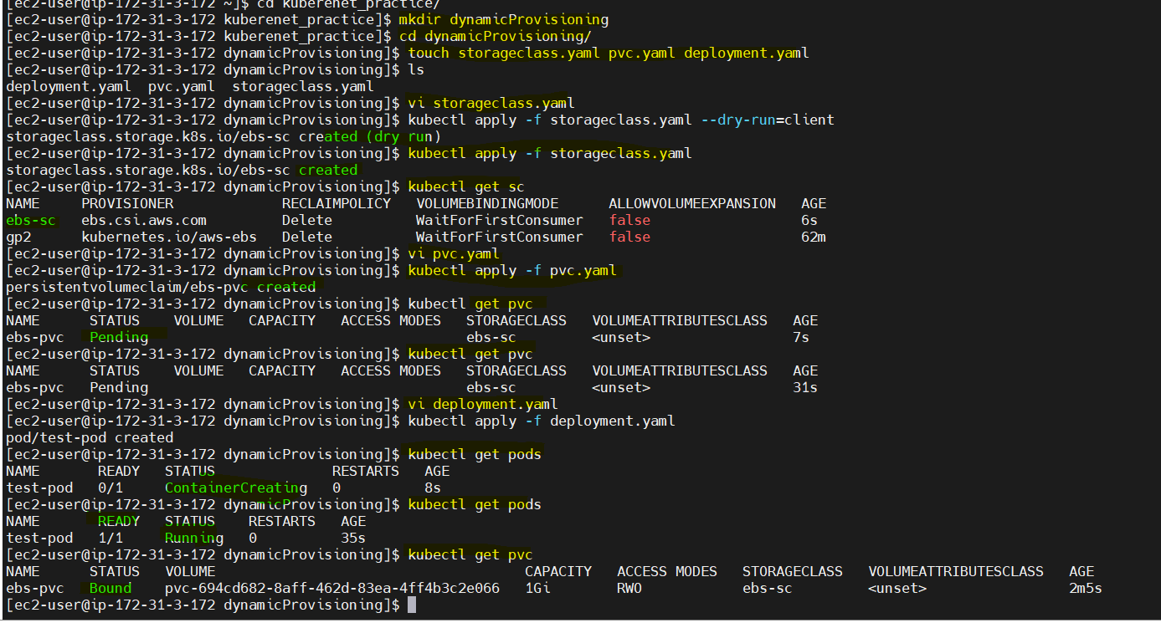
install storage class, pvc and pod yaml

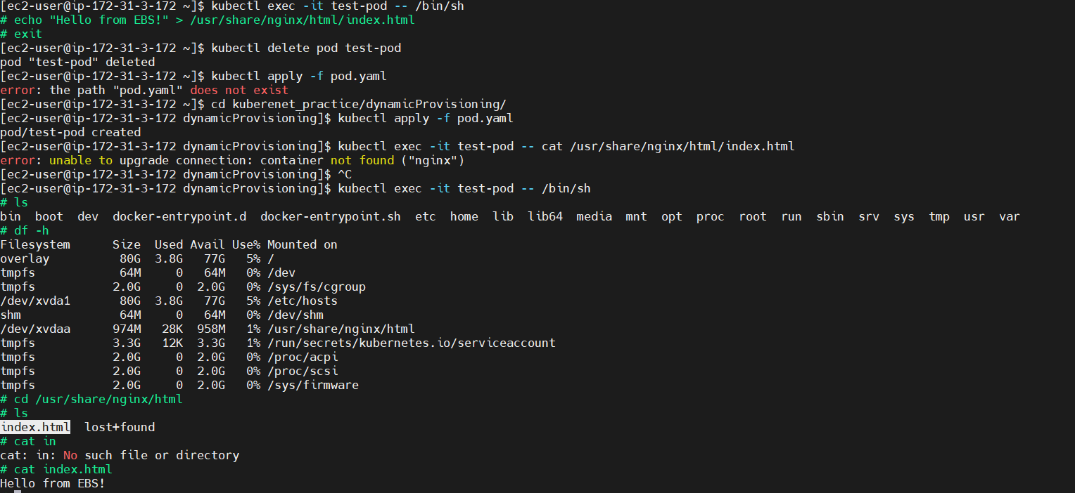
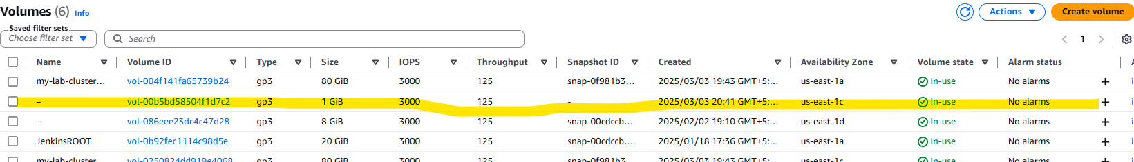
1 gb you can able to see in the volume section if you dlete pod, node, cluster you can see the 1 gb dat over there
yes -after dletation cluster- c2 volume is present in volume
so delete volume manually froma ws console(no need to detach already diable)

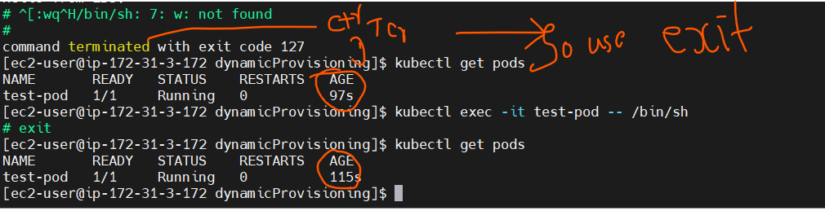
::::::::::::::::::::::::::::::::::::::::::::Dynamic provisioning completed:::::::::::::::::::::::::::::::::::::::::::::::::::
ingress-helm-demonset-statefull set- rela word example(EFK stack)
:::::::::::::::::::::::::::Kuberenets networking startIing(ingres)::::::::::::::::::::::::::::::::::::::::::::::::
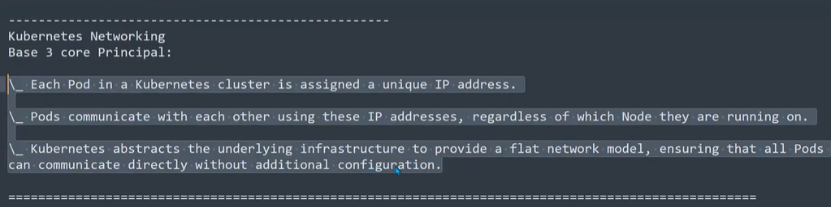
https://kubernetes.io/docs/concepts/extend-kubernetes/compute-storage-net/network-plugins/
all clouad hav eparticular CNI pluggin.
- containerd- docker (container type)
there isno nating direct communication- flat network
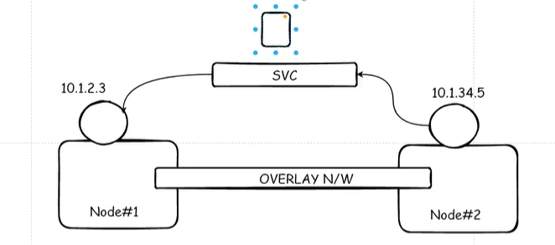
all 3 network policy – we can achive by the CNI pluggin
link: to read network concept
https://github.com/discover-devops/EKS_K8S/blob/main/02_01_Kubernetes_Networking_Introduction.md
and kuberenets workspace repo also read:
cni pluggin responsabilty:
- craete ip address of pods(dynamic ip address)
- assign the uniq ip address to each pods
- configure network interface for pods
- setting up route table to communicating pod-to-pod, pod-to-service
if your are using the manaually master node and worker nodes you only decide teh CNI pluggin
- in cloud no need to woory about the CNI pluggin aws willl take carefully
- manually only from worker and master means
install docker on both, kubeapi installed on master, kubelet-join command in every workernode. Install kubelet and something, install CNI pluggin (flannel using the most of tim
what about pluggin in the aws amanged master node? How its differ tahn manually installation
in manually menasa we only need to install CNI pluggin
- AWS automatically installs and manages the Amazon VPC CNI plugin for networking.
- You do not need to manually install a CNI on the master nodes because you don’t have access to them.
- this amazon vpc cni is the default not possible to remove but you can add the diffrent CNI pluggin.
Check installed cni plugiin:
- kubectl get daemonset -n kube-system
o/p: kube-node so this is aws vpc cni

what are the diffrent types of pluggins? Why
CNI Plugin | Best For | Key Features | Limitations
Flannel | Simplicity, small-scale clusters | Lightweight, easy setup, VXLAN overlay | No network policies, lacks security controls
Calico | Security, policy-based networking | Supports network policies, scalable, BGP support | Slightly complex setup
Cilium | High performance, security, eBPF-based networking | eBPF-powered, faster than iptables, deep observability | More advanced setup
Weave | Simple, encrypted networking | Automatic encryption, works without overlay | Higher latency compared to others
Canal | Hybrid (Calico + Flannel) | Flannel's simplicity + Calico's policies | May require tuning for performance
What could be the challange in microserices:?
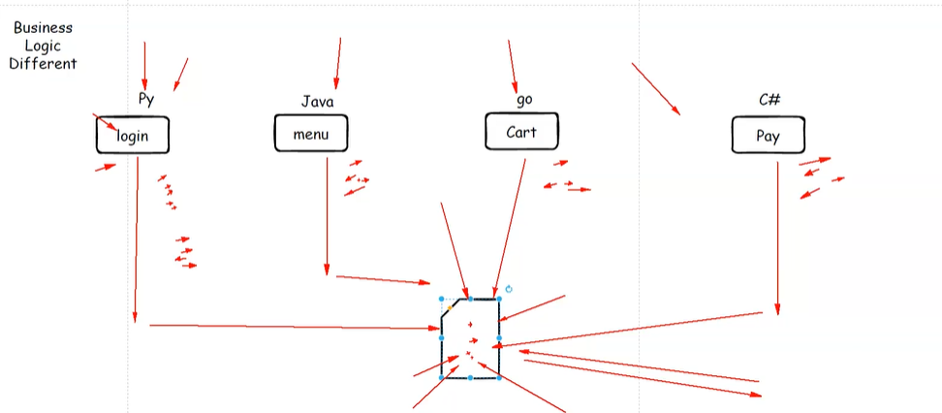
each services has diffrent logic, all busineed logic war wrote by different langauage, all services logs store in central location(but logs format different for each services because business logic is different) so while fetaching and filtering th elogs its headache.
Quotete creation service, application modules, LA setup.

To store all logs files – mechanisam is = Elastic search
elastic search is database.- storing all logs – this db is using fb and google

How Elasticsearch Helps?
🔹 Centralized Logging – Collects logs from all services into one place.
🔹 Fast Search & Querying – Uses indexing to quickly find logs.
🔹 Scalability – Handles large-scale data with distributed architecture.
🔹 Real-time Analytics – Provides insights on logs instantly.
🔹 Integration with Kibana & Logstash – Visualizes logs & processes data easily.
By this also storing ok accessing and featching difficult so we moved EFK stack .

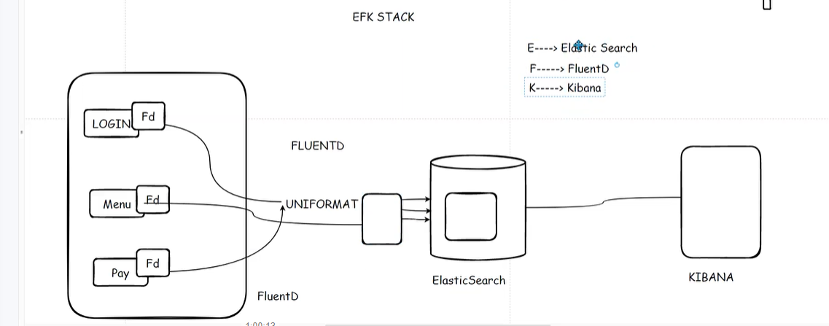

Fluentd is a powerful log collector no need to install on each service Deploy fluentd as daemon set so it run on every nodes and collect logs from all pods inside nodes.(JSON is default)

How Fluentd Works in Microservices?
1️⃣ Collects Logs – Gathers logs from containers, applications, and system logs (stdout, files, journald, etc.).
2️⃣ Processes & Filters Logs – Converts logs into a structured format (JSON) and removes unnecessary data.(all logs converted into one format modtly JSON format)
3️⃣ Routes Logs to Storage – Sends logs to Elasticsearch, S3, Kafka, Prometheus, or other backends.
4️⃣ Supports Real-time Monitoring – Works with Kibana, Grafana, Loki for visualization.
No of pods in one node?
Application container: application is running(hybrid runner running)
sidecar container: use this to collecting logs , monitor and proxy
init container: run this container before main container start (db migration start before app container start)
fluentd importent?
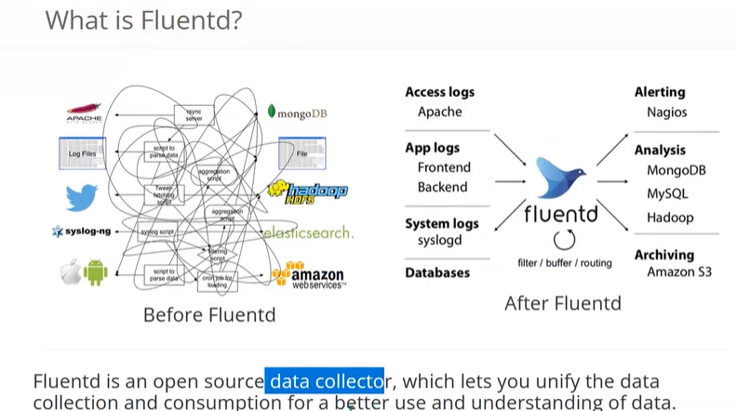
Supported Log Formats in Fluentd
?Fluentd can process logs in various formats, such as:
- JSON (Default)
- Plain text
- CSV (Comma-Separated Values)
- Key-Value format
- XML (using plugins)
- Apache/Nginx log formats
- Custom formats (via regex parsing)
how to implement the EFK in kuberenet cluster:?
Deployment: equal distribution of pod each node is not possible (pod not equally not distribution among the nodes (not guaranty scheduler will decided pod allocation based on resources)
- if deleted pod ip and name will change
- there is no ordering in pods (all pods get lunch at same point in time all pods created and running showing) first create this pods after only go and crete and run the second pods .

Statefullset:::::::::::::::::::::
NOTE:
staefull set yaml is excatly same as deployment.yaml only differance is
kind: StatefullSet
whereas Demonset kind is DeamonSet and remove the replicas.
Deployment will not work with deployment?
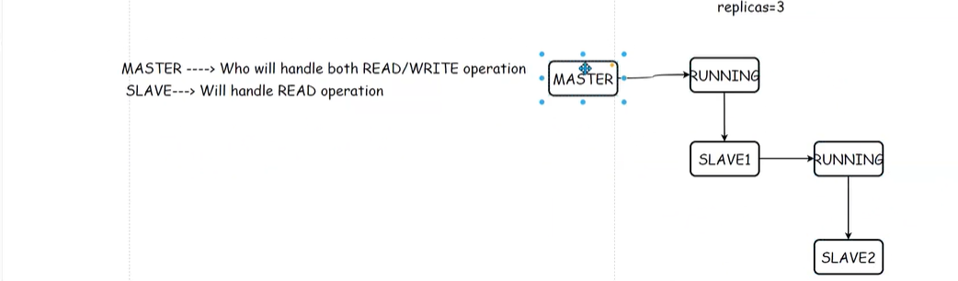
Yes because all pods will create and running at tthe same time no dependedn pod with each other while creation
ex: create master pod once its running create read replica and subreplica under that post running state :

so that is moving (statefull application)- so used the statefullset object
link:
https://github.com/discover-devops/kubernetes_workshop/blob/main/StatefulSets.md
varification:
slave-0 -master – running
slave-1 -slave pod- container creating once status running
slave3-3 -slave(read replicas) (after slave -1 showing running slave 3 will start.
Kubectl delete pod slave-1
deleted and created again with the smae name. Whre as deploymnet random name and ip will created and assined by CNI.
Once pod deleted after created new pod means how this statefull application will follow?
When a new pod replica join the existing set-up, it will creates it's own storage, it will clones the data from the previous pod(pv-pvc), not with ANY other PODS. Once it has up-to-date data cloned, then it starts synchronizes with the master and start listing for any changes by the master POD.
If pod deleted pvc still exist mount this pvn on top of newly created pod.

A new pod does not clone data from previous pods; instead, it retrieves data from a Persistent Volume (PV), a master node (for databases), or an init process. This ensures data consistency and prevents data loss when old pods are deleted.
Difference Between Deployment and StatefulSet:

Feature | Deployment (Stateless) | StatefulSet (Stateful)
Use Case | Web servers, API servers, frontend apps | Databases, message queues, distributed systems
Pod Identity | Each pod is replaceable and does not retain identity | Each pod has a unique, persistent identity (e.g., pod-0, pod-1)
Storage | Uses ephemeral storage (data lost when pod restarts) | Uses persistent storage (data is retained even if pod restarts)
Scaling | Random pod creation and deletion | Pods are created/deleted in order (pod-0 first, then pod-1)
Network | All pods share the same service name (no fixed hostname) | Each pod has a stable network identity
Use for Databases? | ❌ No (risk of data loss) | ✅ Yes (data consistency ensured)

Statefull set practice::::::::::::

EFK- elastic serach- statefullset
fluentd-- Deamon set

fluentd- collect logs from all pods and node
Deamon set: one pod per one node
One Pod Per Node in DaemonSet – Does It Increase Cost?:

When using a DaemonSet, Kubernetes ensures that one pod runs on every node in the cluster. But does this increase cost? Let's break it down:

1️⃣ Understanding "One Pod Per Node"
- DaemonSet schedules one Fluentd pod per node.
- If you have 5 nodes, you will have 5 Fluentd pods (one per node).
- As new nodes are added, Kubernetes automatically creates a Fluentd pod on each node.

2️⃣ Does It Increase Cost?
- No additional cost for Fluentd itself (as it runs as a pod on existing nodes).
- Kubernetes charges based on node instances (CPU, memory, storage usage).
- Fluentd is a lightweight process, so its impact on overall node resources is minimal.

3️⃣ Why Is This Needed?
- Fluentd needs to collect logs from each node’s local storage (/var/log/containers), which is not shared across nodes.
- If Fluentd were deployed as a Deployment, it would only run on some nodes, missing logs from other nodes.

4️⃣ Can We Reduce Cost?
- Optimize Fluentd resource limits (CPU, memory) so it doesn't use too much node capacity.
- Use centralized logging solutions like Fluent Bit (lighter than Fluentd).
- Consider log aggregation at the application level if logs don’t need to be collected from every node.
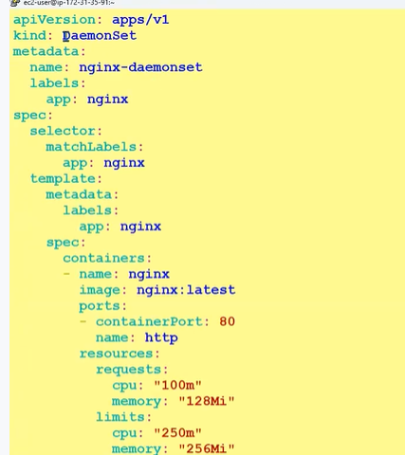
DeamonSet:
Fluentd – use the Deamon set exactly as Deployment (no need to mention the replicaset)
kind: DeamonSet
kind only changed and we dint,nt mention the replicas as like in deployment.

How To Set Up an Elasticsearch, Fluentd and Kibana (EFK) Logging Stack on Kubernetes
Link:
https://www.digitalocean.com/community/tutorials/how-to-set-up-an-elasticsearch-fluentd-and-kibana-efk-logging-stack-on-kubernetes
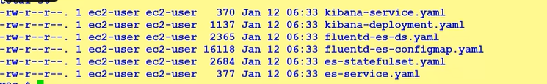
digital ocen docs you can follow.
1. craete some yaml files for elastic serach, fluentd, kibana
E-statefull set and service for access to external world
How to perform convert the one format
F- craete DemonSet and es-configmap.yaml
K- create one deployment.yaml and service for access on browser

base on fluted docker image
k8s deamonset
--- seperating th eobject
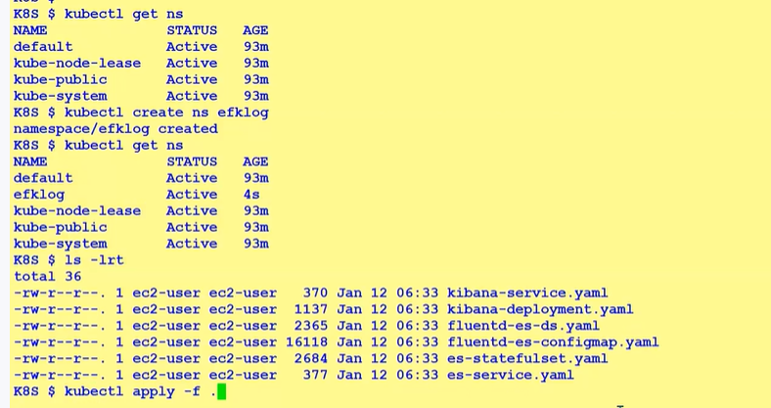
fluent d connect with elastic serarch

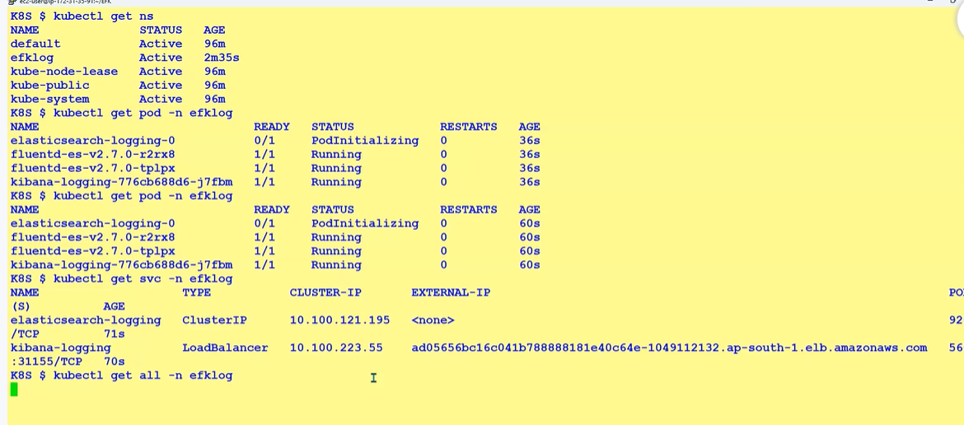

Access kibana by : alb :port

- kubectl api-resources
get all api resoucres with their group and version(apps/v1)
- kubectl api-versions
api verasion available in the cluster.
- kubectl explain deployment
it will show correct name od deployment and vesrion: grp/ver(apps/v1)

link:
https://github.com/discover-devops/kubernetes_workshop/blob/main/EFK.YAML

EFK:
elastic serach- create one statefullset and one service for access statefullset via browsers
FluentD- same one demonsetset and service (not required)+ configmap(here we mentioned the format of log storage)
kibana: one deployment and one service
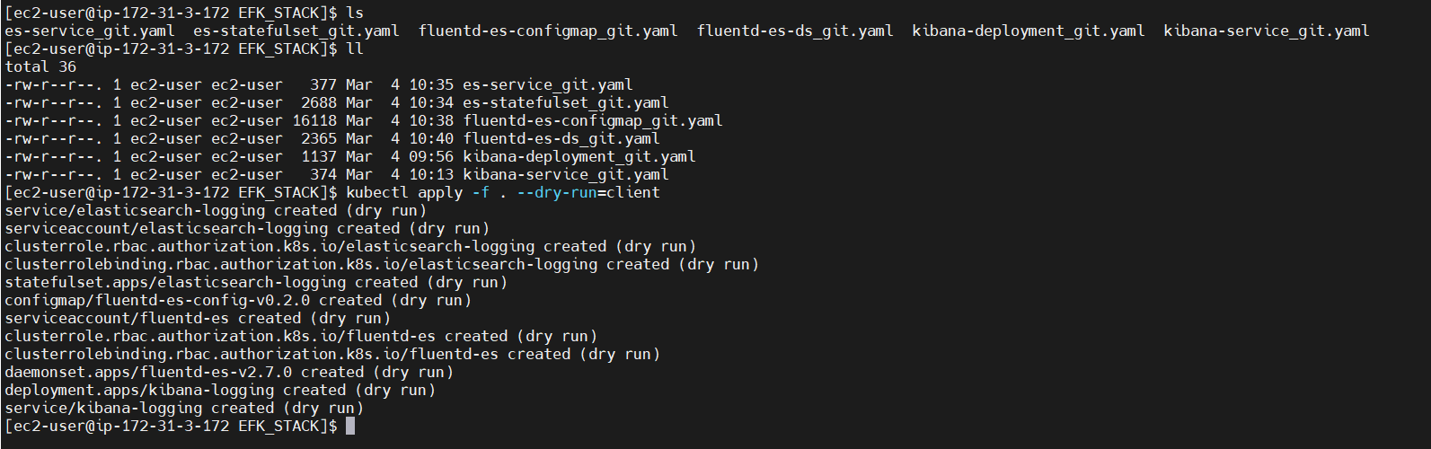

output after efk stack completion:
create serviecs
[ec2-user@ip-172-31-3-172 EFK_STACK]$ kubectl get svc -n efklog
NAME TYPE CLUSTER-IP EXTERNAL-IP PORT(S) AGE
elasticsearch-logging ClusterIP 10.100.224.214 <none> 9200/TCP 10m
kibana-logging LoadBalancer 10.100.106.61 a461ca467dab146ed9a78a891442fd50-1228429170.us-east-1.elb.amazonaws.com 5601:30540/TCP 10m

a461ca467dab146ed9a78a891442fd50-1228429170.us-east-1.elb.amazonaws.com open th e5601 port in the security grp and access

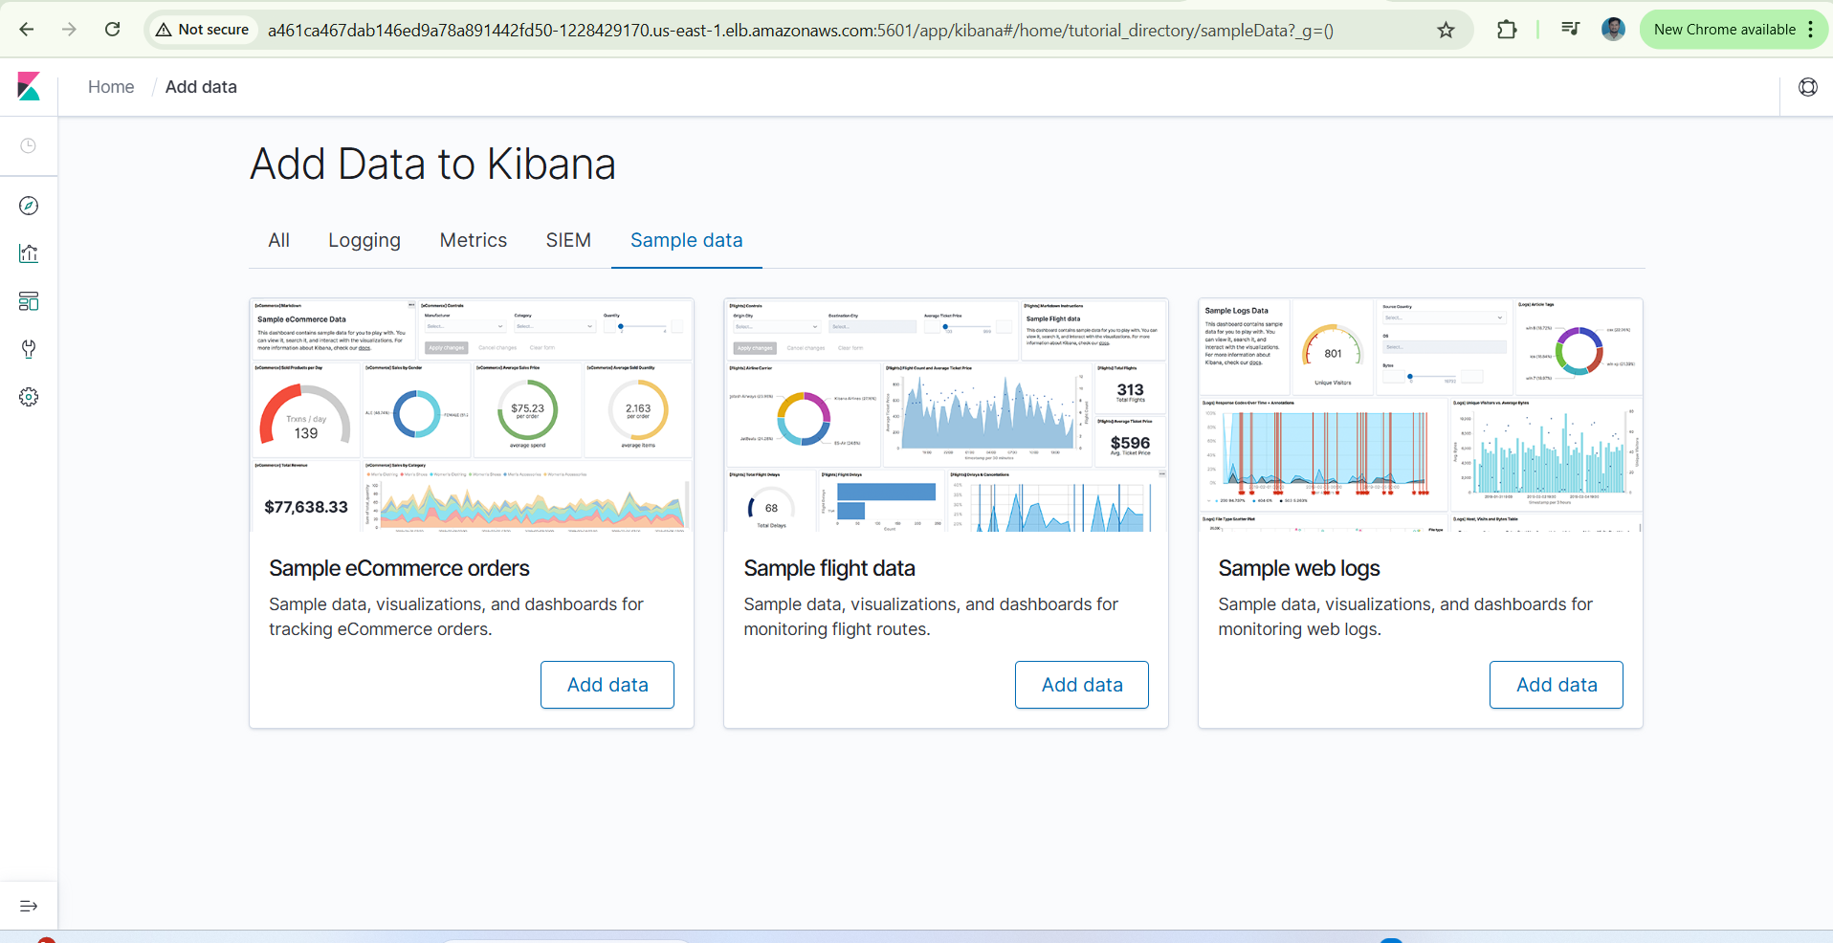

[ec2-user@ip-172-31-3-172 EFK_STACK]$ ll
total 36
-rw-r--r--. 1 ec2-user ec2-user 377 Mar 4 10:35 es-service_git.yaml
-rw-r--r--. 1 ec2-user ec2-user 2688 Mar 4 10:34 es-statefulset_git.yaml
-rw-r--r--. 1 ec2-user ec2-user 16118 Mar 4 10:38 fluentd-es-configmap_git.yaml
-rw-r--r--. 1 ec2-user ec2-user 2365 Mar 4 10:40 fluentd-es-ds_git.yaml
-rw-r--r--. 1 ec2-user ec2-user 1137 Mar 4 09:56 kibana-deployment_git.yaml
-rw-r--r--. 1 ec2-user ec2-user 374 Mar 4 10:13 kibana-service_git.yaml
[ec2-user@ip-172-31-3-172 EFK_STACK]$ kubectl apply -f . --dry-run=client
service/elasticsearch-logging created (dry run)
serviceaccount/elasticsearch-logging created (dry run)
clusterrole.rbac.authorization.k8s.io/elasticsearch-logging created (dry run)
clusterrolebinding.rbac.authorization.k8s.io/elasticsearch-logging created (dry run)
statefulset.apps/elasticsearch-logging created (dry run)
configmap/fluentd-es-config-v0.2.0 created (dry run)
serviceaccount/fluentd-es created (dry run)
clusterrole.rbac.authorization.k8s.io/fluentd-es created (dry run)
clusterrolebinding.rbac.authorization.k8s.io/fluentd-es created (dry run)
daemonset.apps/fluentd-es-v2.7.0 created (dry run)
deployment.apps/kibana-logging created (dry run)
service/kibana-logging created (dry run)
[ec2-user@ip-172-31-3-172 EFK_STACK]$ kubectl apply -f .
clusterrole.rbac.authorization.k8s.io/elasticsearch-logging created
clusterrolebinding.rbac.authorization.k8s.io/elasticsearch-logging created
clusterrole.rbac.authorization.k8s.io/fluentd-es created
clusterrolebinding.rbac.authorization.k8s.io/fluentd-es created
Error from server (NotFound): error when creating "es-service_git.yaml": namespaces "efklog" not found
Error from server (NotFound): error when creating "es-statefulset_git.yaml": namespaces "efklog" not found
Error from server (NotFound): error when creating "es-statefulset_git.yaml": namespaces "efklog" not found
Error from server (NotFound): error when creating "fluentd-es-configmap_git.yaml": namespaces "efklog" not found
Error from server (NotFound): error when creating "fluentd-es-ds_git.yaml": namespaces "efklog" not found
Error from server (NotFound): error when creating "fluentd-es-ds_git.yaml": namespaces "efklog" not found
Error from server (NotFound): error when creating "kibana-deployment_git.yaml": namespaces "efklog" not found
Error from server (NotFound): error when creating "kibana-service_git.yaml": namespaces "efklog" not found
[ec2-user@ip-172-31-3-172 EFK_STACK]$ kubectl create ns efklog
namespace/efklog created
[ec2-user@ip-172-31-3-172 EFK_STACK]$ kubectl apply -f .
service/elasticsearch-logging created
serviceaccount/elasticsearch-logging created
clusterrole.rbac.authorization.k8s.io/elasticsearch-logging unchanged
clusterrolebinding.rbac.authorization.k8s.io/elasticsearch-logging configured
statefulset.apps/elasticsearch-logging created
configmap/fluentd-es-config-v0.2.0 created
serviceaccount/fluentd-es created
clusterrole.rbac.authorization.k8s.io/fluentd-es unchanged
clusterrolebinding.rbac.authorization.k8s.io/fluentd-es configured
Warning: spec.template.metadata.annotations[scheduler.alpha.kubernetes.io/critical-pod]: non-functional in v1.16+; use the "priorityClassName" field instead
daemonset.apps/fluentd-es-v2.7.0 created
Warning: spec.template.metadata.annotations[seccomp.security.alpha.kubernetes.io/pod]: non-functional in v1.27+; use the "seccompProfile" field instead
deployment.apps/kibana-logging created
service/kibana-logging created
[ec2-user@ip-172-31-3-172 EFK_STACK]$ kubectl get pods -o wide
No resources found in default namespace.
[ec2-user@ip-172-31-3-172 EFK_STACK]$ kubectl get pods -o wide -n efllog
No resources found in efllog namespace.
[ec2-user@ip-172-31-3-172 EFK_STACK]$ kubectl get pods -o wide -n efklog
NAME READY STATUS RESTARTS AGE IP NODE NOMINATED NODE READINESS GATES
elasticsearch-logging-0 1/1 Running 0 43s 192.168.1.59 ip-192-168-10-178.ec2.internal <none> <none>
elasticsearch-logging-1 0/1 PodInitializing 0 6s 192.168.62.41 ip-192-168-40-189.ec2.internal <none> <none>
fluentd-es-v2.7.0-bx4cl 1/1 Running 0 38s 192.168.60.102 ip-192-168-40-189.ec2.internal <none> <none>
fluentd-es-v2.7.0-f4gsb 1/1 Running 0 38s 192.168.1.235 ip-192-168-10-178.ec2.internal <none> <none>
kibana-logging-776cb688d6-ntgfs 1/1 Running 0 37s 192.168.28.46 ip-192-168-10-178.ec2.internal <none> <none>
[ec2-user@ip-172-31-3-172 EFK_STACK]$ kubectl get nodes-n efklog
error: the server doesn't have a resource type "nodes-n"
[ec2-user@ip-172-31-3-172 EFK_STACK]$ kubectl get nodes -n efklog
NAME STATUS ROLES AGE VERSION
ip-192-168-10-178.ec2.internal Ready <none> 73m v1.30.9-eks-5d632ec
ip-192-168-40-189.ec2.internal Ready <none> 73m v1.30.9-eks-5d632ec
[ec2-user@ip-172-31-3-172 EFK_STACK]$ kubectl get deployment -n efklog
NAME READY UP-TO-DATE AVAILABLE AGE
kibana-logging 1/1 1 1 71s
[ec2-user@ip-172-31-3-172 EFK_STACK]$ kubectl get sa -n efklog
NAME SECRETS AGE
default 0 96s
elasticsearch-logging 0 89s
fluentd-es 0 85s
[ec2-user@ip-172-31-3-172 EFK_STACK]$ kubectl get service -n efklog
NAME TYPE CLUSTER-IP EXTERNAL-IP PORT(S) AGE
elasticsearch-logging ClusterIP 10.100.224.214 <none> 9200/TCP 2m24s
kibana-logging LoadBalancer 10.100.106.61 a461ca467dab146ed9a78a891442fd50-1228429170.us-east-1.elb.amazonaws.com 5601:30540/TCP 2m14s
[ec2-user@ip-172-31-3-172 EFK_STACK]$ kubectl get cr -n efklog
error: the server doesn't have a resource type "cr"
[ec2-user@ip-172-31-3-172 EFK_STACK]$ kubectl get ClusterRole -n efklog
NAME CREATED AT
admin 2025-03-04T09:25:54Z
aws-node 2025-03-04T09:29:15Z
cluster-admin 2025-03-04T09:25:54Z
edit 2025-03-04T09:25:54Z
eks:addon-manager 2025-03-04T09:25:59Z
eks:az-poller 2025-03-04T09:25:57Z
eks:certificate-controller-approver 2025-03-04T09:25:57Z
eks:certificate-controller-manager 2025-03-04T09:25:57Z
eks:certificate-controller-signer 2025-03-04T09:25:57Z
eks:cloud-controller-manager 2025-03-04T09:25:57Z
eks:cloud-provider-extraction-migration 2025-03-04T09:25:58Z
eks:cluster-event-watcher 2025-03-04T09:25:57Z
eks:coredns-autoscaler 2025-03-04T09:25:57Z
eks:extension-metrics-apiserver 2025-03-04T09:25:57Z
eks:fargate-manager 2025-03-04T09:25:59Z
eks:fargate-scheduler 2025-03-04T09:25:57Z
eks:k8s-metrics 2025-03-04T09:25:57Z
eks:kms-storage-migrator 2025-03-04T09:25:57Z
eks:network-policy-controller 2025-03-04T09:26:01Z
eks:network-webhooks 2025-03-04T09:25:58Z
eks:node-bootstrapper 2025-03-04T09:25:59Z
eks:node-manager 2025-03-04T09:25:57Z
eks:nodewatcher 2025-03-04T09:25:58Z
eks:pod-identity-mutating-webhook 2025-03-04T09:25:58Z
eks:service-operations 2025-03-04T09:25:58Z
eks:tagging-controller 2025-03-04T09:25:58Z
elasticsearch-logging 2025-03-04T10:44:38Z
fluentd-es 2025-03-04T10:44:43Z
system:aggregate-to-admin 2025-03-04T09:25:54Z
system:aggregate-to-edit 2025-03-04T09:25:54Z
system:aggregate-to-view 2025-03-04T09:25:54Z
system:auth-delegator 2025-03-04T09:25:54Z
system:basic-user 2025-03-04T09:25:54Z
system:certificates.k8s.io:certificatesigningrequests:nodeclient 2025-03-04T09:25:54Z
system:certificates.k8s.io:certificatesigningrequests:selfnodeclient 2025-03-04T09:25:54Z
system:certificates.k8s.io:kube-apiserver-client-approver 2025-03-04T09:25:54Z
system:certificates.k8s.io:kube-apiserver-client-kubelet-approver 2025-03-04T09:25:54Z
system:certificates.k8s.io:kubelet-serving-approver 2025-03-04T09:25:54Z
system:certificates.k8s.io:legacy-unknown-approver 2025-03-04T09:25:54Z
system:controller:attachdetach-controller 2025-03-04T09:25:54Z
system:controller:certificate-controller 2025-03-04T09:25:55Z
system:controller:clusterrole-aggregation-controller 2025-03-04T09:25:54Z
system:controller:cronjob-controller 2025-03-04T09:25:54Z
system:controller:daemon-set-controller 2025-03-04T09:25:54Z
system:controller:deployment-controller 2025-03-04T09:25:54Z
system:controller:disruption-controller 2025-03-04T09:25:54Z
system:controller:endpoint-controller 2025-03-04T09:25:54Z
system:controller:endpointslice-controller 2025-03-04T09:25:54Z
system:controller:endpointslicemirroring-controller 2025-03-04T09:25:54Z
system:controller:ephemeral-volume-controller 2025-03-04T09:25:54Z
system:controller:expand-controller 2025-03-04T09:25:54Z
system:controller:generic-garbage-collector 2025-03-04T09:25:54Z
system:controller:horizontal-pod-autoscaler 2025-03-04T09:25:54Z
system:controller:job-controller 2025-03-04T09:25:54Z
system:controller:legacy-service-account-token-cleaner 2025-03-04T09:25:55Z
system:controller:namespace-controller 2025-03-04T09:25:54Z
system:controller:node-controller 2025-03-04T09:25:54Z
system:controller:persistent-volume-binder 2025-03-04T09:25:55Z
system:controller:pod-garbage-collector 2025-03-04T09:25:55Z
system:controller:pv-protection-controller 2025-03-04T09:25:55Z
system:controller:pvc-protection-controller 2025-03-04T09:25:55Z
system:controller:replicaset-controller 2025-03-04T09:25:55Z
system:controller:replication-controller 2025-03-04T09:25:55Z
system:controller:resourcequota-controller 2025-03-04T09:25:55Z
system:controller:root-ca-cert-publisher 2025-03-04T09:25:55Z
system:controller:route-controller 2025-03-04T09:25:55Z
system:controller:service-account-controller 2025-03-04T09:25:55Z
system:controller:service-controller 2025-03-04T09:25:55Z
system:controller:statefulset-controller 2025-03-04T09:25:55Z
system:controller:ttl-after-finished-controller 2025-03-04T09:25:55Z
system:controller:ttl-controller 2025-03-04T09:25:55Z
system:controller:validatingadmissionpolicy-status-controller 2025-03-04T09:25:55Z
system:coredns 2025-03-04T09:29:17Z
system:discovery 2025-03-04T09:25:54Z
system:heapster 2025-03-04T09:25:54Z
system:kube-aggregator 2025-03-04T09:25:54Z
system:kube-controller-manager 2025-03-04T09:25:54Z
system:kube-dns 2025-03-04T09:25:54Z
system:kube-scheduler 2025-03-04T09:25:54Z
system:kubelet-api-admin 2025-03-04T09:25:54Z
system:metrics-server 2025-03-04T09:29:13Z
system:metrics-server-aggregated-reader 2025-03-04T09:29:13Z
system:monitoring 2025-03-04T09:25:54Z
system:node 2025-03-04T09:25:54Z
system:node-bootstrapper 2025-03-04T09:25:54Z
system:node-problem-detector 2025-03-04T09:25:54Z
system:node-proxier 2025-03-04T09:25:54Z
system:persistent-volume-provisioner 2025-03-04T09:25:54Z
system:public-info-viewer 2025-03-04T09:25:54Z
system:service-account-issuer-discovery 2025-03-04T09:25:54Z
system:volume-scheduler 2025-03-04T09:25:54Z
view 2025-03-04T09:25:54Z
vpc-resource-controller-role 2025-03-04T09:26:01Z
[ec2-user@ip-172-31-3-172 EFK_STACK]$ kubectl get ClusterRoleBinding -n efklog
NAME ROLE AGE
aws-node ClusterRole/aws-node 79m
cluster-admin ClusterRole/cluster-admin 82m
eks:addon-cluster-admin ClusterRole/cluster-admin 82m
eks:addon-manager ClusterRole/eks:addon-manager 82m
eks:az-poller ClusterRole/eks:az-poller 82m
eks:certificate-controller ClusterRole/system:controller:certificate-controller 82m
eks:certificate-controller-approver ClusterRole/eks:certificate-controller-approver 82m
eks:certificate-controller-manager ClusterRole/eks:certificate-controller-manager 82m
eks:certificate-controller-signer ClusterRole/eks:certificate-controller-signer 82m
eks:cloud-controller-manager ClusterRole/eks:cloud-controller-manager 82m
eks:cloud-provider-extraction-migration ClusterRole/eks:cloud-provider-extraction-migration 82m
eks:cluster-event-watcher ClusterRole/eks:cluster-event-watcher 82m
eks:coredns-autoscaler ClusterRole/eks:coredns-autoscaler 82m
eks:fargate-manager ClusterRole/eks:fargate-manager 82m
eks:fargate-scheduler ClusterRole/eks:fargate-scheduler 82m
eks:k8s-metrics ClusterRole/eks:k8s-metrics 82m
eks:kms-storage-migrator ClusterRole/eks:kms-storage-migrator 82m
eks:kube-proxy ClusterRole/system:node-proxier 79m
eks:kube-proxy-fargate ClusterRole/system:node-proxier 82m
eks:kube-proxy-windows ClusterRole/system:node-proxier 82m
eks:network-policy-controller ClusterRole/eks:network-policy-controller 82m
eks:network-webhooks ClusterRole/eks:network-webhooks 82m
eks:node-bootstrapper ClusterRole/eks:node-bootstrapper 82m
eks:node-manager ClusterRole/eks:node-manager 82m
eks:nodewatcher ClusterRole/eks:nodewatcher 82m
eks:pod-identity-mutating-webhook ClusterRole/eks:pod-identity-mutating-webhook 82m
eks:service-operations ClusterRole/eks:service-operations 82m
eks:tagging-controller ClusterRole/eks:tagging-controller 82m
elasticsearch-logging ClusterRole/elasticsearch-logging 3m53s
fluentd-es ClusterRole/fluentd-es 3m48s
metrics-server:system:auth-delegator ClusterRole/system:auth-delegator 79m
system:basic-user ClusterRole/system:basic-user 82m
system:controller:attachdetach-controller ClusterRole/system:controller:attachdetach-controller 82m
system:controller:certificate-controller ClusterRole/system:controller:certificate-controller 82m
system:controller:clusterrole-aggregation-controller ClusterRole/system:controller:clusterrole-aggregation-controller 82m
system:controller:cronjob-controller ClusterRole/system:controller:cronjob-controller 82m
system:controller:daemon-set-controller ClusterRole/system:controller:daemon-set-controller 82m
system:controller:deployment-controller ClusterRole/system:controller:deployment-controller 82m
system:controller:disruption-controller ClusterRole/system:controller:disruption-controller 82m
system:controller:endpoint-controller ClusterRole/system:controller:endpoint-controller 82m
system:controller:endpointslice-controller ClusterRole/system:controller:endpointslice-controller 82m
system:controller:endpointslicemirroring-controller ClusterRole/system:controller:endpointslicemirroring-controller 82m
system:controller:ephemeral-volume-controller ClusterRole/system:controller:ephemeral-volume-controller 82m
system:controller:expand-controller ClusterRole/system:controller:expand-controller 82m
system:controller:generic-garbage-collector ClusterRole/system:controller:generic-garbage-collector 82m
system:controller:horizontal-pod-autoscaler ClusterRole/system:controller:horizontal-pod-autoscaler 82m
system:controller:job-controller ClusterRole/system:controller:job-controller 82m
system:controller:legacy-service-account-token-cleaner ClusterRole/system:controller:legacy-service-account-token-cleaner 82m
system:controller:namespace-controller ClusterRole/system:controller:namespace-controller 82m
system:controller:node-controller ClusterRole/system:controller:node-controller 82m
system:controller:persistent-volume-binder ClusterRole/system:controller:persistent-volume-binder 82m
system:controller:pod-garbage-collector ClusterRole/system:controller:pod-garbage-collector 82m
system:controller:pv-protection-controller ClusterRole/system:controller:pv-protection-controller 82m
system:controller:pvc-protection-controller ClusterRole/system:controller:pvc-protection-controller 82m
system:controller:replicaset-controller ClusterRole/system:controller:replicaset-controller 82m
system:controller:replication-controller ClusterRole/system:controller:replication-controller 82m
system:controller:resourcequota-controller ClusterRole/system:controller:resourcequota-controller 82m
system:controller:root-ca-cert-publisher ClusterRole/system:controller:root-ca-cert-publisher 82m
system:controller:route-controller ClusterRole/system:controller:route-controller 82m
system:controller:service-account-controller ClusterRole/system:controller:service-account-controller 82m
system:controller:service-controller ClusterRole/system:controller:service-controller 82m
system:controller:statefulset-controller ClusterRole/system:controller:statefulset-controller 82m
system:controller:ttl-after-finished-controller ClusterRole/system:controller:ttl-after-finished-controller 82m
system:controller:ttl-controller ClusterRole/system:controller:ttl-controller 82m
system:controller:validatingadmissionpolicy-status-controller ClusterRole/system:controller:validatingadmissionpolicy-status-controller 82m
system:coredns ClusterRole/system:coredns 79m
system:discovery ClusterRole/system:discovery 82m
system:kube-controller-manager ClusterRole/system:kube-controller-manager 82m
system:kube-dns ClusterRole/system:kube-dns 82m
system:kube-scheduler ClusterRole/system:kube-scheduler 82m
system:metrics-server ClusterRole/system:metrics-server 79m
system:monitoring ClusterRole/system:monitoring 82m
system:node ClusterRole/system:node 82m
system:node-proxier ClusterRole/system:node-proxier 82m
system:public-info-viewer ClusterRole/system:public-info-viewer 82m
system:service-account-issuer-discovery ClusterRole/system:service-account-issuer-discovery 82m
system:volume-scheduler ClusterRole/system:volume-scheduler 82m
vpc-resource-controller-rolebinding ClusterRole/vpc-resource-controller-role 82m
[ec2-user@ip-172-31-3-172 EFK_STACK]$
[ec2-user@ip-172-31-3-172 EFK_STACK]$ kubectl get svc -n efklog
NAME TYPE CLUSTER-IP EXTERNAL-IP PORT(S) AGE
elasticsearch-logging ClusterIP 10.100.224.214 <none> 9200/TCP 10m
kibana-logging LoadBalancer 10.100.106.61 a461ca467dab146ed9a78a891442fd50-1228429170.us-east-1.elb.amazonaws.com 5601:30540/TCP 10m

es-service_git.yaml es-statefulset_git.yaml fluentd-es-configmap_git.yaml fluentd-es-ds_git.yaml kibana-deployment_git.yaml kibana-service_git.yaml
[ec2-user@ip-172-31-3-172 EFK_STACK]$ kubectl get ds -n efklog
NAME DESIRED CURRENT READY UP-TO-DATE AVAILABLE NODE SELECTOR AGE
fluentd-es-v2.7.0 2 2 2 2 2 <none> 20m
[ec2-user@ip-172-31-3-172 EFK_STACK]$ kubectl get pods -n efklog
NAME READY STATUS RESTARTS AGE
elasticsearch-logging-0 1/1 Running 0 21m
elasticsearch-logging-1 1/1 Running 0 20m
fluentd-es-v2.7.0-bx4cl 1/1 Running 0 20m
fluentd-es-v2.7.0-f4gsb 1/1 Running 0 20m
kibana-logging-776cb688d6-ntgfs 1/1 Running 0 20m
[ec2-user@ip-172-31-3-172 EFK_STACK]$
finaly::::::::::::::::::::::::::::::::::::::::::::::::::::::::::::::::::::::::::::

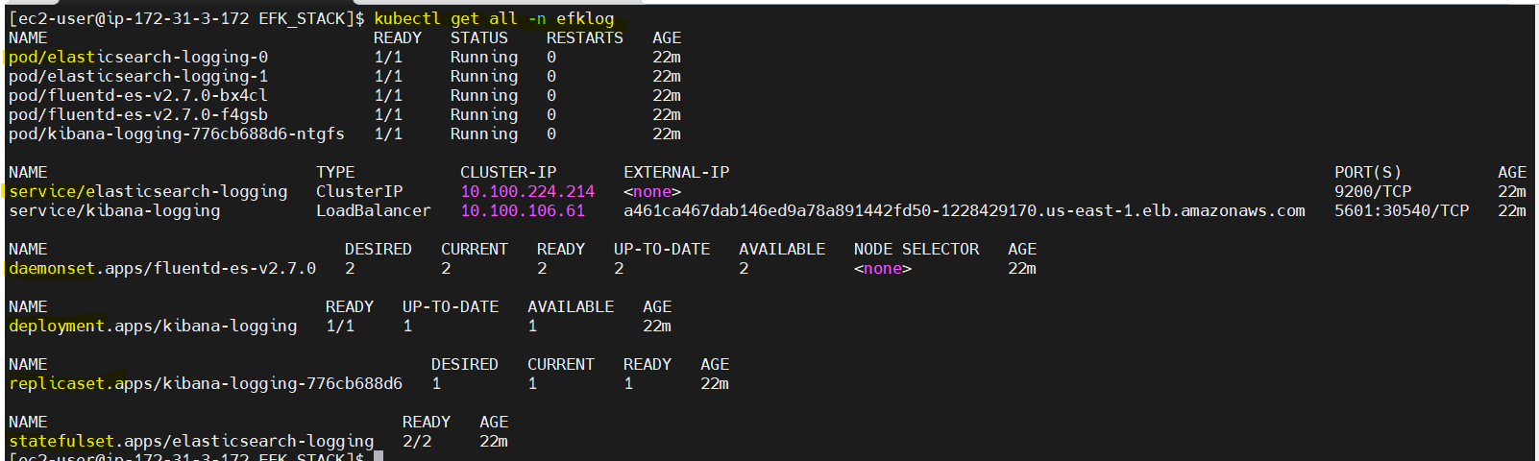

if you commited file want to revert:
git reset --soft HEAD~1
- files are there in working and stagibg
git reset --hard HEAD~1
- completly remove
https://github.com/settings/tokens

If pod deleted or cluster also deleted I want to persist data

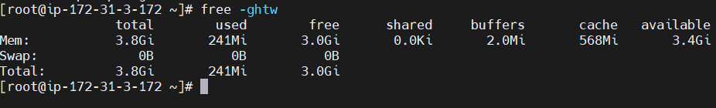
gb in human readable format- t means it will show total mem and swap memory
- cat /proc/meminfo | grep -i 'cached\|buffers'
- sync; echo 3 > /proc/sys/vm/drop_caches
This clears page cache(1), dentries(2), and inodes
- by defiult we dint mention the volume mount means what will take?

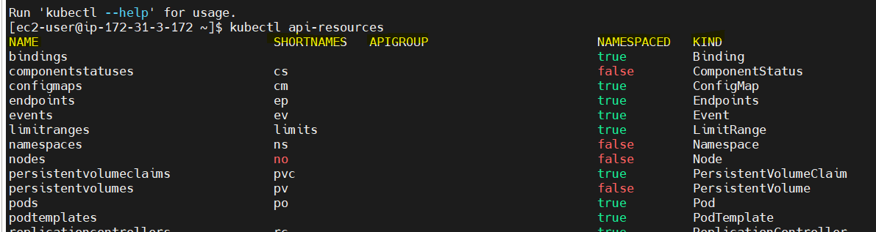
Kubectl api-resources
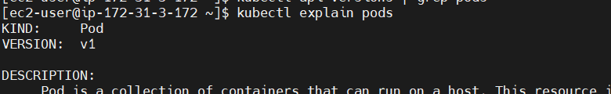
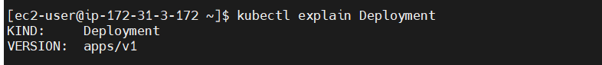
- kubectl apply -f <file.yaml> --dry-run=client
vi - :set number/set nonumber-%s/from source/to changespath/g
check the syntax and indentation of your YAML file, you can use multiple methods.
1. kubectl apply --dry-run=client
2. install yaml lint for validate yaml
pip install yamllint
yamllint pod.yaml
3. use the online yaml editor (for practice only)
In Vi/Vim editor, you can copy everything (entire file content) using different methods.
1. ggVGy
Press gg → Moves to the start of the file.
- Press V → Enters visual mode.
- Press G → Selects everything till the last line.
- Press y (yank/copy).

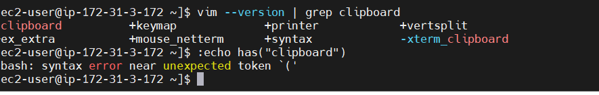
- 2. :%y+
: - enter commands mode %- select entire file, y yank.copy,+ send it to system clipboard

w
clipboard support diasable so that cant able to copy the file entire from vi editor so that install vm based on os which will support the cliboard.3

- . set one command in the vim then ctr+shift+c and y for paste
:set mouse=a
HDFC project:
note: 16 replicas in 4 nodes
each node have 4 pods
each pods have 80 port container another pod also 80 posr ok because pod is isolated from another pod inside the node.
- each pod have unique ip addess.
- container name and port is same in different pods- ok
but inside one pod 2 continer name and port menas it will conflict its not possible.
- each pod name – name+ random prefix
- In node one pod or more than one pod each pod will communicate with the cluster ip service (if you craete eksctl cluster only by default cluster ip service willl craete)
- one pod is communicate with other via service (but ep is track the ip of pod and communication happen via ip only actually.

What will if create 2 continer with different name ans port.

containers: - name: container-1 image: my-app-image:latest ports: - containerPort: 8080 - name: container-2 image: my-app-image:latest ports: - containerPort: 8085
if i mentioned 2 contaier in pod (16 pods will create in 4 servers each pod have 2 containers are running
- create one load balancer service and go to that dns so copy and paste it in the browser you can get the page.
Under load balancer >target group you can able to see the all 4 instance (4 nodes) of cohrent node servers

