Tribhuwan University
Institute of Science and Technology
Bhairahawa Multiple Campus

An internship report on
“Frontend Development”
At Sajilo Digital Pvt. Ltd
(In partial fulfilment of the requirement of Bachelor of Science in Computer Science & Information Technology (BSc. CSIT))

Submitted By:
Arun Neupane (30282 / 078)

Submitted To:
Department of Computer Science and Information Technology
Bhairahawa Multiple Campus
Bhairahawa, Nepal
November, 2025

Under the supervision of
Mr. Suraj Pandey


SUPERVISOR RECOMMENDATION
This is to certify that the internship report titled "Design and Development of Sajilo Digital Official Website Using Next.js" has been prepared by Arun Neupane under my academic supervision. This report is submitted in partial fulfilment of the requirements for the Bachelor of Science in Computer Science and Information Technology degree.
As his college supervisor, I monitored Arun's progress during his internship at Sajilo Digital Pvt. Ltd. He successfully translated his academic knowledge of web technologies into a practical, industry-standard project. His report thoroughly documents the technical implementation, development methodology, and learning outcomes, demonstrating a solid understanding of modern frontend development with Next.js.
The report is well-structured, comprehensive, and meets the academic standards expected for the BSc.CSIT program.

………………………
Mr. Suraj Pandey
Supervisor,
BSc.CSIT, Bhairahawa Multiple Campus



LETTER OF APPROVAL
This is to certify that the internship report "Design and Development of Sajilo Digital Official Website Using Next.js" prepared by Arun Neupane is submitted in partial fulfillment of the requirements for the Bachelor of Science in Computer Science and Information Technology degree. We have examined this report and find it satisfactory in terms of scope, content, quality, and organization. It adequately represents the work carried out during the internship period and fulfills the academic criteria for the degree
………………………….
Lucky Prasad Joshi
Campus Chief
Bhairahawa Multiple Campus
………………………  Sunil Kumar Shah  BSc. CSIT Coordinator  Bhairahawa Multiple Campus | ……………………….  Suraj Pandey  Supervisor  Bhairahawa Multiple Campus
………………………..  Internal Examiner | ………………………  External Examiner  IOST: Tribhuwan University

ACKNOWLEDGEMENT
I wish to express my deepest gratitude to everyone who supported me during my internship and in the preparation of this report.
My sincere thanks go to Sajilo Digital Pvt. Ltd. for granting me the invaluable opportunity to work as a Frontend Developer Intern. I am profoundly grateful to my company mentor, Mr. Shailesh Mishra, for his expert guidance, unwavering support, and insightful feedback throughout the project. His mentorship was instrumental in deepening my understanding of Next.js and professional development practices.
I extend my heartfelt appreciation to my college supervisor, Mr. Suraj Pandey, for his academic guidance, encouragement, and valuable critiques during the internship and report writing process. His oversight ensured my work remained aligned with academic objectives.
I am also thankful to the entire team at Sajilo Digital for fostering a collaborative and knowledge-sharing environment. Their support was crucial to my learning experience.
Finally, I am eternally grateful to my family and friends for their constant love, patience, and motivation throughout my academic and professional journey.

……………………..
Your sincerely
Arun Neupane
Symbol no: 30282 / 078
BSc. CSIT, Bhairahawa Multiple Campus

ABSTRACT
This report presents a comprehensive account of a 10-week internship undertaken at Sajilo Digital Pvt. Ltd. as a Frontend Developer. The primary objective was to design, develop, and deploy the company's official website, sajilodigital.com.np, utilizing the Next.js framework to create a modern, performant, and scalable digital presence. The project encompassed the full frontend development lifecycle, from requirement analysis and UI/UX planning to implementation, optimization, and deployment. Key technical focuses included leveraging Next.js features such as Server-Side Rendering (SSR) and Static Site Generation (SSG) for optimal performance and SEO, implementing a component-based architecture for maintainability, and ensuring full responsiveness across all device types. The website features core sections such as Home, About, Services, Portfolio, and Contact, designed to effectively communicate the company's brand and service offerings. Beyond the main project, the internship included hands-on work on auxiliary projects including a Python WiFi Home Server, a Color Picker web app, and a Quiz Application. These diversified my skill set into backend networking concepts and interactive frontend state management. The internship served as a critical bridge between academic theory and industry practice, significantly enhancing my competencies in modern web technologies, problem-solving, and professional workflow management within a collaborative team environment.
Keywords: Next.js, React, Frontend Development, SSR, Static Site Generation, Responsive Design, Web Performance

TABLE OF CONTENT
SUPERVISOR RECOMMENDATION ii
LETTER OF APPROVAL iii
ACKNOWLEDGEMENT iv
ABSTRACT v
LIST OF ABBRIVIATION viii
LIST OF FIGURES ix
LIST OF TABLES x
CHAPTER 1: INTRODUCTION 1
1.1. Introduction 1
1.2. Problem Statement 1
1.3. Objectives 2
1.4. Scope and Limitation 2
1.5. Report Organization 3
CHAPTER 2: ORGANIZATION DETAILS AND LITERATURE REVIEW 4
2.1. Introduction to Organization 4
2.2. Organizational Hierarchy 4
2.3. Working Domains of Organization 5
2.4. Description of the Intern Department / Unit 5
2.5. Literature Review / Related Study 6
CHAPTER 3: INTERNSHIP ACTIVITIES 8
3.1. Roles and Responsibilities 8
3.2. Weekly Log 8
3.3. Description of the Project (s) Involved During Internship 19
3.4. Tasks / Activities Performed 20
CHAPTER 4: CONCLUSION AND LEARNING OUTCOMES 27
4.1. Conclusion 27
4.2. Learning Outcomes 27
REFERENCES 29
APPENDICES 30

LIST OF ABBRIVIATION
API – Application Programming Interface
CI / CD – Continuous Integration and Continuous Delivery/Deployment
CMS – Content Management System
CSS – Cascading Style Sheet
ERP – Enterprise Resource Planning
HEX – Hexadecimal
HSL – Hue Saturation Lightness
HTTP - Hypertext Transfer Protocol
HTTPS – Hypertext Transfer Protocol Secure
PWA – Progressive Web Apps
QA – Quality Assurance
RGB – Red Green Blue
RWD – Responsive Web Design
SEO – Search Engine Optimization
SPA – Single Page Application
SSG – Static Site Generation
SSR – Server-Side Rendering
UI – User Interface
UX - User Experience
WCAG – Web Content Accessibility Guidelines
Wi-Fi – Wireless Fidelity

LIST OF FIGURES
Figure 2.2: Organization Hierarchy of Sajilo Digital 4

LIST OF TABLES
Table 2.4: Internship Duration 6

CHAPTER 1: INTRODUCTION

1.1. Introduction
In today's digital landscape, a company's website is its primary interface with the world, serving as a cornerstone for brand identity, credibility, and client engagement. For technology firms like Sajilo Digital Pvt. Ltd., a sophisticated, high-performance website is not just a marketing asset but a testament to its technical expertise. This report details my 10-week internship focused on developing the official website for Sajilo Digital using Next.js, a powerful React-based framework.
The project aimed to create a website that is not only visually compelling and informative but also technically robust, leveraging modern web development paradigms. Key considerations included implementing server-side rendering for improved SEO and initial load performance, constructing a reusable component library for future scalability, and ensuring a flawless user experience across all devices through responsive design. This work provided a practical immersion into professional frontend development, translating design concepts into a live, production-grade application.

1.2. Problem Statement
Prior to this project, Sajilo Digital lacked a dedicated, modern website that could effectively represent its growing portfolio and technical capabilities in the competitive digital solutions market. The existing online presence was insufficient and presented several challenges:
- Absence of a Centralized Digital Hub: No single, authoritative platform to showcase services, projects, and company values cohesively.
- Poor Technical Foundation: The previous online presence was not built with modern frameworks, leading to suboptimal performance, poor search engine visibility, and difficult maintenance.
- Non-Responsive Design: The user experience degraded significantly on mobile and tablet devices, which represent a major portion of web traffic.
- Limited Scalability and Maintainability: The structure of any existing web assets did not follow a modular, component-based architecture, hindering future updates and feature additions.
- Weak Brand Representation: The digital facade did not adequately reflect the company's professionalism, innovation, and technical prowess.
This project was initiated to address these gaps by building a website from the ground up using industry-best practices and technologies.

1.3. Objectives
The primary objectives of this internship project were:
- To design and develop a professional, visually appealing, and brand-accurate website for Sajilo Digital Pvt. Ltd.
- To utilize the Next.js framework to implement features like Server-Side Rendering (SSR) and Static Site Generation (SSG) for superior performance and SEO.
- To architect the application using a modular, component-based structure to ensure code reusability, ease of maintenance, and future scalability.
- To implement a fully responsive design that delivers an optimal viewing experience across desktops, tablets, and smartphones.
- To optimize the website for fast loading speeds, accessibility, and cross-browser compatibility.
- To integrate clear content presentation for services, portfolio, and contact information to facilitate user engagement.
- To gain hands-on experience with the complete software development lifecycle, including planning, development, testing, and deployment.

1.4. Scope and Limitation
Scopes:
- Full frontend development of the sajilodigital.com.np website using Next.js and React.
- Design and implementation of all major site sections: Home, About Us, Services, Portfolio, Blog/News, and Contact.
- Implementation of responsive layouts using modern CSS (Flexbox, Grid) and a mobile-first approach.
- Performance optimization through image optimization, code splitting, and leveraging Next.js built-in features.
- Deployment and configuration on the Vercel platform.
- Basic Search Engine Optimization (SEO) setup using meta tags and semantic HTML.

Limitations:
- The project scope was limited to frontend development. Backend logic for forms or a Content Management System (CMS) was not integrated; form submissions were handled via third-party services.
- User authentication and advanced interactive dashboards were beyond the scope of this corporate website project.
- While performance was optimized, advanced monitoring and analytics integration were not implemented.
- The initial launch contained a fixed set of portfolio projects and blog posts; a dynamic content management solution was planned for a future phase.

1.5. Report Organization
This report is structured into four chapters to provide a logical and comprehensive overview of the internship:
- Chapter 1: Introduction
Presents an overview of the project, including the background of the internship, a clear problem statement, the defined objectives, the technical scope and limitations, and the overall organization of this report.
- Chapter 2: Organization Details and Literature Review
Discusses the background of Sajilo Digital Pvt. Ltd., including its organizational hierarchy and core working domains. It also covers the description of the intern department and a review of the foundational technologies and existing literature relevant to modern frontend development.
- Chapter 3: Internship Activities
Serves as the technical core of the report, provides a detailed account of my roles, weekly progress, project descriptions, and specific tasks undertaken.
- Chapter 4: Conclusion and Learning Outcomes
Summarizes the project's achievements and reflects on the professional and technical skills acquired.
Additional sections, including References, and Appendices (containing screenshots, source code snippets), are included at the end of the report to provide supporting documentation and evidence of the work performed.

CHAPTER 2: ORGANIZATION DETAILS AND LITERATURE REVIEW

2.1. Introduction to Organization
Sajilo Digital Pvt. Ltd. is a forward-thinking digital solutions agency based in Butwal, Nepal. The company specializes in providing end-to-end technology services, including custom software development, web and mobile application creation, digital marketing, and IT consultancy. Driven by a mission to empower businesses through innovative and efficient digital tools, Sajilo Digital emphasizes agility, quality, and client-centric development methodologies. The company's commitment to adopting modern tech stacks and fostering a culture of continuous learning made it an ideal environment for an immersive internship experience.

2.2. Organizational Hierarchy
The company employs a flat yet functional hierarchy designed to promote efficiency and collaboration:
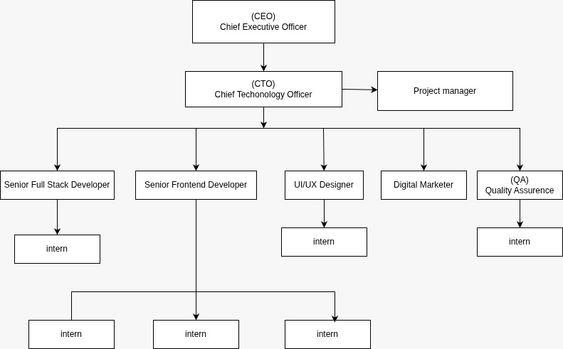
Figure 2.2: Organization Hierarchy of Sajilo Digital
- Leadership / Directors: Set company vision, strategy, and oversee major client relationships.
- Project Management: Responsible for resource planning, timeline management, and acting as the bridge between clients and the technical team.
- Development Teams: Organized into frontend, backend, and full-stack units, tasked with designing, coding, and testing software products.
- UI/UX Design Team: Creates user interface mock-ups, prototypes, and maintains design systems.
- Quality Assurance (QA) Team: Ensures product reliability through systematic testing procedures.
- Marketing & Sales: Handles business development, branding, and client acquisition.
- Interns: Integrated directly into project teams to contribute to real-world projects under mentorship.

2.3. Working Domains of Organization
Sajilo Digital operates across several key domains within the tech industry:
- Custom Web Development: Building responsive websites, progressive web apps (PWAs), and single-page applications (SPAs) using stacks like Next.js, React, and Node.js.
- Mobile App Development: Creating cross-platform (React Native, Flutter) and native mobile applications.
- Enterprise Software Solutions: Developing tailored business management systems, CRMs, and ERPs.
- E-commerce Solutions: Designing and developing online stores with integrated payment and inventory systems.
- Digital Marketing & SEO: Enhancing online visibility and user engagement through targeted strategies.
- Cloud Services & DevOps: Assisting with deployment, hosting, and infrastructure management.

2.4. Description of the Intern Department / Unit
The internship program at Sajilo Digital is structured to provide maximum practical exposure. Interns are treated as junior developers and assigned to active projects. I was placed in the Frontend Development unit under the guidance of my mentor, Mr. Shailesh Mishra.
The department operated with agile-inspired practices, including daily stand-up meetings, weekly sprint planning, and code review sessions. This environment emphasized collaborative problem-solving, version control best practices using Git, and writing clean, documented code. My primary project was the company website, which gave me direct responsibility over a production-critical asset, from conceptualization to deployment.
Table 2.4: Internship Duration
Start Date: | 11/17/2025
Daily Hours: | 10:00 AM to 6:00 PM
Working Days: | Sunday to Friday
Position: | Frontend Developer Intern
Company Mentor: | Mr. Sailesh Mishra
College Supervisor: | Mr. Suraj Pandey

2.5. Literature Review / Related Study
The development of the Sajilo Digital website was guided by contemporary research and established best practices in web development:
Next.js and React Frameworks: The official Next.js documentation and resources like "Next.js in Action" by T. M. Smith (2023) highlight the advantages of hybrid rendering (SSR/SSG) for improving performance, SEO, and user experience principles central to our technical choices.
Component-Based Architecture: Inspired by works like "Clean Architecture" by Robert C. Martin (2017) and React design patterns, the project adopted a modular component structure to promote separation of concerns, testability, and team scalability.
Web Performance Optimization: Studies from Google's Web Vitals initiative and books like "High Performance Browser Networking" by I. Grigorik (2013) informed techniques for minimizing load times, such as image optimization, lazy loading, and efficient bundling.
Responsive Web Design (RWD): The foundational principles established by Ethan Marcotte (2011) were applied, utilizing fluid grids, flexible images, and CSS media queries to ensure accessibility across all screen sizes.
User Experience (UX) Design: Insights from "Don't Make Me Think" by Steve Krug (2006) influenced the design of intuitive navigation and clear information hierarchy to reduce cognitive load for visitors.

CHAPTER 3: INTERNSHIP ACTIVITIES

3.1. Roles and Responsibilities
As a Frontend Developer Intern, my core responsibilities encompassed the entire development process for the company website and contributions to auxiliary projects:
For the Main Website (Next.js):
- Leading the frontend architecture and development of sajilodigital.com.np.
- Translating UI/UX design mock-ups into functional, responsive React components.
- Implementing application routing using the file-based routing system of Next.js.
- Leveraging Next.js data fetching methods (getStaticProps, getServerSideProps) for optimal content rendering.
- Managing global styles and component-level CSS using CSS Modules for scoped styling.
- Integrating and optimizing visual assets (images, icons) for performance.
- Implementing interactive UI elements with React state and effects.
- Ensuring cross-browser compatibility and accessibility standards (WCAG).
- Deploying and managing the production build on the Vercel platform.
- Conducting performance audits and implementing improvements.
General Development Duties:
- Participating in code reviews and adhering to team coding standards.
- Using Git for version control with feature branching and pull requests.
- Documenting components, project setup, and deployment procedures.
- Collaborating with my mentor to plan sprints and review progress.

3.2. Weekly Log
A detailed breakdown of activities, responsibilities, and key learnings for each week:

Weekly Internship Log
Name: Arun Neupane
Project: Sajilo Digital Official Website
Week no: 1 | Date: 11/17/2025 - 11/23/2025
Responsibilities:
- Onboarding and project discovery.
Activities:
- Company orientation.
- Deep dive into project requirements and brand guidelines.
- Analysis of competitor websites and modern design trends for tech companies.
Observation:
- A thorough understanding of the business goals is as important as the technical specifications.
Performance Evaluation by Mentor:
- Demonstrated strong curiosity and understanding of project goals through effective research and onboarding.


……………………………
Mentor’s Approval
Mr. Shailesh Mishra

Weekly Internship Log
Name: Arun Neupane
Project: Sajilo Digital Official Website
Week no: 2 | Date: 11/24/2025 - 11/30/2025
Responsibilities:
- Technical planning and setup.
Activities:
- Selected the tech stack (Next.js, Vercel).
- Set up the development environment and project repository.
- Created the initial project structure and configured essential tools (ESLint, Prettier).
Observation:
- A solid foundation and consistent tooling prevent issues later in the development cycle.
Performance Evaluation by Mentor:
- Showed good technical decision-making by selecting an appropriate stack and setting up a clean development environment.


……………………………
Mentor’s Approval
Mr. Shailesh Mishra

Weekly Internship Log
Name: Arun Neupane
Project: Sajilo Digital Official Website
Week no: 3 | Date: 12/01/2025 - 12/07/2025
Responsibilities:
- Core layout and component development.
Activities:
- Built foundational layout components (Header, Footer, Layout, Navigation).
- Established the CSS architecture and global styles.
- Created reusable UI components (Button, Card, Section).
Observation:
- Investing time in building a robust design system accelerates future development.
Performance Evaluation by Mentor:
- Built a solid foundation with well-structured components and a reusable design system.


……………………………
Mentor’s Approval
Mr. Shailesh Mishra

Weekly Internship Log
Name: Arun Neupane
Project: Sajilo Digital Official Website
Week no: 4 | Date: 12/08/2025 - 12/14/2025
Responsibilities:
- Page structure and initial content.
Activities:
- Developed the skeleton of key pages (Home, About, Services) using Next.js pages.
- Implemented the initial responsive grid layouts.
- Integrated placeholder content.
Observation:
- Building a semantic, accessible HTML structure is crucial before adding styling complexity.
Performance Evaluation by Mentor:
- Effectively established page structures with a focus on semantic and responsive layouts.


……………………………
Mentor’s Approval
Mr. Shailesh Mishra

Weekly Internship Log
Name: Arun Neupane
Project: Sajilo Digital Official Website
Week no: 5 | Date: 12/15/2025 - 12/21/2025
Responsibilities:
- Dynamic features and data fetching.
Activities:
- Implemented dynamic portfolio and blog listing pages using getStaticProps.
- Created markdown/content parsers for blog posts.
- Added interactive elements to the homepage hero section.
Observation:
- Next.js's data fetching methods powerfully decouple content from presentation.
Performance Evaluation by Mentor:
- Demonstrated proficiency in implementing dynamic features and efficient data fetching.


……………………………
Mentor’s Approval
Mr. Shailesh Mishra

Weekly Internship Log
Name: Arun Neupane
Project: Sajilo Digital Official Website
Week no: 6 | Date: 12/22/2025 - 12/28/2025
Responsibilities:
- Styling refinement and responsiveness.
Activities:
- Applied detailed styling to all components and page.
- Performed intensive responsive testing and adjustments across multiple device breakpoints.
- Fixed UI inconsistencies.
Observation:
- Responsive design is an iterative process of testing and refinement.
Performance Evaluation by Mentor:
- Exhibited attention to detail by refining UI design and ensuring responsiveness across devices.


……………………………
Mentor’s Approval
Mr. Shailesh Mishra

Weekly Internship Log
Name: Arun Neupane
Project: Sajilo Digital Official Website
Week no: 7 | Date: 12/29/2025 - 01/04/2026
Responsibilities:
- Performance optimization.
Activities:
- Optimized all images using next/image.
- Implemented lazy loading for below-the-fold components.
- Analysed and reduced JavaScript bundle size.
- Added loading states and skeletons.
Observation:
- Performance work has a direct, measurable impact on user experience and business metrics.
Performance Evaluation by Mentor:
- Applied strong optimization techniques to enhance performance and user experience.


……………………………
Mentor’s Approval
Mr. Shailesh Mishra

Weekly Internship Log
Name: Arun Neupane
Project: Sajilo Digital Official Website
Week no: 8 | Date: 01/05/2026 - 01/11/2026
Responsibilities:
- Testing and content integration.
Activities:
- Conducted cross-browser testing (Chrome, Firefox, Safari, Edge).
- Tested accessibility with keyboard navigation and screen readers.
- Integrated final company copy and real project data.
Observation:
- Rigorous testing uncovers issues that are not apparent during development.
Performance Evaluation by Mentor:
- Maintained high quality through thorough testing and proper integration of final content.


……………………………
Mentor’s Approval
Mr. Shailesh Mishra

Weekly Internship Log
Name: Arun Neupane
Project: Sajilo Digital Official Website
Week no: 9 | Date: 01/12/2026 - 01/18/2026
Responsibilities:
- Final polish and pre-deployment.
Activities:
- Implemented smooth page transitions and micro-interactions.
- Conducted a full performance audit using Lighthouse.
- Fixed final bugs and conducted user acceptance testing with the team.
Observation:
- The final 10% of polish often defines the perceived quality of the product.
Performance Evaluation by Mentor:
- Showed dedication to polish and quality by refining interactions and resolving final issues.


……………………………
Mentor’s Approval
Mr. Shailesh Mishra

Weekly Internship Log
Name: Arun Neupane
Project: Sajilo Digital Official Website
Week no: 10 | Date: 01/19/2026 - 01/23/2026
Responsibilities:
- Deployment, documentation, and handover.
Activities:
- Deployed the final production build to Vercel.
- Set up a custom domain (sajilodigital.com.np) and HTTPS.
- Created comprehensive project documentation for future developers.
- Prepared the final internship presentation and report.
Observation:
- A clean handover and documentation are critical for the long-term maintainability of a project.
Performance Evaluation by Mentor:
- Successfully managed deployment and documentation, ensuring a smooth project handover.


……………………………
Mentor’s Approval
Mr. Shailesh Mishra

3.3. Description of the Project (s) Involved During Internship
Primary Project: Sajilo Digital Official Website (Next.js)
This was the flagship project of my internship. The website serves as the primary digital face of the company, designed to attract clients, showcase expertise, and facilitate contact.
- Live URL: https://sajilodigital.com.np
- Tech Stack: Next.js 14, React 18, CSS Modules, Vercel.
- Key Features and Implementation:
- Hybrid Rendering: Used getStaticProps for blog/portfolio pages (SSG) and getServerSideProps where needed for dynamic content.
- Component Library: Built over 20 reusable, documented components (e.g., ServiceCard, ProjectShowcase, Testimonial).
- Performance: Achieved >90 Lighthouse scores through image optimization, font subsetting, and efficient code splitting.
- Responsiveness: Fully fluid layouts using CSS Grid and Flexbox with a mobile-first approach.
- Contact Integration: Connected contact forms to a backend service for reliable lead capture.
Auxiliary Project 1: Python Wi-Fi Home Server
A personal exploration project to understand basic networking and server-client architecture.
- Objective: Create a lightweight HTTP server in Python that serves files and simple APIs to devices on a local network.
- Learning Outcomes: Gained understanding of socket programming, HTTP request/response cycles, and basic network security considerations.
- Repository: https://github.com/sajilodigital9000/python-server
Auxiliary Project 2: Color Picker Web Application
A focused frontend project to practice state management and interactive UI.
- Objective: Build a tool for designers to select, mix, and copy color values (HEX, RGB, HSL).
- Tech: React, useState/useEffect hooks, CSS.
- Learning Outcomes: Deepened knowledge of React state flow, color theory in code, and clipboard API integration.
- Live Demo: https://easycolorpicker.vercel.app
Auxiliary Project 3: Quiz Web Application
An interactive application to manage complex state and user flow.
- Objective: Develop a timed quiz with multiple categories, score tracking, and result summary.
- Tech: React, Context API for global state (quiz progress, timer), React Router.
- Learning Outcomes: Mastered managing interconnected state (questions, timer, score), conditional rendering patterns, and creating engaging user feedback.
- Live Demo: https://sajiloquiz.vercel.app

3.4. Tasks / Activities Performed
This section provides a detailed breakdown of the technical and professional activities carried out during the 10-week internship. Each activity is elaborated with the context, approach, challenges encountered, and solutions implemented.

3.4.1 Project Setup and Environment Configuration
At the outset of the internship, I established a robust development environment for the Sajilo Digital website. This involved:
Selecting the Tech Stack: After evaluating options, we chose Next.js 14 with React 18 for its hybrid rendering capabilities (SSR/SSG), built‑in performance optimizations, and excellent developer experience. Vercel was selected for deployment due to its seamless integration with Next.js.
Repository Initialization: I created a Git repository on GitHub, setting up a branching strategy with main for production, develop for integration, and feature branches for each new component or page. This ensured clean version control and facilitated team collaboration.
Tooling Configuration: I configured ESLint and Prettier to enforce consistent code style and catch potential errors early. Custom rules were added to align with the company’s coding standards.
Environment Variables: I set up .env.local for development secrets (e.g., API keys, contact form endpoints) and documented the required variables in a .env.example file.
Development Scripts: I enhanced the package.json scripts with commands for running the dev server, building for production, and running lint checks. I also integrated next-optimized-images to handle image optimization during builds.
Challenges and Solutions: Initially, there were conflicts between ESLint and Prettier that caused inconsistent formatting. I resolved this by installing the eslint-config-prettier package and adjusting the eslintrc configuration to defer stylistic rules to Prettier.

3.4.2 Component Architecture and Design System Implementation
To ensure maintainability and consistency, I designed a modular component architecture following the atomic design principle:
Atoms: Created basic building blocks such as Button, Input, Icon, Heading, Text, and Container. These components received props for customization (size, variant, color) and included proper ARIA labels for accessibility.
Molecules: Combined atoms to form functional groups like NavLink, SearchBar, Card, ServiceCard, and TestimonialCard. For example, the ServiceCard accepts an icon, title, description, and a link, rendering a consistent card layout throughout the services section.
Organisms: Developed larger sections that combine molecules, such as HeroSection, FeaturesGrid, ProjectShowcase, and ContactForm. These organisms handled data fetching (via props) and layout logic.
Templates and Pages: Created page templates (e.g., HomeTemplate, ServicesTemplate) that arranged organisms into a page layout. Each Next.js page imported the corresponding template and passed in the required data.
Documentation: I documented each component using JSDoc comments, specifying props, default values, and usage examples. This made it easier for other team members to understand and reuse components.
Challenges and Solutions: One challenge was ensuring that components remained truly reusable without becoming overly complex. I solved this by applying the single responsibility principle—each component does one thing well—and by using composition over configuration. For instance, the Button component accepts an as prop to render as a <button> or <a> element, maintaining flexibility.

3.4.3 Responsive Layout Development
A key requirement was a fully responsive design that works flawlessly on desktops, tablets, and mobile devices. I adopted a mobile‑first approach:
CSS Methodology: I used CSS Modules to scope styles to individual components, preventing global conflicts. A global globals.css defined CSS variables for colors, typography, spacing, and breakpoints.
Breakpoints: Based on common device sizes, I defined breakpoints: 480px (mobile), 768px (tablet), 1024px (desktop), and 1440px (large desktop). Media queries were used to adjust layouts, font sizes, and spacing accordingly.
Layout Components: I created layout components like Container, Grid, and Flex that encapsulate responsive behaviors. The Grid component, for example, uses CSS Grid and accepts props for columns, gaps, and responsiveness (e.g., gridTemplateColumns={{ base: '1fr', md: '1fr 1fr', lg: '1fr 1fr 1fr' }}).
Navigation: The main navigation was implemented as a Navbar component that collapses into a hamburger menu on mobile. I used useState to control the mobile menu’s open/close state and added a smooth transition using CSS transforms.
Testing: I tested the responsiveness using browser dev tools’ device emulation and physical devices (iPhone, iPad, various Android phones). I made extensive use of Chrome DevTools’ responsive design mode to iterate quickly.
Challenges and Solutions: Handling complex layouts like the portfolio grid that needed to adapt from 3 columns on desktop to 2 on tablet to 1 on mobile required careful planning. I solved this by using CSS Grid with repeat(auto-fit, minmax(280px, 1fr)) combined with media queries to fine‑tune the column count for optimal image sizing.

3.4.4 Data Fetching and State Management
Leveraging Next.js data fetching capabilities was central to the project:
Static Generation (SSG): For blog posts and portfolio items, I used getStaticProps to fetch content from local markdown files at build time. I implemented a utility to parse frontmatter and content using gray-matter. This produced static HTML files that load extremely fast.
Server‑Side Rendering (SSR): For pages requiring real‑time data (e.g., a live service status or dynamic content), I used getServerSideProps. This was applied to the contact page to pre‑populate a location map based on IP geolocation (a third‑party API).
Client‑Side State: For interactive elements like the contact form, I used React hooks (useState, useEffect) to manage form state, validation, and submission status. I also used useContext to share a theme preference across the site (light/dark mode) without prop‑drilling.
API Integration: I set up API routes inside Next.js (/api/contact) to handle form submissions and forward them to a backend service. This kept sensitive keys secure and allowed for server‑side validation.
Challenges and Solutions: One challenge was ensuring that dynamic pages (like blog posts) were correctly routed and displayed. Next.js dynamic routing with [slug].js was used, but we needed to generate a list of all slugs at build time. I implemented getStaticPaths to return all possible slugs, and getStaticProps to fetch the content for a specific slug.

3.4.5 Performance Optimization
Performance was a top priority to achieve high Lighthouse scores and a fast user experience:
Image Optimization: All images were served via Next.js’s <Image> component, which automatically optimizes formats (WebP), resizes, and lazy loads. I set appropriate sizes attributes to serve responsive images.
Code Splitting and Lazy Loading: Next.js automatically splits code by page, but I also used dynamic imports (next/dynamic) for components that are not needed immediately, such as the contact form and heavy animations. I added loading skeletons to improve perceived performance.
Bundle Analysis: I used @next/bundle-analyzer to inspect the JavaScript bundle and identified that a large charting library was unnecessarily included. I replaced it with a lightweight alternative.
Font Optimization: I hosted custom fonts locally using next/font to reduce external requests and improve privacy. I also used font-display: swap to avoid layout shifts.
Caching Headers: I configured caching headers in the next.config.js for static assets (e.g., images, fonts) to leverage browser caching.
Results: After optimization, Lighthouse scores consistently exceeded 90 for performance, accessibility, best practices, and SEO.

3.4.6 Cross‑Browser and Accessibility Testing
To ensure a consistent experience across all major browsers and devices, I performed extensive testing:
Browser Testing: I manually tested on Chrome, Firefox, Safari, and Edge on Windows and macOS. I used BrowserStack to test on older browser versions.
Accessibility Testing: I used the WAVE tool and Lighthouse accessibility audits to identify issues. I then implemented fixes such as adding alt attributes to images, ensuring proper heading hierarchy, and adding aria-label to interactive elements.
Keyboard Navigation: I tested the entire site using only keyboard navigation, ensuring that all interactive elements are focusable and that focus order is logical. I added :focus-visible styles for better visual feedback.
Challenges and Solutions: Safari had a specific issue with CSS Grid layout for the portfolio grid. I discovered that Safari required -webkit- prefixes for certain grid properties. I used PostCSS with Autoprefixer to automatically add prefixes during the build process.

3.4.7 Deployment and Continuous Integration
The final phase involved deploying the website to production:
Vercel Setup: I connected the GitHub repository to Vercel, configuring automatic deployments for the main branch. I set up preview deployments for pull requests, allowing the team to review changes before merging.
Custom Domain and SSL: I configured the custom domain sajilodigital.com.np through Vercel’s domain management, which automatically provisions an SSL certificate.
Environment Variables: I added all required environment variables to Vercel’s project settings, ensuring they were available in the production environment.
Monitoring: I enabled Vercel Analytics to track performance metrics and error logging to quickly identify any issues after launch.

3.4.8 Auxiliary Projects
In addition to the main website, I completed three auxiliary projects that broadened my skills:
Python WiFi Home Server: I built a simple HTTP server using Python’s http.server module and extended it with custom endpoints using Flask. This project gave me hands‑on experience with backend concepts, socket programming, and network configurations.
Color Picker Web App: I developed a tool using React that allows users to select colors and copy hex/rgb/hsl values. I practiced managing state with useState and integrating with the Clipboard API.
Quiz Web Application: I created a quiz app with multiple choice questions, a timer, and scoring. I used the Context API to manage global state (current question, score, timer) and React Router for navigation between the quiz and results page. This deepened my understanding of complex state management.

3.4.9 Documentation and Knowledge Transfer
Throughout the internship, I maintained comprehensive documentation:
Component Documentation: I created a Storybook instance for the component library, documenting each component’s props, usage, and examples.
Project Setup Guide: I wrote a README.md with detailed instructions on setting up the project, configuring environment variables, and running the development server.
Deployment Notes: I documented the deployment process, including Vercel configuration, environment variables, and post‑deployment verification steps.
Code Comments: I ensured that all complex logic was accompanied by clear comments explaining the reasoning behind the implementation.

3.4.10 Collaboration and Communication
I actively participated in daily stand‑up meetings, where I reported progress, highlighted blockers, and coordinated with the mentor. I used Slack for real‑time communication and GitHub issues to track tasks and bugs. During code reviews, I provided constructive feedback on peers’ pull requests and incorporated feedback into my own work. This collaborative environment taught me the importance of clear communication and teamwork in software development.
In summary, the 10‑week internship involved a wide range of activities that collectively contributed to the successful delivery of a production‑grade website and significantly enhanced my technical and professional skills.

CHAPTER 4: CONCLUSION AND LEARNING OUTCOMES

4.1. Conclusion
The 10-week internship at Sajilo Digital Pvt. Ltd. was an immensely rewarding and transformative experience. The successful development and launch of the sajilodigital.com.np website stand as a concrete achievement, demonstrating the practical application of modern frontend technologies to solve real business problems. This project provided a deep dive into the Next.js ecosystem, reinforcing the value of frameworks that offer built-in solutions for performance, SEO, and developer experience.
Working on auxiliary projects broadened my technical perspective, giving me hands-on exposure to backend networking concepts and complex frontend state management beyond the primary website. The internship successfully bridged the gap between academic knowledge and industry demands, providing clarity on professional workflows, collaboration tools, and the importance of writing maintainable, scalable code.
Overall, this experience has solidified my passion for web development, equipped me with in-demand skills, and prepared me to contribute effectively in a professional software development environment.

4.2. Learning Outcomes
Technical Skills:
- Mastery of Next.js Framework: Gained extensive experience with App Router, Data Fetching (SSG/SSR), Image Optimization, and Routing, understanding their impact on performance and SEO.
- Advanced React Proficiency: Strengthened concepts of hooks, component lifecycle, context API, and reusable component patterns.
- Performance Optimization Expertise: Learned and applied techniques for bundle splitting, lazy loading, image optimization, and Core Web Vitals improvement.
- Responsive & Accessible Design: Developed the ability to create websites that work flawlessly across all devices and are usable by people with disabilities.
- Deployment & DevOps Basics: Acquired hands-on experience with Vercel platform, CI/CD for frontend projects, and domain management.
- Full-Stack Awareness: Through the Python server project, gained foundational knowledge of backend server mechanics and HTTP protocols.
Professional Skills:
- Project Management: Experienced breaking down a large project into manageable tasks, estimating effort, and working within timelines.
- Collaboration & Communication: Improved skills in articulating technical decisions, participating in code reviews, and working within a team dynamic.
- Problem-Solving: Enhanced ability to debug complex issues, research solutions, and implement effective fixes.
- Professional Workflow: Became proficient with industry-standard tools like Git, VS Code, and agile development practices.
- Documentation: Learned the critical importance of documenting code and processes for future maintainers and one's future self.
This internship has been a cornerstone in my development as a software engineer, providing both the technical toolkit and the professional mindset required for a successful career.

REFERENCES
Banks, A., & Porcello, E. (2017). Learning React: Modern patterns for developing React apps. O'Reilly Media.
Google Developers. (2023). Web Vitals. https://web.dev/vitals/
Grigorik, I. (2013). High performance browser networking. O'Reilly Media.
Krug, S. (2006). Don't make me think: A common-sense approach to web usability. New Riders.
Marcotte, E. (2011). Responsive web design. A Book Apart.
Martin, R. C. (2017). Clean architecture: A craftsman's guide to software structure and design. Prentice Hall.
Next.js Documentation. (n.d.). Retrieved from https://nextjs.org/docs
Smith, T. M. (2023). Next.js in action. Manning Publications.

APPENDICES
Screenshots
- Home page
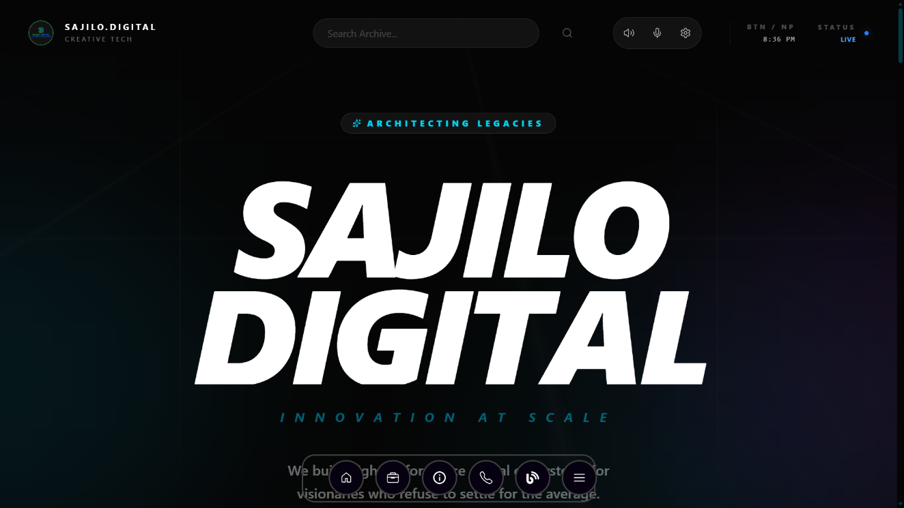
Figure i: Home Page of Sajilo Digital
- Search Bar
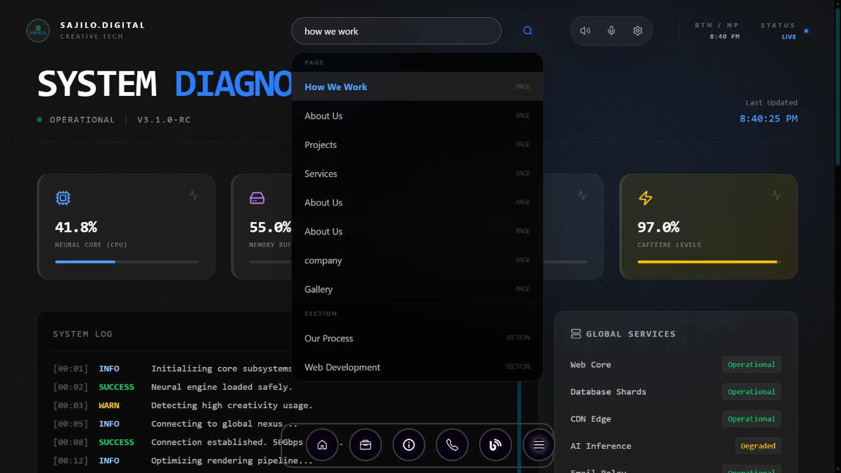
Figure ii: Home Page of Sajilo Digital

- FQA page
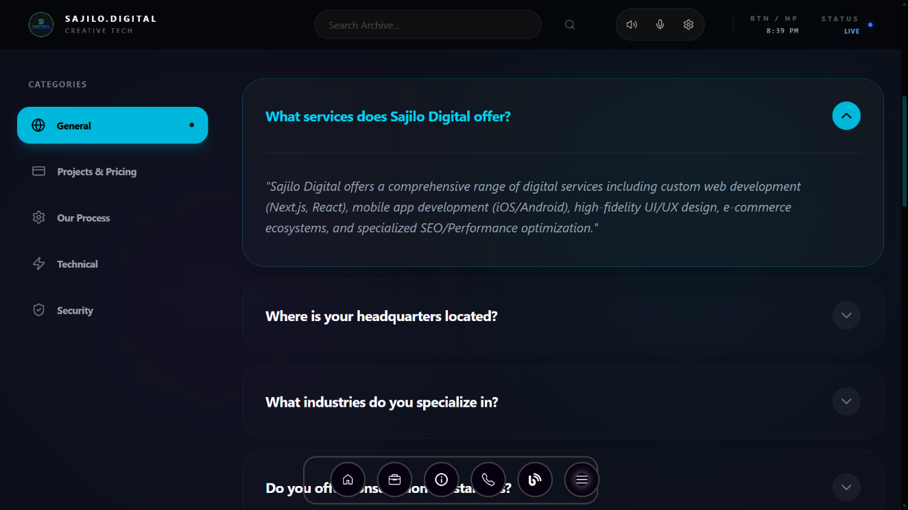
Figure iii: FAQ Page of Sajilo Digital
- Project Page
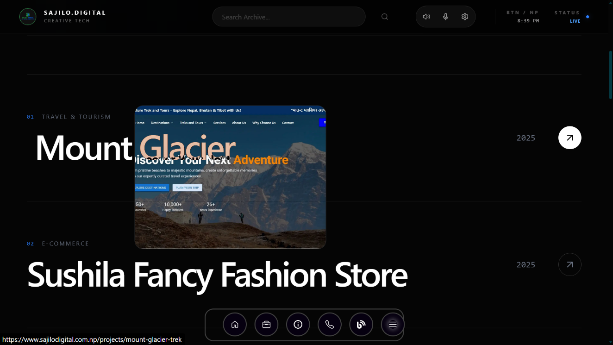
Figure iv: Project Page of Sajilo Digital

- Contact Page
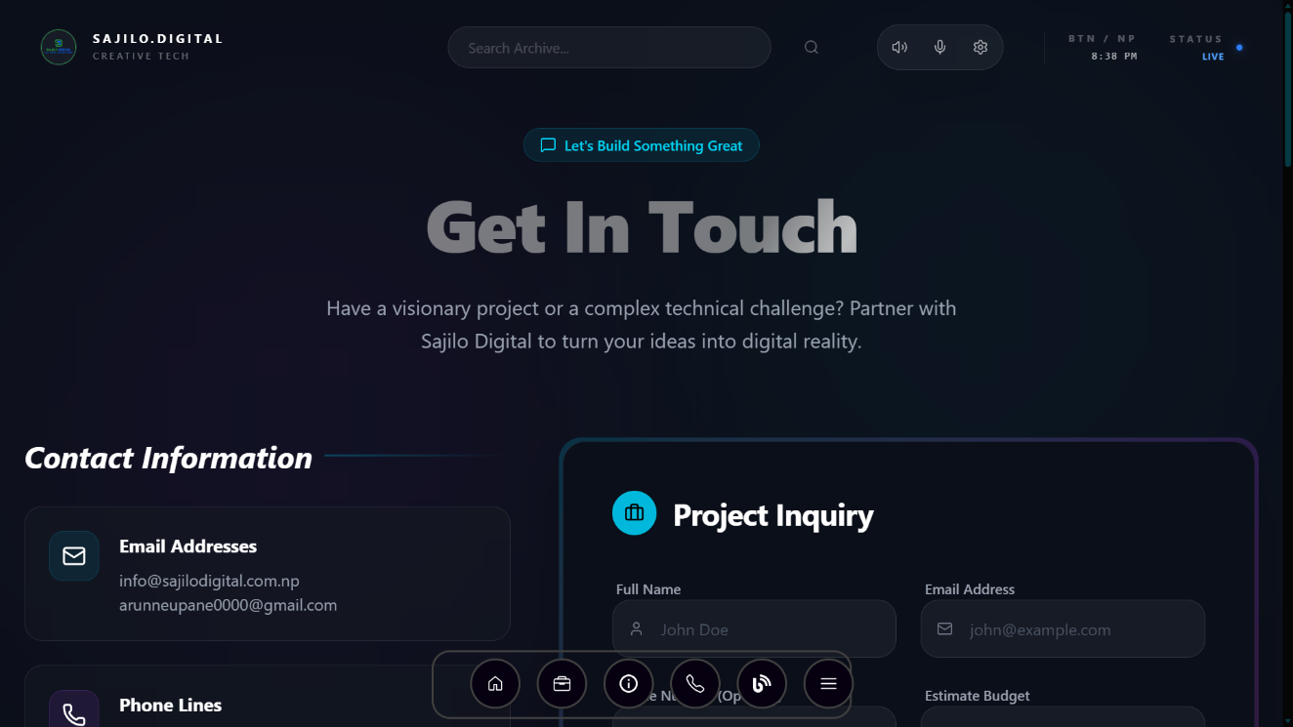
Figure v: Contact Page of Sajilo Digital
- How we work page
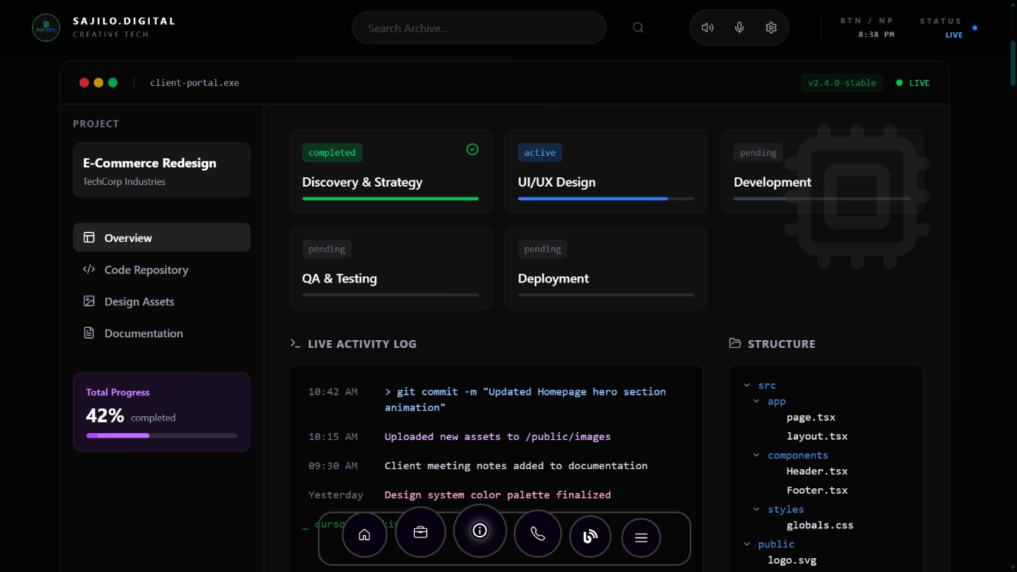
Figure vi: How we Page of Sajilo Digital

- About us page
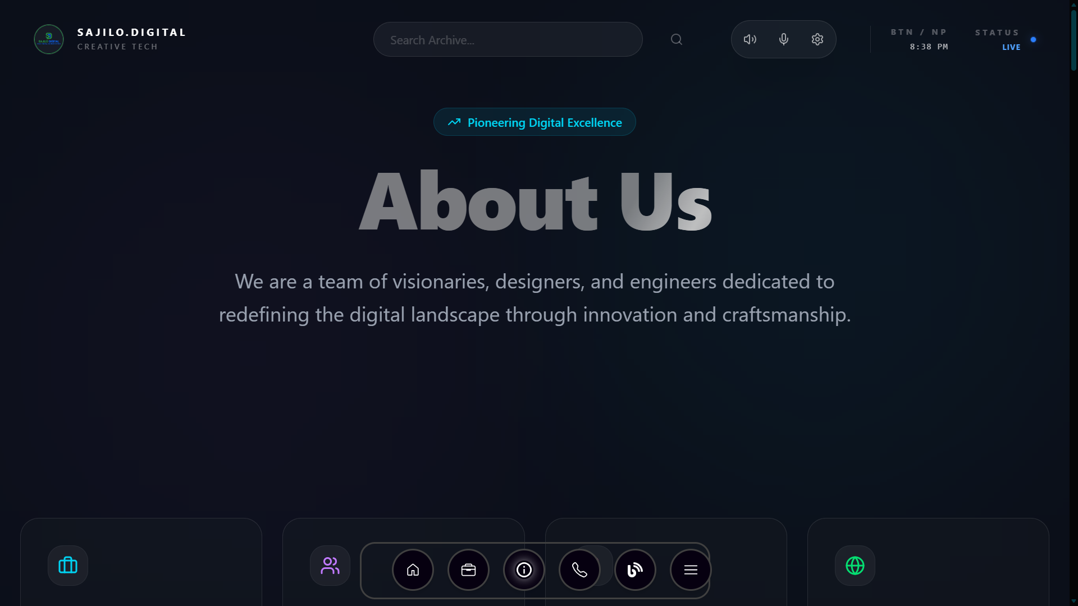
Figure vii: AboutUs Page of Sajilo Digital
- Service Page
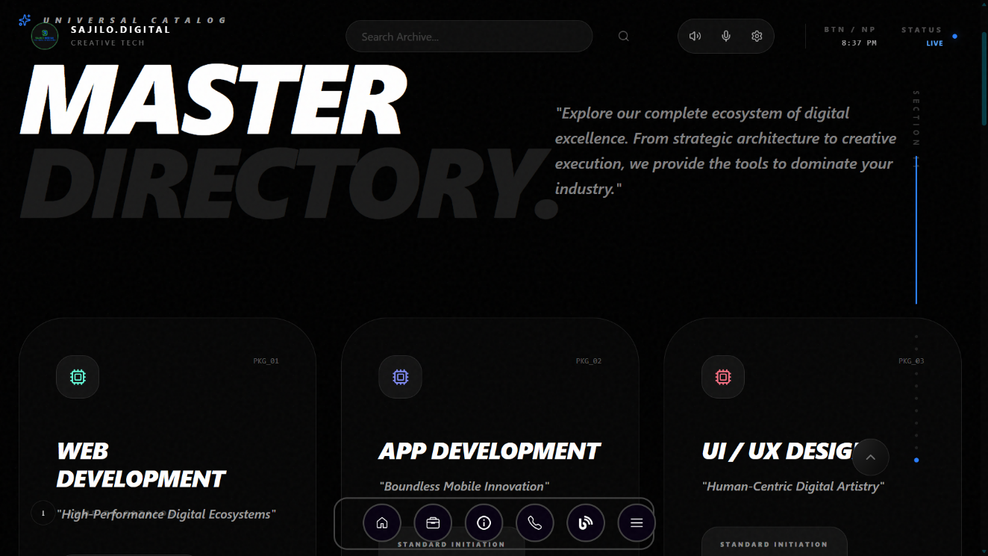
Figure viii: Service Page of Sajilo Digital

