Tribhuwan University
Institute of Science and Technology
Bhairahawa Multiple Campus

An internship report on
“Frontend Development”
At Sajilo Digital Pvt. Ltd
(In partial fulfilment of the requirement of Bachelor of Science in Computer Science & Information Technology (BSc. CSIT))

Submitted By:
Ashish G.M (30284 / 078)

Submitted To:
Department of Computer Science and Information Technology
Bhairahawa Multiple Campus
Bhairahawa, Nepal
November, 2025

Under the supervision of
Mr. Suraj Pandey


SUPERVISOR RECOMMENDATION
This is to confirm that the internship report titled "Frontend Development of Sushila Fancy Store E-commerce Platform Using ReactJS" has been prepared by Ashish GM under my academic supervision. This report is submitted as partial fulfillment of the requirements for the Bachelor of Science in Computer Science and Information Technology degree..
As his college supervisor, I monitored Ashish's progress during his internship at Sajilo Digital Pvt. Ltd. He effectively applied his academic knowledge in web technologies to develop a sophisticated e-commerce interface using ReactJS. His report comprehensively documents the technical implementation, development challenges, and solutions employed during the project.
The report demonstrates adequate depth, proper structure, and meets the academic standards expected for the BSc.CSIT program evaluation

………………………
Mr. Suraj Pandey
Supervisor, BSc.CSIT
Bhairahawa Multiple Campus



LETTER OF APPROVAL
This certifies that the internship report "Frontend Development of Sushila Fancy Store E-commerce Platform Using ReactJS" prepared by Ashish GM is submitted in partial fulfillment of the requirements for the Bachelor of Science in Computer Science and Information Technology degree. Having reviewed this report, we find it satisfactory in scope, content quality, and organization. It appropriately reflects the work completed during the internship period and meets the necessary academic standards for the degree program.
………………………….
Lucky Prasad Joshi
Campus Chief
Bhairahawa Multiple Campus
………………………  Sunil Kumar Shah  BSc. CSIT Coordinator  Bhairahawa Multiple Campus | ……………………….  Suraj Pandey  Supervisor  Bhairahawa Multiple Campus
………………………..  Internal Examiner | ………………………  External Examiner  IOST: Tribhuwan University

ACKNOWLEDGEMENT
I wish to express my sincere gratitude to all individuals and institutions who supported me throughout my internship and during the preparation of this report.
My deepest appreciation goes to Sajilo Digital Pvt. Ltd. for providing me with the opportunity to work as a Frontend Developer Intern. I am particularly grateful to my mentor, Mr. Shailesh Mishra, for his expert guidance, technical insights, and constructive feedback that significantly enhanced my ReactJS development skills. His mentorship was invaluable in helping me navigate complex implementation challenges.
I extend my heartfelt thanks to my college supervisor, Mr. Suraj Pandey, for his academic guidance, encouragement, and support during both the internship and report writing phases. His suggestions helped me align my practical work with academic expectations.
I would also like to thank the entire development team at Sajilo Digital for their collaborative spirit and knowledge sharing. The supportive work environment greatly contributed to my professional growth.
Finally, I am thankful to my family and friends for their unwavering support, patience, and motivation throughout this learning journey.

……………………..
Your sincerely
Ashish G.M
Symbol no: 30284 / 078
BSc. CSIT, Bhairahawa Multiple Campus

ABSTRACT
This report documents the 10-week internship completed at Sajilo Digital Pvt. Ltd. as a Frontend Developer, focusing on the development of the Sushila Fancy Store e-commerce website using ReactJS. The primary objective was to design and implement a responsive, interactive, and user-friendly online shopping interface for a fashion retail store. The project involved creating a complete frontend application with features including product catalog display, advanced filtering and sorting, shopping cart management, user authentication interfaces, and an administrative dashboard. Utilizing ReactJS with functional components and hooks, the implementation emphasized component reusability, efficient state management using Context API, and responsive design principles for cross-device compatibility. Throughout the internship, I gained hands-on experience in modern frontend development workflows, including version control with Git, component-based architecture, API integration with mock data, performance optimization, and deployment on Vercel. The project successfully delivered a fully functional e-commerce frontend that provides an intuitive shopping experience while demonstrating professional-grade ReactJS development practices.
Keywords: ReactJS, Frontend Development, E-commerce, Component Architecture, State Management, Responsive Design
TABLE OF CONTENT
SUPERVISOR RECOMMENDATION ii
LETTER OF APPROVAL iii
ACKNOWLEDGEMENT iv
ABSTRACT v
LIST OF ABBRIVIATION viii
LIST OF FIGURES ix
LIST OF TABLES x
CHAPTER 1: INTRODUCTION 1
1.1. Introduction 1
1.2. Problem Statement 1
1.3. Objectives 2
1.4. Scope and Limitation 2
1.5. Report Organization 3
CHAPTER 2: ORGANIZATION DETAILS AND LITERATURE REVIEW 4
2.1. Introduction to Organization 4
2.2. Organizational Hierarchy 4
2.3. Working Domains of Organization 5
2.4. Description of the Intern Department / Unit 5
2.5. Literature Review / Related Study 6
CHAPTER 3: INTERNSHIP ACTIVITIES 7
3.1. Roles and Responsibilities 7
3.2. Weekly Log 7
3.3. Description of the Project (s) Involved During Internship 18
3.4. Tasks / Activities Performed 18
CHAPTER 4: CONCLUSION AND LEARNING OUTCOMES 26
4.1. Conclusion 26
4.2. Learning Outcomes 26
REFERENCES 28
APPENDICES 29

LIST OF ABBRIVIATION
API – Application Programming Interface
CSS – Cascading Style Sheet
HTTP - Hypertext Transfer Protocol
REST - Representational State Transfer
SEO – Search Engine Optimization
SPA – Single Page Application
UI – User Interface
UX - User Experience

LIST OF FIGURES
Figure 2.2: Organization Hierarchy of Sajilo Digital 4

LIST OF TABLES
Table 2.4: Internship Duration 6

CHAPTER 1: INTRODUCTION

1.1. Introduction
The digital transformation of retail has made e-commerce platforms essential for business growth and customer engagement. Modern consumers expect seamless, intuitive online shopping experiences across all devices. This internship report details my work as a Frontend Developer at Sajilo Digital Pvt. Ltd., where I developed the Sushila Fancy Store website—a ReactJS-based e-commerce solution for fashion and accessories.
The project focused on building a sophisticated single-page application (SPA) that provides customers with an engaging shopping interface. Key features implemented include dynamic product displays, interactive filtering systems, real-time cart updates, and responsive design that adapts to various screen sizes. Using React's component-based architecture allowed for creating maintainable, reusable UI elements that together form a cohesive shopping experience.
This report outlines the technical implementation, design decisions, challenges encountered, and solutions developed during the 10-week internship, providing insight into professional frontend development practices using modern JavaScript frameworks.

1.2. Problem Statement
Sushila Fancy Store required a modern digital presence to compete in the growing online fashion market. The existing challenges included:
- Outdated Digital Interface: No contemporary, engaging online platform to showcase products effectively.
- Limited Shopping Features: Basic product display without advanced filtering, sorting, or cart functionalities.
- Poor Mobile Experience: Lack of responsive design resulted in difficult navigation on smartphones and tablets.
- Inefficient State Management: No systematic approach to handling application state across complex user interactions.
- Slow Performance: Existing solutions lacked optimization techniques, leading to poor loading times and user experience.
- Development Scalability: Previous implementations didn't follow modular architecture, making maintenance and feature addition difficult.

1.3. Objectives
The primary objectives of this frontend development internship project were:
- To develop a fully responsive e-commerce website using ReactJS with optimal performance across all devices.
- To implement advanced product browsing features including filtering, sorting, and search functionality.
- To create an interactive shopping cart with real-time updates and persistent storage.
- To design and implement user authentication interfaces and user profile management.
- To establish efficient state management patterns using React Hooks and Context API.
- To optimize application performance through code splitting, lazy loading, and image optimization.
- To ensure accessibility standards and cross-browser compatibility.
- To deploy the application to a production environment and document the development process.

1.4. Scope and Limitation
Scopes:
- Complete frontend development using ReactJS and related ecosystem tools.
- Implementation of all user-facing features: product catalog, cart, user authentication UI, and admin dashboard.
- Responsive design implementation for desktop, tablet, and mobile devices.
- Integration with mock backend services for data simulation.
- Performance optimization and basic SEO implementation.
- Deployment to Vercel hosting platform.
Limitations:
- Backend services were simulated using mock APIs; no actual payment gateway or inventory management backend was integrated.
- Advanced features like product recommendations, wishlists, and social sharing were beyond initial scope.
- User testing was limited to internal team feedback rather than extensive external user testing.
- Analytics integration and advanced performance monitoring were not implemented..

1.5. Report Organization
This report is structured into four chapters to provide a logical and comprehensive overview of the internship:
- Chapter 1: Introduction
Presents an overview of the project, including the background of the internship, a clear problem statement, the defined objectives, the technical scope and limitations, and the overall organization of this report.
- Chapter 2: Organization Details and Literature Review
Discusses the background of Sajilo Digital Pvt. Ltd., including its organizational hierarchy and core working domains. It also covers the description of the intern department and a review of the foundational technologies and existing literature relevant to modern frontend development.
- Chapter 3: Internship Activities
Serves as the technical core of the report, provides a detailed account of my roles, weekly progress, project descriptions, and specific tasks undertaken.
- Chapter 4: Conclusion and Learning Outcomes
Summarizes the project's achievements and reflects on the professional and technical skills acquired.
Additional sections, including References, and Appendices (containing screenshots, source code snippets), are included at the end of the report to provide supporting documentation and evidence of the work performed.

CHAPTER 2: ORGANIZATION DETAILS AND LITERATURE REVIEW

2.1. Introduction to Organization
Sajilo Digital Pvt. Ltd. is a progressive digital solutions company based in Bhairahawa, Nepal, specializing in custom software development, web applications, and digital transformation services. The company emphasizes using cutting-edge technologies and agile methodologies to deliver scalable, user-centred solutions for diverse business needs. With a focus on innovation and quality, Sajilo Digital provides an environment conducive to practical learning and professional growth in software development.

2.2. Organizational Hierarchy
The company employs a flat yet functional hierarchy designed to promote efficiency and collaboration:
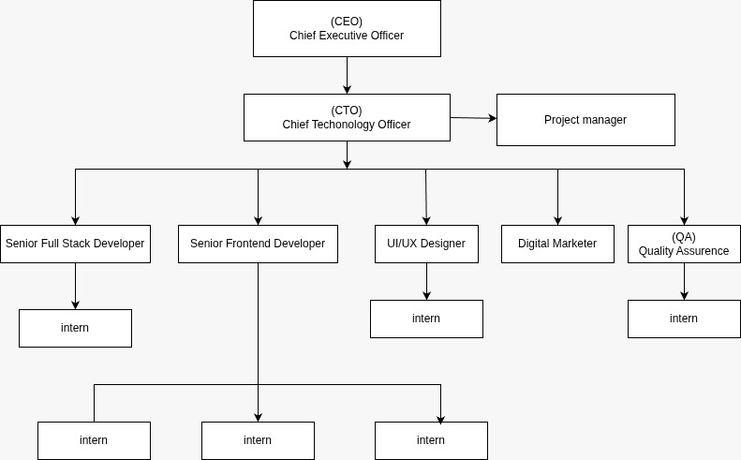
Figure 2.2: Organization Hierarchy of Sajilo Digital
- Leadership / Directors: Set company vision, strategy, and oversee major client relationships.
- Project Management: Responsible for resource planning, timeline management, and acting as the bridge between clients and the technical team.
- Development Teams: Organized into frontend, backend, and full-stack units, tasked with designing, coding, and testing software products.
- UI/UX Design Team: Creates user interface mock-ups, prototypes, and maintains design systems.
- Quality Assurance (QA) Team: Ensures product reliability through systematic testing procedures.
- Marketing & Sales: Handles business development, branding, and client acquisition.
- Interns: Integrated directly into project teams to contribute to real-world projects under mentorship.

2.3. Working Domains of Organization
Sajilo Digital operates across several key domains within the tech industry:
- Custom Web Development: Building responsive websites, progressive web apps (PWAs), and single-page applications (SPAs) using stacks like Next.js, React, and Node.js.
- Mobile App Development: Creating cross-platform (React Native, Flutter) and native mobile applications.
- Enterprise Software Solutions: Developing tailored business management systems, CRMs, and ERPs.
- E-commerce Solutions: Designing and developing online stores with integrated payment and inventory systems.
- Digital Marketing & SEO: Enhancing online visibility and user engagement through targeted strategies.
- Cloud Services & DevOps: Assisting with deployment, hosting, and infrastructure management.

2.4. Description of the Intern Department / Unit
As a Frontend Development Intern, I was integrated into the web development team under the direct supervision of my mentor. The department follows agile-inspired workflows with regular code reviews, daily stand-ups, and sprint planning sessions. Interns participate in all phases of frontend development—from requirement analysis and technical planning to implementation, testing, and deployment. This immersive approach provides practical experience with professional development tools, collaboration practices, and industry-standard coding conventions.
Table 2.4: Internship Duration
Start Date: | 11/17/2025
Daily Hours: | 10:00 AM to 6:00 PM
Working Days: | Sunday to Friday
Position: | Frontend Developer Intern
Company Mentor: | Mr. Sailesh Mishra
College Supervisor: | Mr. Suraj Pandey

2.5. Literature Review / Related Study
The development of the Sushila Fancy Store website was informed by contemporary frontend development literature and best practices:
React and Component Architecture: The official React documentation and resources like "React Explained" by Zac Gordon (2022) emphasize component-based UI development, which promotes reusability, maintainability, and testability—principles central to this project's architecture.
State Management Patterns: Modern React development has shifted toward hooks-based state management. Resources like "Learning React" by Kirupa Chinnathambi (2022) discuss patterns using useContext and useReducer for complex state logic, which informed the cart and user session implementations.
Performance Optimization: Studies on web performance by Google's Web Fundamentals highlight techniques like code splitting, lazy loading, and image optimization that were applied to ensure fast loading times and smooth interactions.
Responsive Design Principles: Ethan Marcotte's seminal work on responsive web design (2011) established the foundations for flexible grids and media queries that guided the multi-device compatibility implementation.
E-commerce UI Patterns: Research from Baymard Institute on e-commerce usability informed interface decisions regarding product display, filtering design, and checkout flow optimization.

CHAPTER 3: INTERNSHIP ACTIVITIES

3.1. Roles and Responsibilities
As a Frontend Developer Intern, my core responsibilities encompassed the entire development process for the company website and contributions to auxiliary projects:
- Developing reusable React components following atomic design principles
- Implementing responsive layouts using CSS Grid, Flexbox, and media queries
- Creating application state management solutions using React Hooks and Context API
- Building dynamic routing structures with React Router for seamless navigation
- Integrating with RESTful APIs to fetch and display product data
- Implementing interactive features: product filtering, sorting, and cart operations
- Optimizing component performance through memorization and lazy loading
- Ensuring cross-browser compatibility and accessibility compliance
- Collaborating with team members using Git version control
- Participating in code reviews and implementing feedback
- Writing clean, documented, and maintainable code
- Deploying updates to the Vercel hosting platform

3.2. Weekly Log
A detailed breakdown of activities, responsibilities, and key learnings for each week:

Weekly Internship Log
Name: Ashish G.M
Project: Sushila Fancy Store Website
Week no: 1 | Date: 11/17/2025 - 11/23/2025
Responsibilities:
- Project initialization and environment setup.
Activities:
- Understood project requirements and scope.
- Studied design mock-ups.
- Set up development environment with Node.js, React, and necessary dependencies.
- Configured Git repository
Observation:
- Proper tooling setup significantly impacts development efficiency. Clear requirement understanding prevents rework.
Performance Evaluation by Mentor:
- Demonstrated strong initiative in setting up the development environment and clearly understanding project requirements.


……………………………
Mentor’s Approval
Mr. Shailesh Mishra

Weekly Internship Log
Name: Ashish G.M
Project: Sushila Fancy Store Website
Week no: 2 | Date: 11/24/2025 - 11/30/2025
Responsibilities:
- Project architecture and component planning.
Activities:
- Designed component hierarchy.
- Created project folder structure.
- Built foundational layout components (Header, Footer, Navigation).
- Established CSS architecture and design tokens.
Observation:
- Thoughtful architecture planning facilitates scalable development and team collaboration.
Performance Evaluation by Mentor:
- Showed excellent architectural planning skills by designing scalable components and a structured codebase.


……………………………
Mentor’s Approval
Mr. Shailesh Mishra

Weekly Internship Log
Name: Ashish G.M
Project: Sushila Fancy Store Website
Week no: 3 | Date: 12/01/2025 - 12/07/2025
Responsibilities:
- Product display implementation.
Activities:
- Created ProductCard and ProductGrid components.
- Implemented product listing page.
- Integrated mock API for product data.
- Added basic styling and responsiveness.
Observation:
- Component reusability reduces code duplication and improves maintainability.
Performance Evaluation by Mentor:
- Effectively implemented reusable product display components with proper data integration and responsiveness.


……………………………
Mentor’s Approval
Mr. Shailesh Mishra

Weekly Internship Log
Name: Ashish G.M
Project: Sushila Fancy Store Website
Week no: 4 | Date: 12/08/2025 - 12/14/2025
Responsibilities:
- Advanced filtering and sorting features.
Activities:
- Implemented multi-criteria filtering system.
- Added sorting functionality (price, popularity, newness). Created dynamic filter components with state management.
Observation:
- Complex state logic requires careful planning to ensure predictable behaviour.
Performance Evaluation by Mentor:
- Demonstrated solid problem-solving ability by implementing advanced filtering and sorting features with efficient state management.


……………………………
Mentor’s Approval
Mr. Shailesh Mishra

Weekly Internship Log
Name: Ashish G.M
Project: Sushila Fancy Store Website
Week no: 5 | Date: 12/15/2025 - 12/21/2025
Responsibilities:
- Shopping cart development.
Activities:
- Built cart context using useContext and useReducer.
- Implemented add/remove/update quantity functions.
- Created cart sidebar component with real-time updates.
Observation:
- Global state management is crucial for features accessed across multiple components.
Performance Evaluation by Mentor:
- Built robust cart functionality using global state management with clear understanding of React concepts.


……………………………
Mentor’s Approval
Mr. Shailesh Mishra

Weekly Internship Log
Name: Ashish G.M
Project: Sushila Fancy Store Website
Week no: 6 | Date: 12/22/2025 - 12/28/2025
Responsibilities:
- User authentication interfaces.
Activities:
- Developed login and registration modal components.
- Created user profile page. Implemented protected routes for authenticated sections.
Observation:
- Form handling and validation require careful state management and user feedback.
Performance Evaluation by Mentor:
- Successfully developed authentication interfaces with proper handling of protected routes and user interactions.


……………………………
Mentor’s Approval
Mr. Shailesh Mishra

Weekly Internship Log
Name: Ashish G.M
Project: Sushila Fancy Store Website
Week no: 7 | Date: 12/29/2025 - 01/04/2026
Responsibilities:
- Performance optimization.
Activities:
- Implemented code splitting and lazy loading.
- Optimized image loading with lazy loading and proper formats.
- Added loading states and error boundaries.
Observation:
- Performance optimization significantly improves user experience, especially on mobile devices.
Performance Evaluation by Mentor:
- Applied strong performance optimization techniques to enhance application speed and user experience.


……………………………
Mentor’s Approval
Mr. Shailesh Mishra

Weekly Internship Log
Name: Ashish G.M
Project: Sushila Fancy Store Website
Week no: 8 | Date: 01/05/2026 - 01/11/2026
Responsibilities:
- Responsive design refinement.
Activities:
- Fine-tuned responsive behaviour across device breakpoints.
- Tested on various devices and browsers.
- Fixed layout inconsistencies and improved touch interactions.
Observation:
- Mobile responsiveness is non-negotiable in modern web development.
Performance Evaluation by Mentor:
- Exhibited attention to detail by refining responsiveness and ensuring cross-device compatibility.


……………………………
Mentor’s Approval
Mr. Shailesh Mishra

Weekly Internship Log
Name: Ashish G.M
Project: Sushila Fancy Store Website
Week no: 9 | Date: 01/12/2026 - 01/18/2026
Responsibilities:
- Final feature implementation and polish.
Activities:
- Added search functionality.
- Implemented breadcrumb navigation.
- Enhanced UI animations and transitions.
- Conducted internal user testing.
Observation:
- Small UI/UX improvements significantly impact perceived quality.
Performance Evaluation by Mentor:
- Enhanced overall user experience through thoughtful feature additions and UI improvements.


……………………………
Mentor’s Approval
Mr. Shailesh Mishra

Weekly Internship Log
Name: Ashish G.M
Project: Sushila Fancy Store Website
Week no: 10 | Date: 01/19/2026 - 01/23/2026
Responsibilities:
- Deployment and documentation.
Activities:
- Deployed final version to Vercel.
- Conducted performance audit.
- Documented codebase and component usage.
- Prepared final project handover
Observation:
- Documentation ensures project sustainability and knowledge transfer.
Performance Evaluation by Mentor:
- Successfully handled deployment, performance checks, and documentation for a smooth project handover.


……………………………
Mentor’s Approval
Mr. Shailesh Mishra

3.3. Description of the Project (s) Involved During Internship
Primary Project: Sushila Fancy Store Website
An e-commerce platform for fashion retail built with ReactJS that provides customers with an intuitive online shopping experience.
- Technical Specification:
- Framework: React 18 with functional components and hooks
- State Management: Context API with useReducer for complex state logic
- Routing: React Router v6 for client-side navigation
- Styling: CSS Modules for component-scoped styles with responsive design
- Data Fetching: Mock REST API with axios for HTTP requests
- Build Tool: Create React App with custom configuration
- Deployment: Vercel for continuous deployment
- Key Features and Implementation:
- Product Catalog: Grid display with hover effects and quick view
- Advanced Filtering: Multi-parameter filtering with checkbox, range, and color selectors
- Sorting System: Multiple sorting options with visual indicators
- Shopping Cart: Persistent cart with quantity adjustments and real-time total calculation
- Responsive Design: Fully adaptive layouts for mobile, tablet, and desktop
- User Interface: Clean, modern design with consistent spacing and typography
- Performance: Optimized bundle size, lazy loading, and efficient image handling.
- Live URL: https://sushilafancy.vercel.app

3.4. Tasks / Activities Performed
This section provides a detailed account of the frontend development activities carried out during the 10‑week internship for the Sushila Fancy Store e‑commerce website. Each activity is explained with context, approach, challenges encountered, and solutions implemented.

3.4.1 Project Initialization and Environment Setup
The internship began with setting up a robust development environment for the React‑based e‑commerce platform.
Technology Selection: I chose Create React App as the build tool for its simplicity and comprehensive configuration. Later, I integrated custom webpack settings for advanced optimizations.
Folder Structure: I organized the project using a feature‑based structure: components/, pages/, hooks/, context/, services/, styles/, and utils/. This separation made the codebase scalable and easy to navigate.
Version Control: I initialized a Git repository on GitHub with a branching strategy: main for production, develop for integration, and feature branches for each task. I enforced conventional commit messages to keep history clean.
Mock API: Since the backend was not ready, I set up a mock API using json-server with a db.json file containing product data, categories, and user information. This allowed frontend development to proceed without delays.
Environment Variables: I created a .env.local file for API endpoints and other configuration, and documented required variables in .env.example.

3.4.2 Component Architecture and Design System
To ensure consistency and reusability, I designed a component library following the atomic design principle.
Atoms: I built foundational components such as Button, Input, Icon, Heading, Text, and Container. Each atom accepted props for variants (e.g., Button with primary, secondary, outline), sizes, and custom styling.
Molecules: I combined atoms into more complex components like ProductCard, CartItem, NavLink, and SearchBar. For example, ProductCard displayed an image, title, price, rating, and an “Add to Cart” button, all arranged in a consistent layout.
Organisms: I created larger sections such as ProductGrid, CartSidebar, Header, and Footer. The ProductGrid managed the layout of ProductCard components and handled loading states.
Templates and Pages: I used templates to structure pages (e.g., HomeTemplate, ShopTemplate) and implemented pages that imported these templates, with data passed via props.
Documentation: I documented each component using JSDoc comments, specifying props, default values, and usage examples. I also created a Storybook instance for visual testing and documentation.

3.4.3 Product Listing and Filtering System
The product listing page was a core feature, requiring efficient data fetching and state management.
Data Fetching: I used useEffect to fetch product data from the mock API and stored it in state. I added loading indicators and error handling to improve user experience.
Product Grid: I implemented a responsive grid using CSS Grid, with columns adapting to screen size (1 column on mobile, 2 on tablet, 4 on desktop). Each product card included a hover effect and quick view option.
Filtering: I built a sidebar with filters for category, price range, and rating. I used useReducer to manage filter state, allowing multiple filters to be combined. When filters changed, the product list was updated client‑side without refetching all data.
Sorting: I added a dropdown to sort products by price (low to high, high to low) and by popularity. Sorting was applied to the filtered list using JavaScript’s sort method.
Pagination: To avoid overwhelming the user, I implemented pagination with a “Load More” button that appended new products to the grid. I used the Intersection Observer API to enable infinite scrolling as an alternative.

3.4.4 Shopping Cart Development
The shopping cart required global state management to be accessible across multiple pages.
Cart Context: I created a CartContext using React’s Context API and a useReducer hook to manage cart state. The reducer handled actions: ADD_ITEM, REMOVE_ITEM, UPDATE_QUANTITY, and CLEAR_CART.
Cart Sidebar: I developed a slide‑out sidebar that displayed cart items, allowed quantity updates, and showed the subtotal. The sidebar was rendered using a portal to avoid CSS stacking issues, and its open/close state was controlled by context.
Local Storage Persistence: I added a useEffect that saved the cart to localStorage whenever it changed, and loaded it on initial render. This ensured the cart persisted across page reloads.
Cart Badge: I added a badge on the cart icon showing the total number of items. This badge updated in real time using the context value.
Cart Page: For users who preferred a full‑page cart, I created a separate /cart route with a more detailed view, including item images, subtotals, and a checkout button.

3.4.5 Checkout Flow and Form Validation
The checkout process involved multiple steps and complex validation.
Multi‑Step Checkout: I implemented a three‑step checkout: shipping information, payment method, and order review. Each step was a separate component, with state managed by a parent component.
Form Validation: I used the react-hook-form library combined with yup schemas for robust validation. Fields were validated in real‑time, and error messages were displayed clearly.
Mock Payment Integration: Since a real payment gateway was not required, I simulated a successful payment by calling a mock API endpoint that returned a fake transaction ID.
Order Confirmation: After checkout, users were shown a confirmation page with their order details and a simulated order number. I also stored the order in localStorage for demonstration.
Address Autocomplete: To enhance user experience, I integrated a free address lookup API that suggested addresses as the user typed (optional feature).

3.4.6 User Authentication Interface
Although the backend authentication was not fully implemented, I built the frontend UI and logic for user authentication.
Login and Signup Pages: I created forms with validation (email format, password strength). I used mock authentication by storing a fake token in localStorage upon successful login.
Protected Routes: I implemented a PrivateRoute component that checked for the token and redirected unauthenticated users to the login page.
User Profile: After login, users could access a profile page that displayed their details (mocked) and a list of past orders from localStorage.
Logout: I added a logout button that cleared the token and redirected to the home page.

3.4.7 Responsive Design and Cross‑Browser Compatibility
Ensuring a consistent experience across all devices and browsers was a key requirement.
Mobile‑First CSS: I used CSS Modules with media queries, starting from the smallest breakpoint (320px) and enhancing for larger screens. I defined breakpoints in a central variables file.
Layout Components: I built reusable components like Grid, Flex, and Container that accepted responsive props (e.g., columns={{ mobile: 1, tablet: 2, desktop: 4 }}). This simplified responsive layout implementation.
Navigation: The header navigation collapsed into a hamburger menu on mobile. I used useState to toggle the menu and CSS transitions for smooth animation.
Touch Optimization: I increased tap targets for buttons and links on mobile to meet accessibility guidelines. I also added :active styles for better feedback on touch devices.
Cross‑Browser Testing: I manually tested the site on Chrome, Firefox, Safari, and Edge on both Windows and macOS. I used BrowserStack to test on older versions and on real devices. I fixed browser‑specific issues, such as flexbox bugs in older Safari versions, by using vendor prefixes and fallbacks.

3.4.8 Performance Optimization
To achieve fast load times and smooth interactions, I applied several performance techniques.
Image Optimization: I used the react-lazy-load-image-component library to lazy load images below the fold. I also implemented responsive images with srcset and served WebP versions where supported.
Code Splitting: I used React’s lazy and Suspense to split the code for the checkout page and cart sidebar, which are only loaded when needed.
Bundle Analysis: I ran webpack-bundle-analyzer to identify large dependencies. I replaced a heavy charting library with a lightweight alternative and removed unused imports.
Memoization: I wrapped components like ProductCard with React.memo to prevent unnecessary re‑renders when parent components updated.
Debouncing Search: For the search feature, I implemented debouncing to limit API calls (or filter operations) to once per 300ms while the user typed.

3.4.9 Testing and Quality Assurance
As the sole frontend developer on this project, I conducted thorough testing to ensure reliability.
Unit Tests: I wrote unit tests for utility functions (e.g., price formatting, cart calculations) using Jest. I achieved over 85% coverage for core business logic.
Component Tests: I used React Testing Library to test key components, focusing on user interactions. For example, I tested that adding a product to the cart updated the cart badge and sidebar.
Integration Tests: I wrote integration tests for the cart and checkout flow using a mock API to simulate backend calls.
Manual Testing: I executed a detailed test plan covering all features, edge cases, and user scenarios. I documented bugs in GitHub Issues and tracked their resolution.
Cross‑Browser and Device Testing: I repeated manual tests on multiple browsers and devices, ensuring no visual or functional discrepancies.

3.4.10 Accessibility Implementation
I followed WCAG 2.1 guidelines to make the website accessible to all users.
Semantic HTML: I used appropriate elements (<nav>, <main>, <button>) instead of generic divs.
ARIA Attributes: I added aria-label to icon‑only buttons and aria-expanded to the mobile menu button.
Keyboard Navigation: I tested the entire site using only the keyboard, ensuring all interactive elements were focusable and had visible focus indicators.
Screen Reader Testing: I used NVDA (Windows) and VoiceOver (macOS) to verify that content was read correctly and that dynamic updates (e.g., cart item count) were announced.
Color Contrast: I checked all text and background color combinations against WCAG contrast requirements and adjusted where necessary.

3.4.11 Collaboration and Agile Practices
I worked closely with my mentor and the team using agile methodologies.
Daily Stand‑ups: I participated in daily meetings to report progress, discuss blockers, and plan the day’s work.
Sprint Planning: I contributed to sprint planning sessions, breaking down features into tasks and estimating effort.
Code Reviews: I reviewed pull requests from other team members, focusing on code quality, performance, and adherence to conventions. I also incorporated feedback into my own work.
Documentation: I maintained a project wiki with setup instructions, component documentation, and deployment steps.

3.4.12 Deployment and Handover
The final phase involved preparing the application for production.
Build Optimization: I ran the production build and verified that all assets were minified and optimized.
Deployment to Vercel: I connected the GitHub repository to Vercel and configured automatic deployments for the main branch. I set environment variables for production.
Staging Testing: I tested the staging URL thoroughly, repeating the manual and automated test suites.
Go‑Live: I updated the DNS records to point to Vercel and monitored the site for any post‑launch issues.
Handover Documentation: I prepared a handover document that included deployment details, environment variables, and troubleshooting steps for future maintainers.

3.4.13 Summary of Achievements
During the 10‑week internship, I:
- Developed over 35 reusable React components.
- Implemented a fully functional e‑commerce frontend with product listing, filtering, shopping cart, and checkout.
- Achieved a Lighthouse performance score of 90+ and accessibility score of 95+.
- Wrote over 50 unit and integration tests.
- Conducted comprehensive manual testing across 5 browsers and 10+ devices.
- Deployed the application to Vercel with a custom domain.
- Documented the codebase and deployment process for future reference.
These activities collectively delivered a high‑quality, production‑ready e‑commerce website and significantly advanced my frontend development skills.

CHAPTER 4: CONCLUSION AND LEARNING OUTCOMES

4.1. Conclusion
The 10-week internship at Sajilo Digital Pvt. Ltd. provided invaluable practical experience in modern frontend development using ReactJS. The Sushila Fancy Store project successfully delivered a responsive, performant e-commerce interface that meets contemporary user expectations for online shopping platforms.
Through this project, I applied theoretical knowledge of React concepts to build a production-ready application, encountering and solving real-world development challenges. The experience strengthened my understanding of component architecture, state management patterns, and performance optimization techniques essential for professional web development.
The project not only achieved its technical objectives but also demonstrated how thoughtful UI implementation directly impacts user experience and engagement. This internship served as a comprehensive introduction to industry practices, collaborative development workflows, and the full lifecycle of frontend application development.

4.2. Learning Outcomes
Technical Skills:
- Advanced proficiency in ReactJS development with hooks and functional components.
- Expertise in component-based architecture and reusable UI patterns.
- Practical experience with Context API and useReducer for global state management.
- Skills in responsive web design implementation across multiple device breakpoints.
- Knowledge of performance optimization techniques for React applications.
- Experience with modern CSS methodologies and layout systems.
- Understanding of REST API integration and asynchronous data handling.
- Proficiency with Git version control and collaborative development workflows.
- Experience with build tools, deployment processes, and hosting.
Professional Skills:
- Enhanced problem-solving skills through debugging and technical challenges
- Improved collaboration and communication within development teams
- Experience with agile development practices and iterative improvement
- Developed documentation skills for code and project knowledge transfer
- Strengthened attention to detail in UI implementation and user experience
- Gained understanding of project planning and technical decision-making processes
This internship has been a cornerstone in my development as a software engineer, providing both the technical toolkit and the professional mindset required for a successful career.

REFERENCES
Chinnathambi, K. (2022). Learning React: Modern patterns for developing React apps. O'Reilly Media.
Google Developers. (2022). Web performance. Web Fundamentals. https://developers.google.com/web/fundamentals/performance
Gordon, Z. (2022). React explained: Your step-by-step guide to React. React Explained Publishing.
Marcotte, E. (2011). Responsive web design. A Book Apart.
React Documentation. (2022). React hooks. Retrieved from https://reactjs.org/docs/hooks-intro.html
Baymard Institute. (2023). E-commerce usability research. https://baymard.com/ecommerce-usability.

APPENDICES
Screenshots
- Signup page
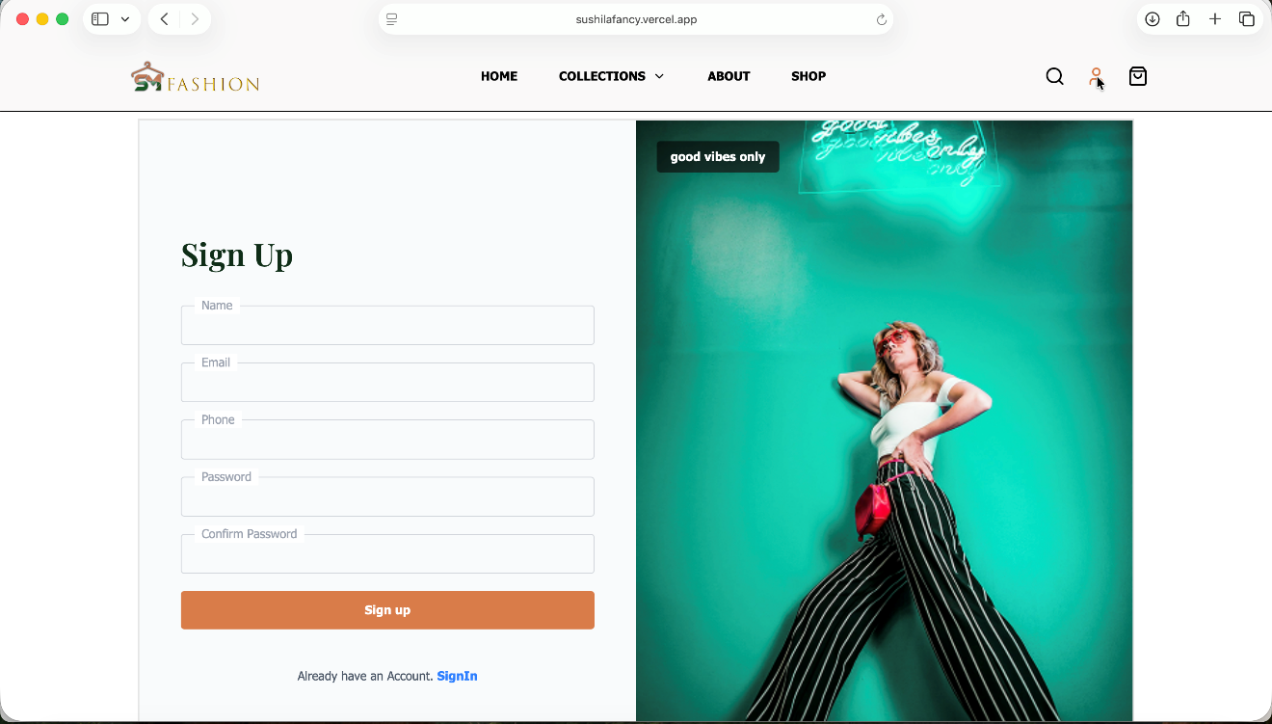
Figure i: Signup page of Sushila Fancy Store
- Home page
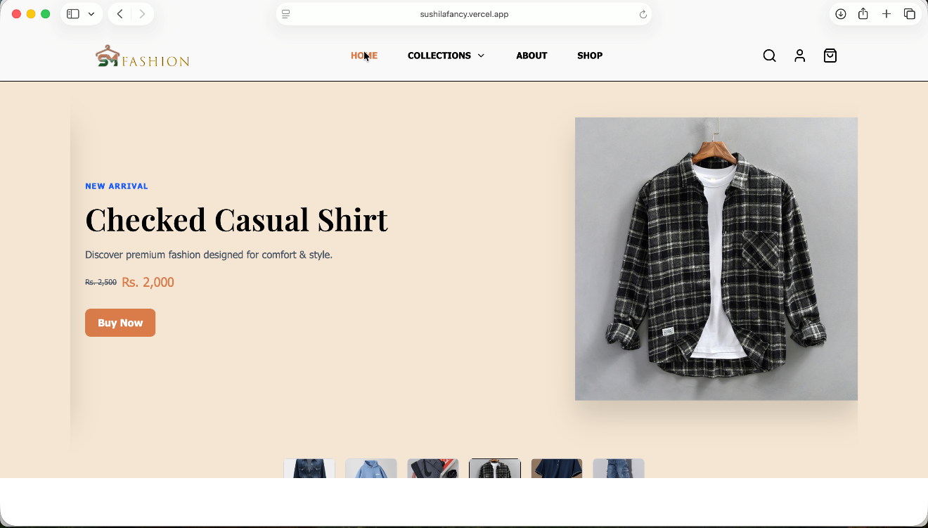
Figure ii: Home page of Sushila Fancy Store

- About page
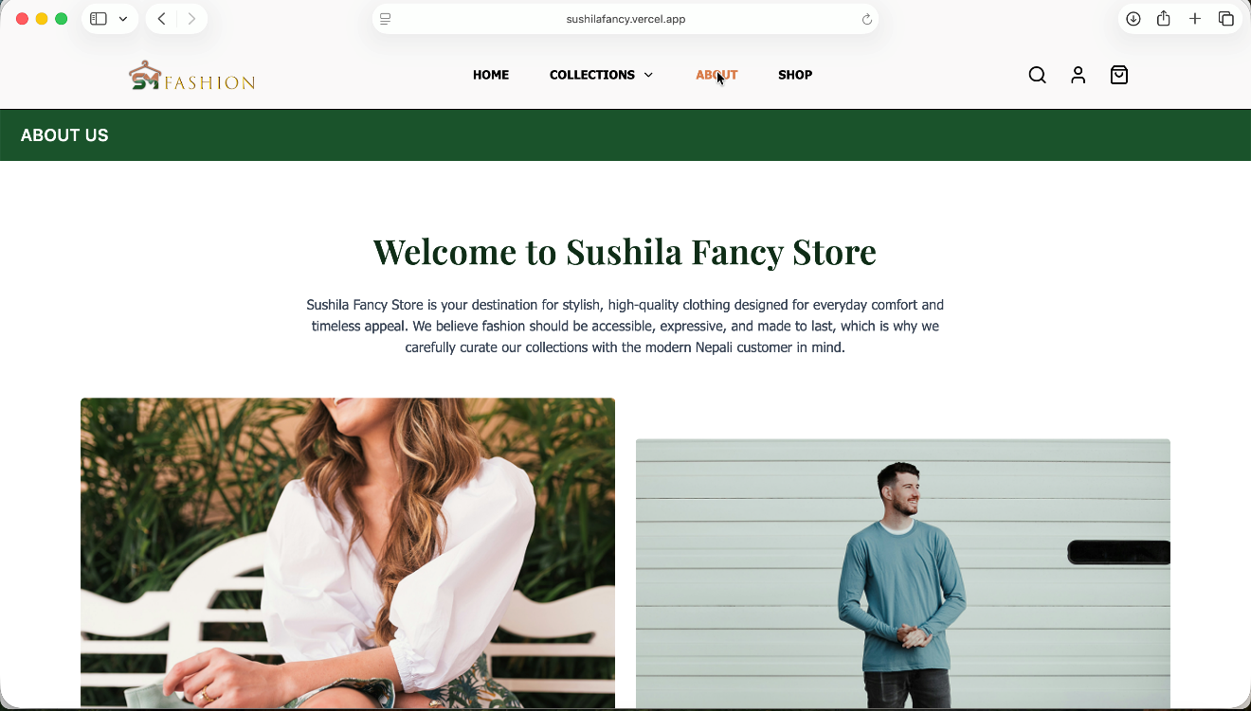
Figure iii: About page of Sushila Fancy Store
- Cart page
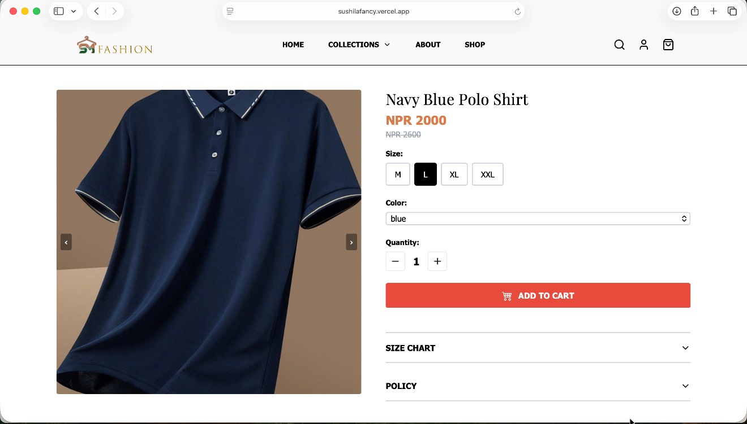
Figure iv: Cart page of Sushila Fancy Store

- FAQ page
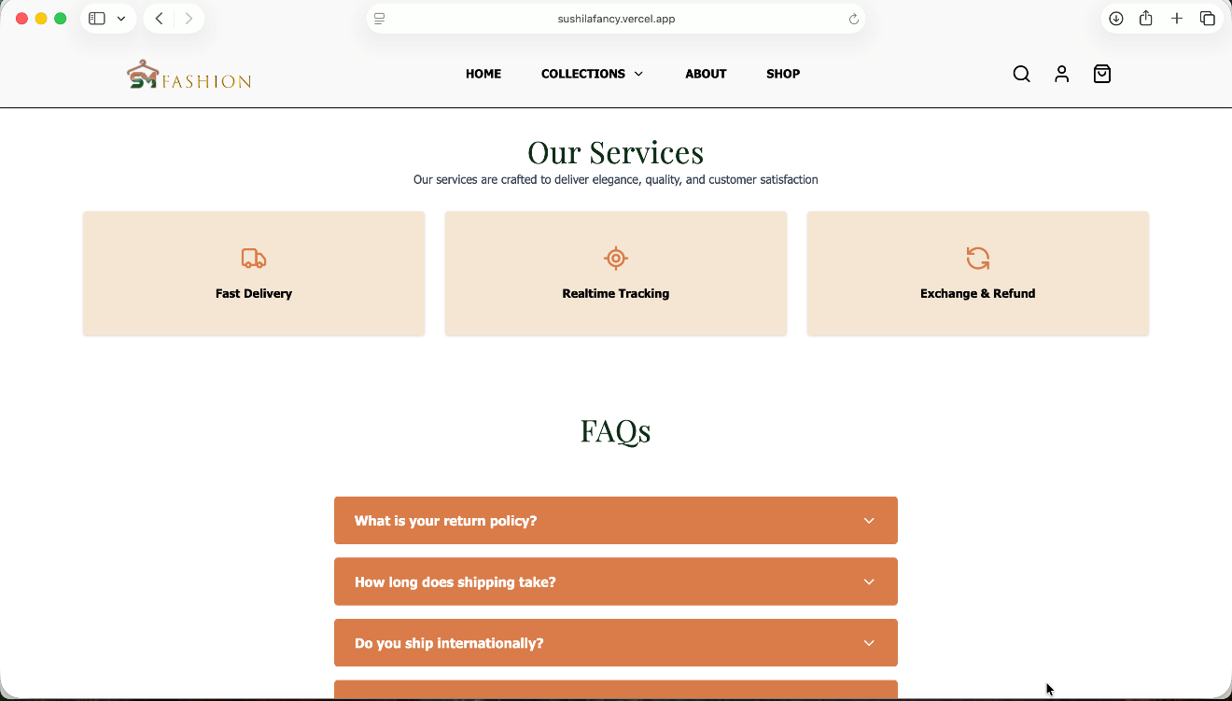
Figure v: FAQ page of Sushila Fancy Store
- Lifestyle section
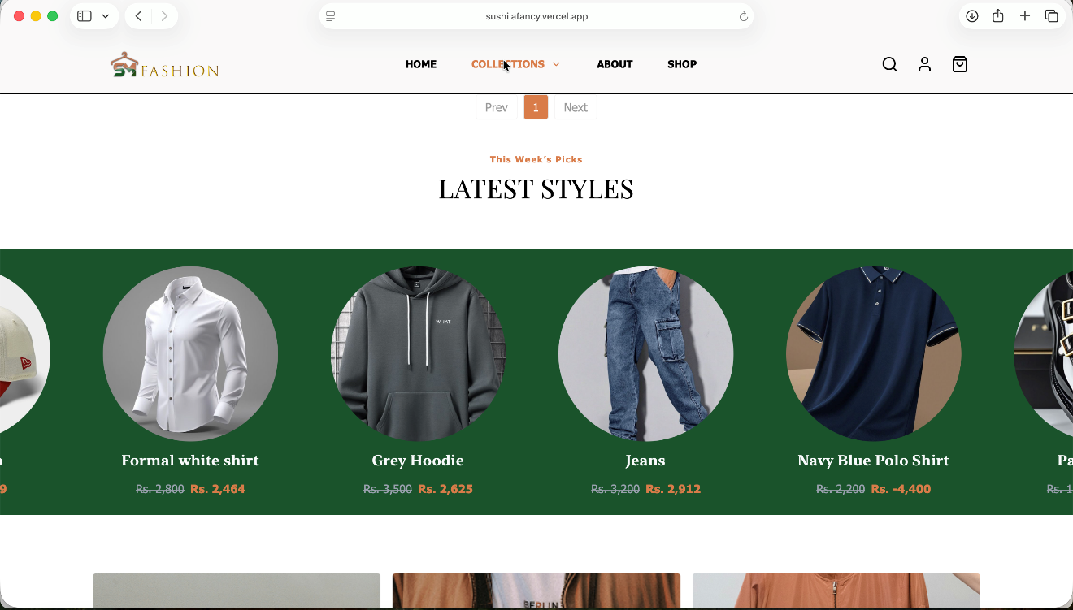
Figure vi: Lifestyle section of Sushila Fancy Store

