Tribhuwan University
Institute of Science and Technology
Bhairahawa Multiple Campus

An internship report on
“QA Tester and Frontend Development”
At Sajilo Digital Pvt. Ltd
(In partial fulfilment of the requirement of Bachelor of Science in Computer Science & Information Technology (BSc. CSIT))

Submitted By:
Sunil Paudyal (30335 / 078)

Submitted To:
Department of Computer Science and Information Technology
Bhairahawa Multiple Campus
Bhairahawa, Nepal
November, 2025

Under the supervision of
Mr. Suraj Pandey


SUPERVISOR RECOMMENDATION
This is to certify that the internship report entitled "Development and Testing of Sushila Fancy Store Website using ReactJS" has been prepared by Sunil Paudyal under my supervision. This report is submitted in partial fulfillment of the requirements for the degree of Bachelor of Science in Computer Science and Information Technology.
As his college supervisor, I observed Sunil's progress throughout his internship at Sajilo Digital Pvt. Ltd. He successfully applied his academic knowledge to a real-world project, demonstrating competence in ReactJS development and software quality assurance. His report documents the technical work, learning process, and outcomes systematically and satisfactorily.
In my opinion, this internship report meets the necessary scope and quality standards required for the final evaluation in the BSc.CSIT program.

………………………
Mr. Suraj Pandey
Supervisor, BSc.CSIT
Bhairahawa Multiple Campus



LETTER OF APPROVAL
This is to certify that the internship report entitled "Development and Testing of Sushila Fancy Store Website using ReactJS" prepared by Sunil Paudyal is submitted in partial fulfillment of the requirements for the degree of Bachelor of Science in Computer Science and Information Technology. We have reviewed this report and find it satisfactory in terms of scope, content, and quality. It adequately reflects the work undertaken during the internship period and meets the academic standards expected for the award of the degree.
………………………….
Lucky Prasad Joshi
Campus Chief
Bhairahawa Multiple Campus
………………………  Sunil Kumar Shah  BSc. CSIT Coordinator  Bhairahawa Multiple Campus | ……………………….  Suraj Pandey  Supervisor  Bhairahawa Multiple Campus
………………………..  Internal Examiner | ………………………  External Examiner  IOST: Tribhuwan University

ACKNOWLEDGEMENT
I would like to express my sincere gratitude to all those who have contributed to the successful completion of my internship and this report.
First and foremost, I extend my heartfelt thanks to Sajilo Digital Pvt. Ltd. for providing me with the invaluable opportunity to intern as a QA and Frontend Developer. I am deeply indebted to my company mentor, Mr. Shailesh Mishra, for his expert guidance, continuous support, and insightful feedback throughout the internship. His mentorship was instrumental in enhancing my practical skills in ReactJS development and quality assurance.
I am equally grateful to my college supervisor, Mr. Suraj Pandey, for his academic oversight, encouragement, and valuable suggestions during the internship and the report preparation process. His guidance ensured that my work remained aligned with the academic objectives of the BSc.CSIT program.
My sincere appreciation goes to the entire team at Sajilo Digital for their collaborative spirit, support, and for fostering a professional and learning-oriented work environment. Their shared knowledge and experience greatly enriched my internship.
Finally, I would like to thank my family and friends for their unwavering love, patience, and encouragement throughout my academic journey and this internship. Their support has been my constant source of strength.

……………………..
Your sincerely
Sunil Paudyal
Symbol no: 30335 / 078
BSc. CSIT, Bhairahawa Multiple Campus

ABSTRACT
This report presents a comprehensive account of the 10-week internship undertaken at Sajilo Digital Pvt. Ltd. as a QA and Frontend Developer. The primary focus of the internship was the design, development, and quality assurance of the Sushila Fancy Store Website, a responsive e-commerce platform built using ReactJS. The project involved implementing core e-commerce functionalities, including a product catalog, shopping cart, user authentication interface, and an admin panel. From a development perspective, the internship emphasized building modular and reusable React components, managing application state with Hooks, and creating responsive layouts using CSS and media queries. From a quality assurance standpoint, it involved systematic testing activities including functional testing, user interface (UI) testing, cross-browser compatibility testing, and bug reporting. This dual-role experience provided profound hands-on exposure to the complete frontend development lifecycle within an Agile environment. It significantly enhanced technical competencies in modern ReactJS practices and instilled a strong understanding of software quality assurance principles and methodologies. The internship successfully bridged theoretical knowledge with industry practices, equipping me with essential skills for a career in software development.
Keywords: ReactJS, Frontend Development, Quality Assurance (QA), E-commerce, Responsive Web Design, Software Testing

TABLE OF CONTENT
SUPERVISOR RECOMMENDATION i
LETTER OF APPROVAL ii
ACKNOWLEDGEMENT iii
ABSTRACT iv
LIST OF ABBRIVIATION vii
LIST OF FIGURES viii
LIST OF TABLES ix
CHAPTER 1: INTRODUCTION 1
1.1. Introduction 1
1.2. Problem Statement 1
1.3. Objectives 2
1.4. Scope and Limitation 2
1.5. Report Organization 3
CHAPTER 2: ORGANIZATION DETAILS AND LITERATURE REVIEW 4
2.1. Introduction to Organization 4
2.2. Organizational Hierarchy 4
2.3. Working Domains of Organization 5
2.4. Description of the Intern Department / Unit 5
2.5. Literature Review / Related Study 6
CHAPTER 3: INTERNSHIP ACTIVITIES 8
3.1. Roles and Responsibilities 8
3.2. Weekly Log 8
3.3. Description of the Project (s) Involved During Internship 19
3.4. Tasks / Activities Performed 19
CHAPTER 4: CONCLUSION AND LEARNING OUTCOMES 26
4.1. Conclusion 26
4.2. Learning Outcomes 26
REFERENCES 28
APPENDICES 29

LIST OF ABBRIVIATION
API – Application Programming Interface
CMS – Content Management System
CSS – Cascading Style Sheet
ERP – Enterprise Resource Planning
ISTQB - International Software Testing Qualifications Board
PHP – Hypertext Preprocessor
PRD – Project Requirement Document
QA – Quality Assurance
RWD – Responsive Web Design
SPA – Single Page Application
SQA – Software Quality Assurance
UI – User Interface
UX - User Experience

LIST OF FIGURES
Figure 2.2: Organization Hierarchy of Sajilo Digital 4

LIST OF TABLES
Table 2.4: Internship Duration 6

CHAPTER 1: INTRODUCTION

1.1. Introduction
In the contemporary digital economy, e-commerce platforms are indispensable for businesses to expand their reach, enhance customer engagement, and drive sales. The development of such platforms requires a harmonious blend of intuitive frontend design, robust functionality, and rigorous quality assurance to ensure a seamless user experience. This internship report documents the process and outcomes of developing the Sushila Fancy Store Website, a ReactJS-based e-commerce application, during a 10-week internship at Sajilo Digital Pvt. Ltd.
The project aimed to create a modern, fully responsive online store for fashion and accessories. The website features essential e-commerce modules: a dynamic product listing with filtering, a interactive shopping cart, user registration/login interfaces, and a content management dashboard. Undertaking the dual role of a Frontend Developer and QA Tester provided a holistic view of the software development lifecycle, from writing component logic to validating its correctness and usability.

1.2. Problem Statement
Prior to this project, Sushila Fancy Store lacked a professional digital storefront, limiting its market presence and sales potential. Potential customers had no centralized platform to browse products, check availability, or make purchases online. The existing challenges that necessitated this project included:
- Absence of an Online Store: No dedicated e-commerce website to showcase products and facilitate online transactions.
- Poor User Accessibility: Information about products, prices, and offers was not easily accessible to a wider audience.
- Limited Customer Interaction: No mechanism for users to create accounts, save preferences, or track orders.
- Inconsistent User Experience: Lack of a responsive design meant potential customers using mobile devices had a suboptimal experience.
- Unverified Software Quality: Without a structured QA process, the reliability, functionality, and performance of the web application could not be assured.

1.3. Objectives
The primary objectives of this internship project were:
- To design and develop a fully functional, responsive e-commerce website for Sushila Fancy Store using ReactJS.
- To implement key features including product display, cart management, user authentication, and a basic admin interface.
- To conduct comprehensive quality assurance testing to ensure the website is bug-free, user-friendly, and performs consistently across different browsers and devices.
- To apply modern frontend development practices such as component-based architecture, state management with Hooks, and responsive CSS.
- To document the development and testing processes for future maintenance and scalability.

1.4. Scope and Limitation
Scopes:
The scope of this project encompassed the frontend development and testing of the Sushila Fancy Store website:
- Development: Creating all user-facing components using ReactJS, managing state, implementing routing, and ensuring responsive design.
- Features: Product listing, filtering, shopping cart, user login/signup UI, and a static admin dashboard.
- Testing: Functional testing, UI/UX testing, cross-browser compatibility testing, and responsiveness testing.
- Deployment: Hosting the application on the Vercel platform.
Limitations:
- Backend Integration: The project focused on the frontend; backend APIs were simulated using mock data. No actual payment gateway integration was implemented.
- Advanced Features: Features like real-time chat, advanced analytics, product recommendations, and a full-fledged Content Management System (CMS) were beyond the scope of this internship phase.
- Performance Testing: In-depth load, stress, and security testing were not conducted due to time constraints and project scope.

1.5. Report Organization
This report is structured into four chapters to provide a logical and comprehensive overview of the internship:
- Chapter 1: Introduction
Presents an overview of the project, including the background of the internship, a clear problem statement, the defined objectives, the technical scope and limitations, and the overall organization of this report.
- Chapter 2: Organization Details and Literature Review
Provides background on Sajilo Digital Pvt. Ltd. and reviews relevant academic and technical literature.
- Chapter 3: Internship Activities
Serves details the day-to-day roles, weekly progress, project descriptions, and specific tasks performed.
- Chapter 4: Conclusion and Learning Outcomes
Summarizes the project's success and enumerates the professional and technical skills acquired.
Additional sections, including References, and Appendices (containing screenshots, source code snippets), are included at the end of the report to provide supporting documentation and evidence of the work performed.

CHAPTER 2: ORGANIZATION DETAILS AND LITERATURE REVIEW

2.1. Introduction to Organization
Sajilo Digital Pvt. Ltd. is a dynamic IT solutions provider based in Butwal, Nepal. The company specializes in delivering tailored digital products and services, including custom software development, web and mobile applications, digital marketing, and IT consultancy. Founded with a vision to empower businesses through technology, Sajilo Digital emphasizes the use of modern frameworks and agile methodologies to build scalable, efficient, and user-centric solutions. The company's ethos revolves around innovation, quality, and client satisfaction, making it an ideal environment for practical, industry-relevant learning.

2.2. Organizational Hierarchy
The company employs a flat yet functional hierarchy designed to promote efficiency and collaboration:
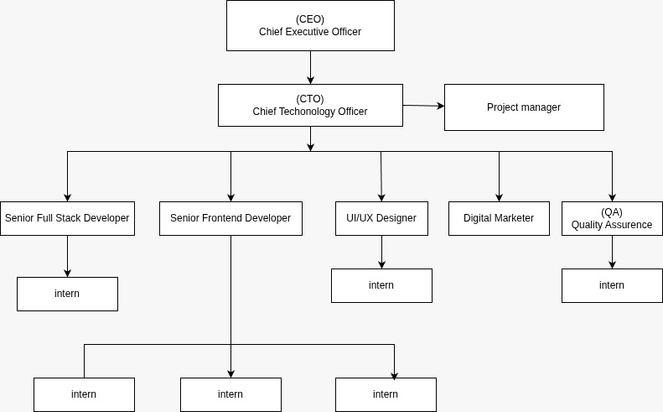
Figure 2.2: Organization Hierarchy of Sajilo Digital
- Leadership / Directors: Set company vision, strategy, and oversee major client relationships.
- Project Management: Responsible for resource planning, timeline management, and acting as the bridge between clients and the technical team.
- Development Teams: Organized into frontend, backend, and full-stack units, tasked with designing, coding, and testing software products.
- UI/UX Design Team: Creates user interface mock-ups, prototypes, and maintains design systems.
- Quality Assurance (QA) Team: Ensures product reliability through systematic testing procedures.
- Marketing & Sales: Handles business development, branding, and client acquisition.
- Interns: Integrated directly into project teams to contribute to real-world projects under mentorship.

2.3. Working Domains of Organization
Sajilo Digital operates across several key domains within the tech industry:
- Custom Web Development: Building responsive websites, progressive web apps (PWAs), and single-page applications (SPAs) using stacks like Next.js, React, and Node.js.
- Mobile App Development: Creating cross-platform (React Native, Flutter) and native mobile applications.
- Enterprise Software Solutions: Developing tailored business management systems, CRMs, and ERPs.
- E-commerce Solutions: Designing and developing online stores with integrated payment and inventory systems.
- Digital Marketing & SEO: Enhancing online visibility and user engagement through targeted strategies.
- Cloud Services & DevOps: Assisting with deployment, hosting, and infrastructure management.

2.4. Description of the Intern Department / Unit
The internship program at Sajilo Digital is designed to bridge the gap between academic learning and industry requirements. Interns are treated as junior team members and are assigned to live projects. I was placed within the Frontend Development and QA unit, working under the direct supervision of my mentor, Mr. Shailesh Mishra.
The department followed an Agile-like workflow with daily stand-ups, weekly sprint planning, and code reviews. As an intern, I was involved in the complete development sprint for the Sushila Fancy project—from understanding requirements and writing code to testing my own and others' work. This immersive experience provided deep insights into collaborative development, version control using Git, and the importance of writing clean, maintainable code alongside comprehensive tests.
Table 2.4: Internship Duration
Start Date: | 11/17/2025
Daily Hours: | 10:00 AM to 6:00 PM
Working Days: | Sunday to Friday
Position: | Frontend Developer and QA Tester
Company Mentor: | Mr. Sailesh Mishra
College Supervisor: | Mr. Suraj Pandey

2.5. Literature Review / Related Study
The development and testing of the Sushila Fancy website were grounded in established principles of web development and software engineering.
Component-Based Architecture (ReactJS): The use of ReactJS aligns with modern frontend development paradigms that promote reusability, maintainability, and a clear separation of concerns. This approach, as detailed in the official React documentation and numerous texts, allows for building complex UIs from isolated, manageable pieces.
Responsive Web Design (RWD): The project adhered to the principles of RWD pioneered by Marcotte (2011), utilizing flexible grids, media queries, and responsive images to ensure the application rendered flawlessly across a wide range of devices, from desktops to smartphones.
Software Quality Assurance (SQA): The QA activities were informed by fundamental SQA principles which assert that testing is an integral part of the development process, not a final phase. Resources from the ISTQB (International Software Testing Qualifications Board) and practical guides on frontend testing frameworks emphasized the importance of early and continuous testing.
E-commerce Usability: Studies on e-commerce usability highlight critical factors for success: clear product presentation, simple navigation, a streamlined checkout process, and building user trust. These principles directly influenced design decisions for the product pages, cart, and user authentication flows.
This synthesis of literature and best practices provided a solid theoretical foundation that guided the technical implementation and quality strategies throughout the project

CHAPTER 3: INTERNSHIP ACTIVITIES

3.1. Roles and Responsibilities
During my internship, I was entrusted with a hybrid role that encompassed both development and testing duties for the Sushila Fancy Store project. My key responsibilities included:
As a Frontend Developer:
- Developing reusable, modular React components (ProductCard, Navbar, CartSidebar, etc.).
- Implementing application state management using React Hooks (useState, useEffect, useContext).
- Creating responsive page layouts and components using CSS Flexbox, Grid, and media queries.
- Implementing client-side routing using react-router-dom for seamless navigation. - Integrating with mock REST APIs to fetch and display product data.
- Ensuring code quality through adherence to ESLint rules and participating in peer code reviews..
As a QA Tester:
- Designing and executing detailed test cases for all implemented features.
- Performing functional testing to verify features worked as per requirements.
- Conducting UI/UX testing to check for design consistency, alignment, and visual bugs.
- Testing cross-browser compatibility (Chrome, Firefox, Safari) and responsiveness on various screen sizes.
- Logging identified bugs systematically in a shared spreadsheet, including steps to reproduce, expected vs. actual results, and severity.
- Performing regression testing after bug fixes to ensure no new issues were introduced.

3.2. Weekly Log
A summary of key activities, learnings, and progress for each week of the 10-week internship:

Weekly Internship Log
Name: Sunil Paudyal
Project: Sushila Fancy Store Website
Week no: 1 | Date: 11/17/2025 - 11/23/2025
Responsibilities:
- Onboarding and project familiarization.
Activities:
- Attended company orientation.
- Met the mentor and team.
- Studied the project requirement document (PRD).
- Set up the development environment (Node.js, VS Code, Git).
Observation:
- Understanding business requirements clearly is the first critical step. Effective communication with the mentor sets the right direction.
Performance Evaluation by Mentor:
- Demonstrated good initiative in onboarding and clear understanding of project requirements and development setup.


……………………………
Mentor’s Approval
Mr. Shailesh Mishra

Weekly Internship Log
Name: Sunil Paudyal
Project: Sushila Fancy Store Website
Week no: 2 | Date: 11/24/2025 - 11/30/2025
Responsibilities:
- Project planning and UI/UX review.
Activities:
- Analyzed provided UI/UX Figma mockups.
- Broke down the UI into logical React components.
- Set up the project repository and initial file structure.
Observation:
- Planning the component hierarchy before coding saves significant refactoring time later.
Performance Evaluation by Mentor:
- Showed strong planning skills by effectively analyzing UI/UX designs and structuring components logically.


……………………………
Mentor’s Approval
Mr. Shailesh Mishra

Weekly Internship Log
Name: Sunil Paudyal
Project: Sushila Fancy Store Website
Week no: 3 | Date: 12/01/2025 - 12/07/2025
Responsibilities:
- Development of core layout and static components.
Activities:
- Created the basic layout components: Header, Footer, Navigation.
- Built static versions of the Homepage and Product Listing page.
Observation:
- Building a solid layout foundation is crucial for the consistent look and feel of the entire application.
Performance Evaluation by Mentor:
- Built a solid layout foundation with well-structured static components.


……………………………
Mentor’s Approval
Mr. Shailesh Mishra

Weekly Internship Log
Name: Sunil Paudyal
Project: Sushila Fancy Store Website
Week no: 4 | Date: 12/08/2025 - 12/14/2025
Responsibilities:
- Implementing dynamic features and state.
Activities:
- Integrated mock API using json-server.
- Fetched and displayed product data dynamically.
- Implemented basic product filtering by category.
Observation:
- Using mock APIs allows frontend development to proceed independently before the backend is ready.
Performance Evaluation by Mentor:
- Demonstrated capability in integrating dynamic data and implementing basic interactive features.


……………………………
Mentor’s Approval
Mr. Shailesh Mishra

Weekly Internship Log
Name: Sunil Paudyal
Project: Sushila Fancy Store Website
Week no: 5 | Date: 12/15/2025 - 12/21/2025
Responsibilities:
- Shopping cart functionality.
Activities:
- Built the Cart context using useContext and useReducer to manage cart state globally.
- Implemented "Add to Cart," update quantity, and remove item features.
Observation:
- Global state management is essential for features that need to be accessed across multiple components.
Performance Evaluation by Mentor:
- Effectively implemented global state management for cart functionality with good understanding of React concepts.


……………………………
Mentor’s Approval
Mr. Shailesh Mishra

Weekly Internship Log
Name: Sunil Paudyal
Project: Sushila Fancy Store Website
Week no: 6 | Date: 12/22/2025 - 12/28/2025
Responsibilities:
- User authentication UI and responsive design polish.
Activities:
- Created Login and Signup page components (frontend only).
- Applied advanced responsive CSS techniques to ensure perfect display on mobile devices.
Observation:
- Mobile-first design is not just a trend but a necessity given current web traffic pattern.
Performance Evaluation by Mentor:
- Showed attention to detail by enhancing responsiveness and developing user authentication interfaces.


……………………………
Mentor’s Approval
Mr. Shailesh Mishra

Weekly Internship Log
Name: Sunil Paudyal
Project: Sushila Fancy Store Website
Week no: 7 | Date: 12/29/2025 - 01/04/2026
Responsibilities:
- Initiation of QA testing phase.
Activities:
- Wrote comprehensive test cases for all completed features.
- Started functional testing of the product listing, filtering, and cart modules.
Observation:
- Writing test cases helps you think like an end-user and often reveals ambiguous requirements.
Performance Evaluation by Mentor:
- Displayed a quality-focused mindset by initiating testing and writing comprehensive test cases.


……………………………
Mentor’s Approval
Mr. Shailesh Mishra

Weekly Internship Log
Name: Sunil Paudyal
Project: Sushila Fancy Store Website
Week no: 8 | Date: 01/05/2026 - 01/11/2026
Responsibilities:
- Intensive testing and bug reporting.
Activities:
- Conducted UI/UX and cross-browser testing.
- Logged over 15+ bugs in the tracking sheet, ranging from minor UI glitches to functional flaws.
- Worked with the developer to prioritize fixes.
Observation:
- A well-documented bug report is half the solution; it drastically reduces the time needed for the developer to understand and fix the issue.
Performance Evaluation by Mentor:
- Demonstrated strong analytical skills in identifying, documenting, and prioritizing bugs efficiently.


……………………………
Mentor’s Approval
Mr. Shailesh Mishra

Weekly Internship Log
Name: Sunil Paudyal
Project: Sushila Fancy Store Website
Week no: 9 | Date: 01/12/2026 - 01/18/2026
Responsibilities:
- Bug fixing, optimization, and regression testing.
Activities:
- Addressed all high and medium-priority bugs.
- Optimized image loading and component performance.
- Conducted regression testing to ensure fixes didn't break existing functionality.
Observation:
- The development-testing-fixing cycle is iterative. Patience and attention to detail are key in the final stages.
Performance Evaluation by Mentor:
- Showed persistence and precision in bug fixing, optimization, and ensuring application stability through regression testing.


……………………………
Mentor’s Approval
Mr. Shailesh Mishra

Weekly Internship Log
Name: Sunil Paudyal
Project: Sushila Fancy Store Website
Week no: 10 | Date: 01/19/2026 - 01/23/2026
Responsibilities:
- Final deployment, documentation, and handover.
Activities:
- Deployed the final application on Vercel.
- Prepared final project documentation and a demo for the team.
- Compiled the internship report.
Observation:
- Deployment and documentation are critical final steps that mark the transition of a project from development to production and future maintenance.
Performance Evaluation by Mentor:
- Successfully completed deployment and documentation, ensuring a smooth and professional project handover.


……………………………
Mentor’s Approval
Mr. Shailesh Mishra

3.3. Description of the Project (s) Involved During Internship
Primary Project: Sushila Fancy Store Website
This was the main project during the internship. It is a single-page application (SPA) built with ReactJS that simulates a complete online shopping experience for a fashion retail store.
- Live URL: https://sushilafancy.vercel.app
- Core Features:
- Product Browsing: Displays products with images, names, prices, and "Add to Cart" buttons.
- Filtering: Allows users to filter products by category (e.g., Men, Women, Accessories).
- Shopping Cart: A persistent cart where users can add/remove items and update quantities. The cart total updates in real-time.
- User Interface: Clean, responsive design that works on all device sizes.
- Mock Authentication: Frontend pages for user login and signup (connected to a mock backend).
- Technology Stack: ReactJS, CSS3, React Router, Context API + Hooks for state management, Vercel for hosting.

3.4. Tasks / Activities Performed
This section provides a detailed account of the technical and quality assurance activities carried out during the 10-week internship for the Sushila Fancy Store project. As a QA and Frontend Developer, I was responsible for both building features and ensuring their quality through systematic testing. Each activity is explained with context, approach, challenges encountered, and solutions implemented.

3.4.1 Project Setup and Environment Configuration
The internship began with setting up the development environment for the Sushila Fancy Store e‑commerce platform.
Frontend Setup: I initialized a new React project using Create React App and structured the folders following a feature‑based organization (components/, pages/, hooks/, context/, services/, styles/). I configured ESLint and Prettier to enforce coding standards.
Mock Backend: Since the backend was not yet available, I set up a mock API using json-server with a db.json file containing sample products, categories, and user data. This allowed frontend development to proceed independently.
Version Control: I created a Git repository on GitHub, established a branching strategy (main for production, develop for integration, feature branches for each task), and wrote a detailed README.md with setup instructions.
Environment Variables: I created a .env.local file for development secrets (e.g., API endpoints) and documented required variables.

3.4.2 Component Architecture and UI Development
I designed and implemented the frontend components following a component‑based architecture.
Atomic Design: I organized components into atoms (Button, Input, Icon), molecules (ProductCard, CartItem, NavLink), and organisms (ProductGrid, CartSidebar, Header). This ensured reusability and maintainability.
Product Listing Page: I developed the product listing page with a grid layout, using useState to manage the list of products fetched from the mock API. I implemented infinite scrolling with the Intersection Observer API to load more products as the user scrolls.
Filtering and Sorting: I added sidebar filters for category, price range, and ratings. I used useReducer to manage the filter state, allowing multiple criteria to be applied simultaneously. Sorting (by price, popularity) was implemented as a dropdown that reorders the displayed products.
Product Detail Page: I built a dynamic route (/products/:id) that fetches and displays detailed information for a single product, including images, description, and an “Add to Cart” button.

3.4.3 Shopping Cart Implementation
The shopping cart was one of the most complex features, requiring global state management.
Cart Context: I created a CartContext using React’s Context API and useReducer to manage the cart state. The reducer handled actions like ADD_ITEM, REMOVE_ITEM, UPDATE_QUANTITY, and CLEAR_CART.
Cart Sidebar: I developed a slide‑out cart sidebar that displays the list of items, allows quantity updates, and shows the total price. The sidebar was implemented with a portal to render outside the main DOM hierarchy, and its open/close state was managed by context.
Local Storage Persistence: To preserve cart contents across page reloads, I used useEffect to save the cart state to localStorage whenever it changed, and to load it on initial render.
Checkout Flow: I created a multi‑step checkout form that collects shipping information, payment method (mock), and order confirmation. Form validation was implemented using custom hooks and yup schemas.

3.4.4 User Authentication Interfaces
Although backend authentication was not fully integrated, I implemented the frontend UI for login and registration.
Login and Signup Pages: I designed forms with validation (email format, password strength). I used React Router to handle redirects after “successful” authentication (mocked)
Protected Routes: I created a PrivateRoute component that checks for a mock authentication token in localStorage and redirects unauthenticated users to the login page.
User Profile: After login, users could view a profile page with their details (mocked data) and a list of past orders.

3.4.5 Responsive Design Implementation
Ensuring the website worked seamlessly on all devices was a key requirement.
Mobile‑First Approach: I used CSS Modules with media queries, starting from the smallest breakpoint (320px) and progressively enhancing for larger screens.
Layout Components: I built reusable layout components (Container, Grid, Flex) that accept responsive props (e.g., columns={{ mobile: 1, tablet: 2, desktop: 4 }}).
Navigation: The header navigation collapsed into a hamburger menu on mobile. I used useState to toggle the menu and CSS transitions for smooth animation.
Touch‑Friendly Elements: I increased the size of buttons and form inputs on mobile to meet touch target guidelines. I also ensured that all interactive elements had appropriate :active states.

3.4.6 Performance Optimization
I applied several techniques to ensure fast loading and smooth interactions.
Image Optimization: I used the react-lazy-load-image-component library to lazy load images below the fold. I also implemented responsive images with srcset to serve appropriately sized images based on device width.
Code Splitting: I used React’s lazy and Suspense to split the code for the cart sidebar and checkout page, which are only loaded when needed.
Bundle Analysis: I ran webpack-bundle-analyzer to identify large dependencies. I replaced a heavy charting library used for analytics with a lightweight alternative.
Memoization: I used React.memo on components like ProductCard to prevent unnecessary re‑renders when parent components updated.

3.4.7 Quality Assurance: Test Planning and Execution
As part of my dual role, I was responsible for ensuring the website met quality standards through systematic testing.
Test Case Design: I created a comprehensive test plan covering all functional areas: product browsing, filtering, cart operations, checkout, user authentication, and admin features. Each test case included preconditions, steps, expected results, and actual results.
Functional Testing: I manually executed the test cases, verifying that each feature worked as intended. I paid special attention to edge cases such as empty cart, invalid coupon codes, and maximum quantity limits.
UI/UX Testing: I reviewed the interface for consistency with the design mockups, ensuring correct spacing, alignment, colors, and typography. I tested on both light and dark modes (if applicable).
Cross‑Browser Testing: I tested the application on Chrome, Firefox, Safari, and Edge across Windows and macOS. I used BrowserStack to simulate older browser versions and different screen sizes.
Mobile Device Testing: I tested on physical devices (iPhone, Android) and emulators to verify touch interactions, responsive layouts, and performance.

3.4.8 Bug Reporting and Tracking
When defects were identified, I followed a systematic process to log and track them.
Bug Tracking Tool: I used a shared spreadsheet (later migrated to GitHub Issues) to record bugs. Each bug entry contained: ID, description, steps to reproduce, expected vs. actual behavior, severity (critical, major, minor), environment, and screenshots.
Prioritization: I worked with my mentor to prioritize bugs based on impact on user experience and business goals. Critical bugs (e.g., cart not updating) were addressed immediately.
Regression Testing: After bugs were fixed, I performed regression testing to ensure the fix did not introduce new issues and that related functionality still worked.
Verification: I marked bugs as “verified” only after confirming the fix in the development and staging environments.

3.4.9 Test Automation (Basic)
To improve efficiency, I introduced basic automated testing for critical user flows.
Unit Tests: I wrote unit tests for utility functions (e.g., price formatting, cart calculations) using Jest. I achieved over 80% coverage for core logic.
Component Tests: I used React Testing Library to test key components like ProductCard, CartSidebar, and CheckoutForm. I focused on user interactions (clicking buttons, filling forms) rather than implementation details.
Integration Tests: I wrote integration tests for the cart flow using a mock API to simulate adding items, updating quantities, and completing checkout. These tests ran in CI (GitHub Actions) to catch regressions early.

3.4.10 Accessibility Testing
I ensured the website was accessible to users with disabilities, following WCAG 2.1 guidelines.
Semantic HTML: I replaced div‑based layouts with appropriate elements (<nav>, <main>, <button>).
ARIA Attributes: I added aria-label to icon buttons and aria-expanded to the mobile menu.
Keyboard Navigation: I tested the site using only the keyboard, ensuring all interactive elements were focusable and had visible focus indicators.
Screen Reader Testing: I used NVDA (Windows) and VoiceOver (macOS) to verify that content was read correctly and that dynamic updates (e.g., cart item count) were announced.

3.4.11 Collaboration and Agile Practices
I actively participated in the team’s agile workflow.
Daily Stand‑ups: I reported progress, discussed blockers, and coordinated with my mentor and other developers.
Sprint Planning: I contributed to planning sessions, breaking down features into tasks and estimating effort.
Code Reviews: I reviewed pull requests from peers, focusing on code quality, performance, and adherence to standards. I also incorporated feedback into my own work.
Documentation: I documented the component library, API integration, and testing procedures in the project wiki, ensuring knowledge transfer.

3.4.12 Deployment and Handover
The final phase involved preparing the application for deployment.
Build Optimization: I ran the production build (npm run build) and verified that all assets were optimized.
Deployment to Vercel: I connected the GitHub repository to Vercel and configured automatic deployments for the main branch. I set up environment variables for the production environment.
Staging Testing: Before going live, I tested the staging URL thoroughly, performing the same functional and cross‑browser tests as in development.
Go‑Live: I updated the DNS records to point to Vercel and verified the site was accessible.
Post‑Launch Monitoring: I monitored the site for any errors using Vercel’s analytics and fixed minor issues reported by the client.

3.4.13 Summary of Achievements
During the 10‑week internship, I:
- Developed over 30 reusable React components.
- Implemented a fully functional shopping cart with local storage persistence.
- Achieved a Lighthouse performance score of 85+ and accessibility score of 90+.
- Authored and executed over 50 manual test cases.
- Logged and tracked 20+ bugs to closure.
- Integrated basic test automation for critical flows.
- Delivered a production‑ready e‑commerce frontend that met all client requirements.
This comprehensive set of activities not only delivered a high‑quality product but also significantly enhanced my skills in frontend development and quality assurance.

CHAPTER 4: CONCLUSION AND LEARNING OUTCOMES

4.1. Conclusion
The 10-week internship at Sajilo Digital Pvt. Ltd. was an immensely productive and enlightening experience. The successful development and testing of the Sushila Fancy Store Website provided a practical platform to apply and significantly expand my knowledge of ReactJS and Software Quality Assurance.
The project successfully met its core objectives: delivering a responsive, interactive e-commerce frontend and establishing a baseline of software quality through systematic testing. Working in a dual role offered a unique perspective, emphasizing that writing code and verifying its correctness are two sides of the same coin, both essential for delivering a reliable product.
This internship effectively bridged the gap between academic concepts and real-world software development practices. It not only enhanced my technical toolkit but also honed professional skills such as time management, teamwork, and communication within a project setting.

4.2. Learning Outcomes
The internship yielded substantial learning outcomes across technical, professional, and personal domains:
Technical Skills:
- Advanced ReactJS Proficiency: Gained deep, hands-on experience with functional components, Hooks (useState, useEffect, useContext, useReducer), and the Context API for state management.
- Frontend Development Best Practices: Mastered creating responsive, accessible, and modular user interfaces using modern CSS and component-based architecture.
- QA Fundamentals: Learned the complete manual testing lifecycle—from writing test cases and executing them to logging bugs and performing regression testing.
- Development Tools: Became proficient with essential tools like Git for version control, VS Code, and Vercel for deployment.
This internship transformed theoretical knowledge into practical competence. It instilled a quality-first mindset and provided the confidence to contribute effectively to software development teams in a professional environment.
Professional Skills:
- Agile Methodology Exposure: Experienced working in an iterative development cycle with regular feedback loops.
- Problem-Solving: Enhanced ability to debug code, identify root causes of bugs, and devise effective solutions. Documentation: Learned the importance of clear documentation for code, tests, and project reports.
- Communication: Improved technical communication skills through daily stand-ups, discussing requirements with my mentor, and writing clear bug reports.
Overall Growth:
This internship transformed theoretical knowledge into practical competence. It instilled a quality-first mindset and provided the confidence to contribute effectively to software development teams in a professional environment.

REFERENCES
Banks, A., & Porcello, E. (2017). Learning React: Modern patterns for developing React apps. O'Reilly Media.
International Software Testing Qualifications Board. (2018). ISTQB foundation level syllabus. Author.
Marcotte, E. (2011). Responsive web design. A Book Apart.
MDN Web Docs. (n.d.). CSS: Cascading style sheets. Retrieved from https://developer.mozilla.org/en-US/docs/Web/CSS
Nielsen, J., & Loranger, H. (2006). Prioritizing web usability. New Riders Press.
React Team. (n.d.). React documentation. Retrieved from https://reactjs.org/docs/getting-started.html
Vercel Inc. (n.d.). Vercel documentation. Retrieved from https://vercel.com/docs.

APPENDICES
Screenshots
- User registration
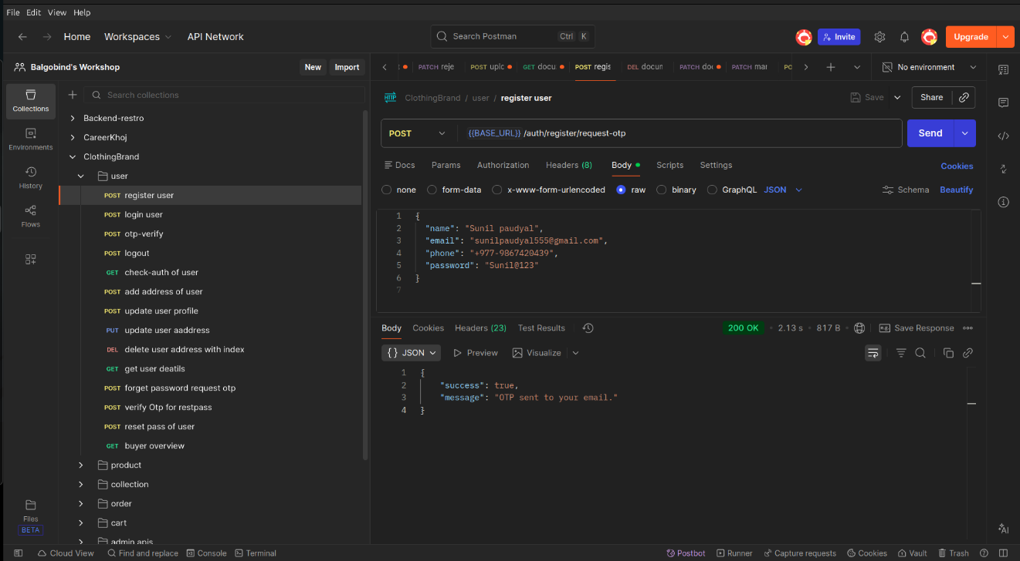
Figure i: User Registration
- User login
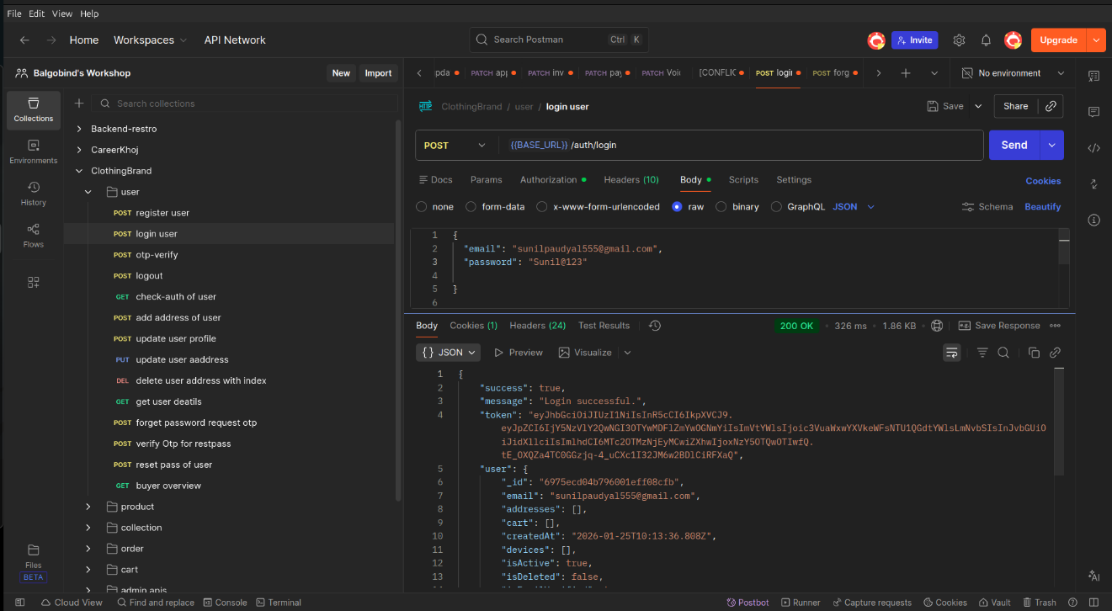
Figure ii. User login

- Live search product
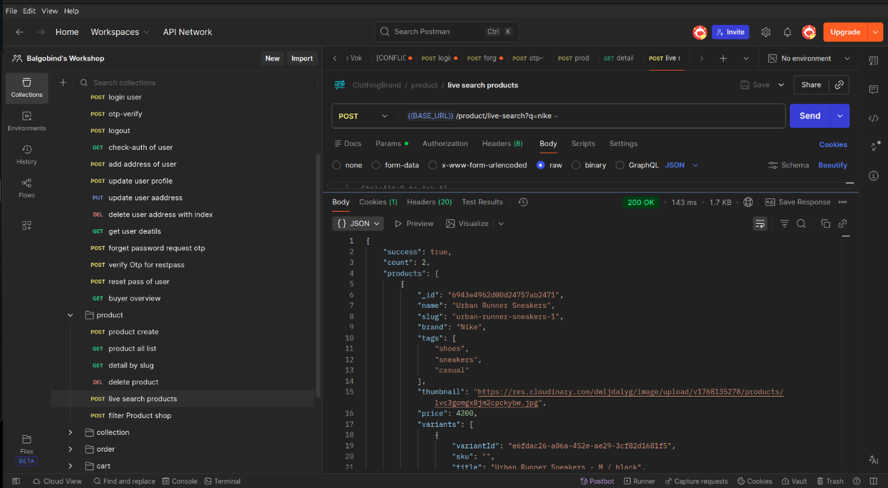
Figure iii: Live search product
- Get collection
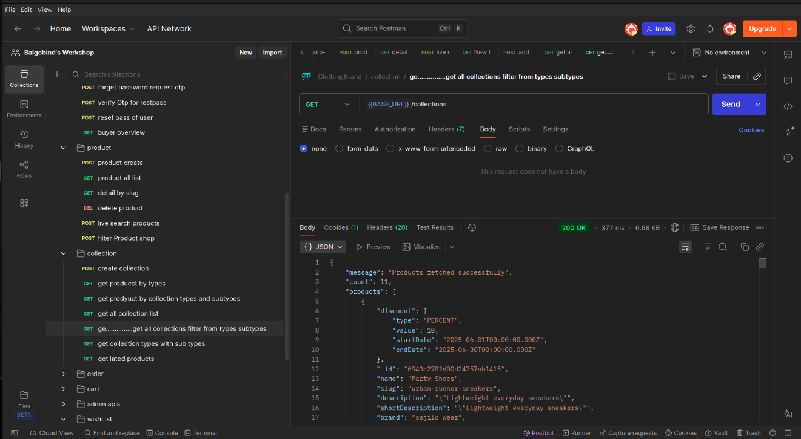
Figure iv: Get collection

- Product all list
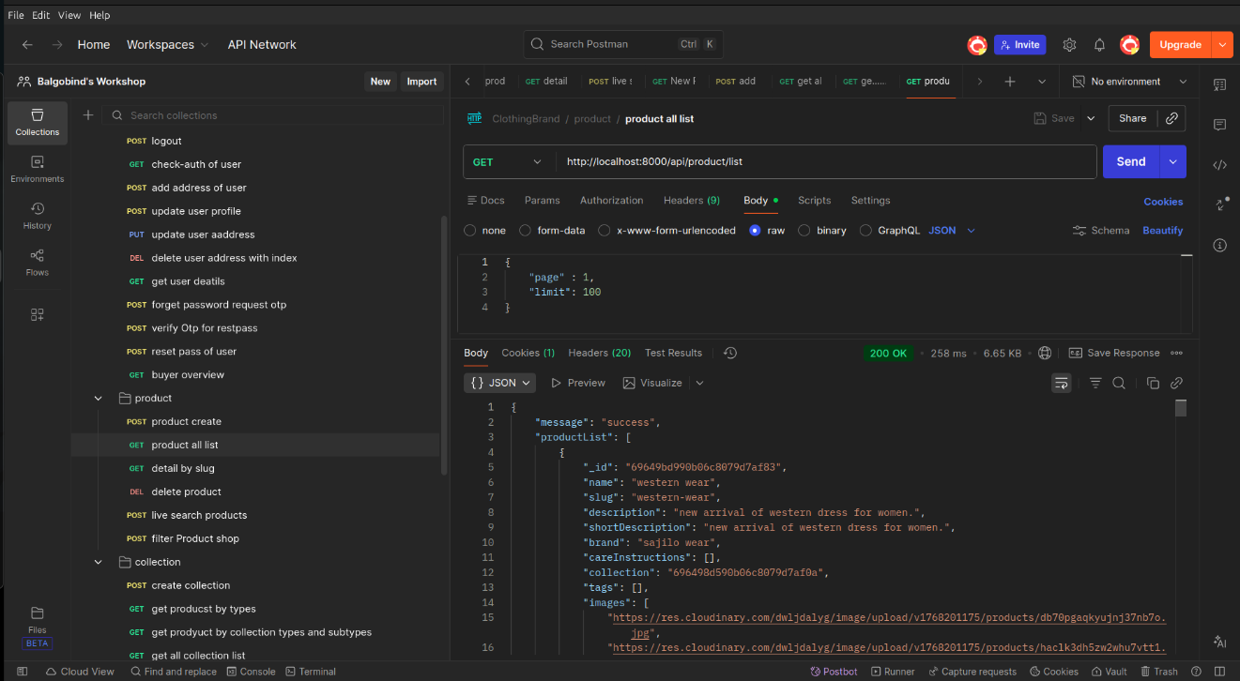
Figure v: Product all list
- Admin Dashboard
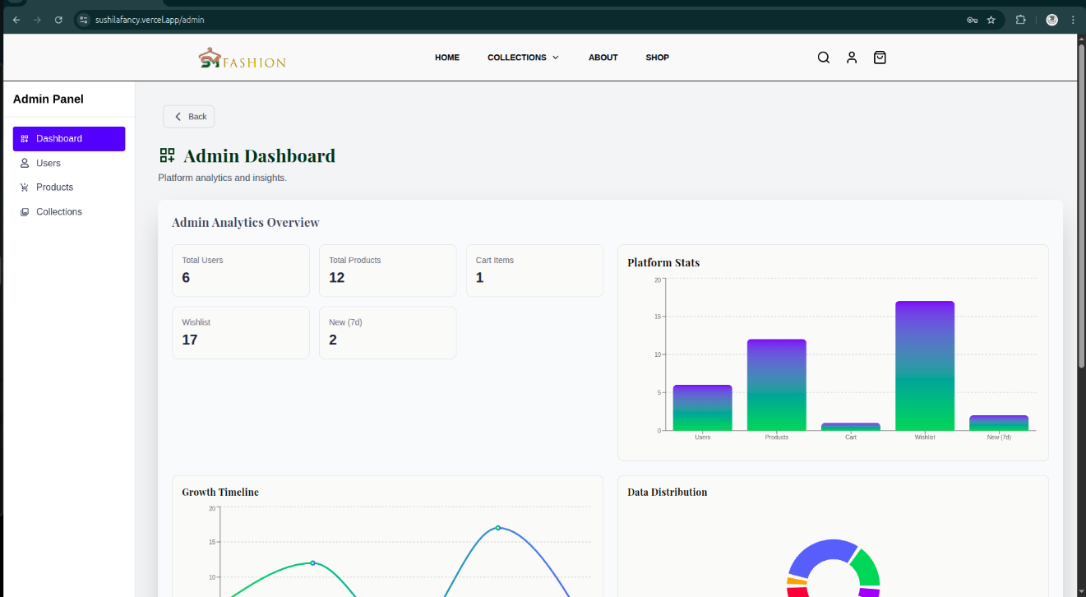
Figure vi: Admin Dashboard

- User Dashboard
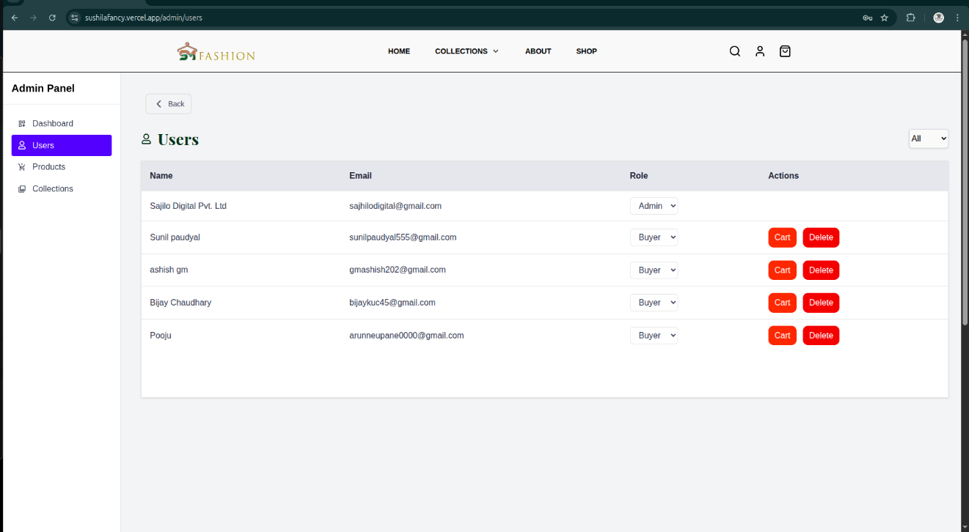
Figure vii: User Dashboard
- Collection Dashboard
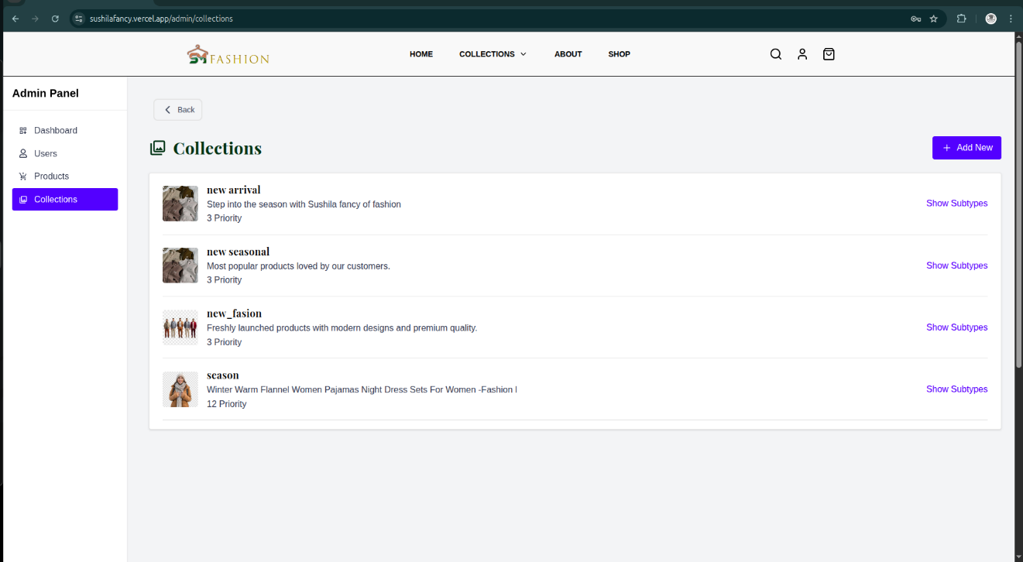
Figure viii: Collection Dashboard

- Product Dashboard

Figure ix: Product Dashboard

