1. Read the .txt file “**134.141.123.1.txt**”, and output the number of successes and failures, along with mean, min, max and std deviation. Also take input from user for start and end times and output the statistics within that time range

Usage: Input start and end times in HH:MM:SS format

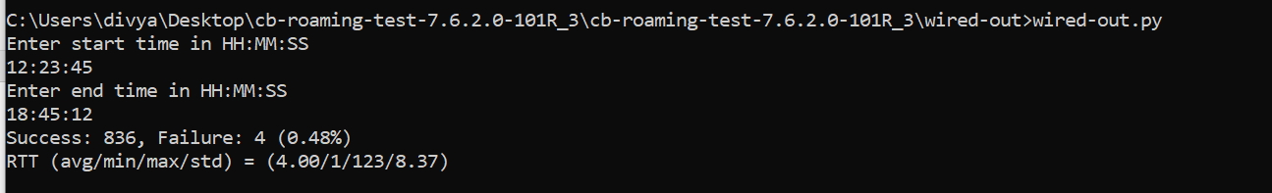

1. Read ‘**XCC_StationEventsLog.csv**’ file, and filter out the MAC address “*94:9B:2C:0E:C8:30*” for event type to be “*Roam*” and count the unique number of ‘*AP Name*’ and count for each of the AP names. Also take input from user for start and end times and output the results within that time range

Usage: Input start and end times in the format: *May 5, 2021 6:59:31 PM*

