ABSTRACT

The Medicines & Medical Equipment Delivery App is designed to provide users with a seamless, secure, and efficient platform to order essential healthcare products online. The application enables users to browse a wide range of medicines, medical equipment, and healthcare essentials, add them to their cart, make secure payments, and receive real-time delivery tracking. It aims to bridge the gap between pharmaceutical providers and consumers by enabling contactless, round-the-clock accessibility to critical medical supplies.

This system emphasizes user convenience and health security by incorporating features like digital prescriptions upload, category-wise product listing, automated stock management, and a highly intuitive user interface. It provides robust authentication and encrypted communication for secure data and payment handling, thereby protecting sensitive medical and financial information.

The app supports both web and mobile interfaces and is developed using a full-stack architecture. It includes features such as user registration, medicine search, prescription validation, order management, admin product control, and delivery tracking.

By providing doorstep delivery of critical items like first-aid kits, wheelchairs, oxygen cylinders, and prescription medications, the platform enhances accessibility for patients, caregivers, and the elderly. The system also includes features for pharmacies and delivery agents to manage inventory and delivery logistics efficiently.

This project aims to transform traditional pharmacy operations through a digital solution that ensures speed, accessibility, transparency, and safety in healthcare delivery. Through a scalable and modular architecture, it can also integrate with hospital systems for real-time medicine prescriptions and dispatch.

INTRODUCTION

With the rapid growth of digital healthcare, the need for online medicine and medical equipment delivery platforms has become increasingly vital. The Medicines & Medical Equipment Delivery App aims to simplify the process of accessing essential healthcare products by allowing users to order medicines, upload prescriptions, and receive doorstep delivery efficiently and securely.

Traditionally, patients relied on physical pharmacies, which often caused delays, especially during emergencies or shortages. This platform addresses these challenges by providing a digital solution that ensures 24/7 access to prescribed medications and medical devices like oximeters, wheelchairs, and thermometers.

The app includes user-friendly features such as secure login, category-based product browsing, admin inventory management, and delivery tracking. It enhances patient convenience, minimizes exposure risks, and complies with healthcare regulations. Developed using modern full-stack technologies, the system ensures scalability, security, and a smooth user experience, making healthcare essentials more accessible and reliable for everyone.

SCOPE

The Medicines & Medical Equipment Delivery App provides a digital platform for users to order medicines and healthcare essentials online. It supports product browsing, prescription uploads, secure payments, and real-time order tracking. Admins manage inventory and approve prescriptions, while delivery agents handle order fulfillment. Designed for accessibility and convenience, the system streamlines the pharmacy experience, especially for elderly, remote, and chronically ill users.

System Features

* User registration and login
* Search and filter medicines/equipment
* Upload and validate prescriptions
* Add to cart and checkout
* Online payment integration
* Real-time order tracking
* Admin inventory and category management
* Delivery agent module
* Order history and invoice generation
* Notifications via email/SMS

System Context

The system interacts with three primary external actors: users (customers), delivery agents, and admins/pharmacists. It connects to a central database for storing user, product, order, and transaction data and communicates securely with payment gateways and prescription verification APIs (if applicable).

Functional Requirements

1. User Authentication

* Register with email, phone, and password
* Login via email/OTP/password
* Role-based access (User/Admin/Delivery)

2. Product Browsing

* List products by category
* Search and filter products
* View product details and images

3. Prescription Upload

* Upload valid prescriptions (PDF/Image)
* Admin approval mechanism

4. Order Management

* Add to cart and place orders
* Cancel and return orders
* Generate invoice and order summary

5. Payment Handling

* Secure online payments
* View transaction history
* Refund processing

6. Delivery Tracking

* Assign delivery agents
* Real-time order tracking
* Mark as delivered

Non-Functional Requirements

1. Performance

* Response time < 3 seconds
* Supports 500+ concurrent users

2. Security

* Encrypted login and payment data
* Prescription access only to assigned personnel

3. Scalability

* Modular architecture for future expansion
* Load balancer support for peak traffic

4. Usability

* Responsive UI for mobile and desktop
* Multi-language support
* Voice search integration (optional)

CLASS DIAGRAM

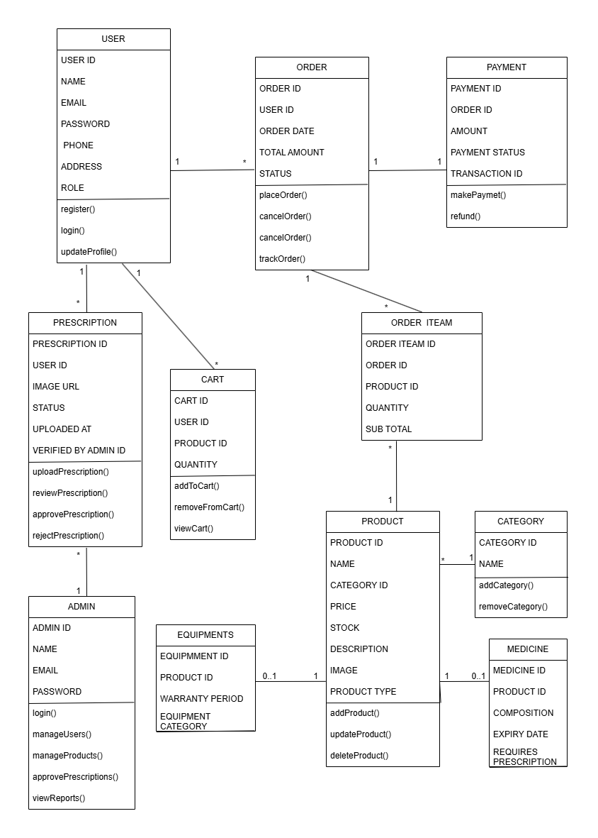

USE-CASE DIAGRAM

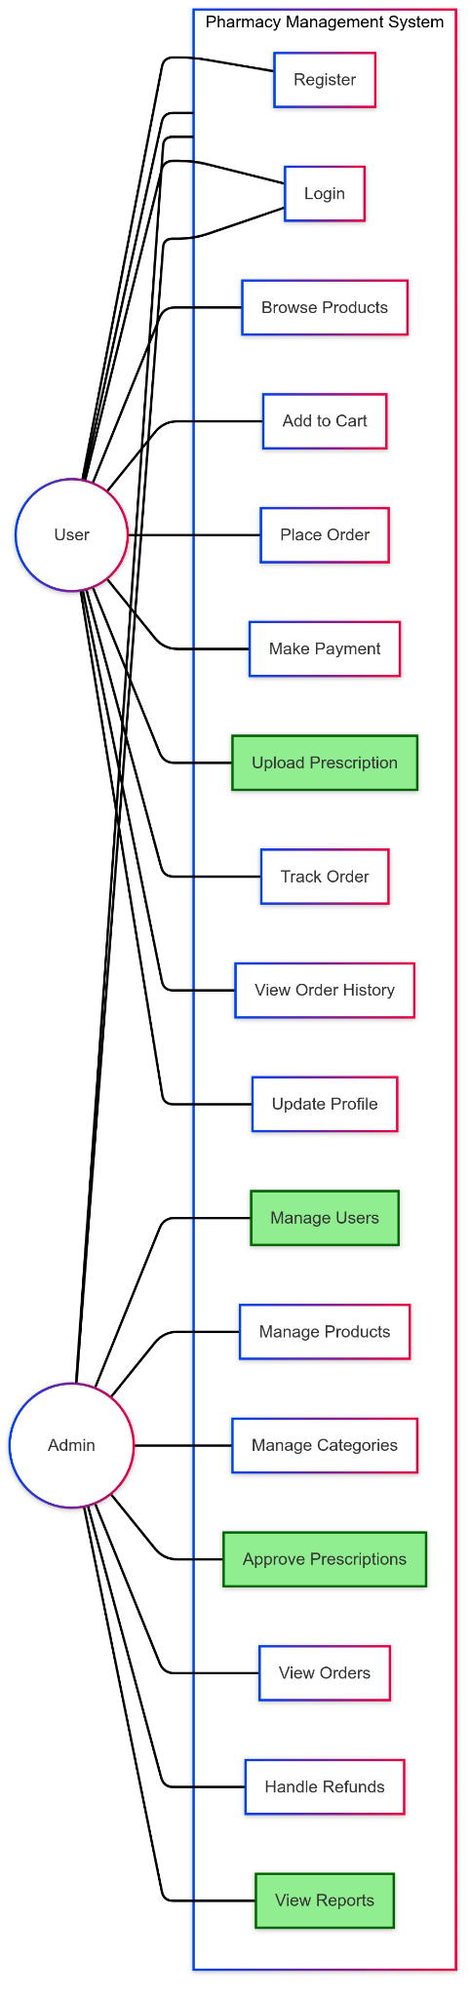

ER DIAGRAM

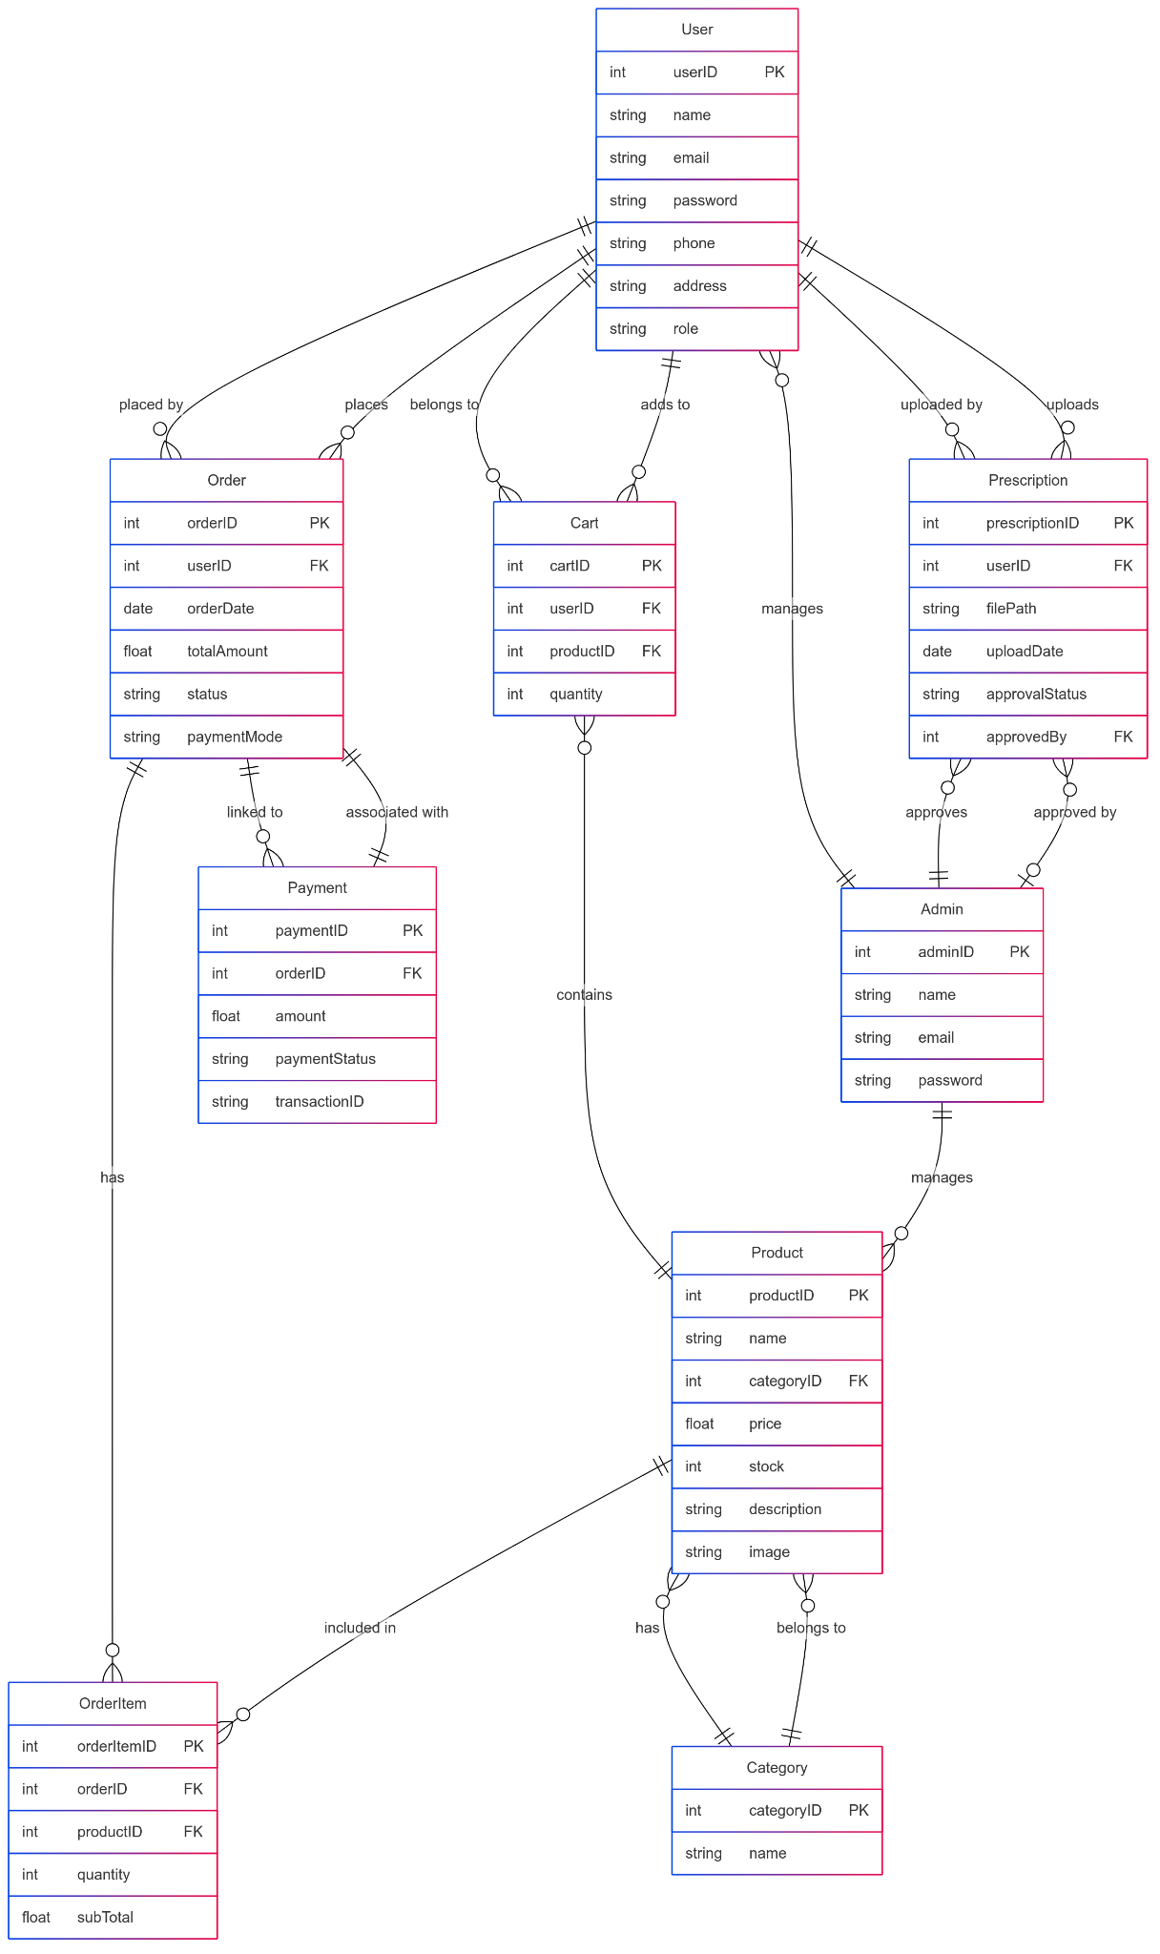

SEQUENCE DIAGRAM

