UPI TRANSACTION ANALYTICS
PostgreSQL Data Analysis
Indian UPI Ecosystem Statistics | August 2016 – February 2025
Project | UPI Transaction Analytics & Growth Dashboard
Primary Tool | PostgreSQL
Dataset | upi_monthly_statistics.csv
Source | Kaggle — Indian UPI Ecosystem Statistics 2016–2025
Data Analyst Portfolio Project
1. Project Overview
This project analyzes monthly UPI transaction data using PostgreSQL to understand transaction growth, monetary value, transaction behavior, bank participation, seasonality, and changes in growth patterns over time. The analysis covers August 2016 to February 2025.
2. Business Objectives
Measure long-term UPI transaction volume and transaction-value growth.
Identify periods with exceptionally high transaction activity or monetary value.
Analyze YoY and MoM growth patterns over time.
Understand whether expansion is driven mainly by transaction frequency or transaction size.
Examine the expansion of participating banks in the UPI ecosystem.
Identify monthly and quarterly patterns in transaction activity.
Prepare analytical outputs for an interactive Power BI dashboard.
3. Dataset Overview
The analysis uses the UPI monthly statistics dataset containing transaction, value, growth, bank-participation, and time-related fields. The source file used for this analysis is upi_monthly_statistics.csv.
Source: Kaggle — Indian UPI Ecosystem Statistics 2016–2025
Dataset URL: https://www.kaggle.com/datasets/vedantagarwal0812/indian-upi-ecosystem-statistics-2016-2025?select=upi_monthly_statistics.csv
Field | Description
date | Monthly observation date
year / month | Calendar time dimensions
fiscal_year / quarter | Fiscal-period dimensions
volume_millions | UPI transaction volume in millions
value_crores | Transaction value in ₹ crore
banks_live | Number of live participating banks
avg_transaction_value_inr | Average transaction value in ₹
yoy_*_growth_pct | Year-over-year growth measures
mom_*_growth_pct | Month-over-month growth measures

4. PostgreSQL Analysis
The following 15 analytical questions examine UPI growth, scale, transaction behaviour, ecosystem expansion, seasonality, and short-term changes. Each analysis includes the SQL query, result and business interpretation.
4.1 Transaction Growth & Scale
1. Question: How has UPI transaction volume changed year by year?
Objective: Measure the long-term change in UPI transaction activity.
SQL:
SELECT
year,
SUM(volume_millions) AS total_transactions_millions
FROM upi_monthly_statistics
GROUP BY year
ORDER BY year;
Result:
UPI transaction volume increased substantially from 3.02 million transactions in 2016 to 171,649 million transactions in 2024. The yearly volume rose consistently across the period, with particularly strong growth after 2020. The 2025 value is 32,644 million transactions, which appears to represent a partial year and therefore should not be directly compared with the complete previous years.
Interpretation:
The data shows a very strong long-term expansion in UPI transaction activity. Annual transaction volume increased from just 3.02 million in 2016 to 171.65 billion in 2024, indicating substantial growth in UPI usage and adoption over the period covered.
2. Question: How has the total transaction value changed year by year?
Objective: Measure the long-term change in monetary value processed through UPI.
SQL:
SELECT
year,
SUM(value_crores) AS total_transaction_value_crores
FROM upi_monthly_statistics
GROUP BY year
ORDER BY year;
Result:
The total value processed through UPI increased substantially from ₹119.78 crore in 2016 to ₹58,76,510 crore in 2024. Transaction value grew consistently across the period, with particularly strong increases after 2020. The 2025 value is ₹11,18,490 crore, which appears to represent a partial year and should therefore not be directly compared with the full-year figures.
Interpretation:
The data indicates a major expansion in the monetary value processed through UPI over the period. The increase from ₹119.78 crore in 2016 to ₹58.77 lakh crore in 2024 reflects the growing scale of UPI as a digital payment system.
3. Question: Which 10 months recorded the highest transaction volume?
Objective: Identify top 10 months with the highest transaction activity.
SQL:
SELECT
date,
volume_millions,
value_crores,
banks_live
FROM upi_monthly_statistics
ORDER BY volume_millions DESC
LIMIT 10;
Result:
The top 10 months with the highest UPI transaction volumes were concentrated in 2024 and early 2025. January 2025 recorded the highest volume at 16,994 million transactions, followed by December 2024 with 16,727 million transactions and October 2024 with 16,584 million transactions. All 10 highest-volume months recorded more than 13,800 million transactions.
Interpretation:
The highest levels of monthly UPI transaction activity occurred toward the end of 2024 and beginning of 2025, indicating that transaction activity had reached a significantly higher scale during this period compared with earlier years.
4. Question: Which 10 months recorded the highest transaction value?
Objective: Identify top 10 months with the highest monetary transaction value.
SQL:
SELECT
date,
value_crores,
volume_millions,
avg_transaction_value_inr
FROM upi_monthly_statistics
ORDER BY value_crores DESC
LIMIT 10;
Result:
The 10 highest transaction-value months were all recorded between May 2024 and February 2025. January 2025 recorded the highest transaction value at ₹5,82,310 crore, followed by December 2024 at ₹5,72,770 crore and October 2024 at ₹5,67,570 crore. The average transaction value during these high-value months remained relatively stable at around ₹342 per transaction.
Interpretation:
The data shows that the highest monetary value processed through UPI occurred during late 2024 and early 2025. The relatively stable average transaction value, despite the large increase in total transaction value, suggests that the growth in monetary value was primarily associated with the increase in transaction volume.
4.2 Growth Rate Analysis
5. Question: Which months had the highest YoY transaction-volume growth?
Objective: Identify periods with the strongest year-over-year transaction-volume growth.
SQL:
SELECT
date,
yoy_volume_growth_pct
FROM upi_monthly_statistics
WHERE yoy_volume_growth_pct IS NOT NULL
ORDER BY yoy_volume_growth_pct DESC
LIMIT 10;
Result:
The highest year-over-year transaction-volume growth occurred primarily during 2017 and early 2018. September 2017 recorded the highest YoY growth at 40,592.31%, followed by August 2017 at 34,122.22% and October 2017 at 25,500%. The remaining top-growth months also occurred between late 2017 and early 2018.
Interpretation:
The exceptionally high YoY growth rates were concentrated in the early stages of UPI adoption. These percentages reflect growth from a relatively small initial transaction base, so even large absolute increases could produce extremely high percentage growth rates. The results indicate that UPI experienced its most rapid proportional expansion during its early adoption phase.
6. Question: How has YoY transaction growth changed over time?
Objective: Examine how YoY growth has evolved as the ecosystem expanded.
SQL:
SELECT
date,
yoy_volume_growth_pct,
yoy_value_growth_pct
FROM upi_monthly_statistics
WHERE yoy_volume_growth_pct IS NOT NULL
ORDER BY date;
Result:
YoY transaction-volume growth was extremely high in 2017–2018, then gradually declined. It remained above 100% during several periods in 2021–2022, before falling to around 40–60% during 2023–2024 and 36.81% by February 2025.
Interpretation:
UPI's growth rate has slowed as the ecosystem has matured, while transaction volumes themselves continue to increase. This indicates a shift from rapid early-stage expansion toward more moderate, sustained growth.
7. Question: Are transaction volume and transaction value growing at the same rate?
Objective: Compare growth in transaction count with growth in transaction value.
SQL:
SELECT
date,
yoy_volume_growth_pct,
yoy_value_growth_pct,
ROUND(
(yoy_value_growth_pct - yoy_volume_growth_pct)::NUMERIC,
2
) AS growth_rate_difference
FROM upi_monthly_statistics
WHERE yoy_volume_growth_pct IS NOT NULL
ORDER BY date;
Result:
In the early years, transaction volume generally grew faster than transaction value, with large negative differences during 2017–2018. From around 2019 onward, the difference became much smaller, with value and volume growth rates often remaining within a few percentage points of each other.
Interpretation:
UPI's volume and value growth have become increasingly aligned over time. The smaller differences in recent years suggest that changes in transaction value are broadly keeping pace with changes in transaction volume.
4.3 Transaction Behaviour
8. Question: How has the average transaction value changed over time?
Objective: Examine changes in typical transaction size over time.
SQL:
SELECT
date,
avg_transaction_value_inr
FROM upi_monthly_statistics
ORDER BY date;
Result:
The average transaction value fluctuated considerably during 2016–2017, but from 2018 onward it remained relatively stable, generally around ₹335–₹355 per transaction. By 2024–early 2025, it stayed close to ₹342.
Interpretation:
The data suggests that the rapid growth in UPI has been driven primarily by more transactions rather than a major increase in the average transaction size. Average transaction value has remained broadly stable over the later period.
9. Question: Which months had the highest average transaction value?
Objective: Identify periods with the highest average transaction value.
SQL:
SELECT
date,
avg_transaction_value_inr,
volume_millions,
value_crores
FROM upi_monthly_statistics
ORDER BY avg_transaction_value_inr DESC
LIMIT 10;
Result:
The highest average transaction value was recorded in October 2016 at ₹533.67, followed by November 2016 at ₹481. The top 10 months were concentrated in 2016–2017, when transaction volumes were still relatively low.
Interpretation:
The highest average transaction values occurred during UPI's early adoption period. These high averages were associated with much smaller transaction volumes, while the average value later stabilized around ₹340–₹350.
10. Question: Does higher transaction volume correspond to higher average transaction value?
Objective: Examine the relationship between transaction volume and average transaction value.
SQL:
SELECT
date,
volume_millions,
avg_transaction_value_inr
FROM upi_monthly_statistics
ORDER BY date;
Result:
Transaction volume increased dramatically over time, from 0.09 million in August 2016 to 16,994 million in January 2025. However, the average transaction value remained relatively stable, generally around ₹335–₹355 in the later period.
Interpretation:
Higher UPI transaction volume does not appear to correspond to a significant increase in transaction size. UPI usage expanded mainly through a much larger number of transactions rather than consistently larger individual transactions.
4.4 Ecosystem & Time Patterns
11. Question: How has the number of live banks grown?
Objective: Measure the expansion of bank participation.
SQL:
SELECT
date,
banks_live
FROM upi_monthly_statistics
ORDER BY date;
Result:
The number of live banks increased from 21 in August 2016 to 456 by February 2025. Growth was especially rapid during 2017–2018, followed by steady expansion in subsequent years.
Interpretation:
The data shows a substantial expansion in bank participation in the UPI ecosystem, growing from 21 to 456 live banks over the period.
12. Question: Is bank expansion associated with transaction growth?
Objective: Examine the association between bank participation and transaction activity.
SQL:
SELECT
date,
banks_live,
volume_millions,
value_crores
FROM upi_monthly_statistics
ORDER BY date;
Result:
Bank participation increased from 21 banks in August 2016 to 456 in February 2025, while monthly transaction volume increased from 0.09 million to 15,650 million. Both measures generally increased together over the period.
Interpretation:
The data shows a clear positive association between the expansion of participating banks and UPI transaction activity. However, this relationship indicates association rather than proving that bank expansion alone caused the increase in transactions.
13. Question: Which months of the year typically have the highest transaction volume?
Objective: Identify recurring calendar-month patterns in transaction volume.
SQL:
SELECT
month,
ROUND(AVG(volume_millions), 2) AS avg_monthly_transactions_millions
FROM upi_monthly_statistics
GROUP BY month
ORDER BY avg_monthly_transactions_millions DESC;
Result:
January had the highest average transaction volume at 5,143.46 million, followed by December (5,049.67 million) and February (4,847.16 million). April recorded the lowest average at 4,052.09 million.
Interpretation:
The results show some seasonal variation in UPI transaction activity, with higher average volumes toward the beginning and end of the year. However, the differences are relatively moderate.
14. Question: Which quarter generates the highest transaction volume and value?
Objective: Compare transaction performance across fiscal quarters.
SQL:
SELECT
fiscal_year,
quarter,
SUM(volume_millions) AS total_transactions_millions,
SUM(value_crores) AS total_value_crores
FROM upi_monthly_statistics
GROUP BY fiscal_year, quarter
ORDER BY total_transactions_millions DESC;
Result:
FY2024-25 Q3 recorded the highest transaction volume at 48,798 million transactions and the highest transaction value at ₹16,70,580 crore. Within each recent fiscal year, transaction activity generally increased from Q1 toward Q3.
Interpretation:
The results indicate that Q3 has been the strongest-performing quarter in the most recent fiscal years, with the highest overall transaction volume and value occurring in FY2024-25 Q3.
15. Question: Which months experienced the largest month-over-month changes?
Objective: Identify periods with the largest short-term changes in transaction volume.
SQL:
SELECT
date,
mom_volume_growth_pct,
mom_value_growth_pct
FROM upi_monthly_statistics
WHERE mom_volume_growth_pct IS NOT NULL
ORDER BY ABS(mom_volume_growth_pct) DESC
LIMIT 10;
Result:
The largest month-over-month changes occurred mainly during 2016–2017. December 2016 recorded the highest volume growth at 300%, while October 2016 had the highest value growth at 203.22% among the listed months.
Interpretation:
The biggest month-to-month changes were concentrated in UPI's early development period, when the transaction base was still small. This resulted in large percentage changes as UPI activity expanded rapidly.

5. Key Findings
UPI transaction volume expanded dramatically over the analysis period, with the highest observed monthly activity concentrated in late 2024 and early 2025.
Transaction value also increased substantially, indicating a major expansion in the monetary scale of UPI activity.
The highest monthly transaction-value observations were concentrated between May 2024 and February 2025.
Exceptionally high YoY growth occurred during the early adoption period, when the underlying transaction base was relatively small.
YoY growth moderated over time while absolute transaction volume continued to increase, indicating a transition toward more mature growth.
Average transaction value became comparatively stable from 2018 onward, suggesting that later expansion was driven primarily by transaction frequency rather than a large sustained increase in transaction size.
Bank participation increased substantially alongside transaction activity; the observed relationship indicates association rather than causation.
Monthly and quarterly results show variation in transaction activity across the calendar and fiscal year.
6. Power BI Dashboard
6.1 Interactive Features
The dashboard includes interactive Year, Fiscal Year, and Quarter filters that allow users to explore the analysis across different time periods.
The Power BI dashboard therefore converts the PostgreSQL findings into an interactive visual analysis of UPI transaction growth, transaction behaviour, ecosystem expansion, and time-based patterns.

6.2 Dashboard Pages
Page 1 — UPI Growth & Transaction Scale
Presents the overall scale and long-term growth of UPI through:
- Total Transactions
- Total Transaction Value
- Live Banks
- Average Transaction Value
- Annual transaction volume and value trends
- Top 10 months by transaction volume
- Top 10 months by transaction value
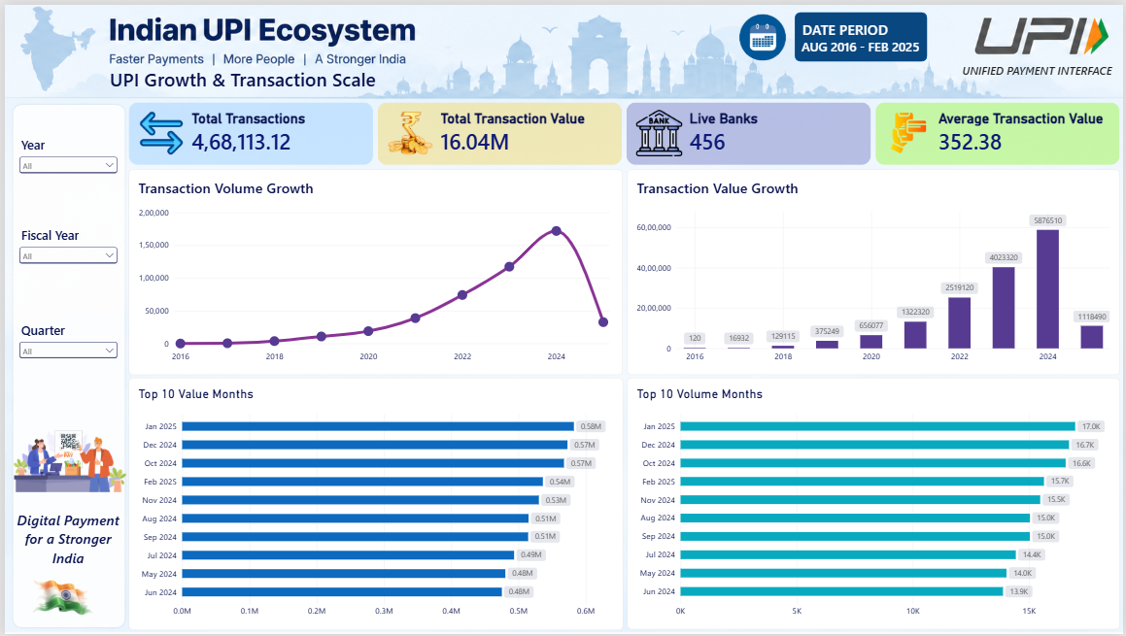

Page 2 — UPI Growth & Transaction Behaviour
Focuses on growth patterns and transaction behaviour through:
- YoY Volume Growth
- YoY Value Growth
- YoY growth comparison
- Average Transaction Value trends
- Top 10 months by average transaction value
- Transaction Volume vs Average Transaction Value
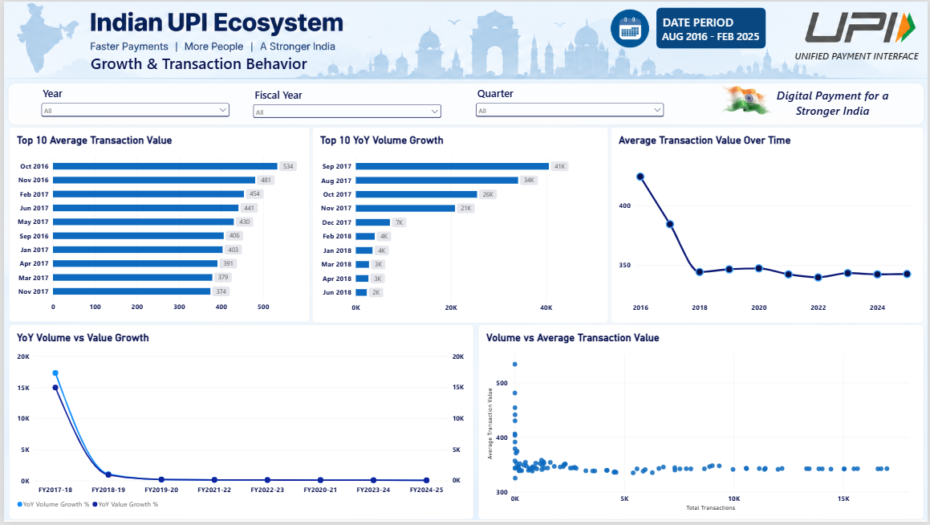
Page 3 — UPI Ecosystem & Time Trends
Examines ecosystem expansion and time-based patterns through:
- YoY and MoM growth KPIs
- Live Banks Growth
- Banks vs Transaction Volume
- Monthly Seasonality
- Quarterly Transaction Performance
- Top 10 MoM Volume Growth Months
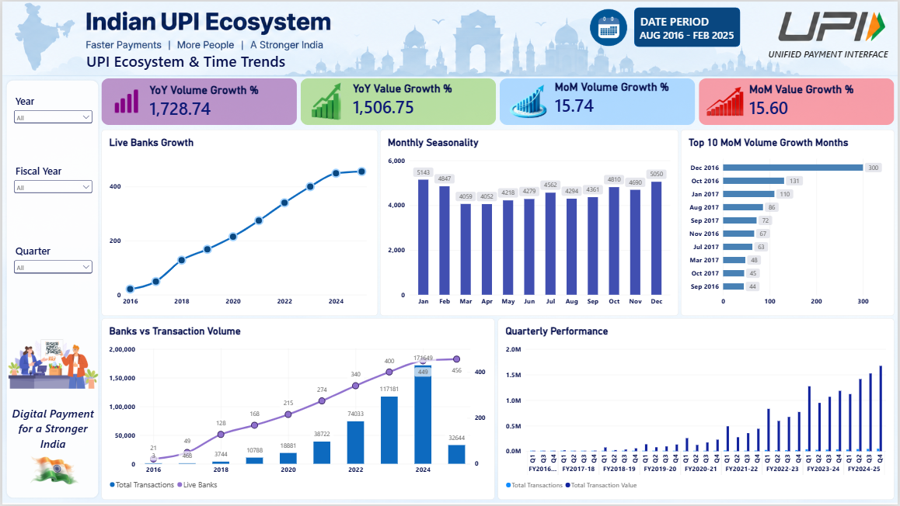
7. Conclusion
This project provides a structured analysis of the evolution of India’s UPI ecosystem from 2016 to early 2025. The PostgreSQL analysis highlights substantial growth in transaction volume, transaction value, and participating banks, while also revealing changes in growth patterns, transaction behaviour, seasonality, and short-term fluctuations. The findings indicate that UPI’s expansion has increasingly been driven by transaction frequency, with average transaction values becoming relatively stable in later years.
The analysis was further transformed into an interactive Power BI dashboard, enabling users to explore these patterns through KPIs, trends, comparisons, and time-based filters. Together, PostgreSQL and Power BI provide a clear analytical view of UPI’s growth and development.

