**GIT Assignment**

1. **Create and collaborate on a new empty repository on GitHub.**

To create a empty repository on GitHub,

* First we have to login in our GitHub accounts and then go to the repositories and make a new repository.
* Here I made a new Public Repository named as Assignment.

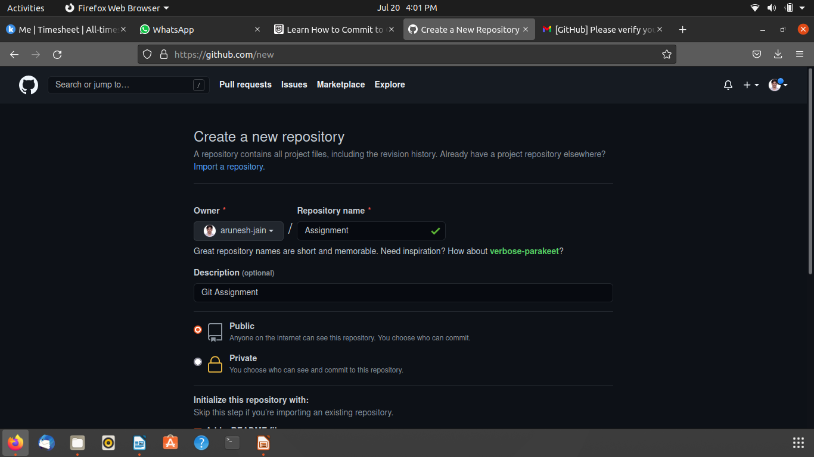

**Git Clone** - The Git clone action will create a new local directory for the repository, copy all the contents of the specified repository, create the remote tracked branches, and checkout an initial branch locally. By default, clone will create a reference to the remote repository called **origin**

**Git Status -** The git status command **displays the state of the working directory and the staging area**.

* Then Clone the GitHub Repository into your local Repository.

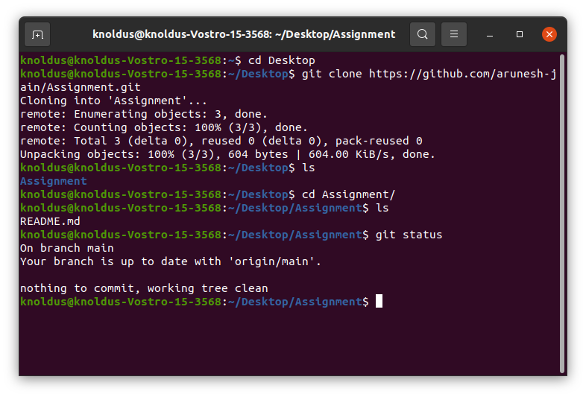

* Here are some stages in Repository:

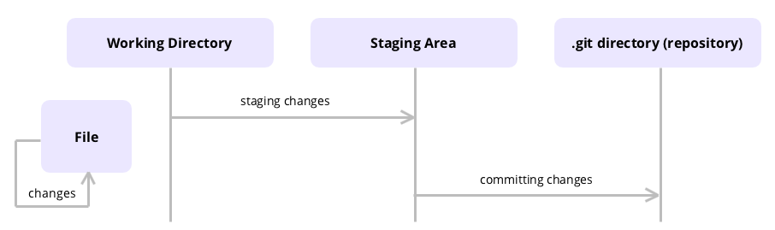

Staging in Git refers to a **phase** which includes all the changes you want to include in the **next commit**. Here are the steps leading to staging:

* You make **changes** to a file in the working directory.
* You use the Git **add** command to move those changes from the working directory to the **staging area**.
* Git does not save changes yet. You need to run the Git **commit** command to move changes from the staging area to the **local repository**.

Additionally, you may use **git status** command to check the status of the files and the staging area. If changes are not staged for commit, they **won't be saved**.

* Make text file Index.txt and save it in the directory. And performed git status.

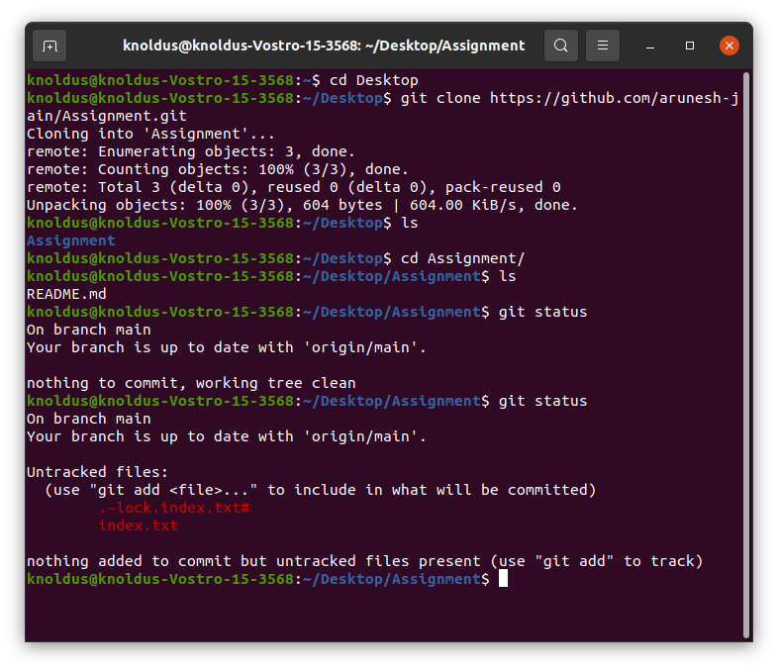

* Use “git add” command for transfer index.txt file from Working directory to Staging area.

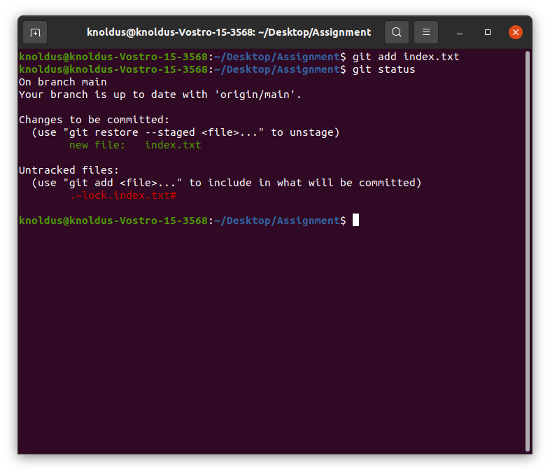

1. **Each member should make one commit each.**

* Uses the “git commit -m” command for transfer the index.txt from staging area to .git directory(repository).

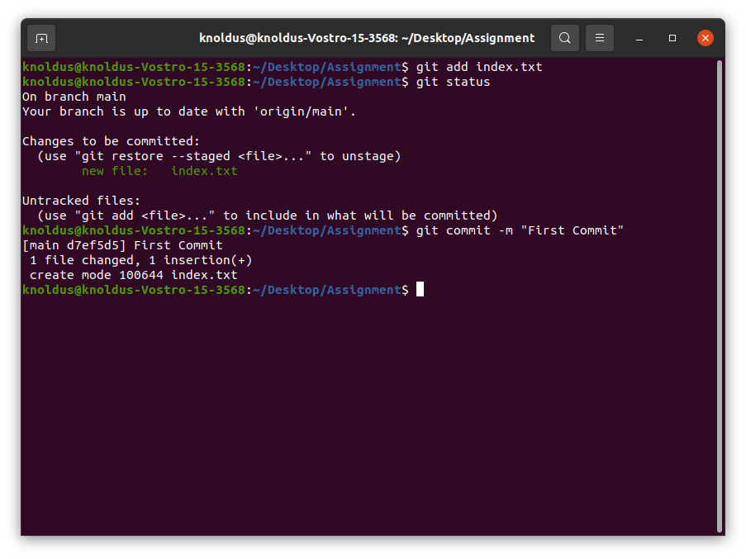

1. **This group needs to learn and discuss on the following topic – commit**

* **git commit:** This starts the commit process, but since it doesn't include a -m flag for the message, your default text editor will be opened for you to create the commit message. If you haven't configured anything, there's a good chance this will be VI or Vim.

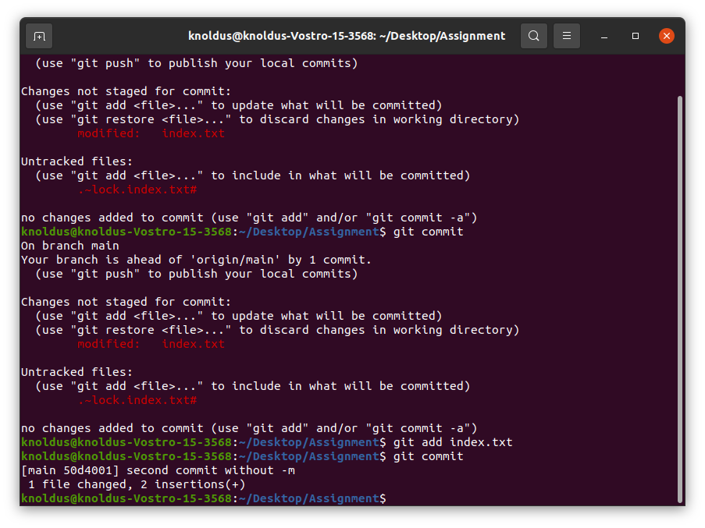

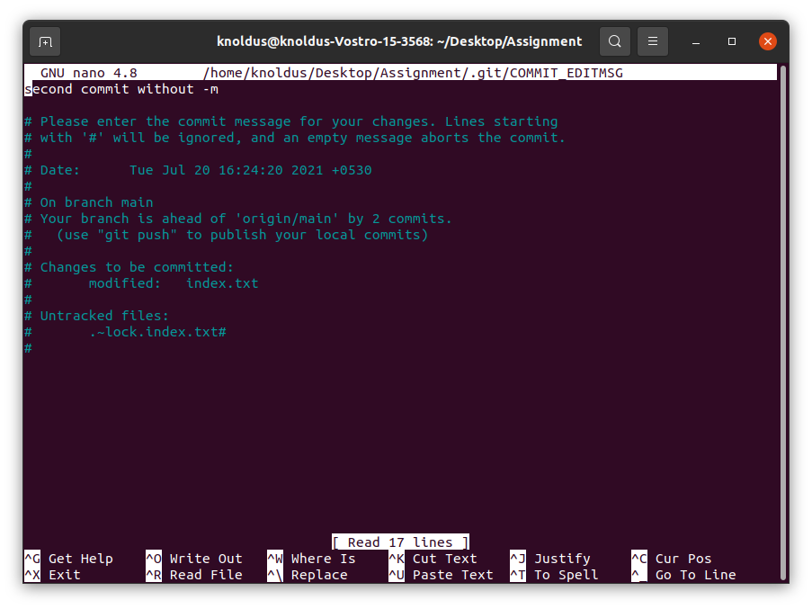

* **git commit -a :** This option allows you to skip the staging phase and commits the changes.

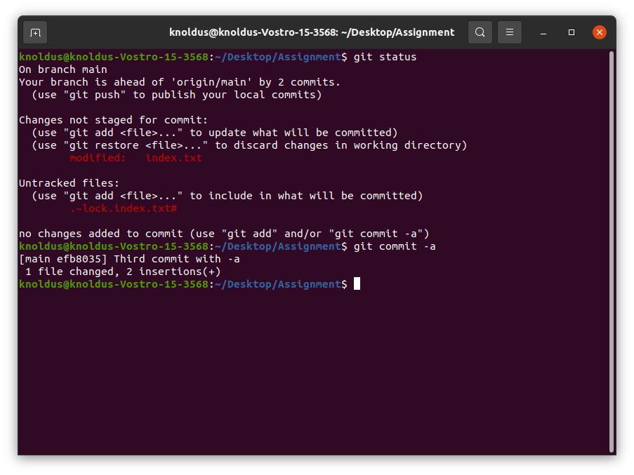

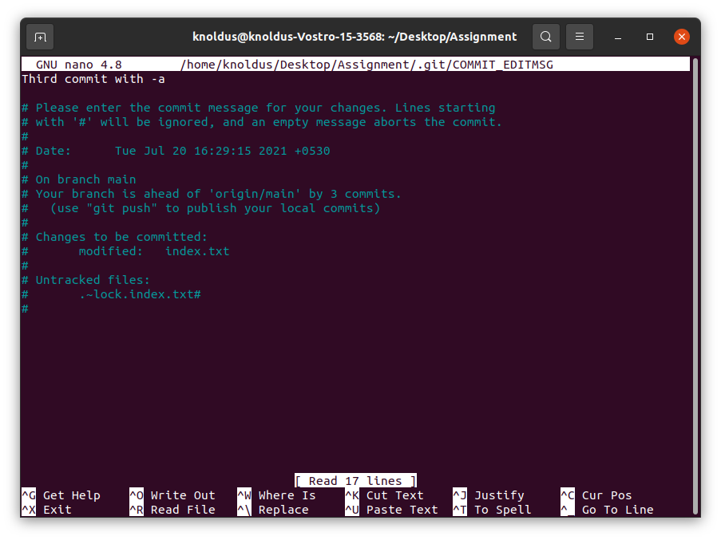

* **git commit -m "descriptive commit message":** This starts the commit process, and allows you to include the commit message at the same time.



* **git commit -am "descriptive commit message":** In addition to including the commit message, this option allows you to skip the staging phase. The addition of -a will automatically stage any files that are already being tracked by Git (changes to files that you've committed before).

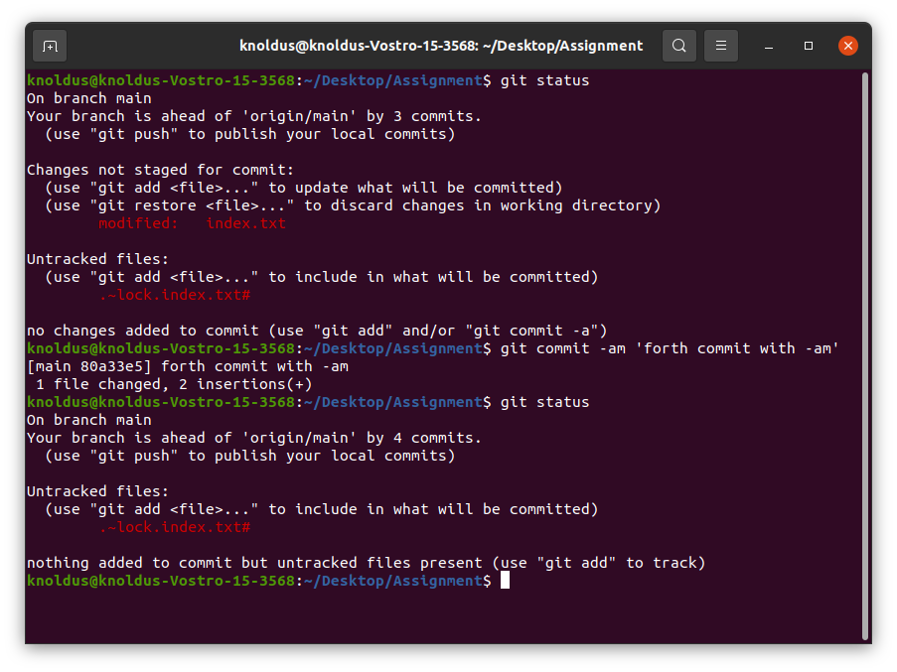

* **git commit --amend:** Replaces the most recent commit with a new commit.

1. **You need to push the slides or the doc you create to this repository.**

