

PRATICAL FILEFOR PAPER CODE 32347504

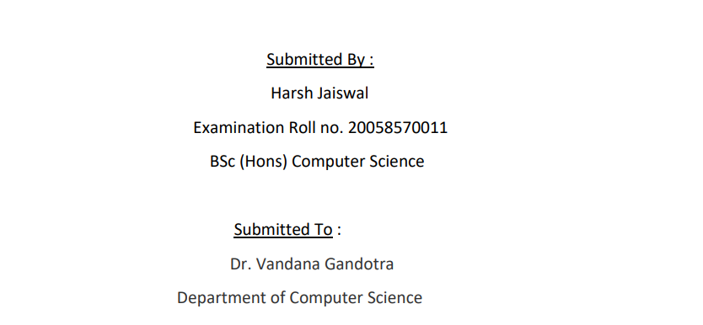

**Question1** Write a program for 32-bit binary Addition ,Subtraction, Division ,and Multiplication .

**Solution:**

**32-Bit Binary Addition:**

.model small ;contain two segment data and code

.386 ;instructions for the 80386 processor

.data ; start of data segment

DATA1 dd 00000000H ;initializes memory with 32 bit word

msg db 10,13,"Enter the first no.:: $" ;  10 is the ASCII control code for line feed while 13 is the code for carriage return

msg1 db 10,13,"Enter the second no.:: $"

msg2 db 10,13,"The Resultant sum is :: $"

.code ; start of code segment

.startup ;Generates program start-up code

MOV AH,09 ; moving 9 into AH for outputting string

MOV DX,OFFSET msg

INT 21H ; calling interrupt to display string whose address present in DX it will check AH value first

MOV EBX,0

MOV CX,8 ; setting number of loop

AGAIN: MOV AH,01 ;1ST NO. ENTERED

INT 21H

CMP AL,'A'

JGE L5

SUB AL,30H ; convert the hexadecimal digits into its equivalent ASCII

JMP L6

L5: SUB AL,37H ; convert the hexadecimal digits into its equivalent ASCII

L6: SHL EBX,4 ; multiply by 16

ADD BL,AL

LOOP AGAIN ; go-to label AGAIN

MOV DATA1,EBX

MOV AH,09

MOV DX,OFFSET msg1

INT 21H ; calling interrupt to display string whose address present in DX it will check AH value first

MOV EBX,0

MOV CX,8

AGAIN1:MOV AH,01 ;2nd NO. ENTERED

INT 21H

CMP AL,'A'

JGE L7

SUB AL,30H ; convert the hexadecimal digits into its equivalent ASCII

JMP L8

L7: SUB AL,37H ; convert the hexadecimal digits into its equivalent ASCII

L8: SHL EBX,4 ; multiply by 16

ADD BL,AL

LOOP AGAIN1

ADD EBX,DATA1 ;ADDITION

MOV AH,09

MOV DX,OFFSET msg2

INT 21H ; displaying the result

MOV CX,8

AGAIN2: ROL EBX,4 rotates the bits within the destination operand to the left

MOV DL,BL

AND DL,0FH

CMP DL,09

JG L1 ; to o/p given no.

ADD DL,30H

JMP PRINT

L1: ADD DL,37H

PRINT: MOV AH,02

INT 21H ; Output a character present in DL , as AH value is 2

LOOP AGAIN2 ; go-to label AGAIN2

END

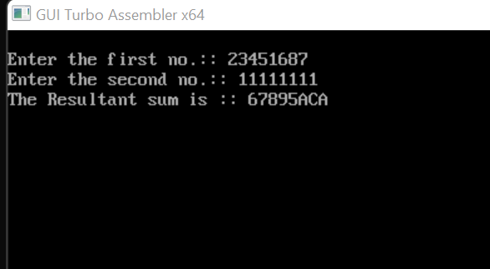

**32-Bit Binary Subtration:-**

.model small ;contain two segment data and code

.386 ;instructions for the 80386 processor

.data ; start of data segment

DATA1 dd 00000000H ;initializes memory with 32 bit word

msg db 10,13,"Enter the first no.:: $" ;  10 is the ASCII control code for line feed while 13 is the code for carriage return

msg1 db 10,13,"Enter the second no.:: $"

msg2 db 10,13,"The Resultant sum is :: $"

.code ; start of code segment

.startup ;Generates program start-up code

MOV AH,09

MOV DX,OFFSET msg

INT 21H ; calling interrupt to display string whose address present in DX it will check AH value first

MOV EBX,0

MOV CX,8 ; setting number of loop

AGAIN: MOV AH,01 ;1ST NO. ENTERED

INT 21H

CMP AL,'A'

JGE L5

SUB AL,30H ; convert the hexadecimal digits into its equivalent ASCII

JMP L6

L5: SUB AL,37H ; convert the hexadecimal digits into its equivalent ASCII

L6: SHL EBX,4 ; multiply by 16

ADD BL,AL

LOOP AGAIN

MOV DATA1,EBX

MOV AH,09

MOV DX,OFFSET msg1

INT 21H ; displaying string message

MOV EBX,0

MOV CX,8 ; setting number of loop

AGAIN1:MOV AH,01 ;2nd NO. ENTERED

INT 21H

CMP AL,'A'

JGE L7

SUB AL,30H ; convert the hexadecimal digits into its equivalent ASCII

JMP L8

L7: SUB AL,37H ; convert the hexadecimal digits into its equivalent ASCII

L8: SHL EBX,4 ; multiply by 16

ADD BL,AL

LOOP AGAIN1

SUB EBX,DATA1 ;ADDITION

MOV AH,09

MOV DX,OFFSET msg2

INT 21H

MOV CX,8

AGAIN2: ROL EBX,4 ; rotates the bits within the destination operand to the left

MOV DL,BL

AND DL,0FH

CMP DL,09

JG L1 ; to o/p given no.

ADD DL,30H

JMP PRINT

L1: ADD DL,37H

PRINT: MOV AH,02

INT 21H ; Output a character present in DL , as AH value is 2

LOOP AGAIN2

END

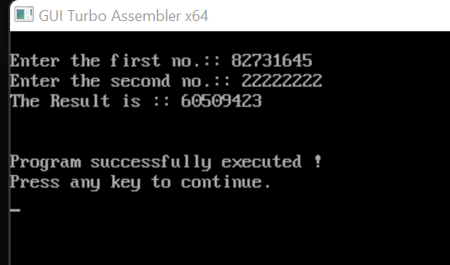

**32-bit Multiplication:-**

.model small ; contain two segment data and code

.386 ;instructions for the 80386 processor

.data ; start of data segment

DATA1 dd 00000000H ; initializes memory with 32 bit word

DATA2 dd 00000000H ; initializes memory with 32 bit word

PROD1 dd ? ; set double word variable

PROD2 dd ? ; set double word variable

msg db 10,13,"Enter the first no.:: $" ;  10 is the ASCII control code for line feed while 13 is the code for carriage return

msg1 db 10,13,"Enter the second no.:: $"

msg2 db 10,13,"The product(in hexadecimal) is :: $"

.code ; start of code segment

.startup ;Generates program start-up code

MOV AH,09

MOV DX,OFFSET msg

INT 21H ; calling interrupt to display string whose address present in DX it will check AH value first

MOV EBX,0

MOV CX,8 ; setting number of loop

AGAIN: MOV AH,01 ;1ST NO. ENTERED

INT 21H

CMP AL,'A'

JGE L5

SUB AL,30H ;convert the hexadecimal digits into its equivalent ASCII

JMP L6

L5: SUB AL,37H ; convert the hexadecimal digits into its equivalent ASCII

L6: SHL EBX,4 ; multiply by 16

ADD BL,AL

LOOP AGAIN

MOV DATA1,EBX

MOV AH,09

MOV DX,OFFSET msg1

INT 21H ; calling interrupt to display string whose address present in DX it will check AH value first

MOV EBX,0

MOV CX,8 ; setting number of loop

AGAIN1:MOV AH,01 ;2nd NO. ENTERED

INT 21H

CMP AL,'A'

JGE L7

SUB AL,30H ;convert the hexadecimal digits into its equivalent ASCII

JMP L8

L7: SUB AL,37H ;convert the hexadecimal digits into its equivalent ASCII

L8: SHL EBX,4 ; multiply by 16

ADD BL,AL

LOOP AGAIN1 ; goto AGAIN1 label

MOV DATA2,EBX

MOV EBX,0

MOV EDX,0

MOV EAX,0

MOV EAX,DATA1

MOV EBX,DATA2

MUL EBX

MOV PROD1,EDX

MOV PROD2,EAX

MOV AH,09

MOV DX,OFFSET msg2

INT 21H ; Output a string terminated by '$’ stored in DX

MOV EBX,PROD1

MOV CX,8

AGAIN2: ROL EBX,4 ; rotates the bits within the destination operand to the left

MOV DL,BL

AND DL,0FH ; to o/p the result

CMP DL,9

JBE L1

ADD DL,37H

MOV AH,02

INT 21H ; Output a character present in DL , as AH value is 2

JMP L2

L1: ADD DL,30H

MOV AH,02

INT 21H ; Output a character present in DL , as AH value is 2

L2: LOOP AGAIN2

MOV EBX,PROD2

MOV CX,8

AGAIN3: ROL EBX,4 ; rotates the bits within the destination operand to the left

MOV DL,BL

AND DL,0FH ; to o/p the result

CMP DL,9

JBE L3

ADD DL,37H

MOV AH,02

INT 21H ; Output a character present in DL , as AH value is 2

JMP L4

L3: ADD DL,30H

MOV AH,02

INT 21H ; Output a character present in DL , as AH value is 2

L4: LOOP AGAIN3

MOV AH,4CH

INT 21H ; causes the current process to terminate

END

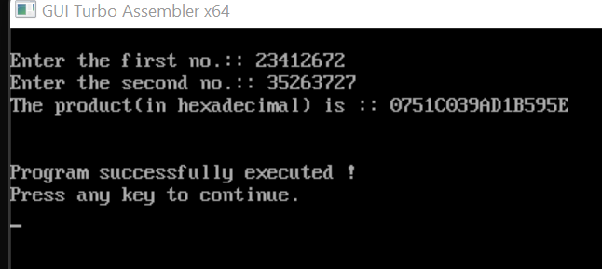

**32-bit division**

.model small ; contain two segment data and code

.386 ;instructions for the 80386 processor

.data ; start of data segment

DATA1 dd 00000000H ; initializes memory with 32 bit word

DATA2 dd 00000000H ; initializes memory with 32 bit word

REM dd ? ; set double word variable

QUO dd ? ; set double word variable

msg db 10,13,"Enter the first no.:: $" ;  10 is the ASCII control code for line feed while 13 is the code for carriage return

msg1 db 10,13,"Enter the second no.:: $"

msg2 db 10,13,"The Remainder is :: $"

msg3 db 10,13,"The Quotient is :: $"

.code ; start of code segment

.startup ; Generates program start-up code

MOV AH,09

MOV DX,OFFSET msg

INT 21H ; calling interrupt to display string whose address present in DX it will check AH value first

MOV EBX,0

MOV CX,8 ; setting number of loop

AGAIN: MOV AH,01 ;1ST NO. ENTERED

INT 21H

CMP AL,'A'

JGE L5

JMP L6

L5: SUB AL,37H ;convert the hexadecimal digits into its equivalent ASCII

L6: SUB AL,30H ;convert the hexadecimal digits into its equivalent ASCII

SHL EBX,4 ; multiply by 16

ADD BL,AL

LOOP AGAIN

MOV DATA1,EBX

MOV AH,09

MOV DX,OFFSET msg1

INT 21H ; Output a string terminated by '$’ stored in DX

MOV EBX,0

MOV CX,8 ; setting number of loop

AGAIN1:MOV AH,01 ;2nd NO. ENTERED

INT 21H

CMP AL,'A'

JGE L7

SUB AL,30H ;convert the hexadecimal digits into its equivalent ASCII

JMP L8

L7: SUB AL,37H ;convert the hexadecimal digits into its equivalent ASCII

L8: SHL EBX,4 ; multiply by 16

ADD BL,AL

LOOP AGAIN1

MOV DATA2,EBX

MOV EBX,0

MOV EDX,0

MOV EAX,0

MOV EAX,DATA1

MOV EBX,DATA2

DIV EBX

MOV REM,EDX ;REM=REMAINDER

MOV QUO,EAX ;QUO=QUOTIENT

MOV AH,09

MOV DX,OFFSET msg2

INT 21H ; Output a string terminated by '$’ stored in DX, as AH =9

MOV EBX,REM

MOV CX,8

AGAIN2: ROL EBX,4 ; rotates the bits within the destination operand to the left

MOV DL,BL

AND DL,0FH ; to o/p the result in rem

CMP DL,9

JBE L1

ADD DL,37H

MOV AH,02

INT 21H ; Output a character stored in DL, as AH value is 2

JMP L2

L1: ADD DL,30H

MOV AH,02

INT 21H ; Output a character stored in DL, as AH value is 2

L2: LOOP AGAIN2

MOV AH,09

MOV DX,OFFSET msg3

INT 21H ; Output a string terminated by '$’ stored in DX, as AH =9

MOV EBX,QUO

MOV CX,8 ; setting the number of loop

AGAIN3: ROL EBX,4 ; rotates the bits within the destination operand to the left

MOV DL,BL

AND DL,0FH ; to o/p the result in quo

CMP DL,9

JBE L3

ADD DL,37H

MOV AH,02

INT 21H ; Output a character present in DL , as AH value is 2

JMP L4

L3: ADD DL,30H

MOV AH,02

INT 21H ; Output a character present in DL , as AH value is 2

L4: LOOP AGAIN3

MOV AH,4CH ; causes the current process to terminate

INT 21H

END

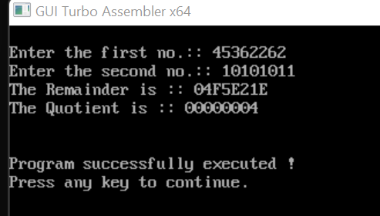

**Question 2 :-**Write a program for 32-Bit BCD Addtion and Subtraction.

**Solution:-**

**32-Bit BCD Addition**

.model small ; contain two segment data and code

.386 ;instructions for the 80386 processor

.data ; start of data segment

MESS0 DB 10,13,"ENTER THE FIRST NUMBER:$" ;  10 is the ASCII control code for line feed while 13 is the code for carriage return

MESS1 DB 10,13,"ENTER THE SECOND NUMBER:$"

MESS2 DB 10,13,"THE SUM IS:$"

A DD ? ; set double word variable

B DD ? ; set double word variable

C DD ? ; set double word variable

COUNT DB 04h ; reserve byte of memory locations

.code ; start of code segment

.startup ; Generates program start-up code

LEA DX,MESS0 ; load the effective address

MOV AH,09

INT 21H ; Output a string terminated by '$’ stored in DX, as AH =9

MOV EBX,0

MOV CX,8

AGAIN:

MOV AH,01

INT 21H ; input the number

CMP AL,'A'

JGE L5

SUB AL,30H ; convert the hexadecimal digits into its equivalent ASCII

JMP L6

L5: SUB AL,37H ; convert the hexadecimal digits into its equivalent ASCII

L6: SHL EBX,4 ; multiply by 16

ADD BL,AL

LOOP AGAIN

MOV A,EBX

LEA DX,MESS1

MOV AH,09

INT 21H ; Output a string terminated by '$’ stored in DX, as AH =9

MOV EBX,0

MOV CX,8

AGAINS:

MOV AH,01

INT 21H ; input the number as AH =01

CMP AL,'A'

JGE L51

SUB AL,30H ; convert the hexadecimal digits into its equivalent ASCII

JMP L61

L51: SUB AL,37H ; convert the hexadecimal digits into its equivalent ASCII

L61: SHL EBX,4 ; multiply by 16

ADD BL,AL

LOOP AGAINS ; Goto label again

MOV B,EBX

MOV AX,WORD PTR A ; retrieve only the lowest word (2 bytes) at the "A" address

MOV BX,WORD PTR B ; retrieve only the lowest word (2 bytes) at the "B" address

ADD AL,BL

DAA ; represented number in 8-bit packed BCD code

MOV BL,AL

ADC AH,BH ; Add with carry BH to AH

MOV AL,AH

DAA ; represented number in 8-bit packed BCD code

MOV BH,AL

MOV WORD PTR C,BX

MOV AX,WORD PTR A+2 ; retrieve the highest word  at the "A" address

MOV BX,WORD PTR B+2 ; retrieve the highest word  at the "B" address

ADC AL,BL ; Add with carry BL to AL

DAA ; represented number in 8-bit packed BCD code

MOV BL,AL

ADC AH,BH ; ; Add with carry BH to AH

MOV AL,AH

DAA ; represented number in 8-bit packed BCD code

MOV BH,AL

MOV WORD PTR C+2,BX

LEA DX,MESS2

MOV AH,09

INT 21H ;Output a string terminated by '$’ stored in DX, as AH =9

MOV BX,WORD PTR C+2 ; replace the highest word  at the "C" address

MOV DH,2

L1: MOV CH,04H

MOV CL,04H

L2: ROL BX,CL ;  rotates the bits within the destination operand to the left

MOV DL,BL

AND DL,0FH

CMP DL,09

JBE L4

ADD DL,07

L4: ADD DL,30H

MOV AH,02

INT 21H ; Output a character present in DL , as AH value is 2

DEC CH

JNZ L2

DEC DH

CMP DH,0

MOV BX,WORD PTR C ; replace only the lowest word (2 bytes) at the "C" address

JNZ L1

MOV AH,4CH

INT 21H ; causes the current process to terminate

END

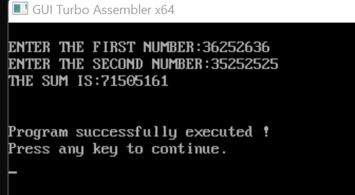

**32-Bit BCD SUBTRATION:-**

.model small ; contain two segment data and code

.386 ;instructions for the 80386 processor

.data ; start of data segment

MESS0 DB 10,13,"ENTER THE FIRST NUMBER:$" ; ;  10 is the ASCII control code for line feed while 13 is the code for carriage return

MESS1 DB 10,13,"ENTER THE SECOND NUMBER:$"

MESS2 DB 10,13,"THE DIFFERENCE IS:$"

A DD ? ; set double word variable

B DD ? ; set double word variable

C DD ? ; set double word variable

COUNT DB 04h reserve byte of memory locations

.code ; start of code segment

.startup ; Generates program start-up code

LEA DX,MESS0 ; load the effective address

MOV AH,09

INT 21H ; Output a string terminated by '$’ stored in DX, as AH =9

MOV EBX,0

MOV CX,8

AGAIN:

MOV AH,01

INT 21H ; input the number

CMP AL,'A'

JGE L5

SUB AL,30H ; convert the hexadecimal digits into its equivalent ASCII

JMP L6

L5: SUB AL,37H ; convert the hexadecimal digits into its equivalent ASCII

L6: SHL EBX,4 ; multiply by 16

ADD BL,AL

LOOP AGAIN ; goto AGAIN label

MOV A,EBX

LEA DX,MESS1

MOV AH,09

INT 21H ; Output a string terminated by '$’ stored in DX, as AH =9

MOV EBX,0

MOV CX,8

AGAINS:

MOV AH,01

INT 21H ; input the number

CMP AL,'A'

JGE L51

SUB AL,30H ; convert the hexadecimal digits into its equivalent ASCII

JMP L61

L51: SUB AL,37H ; convert the hexadecimal digits into its equivalent ASCII

L61: SHL EBX,4 ; multiply by 16

ADD BL,AL

LOOP AGAINS ; goto AGAIN label

MOV B,EBX

MOV AX,WORD PTR A ; retrieve only the lowest word (2 bytes) at the "A" address

MOV BX,WORD PTR B ; retrieve only the lowest word (2 bytes) at the "B" address

SUB AL,BL

DAS ; Adjusts the result of the subtraction to create a packed BCD result

MOV BL,AL

SBB AH,BH ; Subtract with borrow BH from AH

MOV AL,AH

DAS ; Adjusts the result of the subtraction to create a packed BCD result

MOV BH,AL

MOV WORD PTR C,BX ; ; replace only the lowest word (2 bytes) at the "C" address

MOV AX,WORD PTR A+2 ; retrieve the highest word  at the "A" address

MOV BX,WORD PTR B+2 ; retrieve the highest word  at the "B" address

SBB AL,BL ;Subtract with borrow BL from AL

DAS ; Adjusts the result of the subtraction to create a packed BCD result

MOV BL,AL

SBB AH,BH ; Subtract with borrow BH from AH

MOV AL,AH

DAS ; Adjusts the result of the subtraction to create a packed BCD result

MOV BH,AL

MOV WORD PTR C+2,BX ; replace the highest word  at the "C" address

LEA DX,MESS2

MOV AH,09

INT 21H ; Output a string terminated by '$’ stored in DX, as AH =9

MOV BX,WORD PTR C+2 ; ;replace the highest word  at the "C" address

MOV DH,2

L1: MOV CH,04H

MOV CL,04H

L2: ROL BX,CL ; rotates the bits within the destination operand to the left

MOV DL,BL

AND DL,0FH

CMP DL,09

JBE L4

ADD DL,07

L4: ADD DL,30H

MOV AH,02

INT 21H ; Output a character present in DL , as AH value is 2

DEC CH

JNZ L2

DEC DH

CMP DH,0

MOV BX,WORD PTR C ; retrieve the lowest word  at the "C" address

JNZ L1

MOV AH,4CH

INT 21H ; causes the current process to terminate

END

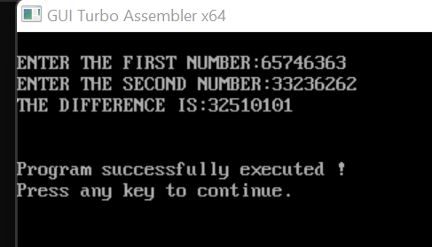

**Question3:-** Write a program for Sorting.

**Solution:-**

.model small ; contain two segment data and code

.386 ;instructions for the 80386 processor

.data ; start of data segment

ARRAY DW 20 DUP (?) ; Declaring an array with garbage

DATA1 dw 0000H ; initializes memory with word

msg db 10,13,"Enter the size of the array :: $" ;  10 is the ASCII control code for line feed while 13 is the code for carriage return

msg2 db 10,13,"Enter the array :: $"

msg3 db 10,13,"The sorted array is :: $"

.code ; start of code segment

.startup ; Generates program start-up code

MOV AH,09

MOV DX,OFFSET msg

INT 21H ; Output a string terminated by '$’ stored in DX, as AH =9

MOV AH,01

INT 21H ; input from user

SUB AL,30H ; convert the hexadecimal digits into its equivalent ASCII

MOV AH,0

MOV CX,AX

MOV DATA1,AX

MOV AH,09

MOV DX,OFFSET msg2

INT 21H ; Output a string terminated by '$’ stored in DX, as AH =9

MOV AH,0

MOV SI, 0

MOV BX, OFFSET ARRAY

L1: MOV DL, 0AH ; jump onto next line

MOV AH, 02H

INT 21H

MOV DX, SI ; input element of the array

MOV AH, 01H

INT 21H

SUB AL,30H ; convert the hexadecimal digits into its equivalent ASCII

MOV SI, DX

MOV [BX + SI], AX ; store at memory location addressed by DS[BX+SI]

INC SI

LOOP L1

MOV CX, DATA1

MOV BX, OFFSET ARRAY ; store the offset address of array

MOV DI,CX

L2: MOV CX, DATA1

MOV SI, 0

L3: MOV AL, [BX + SI]

CMP AL, [BX + SI + 1] ; compare the value of content in AL and at DS[BX+SI+1]

JL L4

XCHG AL,[BX + SI + 1] ; exchange the value of content in AL and at DS[BX+SI+1]

MOV [BX + SI],AL

L4: INC SI

LOOP L3

DEC DI

JNZ L2

MOV CX, DATA1

MOV SI, 1

MOV BX, OFFSET ARRAY

MOV AH,09

MOV DX,OFFSET msg3

INT 21H ; Output a string terminated by '$’ stored in DX, as AH =9

L5: MOV DL, 0AH ; jump onto next line

MOV AH, 02H

INT 21H

MOV DX, [BX + SI]

INC SI

ADD DL, 30H

MOV AH, 02

INT 21H ; Output a character present in DL , as AH value is 2

LOOP L5

END

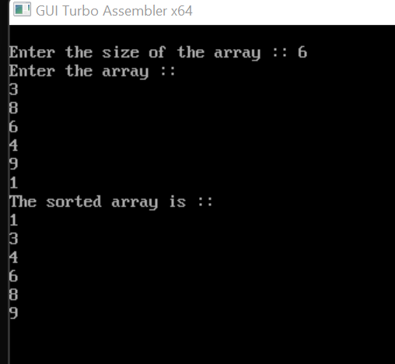

**Question4:-** Write a program for Linear search and Binary Search.

**Solution:-**

**Linear – Search:-**

.model small ; contain two segment data and code

.STACK ; tells the assembler to reserve storage

.386 ;instructions for the 80386 processor

.DATA ; start of data segment

ARRAY DB 9 DUP(?) ; Declaring an array with garbage

MESS01 DB 13,10,"MAX. NO. OF ELEMENTS IN ARRAY IS 9 $"

MESS02 DB 13,10," $" ;  10 is the ASCII control code for line feed while 13 is the code for carriage return

MESS1 DB 13,10,"ENTER THE NUMBER OF ELEMENTS: $"

MESS0 DB 13,10,"ENTER THE NUMBER: $"

MESS2 DB 13,10,"ENTER THE ELEMENT TO BE SEARCHED: $"

MESS3 DB 13,10,"VALUE FOUND AT LOCATION - $"

MESS4 DB 13,10,"VALUE NOT FOUND!!!$"

ErrMess DB 13,10,"ERROR IN INPUT DIGIT$"

DAT DB ? ; set byte size variable

number dw ? ; set double word variable

POS DW ? ; set double word variable

.code ; start of code segment

.startup ; Generates program start-up code

MOV DX, OFFSET MESS01

MOV AH, 09

INT 21H ; Output a string terminated by '$’ stored in DX, as AH =9

MOV DX, OFFSET MESS02

MOV AH, 09

INT 21H ; Output a string terminated by '$’ stored in DX, as AH =9

MOV DX,OFFSET MESS1

MOV AH, 09

INT 21H ; Output a string terminated by '$’ stored in DX, as AH =9

MOV AH, 01

INT 21H ; input from user

CMP al,39h

JBE abc ; jump if below or equal to

MOV DX, OFFSET ErrMess

MOV AH, 09

INT 21H ; Output a string terminated by '$’ stored in DX, as AH =9

JMP myexit

abc: AND AL, 0FH

MOV AH, 0

MOV number, AX

MOV CX, AX ; SET COUNTER AL TIMES

MOV DI, 0

; INPUT ELEMENTS IN ARRAY

MYLOOP:

MOV DX, OFFSET MESS0

MOV AH, 09

INT 21H ; Output a string terminated by '$’ stored in DX, as AH =9

; Tens digit

MOV AH, 01

INT 21H ; input from user

CMP AL, 39H

JBE abc2 ;; jump if below or equal to

MOV DX, OFFSET ErrMess

MOV AH,09

INT 21H ; Output a string terminated by '$’ stored in DX, as AH =9

JMP myexit

abc2: AND al,0fh

SHL AL, 4 ; multiply by 16

MOV BL, AL

; Units digit

MOV AH,01

INT 21H

cmp al,39h

jbe abcx ; jump if below or equal to

MOV DX,OFFSET ErrMess

MOV AH,09

INT 21H ; Output a string terminated by '$’ stored in DX, as AH =9

jmp myexit

abcx:

AND al,0fh

ADD al, bl

MOV ARRAY[DI], AL

INC DI

LOOP MYLOOP

;INPUT ELEMENT TO BE SEARCHED

MOV DX,OFFSET MESS2

MOV AH,09

INT 21H ; Output a string terminated by '$’ stored in DX, as AH =9

; Tens digit

MOV AH,01

INT 21H

cmp al,39h

jbe abcl ; jump if below or equal to

MOV DX,OFFSET ErrMess

MOV AH,09

INT 21H

jmp myexit

abcl:

and al,0fh

shl al,4 ; multiply by 16

mov bl,al

; Units digit

MOV AH,01

INT 21H ; input from user

cmp al,39h

jbe abcm ; jump if below or equal to

MOV DX,OFFSET ErrMess

MOV AH,09

INT 21H ; Output a string terminated by '$’ stored in DX, as AH =9

jmp myexit

abcm:

and al,0fh

add al,bl

mov DAT,AL

; SEARCH PROCESS

MOV AX, DS

MOV ES, AX

MOV AL, DAT

CLD ; Auto-Increment Mode

MOV CX, number

MOV DI, OFFSET ARRAY

REPNE SCASB

CMP CX, 0

JE NOTFOUND

MOV DX, OFFSET MESS02

MOV AH, 09

INT 21H ; Output a string terminated by '$’ stored in DX, as AH =9

MOV DX, OFFSET MESS3

MOV AH,09

INT 21H ; Output a string terminated by '$’ stored in DX, as AH =9

SUB NUMBER, CX

ADD NUMBER,30H ; convert the hexadecimal digits into its equivalent ASCII

MOV DX, NUMBER

MOV AH, 02

INT 21H ; Output a character present in DL , as AH value is 2

JMP myexit

NOTFOUND:

MOV DX,OFFSET MESS4

MOV AH,09

INT 21H ; Output a string terminated by '$’ stored in DX, as AH =9

myexit:

MOV DX, OFFSET MESS02

MOV AH, 09

INT 21H ; Output a string terminated by '$’ stored in DX, as AH =9

.EXIT

END

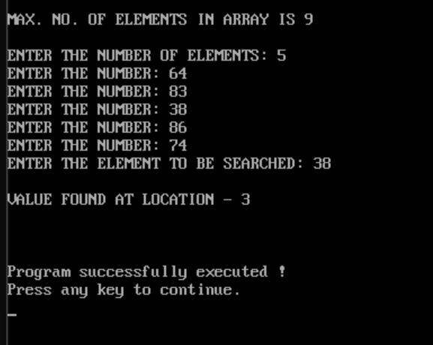

**Binary-Search :-**

.model small ; contain two segment data and code

.stack ; tells the assembler to reserve storage

.386 ;instructions for the 80386 processor

.data ; start of data segment

ARRAY DB 10 DUP(?); Declaring an array with garbage

MESS0 DB 13,10,"ENTER THE NUMBER: $" ;  10 is the ASCII control code for line feed while 13 is the code for carriage return

MESS1 DB 13,10,"ENTER THE NUMBER OF ELEMENTS: $"

MESS2 DB 13,10,"ENTER THE ELEMENT TO BE SEARCHED: $"

MESS3 DB 13,10,"VALUE FOUND AT LOCATION- $"

MESS4 DB 13,10,"VALUE NOT FOUND!!!$"

ErrMess DB 13,10,"ERROR IN INPUT DIGIT$"

DAT DB ? ;set byte size variable

number dw ? ; set double word size variable

.code ; start of code segment

.startup ; Generates program start-up code

MOV DX,OFFSET MESS1

MOV AH,09

INT 21H ; Output a string terminated by '$’ stored in DX, as AH =9

MOV AH,01

INT 21H ; input from user

cmp al,39h

jbe abc ; jump if below or equal to

MOV DX,OFFSET ErrMess

MOV AH,09

INT 21H ; Output a string terminated by '$’ stored in DX, as AH =9

jmp myexit

abc:

and al,0fh

mov ah,0

mov number,ax

MOV CX,AX

MOV DI,0

MYLOOP:

MOV DX,OFFSET MESS0

MOV AH,09

INT 21H ; Output a string terminated by '$’ stored in DX, as AH =9

MOV AH,01

INT 21H ; input from user

cmp al,39h

jbe abc2 ; jump if below or equal to

MOV DX,OFFSET ErrMess

MOV AH,09

INT 21H ; Output a string terminated by '$’ stored in DX, as AH =9

jmp myexit

abc2:

and al,0fh

MOV ARRAY[DI],AL

INC DI

LOOP MYLOOP

MOV DX,OFFSET MESS2

MOV AH,09

INT 21H ; Output a string terminated by '$’ stored in DX, as AH =9

MOV AH,01

INT 21H ; input from user

cmp al,39h

jbe abc3 ; jump if below or equal to

MOV DX,OFFSET ErrMess

MOV AH,09

INT 21H ; Output a string terminated by '$’ stored in DX, as AH =9

jmp myexit

abc3:

and al,0fh

MOV DAT,AL

mov ax,ds

mov es,ax

mov al,dat

CLD ; auto increment mode

mov cx,number

INC CX

mov DI, offset ARRAY

repne SCASB ; scan the memory for AL

CMP CX,0

JE NTFOUND

MOV DX,OFFSET MESS3

MOV AH,09

INT 21H ; Output a string terminated by '$’ stored in DX, as AH =9

SUB NUMBER,CX ;FIND ELEMENT LOCATION

ADD NUMBER,30H

MOV DX,NUMBER

INC DX

MOV AH,02

INT 21H ; Output a character present in DL , as AH value is 2

JMP myexit

NTFOUND:

MOV DX,OFFSET MESS4

MOV AH,09

INT 21H ; Output a string terminated by '$’ stored in DX, as AH =9

myexit:

MOV AH,4CH

INT 21H ; causes the current process to terminate

END

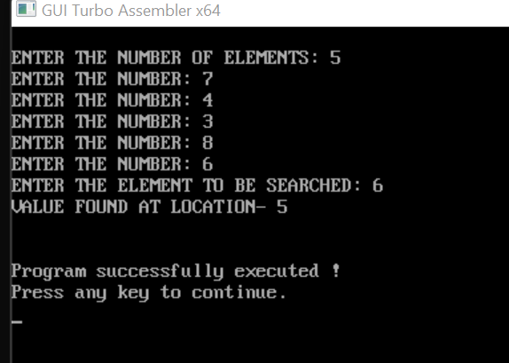

**Question5:-** Write a program to add and subtract two array.

**Solution:-**

**Addition of Two Array:**

.model small ; contain two segment data and code

.data ; start of data segment

mat1 db 12h, 11h, 12h, 10h, 11h, 12h, 10h, 11h, 12h ; defined variable

mat2 db 13h, 02h, 02h, 02h, 02h, 02h, 02h, 02h, 02h

res3 dw 9 dup(?); Declaring an array with garbage

.code ; start of code segment

mov ax, @data ; loading starting address of data segment in ax

mov ds, ax

mov cx, 09h

mov di, offset mat1

mov bx, offset mat2

mov si, offset res3

back : mov ah, 0

mov al, [di]

add al, [bx]

adc ah, 00

mov [si], ax

inc di

inc bx

inc si

inc si

loop back

mov si, offset res3

mov dh, 9

l10: mov ch, 04h

mov cl, 04h

mov bx, [si]

l2: rol bx, cl ; rotates the bits within the destination operand to the left

mov dl, bl

and dl, 0fh

cmp dl, 09

jbe l4

add dl, 07

l4: add dl, 30h

mov ah, 02

int 21h

dec ch

jnz l2

mov dl, ' ' ;This is a whitespace

int 21h

inc si

inc si

dec dh

jnz l10

mov ah, 4ch

int 21h ; causes the current process to terminate

end

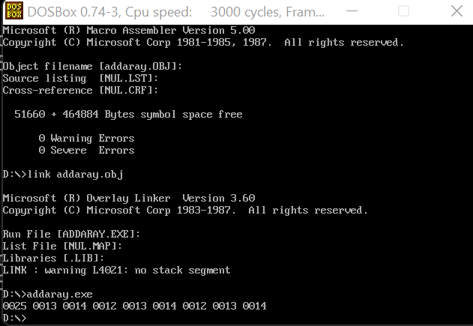

**Subtraction of two array:-**

.model small ; contain two segment data and code

.data ; start of data segment

mat1 db 12h, 11h, 12h, 10h, 11h, 12h, 10h, 11h, 12h ; defining byte size variable

mat2 db 13h, 02h, 02h, 02h, 02h, 02h, 02h, 02h, 02h

res3 dw 9 dup(?); Declaring an array with garbage

.code ; start of code segment

mov ax, @data ;loading starting address of data segment in ax

mov ds, ax

mov cx, 09h

mov di, offset mat1

mov bx, offset mat2

mov si, offset res3

back : mov ah, 0

mov al, [di]

sub al, [bx]

adc ah, 00

mov [si], ax

inc di

inc bx

inc si

inc si

loop back

mov si, offset res3

mov dh, 9

l10: mov ch, 04h

mov cl, 04h

mov bx, [si]

l2: rol bx, cl ; rotates the bits within the destination operand to the left

mov dl, bl

and dl, 0fh

cmp dl, 09

jbe l4

add dl, 07

l4: add dl, 30h

mov ah, 02

int 21h ; display single character as ah = 2

dec ch

jnz l2

mov dl, ' ' ;This is a whitespace

int 21h

inc si

inc si

dec dh

jnz l10

mov ah, 4ch

int 21h ; causes the current process to terminate

end

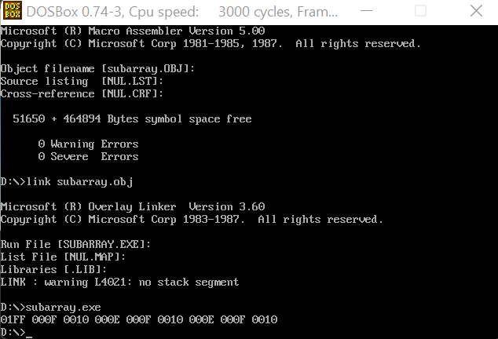

**Question6:-**write a program for binary to ascii conversion.

.MODEL SMALL ; contain two segment data and code

.DATA ; start of data segment

INPUT DB 10,13 , 'ENTER BINARY NO: $' ;  10 is the ASCII control code for line feed while 13 is the code for carriage return

DB 10,13, 'THE ASCII CHARACTER IS:$'

ARR DB ? ; define byte size variable

.CODE ; start of code segment

.STARTUP ; Generates program start-up code

MOV AH,09H

MOV DX,OFFSET INPUT

INT 21H ; Output a string terminated by '$’ stored in DX, as AH =9

MOV BL, 00H

MOV CL,08H

INPUT1: MOV AH,01H

INT 21H ; input from user

SUB AL,30H ; convert the hexadecimal digits into its equivalent ASCII

SHL BL,1 ; multiply by 16

ADD BL,AL

LOOP INPUT1 ; go-to label INPUT

MOV AH,09H

LEA DX,

INT 21H ; Output a string terminated by '$’ stored in DX, as AH =9

MOV AH,02H

MOV DL,BL

INT 21H ; Output a character present in DL , as AH value is 2

MOV AH,4CH

INT 21H ; causes the current process to terminate

END

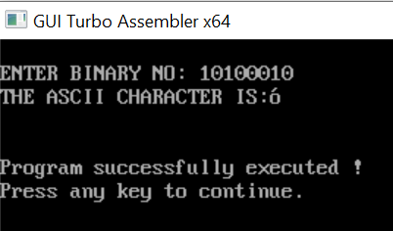

**Question 7:-**Write a program for ascii to binary conversion.

.model small ; contain two segment data and code

.stack 100h ; tells the assembler to reserve 100 byte storage

.data ; start of data segment

input db "Enter an ASCII character :$"

output db 10,13,"Binary Equiv: $";  10 is the ASCII control code for line feed while 13 is the code for carriage return

.code ; start of code segment

MOV AX ,@DATA ; loading starting address of data segment in ax

MOV DS ,AX

MOV DX ,OFFSET input ; loading the offset address

MOV AH, 09H

INT 21H ; Output a string terminated by '$’ stored in DX, as AH =9

MOV AH,01H

INT 21H ; input from the user

MOV BL,AL

MOV DX,OFFSET output

MOV AH,09H

INT 21H ; Output a string terminated by '$’ stored in DX, as AH =9

MOV CX,8

BIN_EQUIV:

SHL BL,1 ; multiply by 16

JC PRINTONE

PRINTZERO:

MOV DL,30H

JMP PRINT

PRINTONE:

MOV DL,31H

PRINT:

MOV AH,02H

INT 21H ; Output a character present in DL , as AH value is 2

LOOP BIN_EQUIV

MOV AH,4CH

INT 21H ; causes the current process to terminate

END

