LabelAssist
AI-Powered Label Verification
Design Approach: AI Suggestions with Human Validation

1. Purpose of This Document
This document presents the core architectural philosophy for LabelAssist and explores the design tradeoffs that led to our recommended approach: AI-generated suggestions with mandatory human validation. It is intended to guide engineering and product decisions during the prototype phase and to provide a framework for progressively automating portions of the application as trust in the AI subsystem is established through measured performance.

The overarching goal is not to replace compliance agents — it is to remove the mechanical burden from their work so they can focus on the judgment calls that actually require human expertise.

2. The Core Design Philosophy

2.1 Why Not Full Automation?
The intuitive case for full automation is compelling: if an AI can accurately check whether a brand name on a label matches the application, why involve a human at all? The TTB processes 150,000 label applications annually, and a large proportion involve straightforward field verification. Eliminating the human from that loop would appear to be the obvious efficiency gain.

However, three realities argue strongly against full automation in the initial deployment:

- High stakes. Regulatory consequence of errors.
- A false approval — passing a non-compliant label — carries legal and regulatory liability. A false rejection — blocking a compliant label — creates delays and damages relationships with producers. Neither error type is acceptable at the rate typical of current LLMs on nuanced document tasks.
- Edge cases exist. Nuance that resists deterministic rules.
- Senior agents like Dave Morrison regularly encounter cases where a strict mismatch is obviously not a real violation (e.g., "STONE'S THROW" vs. "Stone's Throw"). Conversely, Jenny Park's experience shows that seemingly minor formatting deviations — title-case in the Government Warning — are legitimate violations. An automated system that can't reliably distinguish these two situations will either reject too much or approve too much.
- Trust must be earned. No accuracy baseline yet.
- There is no performance data on how a vision-LLM performs against real TTB labels. Deploying full automation without that baseline is not defensible in a regulatory context.

2.2 Why Not Pure Human Review (Status Quo)?
The status quo — agents reviewing every field manually — is also clearly unsatisfactory:

- Agent time is wasted on mechanical matching that adds no judgment value.
- The team of 47 agents is overwhelmed by 150,000 annual applications — a volume that will not decrease.
- Batch processing (200–300 applications at once from large importers) is impossible under the current workflow.
- Error rates on repetitive manual tasks increase with fatigue; AI does not fatigue.

2.3 The Recommended Middle Path
TLDR | The AI surfaces findings. The agent decides. Every AI determination is a suggestion until a human confirms it.

This approach — often called Human-in-the-Loop (HITL) — captures most of the efficiency gains while preserving the agent's authority and catching AI errors before they have consequence. Critically, it also generates the labeled performance data needed to safely automate specific fields over time.

3. Tradeoff Analysis by Design Dimension

3.1 Overall Automation Strategy
The following table compares the three principal approaches at the system level:

Approach | Strengths | Weaknesses
Full Automation(AI decides, no human review) | Maximum throughput; near-zero agent time per label | No performance baseline; regulatory risk on errors; no human override for edge cases
AI Suggestions +Human Validation (Recommended) | Dramatically reduces mechanical work; agents focus on flagged items; generates accuracy data; safe to deploy | Agents still in loop; throughput gains are partial until automation expands
Pure Human Review(Status quo) | Full agent control; no AI risk surface | Unsustainable at volume; fatigue errors; no batch capability; no efficiency gain

3.2 AI Architecture: How the Label Gets Analyzed
Even within the HITL model, there are several ways to structure the AI layer itself:

Approach | Strengths | Weaknesses
Multimodal LLM(vision + language) | Handles imperfect images; understands formatting nuance; single API call; flexible reasoning | Latency risk; non-deterministic; harder to audit; per-call cost
OCR + Rule-BasedComparison | Fast; cheap; fully deterministic; easy to audit | Brittle on image quality; no semantic flexibility; can't handle formatting checks like warning capitalization
OCR + LLMSemantic Layer | OCR handles extraction cheaply; LLM only resolves ambiguous matches | Two-stage adds latency; OCR failures cascade to LLM; more complex error handling

RECOMMENDED | Multimodal LLM for prototype. The image robustness requirement and government warning formatting check are best served by a single-pass vision model. OCR pipeline is the right evolution path if the system scales beyond prototype volumes.

3.3 Matching Policy: Strict vs. Fuzzy
The most consequential design decision at the field level is how tolerant the comparison logic should be. Dave's 'STONE'S THROW' example and Jenny's title-case warning example represent opposite ends of the spectrum — and both are correct in their respective contexts.

A single global tolerance setting is wrong in both directions:

- A globally strict policy produces too many false positives on inconsequential differences, eroding agent trust and causing them to ignore the tool.
- A globally fuzzy policy misses real violations, defeating the compliance purpose entirely.

The correct design is a field-level policy, where each field type has its own tolerance:

Approach | Strengths | Weaknesses
Government Warning(Strict — exact match) | Catches real violations (capitalization, wording). Legally required to be exact. | Zero tolerance means any OCR noise becomes a false flag; requires high-confidence extraction
ABV / Net Contents(Numeric equivalence) | 45% == 45.0% == 45.00%; unit normalization (750mL == 750 ml) | Must handle unit variants correctly; edge cases like metric/imperial conversion
Brand Name(Case-insensitive, punct-normalized) | Eliminates trivial casing mismatches; flags genuine differences | Requires clear severity labeling so agents know 'warning' vs. 'fail'
Class/Type(Semantic similarity via LLM) | Can understand that 'Kentucky Straight Bourbon' matches 'Straight Bourbon Whiskey, Kentucky' | LLM judgment introduces non-determinism; needs confidence threshold for auto-pass

3.4 Results Presentation: How Findings Are Surfaced to Agents
How the AI's output is displayed to the agent directly determines whether they trust and use the tool. The wrong UX choice can make a technically accurate system useless in practice — as the failed scanning vendor pilot demonstrated.

Approach | Strengths | Weaknesses
Binary Pass/Fail per field | Simple; easy to scan quickly | Conflates a trivial casing issue with a missing warning statement; agents can't triage
Severity-Tiered(Pass / Warning / Fail) | Matches how agents actually think; allows override on low-severity items | Requires defining severity policy per field type (adds design surface)
Confidence Scoreper field (0–100%) | Transparent about AI uncertainty | Agents may not know how to act on '67% confident'; adds cognitive load
Reasoning traceper discrepancy | Agents can review AI logic and make informed overrides; builds trust | Verbose; risk of information overload for high-volume sessions

RECOMMENDED | Severity-tiered results (Pass / Warning / Fail) with a one-line reasoning note per flagged field. This respects Dave's expertise while still surfacing Jenny's hard failures. Reasoning trace is shown on expand, not by default.

3.5 Batch Processing Architecture
Sarah Chen identified peak-load batch submissions of 200–300 applications as a critical unmet need. The batch architecture choice has direct implications for the 5-second latency requirement:

Approach | Strengths | Weaknesses
Sequential processing | Trivially simple; no concurrency management | 25+ minutes for 300 labels at 5s/each; completely unacceptable
Parallel with concurrency cap (Recommended) | 1–2 minutes for 300 labels at 20 concurrent; manageable with API rate limits | Requires queue management; API rate limit handling; partial failure logic
Async job queue(background processing) | Ideal for large batches; agent not blocked; scalable | Requires backend job infrastructure; significant additional engineering for prototype

4. The Human Validation Layer in Detail

4.1 What Agents See
For each label submission, the agent is presented with:

- A side-by-side view of the uploaded label image and the application fields
- Per-field comparison results, color-coded by severity: green (Pass), amber (Warning), red (Fail)
- A one-line reason for each non-passing field (e.g., "Warning: Brand name casing differs — label shows 'Stone's Throw', application shows 'STONE'S THROW'")
- A single overall recommendation: Approve / Review Required / Reject
- An override control on each field, with a required free-text note when overriding a Fail

4.2 What Agents Decide
The agent retains authority on:

- Accepting or rejecting the AI's field-level determination
- Overriding a Fail to Approve with written justification (creates audit trail)
- Escalating an ambiguous case for senior review
- Final approval or rejection of the full application

No label is approved or rejected without an agent action. The AI cannot finalize a determination.

4.3 The Override Mechanism as a Data Asset
Every agent override is not just a correction — it is a labeled training data point. When an agent overrides a Fail on a brand name casing mismatch, the system records:

- What the AI flagged
- What the agent decided
- The agent's reasoning (if provided)

Over time, this dataset enables two things: first, measuring true AI accuracy by field type; second, identifying patterns that can safely be automated — the specific field/condition combinations where the AI's suggestion aligns with agent decisions at a high enough rate to remove the human from that loop.
There is a longer-horizon implication to this data asset worth naming explicitly, even if it is out of scope for the prototype.

4.4 Human Judgments as RLHF Signal for Future Fine-Tuning
Every agent validation or override is structurally equivalent to a preference signal in Reinforcement Learning from Human Feedback (RLHF). When an agent confirms an AI suggestion, corrects a false flag, or escalates an ambiguous case, they are signaling to the model: “this determination was correct” or “this determination was wrong, and here is the right answer.” The HITL workflow is not only a safety mechanism — it is an RLHF data pipeline running in production from day one.
If LabelAssist evolves toward a self-hosted model architecture — whether for privacy reasons, to reduce dependency on third-party API providers, or for FedRAMP compliance — the accumulated validation dataset becomes a fine-tuning corpus. A base vision-language model fine-tuned on thousands of TTB-specific label comparisons, with human preference labels attached, would be expected to significantly outperform a general-purpose model on this narrow task. The domain is small and well-defined; that is precisely the kind of problem where fine-tuning on labeled domain data yields outsized gains over a general-purpose baseline.
For this to be actionable, the data schema should be designed with fine-tuning in mind from the start: each record should capture the input image, the structured application fields, the AI’s per-field determinations with reasoning, and the agent’s final decision with any override notes. This is precisely the (prompt, completion, preference) triple that supervised fine-tuning and RLHF pipelines expect. Building this schema correctly in the prototype costs almost nothing; retrofitting it later onto a large existing dataset is significantly more expensive.

5. Path to Progressive Automation

5.1 The Automation Readiness Model
Automation should be introduced field by field, not as a system-wide switch. The criterion for automating a specific field is an empirically measured agreement rate between AI suggestions and agent decisions, sustained over a statistically significant sample.

A working threshold: if the AI and agent agree on a specific field type in 99%+ of cases over 1,000 reviewed labels, that field is a candidate for auto-pass. The agent is then only shown that field if the AI flags a problem, not for every label.

5.2 Expected Automation Progression
Based on field complexity, the expected sequence of automation readiness is:

Field / Feature | Validation Mode | Automation Readiness
Net Contents (volume) | AI suggestion + validation | High — numeric; format-normalized
ABV (numeric) | AI suggestion + validation | High — numeric equivalence; clear rules
Brand Name (exact-match variant) | AI suggestion + validation | Medium — casing/punct normalization needed
Country of Origin | AI suggestion + validation | Medium — limited vocabulary; clear values
Class/Type Designation | AI suggestion + validation | Medium — semantic; some ambiguity
Bottler Name/Address | AI suggestion + validation | Low — high variance; abbreviations; OCR noise
Government Warning Statement | Strict validation, always human | Low — exact match required; zero tolerance for errors

The Government Warning Statement should remain under human validation indefinitely in the prototype phase. It is the highest-consequence field and the one where a false approval carries the clearest regulatory risk.

5.3 Guardrails During the Automation Transition
As individual fields transition to auto-processing, the following guardrails apply:

- Auto-processed fields are still surfaced in the UI — they are just pre-confirmed, not hidden. Agents can still override.
- Any auto-processed field that the AI flags as failing still requires human review. Automation only affects the pass path.
- A monthly accuracy report is generated per field type to monitor for model drift or distribution shifts in label submissions.
- Any field where the auto-pass rate drops below threshold is reverted to full human validation automatically.

6. Deployment Architecture and Privacy Protections

6.1 Virtual Private Cloud Isolation
Label images submitted to LabelAssist contain potentially sensitive commercial information: unreleased brand names, proprietary label artwork, and production details implied by net content and bottler information. In a production deployment, this data should never leave a controlled network boundary.
The recommended architecture for a production deployment is a Virtual Private Cloud (VPC) on Azure — consistent with the TTB’s existing infrastructure. All components (the application server, the AI inference endpoint, and the validation data store) are deployed within a private subnet with no public ingress except through a hardened API gateway. Key properties of this model:
- Label images never leave the VPC boundary. AI inference calls route to a private endpoint, eliminating the firewall and data-egress concerns raised during discovery.
- Validation data and agent overrides are stored in a private database that never transits a public network or touches a third-party logging service.
- FedRAMP and federal data retention compliance is easier to demonstrate when all data flows are internal to a single Azure tenancy the agency already controls.

6.2 On-Device OCR as a Fallback for Challenging Environments
In environments where network connectivity is restricted or where even VPC-routed API calls are not permissible — such as highly air-gapped field offices — on-device OCR represents a possible fallback for the text extraction step of the pipeline. Lightweight OCR models (e.g., Tesseract, Apple’s Vision framework, or on-device ML Kit) can run entirely on the user’s device with no network call required. Extracted text is then compared locally against application fields using deterministic rules, with results surfaced to the agent for validation.
The accuracy tradeoff is significant and should not be understated. On-device models are constrained by memory and compute budgets that force aggressive quantization and architectural simplification relative to server-side vision-language models. Error rates are meaningfully higher, particularly on the conditions most common in real TTB submissions: low-contrast labels, glare, off-angle photography, and decorative fonts on premium spirits. The government warning statement — the highest-consequence field, already prone to small-font violations — is also the field most likely to be misread by an under-resourced on-device model.
On-device OCR should therefore be treated as a clearly-marked degraded mode, not a silent substitution. If it is offered, the UI must explicitly communicate reduced confidence and direct the agent to treat all fields as requiring careful manual review. It should never be enabled automatically when connectivity is poor without the agent’s awareness.

7. Risks and Mitigations

Approach | Strengths | Weaknesses
LLM latency exceeds 5s | Prompt optimization; streaming results; show partial field results as they resolve
Agent over-reliance on AI suggestions | UI design: AI results shown after agent's initial scan; override logging creates accountability
Model drift over time | Monthly accuracy reports; automated threshold monitoring; field-level reversion triggers
Poor image quality defeats extraction | Image quality confidence flag surfaced prominently; agent prompted to request resubmission
Agent distrust of the tool | Reasoning transparency; easy override; no punishment for disagreeing with AI

8. Screenshots

Below are some of the screenshots from the prototype web application hosted at https://labelassist-ai.onrender.com/

AI Review result screen:
Shows the overall AI recommendation and the latency. This can be overridden by a human.

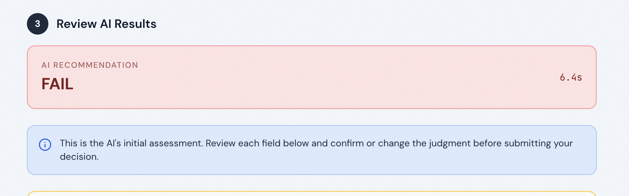

Per feature matching result:
Result for the match of each facet. We could have human judgement be available here as well on a per feature basis:

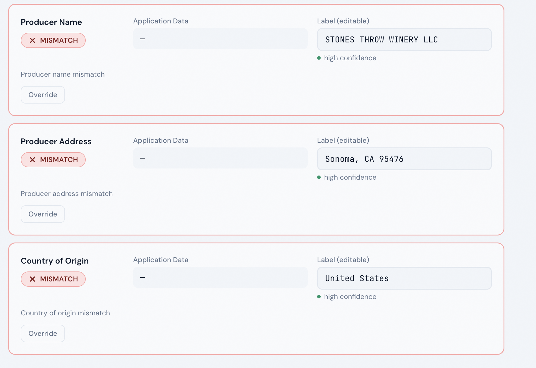

Overall result from human assessment:
In this version, the AI presents its judgement to the human and allows the human to have the final say. Later on, as the models get fine tuned with RLHF and depending on the input from the on-field operators, we could reduce the human involvement on a step-by-step basis.
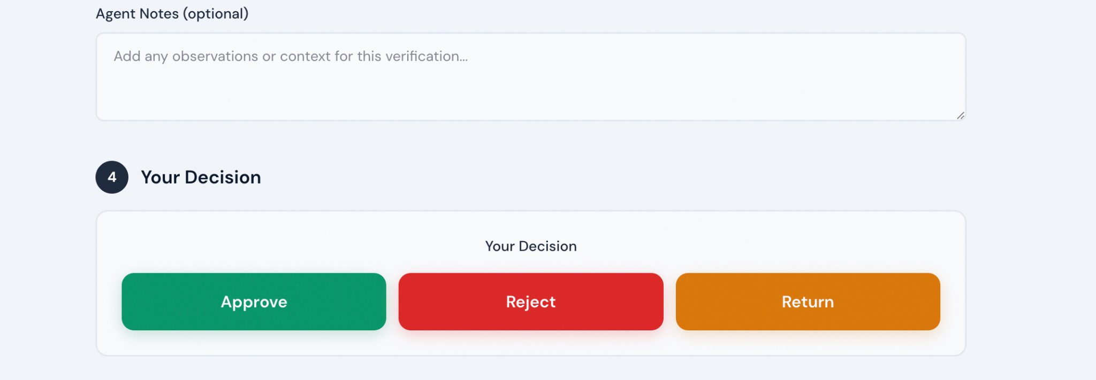

9. Conclusion
The AI suggestions + human validation model is the right starting point for LabelAssist because it is the only approach that simultaneously:

- Delivers meaningful efficiency gains (agents spend time on judgment, not mechanical matching)
- Maintains compliance integrity (no label is approved without human sign-off)
- Generates the performance data needed to extend automation responsibly
- Builds agent trust through transparency and control rather than eroding it

Full automation of specific, low-risk fields is a realistic near-term outcome — but it should be earned through demonstrated accuracy, not assumed. This document provides the framework for making that transition deliberately and defensibly.

NORTH STAR | Build the tool agents want to use, measure what the AI actually gets right, then automate only what it has earned the right to own.

