**STATE OF CHARGE ESTIMATION OF LI-ION BATTERY FOR ELECTRIC VEHICLES USING EXTENDED KALMAN FILTER**

**Arunesh E**

**Final Year**

**B.Tech Electrical and Electronics Engineering (Smart Grid & Electric Vehicle)**

**SASTRA Deemed University**

June 2025

**TABLE OF CONTENTS**

**Abstract 03**

**Objective 03**

**Theory 03**

**SOC estimation 03**

**Working of Kalman filter 04**

**Working of Extended Kalman Filtering 05**

**Methodology 06**

**Results 07**

**Conclusion 10**

**Future Scope 10**

**References 10**

**Abstract:**

Accurate State of Charge (SOC) estimation is critical in Electric Vehicle (EV) battery management for safety and efficiency.

This project implements an Extended Kalman Filter (EKF) in MATLAB to estimate SOC of a Li-ion battery using a first-order Thevenin model. Real-world current, voltage, and temperature data are used, with battery parameters (R₀, R₁, C₁) interpolated dynamically. An 11th-order OCV-SOC polynomial fit supports the EKF's internal computations. Estimated SOC and terminal voltage are validated against Coulomb Counting results.

The EKF shows reduced error and improved robustness, offering a strong base for BMS applications in EVs.

**Objective:**

* To estimate the State of Charge (SOC) of a Li-ion battery using the Extended Kalman Filter (EKF) in MATLAB.
* To implement a first-order Thevenin equivalent circuit model for the battery.
* To interpolate battery parameters (R₀, R₁, C₁) dynamically based on SOC and temperature.
* To fit an OCV-SOC curve using an 11th-order polynomial and compute its derivative.
* To validate EKF-estimated SOC and terminal voltage against Coulomb Counting results.
* To analyze estimation error and demonstrate the EKF’s robustness under realistic load conditions.

**Theory:**

The **State of Charge (SOC)** indicates the remaining usable capacity of a battery, expressed as a percentage (%). SOC is like the "fuel gauge" for conventional IC engine vehicles critical for EVs.

And Its very essential to estimate SOC accurately to Range prediction, Battery protection, Optimal energy management, Charging/discharging control

An inaccurate SOC can lead to range anxiety, unexpected shutdowns, or battery damage, making accurate SOC estimation a top priority in Battery Management Systems (BMS).

SOC estimation of a Battery need a Mathematical modeling of the battery. ECM (Equivalent Circuit modelling) of Battery by Thevenin Model is used Widely. The first-order Thevenin model, which balances accuracy with computational simplicity.

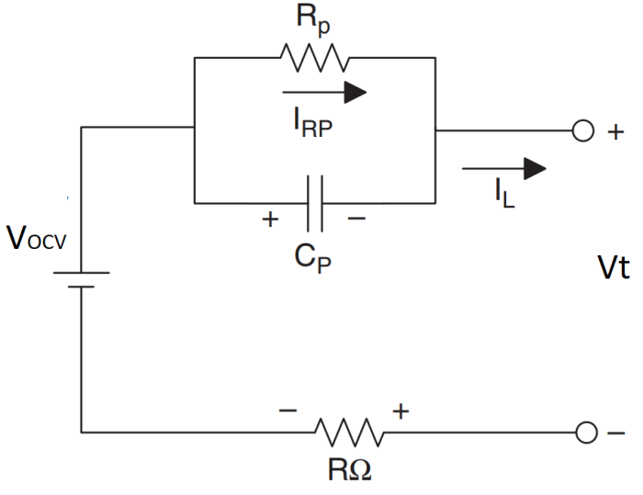

This model includes:

* OCV (Open Circuit Voltage): Non-linear function of SOC
* R (Internal resistance): Accounts for instantaneous voltage drop
* Rp and Cp: Form an RC branch to model transient behavior (voltage recovery after load change)

The terminal voltage equation becomes:

$$Vt=OCV\left(SOC\right)-I_{l} R-V_{RC}$$

where $V_{RC}$ ​ is the voltage across the RC branch, dynamically updated during operation.

**Working of Kalman filtering:**

The Kalman Filter is a smart method used to estimate the SOC of a battery when it cannot be measured directly. Instead of relying solely on basic voltage or current readings, the filter combines past data with a simple battery model to make a first guess of the SOC. It then corrects that guess using real-time measurements like terminal voltage or temperature. The correction depends on which source the model or the measurements is more reliable, a balance controlled by a factor called the Kalman Gain. This process repeats at every time step, enabling the SOC estimate to improve continuously, even in the presence of noise. This makes Kalman Filters highly useful for BMS in electric vehicles.

However, standard Kalman Filters assume a linear system, which is a major limitation for real-world applications like battery systems, where behaviors (i.e OCV–SOC relationship) are inherently nonlinear. This mismatch can lead to poor estimation accuracy or even divergence over time.

To solve this, the Extended Kalman Filter (EKF) adapts the Kalman approach for nonlinear systems. It does this by linearizing the nonlinear state and measurement equations at each time step using Jacobian matrices. This makes EKF capable of approximating complex, real-world battery behavior — where parameters like voltage, resistance, and SOC change nonlinearly with temperature and load — much more effectively.

**Working of Extended Kalman Filter – EKF**

Loading measured current, voltage, and temperature values from the dataset.

Initializating SOC to 100%, V₁ = 0 (voltage across RC branch) and Defining process and measurement noise covariance matrices: Q_x, R_x, and initial error P_x

Loop Through Each Time Step (For each sample in the dataset:)

* Estimate Battery Parameters by using interpolated functions to find R₀, R₁, and C₁ based on current SOC and temperature
* Predict Next State  
  Compute predicted SOC and V₁ using Thevenin model equations  
  Estimate terminal voltage (Vt) using:
$$Vt=OCV\left(SOC\right)-I_{l} R-V_{RC}$$

* Compare with Measured Voltage  
  Compute voltage error:
$${Error }_{Vt}={V_{t}}_{Measured}-{V_{t}}_{Estimated}$$

* Update Kalman Gain (K) by using current state covariance (P_x) and measurement sensitivity to calculate K
$$K=P_{x}.{C_{x}}^{T}. {(C_{x}.P_{x}.{C_{x}}^{T}+R_{x})}^{-1}$$

* Correct State Estimate  
  Adjust SOC and V₁ using Kalman Gain and voltage error
* Update Covariance Matrix  
  Recalculate $P_{x}$ to reduce uncertainty for next iteration
* Output
* Estimated SOC over time
* Estimated terminal voltage
* Voltage estimation error

**Methodology:**

### **Data Preprocessing**

* Real-world data of voltage, current, temperature, and ampere-hour (Ah) readings were loaded.
* Coulomb counting was used to calculate the **measured SOC**, serving as reference.
* Data was downsampled to reduce computational load and noise.
* The current was inverted to follow standard modeling (discharge = negative).

### **Battery Modeling**

* A **first-order Thevenin equivalent circuit** was used to represent the battery.
* Temperature- and SOC-dependent values of R0,R1,C1R_0, R_1, C_1R0​,R1​,C1​ were dynamically interpolated from experimental battery model data.
* The **OCV–SOC relationship** was modeled using an 11th-order polynomial fit.

### Initialization

* **Initial SOC**: Assumed to be **100%**, representing a fully charged battery.
* **Initial V₁** (RC branch voltage): Set to **0 V**, assuming no initial internal polarization.
* **Sampling time**: Set to **1 second**, matching the data update rate.
* **Efficiency**: Assumed to be **100%**, ignoring energy losses for simplicity.
* **State error covariance (Pₓ)**: Reflects uncertainty in the initial state estimates:
  + Values: **0.025** for SOC and **0.01** for V₁.
* **Process noise covariance (Qₓ)**: Captures uncertainties in the battery model dynamics
  + Values: **0.0001** for both SOC and V₁.
* **Measurement noise covariance (Rₓ)**: Reflects expected noise in terminal voltage measurements
  + Value: **0.2**

EKF Estimation Loop

For each time step:

* Predict next state using current input (I), previous state (SOC, VRC), and system dynamics.
* Compute predicted terminal voltage using:
$$Vt=OCV\left(SOC\right)-I_{l} R-V_{RC}$$

* Calculate voltage error between measured and predicted values.
* Compute Kalman Gain K and update the state vector:

$X_{k}= X_{k}+K (Voltage Error)$

* Update error covariance matrix $P_{x}$ ​ accordingly.

### **Output**

* The simulation outputs the estimated SOC, predicted terminal voltage, and estimation errors.
* Graphical plots are generated for:
  + Terminal voltage comparison
  + SOC estimation vs Coulomb Counting
  + Voltage and SOC error over time

**Results and Analysis:**

Figures:

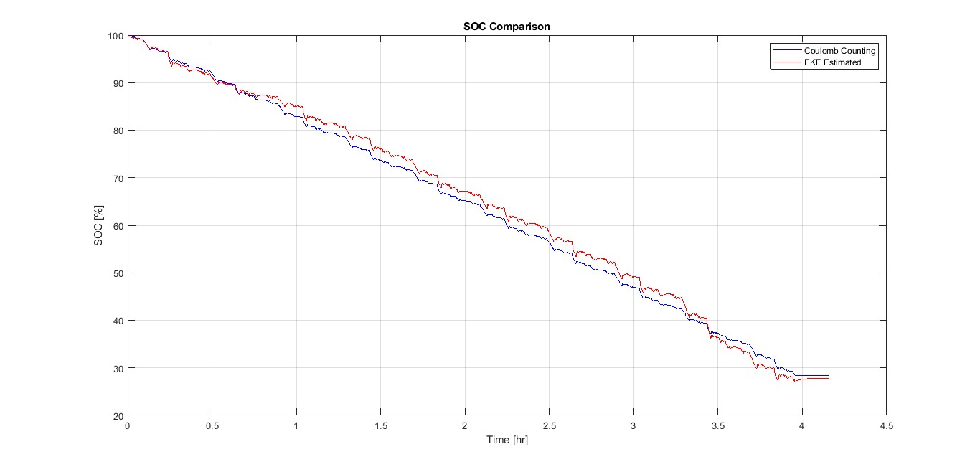SOC estimation using EKF closely tracks Coulomb Counting, even during load changes, and handles noise better.

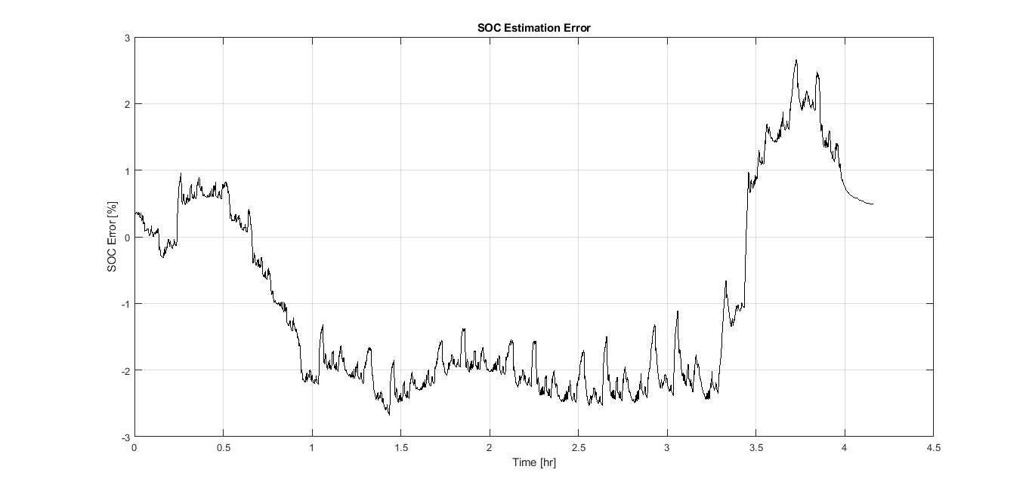SOC error stays within ±2.5%, mostly under ±1% in the first 3 hours, proving it’s suitable for real-time EV applications.

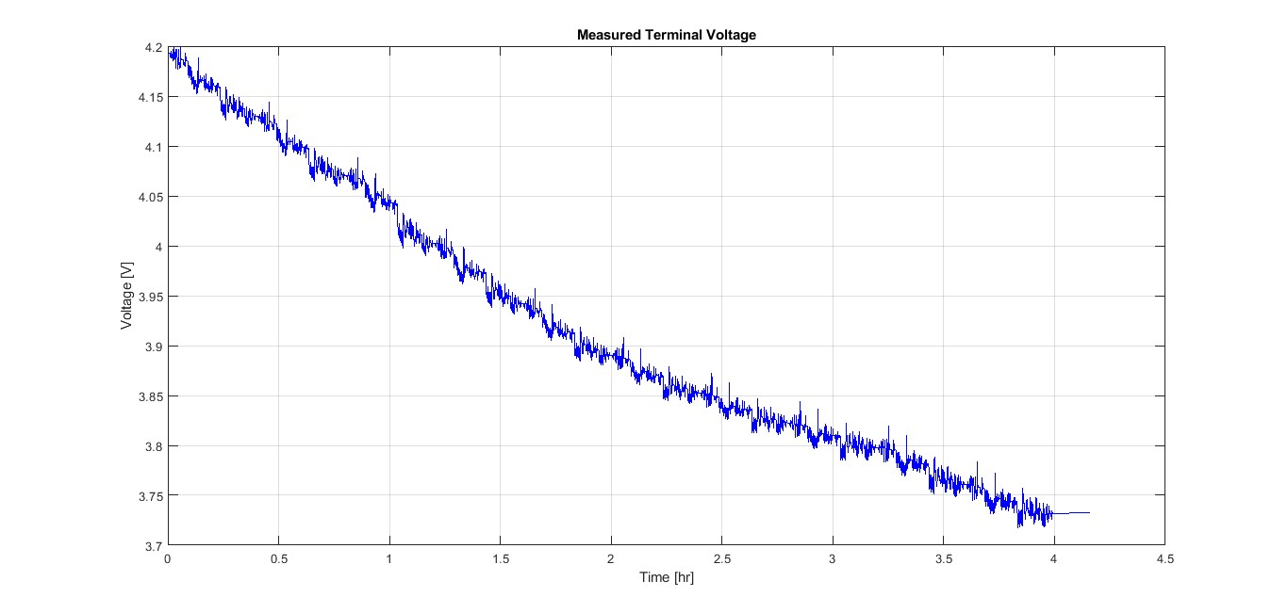Estimated terminal voltage matches measured voltage accurately, showing the model reflects real battery behavior.

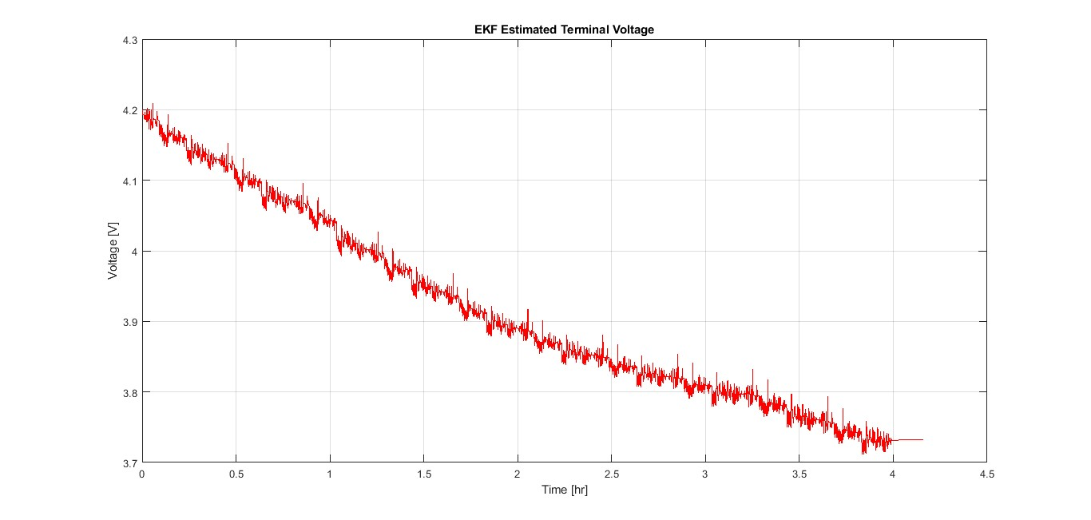Voltage error is mostly under ±0.5V, even during current spikes, confirming EKF’s noise resilience.

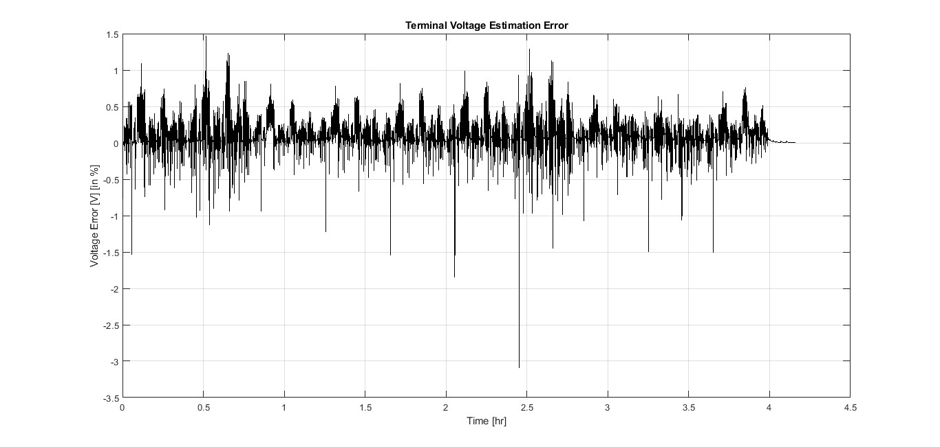

No cumulative drift observed, indicating proper EKF tuning and stable performance over time.

**Note**: High-resolution versions of all plots are also available in the **‘Figures’** folder of the project directory for detailed viewing.

**Conclusion:**

* Gained hands-on experience in implementing the Extended Kalman Filter (EKF) for SOC estimation.
* Understood how Thevenin equivalent circuit modeling represents real battery behavior. And learned how to handle real-world battery data, including preprocessing, downsampling, and interpreting sensor values.
* Improved skills in MATLAB programming, especially in system modeling, filtering techniques, and plotting meaningful results.

**Future Scope:**

* **Adaptive Tuning**: Instead of using fixed covariance values (Qₓ, Rₓ, Pₓ), future versions can implement adaptive tuning methods that adjust these values based on load conditions, improving robustness in varying driving environments.
* **Cross-Dataset Testing**: The EKF model can be tested on different datasets or battery chemistries (e.g., LFP, NMC) to ensure generalization and flexibility across EV platforms.
* **Real-Time Deployment**: The algorithm can be implemented on embedded hardware like microcontrollers or dedicated BMS chips, enabling real-time SOC tracking in actual EV applications.

**Sources & References:**

**Datasets:**

Battery_datapoint.mat - (Contains 149k + Data points of Voltage, Current, Amp_hr, Watt_hr, Power, Battery_Temp )

BatteryModel.mat - (Contains value of SOC, R0, R1, C1, T)

SOC-OCV.mat – (Contains SOC, OCV Curve with Temperature)

**References:**

1. Jiang, Jiuchun, and Caiping Zhang. Fundamentals and Applications of Lithium-Ion Batteries in Electric Drive Vehicles. John Wiley & Sons Singapore Pte. Ltd., 2015.
2. Zarchan, Paul, and Howard Musoff. Fundamentals of Kalman Filtering: A Practical Approach. 3rd ed., Progress in Astronautics and Aeronautics, Vol. 232, American Institute of Aeronautics and Astronautics, 2009.
3. Padhi, R. (2013, February 1). *Mod-12 Lec-29 Kalman Filter Design – II* [Video]. NPTEL, IISc Bangalore. [YouTube](https://youtu.be/17qEwiqY9Xc).
4. Mukhopadhyay, S. (2009, October 5). *Lec-18 Kalman Filter – Model and Derivation* [Video]. NPTEL, IIT Kharagpur. [YouTube](https://youtu.be/2uHcOTcaxeY).