**Background**: Mobicon is a telecom company which is concerned of their higher churn rate. Churn is when a customer with an existing operator switch to a different operator. This project is aimed at developing a model which would answer a few key questions of interest to roll out targeted proactive retention programs, which would help in reducing the churn rate.

**What are the top five factors driving likelihood of churn at Mobicom?**

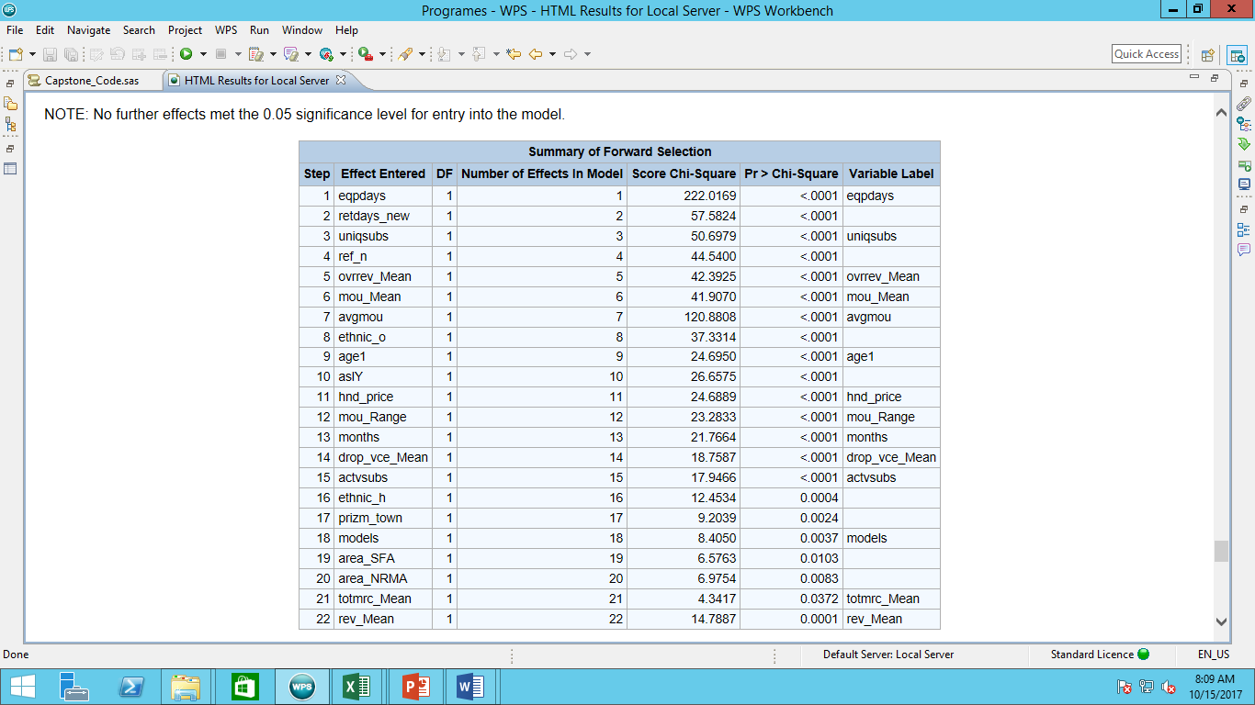

The top five factors driving likelihood of churn at mobicon are:

* Eqpdays - Number of days (age) of current equipment
* Retdays - Number of days since last retention call (Retention calls include any calls from the customer regarding loyalty or retention, e.g. contract renewal, relating competitor's offer, etc.)
* Uniqsubs - Number of unique subscribers in the household
* Refurb_new - Handset: refurbished or new
* Ovrrev_mean - Mean overage revenue (Mean overage revenue is the sum of data and voice overage revenues.)

**Validation of survey findings. a) Whether “cost and billing” and “network and service quality” are important factors influencing churn behaviour. b) Are data usage connectivity issues turning out to be costly? In other words, is it leading to churn?**

1. Mean total monthly recurring charge(totmrc_mean), Mean monthly revenue (rev_mean) and mean overage revenue (ovrrev_mean) are predictor variables in the following model. Therefore, cost and billing are important factors for churn behaviour.
2. Mean number of dropped (failed) voice calls (drop_vce_mean) is a predictor variables with p-value less than 0.0001. Therefore, network and sevice quality are important factors for churn behaviour.
3. Since Mean number of dropped data calls or Mean number of completed data calls are not predictor variables in the model, hence we can probably conclude that data usage connectivity issue is not influencing the churn behaviour.

**Would you recommend rate plan migration as a proactive retention strategy?**

Mean total monthly recurring charge(totmrc_mean), Mean number of monthly minutes of use(Mou_mean), Average monthly minutes of use over the life of the customer(avgmou) are predictor variables with significant affect on churn and the customer can be advised accordingly on the rate plan. Customer’s rate plan suitability is determined based on these parameters. Since mean overage revenue (ovrrev_Mean) is also a major churn influencer, only after detailed analysis of customer’s rate plan suitability can rate plan migration be recommended to subscribers as they often switch to non-optimal rate plans to save overage costs.

**What would be your recommendation on how to use this churn model for prioritisation of customers for a proactive retention campaigns in the future?**

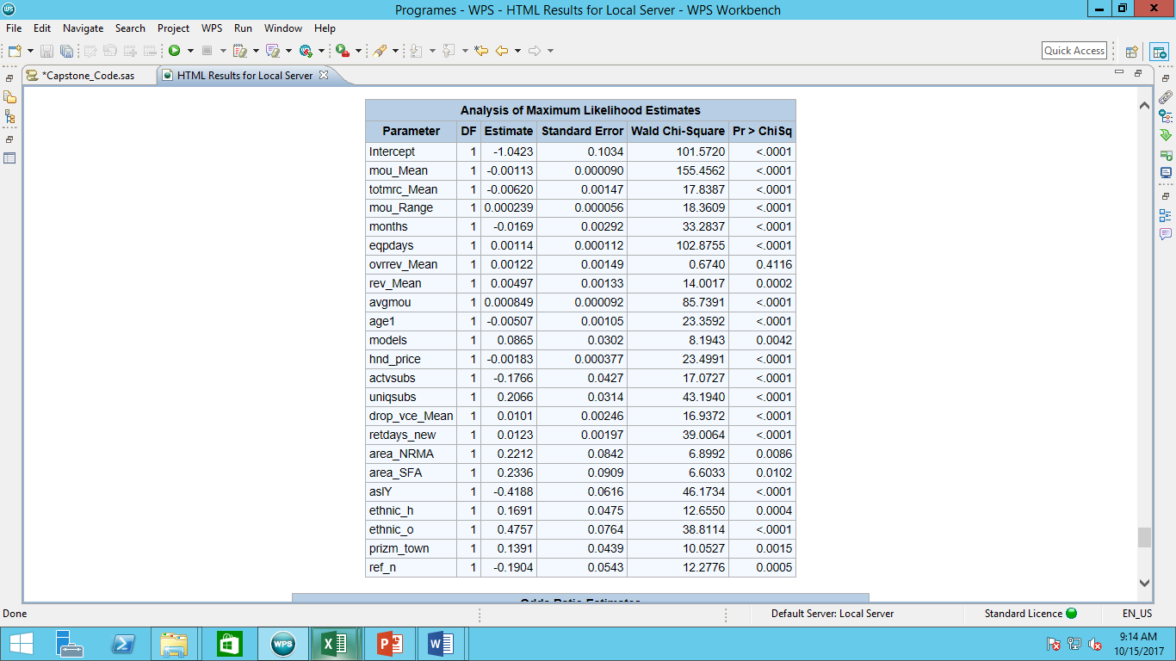

From the analysis of predictor variables we can infer that:

* Mou_Mean, mou_Range and avgmou can be used to determine a customer’s rate plan suitability. Using revenue information like totmrc_Mean, ovrrev_Mean, rev_mean and account spending limit a suitable plan can be constructed and recommended for proactive retention campaigns in the future.
* Since mean number of dropped calls is a predictor variable, thus ensuring better network facilities can help in retention of customers.
* Since increase in the total number of months in service reduces the probability of churning, targeted plans can be provided to those who have stayed loyal for a long time. This will ensure in decreasing the churn rate.
* Since with increase in active subscribers in a family the probability of churn rate decreases, offer bundling for family can be used as a means to increase active subscribers in a household which brings down churn rate. This will prove beneficial as referrals from family members are a deciding factor for switching carrier.

**proc** **import** datafile = "Z:\Assignments\Graded Assignment\Topic 13 - Final Case Study Implementation\telecomfinal.csv"

out=telecom dbms=csv replace;

**run**;

/*------------------------ DATA EXPLORATION ---------------*/

**proc** **contents** data = telecom;

**run**;

**proc** **means** n nmiss mean stddev min max data = telecom;

**run**;

**proc** **freq** data = telecom;

tables churn;

**run**;

**proc** **freq** data=telecom;

table area asl_flag car_buy cartype children crclscod csa div_type

dwllsize dwlltype ethnic hnd_webcap income mailordr mailresp marital numbcars occu1

prizm_social_one proptype refurb_new retdays solflag wrkwoman;

**run**;

/*--------------------- DATA PREPARATION ------------------------*/

**data** telecom_prepd(drop = car_buy cartype children crclscod csa div_type dwllsize dwlltype mailordr mailresp numbcars occu1 proptype wrkwoman solflag);

set telecom;

retdays_new = *input*(retdays,8.);

**run**;

**data** telecom_prepd(drop = retdays);

set telecom_prepd;

if retdays_new = . then retdays_new = 0;

**run**;

**data** telecom_prepd;

set telecom_prepd;

where mou_Mean<10000 and rev_Range<5000 and mou_Range<20000

and change_mou<5000 and custcare_Mean<150 and iwylis_vce_Mean<400

and ccrndmou_Range<1000 and adjqty<90000 and rev_Mean<1500 and ovrmou_Mean<2500

and avg3mou<7000 and avgmou<5500 and hnd_price<200 and opk_dat_Mean<200

and roam_Mean<400 and recv_sms_Mean<100 and blck_dat_Mean<100

and mou_pead_Mean<300 and da_Mean<100 and datovr_Mean<120

and drop_dat_Mean<60 and adjmou<180000 and totrev<16000 and adjrev<15000

and avgrev<800 and mtrcycle != . and truck != . and forgntvl != .

and area ne "NA" and hnd_webcap ne "UNKW" and ethnic ne "U"

and income ne "NA" and prizm_social_one ne "NA";

**run**;

**proc** **means** n nmiss mean stddev min max data = telecom_prepd;

**run**;

**proc** **freq** data=telecom_prepd;

table area asl_flag ethnic hnd_webcap income marital

prizm_social_one refurb_new;

**run**;

**data** telecom_prepd;

set telecom_prepd;

if mou_Mean=. then mou_Mean=486.55;

if totmrc_Mean=. then totmrc_Mean=45.74;

if rev_Range=. then rev_Range=39.68;

if mou_Range=. then mou_Range=342.61;

if change_mou=. then change_mou=-8.16;

if ovrrev_Mean=. then ovrrev_Mean=12.13;

if rev_Mean=. then rev_Mean=56.52;

if ovrmou_Mean=. then ovrmou_Mean=36.95;

if avg6mou=. then avg6mou=478.68;

if avg6qty=. then avg6qty=170.24;

if age1=. then age1=40.57;

if age2=. then age2=27.86;

if hnd_price=. then hnd_price=101;

if roam_Mean=. then roam_Mean=1.05;

if da_Mean=. then da_Mean=0.84;

if da_Range=. then da_Range=1.54;

if datovr_Mean=. then datovr_Mean=0.21;

if datovr_Range=. then datovr_Range=0.62;

**run**;

/*data check;

set telecom;

where truck != .;

run;

proc means n nmiss data = check;

var mou_Mean;

run;

proc freq data = telecom_prepd;

tables churn;

run;*/

/*----- Creating dummy variables ------- */

**data** telecom_prepd;

set telecom_prepd;

if area="ATLANTIC SOUTH AREA" then area_ASA=1; else area_ASA = 0;

if area="CALIFORNIA NORTH AREA" then area_CNA=1; else area_CNA = 0;

if area="CENTRAL/SOUTH TEXAS AREA" then area_CSTA=1; else area_CSTA = 0;

if area="CHICAGO AREA" then area_CA=1; else area_CA = 0;

if area="HOUSTON AREA" then area_HA=1; else area_HA = 0;

if area="LOS ANGELES AREA" then area_LAA=1; else area_LAA = 0;

if area="MIDWEST AREA" then area_MA=1; else area_MA = 0;

if area="NEW ENGLAND AREA" then area_NEA=1; area_NEA = 0;

if area="NEW YORK CITY AREA" then area_NYCA=1; area_NYCA = 0;

if area="NORTH FLORIDA AREA" then area_NFA=1; else area_NFA = 0;

if area="NORTHWEST/ROCKY MOUNTAIN AREA" then area_NRMA=1; else area_NRMA = 0;

if area="OHIO AREA" then area_OA=1; else area_OA = 0;

if area="PHILADELPHIA AREA" then area_PA=1; else area_PA = 0;

if area="SOUTH FLORIDA AREA" then area_SFA=1; else area_SFA = 0;

if area="SOUTHWEST AREA" then area_SA=1; else area_SA = 0;

if area="TENNESSEE AREA" then area_TA=1; else area_TA = 0;

if area="DALLAS AREA" then area_DA=1; else area_DA = 0;

if area="DC/MARYLAND/VIRGINIA AREA" then area_DMVA=1; else area_DMVA = 0;

if area="GREAT LAKES AREA" then area_GLA=1; else area_GLA = 0;

**run**;

**data** telecom_prepd;

set telecom_prepd;

if asl_flag='Y' then aslY=1;

else aslY=0;

**run**;

**data** telecom_prepd;

set telecom_prepd;

if ethnic='B' then ethnic_b=1; else ethnic_b=0;

if ethnic='C' then ethnic_c=1; else ethnic_c=0;

if ethnic='D' then ethnic_d=1; else ethnic_d=0;

if ethnic='F' then ethnic_f=1; else ethnic_f=0;

if ethnic='G' then ethnic_g=1; else ethnic_g=0;

if ethnic='H' then ethnic_h=1; else ethnic_h=0;

if ethnic='I' then ethnic_i=1; else ethnic_i=0;

if ethnic='J' then ethnic_j=1; else ethnic_j=0;

if ethnic='M' then ethnic_m=1; else ethnic_m=0;

if ethnic='N' then ethnic_n=1; else ethnic_n=0;

if ethnic='O' then ethnic_o=1; else ethnic_o=0;

if ethnic='P' then ethnic_p=1; else ethnic_p=0;

if ethnic='R' then ethnic_r=1; else ethnic_r=0;

if ethnic='S' then ethnic_s=1; else ethnic_s=0;

if ethnic='X' then ethnic_x=1; else ethnic_x=0;

if ethnic='Z' then ethnic_z=1; else ethnic_z=0;

**run**;

**data** telecom_prepd;

set telecom_prepd;

if hnd_webcap='NA' then hndna=1;

else hndna=0;

if hnd_webcap='WC' then hndwc=1;

else hndwc=0;

if hnd_webcap='WCMB' then hndwcmb=1;

else hndwcmb=0;

**run**;

**data** telecom_prepd;

set telecom_prepd;

if income='1' then income1=1;

else income1=0;

if income='2' then income2=1;

else income2=0;

if income='3' then income3=1;

else income3=0;

if income='4' then income4=1;

else income4=0;

if income='5' then income5=1;

else income5=0;

if income='6' then income6=1;

else income6=0;

if income='7' then income7=1;

else income7=0;

if income='8' then income8=1;

else income8=0;

if income='9' then income9=1;

else income9=0;

**run**;

**data** telecom_prepd;

set telecom_prepd;

if marital='A' then marital_a=1;

else marital_a=0;

if marital='B' then marital_b=1;

else marital_b=0;

if marital='M' then marital_m=1;

else marital_m=0;

if marital='S' then marital_s=1;

else marital_s=0;

if marital='U' then marital_u=1;

else marital_u=0;

**run**;

**data** telecom_prepd;

set telecom_prepd;

if prizm_social_one='C' then prizm_city=1;

else prizm_city=0;

if prizm_social_one='R' then prizm_rural=1;

else prizm_rural=0;

if prizm_social_one='S' then prizm_sub=1;

else prizm_sub=0;

if prizm_social_one='T' then prizm_town=1;

else prizm_town=0;

if prizm_social_one='U' then prizm_urban=1;

else prizm_urban=0;

**run**;

**data** telecom_prepd;

set telecom_prepd;

if refurb_new='N' then ref_n=1;

else ref_n=0;

if refurb_new='R' then ref_r=1;

else ref_r=0;

**run**;

/*----------------- LOGISTIC REGRESSION ------------------*/

**proc** **surveyselect** data = telecom_prepd

method = srs out = telecom_samp samprate = 0.5 outall;

**run**;

**data** telecom_train telecom_validation;

set telecom_samp;

if selected = 0 then output telecom_train;

else output telecom_validation;

**run**;

**proc** **logistic** data = telecom_train descending;

model churn = mou_Mean totmrc_Mean /*rev_Range*/ mou_Range /*change_mou

drop_blk_Mean drop_vce_Range owylis_vce_Range mou_opkv_Range*/ months

/*totcalls*/ eqpdays /*custcare_Mean callwait_Mean iwylis_vce_Mean

callwait_Range ccrndmou_Range adjqty*/ ovrrev_Mean rev_Mean /*ovrmou_Mean

comp_vce_Mean plcd_vce_Mean avg3mou*/ avgmou /*avg3qty avgqty

avg6mou avg6qty*/ age1 /*age2*/ models hnd_price actvsubs uniqsubs /*forgntvl

opk_dat_Mean mtrcycle*/ truck /*roam_Mean recv_sms_Mean blck_dat_Mean

mou_pead_Mean da_Mean da_Range datovr_Mean datovr_Range drop_dat_Mean*/

drop_vce_Mean /*adjmou totrev adjrev avgrev*/ retdays_new

area_ASA area_CNA /*area_CSTA area_CA area_HA area_LAA area_MA area_NEA

area_NYCA area_NFA*/ area_NRMA /*area_OA area_PA*/ area_SFA /*area_SA area_DA

area_DMVA area_GLA*/ aslY /*ethnic_b*/ ethnic_c /*ethnic_d ethnic_f ethnic_g*/

ethnic_h /*ethnic_i ethnic_j ethnic_m ethnic_n*/ ethnic_o /*ethnic_p ethnic_r

ethnic_s ethnic_x*/ /*hndna hndwc income1 income2 income3*/ income4 /*income5

income6 income7 income8 marital_a*/ marital_b /*marital_m marital_s prizm_city

prizm_rural prizm_sub*/ prizm_town ref_n;

score out = telecom_train_score;

**run**;

**proc** **logistic** data = telecom_validation descending;

model churn = mou_Mean totmrc_Mean /*rev_Range*/ mou_Range change_mou

/*drop_blk_Mean drop_vce_Range owylis_vce_Range mou_opkv_Range*/ months

/*totcalls*/ eqpdays /*custcare_Mean callwait_Mean iwylis_vce_Mean

callwait_Range ccrndmou_Range adjqty*/ ovrrev_Mean rev_Mean /*ovrmou_Mean

comp_vce_Mean plcd_vce_Mean avg3mou*/ avgmou /*avg3qty avgqty

avg6mou avg6qty*/ age1 /*age2*/ models hnd_price actvsubs uniqsubs /*forgntvl

opk_dat_Mean mtrcycle*/ truck /*roam_Mean recv_sms_Mean blck_dat_Mean

mou_pead_Mean da_Mean da_Range datovr_Mean datovr_Range drop_dat_Mean*/

drop_vce_Mean /*adjmou totrev adjrev avgrev*/ retdays_new

area_ASA area_CNA /*area_CSTA area_CA area_HA area_LAA area_MA area_NEA

area_NYCA area_NFA*/ area_NRMA /*area_OA area_PA*/ area_SFA /*area_SA area_DA

area_DMVA area_GLA*/ aslY /*ethnic_b*/ ethnic_c /*ethnic_d ethnic_f ethnic_g*/

ethnic_h /*ethnic_i ethnic_j ethnic_m ethnic_n*/ ethnic_o /*ethnic_p ethnic_r

ethnic_s ethnic_x*/ /*hndna hndwc income1 income2 income3*/ income4 /*income5

income6 income7 income8 marital_a*/ marital_b /*marital_m marital_s prizm_city

prizm_rural prizm_sub*/ prizm_town ref_n/selection = forward;

score out = telecom_validation_score outroc = roc;

**run**;

**proc** **gplot** data = roc;

plot _sensit_*_1MSPEC_;

**run**;

**proc** **rank** data = telecom_validation_score out = decile groups = 10 ties = mean;

var P_1;

ranks decile;

**run**;

**proc** **sort** data = decile;

by descending P_1;

**run**;

**proc** **means** n data = decile;

class decile;

var decile;

**run**;

**proc** **means** n data = decile;

class decile;

var churn;

where churn = 1;

**run**;

**proc** **export** data = decile (keep = churn P_1 decile) outfile = "D:\Users\Jig14765\Programes\Jig14765\Capstone_gainschart.csv"

dbms = csv replace;

**run**;