Capstone – 2
FastAPI Ecommerce Backend

1. Introduction
This project is an E-Commerce Backend System built with modern RESTful API principles. It supports essential features such as user authentication, role-based access control (admin/user), product management, cart functionality, order history, and password reset flows. The goal is to provide a scalable and secure backend system that can serve as the foundation for a complete e-commerce platform.

2. Problem Faced
Many beginner e-commerce platforms struggle with:
- Lack of proper authentication and user management.
- No separation of user roles (admin/user), leading to security issues.
- Inconsistent cart and order management.
- Difficulty in scaling due to unstructured architecture.
- Lack of built-in support for resetting forgotten passwords securely.
- No standardized REST API structure for easy frontend integration.

3. Key Highlights
- JWT-based Access & Refresh Token Authentication
- Role-Based Access Control (RBAC) for Admin and Users
- RESTful APIs with input validation
- Secure password hashing and reset flow
- Admin-only product management (CRUD)
- User-specific cart and order history
- PostgreSQL + SQLAlchemy ORM integration
- Ready-to-use with Swagger (FastAPI docs) and Postman Collection

4. Target Users
- Developers building a full-stack or frontend e-commerce app
- Startups or individuals creating MVPs for online shopping platforms
- Students working on final-year projects involving real-world backend systems
- Educators wanting a teaching reference for FastAPI, SQLAlchemy, and JWT authentication

5. Tech Stack
Backend Framework | FastAPI
ORM | SQLAlchemy
Database | PostgreSQL
Auth & Security | JWT (via fastapi_jwt)
Migrations | Alembic
API Testing | Swagger UI, Postman
Validation | Pydantic
Linting & Formatting | flake8, black
Deployment Ready | Docker Support (optional)
2. ER Diagram

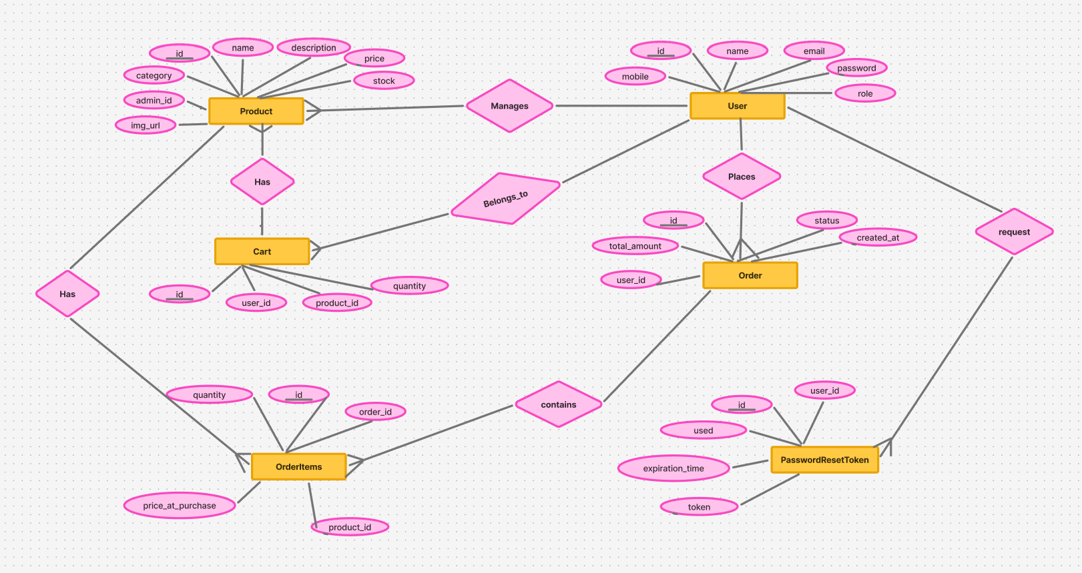
Figure: 1 ER Diagram for Ecommerce App

ER Diagram Description

1. User
Represents the individuals who use the system, either as admins/sellers or customers.
Fields: id, name, email, password, mobile, role
Relationships:
- One-to-Many → Orders
- One-to-Many → PasswordResetTokens
- One-to-Many → Cart Items

2. Product
Stores details of the items available for sale in the system.
Fields: id, name, description, price, stock, category, image_url, admin_id
Relationships:
- Many-to-One → Admin (User)
- One-to-Many → Cart Items
- One-to-Many → Order Items

3. Cart
Temporarily stores products that users intend to purchase.
Fields: id, user_id, product_id, quantity
Relationships:
- Many-to-One → User
- Many-to-One → Product

4. Order
Represents confirmed purchases made by users.
Fields: id, user_id, total_amount, status, created_at
Relationships:
- Many-to-One → User
- One-to-Many → Order Items

5. OrderItem
Contains item-level details for each order.
Fields: id, order_id, product_id, quantity, price_at_purchase
Relationships:
- Many-to-One → Order
- Many-to-One → Product

6. PasswordResetToken
Stores secure tokens for password recovery process.
Fields: id, user_id, token, expiration_time, used
Relationships:
- Many-to-One → User

3. Use Case Diagram

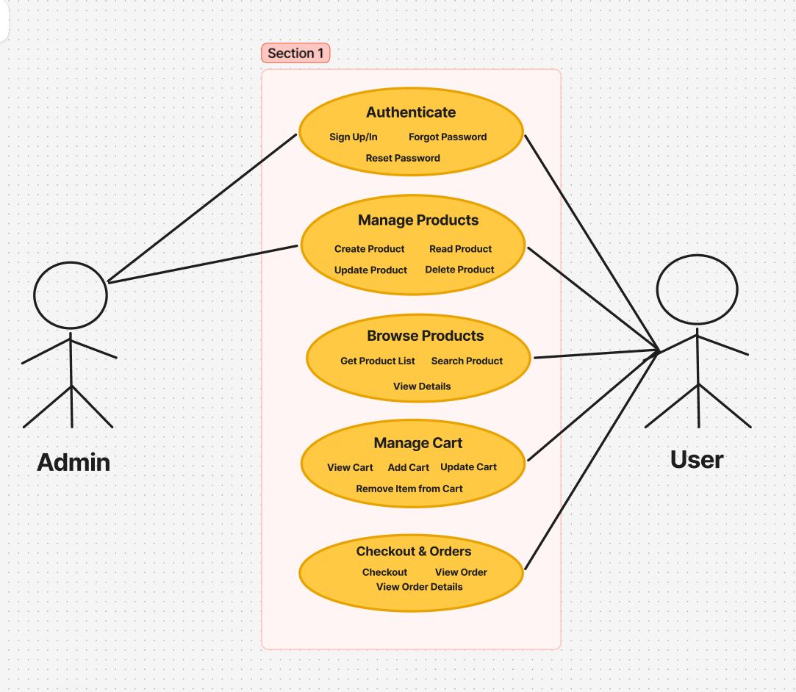
Figure: 2 Use Case Diagram for Ecommerce App

Use Case Diagram Description

Actors
- User (Customer): Regular user who browses products, manages cart, and places orders.
- Admin: A user with elevated privileges to manage products.
- System: Handles authentication, token validation, and password reset logic.

Use Cases by Actor
1. User (Customer)
Can register, log in, browse products, manage cart, place orders, and reset password.
- Signup – Register with name, email, password, and role
- Login – Authenticate using email and password
- Forgot Password – Request password reset via email
- Reset Password – Set a new password using a token
- View Products – Browse available products
- Search Products – Search products by keyword
- Filter Products – Use filters like category, price, sort
- Add to Cart – Add product and quantity to cart
- Update Cart – Modify product quantity in cart
- Remove from Cart – Delete product from cart
- View Cart – See all items in the cart
- Checkout – Simulate payment and place order
- View Orders – Access order history
- View Order Details – See line items of an order

2. Admin
Can perform full CRUD operations on products.
- Login – Authenticate using email and password
- Create Product – Add a new product
- View All Products – List all products with pagination
- View Product Details – Get details of a specific product
- Update Product – Modify product data
- Delete Product – Remove product

3. System (Internal Logic)
Handles backend services like authentication and secure token validation.
- Hash Password – Securely hash user passwords
- Generate JWT Tokens – Issue access and refresh tokens upon login
- Send Password Reset Email – Deliver reset token to user's email
- Validate Token – Check token validity and expiration
- Expire Used Tokens – Mark reset tokens as used after one-time usage
- Role-Based Access Control – Restrict admin routes from user access

4. Postman Collection
A. Link- https://galactic-meteor-129784.postman.co/workspace/My-Workspace~8d3c82cd-2768-4270-8175-85403c677efa/collection/30383076-0453550a-7139-41f3-a2d2-f2b5fc71d2ba?action=share&creator=30383076

B. Github Project Link
https://github.com/arung4/e_commerce-FastAPI-Backend/tree/dev

Screenshots:
  - Register a user

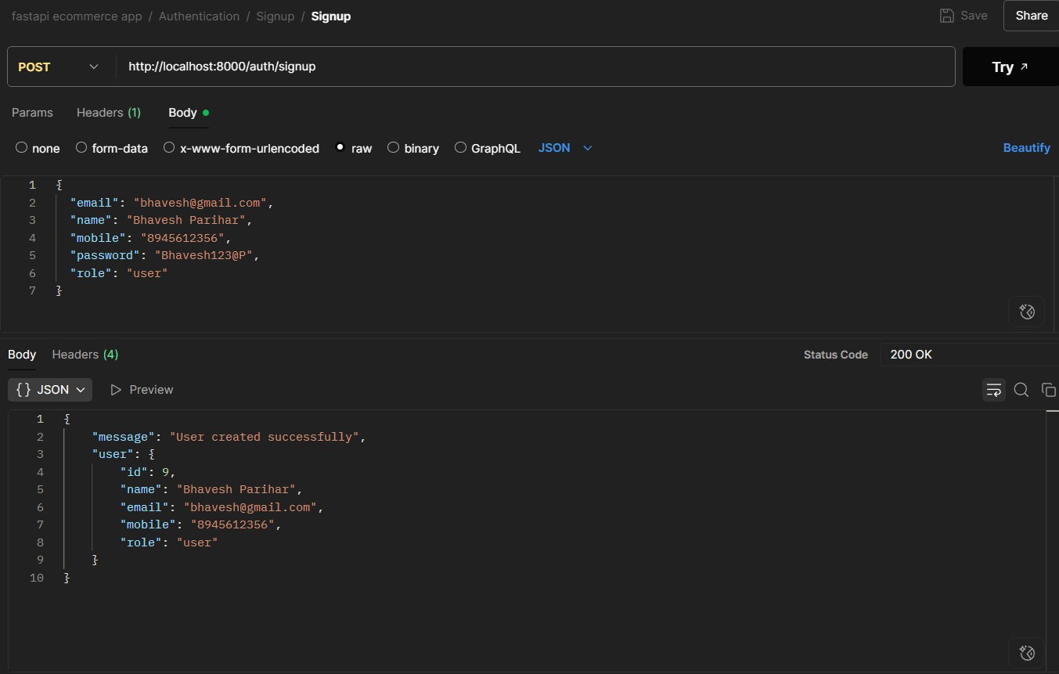

2.Login a user
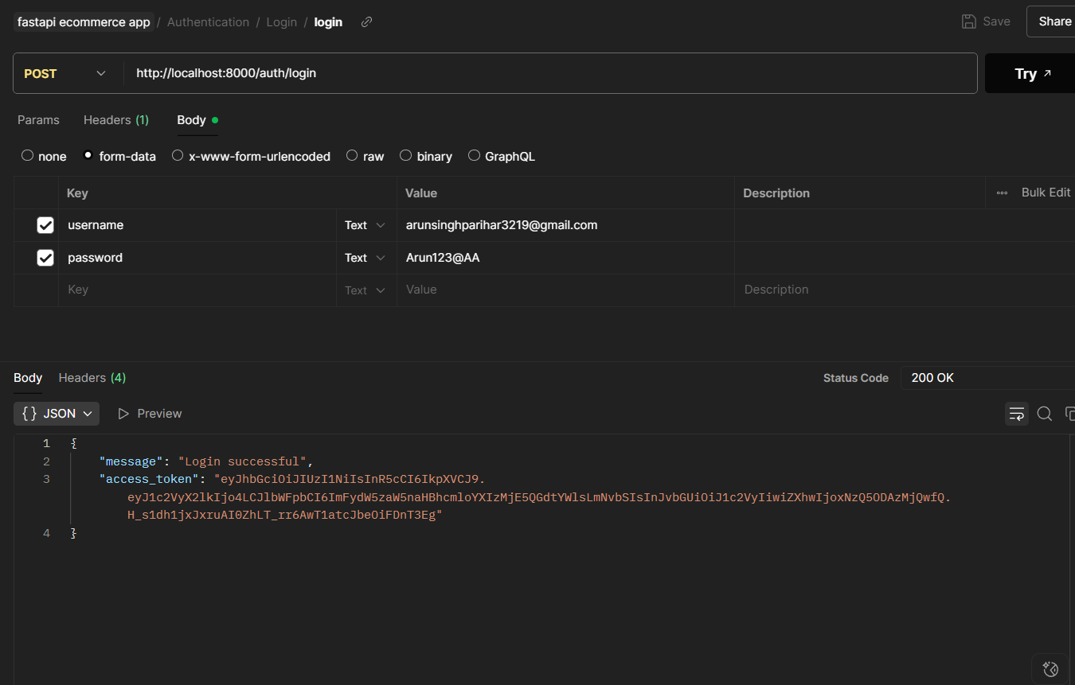

3.Forgot Password
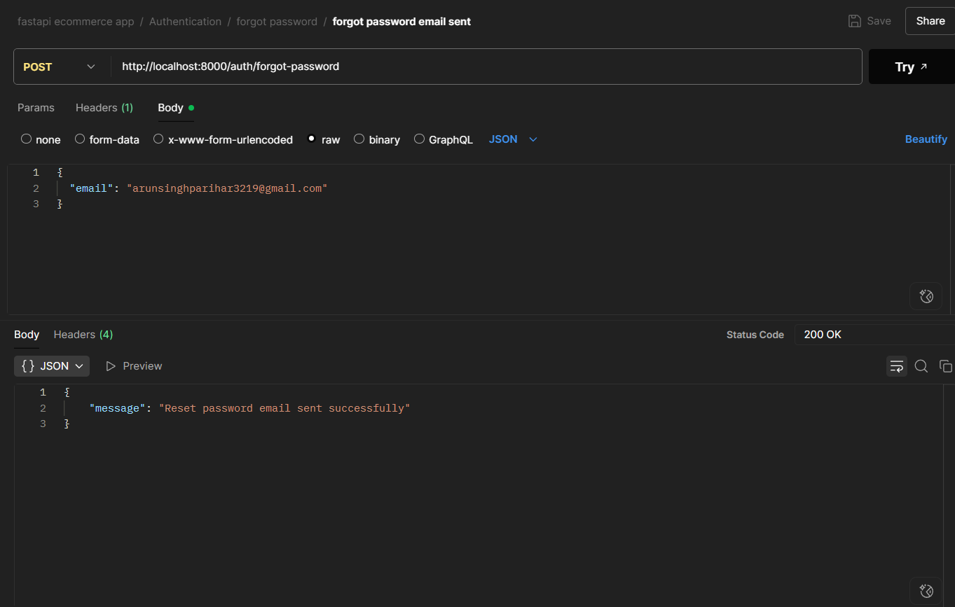

4.Reset Password
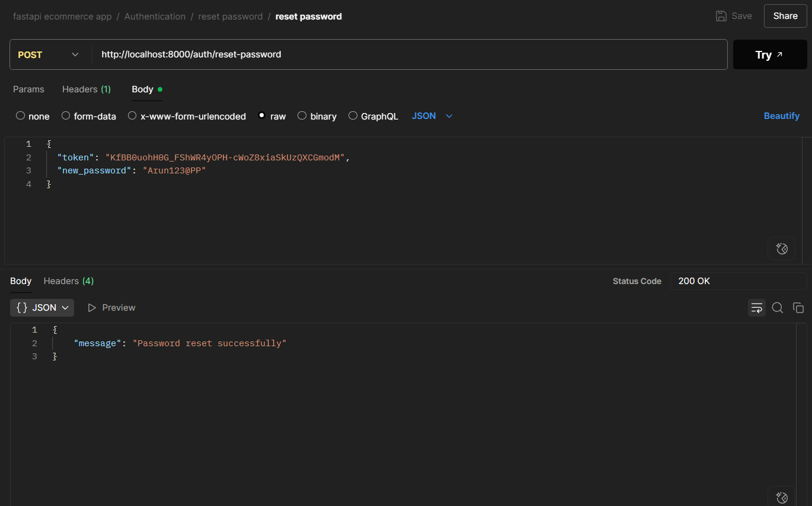

5.Add Product
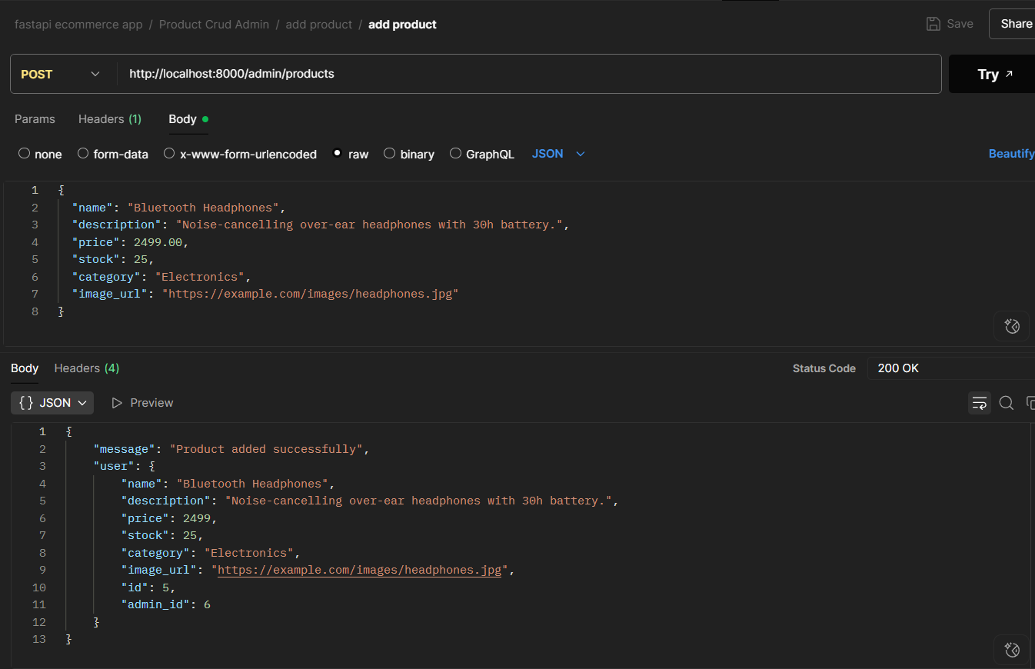

6.Update Product
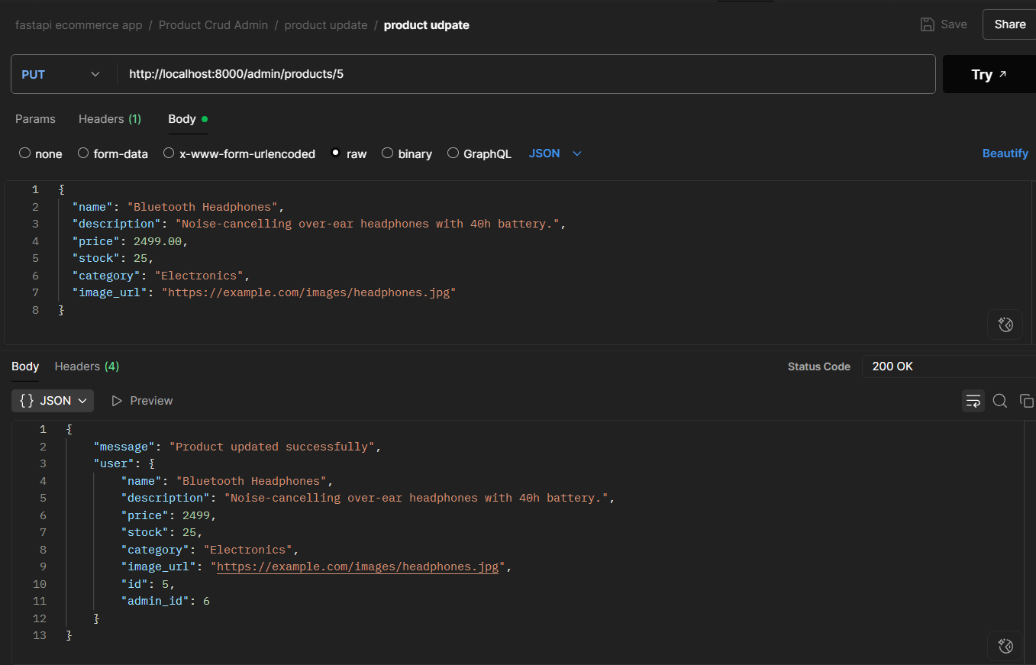

7.Delete Product
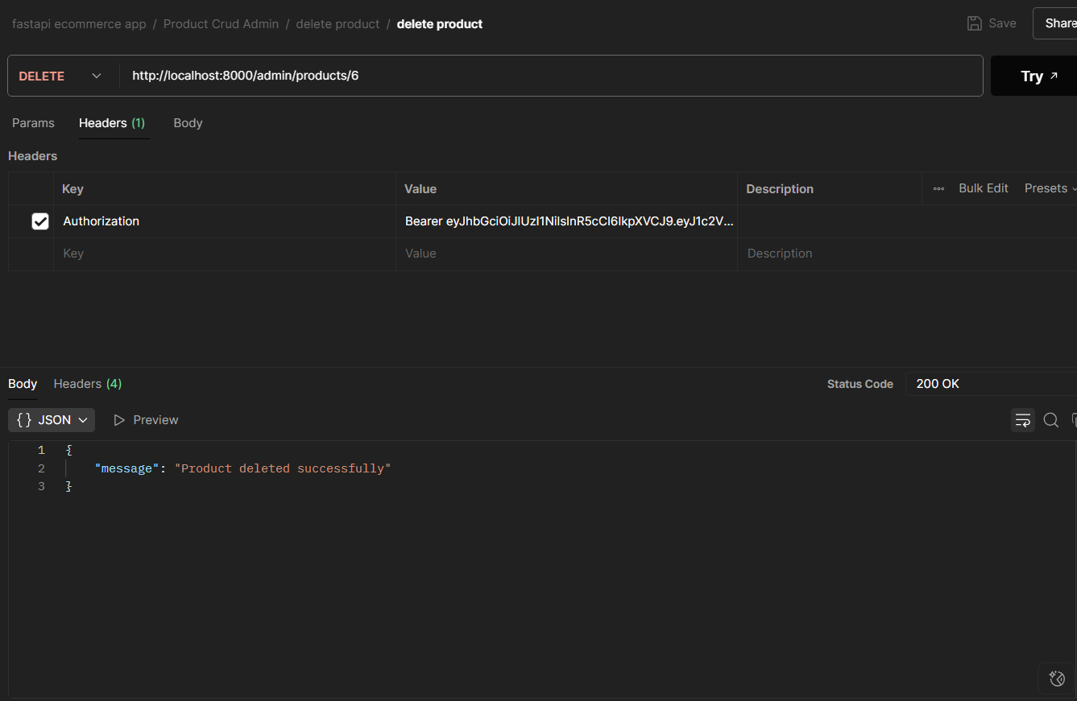

8. Get All Products (Public API)
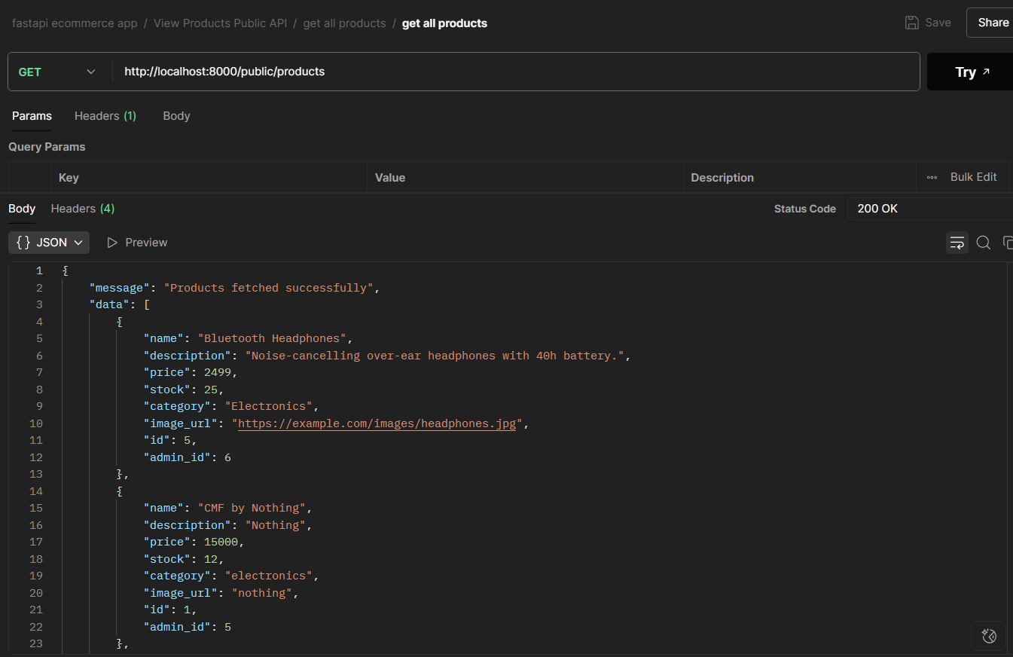

9. Search Products
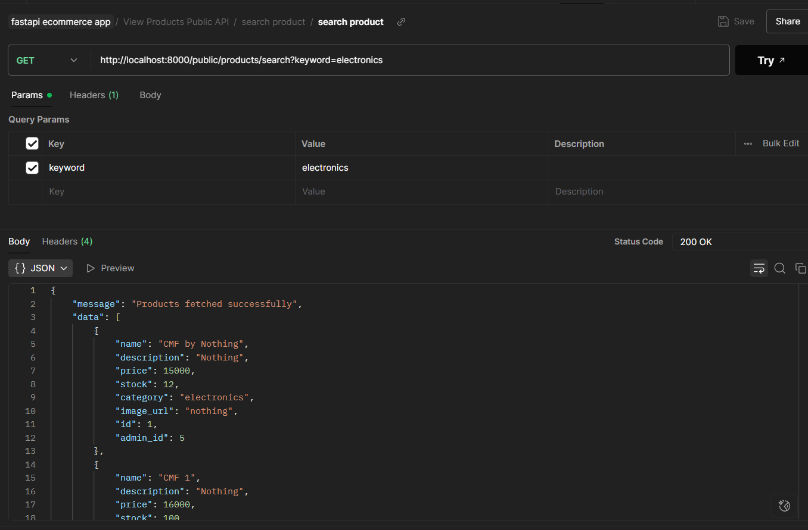

10. View Cart
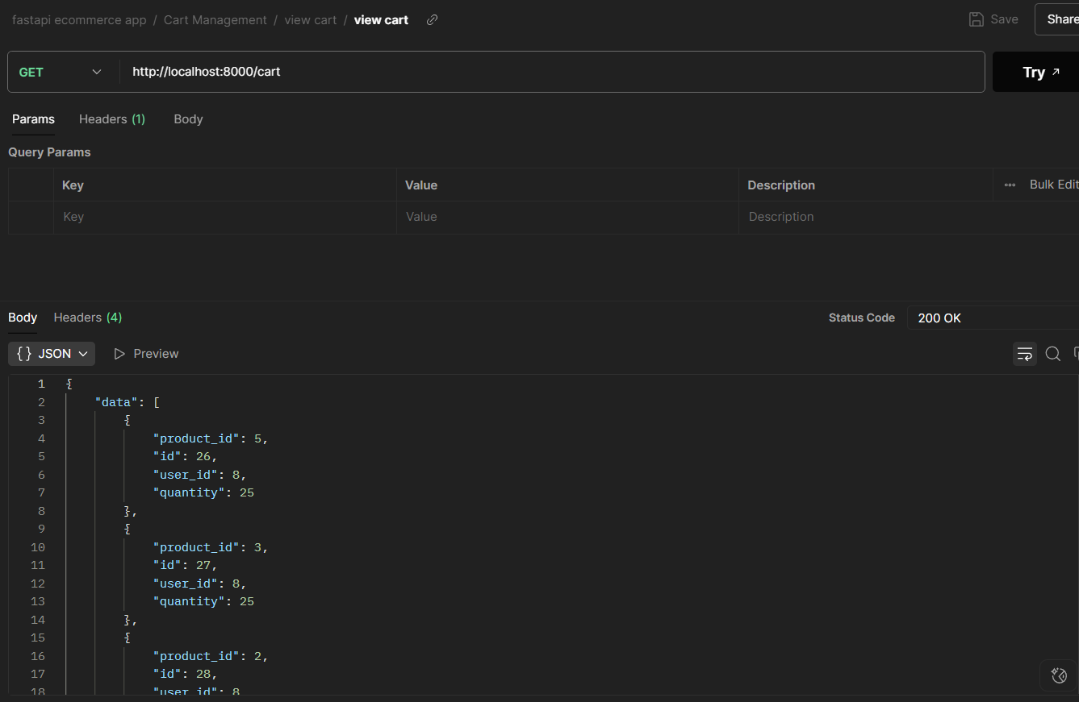
11. Update Cart
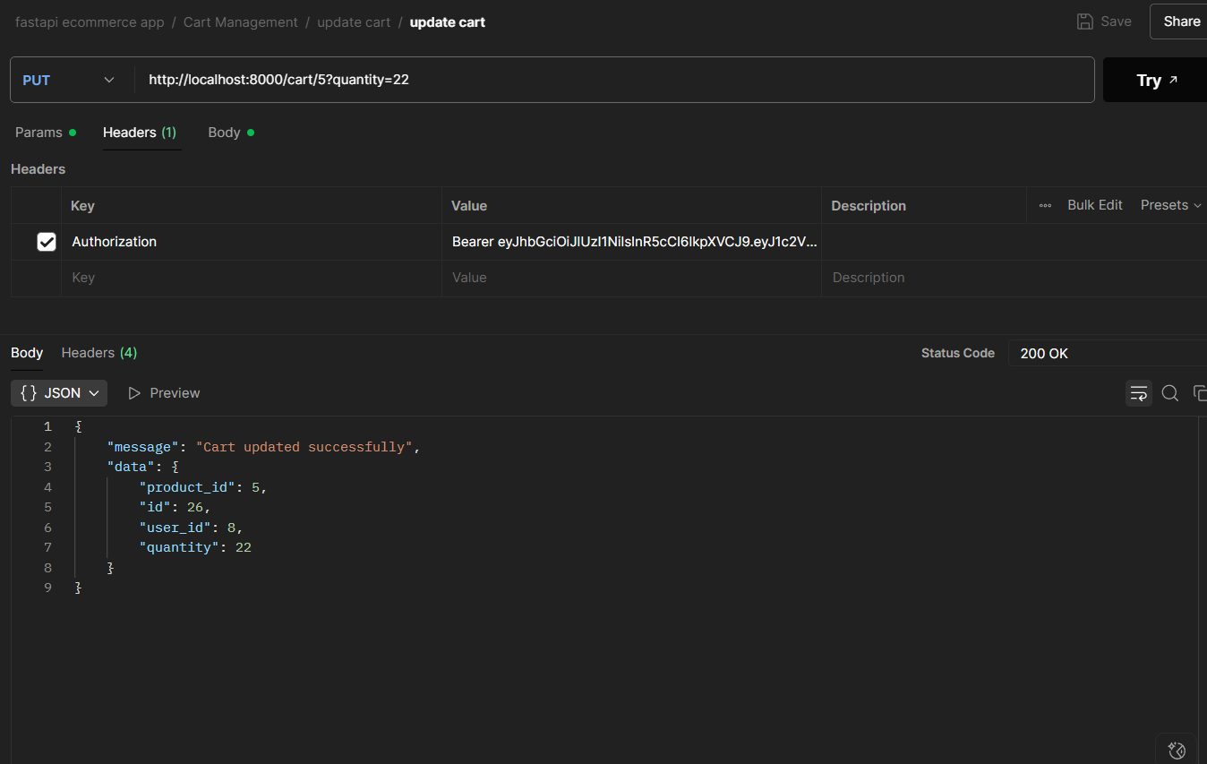

12. Delete product from cart
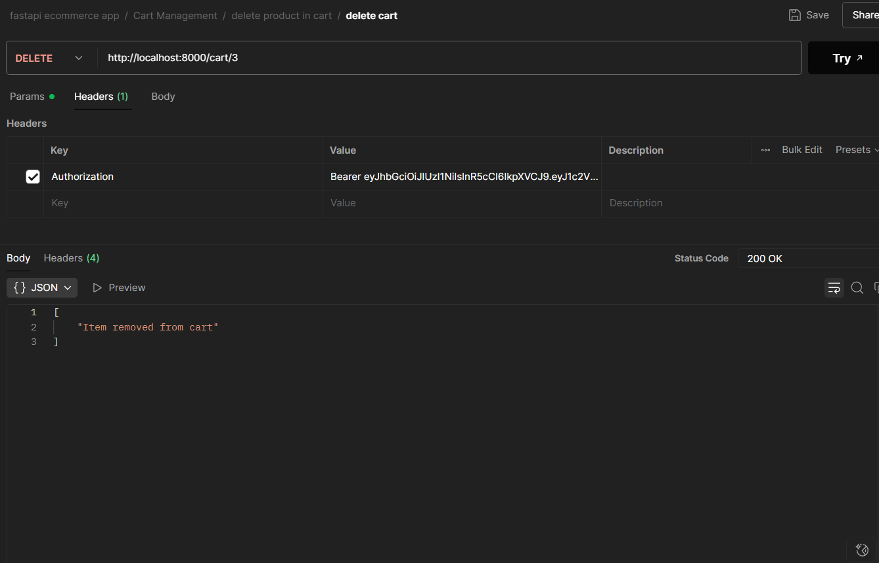
13. Add product in cart
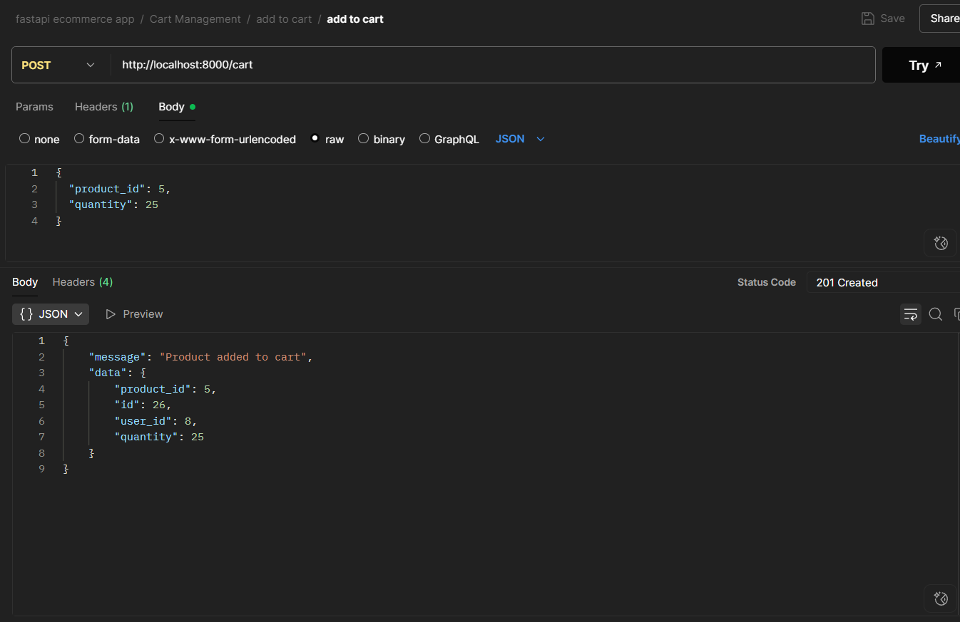

14. Checkout
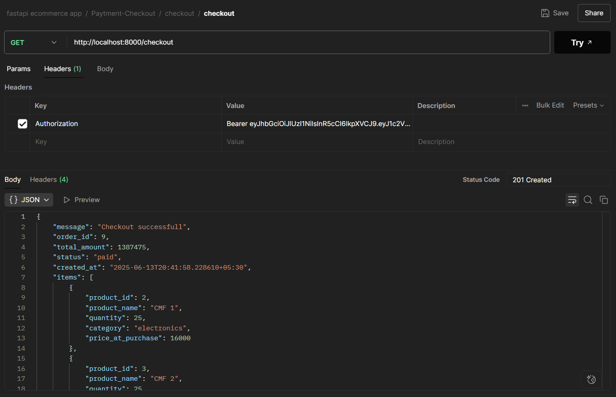
15. Get Order done by customers
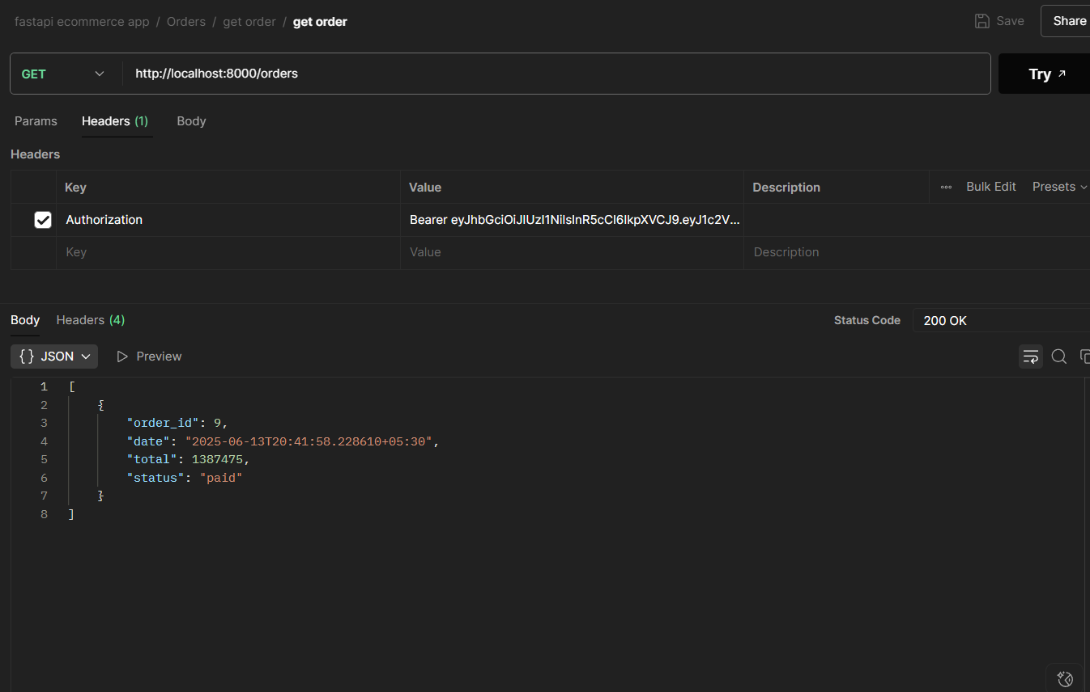

16. View Order Details
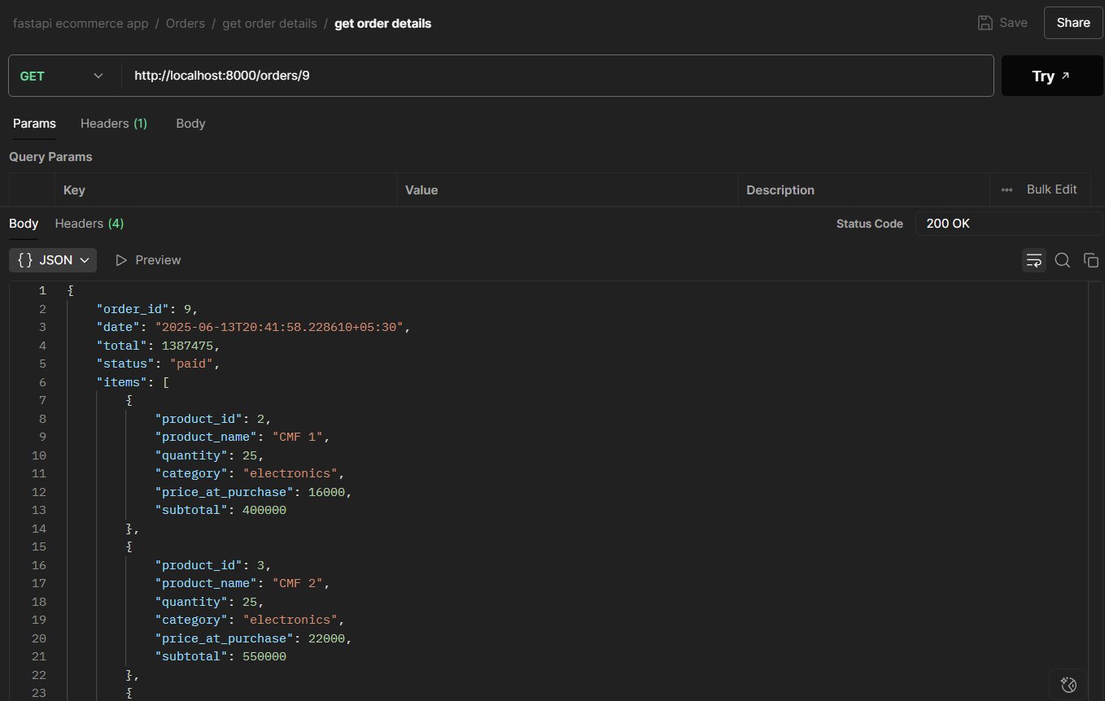
  - Architecture Diagram

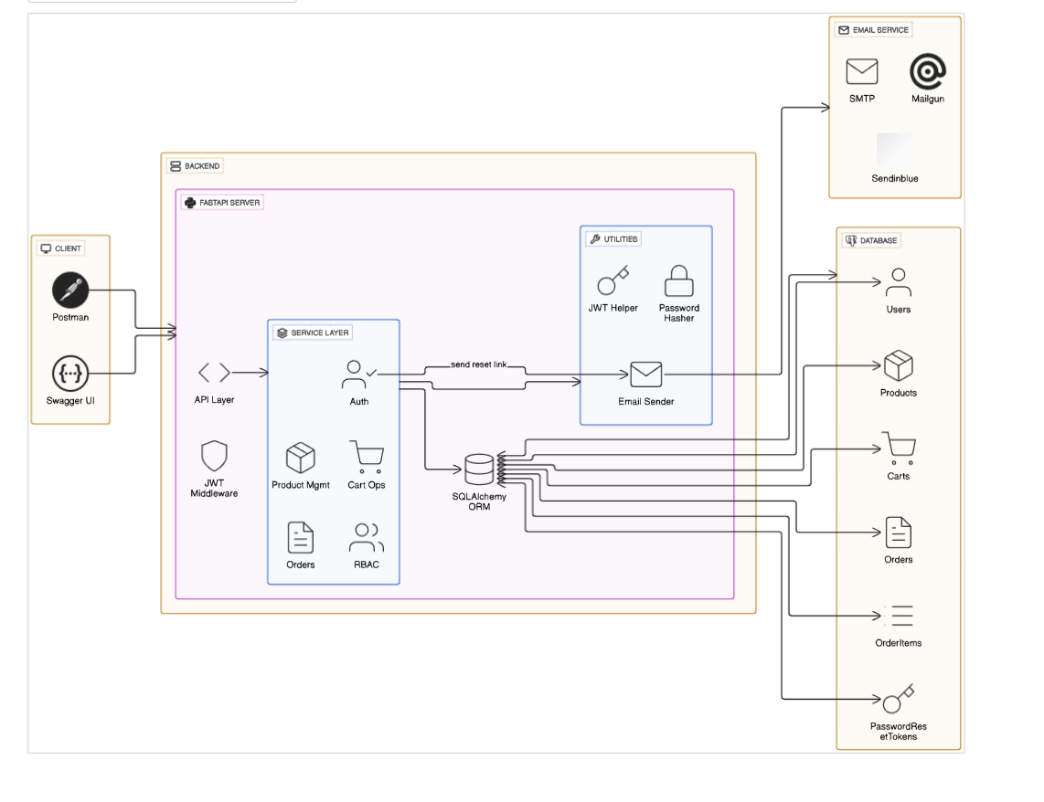
Fig: 3 Architecture Diagram for Ecommerce App

Architecture Diagram Description

1. Client (Frontend)
- Tool: Postman / Swagger UI (for testing APIs)
- Function:
- Sends HTTP requests to backend endpoints.
- Handles user input (email, password, etc.).
- Displays responses like product listings, cart items, order history, etc

2. FastAPI Backend (API Layer)
- Framework: FastAPI (Python)
- Responsibilities:
- Handle incoming API requests from client.
- Authenticate users via JWT.
- Apply role-based access control (RBAC).
- Route requests to appropriate controllers/services.

3. Core Functional Modules
a. Authentication Module
- Handles signup, login, forgot/reset password.
- Manages hashing (e.g., bcrypt), JWT token generation.
- Ensures secure token validation and expiration handling.
b. User Management
- Manages user creation, role assignment (admin/user).
- Ensures email uniqueness and password security.
c. Product Management
- Admin-only module for CRUD operations on products.
- Handles product details like name, category, price, image, stock.
d. Cart Management
- Allows users to add/update/remove/view cart items.
- Tied to user sessions and product IDs.
e. Order Management
- Handles order creation during checkout.
- Stores order items, total price, timestamps.
- Returns history and detailed order view.

4. Database Layer (PostgreSQL)
- Tables:
  - users: Stores user info (name, email, password, role).
  - products: Stores product details.
  - carts: Temporary user-specific product list.
  - orders: Master record for each order.
  - order_items: Item-level breakdown for orders.
  - password_reset_token: Token data for password reset functionality.

5. Email Service (External Integration)
- Used In:
  - Forgot Password flow.
- Function:
  - Sends reset password token link to user’s email.
  - Can use services like Gmail SMTP, SendGrid (free tier).

6. JWT Token Mechanism
- Access Token: Short-lived token used for protected endpoints.
- Refresh Token: Longer-lived token to regenerate access tokens.
- Stored in headers or local storage (Postman/browser memory).

7. Security Features
- Password Hashing: Bcrypt (or equivalent).
- Token Expiry: Password reset tokens are single-use & time-limited.
- RBAC: Ensures only admins can access admin endpoints.

