**Task Name :** Evaluation_4

**Name :** Arunprasath Ganesan

**Date :** 19th Apr 2025

**Questions:**

**1. Fork the project http://github.com/adikarthick/project**

**2. follow the instructions provided and setup e2e jenkinspipeline and run the application**

**3. push the built images to docker hub**

**4. run the containers with new images**

**5. application should be accessible on port 9095 over a loadbalancer**

**Step 1: Fork the project** [**http://github.com/adikarthik/project**](http://github.com/adikarthik/project)**:**

We will fork the repo to our repo from <http://github.com/adikarthik/project>

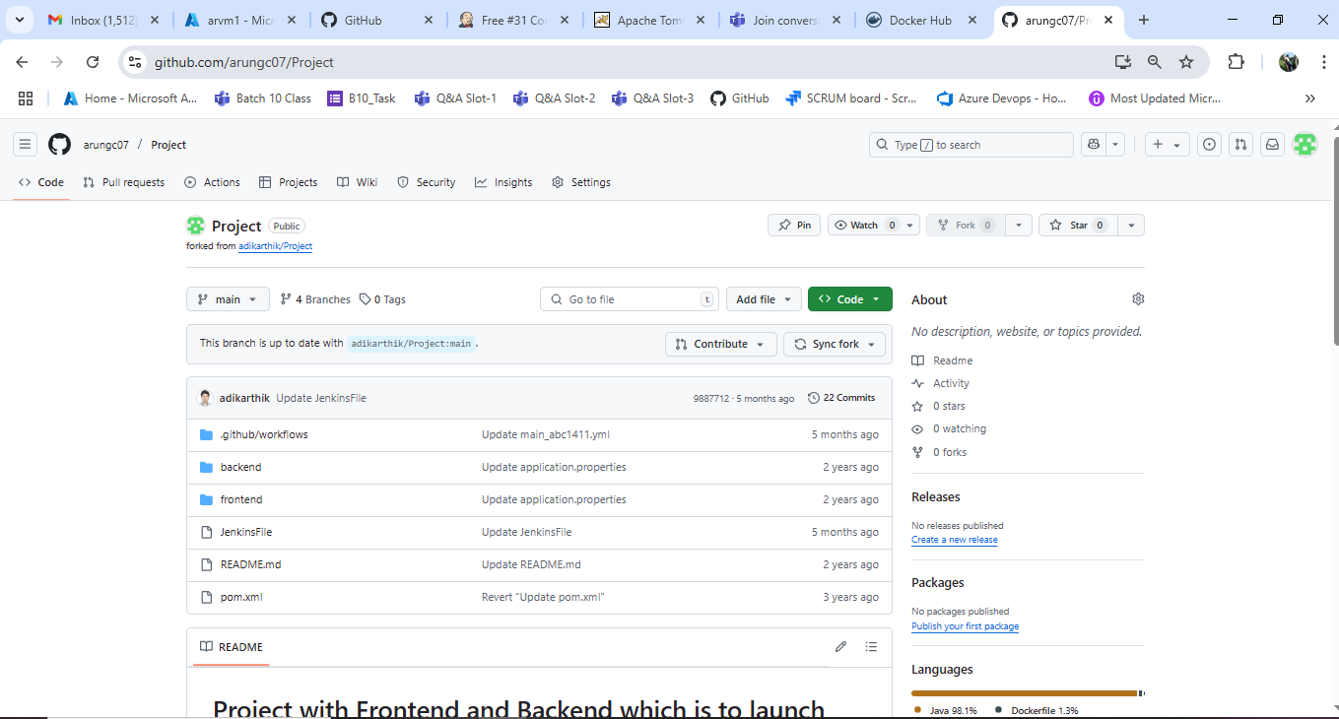

**Step 2. Follow the instructions provided and setup e2e Jenkins pipeline and run the application**

pipeline {

agent any

stages {

stage('Checkout') {

steps {

git branch: 'main', url: 'https://github.com/arungc07/Project.git'

}

}

stage(run) {

steps { sh 'mvn clean spring-boot:run &;curl http://135.235.156.235/:8080/docs'

sh 'mvn clean install'

}

}

stage('Build Docker Images') {

parallel {

stage('Build Frontend Image') {

steps {

dir("frontend") {

sh 'docker build -t frontend:latest .'

}

}

}

stage('Build Backend Image') {

steps {

dir("backend") {

sh 'docker build -t backend:latest .'

}

}

}

}

}

stage('Run Docker Containers') {

steps {

sh 'docker run -p 8085:8080 -d backend:latest'

sh 'docker run -p 8084:8080 -d frontend:latest'

}

}

}

}

**3. Push the built images to docker hub**

Will tag the image and will push to docker hub

docker tag backend:latest arungc07/maven:backend:latest

docker tag frontend:latest arungc07/maven:frontend:latest

docker Push backend:latest arungc07/maven:backend:latest

docker Push frontend:latest arungc07/maven:frontend:latest

4. **Run the containers with new images**

**5.** **Application should be accessible on port 9095 over a loadbalancer**

docker run -d --name backend -p 8080:8080 frontend:latest

docker run -d --name frontend -e BACKEND=http://135.235.156.235/:9095/api -p 8081:8080 backend:latest

Build success:

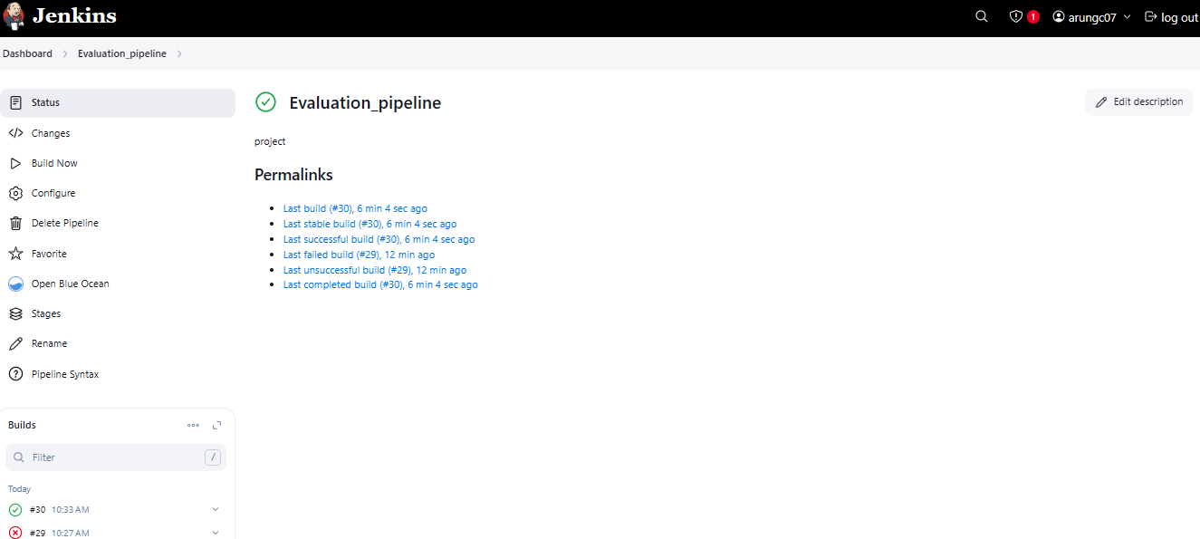

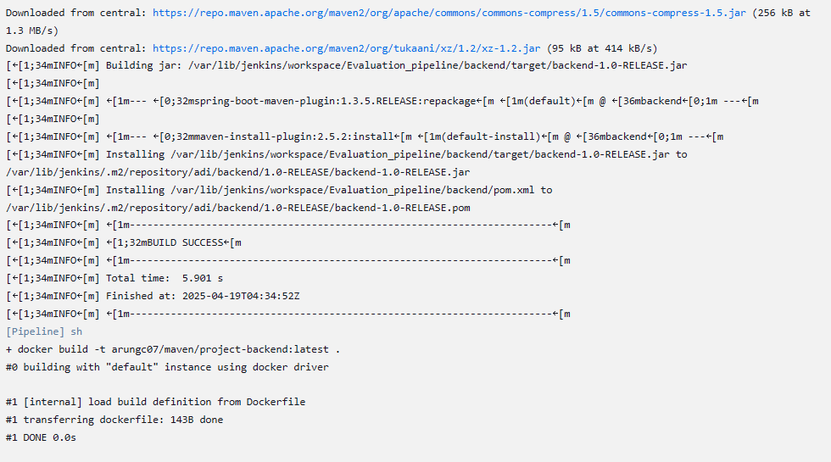

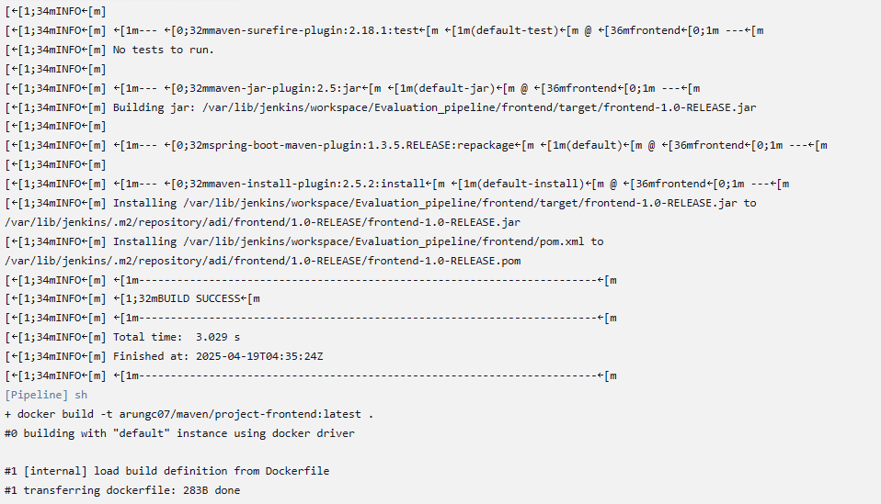

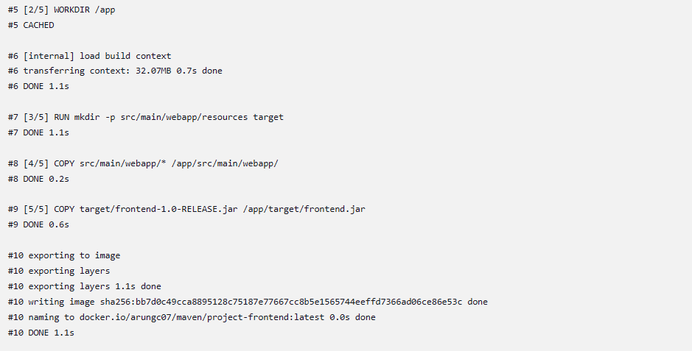

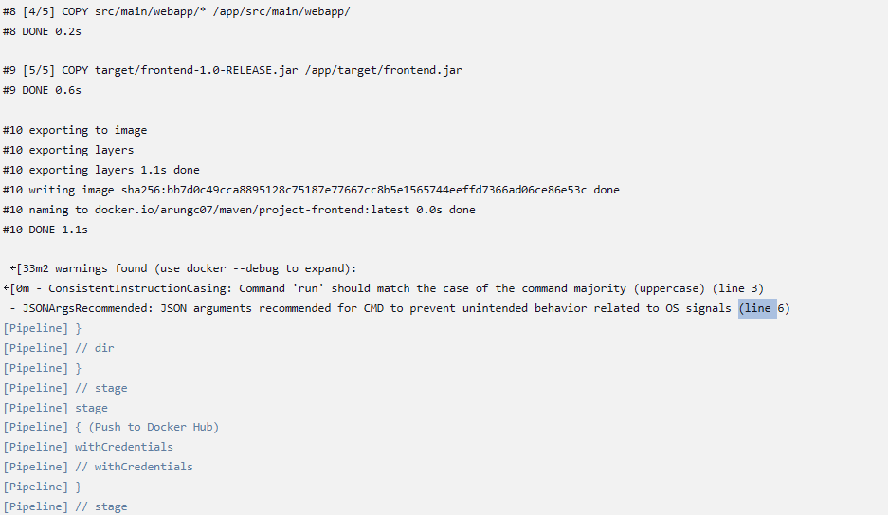

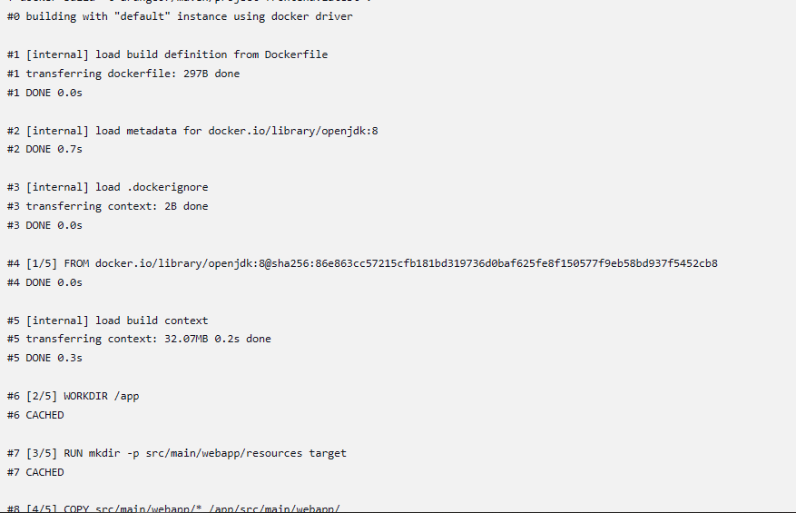

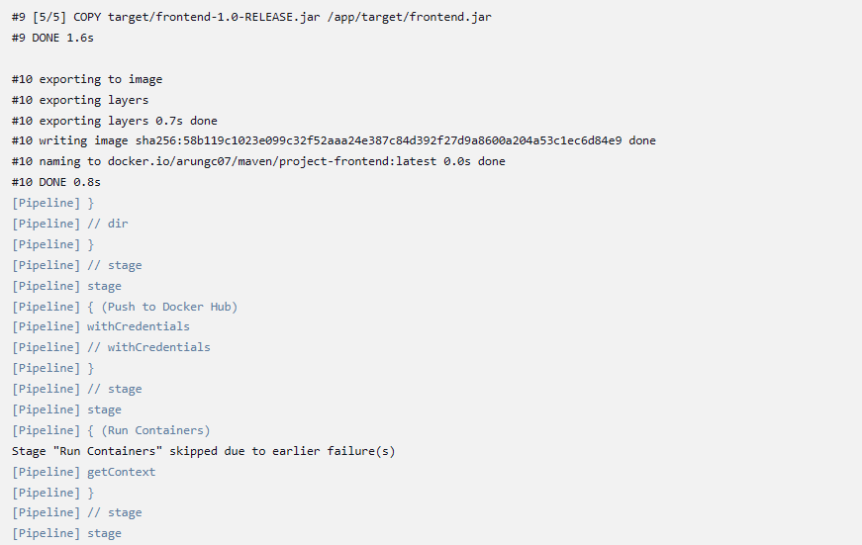

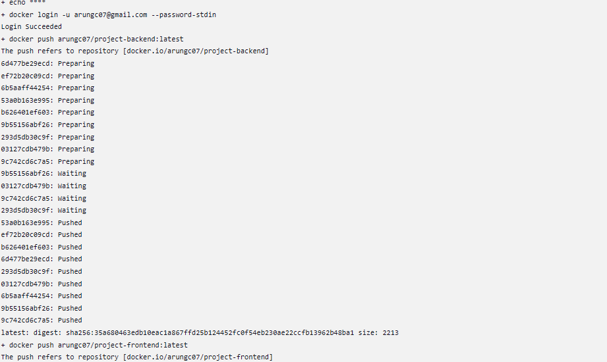

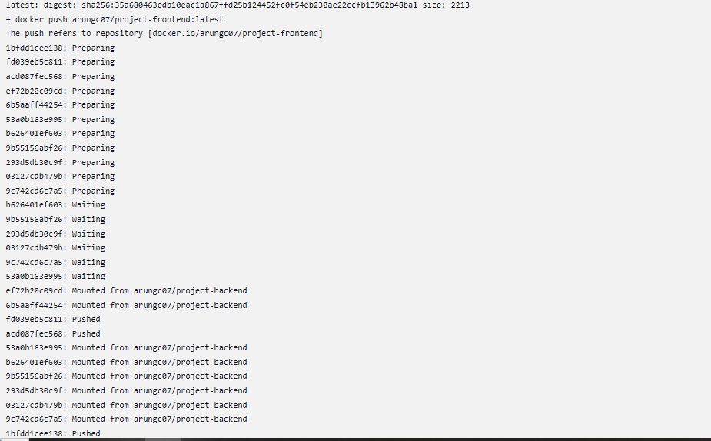

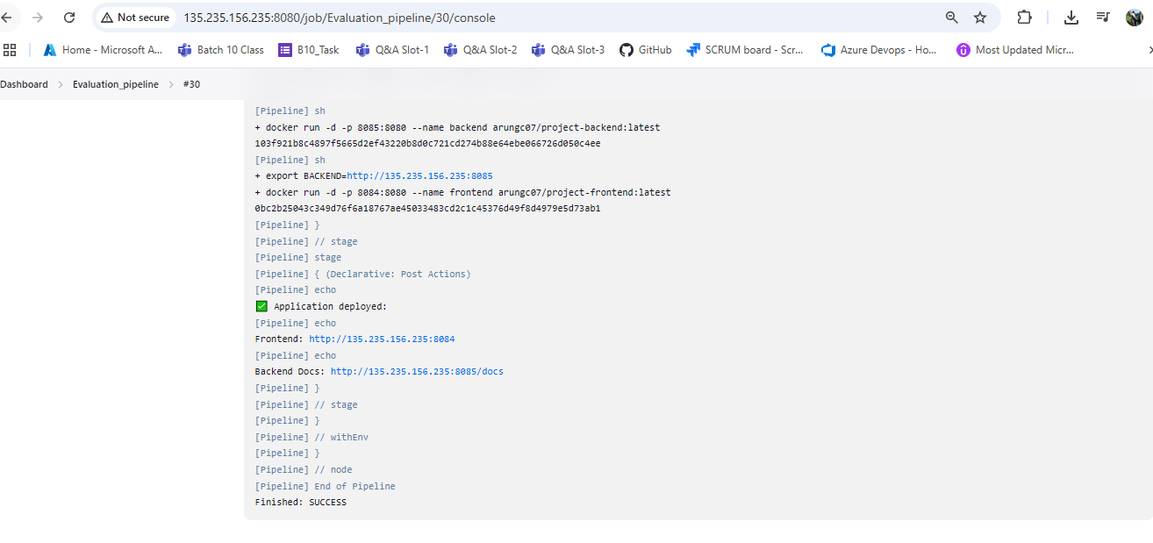

Bothe images successfully created and pushed to Docker hub

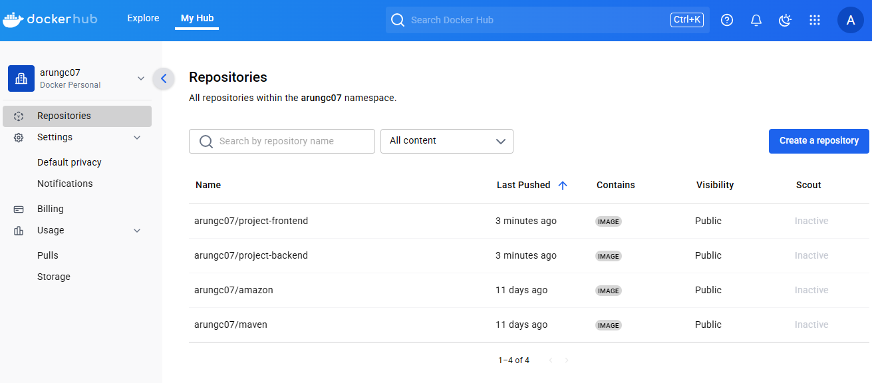

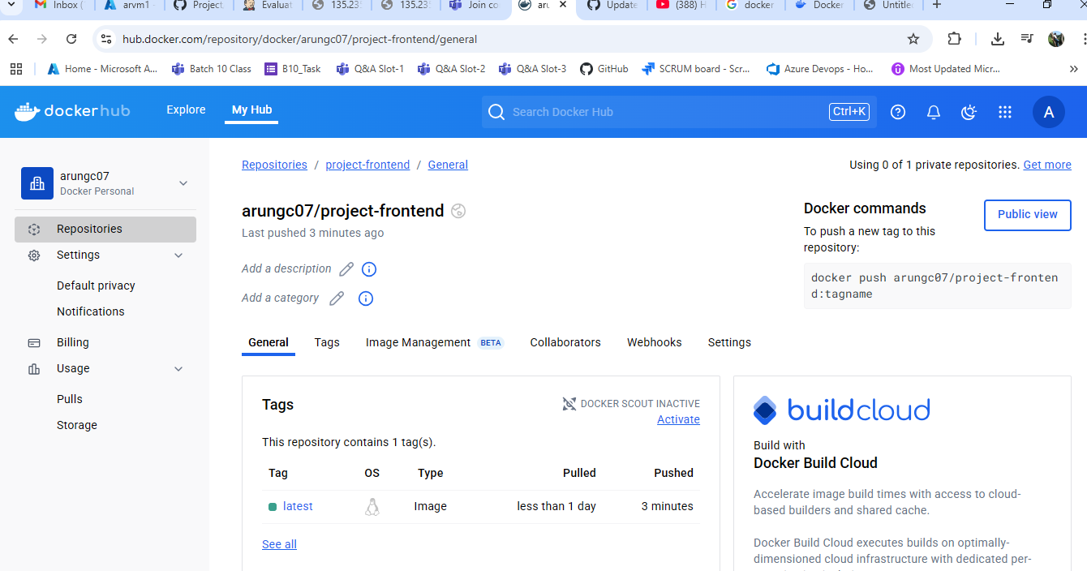

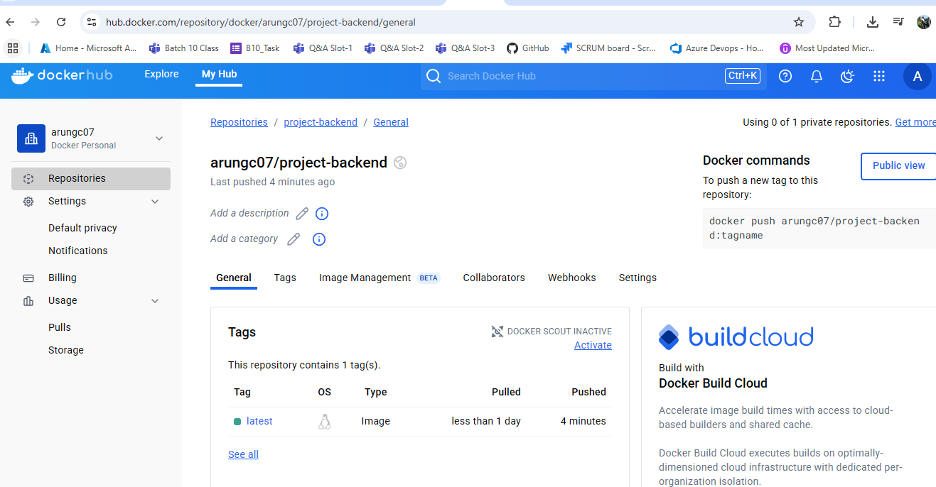

1. Fork the project <http://github.com/adikarthick/project> --- Completed

2. follow the instructions provided and setup e2e jenkinspipeline and run the application – Completed

3. push the built images to docker hub – completed

4. run the containers with new images -- completed

5. application should be accessible on port 9095 over a loadbalancer

