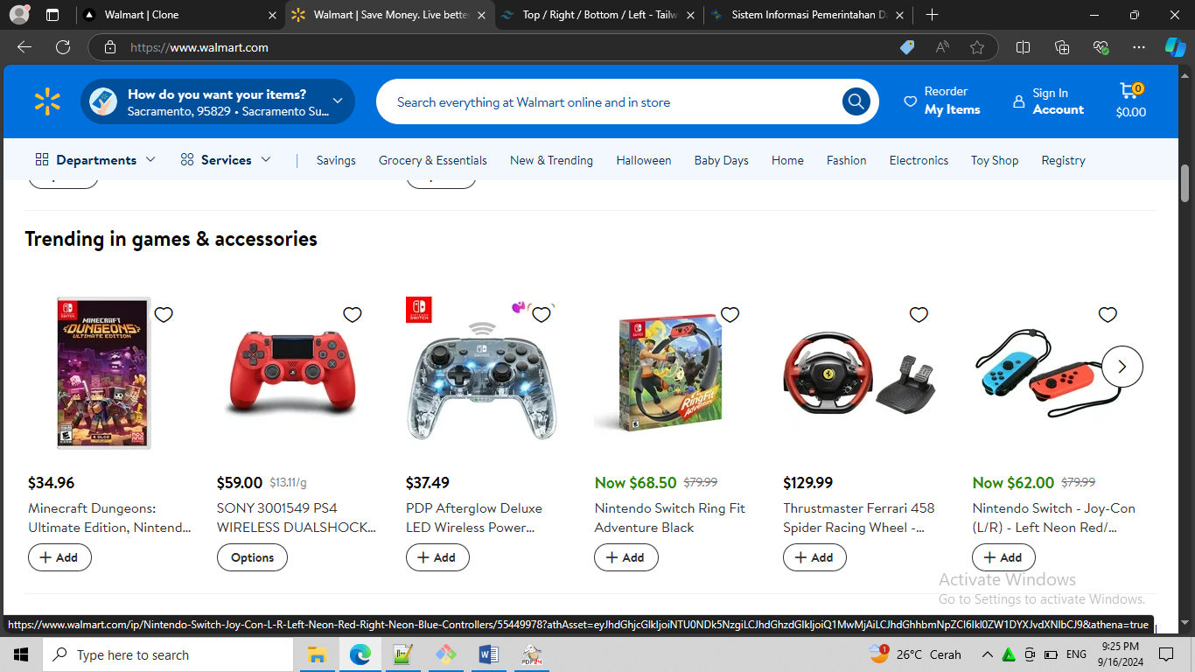

# Minecraft Dungeons: Ultimate Edition, Nintendo Switch, 045496598105

# SONY 3001549 PS4 WIRELESS DUALSHOCK CONTROLLER - MAGMA RED

# PDP Afterglow Deluxe LED Wireless Power Nintendo Switch Pro Controller, Switch Lite/OLED Compatible

# Thrustmaster Ferrari 458 Spider Racing Wheel - (Xbox Series X|S, One)

# Nintendo Switch - Joy-Con (L/R) - Left Neon Red/ Right Neon Blue Controllers

