# Cloud Computing AWS Assignment

Name: Krishna Arun Goud Damaragidda (M15912037)

Email: damarakd@mail.uc.edu

**GitHub:** [**https://github.com/arungoud15/Aws_Homework1**](https://github.com/arungoud15/Aws_Homework1)

**Website URL**

[Login (ec2-3-18-223-48.us-east-2.compute.amazonaws.com)](http://ec2-3-18-223-48.us-east-2.compute.amazonaws.com/)

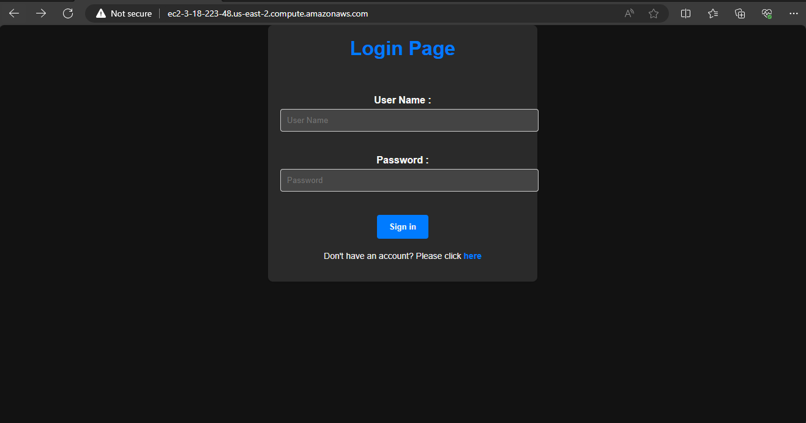

**Registration page:**

[Register (ec2-3-18-223-48.us-east-2.compute.amazonaws.com)](http://ec2-3-18-223-48.us-east-2.compute.amazonaws.com/registration)

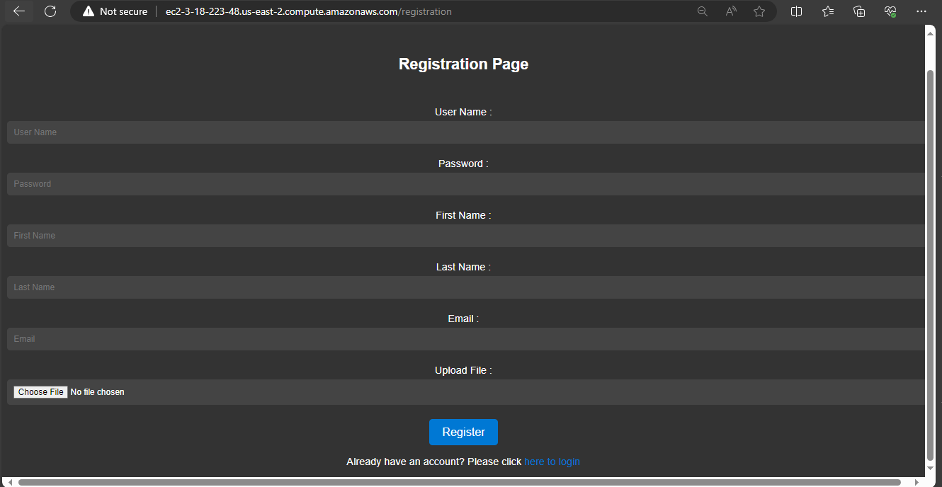

**Output Page**

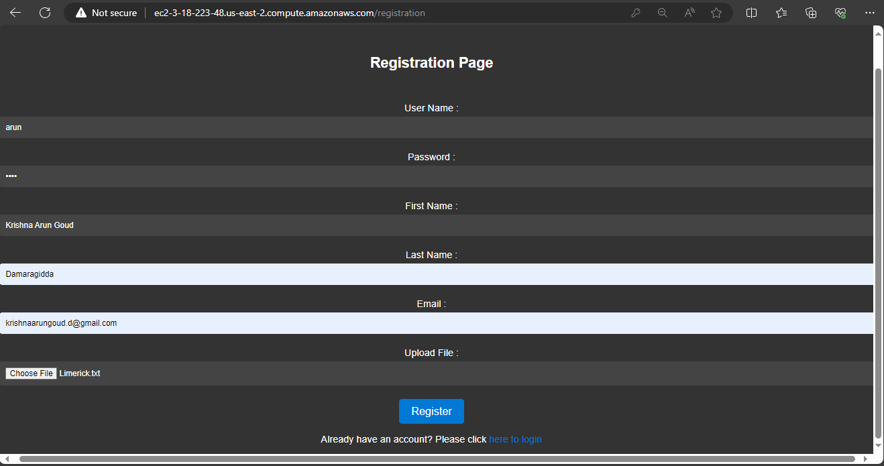

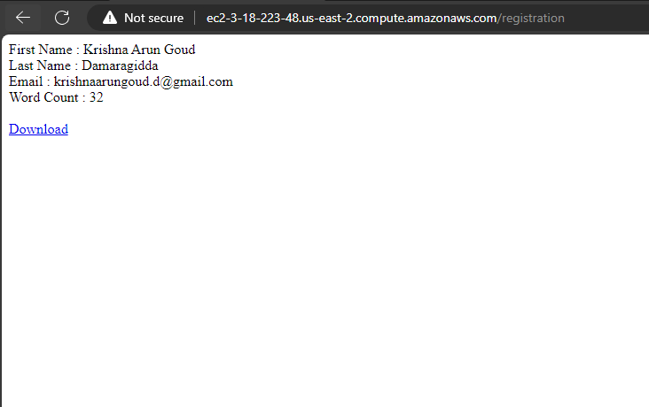

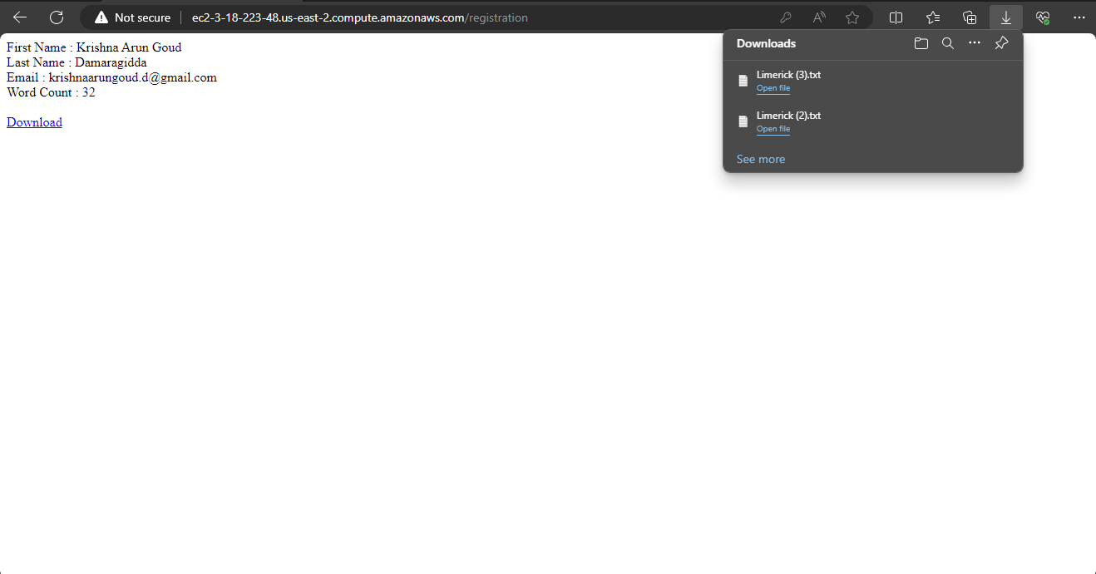

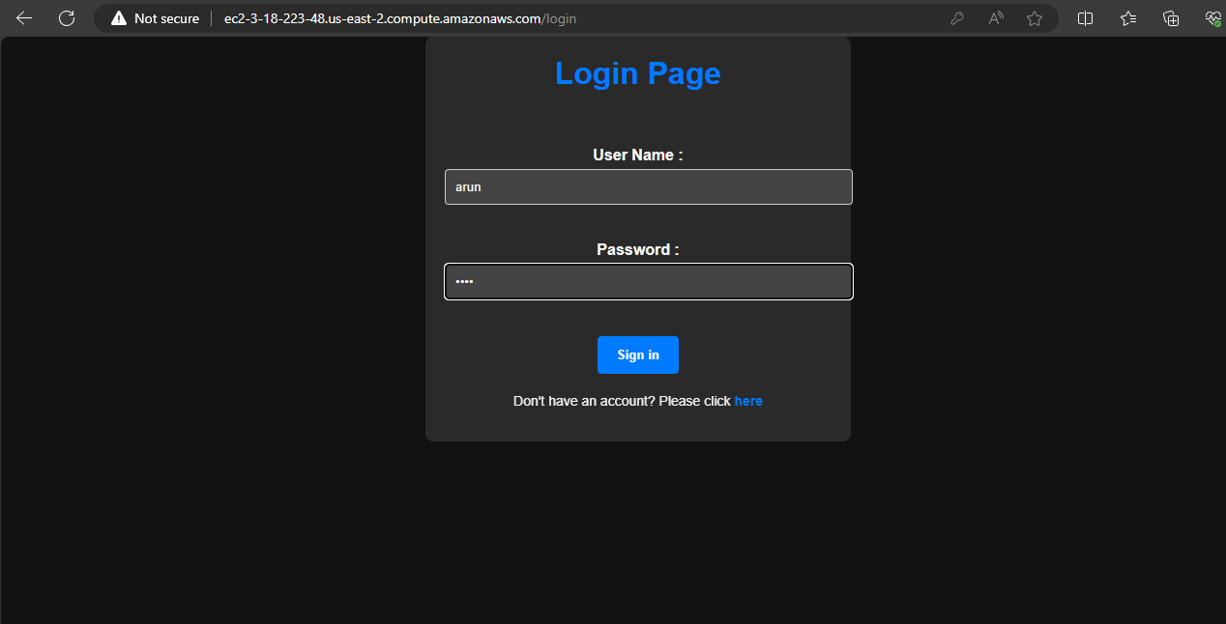

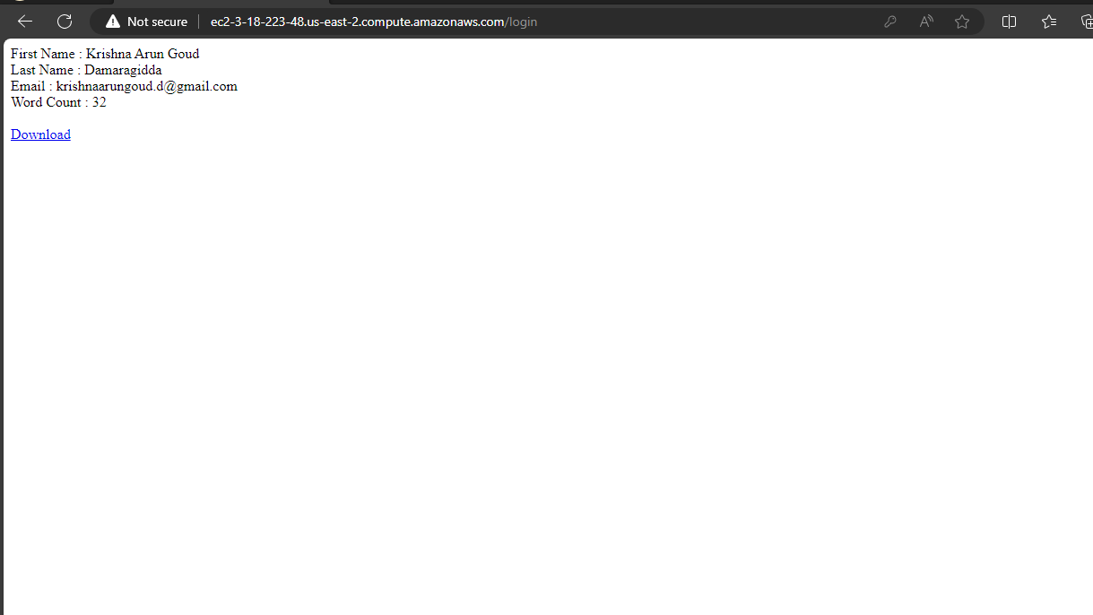

Extra Credit : Displayed the number of words in the given text file and provided attachment to download it.

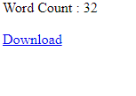

Once after logged in:

