Assignment 6: Medians, Order Statistics, and Elementary Data Structures
Arun Gyawali
005033472

An assignment submitted in partial fulfillment of the requirements for MSCS-532 as part of the Master of Science
In
Computer Science

Department of Graduate Information Technology
University of the Cumberlands
MSCS-532: Algorithms and Data Structures
Michael Solomon
July 30, 2026

Summer 2026

Medians, Order Statistics, and Elementary Data Structures
Introduction
This assignment examined two important areas of algorithm and data structure design. Part 1 implemented algorithms to find the k-th smallest element without sorting the entire input. The deterministic method used Median of Medians, while the randomized method used Randomized Quickselect. Part 2 implemented a dynamic array, a matrix, a stack, a circular queue, and a singly linked list from scratch. The implementation was designed to remain simple, handle invalid input, and demonstrate the main operations required by the assignment. The rooted tree was not included because it was optional.
The testing program checked correctness before measuring performance. It then compared the two selection algorithms on random, sorted, and reverse-sorted datasets containing 100 to 5,000 values. The same program demonstrated insertion, deletion, access, updating, pushing, popping, enqueuing, dequeuing, searching, and traversal operations on elementary data structures.
Part 1: Selection Algorithms
Implementation
The deterministic algorithm uses Median of Medians to select a pivot. The values are divided into groups of five; each group is sorted, and its middle value is collected. The process is repeated recursively on the group medians until a pivot is obtained. This method was developed to provide a guaranteed linear-time solution to the general selection problem (Blum et al., 1973).

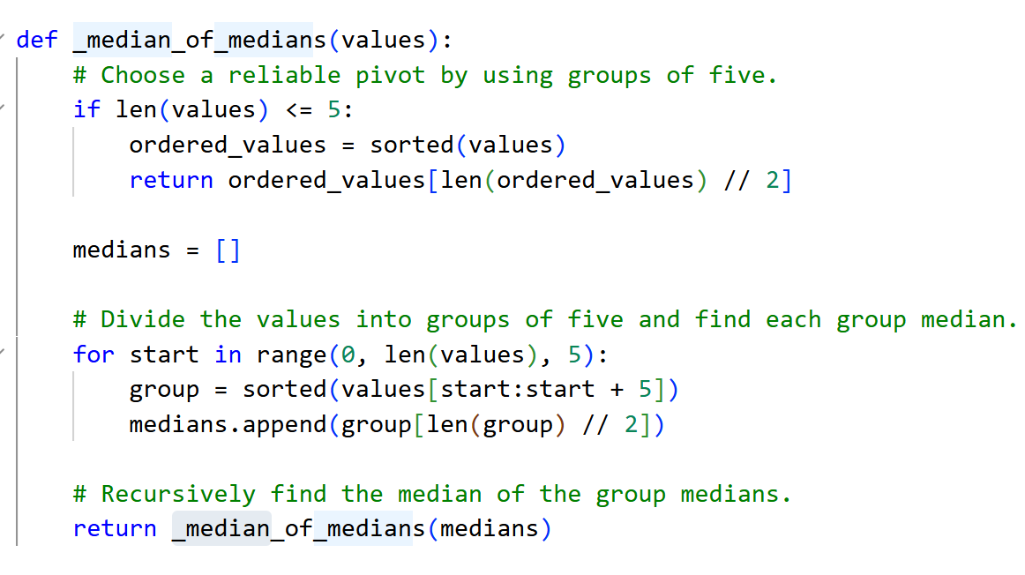
Figure 1: Median of Medians Pivot Selection
After the pivot is selected, the implementation creates smaller, equal, and larger partitions. The separate-equal partition is important because the generated datasets may contain duplicates. The algorithm continues only in the partition containing the target index, so it does not sort values that are no longer relevant.
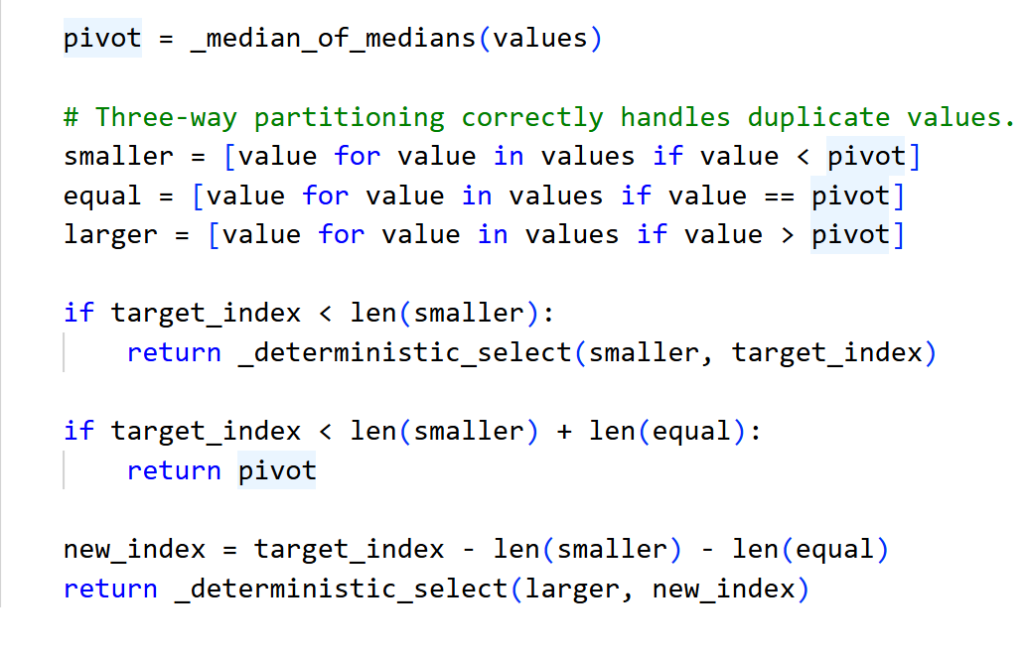
Figure 2: Deterministic Selection and Three-Way Partitioning
Randomized Quickselect follows the same partitioning idea, but it selects the pivot with “random.choice()”. Hoare's Find algorithm established the partition-based approach to selection, and later analysis demonstrated strong expected performance for randomized selection methods (Floyd & Rivest, 1975; Hoare, 1961). The implementation uses a loop instead of recursive calls for the main randomized search.
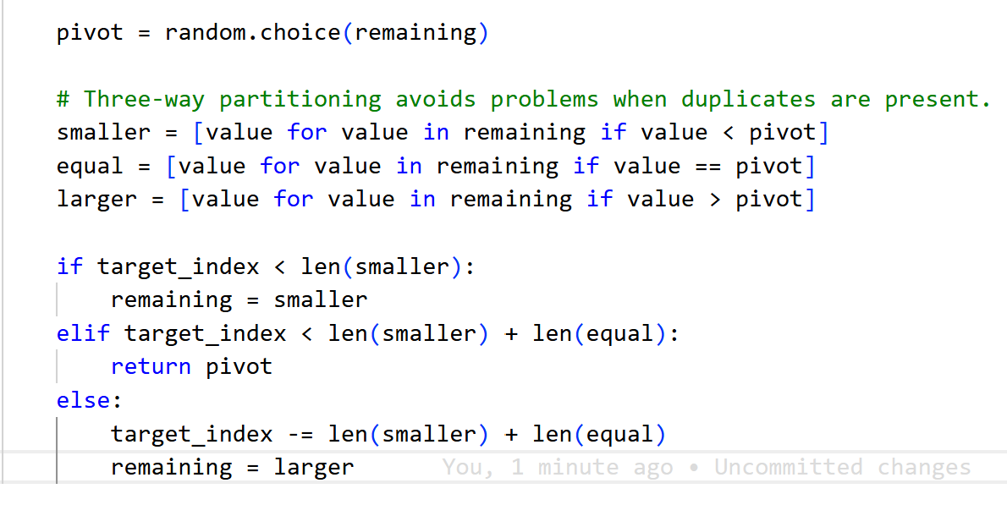
Figure 3: Randomized Quickselect

Time and Space Complexity
For Median of Medians, the pivot calculation examines groups of five and recursively selects a median from approximately n/5 values. The pivot guarantees that a fixed fraction of values can be removed from further consideration. A simplified recurrence is:
T(n) <= T(n/5) + T(7n/10) + O(n) = O(n)
Therefore, the deterministic algorithm has O(n) worst-case time complexity. The Randomized Quickselect algorithm has O(n) expected time because a typical random pivot removes a substantial part of the remaining input. Its worst case is O(n^2), which can occur when highly unbalanced pivots are repeatedly selected. This worst case is possible but uncommon when pivots are selected randomly (Floyd & Rivest, 1975).
Both algorithms use O(n) additional space in this Python implementation. The input is copied, and each partition step creates new, smaller, equal, and larger lists. The deterministic method also uses recursive calls. An in-place Quickselect implementation could reduce the extra array storage, but the list-based design was used because it is clearer and handles duplicates directly.
Empirical Analysis
The experiment tested the middle order statistic for five input sizes and three data distributions. All times were averaged across five trials using time.perf_counter(). Before recording a result, the selected value was compared with the value at the same position in a sorted copy. A fixed random seed was also used so the experiment could be reproduced.
Table 1
Measured Selection Algorithm Running Times in Seconds
Input Size | Distribution | Deterministic | Randomized
100 | Random | 0.00005120 | 0.00002884
100 | Sorted | 0.00006504 | 0.00005808
100 | Reverse-sorted | 0.00006934 | 0.00006338
500 | Random | 0.00049932 | 0.00024022
500 | Sorted | 0.00019688 | 0.00015442
500 | Reverse-sorted | 0.00018314 | 0.00020158
1000 | Random | 0.00069630 | 0.00051724
1000 | Sorted | 0.00412940 | 0.00044500
1000 | Reverse-sorted | 0.00061836 | 0.00060840
2500 | Random | 0.00165546 | 0.00106306
2500 | Sorted | 0.00092110 | 0.00062854
2500 | Reverse-sorted | 0.00118184 | 0.00141556
5000 | Random | 0.00213550 | 0.00119956
5000 | Sorted | 0.02036056 | 0.00099964
5000 | Reverse-sorted | 0.00133394 | 0.00087664
Note. Each result is the average of five trials. The selected k value was the middle position for each input size.

Note. Each result is the average of five trials. The selected k value was the middle position for each input size.
The results show that running time generally increased with input size. Randomized Quickselect was faster in 13 of the 15 measured cases. The largest difference occurred for the sorted dataset of 5,000 values, where the deterministic method required about 0.02036 seconds and the randomized method required about 0.00100 seconds. The deterministic method was slightly faster for the reverse-sorted datasets of sizes 500 and 2,500.
The results do not contradict the O(n) worst-case guarantee of Median of Medians. Asymptotic complexity describes growth for large inputs and does not remove constant costs. This implementation repeatedly sorts small groups, creates several new lists, and performs recursive function calls. Randomized Quickselect has a weaker worst-case bound but less pivot-selection overhead and was therefore faster in most of these small Python experiments.
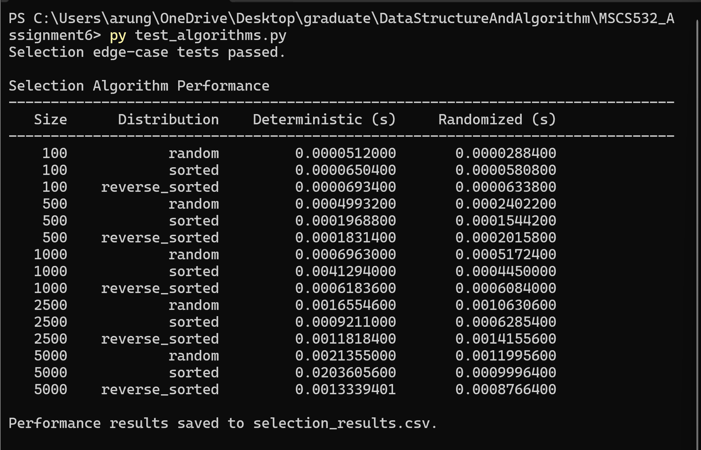
Figure 4: Selection Algorithm Performance Output
Part 2: Elementary Data Structures
Implementation
The Array class stores elements in a fixed-capacity list and doubles the capacity when the storage becomes full. This resizing method gives an amortized O(1) cost, even though an individual resize requires O(n) copying (Haslbeck & Lammich, 2022). The Matrix class uses a rectangular list of rows and supports row and column insertion and deletion, as well as row and column updates.
The Stack class is implemented on top of the custom Array class. Push adds a value to the end, while pop removes the last value, which provides last-in, first-out behavior. The Queue class uses a circular array. The front index moves after each dequeue, and modular arithmetic determines the next rear position. This avoids shifting every remaining item after a dequeue.
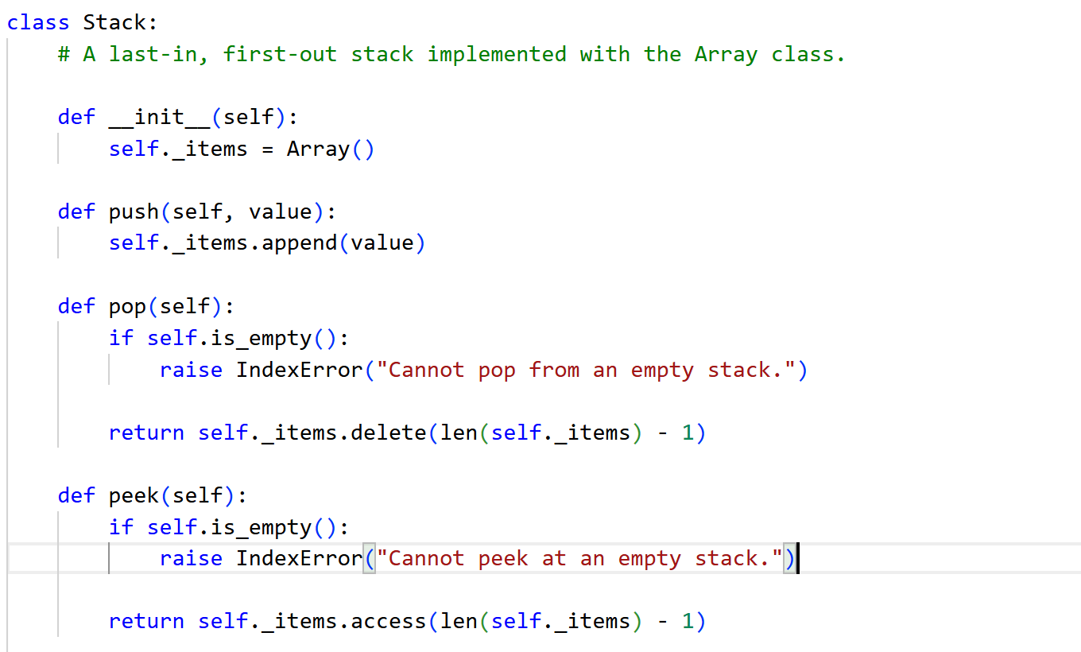
Figure 5: Stack Operations
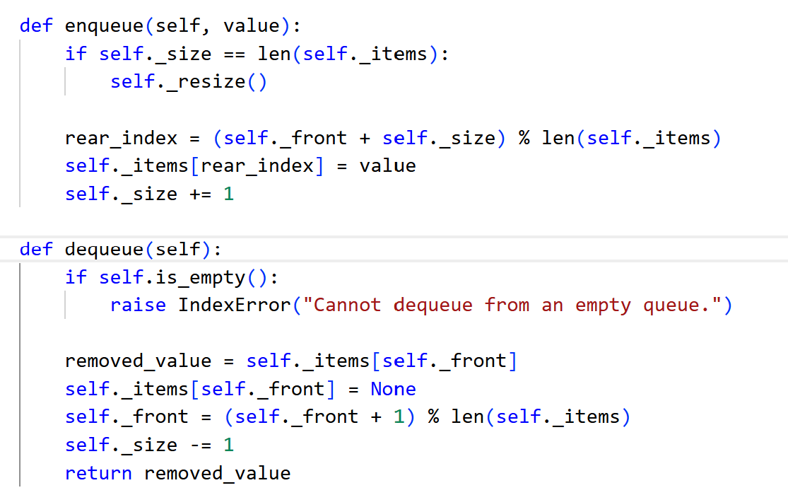
Figure 6: Circular Queue Operations
The singly linked list stores values in Node objects. Each node points to the next node. Insertion at the front only changes the head reference, while operations near the end require traversal. The delete method handles the head separately and then reconnects references when a matching value is found.
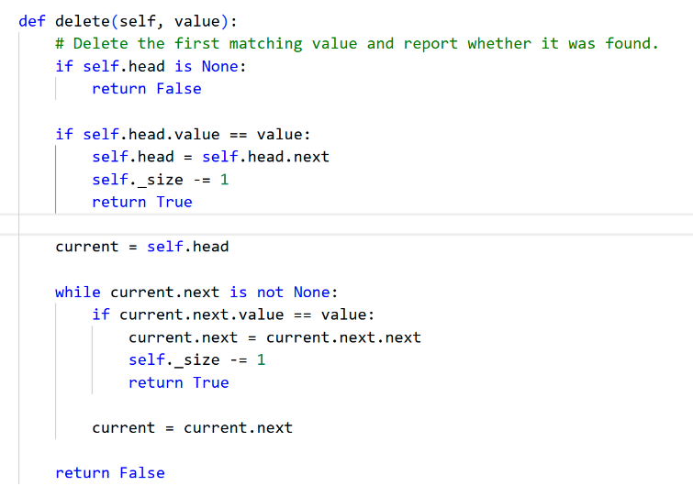
Figure 7: Singly Linked List Deletion
Operation Complexity
Table 2
Time Complexity of Implemented Data Structure Operations
Data Structure | Operation | Time Complexity
Dynamic array | Access or update | O(1)
Dynamic array | Insert or delete at an index | O(n)
Dynamic array | Append | O(1) amortized; O(n) during resize
Matrix | Access or update | O(1)
Matrix | Insert/delete a row | O(r + c) / O(r)
Matrix | Insert/delete a column | O(r x c)
Stack | Push, pop, or peek | O(1) amortized
Circular queue | Enqueue, dequeue, or peek | O(1) amortized
Singly linked list | Insert at front | O(1)
Singly linked list | Insert at end, search, delete, traverse | O(n)

Trade-Offs and Practical Applications
Arrays provide direct O(1) index access and typically exhibit strong memory locality because values are stored contiguously. Linked lists are more flexible for inserting or deleting nodes when the correct position is already known, but they require extra references and do not support direct index access. Research on data layout shows that memory placement and cache locality can have a major effect on practical performance, especially for pointer-based structures (Chilimbi et al., 1999).
For a stack, an array is a natural choice because operations occur at one end. Stacks are used for function calls, expression evaluation, undo operations, and depth-first search. A circular array is effective for a queue because enqueue and dequeue can remain in constant time without shifting values. Queues are used in task scheduling, message processing, breadth-first search, and producer-consumer systems. Queue design remains important in high-performance concurrent systems because enqueue and dequeue operations may need to proceed efficiently simultaneously (Michael & Scott, 1996).
Matrices are appropriate for tables, grids, image data, graph representations, and scientific calculations because rows and columns identify each value. Singly linked lists are useful when the number of elements changes frequently, and sequential traversal is acceptable. The preferred structure depends on the required operations: arrays are usually better for fast indexed access, while linked lists are more suitable when flexible node connections are more important than random access.
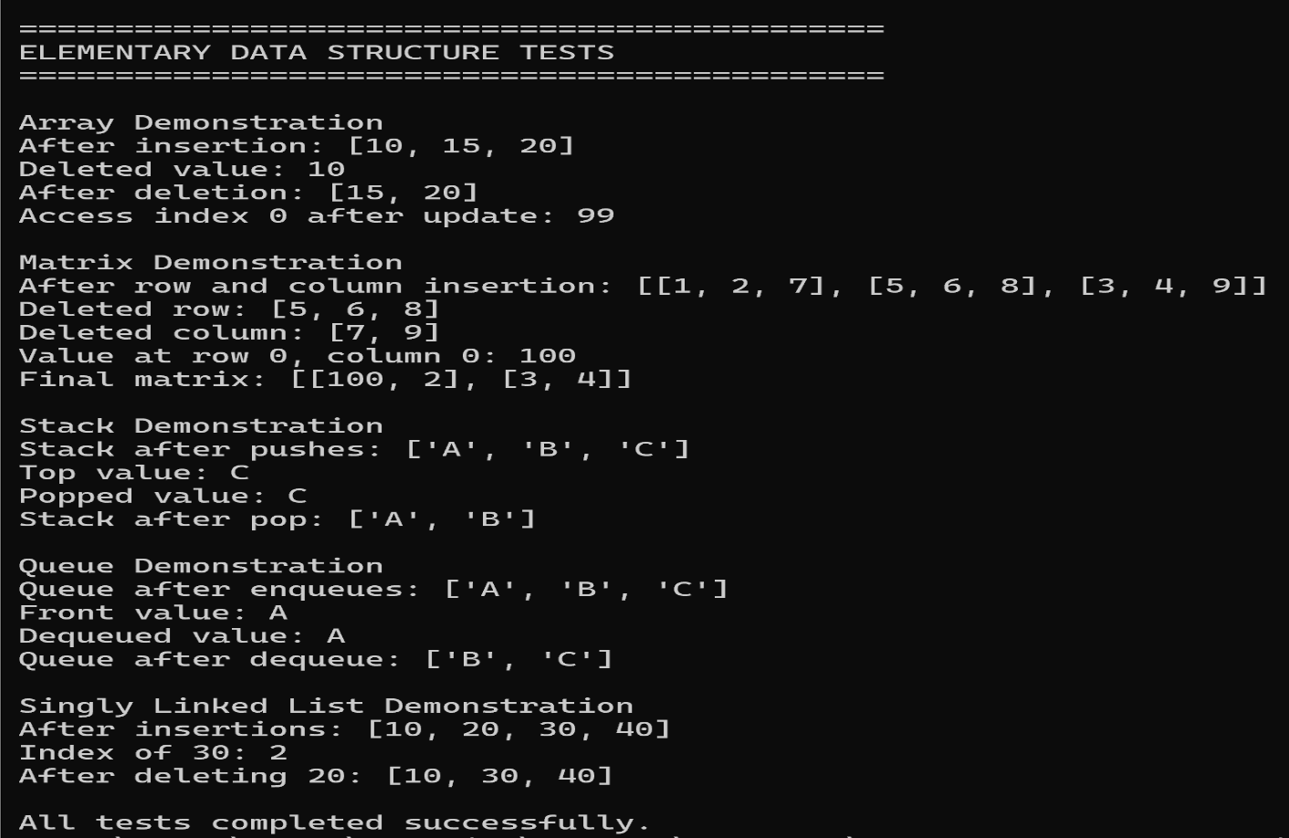
Figure 8: Elementary Data Structure Test Output
Conclusion
This assignment demonstrated that the selection problem can be solved without sorting an entire array. Median of Medians guarantees O(n) worst-case time, while Randomized Quickselect provides O(n) expected time with lower practical overhead. In the empirical tests, both algorithms returned correct results for duplicate values and different input orders, but Randomized Quickselect was faster in most cases.
The elementary data structure implementations showed how operation requirements determine the best structure. Arrays and matrices provide direct access, stacks and circular queues support efficient end-based operations, and linked lists provide flexible node-based storage. The testing output confirmed that all required operations worked correctly. Together, the two parts connected theoretical complexity analysis with practical Python implementation and measurement.

References
Blum, M., Floyd, R. W., Pratt, V., Rivest, R. L., & Tarjan, R. E. (1973). Time bounds for selection. Journal of Computer and System Sciences, 7(4), 448-461. https://doi.org/10.1016/S0022-0000(73)80033-9
Chilimbi, T. M., Hill, M. D., & Larus, J. R. (1999). Cache-conscious structure layout. Proceedings of the 1999 ACM SIGPLAN Conference on Programming Language Design and Implementation, 1-12. https://doi.org/10.1145/301618.301633
Floyd, R. W., & Rivest, R. L. (1975). Expected time bounds for selection. Communications of the ACM, 18(3), 165-172. https://doi.org/10.1145/360680.360691
Haslbeck, M. P. L., & Lammich, P. (2022). For a few dollars more: Verified fine-grained algorithm analysis down to LLVM. ACM Transactions on Programming Languages and Systems, 44(3), Article 14. https://doi.org/10.1145/3486169
Hoare, C. A. R. (1961). Algorithm 65: Find. Communications of the ACM, 4(7), 321-322. https://doi.org/10.1145/366622.366647
Michael, M. M., & Scott, M. L. (1996). Simple, fast, and practical non-blocking and blocking concurrent queue algorithms. Proceedings of the Fifteenth Annual ACM Symposium on Principles of Distributed Computing, 267-275. https://doi.org/10.1145/248052.248106

