Residency Session
Advanced Data Mining for Data-Driven Insights and Predictive Modelling
MSCS 634 - Advanced Big Data and Data Mining
University of the Cumberlands
Professor Satish Penmatsa

Group Members:
Arun Gyawali
Kashif Ali Syed
Jiwon Jung
Hanuman Sai Chanukya Srinivas Chilamkuri

07/26/2026

Summer 2026

Advanced Data Mining for Data-Driven Insights and Predictive Modeling

Introduction
This final report brings together the work completed across the earlier project deliverables. The project used the Online Shoppers Purchasing Intention Dataset to study customer browsing behavior and online purchase outcomes. The main goal was to understand which session behaviors are connected with purchasing and how data mining models can support practical e-commerce decisions.
The project followed a step-by-step process. First, the dataset was cleaned and explored. Then regression models were used to predict a continuous engagement outcome. After that, classification, clustering, and association rule mining were used to identify purchase patterns and customer-session groups.
Dataset Description
The dataset came from the UCI Machine Learning Repository. Each record represents one online shopping session. It includes page visit counts, page durations, bounce rates, exit rates, page values, visitor information, month, weekend status, traffic information, and the Revenue outcome.
Item | Value
Original records | 12,330
Cleaned records | 12,205
Attributes | 18
Target variable | Revenue
Purchase sessions | 1,908
Non-purchase sessions | 10,297
Purchase rate | 15.63%

The Revenue variable shows whether a session resulted in a purchase. Since only 15.63% of sessions resulted in a purchase, this is an imbalanced classification problem. Because of this, F1 score, ROC-AUC, and confusion matrices were used along with accuracy.
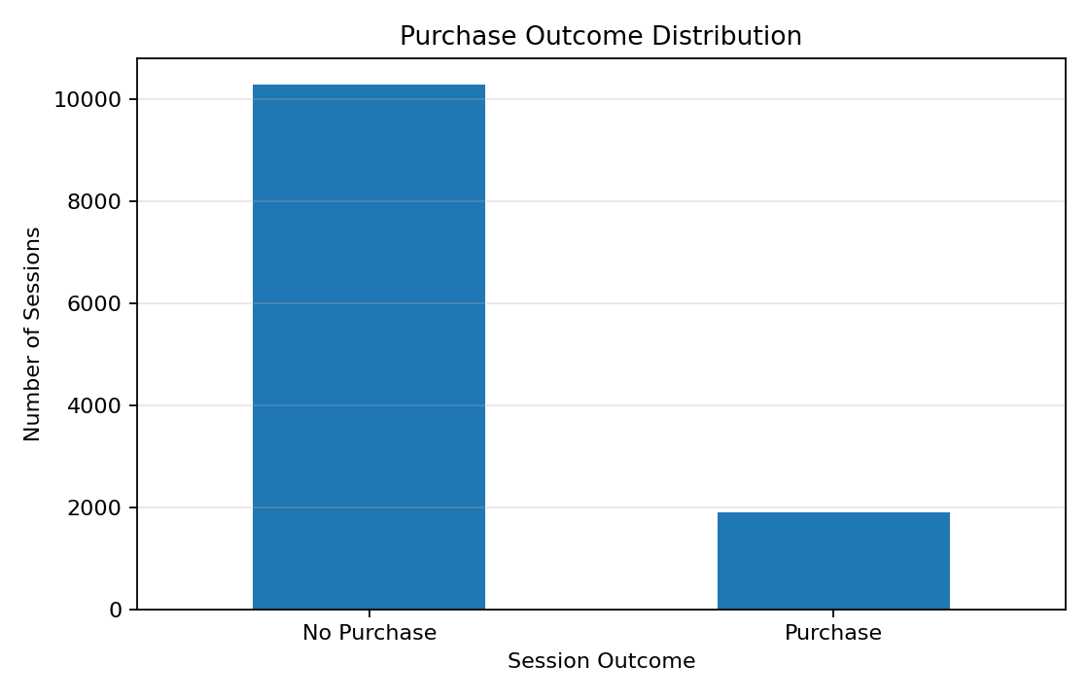
Figure 1. Purchase outcome distribution.
Data Preparation and Cleaning
The first deliverable focused on preparing the data. The data was checked for missing values, duplicates, invalid values, inconsistent text, and outliers. A total of 125 exact duplicate records were removed. No missing values, negative numerical values, or invalid rate values were found.
The duration variables were strongly right-skewed. Instead of deleting long sessions, values above the 99th percentile were capped. This reduced the influence of extreme values while preserving all unique customer sessions. Browser, OperatingSystems, Region, and TrafficType were treated as categories because they were coded labels, not true continuous measurements.

Exploratory Data Analysis
Exploratory analysis showed that purchase sessions had stronger engagement than non-purchase sessions. Purchase sessions had more product-related pages, longer product-related duration, lower bounce and exit rates, and higher PageValues.
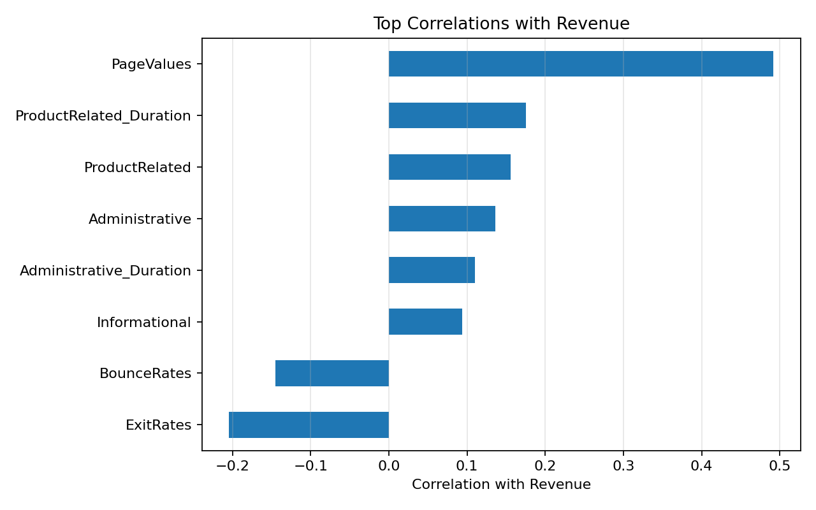
Figure 2. Top correlations with Revenue.
PageValues had the strongest positive correlation with Revenue. ExitRates and BounceRates were negatively related to Revenue, which means sessions with more abandonment behavior were less likely to produce purchases.
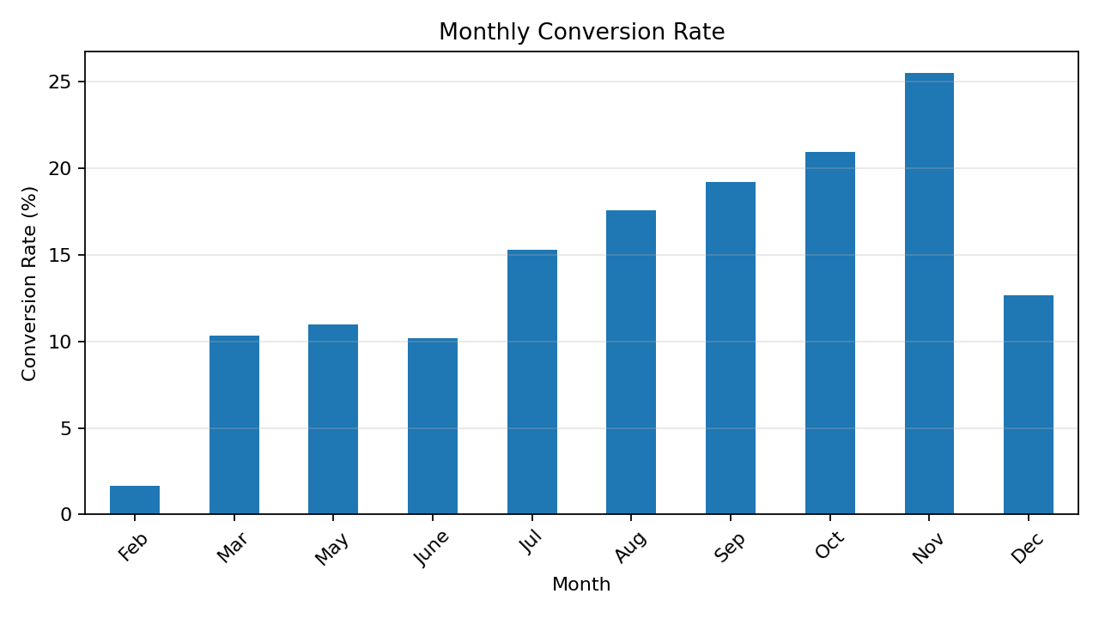
Figure 3. Monthly conversion rate.
Monthly conversion rates showed that November had the highest conversion rate, followed by October and September. This suggests that seasonality may affect purchase behavior.
Feature Engineering
Five behavioral features were created to summarize session activity and support later models. These features were reused across the regression and classification work.
Feature | Description
Total_Pages | Total Administrative, Informational, and ProductRelated pages
NonProduct_Duration | Combined Administrative and Informational duration
Avg_NonProduct_Duration_Per_Page | Average time spent per non-product page
BounceExitRatio | Ratio of BounceRates to ExitRates
Engagement_Score | ProductRelated page count multiplied by PageValues

Regression Modeling Results
The regression task predicted ProductRelated_Duration, which measures total time spent on product-related pages. This was selected because Revenue is Boolean and was used for classification. Four regression models were compared.
Model | R-squared | RMSE | CV R-squared | CV RMSE
Linear Regression | 0.7188 | 832.46 | 0.7318 | 803.28
Ridge Regression | 0.7188 | 832.57 | 0.7318 | 803.28
Lasso Regression | 0.719 | 832.22 | 0.7321 | 802.96
Random Forest | 0.7506 | 784.02 | 0.7702 | 742.97

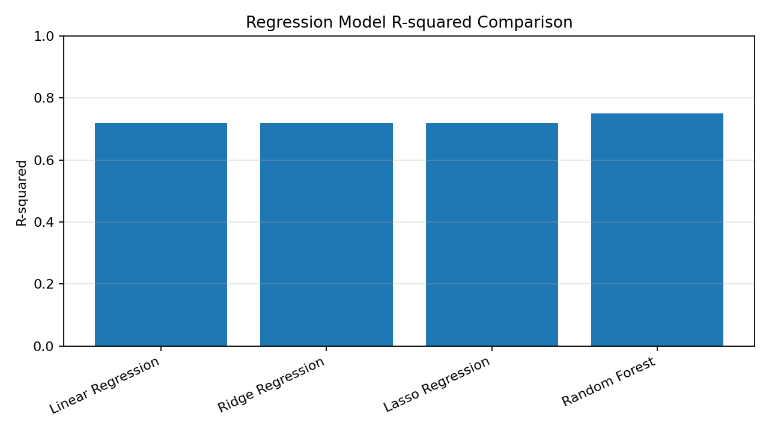
Figure 4. Regression model R-squared comparison.
Random Forest performed best with a test R-squared of 0.7506 and RMSE of 784.02 seconds. This shows that the relationship between browsing behavior and product-related duration was partly non-linear.
Classification Results
The classification task predicted whether a session resulted in a purchase. Logistic Regression and a tuned Random Forest Classifier were compared. Balanced class weights were used because purchases were the minority class.
Model | Accuracy | F1 Score | ROC-AUC
Logistic Regression | 0.8484 | 0.6255 | 0.9084
Tuned Random Forest | 0.8751 | 0.6745 | 0.9341

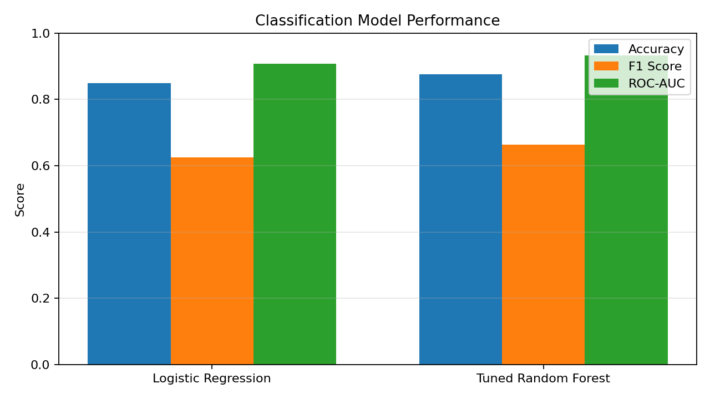
Figure 5. Classification model performance.
The tuned Random Forest Classifier performed best, with accuracy of 0.8751, F1 score of 0.6745, and ROC-AUC of 0.9341. PageValues and Engagement_Score were the strongest indicators in the model.
Clustering Results
K-Means clustering was used to identify session groups. Three clusters were selected because they produced the highest silhouette score among the tested options.
Cluster | Sessions | Share | Purchase Rate | Interpretation
0 | 9,430 | 77.3% | 14.7% | Typical browsing sessions
1 | 920 | 7.5% | 0.7% | Quick-exit sessions
2 | 1,855 | 15.2% | 27.8% | Highly engaged sessions

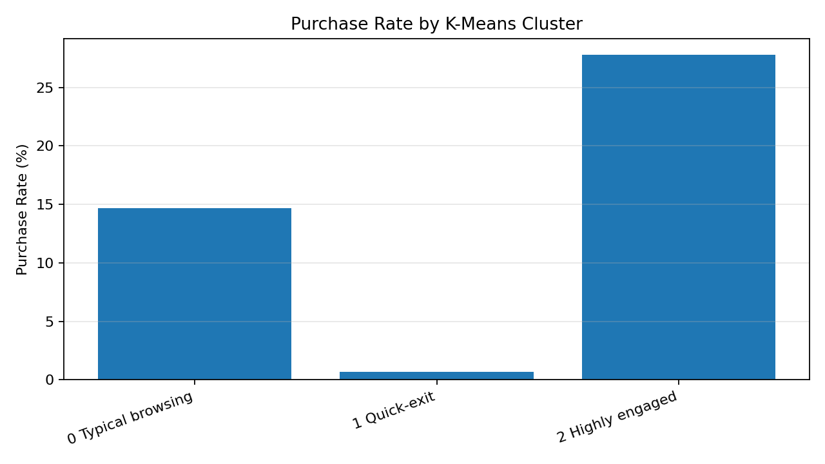
Figure 6. Purchase rate by cluster.
Cluster 2 was the highly engaged group and had the highest purchase rate. Cluster 1 represented quick-exit sessions and had almost no purchase activity.
Association Rule Mining Results
Because the dataset is based on session behavior instead of product baskets, selected behavioral measures were converted into Boolean items. Apriori was then used to find frequent behavior patterns connected with purchases.
Antecedent | Support | Confidence | Lift
Low Bounce + Low Exit + Positive PageValues | 0.0738 | 0.68 | 4.3498
Low Bounce + Positive PageValues | 0.0818 | 0.6757 | 4.3222
Long Product Duration + Low Bounce + Positive PageValues | 0.056 | 0.617 | 3.9467
Low Exit + Positive PageValues | 0.1014 | 0.6126 | 3.9184
Positive PageValues | 0.126 | 0.5634 | 3.6037

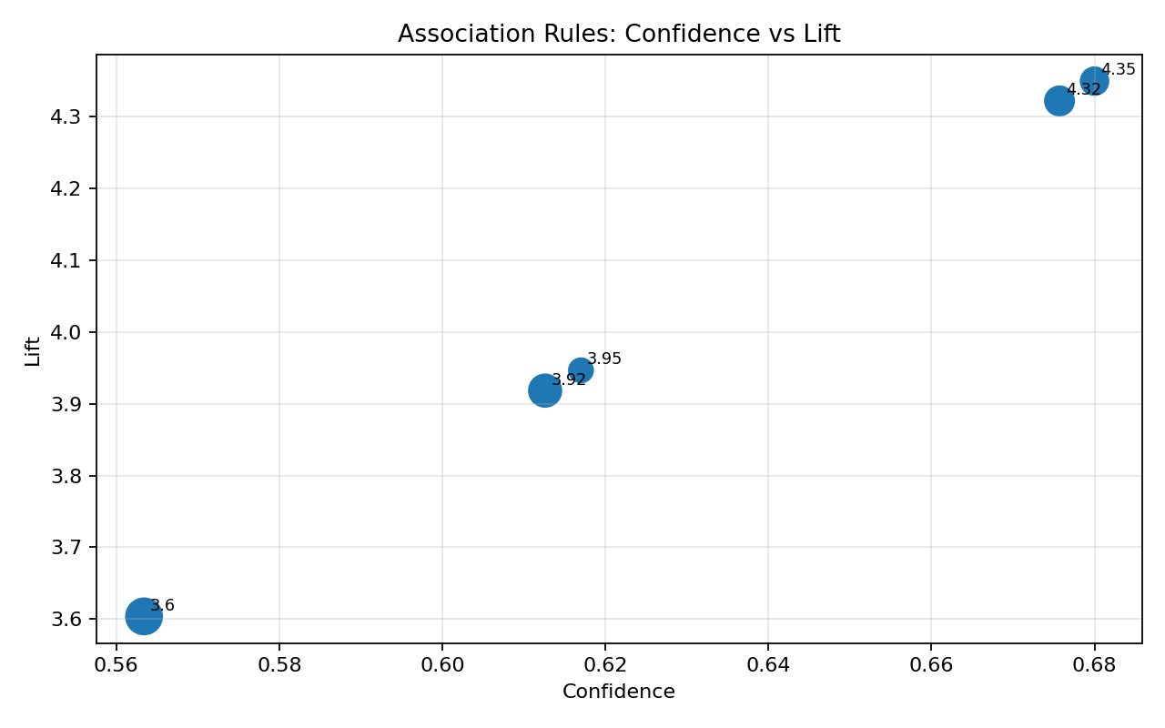
Figure 7. Association rules: confidence and lift.
The strongest rules combined positive PageValues with low bounce and low exit behavior. The top rule had confidence of 0.6800 and lift of 4.3498. These rules show useful patterns, but they do not prove causation.
Practical Recommendations
- Use PageValues, Engagement_Score, and ExitRates as key signals for high-intent sessions.
- Use the tuned Random Forest classifier as a decision-support tool for likely purchase sessions.
- Create offers, reminders, or assistance for highly engaged sessions before customers leave.
- Improve landing pages and product discovery for quick-exit sessions.
- Use association rules to identify high-intent behavior triggers.
- Retrain the models over time because online behavior changes by month, season, and marketing campaign.

Ethical Considerations
This project uses online browsing behavior, so privacy and responsible use are important. Personally identifying information is not needed for this type of analysis. If used in a real business environment, customer details should be removed or protected and access should be limited. Fairness is also important. If some visitor groups are overrepresented or underrepresented, the model may work better for some groups than others. The business should monitor model performance and avoid unfair targeting or exclusion.
The models should support human decision-making rather than fully replace it. Association rules and feature importance values should be interpreted as patterns, not as proof that one behavior directly causes another.
Limitations and Future Improvements
- The dataset does not contain detailed product-basket information.
- Revenue is imbalanced because most sessions did not result in purchases.
- Association rules were created from behavior indicators instead of products.
- Future work could include product-level data, customer history, and A/B testing results.
- Future models could test gradient boosting or other advanced methods.

Conclusion
The project showed how data mining methods can turn raw website session data into practical insights. Data cleaning and EDA showed that purchase sessions were more engaged and had lower abandonment behavior. Regression and classification showed that Random Forest performed best for both engagement prediction and purchase prediction. Clustering separated sessions into typical browsing, quick-exit, and highly engaged groups. Association rule mining showed that positive PageValues with low bounce and exit behavior is a strong high-intent pattern. Overall, these results can help an e-commerce business understand customer intent, reduce abandonment, prioritize high-value sessions, and make better online marketing decisions.

References
Sakar, C., & Kastro, Y. (2018). Online Shoppers Purchasing Intention Dataset [Data set]. UCI Machine Learning Repository. https://doi.org/10.24432/C5F88Q
Han, J., Pei, J., & Tong, H. (2022). Data mining (4th ed.). Elsevier.
Wu, D. (2024). Data mining with Python. Taylor & Francis.

