1. about.html

<html lang="en">

<head>

<meta charset="UTF-8">

<meta name="viewport" content="width=device-width, initial-scale=1.0">

<title>Travel Blog - Aruni Dinushika</title>

<style>

/\* Global Styles \*/

\* {

margin: 0;

padding: 0;

box-sizing: border-box;

font-family: 'Segoe UI', Tahoma, Geneva, Verdana, sans-serif;

} body {

background-color: #f8f9fa;

color: #333;

line-height: 1.6;

} .container {

width: 90%;

max-width: 1200px;

margin: 0 auto;

padding: 20px;

}

header {

background: linear-gradient(135deg, #1a2a6c, #b21f1f, #fdbb2d);

color: white;

padding: 1rem 0;

box-shadow: 0 2px 10px rgba(0, 0, 0, 0.1);

}

nav {

display: flex;

justify-content: space-between;

align-items: center;

}

.logo {

font-size: 1.8rem;

font-weight: bold;

} .nav-links {

display: flex;

list-style: none;

} .nav-links li {

margin-left: 1.5rem;

} .nav-links a {

color: white;

text-decoration: none;

font-weight: 500;

transition: color 0.3s;

}

.nav-links a:hover {

color: #ffd700;

}

.page-title {

text-align: center;

margin: 2rem 0;

color: #1a2a6c;

font-size: 2.5rem;

}

.profile-section {

display: flex;

flex-direction: column;

align-items: center;

margin-bottom: 3rem;

}

.profile-img {

width: 200px;

height: 200px;

border-radius: 50%;

object-fit: cover;

border: 5px solid #fdbb2d;

margin-bottom: 1.5rem;

}

.about-content {

background: white;

padding: 2rem;

border-radius: 10px;

box-shadow: 0 5px 15px rgba(0, 0, 0, 0.1);

margin-bottom: 2rem;

}

.interests-list {

display: grid;

grid-template-columns: repeat(auto-fit, minmax(250px, 1fr));

gap: 1.5rem;

margin-top: 2rem;

}.interest-item {

background: white;

padding: 1.5rem;

border-radius: 10px;

box-shadow: 0 5px 15px rgba(0, 0, 0, 0.1);

text-align: center;

}

.interest-icon {

font-size: 2.5rem;

margin-bottom: 1rem;

color: #1a2a6c;

}

.contact-info {

background: white;

padding: 2rem;

border-radius: 10px;

box-shadow: 0 5px 15px rgba(0, 0, 0, 0.1);

margin-top: 2rem;

}

.contact-info h3 {

color: #1a2a6c;

margin-bottom: 1rem;

}

.destination-card {

background: white;

border-radius: 10px;

box-shadow: 0 5px 15px rgba(0, 0, 0, 0.1);

overflow: hidden;

margin-bottom: 3rem;

}

.destination-img {

width: 100%;

height: 300px;

object-fit: cover;

}

.destination-content {

padding: 2rem;

}

.destination-content h3 {

font-size: 1.8rem;

color: #1a2a6c;

margin-bottom: 1rem;

}

.highlights-list {

margin-top: 1rem;

padding-left: 1.5rem;

}

.highlights-list li {

margin-bottom: 0.5rem;

}

footer {

background: #1a2a6c;

color: white;

text-align: center;

padding: 2rem 0;

margin-top: 3rem;

}

.student-badge {

background: #fdbb2d;

color: #333;

padding: 0.3rem 1rem;

border-radius: 20px;

font-size: 0.9rem;

font-weight: bold;

margin-top: 0.5rem;

}

/\* Responsive Design \*/

@media (max-width: 768px) {

.nav-links {

flex-direction: column;

display: none;

}

.profile-section {

text-align: center;

}

.interests-list {

grid-template-columns: 1fr;

}

}

</style>

</head>

<body>

<!-- Header with Navigation -->

<header>

<div class="container">

<nav>

<div class="logo">Wanderlust Diaries</div>

<ul class="nav-links">

<li><a href="index.html">Home</a></li>

<li><a href="about.html">About Me</a></li>

<li><a href="destinations.html">Destinations</a></li>

<li><a href="gallery.html">Gallery</a></li>

</ul>

</nav>

</div>

</header>

<!-- About Me Page Content -->

<div class="container">

<h1 class="page-title">About Me</h1>

<div class="profile-section">

<img src="profile photo.jpg" alt="Profile Photo" class="profile-img">

<h2>Aruni Dinushika</h2>

<div class="student-badge">University Student</div>

<p>Passionate Traveler & Adventure Seeker</p>

</div>

<div class="about-content">

<h2>My Travel Story</h2>

<p>Hello! I'm Aruni Dinushika, a university student with a passion for exploring new places while balancing my academic life. My journey into travel began when I started taking short trips during semester breaks to destress and experience different cultures.</p>

<p>As a student, I've learned to travel on a budget while still having meaningful experiences. I believe that travel is one of the best forms of education - it teaches you about history, culture, and most importantly, about yourself. My goal is to visit at least one new place every semester break.</p>

<p>Through this blog, I want to share my experiences as a student traveler - showing that you don't need a big budget to explore the world. I focus on affordable travel options, student discounts, and meaningful experiences that enrich both my personal growth and academic perspective.</p>

</div>

<div class="about-content">

<h2>My Travel Interests</h2>

<div class="interests-list">

<div class="interest-item">

<div class="interest-icon">🏞️</div>

<h3>Budget Travel</h3>

<p>Finding affordable ways to explore new destinations without compromising on experiences.</p>

</div>

<div class="interest-item">

<div class="interest-icon">🏛️</div>

<h3>Cultural Immersion</h3>

<p>Learning about local traditions and history to complement my university studies.</p>

</div>

<div class="interest-item">

<div class="interest-icon">📸</div>

<h3>Travel Photography</h3>

<p>Documenting my journeys to share with fellow students and travel enthusiasts.</p>

</div>

<div class="interest-item">

<div class="interest-icon">🌍</div>

<h3>Student Travel</h3>

<p>Exploring travel opportunities specifically available to university students.</p>

</div>

</div>

</div>

<div class="contact-info">

<h3>Contact Information</h3>

<p>Email: aruni.dinushika@example.com</p>

<p>Phone: +94 77 123 4567</p>

<p>University: University of Kelaniya</p>

<p>Follow me on social media: @AruniTravels</p>

</div>

</div>

<!-- Footer -->

<footer>

<div class="container">

<p>&copy; 2023 Wanderlust Diaries. All rights reserved.</p>

<p>Created by Aruni Dinushika | University Student</p>

</div>

</footer>

</body>

</html>

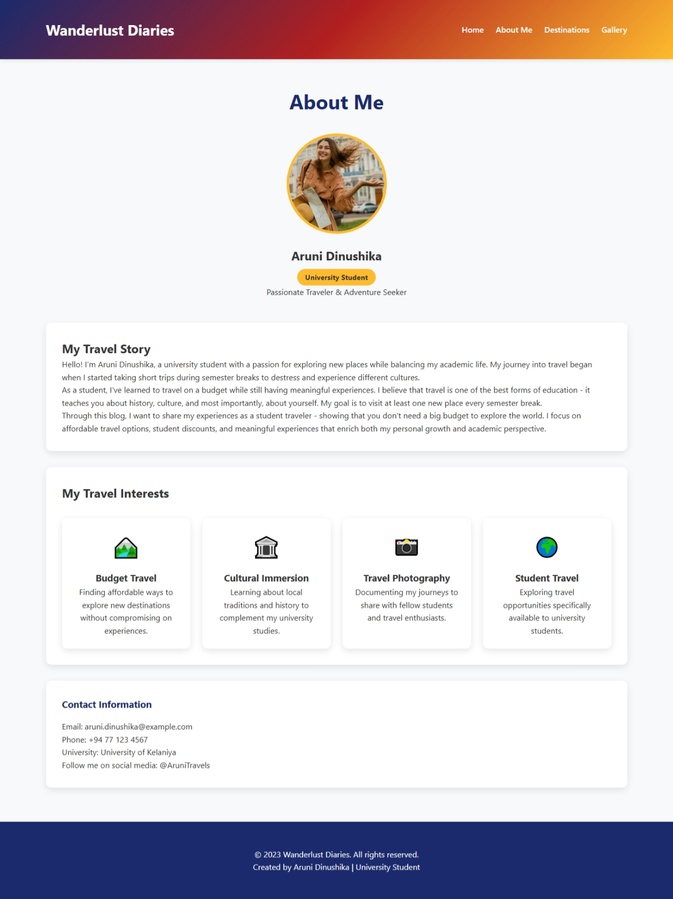

1. destinations.html

<html lang="en">

<head>

<meta charset="UTF-8">

<meta name="viewport" content="width=device-width, initial-scale=1.0">

<title>Destinations - Travel Blog</title>

<style>

/\* Global Styles \*/

\* {

margin: 0;

padding: 0;

box-sizing: border-box;

font-family: 'Segoe UI', Tahoma, Geneva, Verdana, sans-serif;

}

body {

background-color: #f8f9fa;

color: #333;

line-height: 1.6;

}

.container {

width: 90%;

max-width: 1200px;

margin: 0 auto;

padding: 20px;

}

header {

background: linear-gradient(135deg, #1a2a6c, #b21f1f, #fdbb2d);

color: white;

padding: 1rem 0;

box-shadow: 0 2px 10px rgba(0, 0, 0, 0.1);

}

nav {

display: flex;

justify-content: space-between;

align-items: center;

}

.logo {

font-size: 1.8rem;

font-weight: bold;

}

.nav-links {

display: flex;

list-style: none;

}

.nav-links li {

margin-left: 1.5rem;

}

.nav-links a {

color: white;

text-decoration: none;

font-weight: 500;

transition: color 0.3s;

}

.nav-links a:hover {

color: #ffd700;

}

.page-title {

text-align: center;

margin: 2rem 0;

color: #1a2a6c;

font-size: 2.5rem;

}

.destination-card {

background: white;

border-radius: 10px;

box-shadow: 0 5px 15px rgba(0, 0, 0, 0.1);

overflow: hidden;

margin-bottom: 3rem;

transition: transform 0.3s;

}

.destination-card:hover {

transform: translateY(-5px);

}

.destination-img {

width: 100%;

height: 400px;

object-fit: cover;

}

.destination-content {

padding: 2rem;

}

.destination-content h3 {

font-size: 1.8rem;

color: #1a2a6c;

margin-bottom: 1rem;

}

.highlights-list {

margin-top: 1rem;

padding-left: 1.5rem;

}

.highlights-list li {

margin-bottom: 0.5rem;

position: relative;

}

.highlights-list li:before {

content: "✓";

color: #fdbb2d;

font-weight: bold;

margin-right: 0.5rem;

}

.student-tip {

background: #e8f4f8;

border-left: 4px solid #1a2a6c;

padding: 1rem;

margin-top: 1rem;

border-radius: 0 5px 5px 0;

}

footer {

background: #1a2a6c;

color: white;

text-align: center;

padding: 2rem 0;

margin-top: 3rem;

}

/\* Responsive Design \*/

@media (max-width: 768px) {

.nav-links {

flex-direction: column;

display: none;

}

.destination-img {

height: 250px;

}

}

</style>

</head>

<body>

<!-- Header with Navigation -->

<header>

<div class="container">

<nav>

<div class="logo">Wanderlust Diaries</div>

<ul class="nav-links">

<li><a href="index.html">Home</a></li>

<li><a href="about.html">About Me</a></li>

<li><a href="destinations.html">Destinations</a></li>

<li><a href="gallery.html">Gallery</a></li>

</ul>

</nav>

</div>

</header>

<!-- Destinations Page Content -->

<div class="container">

<h1 class="page-title">My Travel Destinations</h1>

<!-- Destination 1 -->

<div class="destination-card" id="ella">

<img src="ella.JFIF" alt="Ella, Sri Lanka" class="destination-img">

<div class="destination-content">

<h3>Ella, Sri Lanka</h3>

<p>Ella is a small town in the Badulla District of Sri Lanka, surrounded by hills covered with cloud forests and tea plantations. It's a perfect destination for students looking for an affordable yet breathtaking travel experience close to nature.</p>

<h4>Highlights & Activities:</h4>

<ul class="highlights-list">

<li>Hike to the top of Little Adam's Peak for stunning views</li>

<li>Walk across the famous Nine Arch Bridge</li>

<li>Visit Ravana Falls and take a refreshing dip</li>

<li>Explore tea plantations and learn about tea production</li>

<li>Enjoy budget-friendly local cuisine</li>

<li>Watch sunrise from Ella Rock</li>

</ul>

<div class="student-tip">

<strong>Student Tip:</strong> Travel by train from Colombo to Ella for one of the most scenic railway journeys in the world at a student-discounted fare.

</div>

</div>

</div>

<!-- Destination 2 -->

<div class="destination-card" id="kandy">

<img src="kandy.jpg" alt="Kandy, Sri Lanka" class="destination-img">

<div class="destination-content">

<h3>Kandy, Sri Lanka</h3>

<p>Kandy is a major city in central Sri Lanka, known for its rich history, cultural significance, and beautiful landscapes. It's home to the Temple of the Sacred Tooth Relic, a UNESCO World Heritage Site, making it a perfect educational destination for students.</p>

<h4>Highlights & Activities:</h4>

<ul class="highlights-list">

<li>Visit the Temple of the Sacred Tooth Relic</li>

<li>Explore the Royal Botanical Gardens in Peradeniya</li>

<li>Watch traditional Kandyan dance performances</li>

<li>Walk around Kandy Lake in the evening</li>

<li>Visit the Ceylon Tea Museum</li>

<li>Explore Udawatta Kele Sanctuary</li>

</ul>

<div class="student-tip">

<strong>Student Tip:</strong> Many cultural sites offer discounted entry fees for students with valid university ID cards.

</div>

</div>

</div>

<!-- Destination 3 -->

<div class="destination-card" id="galle">

<img src="galle.jpg" alt="Galle, Sri Lanka" class="destination-img">

<div class="destination-content">

<h3>Galle, Sri Lanka</h3>

<p>Galle is a city on the southwest coast of Sri Lanka, known for its fortified old city founded by Portuguese colonists in the 16th century. The Galle Fort is a UNESCO World Heritage Site and offers a unique blend of European architecture and South Asian traditions.</p>

<h4>Highlights & Activities:</h4>

<ul class="highlights-list">

<li>Explore the historic Galle Fort</li>

<li>Visit the Galle Lighthouse and Maritime Museum</li>

<li>Relax on Unawatuna Beach</li>

<li>Shop for souvenirs at the Galle Fort shopping streets</li>

<li>Watch sunset from the fort walls</li>

<li>Try fresh seafood at beachside restaurants</li>

</ul>

<div class="student-tip">

<strong>Student Tip:</strong> Visit during the off-peak season (May-November) for better deals on accommodation and fewer crowds.

</div>

</div>

</div>

</div>

<!-- Footer -->

<footer>

<div class="container">

<p>&copy; 2023 Wanderlust Diaries. All rights reserved.</p>

<p>Created by Aruni Dinushika | University of Kelaniya</p>

</div>

</footer>

</body>

</html>

