CampusCart
Campus Marketplace Management System

A Project Report

Submitted by
Arunika
Register No: 922525105002

Department of Electrical and Electronics Engineering
VSB Engineering College, Karudayampalayam, Karur

Certificate
This is to certify that the project report titled "CampusCart – Campus Marketplace Management System" is a bonafide record of work carried out by Arunika (Register No: 922525105002), a student of the Department of Electrical and Electronics Engineering, VSB Engineering College, Karudayampalayam, Karur, in partial fulfilment of the requirements for the academic project/SOP submission.

Project Guide
Head of Department

Date:
Place:

Declaration
I hereby declare that the project work entitled "CampusCart – Campus Marketplace Management System" submitted by me is an original work carried out by me, under the guidance of my project guide, and has not been submitted elsewhere for the award of any degree or diploma.

Name: Arunika
Register No: 922525105002
Date:

Acknowledgement
I would like to express my sincere gratitude to my project guide and the faculty of the Department of Electrical and Electronics Engineering, VSB Engineering College, for their valuable guidance and support throughout the development of this project. I also thank the Head of the Department and my friends for their encouragement and assistance during this work.

Abstract
CampusCart is a full-stack, web-based Campus Marketplace Management System developed to help manage information about products useful to students in a college environment, such as textbooks, calculators, stationery, and laboratory items. The system implements the four fundamental Create, Read, Update, and Delete (CRUD) database operations through a layered architecture.
The frontend is built using HTML, CSS, and JavaScript, providing a simple and responsive interface for adding, viewing, searching, editing, and deleting products. The backend is developed using Java Spring Boot, structured into controller, service, and repository layers, and communicates with the frontend through REST APIs. Product data is persisted in a MySQL database using Spring Data JPA.
The project demonstrates practical, end-to-end full-stack development skills, including frontend design, REST API development, backend business logic, database design, and frontend-backend integration, and provides a foundation that can be extended with authentication, product images, and shopping-cart features in future work.

Table of Contents

1. Introduction
CampusCart is a full-stack web-based Campus Marketplace Management System developed to manage product information in a campus environment. The application allows users to add, view, search, update, and delete product information, combining a simple HTML/CSS/JavaScript frontend with a Java Spring Boot backend and a MySQL database.
The project demonstrates the practical implementation of CRUD operations, REST APIs, backend programming, database connectivity, and frontend-backend integration, in line with the college's Standard Operating Procedure for full-stack CRUD application development.

2. Problem Statement
In a campus environment, information about useful student products such as textbooks, calculators, stationery, and other educational items can be difficult to organize and manage manually. A simple digital system makes such product information easier to store, view, update, and remove.
CampusCart addresses this problem by providing a centralized, web-based system for managing product information through a user-friendly interface backed by a relational database.

3. Objectives
- To develop a web-based campus product management system.
- To implement Create, Read, Update, and Delete (CRUD) operations.
- To connect a frontend application with a Java Spring Boot backend.
- To store product information in a MySQL database.
- To implement REST API communication between frontend and backend.
- To provide search functionality for products.
- To create a simple and user-friendly interface.
- To gain practical experience in full-stack application development.

4. Scope of the Project
The current system supports:
- Adding new products
- Viewing available products
- Searching products
- Updating product details
- Deleting products
- Maintaining product information in MySQL
- Communicating between frontend and backend using REST APIs
The system can be further extended with user authentication, product images, shopping cart features, and online transactions, as discussed in Section 17.

5. Technologies Used
Technology | Purpose
HTML | Web page structure
CSS | Styling and responsive design
JavaScript | Frontend functionality
Java | Backend programming language
Spring Boot | Backend framework
Spring Data JPA | Database interaction / ORM
MySQL | Relational database management
REST API | Frontend-backend communication
Maven | Project and build management
VS Code | Development environment

6. System Architecture
CampusCart follows a simple layered architecture separating the frontend, backend, and database:
Frontend (HTML + CSS + JS) → REST API → Spring Boot Backend (Controller → Service → Repository) → MySQL Database

6.1 Frontend Layer
Provides the user interface using HTML, CSS, and JavaScript.

6.2 Controller Layer
The Spring Boot controller receives requests from the frontend and returns the appropriate response.

6.3 Service Layer
Handles the application's business logic, acting as an intermediary between the controller and repository.

6.4 Repository Layer
Communicates with the MySQL database using Spring Data JPA.

6.5 Database Layer
MySQL stores product information permanently.

7. Functional Requirements

7.1 Add Product
The user enters Product Name, Price, Category, and Description. The information is sent to the backend using a POST request and stored in the MySQL database.

7.2 View Products
The application retrieves product information from the backend using a GET request. Available products are displayed as product cards on the webpage.

7.3 Search Product
The search box allows users to search for products; the system filters the products displayed on the webpage to show matching results.

7.4 Edit Product
The user selects the Edit control for an existing product, changes the details, and the updated data is sent to the backend using a PUT request.

7.5 Delete Product
The user selects the Delete control to remove a product. The application sends a DELETE request and the record is removed from the database.

8. CRUD Operations
Operation | HTTP Method | Endpoint | Purpose
Create | POST | /products | Add a new product
Read | GET | /products | Display all products
Update | PUT | /products/{id} | Modify an existing product
Delete | DELETE | /products/{id} | Remove a product

9. Database Design
Database name: campuscart Main table: product
Field | Data Type | Description
id | BIGINT | Primary key (auto-generated)
name | VARCHAR | Product name
description | VARCHAR | Product description
price | DOUBLE | Product price
category | VARCHAR | Product category
The id field is the primary key and is generated automatically using JPA's @GeneratedValue annotation.

10. Backend Implementation
The backend is developed using Java Spring Boot and organized as follows:
com.campuscart.campuscart
├── CampuscartApplication.java
├── model / Product.java
├── controller / ProductController.java
├── service / ProductService.java
└── repository / ProductRepository.java

10.1 Product Entity
Product.java represents the product entity, containing id, name, description, price, and category fields. The @Entity annotation maps the class to a database table, @Id identifies the primary key, and @GeneratedValue enables automatic ID generation.

10.2 Product Controller
ProductController.java handles HTTP requests and exposes the GET, POST, PUT, and DELETE endpoints under /products, acting as the communication point between frontend and backend.

10.3 Product Service
ProductService.java contains the business logic, providing methods to get all products, save a product, update a product, and delete a product.

10.4 Product Repository
ProductRepository.java extends JpaRepository<Product, Long>, providing standard CRUD database operations without requiring manually written SQL queries.

11. Frontend Implementation
The frontend consists of three main files: index.html, style.css, and script.js.

11.1 index.html
Defines the page structure: header, Add Product form, search box, product list, product count, and footer.

11.2 style.css
Provides the visual design — styling for the header, form, input fields, product cards, buttons, search box, category labels, and responsive layout.

11.3 script.js
Provides frontend functionality: loading products, adding products, searching products, editing products, deleting products, updating the product count, and communicating with the backend via fetch requests.

12. API Communication
The frontend communicates with the Spring Boot backend through REST APIs. The backend runs at http://localhost:8080 and exposes the product API at http://localhost:8080/products. For example, when a product is added, JavaScript sends a POST request to /products; the Spring Boot backend receives the request and saves the product through the service and repository layers.

13. Testing
The application was tested using the following CRUD-based test cases:
Test Case | Action | Expected Result
TC01 | Add product | Product is added successfully
TC02 | View products | Products are displayed correctly
TC03 | Search product | Matching product is displayed
TC04 | Edit product | Product details are updated
TC05 | Delete product | Product is removed
TC06 | Refresh page | Database products remain available

14. Screenshots
The following screenshots illustrate the working application, captured from the running system.

14.1 Project Structure
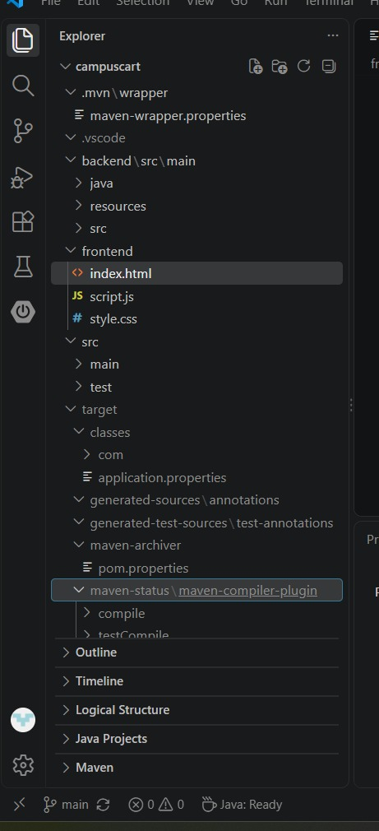

14.2 Home Page
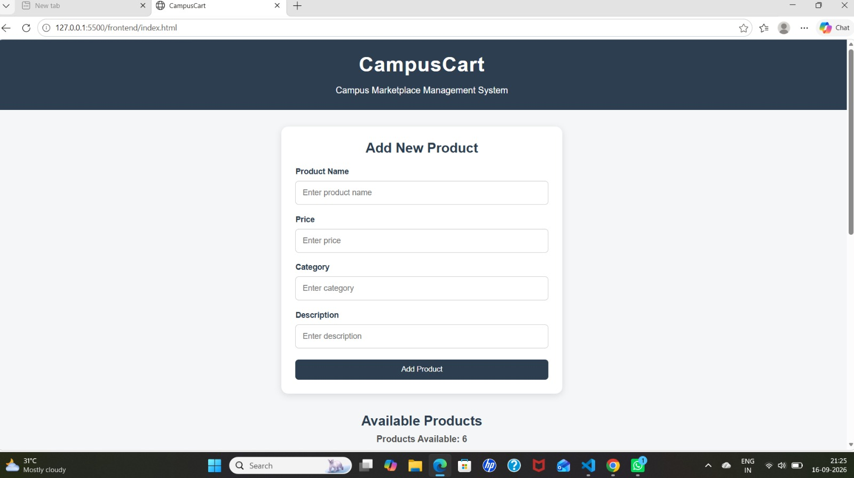

14.3 Product List
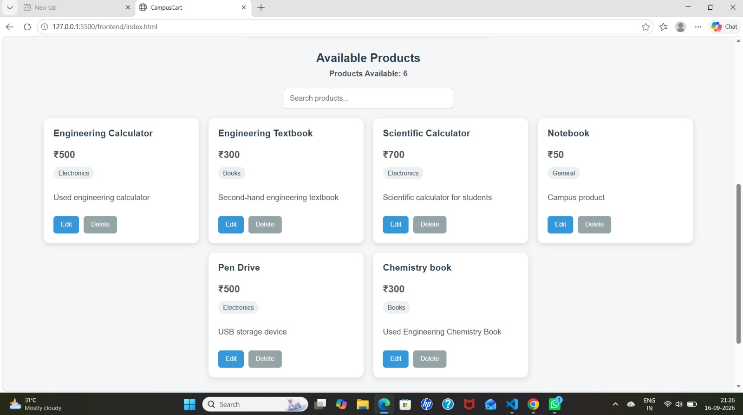

14.4 Product List (continued) / Footer
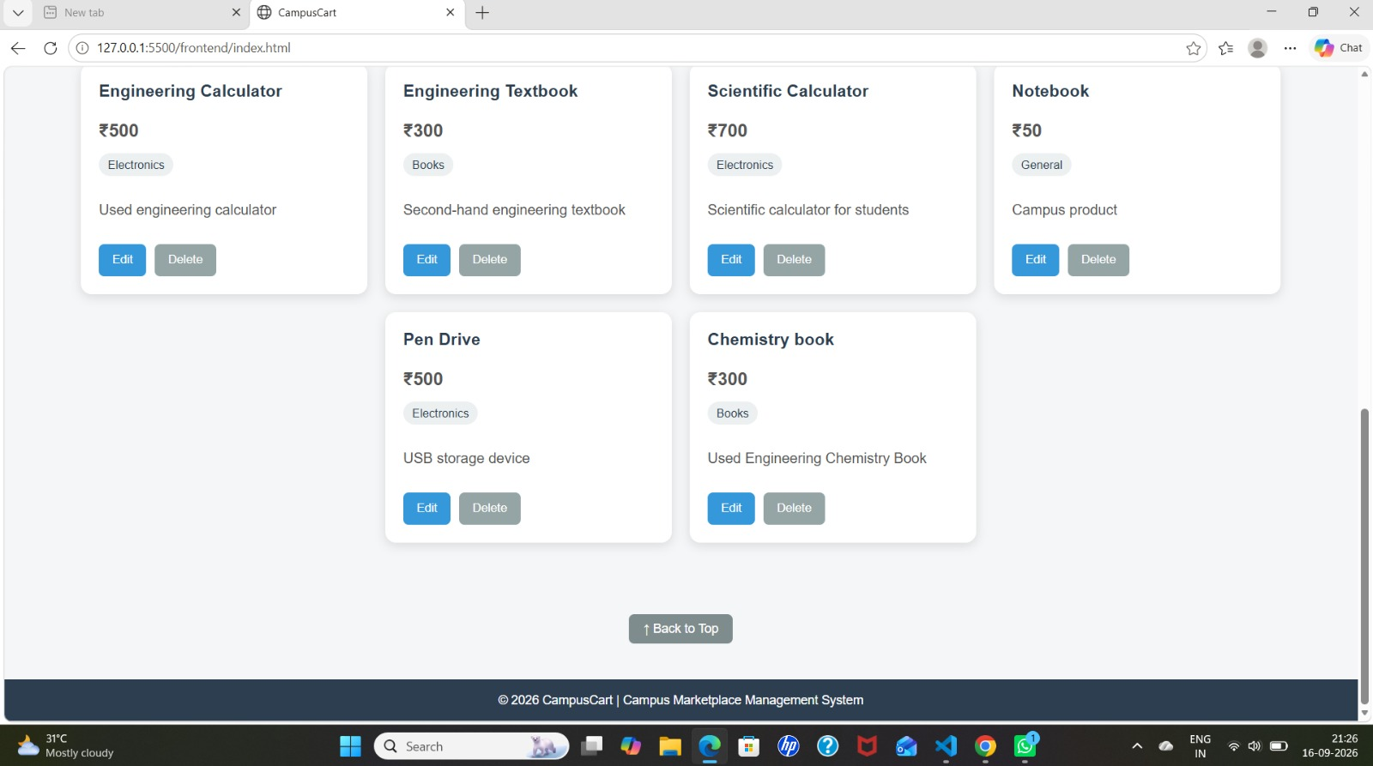

14.5 Edit Product Operation
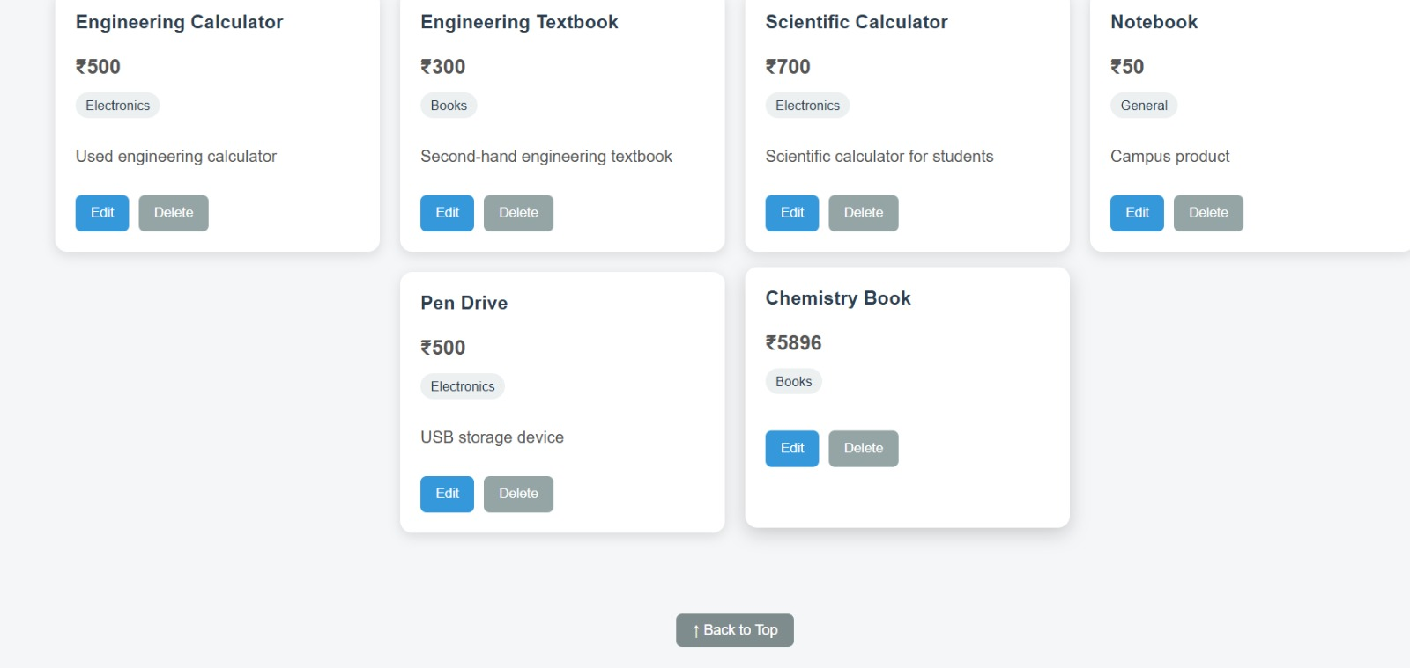
Chemistry Book price updated from ₹300 to ₹5896, demonstrating the Update (PUT) operation.

14.6 Delete Product Operation
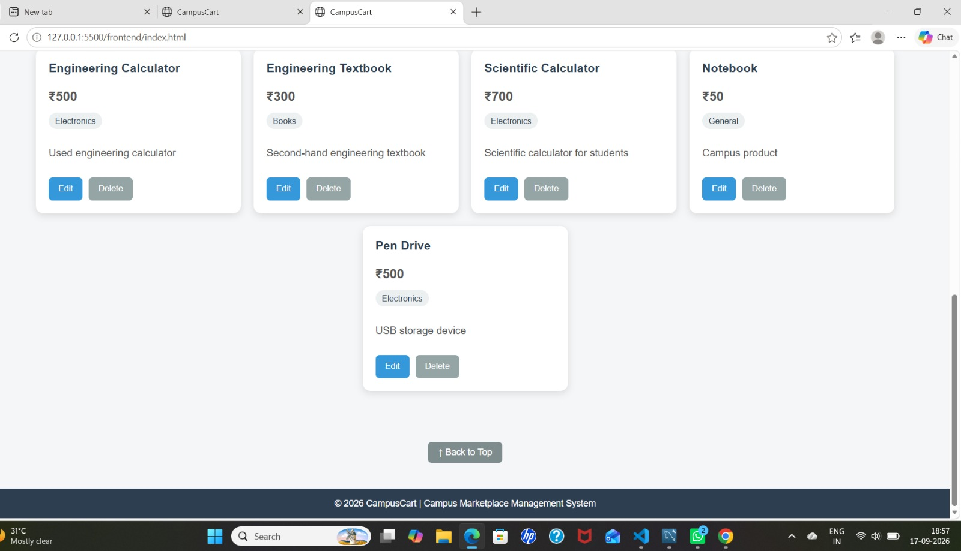
Chemistry Book removed from the product list, demonstrating the Delete operation.

14.7 MySQL Database (campuscart)
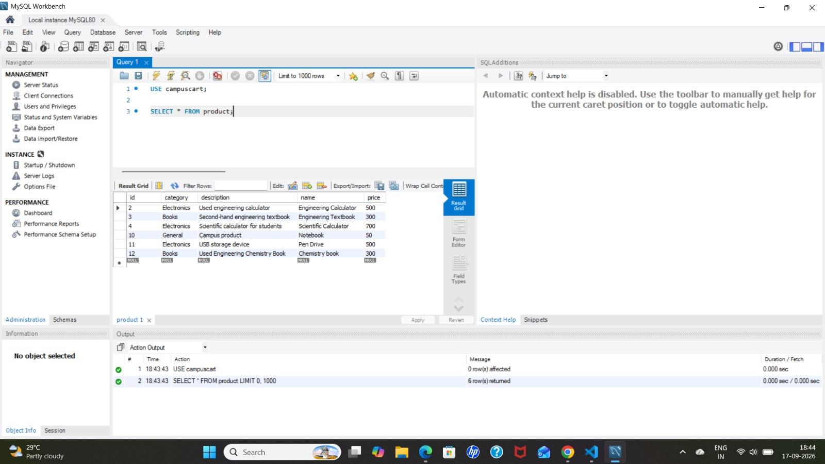

15. Advantages
- Simple and user-friendly interface
- Complete CRUD functionality
- Uses a relational database for persistent storage
- Demonstrates REST API implementation
- Separates controller, service, and repository layers
- Provides search functionality
- Can be extended for larger applications
- Demonstrates practical full-stack development

16. Limitations
- No user authentication
- No administrator login
- No product image upload
- No online payment facility
- No shopping cart
- Product editing currently uses simple prompts
- The application is designed to run locally

17. Future Enhancements
- User registration and login
- Admin dashboard
- Product image upload
- Product availability status
- Shopping cart
- Product filtering by category
- Product exchange functionality
- Online payment integration
- Cloud database
- Deployment to a cloud platform

18. Conclusion
CampusCart is a full-stack Campus Marketplace Management System developed using HTML, CSS, JavaScript, Java Spring Boot, Spring Data JPA, and MySQL. The project demonstrates the implementation of CRUD operations and communication between a frontend application, a REST-based backend, and a relational database.
Through this project, the concepts of web development, Java programming, Spring Boot, REST APIs, JPA, MySQL database connectivity, and frontend-backend integration have been practically demonstrated, providing a solid foundation for developing larger full-stack applications.

19. References
- Java Documentation
- Spring Boot Documentation
- Spring Data JPA Documentation
- MySQL Documentation
- MDN Web Documentation
- HTML, CSS and JavaScript Documentation

