**Lab 5: Basic 8255 Interfacing**

Task :

Study 8255, interface and run test program to light the given LED.

The 8255 is a programmable, parallel I/O device. It can be programmed to transfer data under various conditions.

The 8255 has 24 i/o pins that can be grouped primarily in two 8-bit parallel ports A and B, with remaining 8-bit as port C. The 8-bit of port c can be used as individual bits or can be grouped in two 4-bits port cupper and clower

**Port A**: One 8 bit data output latch/buffer and one 8-bit data input latch.

**Port B**: One 8-bit data output latch/buffer and one 8-bit data input buffer.

**Port C**: One 8-bit data output latch/buffer and one 8-bit data input buffer (no latch for input). This port can be divided into two buffer (no latch for input). This port can be divided into two 4-bit ports under the mode control. Each 4-bit port contains a 4-bit latch and it can be used for the controls signal outputs and status signal inputs in conjunction with ports A and B

The function of these ports is defined by writing control word in the control register.

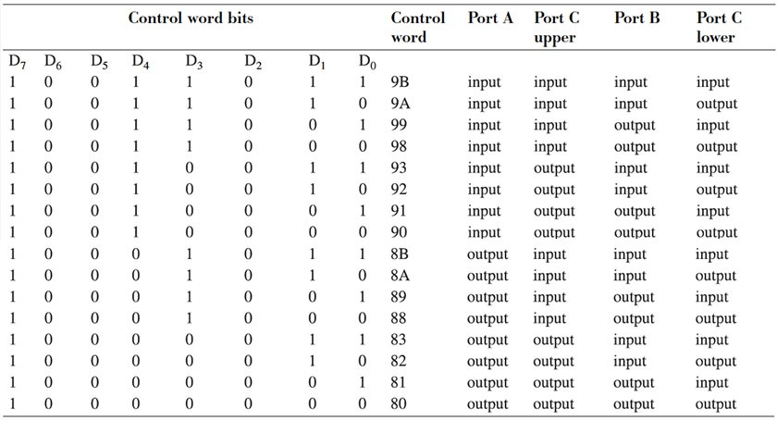

**Control word**

Steps to execute program using TLLC(8255)

1. Connect XPO 86 to TLCC using FRC cable.
2. Write the program in XPO 86 and and execute it.

**26 pin FRC connector:**

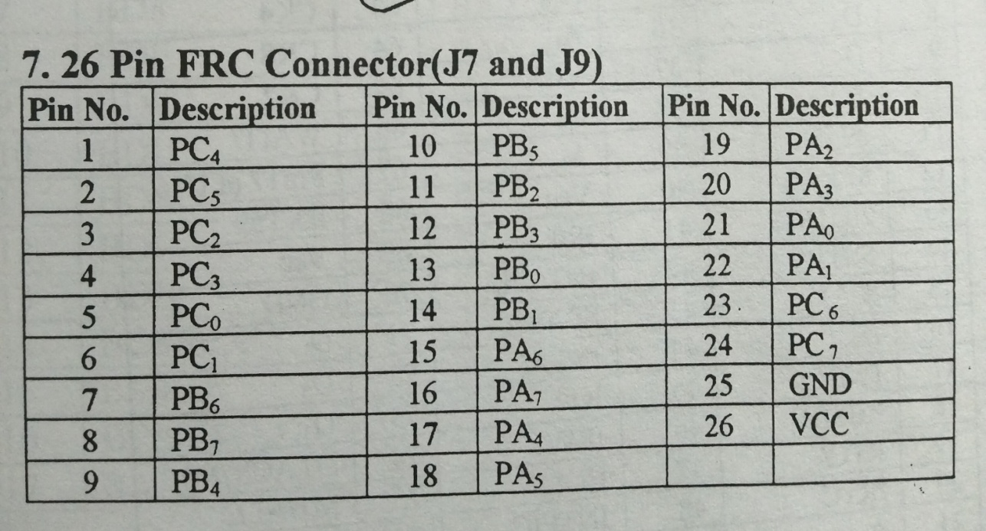

Example :

Write an assembly language program in XP086 kit to send the data in port A and port C_upper to port B and portC_lower”

The address of 8255(U): 8801,8803,8805,8807 and 8255(L)):8000,8002,8004,8006

Ans:-

MOV AL,98

MOV DX,8006

OUT DX,AL

MOV DX,8000

IN AL,DX

MOV DX,8002

OUT DX,AL

MOV DX,8004

IN AL,DX

AND AL,F0

MOV CL,04

SHR AL,CL

OUT DX,AL

INT A5

INPUT: A0=0,A1=0,A2=1,A3=1,A4=1,A5=1,A6=0,A7=0,C7=0,C6=0,C5=1,C4=1

OUTPUT: B0 B1 B2 B3 B4 B5 B6 B7 C0=0,C1=0,C2=1,C3=1

**Your** **Assignment.**

**Q1`: Study the manual and understand how 8255s are interfaced. How many 8255s are interfaced in the** XPO86 kit, identify the respective port addresses

**(10 points)**

Q2: **Q2:** Interface single LED to 8255 Port A (0) and with 0.5 second time delay or Use appropriate and display using LEDs

**(15 points)**

**Q2:** Interface the given 7-segment Display to 8255 Port A (3:0) and display digits 0 to 9 with 0.5 second time delay or Use appropriate and display using LEDs

**(20 Points)**

Submission in hardcopy (in Lab) and Demo.