**Roll no:**

**CS321: Quiz1 ANSWERS**

Max Marks: 100; Time: 1 hr

Q1: Convert (478)­10 into

1. a 32-bit unsigned number……………………………………………………………………………
2. a 32 bit signed number ………………………………………………………………………………
3. a 32bit representation of -478 is ……………………………………………….
4. Single Precision Float representation is : …………………………………………………..
5. 00000000000000000000000111011110
6. 00000000000000000000000111011110
7. 11111111111111111111111000100010
8. 01000011111011110000000000000000 (0x43ef0000)

4x5 Marks

Q2:

Write a 8085/8086 ASM Program to find Sum of the first n natural numbers.

Ans:

LDA n

MOV B, A

XRA A

*Loop:* ADD B

DCR B

JNZ *Loop*

STA *total*

**(5 points)**

**Q3 .** (Brief explanation of the answer is a requirement). Consider an 8085 Microprocessor system.  
The following program start at location 0100H.  
                         LXI SP, 00FF  
                         LXI H, 0107  
                         MVI A, 20H  
                         SUB M  
 **(a)** The content of accumulator when the program counter reaches 0109H is:

**Write your answer here:**

**Ans:** 00H

**Explanation:**  
  
0100 LXI SP, 00FF  
0103 LXI H, 0107  
0106 MVI A, 20H  
0108 SUB M  
0109  
  
M Contains the data of memory whose address which is in HL pair.  
HL has address 0107  
0107 corresponds to 20H.  
therefore A-M=20H-20H = **00H (Ans)**

**(10 points)**

**(b)** If in addition following code exists from 0109H onwards,  
ORI 40H  
ADD M  
What will be the result in the accumulator after the last instruction is executed?  
  
**Write your answer here:**

**(10 points)**

**Ans: 60H**

After 0109 Accumulator will contain 00H  
ORI will execute OR operation between Accumulator and 40H and store the content to Accumulator A = 40H => 00H OR 40H  
Now Adding M(20H) with A(40H) gives **60H**.

Q3: Consider the following assembly language program.

|  |  |  |  |  |
| --- | --- | --- | --- | --- |
| 1 |  | MVI | B,87H |  |
| 2 |  | MOV | A, B |  |
| 3 | START: | JMP | NEXT |  |
| 4 |  | MVI | B, 00H |  |
| 5 |  | XRA | B |  |
| 6 |  | OUT | PORT 1 |  |
| 7 |  | HLT |  |  |
| 8 | NEXT: | XRA | B |  |
| 9 |  | JP | START |  |
| 10 |  | OUT | PORT 2 |  |
| 11 |  | HLT |  |  |

What is the output at PORT 2

First Loop A=87; B=87

NEX: XRA B= A=00; B=87

JP (jump on positive): jumps to Start

XRA B= A xor B , A= 87 ( now Sign=1; ) goes to OUT PORT 2 instruction.

**Ans: output of 87H at PORT2**

**(15 points)**

**Q4:** Figure shows the timing diagram of STA 526AH instruction in 8085. Assuming that Accumulation contains 77H and instruction is stored in memory starting 80FF H, which contains opcode 32H, fill the content of Address and Data bus in the timing diagram (places marked **H**)

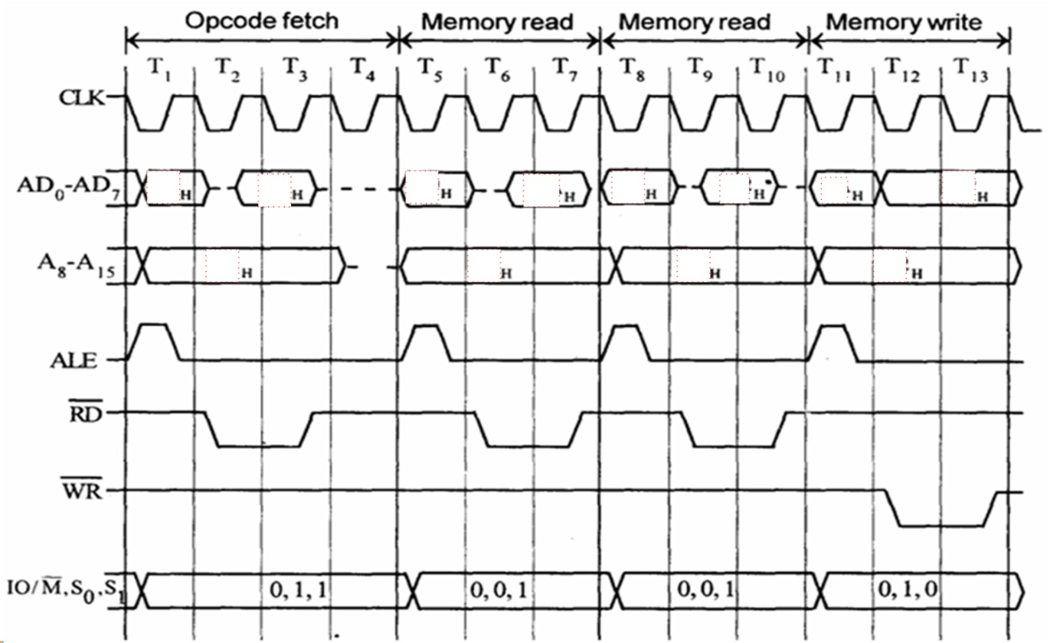

**(5 Points)**



77

6A

52

01

6A

00

32

FF

521

81

81

80

**ANS**

80FF: 32

8100:6A

8101:52

ACC:77

**(16 points)**

**Q5** In an 8086 Processor, If ax contains 0002h and bx contains 01FFh

After mul bx

dx = 0000h ax = 03FEh

If ax contains 0001h and bx contains FFFFh

mul bx

dx = 0000h ax = FFFFh

imul bx

dx = FFFFh ax = FFFFh

**(12 points)**

**Q6** In an 8086 Processor, If dx = 0000h, ax = 00005h, and bx = 0002h

div bx

ax = 0002h dx = 0001h

If dx = 0000h, ax = 0005h, and bx = FFFE fffh

div bx

ax = 0000h dx = 0005h

idiv bx

ax = FFFEh dx = 0001h

**(12 points)**