**Lab 8: RISC processor Design(Components)**

Task 1: Study and the following 32x32 register file with two read port and one write port. Perform read and write operation and understand the operation of a register file. ( sample design give: mips_regfile.circ)

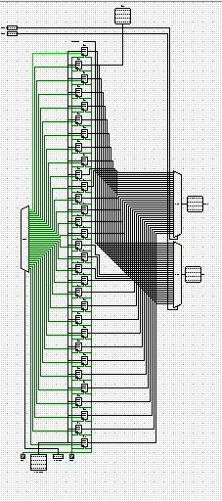

Your Task: Design a **16x16 r**egister file with two read port and one write port. Perform read and write operation and understand the operation of a register file

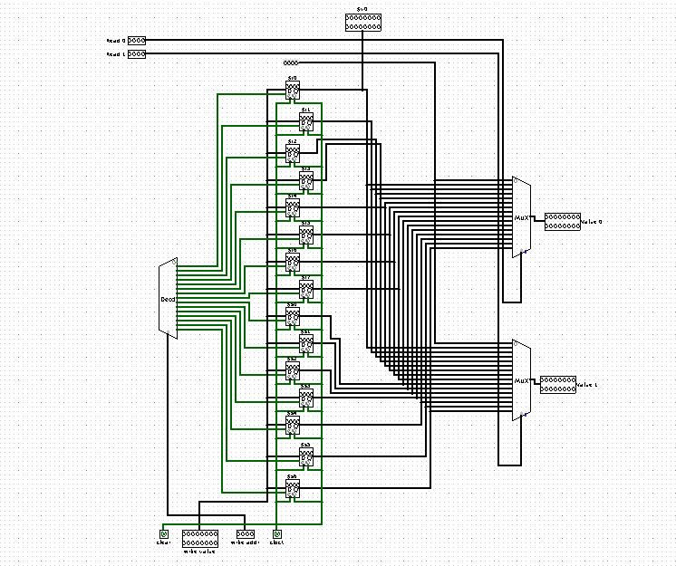Answer Here:

Task 2: Study the give 32 bit ALU. Identity the operations and corresponding control word (S0S1S2). Re-design the ALU with 5 more operations which are suitable for implementing MIPS instruction set.

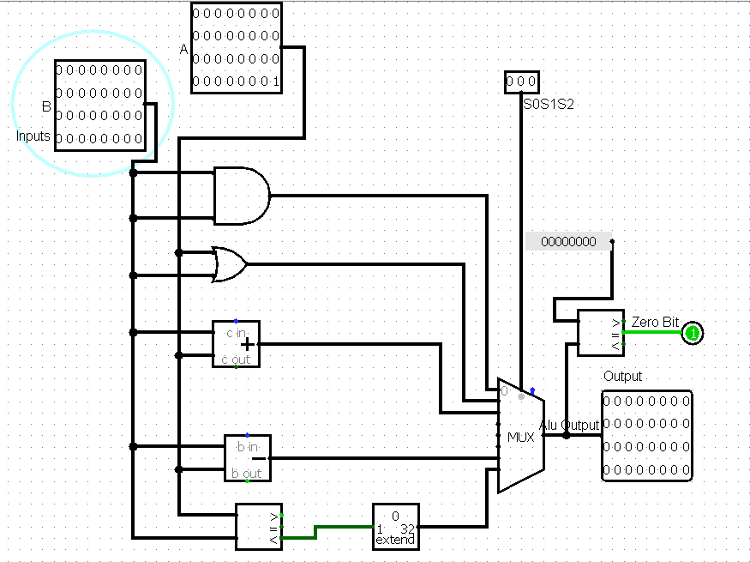

***Your Answer Here;***

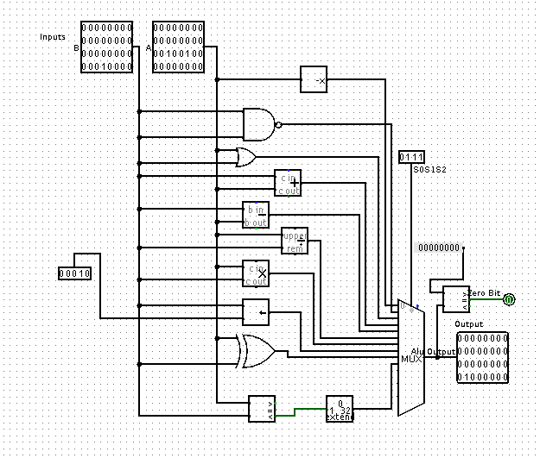

***Task 3: Perform read/write operation in the given memory block. Re-deign with a new memory size.***

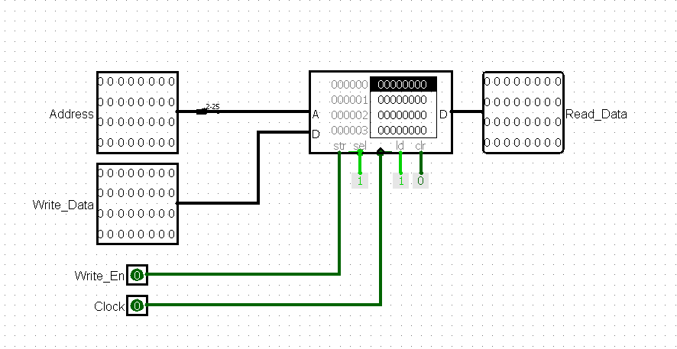

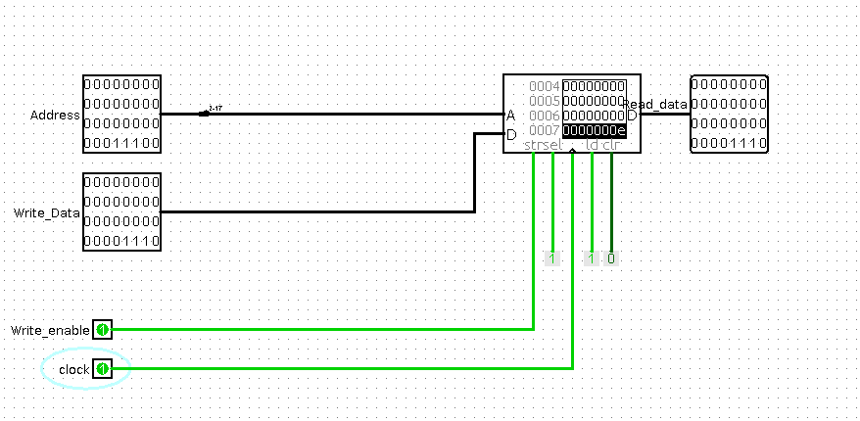

**Submission :**

Submit single doc/pdf file with above answers. Course work submission through cs322.iitp@gmail.com with subject: YourrollNo_Lab7. **Due on** 8th October 2018 , 5PM**.**