1. When to use (Rapid Application Development) RAD model. When not to use (Rapid Application Development) RAD model.

- RAD is a system development approach that employs tools, techniques, and methodologies designed to speed application development.
- It is adoption of waterfall model,it aims at developing a software in a short span of time.
- It concentrates on input output source and destination of information.
- RAD model is based on prototyping and rapid cycles of iterative development .

RAD IS USED
- When development time is critical, or when a product is needed now before things change
- When stakeholders are not sure exactly what they want other than some basic requirements
- When Quality is negotiable.
- When the customer gives priority to faster delivery rather than quality.
- Customer is looking for output and not for outcome.
- RAD should be used when there is a need to create a system that can be modularized in 2-3 months of time.
- It should be used only if high skilled resources are available in designing developing and modelling the system.
- It is only accounted if the budget is high enough to afford the cost of automated code generating tools.
- It is used in situation to accomodate changing requirements .
- It is used when the developement time is very less.
- It is used when there is a need to reuse the components.
RAD IS NOT USED:
- When stakeholders think they will save a lot of money using RAD .
- When stakeholders are not willing to compromise on Quality.
- When project management will not accept informal project deliverables .
- When the product must support or interface with other critical systems (reliability and performance are not critical)
- When highly skilled resources are unavailable.
- When system to be developed cannot be modularized.
- When budget allocated is very less.

2. Define an ER diagram of a Software Organization with all the relationship
model that was discussed in the classroom.

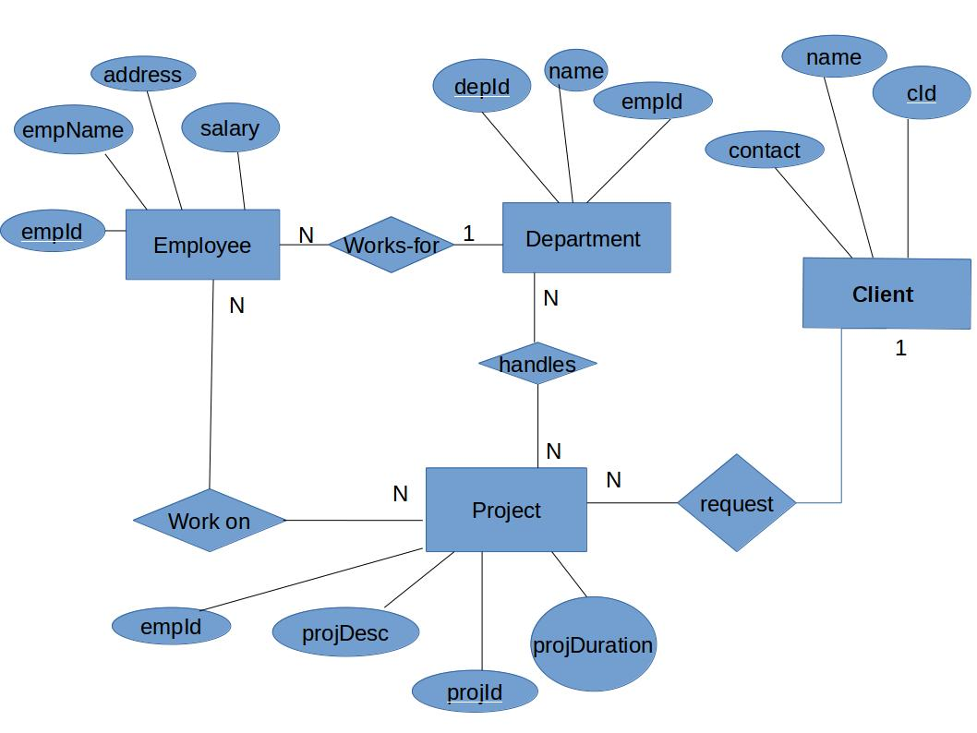

3. Describe the Entity Relationships for the following diagram

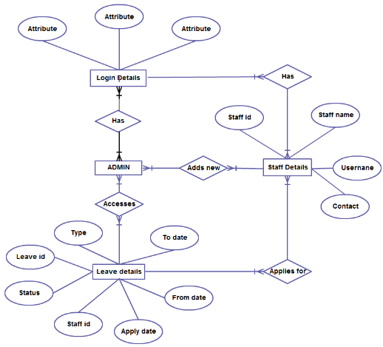

This is an Entity relationship diagram ie; a graphical representation of entities.
It contains mainly 4 entities:-
- Admin
- Login details
- Staff details
- Leave details.

An attribute characterize an entity.

- Login deatils contains 3 attributes as id,password and the captcha.

- Staff details contains 4 attributes as staff id,staff name,username and contact.
Here staff id can be a primary key.

- Leave details contain staff id,status,leave id,type,apply date,to date and from date.Here staff id can be treated as foriegn key because it is the primary key of staff details.

Relationships

Relationships are specified between the entities.

- Entity Admin has a many to many relationship with Login Details.

- Entity Admin has a many to many relationship with Leave details

- Entity Admin has a many to many relationship with staff details.Admin can add new details.

- Entity staff details has many to many relationship with Leave Details.Every staff can apply for many leaves and their will be more than one leave for each of the staff.

