AIML ZG535 | Machine Learning on Edge
LogiEdge Assignment Requirements & Submission Blueprint
Cold-Chain Edge AI Platform for FreightBridge Logistics

Purpose
This document converts the attached assignment into an implementation-ready requirements blueprint, calculation sheet, report structure, checklist and demo runbook. It does not fabricate measured model results; items that must come from your actual execution are clearly marked as MEASURE AFTER RUN.

Field | Requirement
Instructor | Pravin Yashwant Pawar
Submission mode | GitHub repository + demo video + final PDF report via LMS
Mandatory deliverables | All three are required; missing any one caps marks at 18
Final report | 2,500-3,000 words, PDF, named GROUPNO_LogiEdge_Final.pdf
Architecture rule | Offline-first edge inference; cloud-dependent architecture is not acceptable

1. Line-by-Line Requirement Traceability
Read-first principle
Every task below is traceable to the attached problem statement. Use this section as the master checklist while building the repository and final report.

ID | Requirement | Acceptance Criteria | Where to Submit
A1 | Constraint analysis | 350-500 words in final PDF: latency, bandwidth, connectivity, privacy with quantitative evidence. | Report Section 1
A2 | System architecture diagram | Truck edge node, sensors, local MQTT broker, inference pipeline, local alert log, cellular uplink, operations centre. | Report Section 1 + repo PNG
B1 | Constraint Triangle | Compare Pi+AI HAT+, Jetson Orin Nano, STM32H7; reference 90s SLA, 10W budget, fleet cost. | hardware/hardware_justification.md
B2 | Roofline analysis | AI = 45 MFLOPs / 18 MB; ridge = 16 GFLOP/s / 12 GB/s; classify bottleneck. | Report Section 1
C1 | Sensor simulator | CLI --anomaly {none,temp_drift,vibration,combined}; publish all streams to local Mosquitto. | data_pipeline/simulator.py
C2 | Preprocessing | 5-sample moving average; 30s windows step 10s; 6 features; externally saved training_stats.npy; shifted 3 sigma experiment. | data_pipeline/preprocessing.py + Phase 2 report
C3 | Feature-level fusion | Extract independent sensor features then concatenate into one 6-value vector; justify versus data-level and decision-level fusion. | Report Section 2
D1 | Dataset and model | Generate labelled windows for 20/15/15 minutes; train MLP 32/16 ReLU; validation accuracy must exceed 88%. | training/
D2 | Docker and OTA demo | python:3.11-slim; pip layers before model copy; MODEL_PATH env var; MQTT inference topic; layer-cache demo. | inference/Dockerfile + demo video
D3 | 10-stage pipeline mapping | Map each edge ML pipeline stage to LogiEdge-specific component, 1-2 sentences each. | Report Section 3
E1 | PSI drift monitoring | 4 bins; reference on 300 clean windows; rolling 100 scores; alert above 0.25; recovery below 0.10. | monitoring/drift_monitor.py + demo
E2 | Ansible playbook | Exactly 7 tasks; run twice; second run must show changed=0. | deployment/logibridge_deploy.yml + demo
E3 | OTA strategy | Evaluate full replacement, canary 10 trucks, shadow mode; calculate bandwidth at 280 KB/model and Rs 0.10/MB. | Report Section 3
F1 | Three variants | M1 FP32, M2 full INT8 PTQ >=200 calibration samples, M3 35% structured pruning + INT8. | training/models/
F2 | Benchmark five metrics | Mean latency, p95 latency, size, accuracy, energy per inference. | optimisation/benchmark.py + CSV
F3 | Deployment recommendation | Recommend model for 85 trucks; include SLA, hardware constraints, and Class 2 recall >95%. | Report Section 4

2. Quantitative Calculations to Use in the Report

2.1 Bandwidth and transmission cost
The assignment gives raw sensor rates for the bandwidth analysis: temperature at 1 Hz, vibration at 500 Hz with 3 axes, and door events as discrete events. Door events are negligible compared with vibration unless high-frequency state polling is added.
Signal | Calculation | Per day
Temperature | 1 sample/s x 86,400 s x (8-byte timestamp + 4-byte float) | 1,036,800 bytes = 1.04 MB/day
Vibration raw 3-axis | 500 samples/s x 86,400 s x (8-byte timestamp + 3 x 4-byte floats) | 864,000,000 bytes = 864 MB/day
Total raw stream | Temperature + vibration + negligible discrete door events | ~865.04 MB/truck/day
Transmission cost | 865.04 MB x Rs 0.10/MB | ~Rs 86.50/truck/day; 85 trucks ~Rs 7,352/day

Report wording to avoid assumptions
State explicitly that this is a binary-light numeric payload estimate using timestamp + float32 values. If JSON payloads are transmitted, actual bandwidth will be higher. Edge processing reduces cloud traffic to alerts and synced summaries rather than raw vibration streams.

2.2 Roofline / Arithmetic Intensity
Metric | Formula | Result
Arithmetic Intensity | 45 MFLOPs / 18 MB | 2.5 FLOP/byte
Ridge point | 16 GFLOP/s / 12 GB/s | 1.33 FLOP/byte
Bottleneck classification | AI 2.5 > ridge 1.33 | Compute-bound on Raspberry Pi 5 CPU roofline
Optimisation implication | Reduce operations or improve compute path | INT8 quantisation, pruning, vectorisation, batching discipline, or Hailo offload

2.3 Hardware fleet cost and selection
Option | Power vs 10W budget | Pilot cost 85 trucks | Full cost 265 trucks | Decision
Raspberry Pi 5 8GB + AI HAT+ | 7.5W: within power budget | Rs 12.75 lakh | Rs 39.75 lakh | Recommended: Linux, Docker, MQTT, local logging, TFLite/Hailo path, manageable cost
Jetson Orin Nano Super | 15W moderate load: exceeds stated AI budget | Rs 38.25 lakh | Rs 119.25 lakh | Reject for pilot: excellent TOPS but over power and high fleet cost
STM32H7 custom MCU | 0.4W: excellent power | Rs 2.98 lakh | Rs 9.28 lakh | Reject for this assignment deployment: too constrained for Docker/MLOps/local broker and model lifecycle requirements

2.4 OTA bandwidth cost
Strategy | Bandwidth calculation | Cost per update cycle | Recommendation view
Full replacement | 85 x 0.28 MB = 23.8 MB | Rs 2.38 | Cheap, but pushes all trucks at once; operationally risky for safety-critical cold-chain
Canary, 10 trucks first | Phase 1: 10 x 0.28 = 2.8 MB; if accepted all 85 = 23.8 MB total | Rs 0.28 first phase; Rs 2.38 after full rollout | Recommended: contains risk under rural connectivity and validates model before fleet-wide update
Shadow mode | New model sent to all 85 while old model remains active = 23.8 MB model traffic | Rs 2.38 excluding extra telemetry | Best for high assurance, but more compute/logging during shadow and slower operational cutover

3. Architecture and MQTT Design Figures
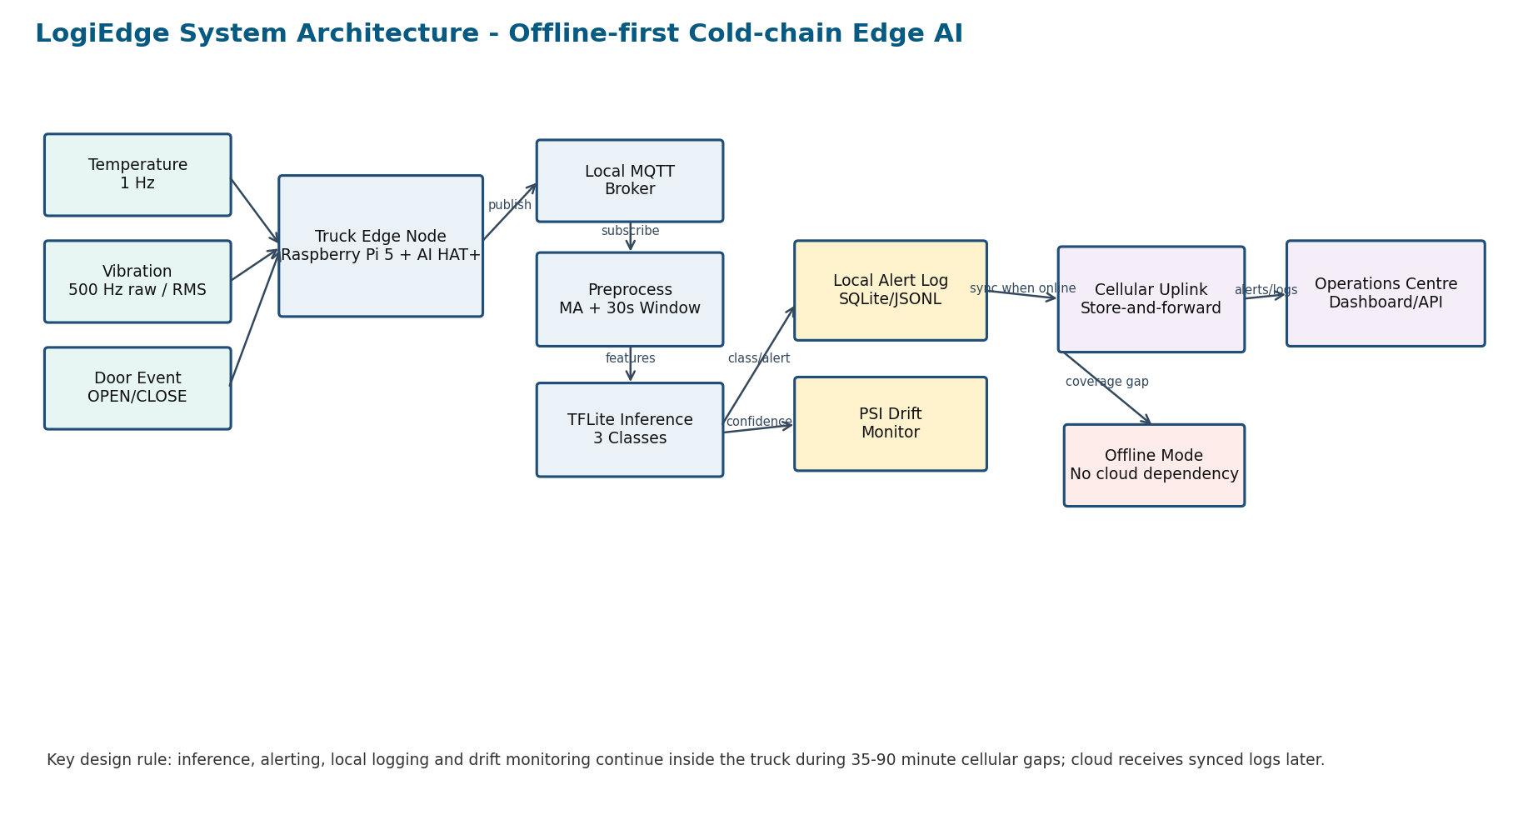
Figure 1. Offline-first system architecture to include in the final report.
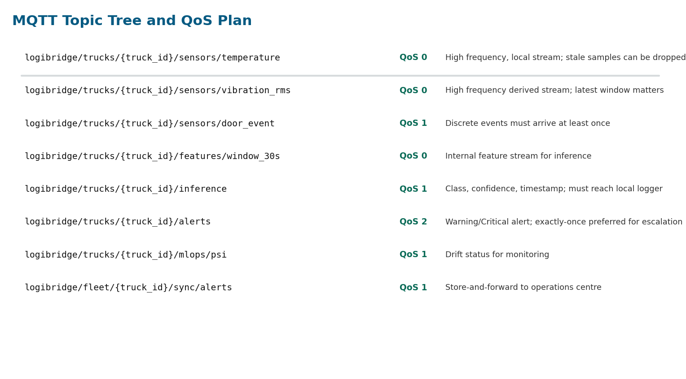
Figure 2. MQTT topic tree and QoS plan.

4. Final Report Structure: Ready-to-Fill Blueprint

1 - FreightBridge Deployment Context (400-500 words)
- Business context: 85 refrigerated trucks in pilot, scale to 265 vehicles, pharmaceutical cold-chain risk and prior incidents.
- Four constraints: latency within 90 seconds, bandwidth economics, rural connectivity gaps of 35-90 minutes, privacy through on-device inference.
- Hardware selection: recommend Raspberry Pi 5 + AI HAT+ based on 7.5W, fleet cost and deployment practicality.
- Include Figure 1 and roofline result: AI 2.5 FLOP/byte, ridge 1.33 FLOP/byte, compute-bound.

2 - Sensor Pipeline and MQTT Design (500-600 words)
- Explain simulator modes and publish streams to local Mosquitto.
- Insert MQTT topic tree and QoS reasons.
- Describe moving average, sliding window, six features, saved training_stats.npy.
- MEASURE AFTER RUN: add table comparing accuracy with correct stats versus stats shifted by 3 sigma.
- Justify feature-level fusion over raw data-level and decision-level fusion.

3 - Model Deployment and Pipeline Mapping (400-500 words)
- Map all 10 stages to actual LogiEdge components.
- Explain Dockerfile layer order and MODEL_PATH switching.
- MEASURE AFTER RUN: add Docker layer-cache demo result.
- Add OTA cost table and recommend canary strategy.

4 - Optimisation and Pareto Analysis (400-500 words)
- MEASURE AFTER RUN: benchmarking table with 3 variants x 5 metrics.
- Insert Pareto chart from optimisation/results/pareto_chart.png.
- MEASURE AFTER RUN: include Class 2 recall for recommended variant; it must exceed 95%.
- Deployment recommendation must tie back to 90s SLA, device memory/flash and accuracy.

5 - MLOps Monitoring and Reflection (300-400 words)
- MEASURE AFTER RUN: PSI values before, after combined-anomaly injection, and after recovery.
- Classify drift as covariate/operational drift based on sensor conditions.
- MEASURE AFTER RUN: Ansible second run changed=0.
- Add one genuine technical difficulty and one future architecture change.

5. Ten-Stage Edge ML Pipeline Mapping
Stage | LogiEdge Mapping
1. Data sources | Truck temperature, vibration and door-event streams generated by physical sensors or simulator.
2. Data ingestion | Local Mosquitto broker receives sensor messages; network uplink is not required for local processing.
3. Preprocessing | 5-sample moving average smooths temperature and vibration streams; windows are formed every 10 seconds.
4. Feature engineering | Each 30-second window generates six features: temperature mean/std/rate, vibration RMS/peak/kurtosis.
5. Dataset labelling | Simulator mode maps to Normal, Warning and Critical classes using assignment-provided durations.
6. Model training | 2-hidden-layer MLP with 32/16 ReLU units trained and validated with 20% held-out split.
7. Model conversion | FP32 model converted to TFLite, with INT8 PTQ and pruned INT8 variants.
8. Packaging | Inference service container includes preprocessing, runtime stats loading, model inference and MQTT publishing.
9. Edge deployment | Docker image and Ansible playbook deploy model, reference distribution and container settings to edge nodes.
10. Monitoring and update | PSI drift monitoring, alert logging, canary OTA and store-and-forward sync manage fleet lifecycle.

6. Repository Structure and File Acceptance Checklist
logibridge/
├── README.md
├── scenario_architecture/
│ ├── constraint_analysis.md
│ └── system_architecture.png
├── hardware/hardware_justification.md
├── data_pipeline/
│ ├── simulator.py
│ ├── preprocessing.py
│ ├── training_stats.npy
│ └── mqtt_architecture.md
├── training/
│ ├── generate_dataset.py
│ ├── train_model.py
│ ├── convert_ptq.py
│ ├── prune_quantise.py
│ └── models/
├── inference/
│ ├── Dockerfile
│ ├── inference_service.py
│ └── model.tflite
├── monitoring/
│ ├── drift_monitor.py
│ └── reference_dist.json
├── deployment/logibridge_deploy.yml
├── optimisation/
│ ├── benchmark.py
│ └── results/benchmark_results.csv, pareto_chart.png
└── reports/final_report.pdf
Checklist Item | Pass Condition
Validation accuracy | Greater than 88% before proceeding to conversion
Critical recall | Recommended model Class 2 recall greater than 95%
Offline operation | Inference, alerting and local logging work with cellular disabled
Docker OTA layer cache | Only model layer rebuilds when model.tflite changes
Ansible idempotency | Second run without changes reports changed=0
PSI demo | PSI crosses 0.25 within 5 minutes of combined anomaly and returns below 0.10 after recovery
Final submission | Exactly three items: repo URL, demo link, final PDF named GROUPNO_LogiEdge_Final.pdf

7. Demo Video Runbook (15-20 Minutes)
- 0:00-2:00 - Show repository structure, README, assignment traceability and environment.
- 2:00-5:00 - Start Mosquitto and simulator in normal mode; show sensor messages and preprocessing windows.
- 5:00-7:00 - Run inference service locally; show topic logibridge/trucks/{truck_id}/inference.
- 7:00-9:00 - Switch anomaly to temp_drift/combined; show Warning/Critical alert without cloud dependency.
- 9:00-11:00 - Show model training/validation result and TFLite conversion artifacts.
- 11:00-13:00 - Docker rebuild after model-only change; point out cached layers and bandwidth saving.
- 13:00-15:00 - PSI drift monitor: baseline, combined anomaly crossing 0.25, recovery below 0.10.
- 15:00-17:00 - Run Ansible playbook twice; show second run changed=0.
- 17:00-20:00 - Show benchmark CSV/Pareto chart and final recommendation.

8. Non-Fabrication Notes
What must be replaced with your own measured results
Do not submit placeholder values for validation accuracy, Class 2 recall, benchmark latency, energy, PSI plots or Ansible output. These must be generated by your own live pipeline and should match what you demonstrate in the video.

9. Critical Implementation Rules to Verify in Code
File | Rule
simulator.py | argparse must define --anomaly with exactly none, temp_drift, vibration, combined; publish to localhost broker.
preprocessing.py | Load training_stats.npy at runtime; never recompute normalization from live data.
Dockerfile | Use python:3.11-slim; pip install layers before COPY model.tflite .; MODEL_PATH env var used by inference service.
drift_monitor.py | Use four bins [0,0.25), [0.25,0.50), [0.50,0.75), [0.75,1.0]; rolling 100; alert message exact prefix.
logibridge_deploy.yml | Exactly 7 tasks matching assignment wording; second unchanged run changed=0.
benchmark.py | 200 measured runs after 10 warmups; report mean, p95, size, accuracy and E=Pxt energy.

