Trader Performance vs. Bitcoin Market Sentiment
An analysis of Hyperliquid trader behavior against the Fear & Greed Index
Prepared for: Primetrade.ai — Data Science Hiring Assignment
Prepared by: Arunima
July 2026

Executive Summary
This report examines 211,224 trade records from 32 Hyperliquid accounts across 246 tokens (May 2023 – May 2025), merged with the daily Bitcoin Fear & Greed Index, to test whether market-wide sentiment is associated with systematic differences in trader performance, positioning, and risk behavior.
The headline finding is counter-intuitive: traders in this dataset performed best during Extreme Greed and ordinary Fear regimes, and worst during Extreme Fear — the opposite of the popular "buy when others are fearful" narrative. Trader skill (account-level) also explains far more of the variance in outcomes than sentiment regime does, suggesting sentiment is a secondary, tactical signal rather than a primary strategy driver.

Key Numbers at a Glance
Metric | Extreme Fear | Fear | Neutral | Greed | Extreme Greed
Trades (closed) | 10,406 | 29,808 | 18,159 | 25,176 | 20,853
Win rate | 76.2% | 87.3% | 82.4% | 76.9% | 89.2%
Avg PnL / trade | $71.03 | $112.63 | $71.20 | $85.40 | $130.21
Total realized PnL | $0.74M | $3.36M | $1.29M | $2.15M | $2.72M
Table 1. Closed-trade PnL and win rate across the five Fear & Greed regimes.

1. Data & Methodology

1.1 Datasets
- Bitcoin Fear & Greed Index: 2,644 daily records (Feb 2018 – May 2025) with a 0–100 sentiment score and a 5-level classification (Extreme Fear → Extreme Greed).
- Hyperliquid historical trades: 211,224 execution-level records across 32 accounts and 246 coins, including price, size, side, direction, closed PnL, fees, and timestamps.

1.2 Preparation
- Parsed IST timestamps and normalized to trade date; joined trades to the sentiment index on date (99.997% match rate — only 6 of 211,224 rows had no matching sentiment record and were dropped).
- Simplified the 5-level classification into Fear / Neutral / Greed where a coarser view was useful, but kept the full 5-level breakdown for the main analysis since it revealed non-monotonic patterns the 3-level view would have hidden.
- Defined a trade as "closed" (PnL-realizing) when Closed PnL ≠ 0; roughly 49% of rows are closing trades, the rest are position-opening or zero-PnL fills.
- All dollar figures are realized PnL in USD, before subtracting fees unless noted.

1.3 Scope & Limitations
- The 32 accounts in this dataset are not necessarily representative of the broader Hyperliquid trader base — results describe this cohort, not the market as a whole.
- Sentiment is measured at the daily level (BTC-wide), while trades span 246 different coins — sentiment toward BTC is a proxy for "market mood," not a coin-specific signal.
- Correlation results below describe association, not causation; sentiment could be a coincident indicator of the same volatility that drives PnL, rather than a cause of it.

2. Finding 1 — Performance Is Non-Monotonic Across Sentiment
If sentiment purely reflected "crowd is wrong, be a contrarian," we'd expect performance to rise steadily from Extreme Greed toward Extreme Fear (buying into fear) or vice versa. Instead, the relationship is U/W-shaped: Fear and Extreme Greed are the two strongest regimes, while Extreme Fear is the weakest and Greed is middling.
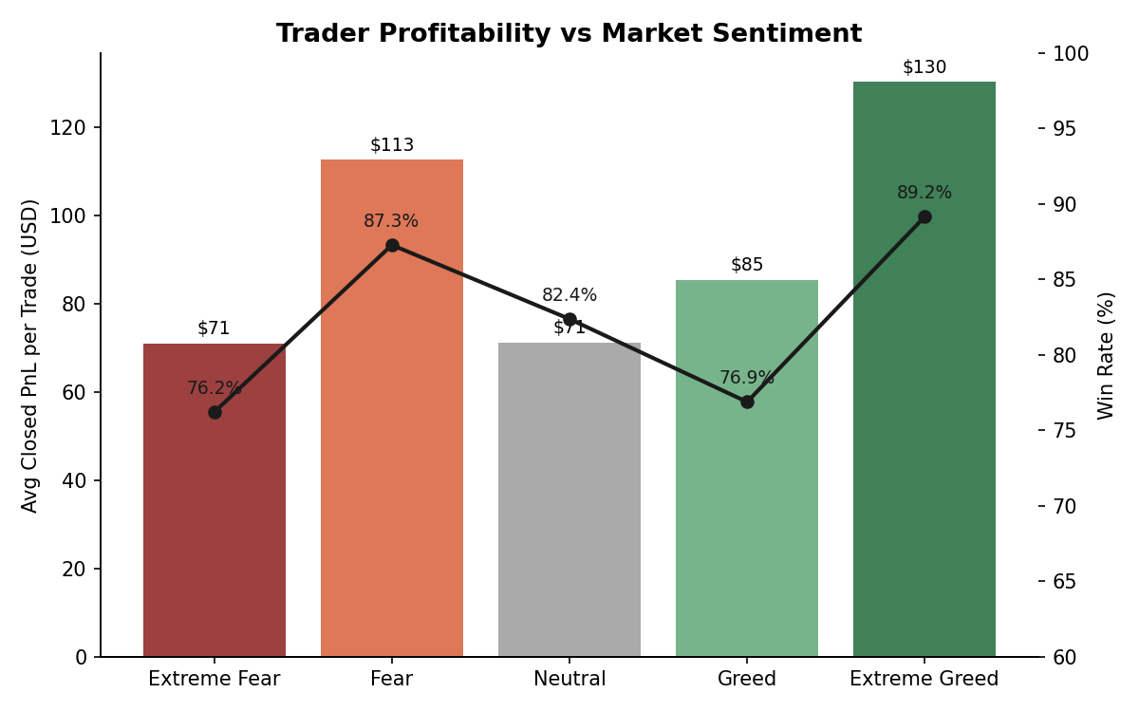
Figure 1. Average realized PnL per trade (bars) and win rate (line) by sentiment regime.
Extreme Fear produced the lowest win rate (76.2%) and among the lowest average PnL ($71.03) of any regime, despite conventional wisdom that extreme fear marks good entry points. This is consistent with extreme-fear periods being high-volatility, high-slippage environments where even directionally-correct trades get stopped out or reversed before they pay off.
Extreme Greed, by contrast, produced this dataset's best win rate (89.2%) and best average PnL ($130.21) — traders in euphoric markets in this sample were more selective and rode established trends rather than fighting them.

3. Finding 2 — Traders Cut Size and Frequency as Greed Builds
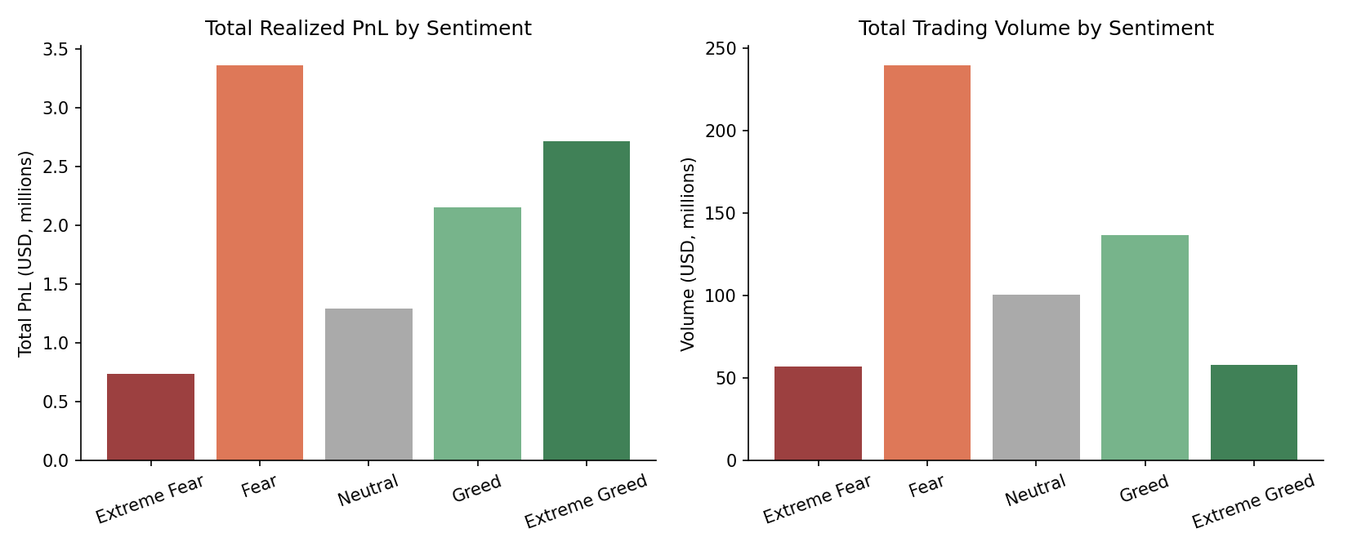
Figure 2. Total realized PnL and total trading volume by sentiment regime.
Trading volume and trade count are highest during Fear and lowest during Extreme Fear / Extreme Greed. Average trade size follows a similar pattern: it peaks at $7,816 during Fear and falls to $3,112 during Extreme Greed — less than half. Traders in this cohort appear to trade more, and bigger, when the market is moderately fearful, and pull back to smaller, more selective positions once sentiment turns euphoric — which lines up with the higher win rate observed in Extreme Greed.

4. Finding 3 — Positioning Flips from Long-Biased to Short-Biased as Sentiment Warms
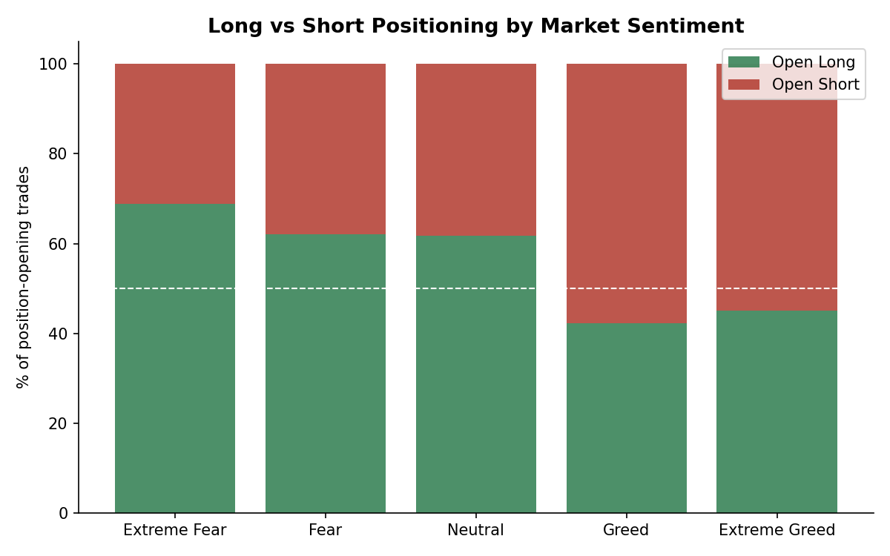
Figure 3. Share of position-opening trades that are long vs. short, by sentiment.
During Fear, Extreme Fear, and Neutral regimes, roughly 62–69% of new positions are longs. That flips during Greed and Extreme Greed, where 55–58% of new positions are shorts. This is a genuinely contrarian pattern: traders lean long while the market is fearful (or already recovering) and lean short once greed sets in — consistent with fading extended rallies or hedging into strength rather than chasing it.
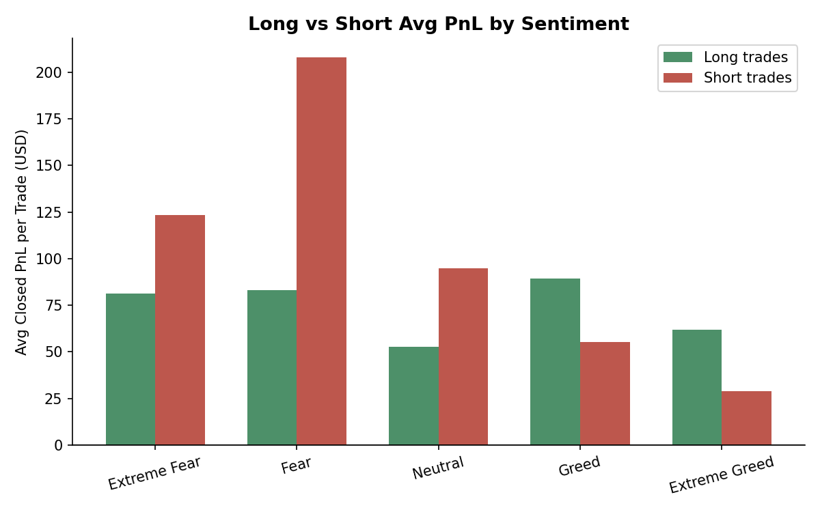
Figure 4. Average PnL per closing trade, split by long vs. short, across sentiment regimes.
The profitability of that positioning is regime-dependent. During Fear, short trades were far more profitable on average ($207.88) than longs ($83.00) — the minority short positions taken during fear paid off disproportionately. During Greed and Extreme Greed, longs outperform shorts ($89.35 vs. $55.21, and $61.84 vs. $29.01 respectively), meaning the majority-long stance in calmer periods and majority-short stance in euphoric periods weren't always the higher-PnL side — sizing and selection mattered more than simple direction.

5. Finding 4 — Sentiment Score Correlates Weakly (and Negatively) with Daily PnL and Volume
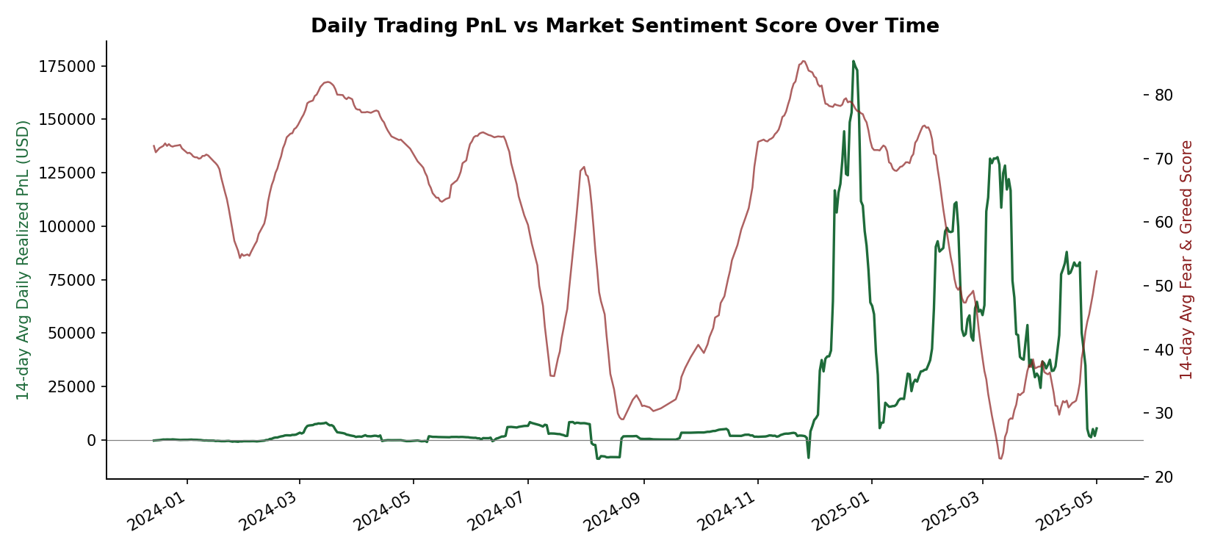
Figure 5. 14-day rolling average of daily realized PnL vs. 14-day rolling average Fear & Greed score.
At the daily aggregate level, the Fear & Greed score has only weak correlations with trading outcomes: −0.10 with total daily PnL, −0.29 with daily volume, and −0.25 with daily trade count. In other words, as the index moves toward "Greed," this cohort tends to trade less often and in smaller size — but per-trade quality (win rate, average PnL) actually improves, which is the more decision-useful signal than the raw correlation implies.

6. Finding 5 — Trader Skill Dominates Sentiment as a Performance Driver
The spread in outcomes across accounts dwarfs the spread across sentiment regimes. The best-performing account in the dataset closed $2.14M in realized PnL across 6,279 trades (avg $341/trade); the worst closed a net loss of $167,621 across 2,341 trades (avg −$71.60/trade). By comparison, the largest gap between sentiment regimes was about $59 of average PnL per trade (Extreme Greed $130.21 vs. Extreme Fear $71.03).
Account (truncated) | Trades | Avg PnL / trade | Total PnL
0xb1231a4a... | 6,279 | $341.36 | $2,143,382
0x083384f8... | 1,732 | $923.92 | $1,600,230
0xbaaaf657... | 9,997 | $94.04 | $940,164
0x8170715b... (bottom) | 2,341 | −$71.60 | −$167,621
0x271b2809... (bottom) | 1,607 | −$43.83 | −$70,436
Table 2. Top and bottom accounts by total realized PnL — the account-level spread is roughly 40x larger than the sentiment-regime spread.
This means sentiment is best used as a tactical overlay — adjusting size, selectivity, or side — rather than as a standalone strategy. A skilled trader following their edge across all regimes will outperform an unskilled trader trying to time sentiment.

7. Finding 6 — Coin-Level Behavior Is Highly Regime-Dependent
Individual tokens swing between best- and worst-performer status depending on the sentiment regime, which argues against a one-size-fits-all coin selection rule. A few examples from tokens with at least 50 trades in a given regime:
- ETH was among the best performers during Extreme Fear (avg $349.90/trade) but a net loser during Extreme Greed (avg −$58.93/trade, on 713 trades).
- SOL was the top performer during Greed (avg $890.91/trade across 507 trades) and strong during Neutral, but wasn't a standout in fear regimes.
- TRUMP swung from the best avg PnL during Extreme Fear ($421.84/trade) to the worst during Greed (−$1,173.21/trade, a $432,915 aggregate loss) — consistent with a high-beta, sentiment-driven token.
- FARTCOIN was a consistent loser across both Extreme Fear and Fear regimes, suggesting persistent weak performance for that token regardless of broader sentiment.

8. Strategic Recommendations
- Treat Extreme Fear with caution rather than as an automatic buy signal: this cohort's worst win rate and near-worst average PnL both occurred here, likely due to elevated volatility and whipsaws. If entering, favor smaller size and wider risk tolerance.
- Lean into Fear (non-extreme) and Extreme Greed regimes for size: these two regimes produced the strongest win rates (87–89%) and PnL in the dataset. Extreme Greed in particular rewards a selective, lower-frequency approach — quality over quantity.
- Watch the short side during Fear: short trades meaningfully outperformed longs during Fear regimes ($207.88 vs. $83.00 avg PnL) even though longs were the majority position — a systematic mismatch worth investigating further (e.g., are the profitable shorts concentrated in a few accounts or tokens?).
- Use sentiment as a position-sizing / selectivity dial, not a directional strategy on its own — the account-level skill gap is ~40x larger than the sentiment-regime gap, so edge and risk management matter more than sentiment timing.
- Apply regime-aware, coin-specific rules rather than static coin picks: tokens like TRUMP and ETH show performance that flips sign across sentiment regimes, so a coin that works in Fear may need to be avoided or hedged in Greed.

9. Suggested Next Steps
- Build a per-account sentiment-sensitivity score to identify which traders' edges are genuinely regime-dependent versus sentiment-agnostic.
- Extend the sentiment signal beyond BTC-wide daily values (e.g., coin-specific momentum, funding rates, realized volatility) to sharpen the coin-level findings in Section 7.
- Test whether the Fear/Extreme-Greed "sweet spot" and Extreme-Fear underperformance persist out-of-sample as more recent Fear & Greed data becomes available.
- Investigate the Fear-regime short-side outperformance at the trade level to see if it is driven by a small number of large, well-timed trades or a broad pattern.

Full analysis code, intermediate tables, and chart-generation scripts accompany this report as separate files.

