-WATER FLOW MONITORING AND LEAKAGE DETECTION

Submitted by,
Arunima V S (12406028)
Lekshmi V (12406067)
Arya M R(12406033)
Ameena M (12406009)
CONTENTS

- Abstract
- Introduction
- System Analysis
- Existing System
- Proposed System
  - 1.Sensor Module
  - 2. Hardware Implementations
  - 3.Software Specifications
  - 4. IoT communication and computation
  - 5. Actuation
- Hardware Connection
- Literature Survey
- Conclusion
- References

ABSTRACT

The project aims at developing a leakage detection mechanism for the municipality pipelines.
The developed product is placed near to the check valves, which contains a microcontroller system along with a NRF module which is used for the communication between the modules. This information is obtained from the sensors placed near the device or near to these check valves. When the microcontroller gets the required sensor output, i.e., when a leakage is detected, it sends a notification through a web page to the concerned authorities about the issue and the information about the leakage, is pushed onto the cloud and is updated on a web server. This server is referred when the notification is received for the location, leakage rate and valve position.
The authorities can take the required measures if the leakage is below a particular level and through the web server the intensity of the leakage is highlighted. If the leakage is above a particular threshold value, then the check valve is automatically closed and the supply is abruptly cut.
The project aims at developing a system which can identify the leakage near the areas where the product is placed and notify the authorities or close down the valves as and when required. Also, an automated water flow regulation system is also incorporated.

INTRODUCTION

Pipeline connections are subjected to cracks and leakage of water through these pipelines are a major source of loss for the government as of today. A device which can properly detect the location of the leakage and any measure to stop it immediately can lead to an efficient way to rectify the problem.
Initially, the developed product is placed near a point, say the check valve with all the connections established. Sensors are placed near these valves of which the outputs are given to the microcontroller system. Sensors are placed which detect the presence of water and distinguishes it with rain water.
These outputs are fetched by the microcontroller system which then pushes this information onto the cloud. This information is extremely useful as the location and frequency of the damage can easily be identified. A web server is constantly updated with the information about the leakage. This contains the location, flow rate, position of the valve and the information about the leakage..
The flow rate is identified using a flow meter using a bypass tube and the difference in the flow between two check valves is found out.The check valves are operated such that the flow rate can be controlled and the valves can be automated. The intensity of the leakage is highlighted in the server. If the leakage is above a threshold value, the check valve near to it, the information about which is retrieved from the database, is automated and closed down so that the water supply is cut. According to the requirements, regulation of the water flow is also provided. This automation brings greater ease to control the water flow for the works or for any other requirements without manual labour.

SYSTEM ANALYSIS

EXISTING SYSTEM
The existing system has :
1.Smart Ball
2.Sahara Pipeline Inspection System
Both technologies working on live pipes provide information on structural defects in the pipeline. The information coded in the Smart Ball can be decoded once it is taken out of the pipeline.
1.Smart Ball
Smart Ball is a free-swimming acoustic leak detector capable of detecting very small leaks. The cost of one such ball is about Rs. 6.5 lakhs and has a spongy texture with a diameter of about 150 mm. It can be used only in pipelines that are not less than 350 mm in diameter
Smart Ball will be inserted only after the successful insertion and retrieval of a dummy ball at the marked points.
The disadvantages of the system include :
Inability to pinpoint the leak location, and the high rate of false alarms. These systems are also very expensive for monitoring a large network of pipes.

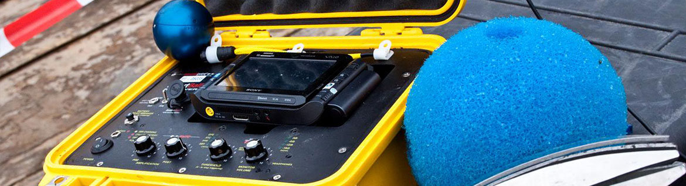

2.Sahara Pipeline Inspection System
The Sahara system is inserted into a live pipeline through a clear bore tapping with a minimum diameter of 1-7/8 inches. The insertion assembly is attached to a 2-inch full port valve with a 2-inch female NPT connection. The sensor is propelled by the flow of water using a drag chute that carries the tethered sensor head through the pipeline for distances up to 6,000 feet per insertion as the data cable is unreeled from the cable drum. Common entry points include existing air valves or gauging points (flow/meter taps).
The acoustic signal processor equipment and software provides the primary operator the ability to monitor and analyze the data collected from the Sahara sensor in real time. This allows for near real-time reporting of acoustic anomalies detected in the pressurized pipeline. The acoustic signal processor software also converts the audio signal into visual form, displaying the signal amplitude, signal frequencies, head position, and velocity, allowing the operator to distinguish pipeline features, isolate acoustic anomaly locations, estimate leak magnitude qualitatively, and provide the limits of pockets of trapped gas. The precise location of an acoustic anomaly is identified by positioning the sensor within the pipe and simultaneously positioning the Sahara Locator directly above the sensor head, allowing for above-ground location. The location of an acoustic anomaly can also be referenced using the Sahara encoder equipment to provide an accurate measurement of events from the point of insertion, or from the nearest pipeline appurtenance, such as an elbow or known feature.
Drawbacks of these methods include the necessary experience needed by the operator. The method is not scalable to the network range since the procedure is very slow.
More sophisticated techniques use acoustic correlation methods, where two sensors are placed on either side of the leak along a pipeline. The sensors bracket the leak and the time lag between the acoustic signals detected by the two sensors is used to identify and locate the leak . This cross-correlation method works well in metal pipes. However, a number of difficulties are encountered in plastic pipes and the effectiveness of the method is doubtful .



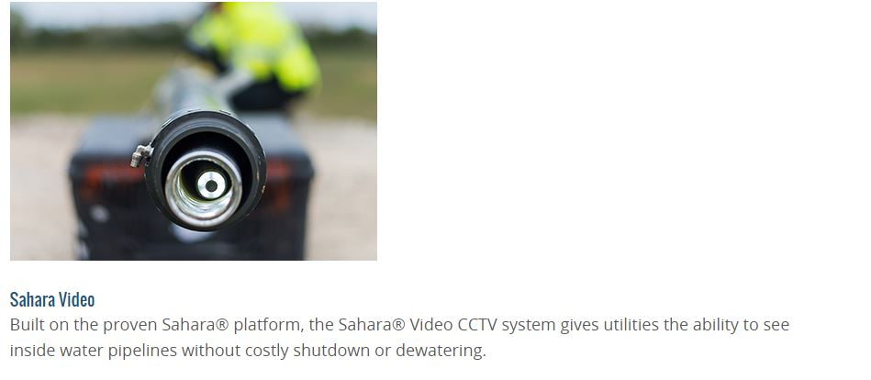

PROPOSED SYSTEM
Our proposed model is a flow control system that consists of
1.Sensor Module
2. Hardware Implementations
3.Software Specifications
4. IoT communication and computation
5. Actuation
1.Sensor module
The system aims to check the amount of water flowing in between two check valves . The water flow from the main pipe will be at a constant rate that any considerable change in flow rate from one valve to the next makes it evident about the water leakage(taking into consideration the size of pipe).
Also, leakage detecting sensors are attached to the pipe in between the check valves to detect any considerable amount of leakage and to ensure that it is municipal water and thereby confirming the leakage.
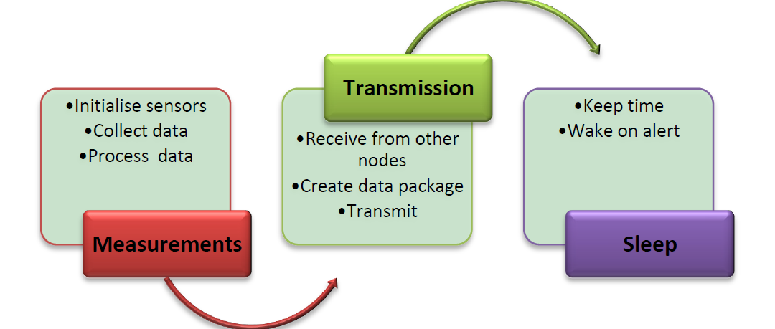
Sensor node routine
2.Hardware implementations
All the sensor modules are connected to the microcontroller. Controller detects the amount of water flowing in between the check valves and the water flow rate at each check point which is updated onto the cloud from time to time.
Sensor modules attached to different points of pipe to detect any moisture content on the pipe. If any moisture content is detected it checks for the time taken by the electrodes placed above and below, to detect the presence of water, thus identifying the difference between rain water and municipal water.
water and any considerable amount of leakage is pushed onto the cloud for further analysis.
3.Software Implementation
Sensor Module :
Number of sensors used-3
- Flow meter using bypass tube

- Moisture detection sensor
The Raspberry Pi connected to a display device is used as the cloud for the updation and storage of information.
This includes:
(i)Database -
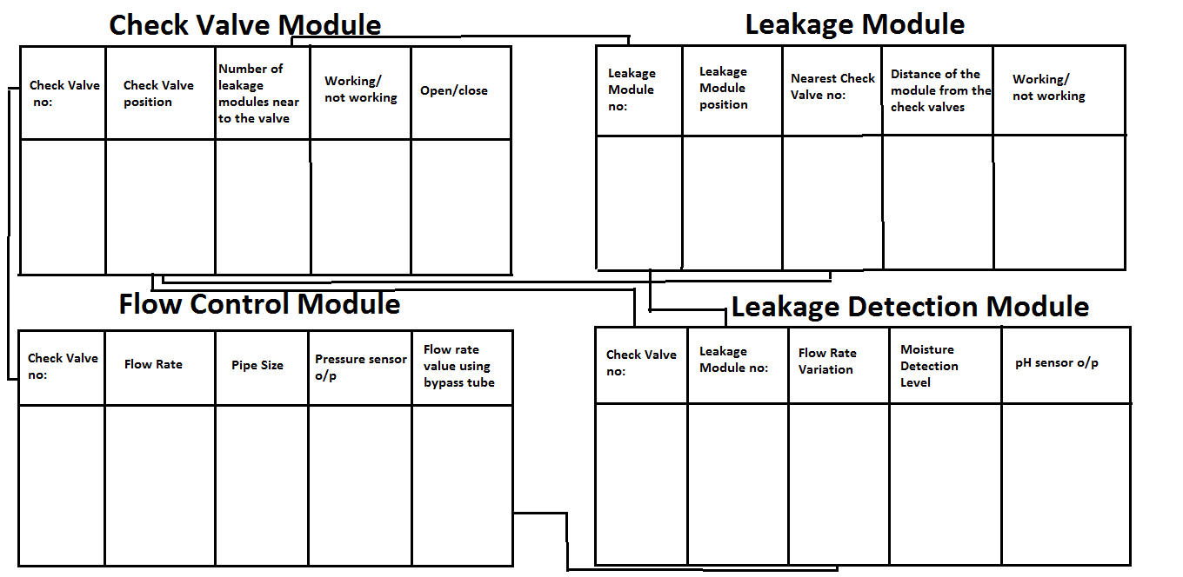
(ii)Web-Application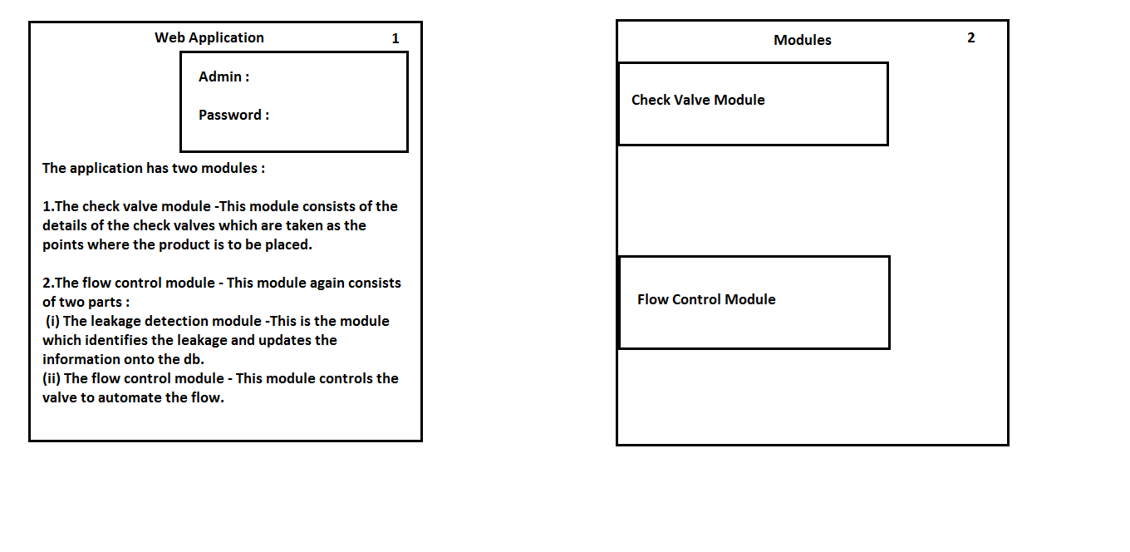
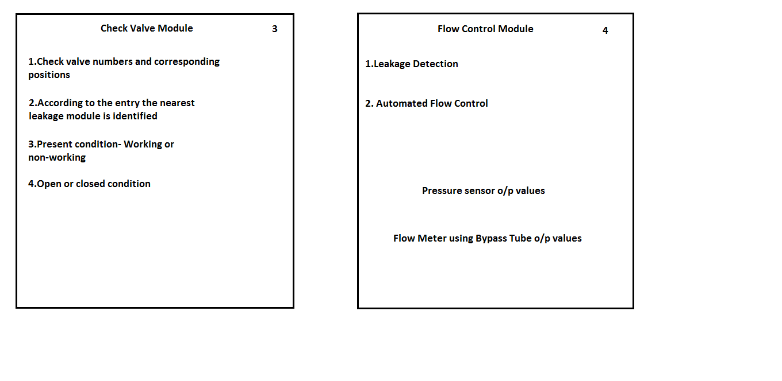
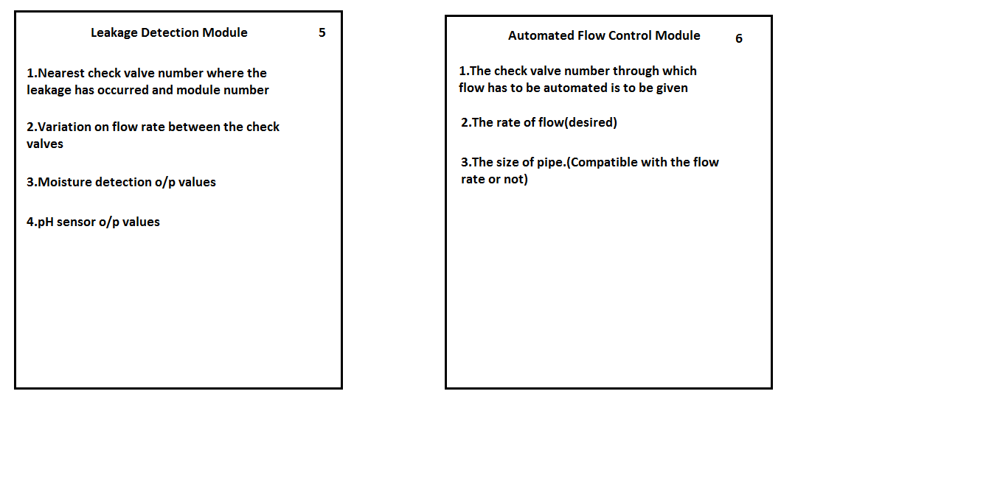
4.Communication and computation
All the data from the hardware is pushed on to a cloud via the wifi module. The data in cloud is retrieved to compute overall performance of pipeline at various check points. The server is already updated with the name of leakage detecting modules attached to several points of pipe and also the distance of each sensor module from the check valves.
Water will be flowing at a constant rate from the main pipe which is initially noted down by the primary stakeholder. Water flow at each points is compared with the flow rate from main pipe according to the size of pipe through which the water flows.
The amount of water that reaches the second check valve is considered and compared with initial flow rate which when is noted to decreased proves the evident presence of a leakage.
Further the values in the cloud updated from sensor module attached to the points of pipe is checked to detect the leakage point.
Proposed wireless sensor network model
5. Actuation
The actuation part enables the automation of the check valve nearest to the sensor module that detects the leakage. When there is a leakage detected and if it is above a threshold value, then there is a need to close down the nearest check valve for the work and for not allowing the water wastage.
Now, the water authority gets a clean information about the point at which the leak has occurred and also the information about the check valve to continue the rest of the works. Also because the check valve gets automatically closed when there is an intense leakage, the wastage is optimized.
This part also enables flow control so that the amount of water flowing through a particular check valve can be automated and controlled as per the requirements.
Advantages
- Real time municipality pipeline leakage detection
- Leakage point detection to enable a quick maintenance work.
- Check valve automation to enable flow control.
- Reduce the tedious ,time consuming work of manual closing of check valve underground which affects the public conveyance as well.
- Maintaining a well developed data server that can be efficiently used to give a track of pipeline path.

HARDWARE CONNECTIONS

The system contains three sections :
- Wireless Transmission Module -1
The transmitter block collects the sensor values and send it to the reception module over an NRF module.
The main parts in the transmitter section are
- UNO board
- Power Transformer
- NRF Module (Transmitter)
2) Wireless Transmission Module - 2
The main parts in the transmitter section are
- Arduino UNO
- NRF Module (Transmitter)
3) Wireless Reception Module (Internet-enabled)
This reception module receives sensor data through NRF module and sends it to cloud.
This block contains parts such as
- Arduino Atmega-2560
- NRF module (reception)
- ESP module

Powering(Transformer)

LITERATURE SURVEY

Leaks waste both a precious natural resource and money. A large percentage of water usually is lost from the distribution systems in transit from the treatment plant to the consumer. According to an inquiry made in 1991 by the International Water Supply Association (IWSA), the amount of lost or unaccounted for water is typically 20 to 30 percent of total water production. Some distribution systems, mostly older ones, may lose as much as 50 percent. The primary economic loss comes from the cost of raw water, its treatment, and transportation. Leakage inevitably also results in secondary economic loss in the form of damage to the distribution network itself (e.g. erosion of pipe bedding and major pipe breaks) and to the foundations of roads and other manmade structures. Leaky pipes also create a public health risk, as every leak is a potential entry point for contaminants if pressure should drop in the system. Economic cost and scarcity of public water sources mandate that a systemic leakage control program be developed. In such a program, there are two components: water audits and leak detection surveys. Water audits measure water flow into and out of the distribution system, or parts of it, and to help identify those parts of the distribution system that have excessive leakage. However, water audits do not identify the specific location of a leak. To find the specific location needing repair, a leak detection survey must be performed (Hunaidi et al., 2000).

Detection of fluid loss due to leakage from underground distribution pipes represents a major challenge to scientists and engineers. The key to the solution is threefold: selection of the right combination of sensing equipment, proper adaptation of procedure for each field operation, and data analysis. Since each problem is unique considering soil conditions, type of distribution system, groundwater conditions, and intensity of the leak, it is essential that a pre-tested combination be used to effectively devise the appropriate corrective measures in the shortest possible time. Testing and guessing in the field might rush a wrong decision. Bose and Olson (1993), Carlson (1993), and Turner (1991) classified the leak detection methods in three groups which may be applied to monitor the integrity of a pipeline (Zhang,
1996). These are:

Biological Methods: Experienced personnel or trained dogs may detect and locate leaks by visual inspection, order or sound.

Hardware-Based Methods: Different hardware devices are used to assist in the detection and location of leaks. Typical devices used include acoustic sensors, gas detectors, negative pressure detectors and infrared thermography.
detect leaks in a pipeline. The complexity and reliability of these packages
Software–Based Methods: Various computer software packages are used to vary significantly. Examples of these methods are flow/pressure change detection, mass/volume balance, the dynamic model-based system, and pressure point analysis.

Acoustic equipment (a Hardware-Based method) is the most used among the leak detection methods. In general, it has a fair percentage of success in metal pipes, however, the effectiveness of this traditional method for plastic pipes is limited. The equipment was developed primarily for metal pipes, however the acoustical characteristics of leak signals in plastic pipes are not as pronounced as in metal pipes. This has prompted an extensive investigation of the
effectiveness of acoustic methods and the potential of alternative non-acoustic methods for leak detection in plastic pipes (Hunaidi and Giamou, 1998). This, if combined with the large increase of using plastic pipes in the water distribution system, makes the problem more acute and significantly more challenging. This leads to the increased need for development of noninvasive techniques to explore and retrieve information about the subsurface, either to obtain the soil conditions or to locate specific targets. To this end, the trend is toward development of more and more sophisticated systems like the ground penetrating radar (GPR) technique, which is safe for use in urban environments, as well as protecting the geological, environmental and archaeological integrity of subsurface settings (Gamba and Lossani, 2000).

EXISTING SYSTEMS

1.GPR:

The GPR geophysical method is a rapid, high-resolution tool for non-invasive subsurface investigation. GPR produces electromagnetic radiation that propagates through the ground then returns to the surface. The radar waves travel at velocities that are dependent upon the dielectric constant of the subsurface. Reflections are produced by changes in the dielectric constant due to changes in the subsurface material and/or conditions. The travel time of the electromagnetic waves as they leave the transmitting antenna into media and reflect back to the receiving antenna at the surface is a function of the depth of the reflection point and the electric properties of the media. Thus, interpretation of this reflected energy may yield information on subsurface structural variation and condition of the media. As in seismic geophysical techniques, there is a trade-off between frequency and structural resolution. The high-frequency waves produce higher resolution models at shallow depth only, whereas low frequency waves produce lower resolution models that may be located at greater depth. The choice of appropriate antenna is a target dependent on the projects goal. Data are most often collected along a profile, so that plots of the recorded signals with respect to survey position and travel-time can be associated with images of the subsurface structure. GPR signals can be collected fairly rapidly and initial interpretations can be made with minimal data processing, thereby making the use of ground penetrating radar for shallow geophysical investigation cost-effective with the least technical support (Cardimona et al., 2000).

GPR could, in principle, identify leaks in buried water pipes either by detecting underground voids created by the leaking water as it erodes the material around the pipe, or by detecting anomalous change in the properties of the material around pipes due to water saturation. Unlike acoustic methods, application of ground penetrating radar for leak detection is independent of the pipe type (e.g., metal or plastic). Therefore, GPR could have a higher potential of avoiding difficulties encountered with commonly used acoustic leak detection methods as it applies to plastic pipes (Hunaidi and Giamou, 1998). GPR could also be used as a supplement to these methods to increase accuracy in high risk areas such as high traffic streets and large structures.

With metal pipe

With PVC pipe
2.GEO PHONE
With geophone the operator detects the micro location of the leak (Figure 9, 11) by the noise "listening"
Measurements with Geophone

The operator lays down the geophone sensor directly on the ground, listens to the noise and simultaneously watches the monitor. The louder the noise, the closer is the operator to the leak. Small leaks under high pressure usually make more noise than larger leaks under low pressure (many large leaks make almost Geophone With geophone the operator detects the micro location of the leak by the noise "listening" .

SOURCE CODE

TRANSMITTER 1

#include <SPI.h>
#include <nRF24L01.h>
#include <RF24.h>
#include <RF24_config.h>
#include <EEPROM.h>
//int a = 12345;

int l1=0;
unsigned long int time1=0,time2=0,time;//time1 and time2 to measure the time delay of leakage

const int pulse =2;//port for flow sensor
int ps1,ps,pulsec=0,kp;
int flag1=0,flag2=0,flag=0;//flag for electrode 1 and 2
int sensorValue1, sensorValue2;//electrode 1 and 2

int msg[1];
RF24 radio(9,10);
int sc=55,sb=55;
const uint64_t pipe = 0xE8E8F3F3E1LL;//pipe address for NRF
void setup(void){
Serial.begin(9600);
pinMode(pulse, INPUT);

kp=0;
radio.begin();
radio.openWritingPipe(pipe);//writing it on to NRF
}
void loop(void){

sensorValue1 = analogRead(A0);//electrode 1
sensorValue2= analogRead(A1);//electrode 2

Serial.print("sensorValue1");

Serial.print(sensorValue1);
Serial.print("sensorValue2");
Serial.print(sensorValue2);
Serial.println("");

if(sensorValue2<400||sensorValue1<400)//if electrodes are wet
{
if(flag==0)
{
if(sensorValue1<500&&flag1==0)//if electrode1 is wet
{
time1=millis();//time measure of electrode 1
flag1=1;
}
if(sensorValue2<500&&flag2==0)//if electrode 2 is wet
{
time2=millis();//time measure for electrode 2
flag2=1;
}

if((flag1==1&&flag2==1)||(flag2==1))//leakage confirmed
{
time=time2-time1;

if(time<15000)//leakage confirming time delay
{
l1=1;
}

flag=1;
}

}
}

ps = digitalRead(pulse);
if(ps==1)
while(ps==1)
ps = digitalRead(pulse);//read digital high
if(ps==0)
while(ps==0)
ps = digitalRead(pulse);//read digital low

pulsec++;
if(pulsec==100)//flowrate threshold
{
pulsec=0;
kp++;//flowrate value
EEPROM.write(1, kp);
Serial.println(kp);

Serial.println("kp");
delay(1000);

String theMessage = "";

theMessage.concat("*A");

theMessage.concat(kp);
theMessage.concat(",");//*Avalue, differentiate flow rate

theMessage.concat(l1);
theMessage.concat("#");//,value# diffrentiate leak value

//write data on to NRF

int messageSize = theMessage.length();
for (int i = -1; i < messageSize; i++) {
int charToSend[1];
charToSend[0] = theMessage.charAt(i);//char by char
radio.write(charToSend,1);
}
msg[0] = 2;
radio.write(msg,1);

}
}

TRANSMITTER 2

#include <SPI.h>
#include <nRF24L01.h>
#include <RF24.h>
#include <RF24_config.h>
#include <EEPROM.h>

int l1=0;
unsigned long int time1=0,time2=0,time;//time1 and time2 to measure the time delay of leakage

const int pulse =2;//port for flow sensor
int ps1,ps,pulsec=0,kp;
int flag1=0,flag2=0,flag=0;//flag for electrode 1 and 2
int sensorValue1, sensorValue2;//electrode 1 and 2
String theMessage;
int msg[1];
RF24 radio(9,10);
int sc=55,sb=55;
const uint64_t pipe = 0xE8E8F5F5E2LL;//pipe address 2 for NRF
void setup(void){
Serial.begin(9600);
pinMode(pulse, INPUT);

kp=0;
radio.begin();
radio.openWritingPipe(pipe);//write data n to NRF
}
void loop(void){

ps = digitalRead(pulse);
if(ps==1)
while(ps==1)
ps = digitalRead(pulse);//read digital high value
if(ps==0)
while(ps==0)
ps = digitalRead(pulse);//read digital low value

pulsec++;
if(pulsec==100)//to read flow rate threshold
{
pulsec=0;
kp++;//flowrate
EEPROM.write(1, kp);
Serial.println(kp);

Serial.println("kp");
delay(1000);

theMessage = "";

theMessage.concat("*B");

theMessage.concat(kp);
theMessage.concat(",");//*Bvalue, diffrentiate kp

theMessage.concat(l1);
theMessage.concat("#");//,value# diffrentiate l1

//sending data to NRF module
int messageSize = theMessage.length();
for (int i = -1; i < messageSize; i++) {
int charToSend[1];
charToSend[0] = theMessage.charAt(i);//write char by char
radio.write(charToSend,1);
}
msg[0] = 2;
radio.write(msg,1);

}

}

RECEIVER

#include <nRF24L01.h>
#include <RF24.h>
#include <RF24_config.h> //header file for NRF module
#include <SPI.h>
#include<TESPI.h> //header file for ESP module
int msg[1];
RF24 radio(9, 53); //Atmega pins for NRF reception
TESPI esp(Serial3);
const uint64_t pipe1 = 0xE8E8F3F3E1LL;//pipe 1
const uint64_t pipe2 = 0xE8E8F5F5E2LL;//pipe 2
int f1 = 0, f2 = 1;

String theMessage = "";
void setup(void) {
Serial.begin(9600);
Serial3.begin(9600);
radio.begin();//start reading the data from NRF transmitter
esp.setWifiStationConfig("Cygnus", "icfoss123", 1);//wifi address
esp.loadWifiStationConfig();
}
void loop(void) {

Serial.println("pipe1");

f1 = 0;
radio.openReadingPipe(1, pipe1);//read data from pipe 1
radio.startListening();
theMessage = "";
while (f1 == 0)//read until f1 is 0
{
if (radio.available()) {
bool done = false;
done = radio.read(msg, 1);//read char by char
char theChar = msg[0];
if (msg[0] != 2) {
theMessage.concat(theChar);
}
else {
//communication of data from pipe 1 onto esp
theMessage.trim();
int commaA = theMessage.indexOf(','), hashA;
char leakA;
String flowA;
Serial.println(theMessage);
if (theMessage.indexOf('A') == 1) {
flowA = theMessage.substring(2, commaA);
leakA = theMessage.charAt(commaA + 1);

Serial.println("FLOW = " + flowA + " and LEAK = " + leakA);
hashA = theMessage.indexOf('#');

esp.HTTP_GET("/wm/update.php?cv_no=1&flowrate="+flowA,"smartnodes.in",80);//update data received in cloud
delay(500);
if(leakA=='1')
{ esp.HTTP_GET("/wm/update.php?lv_no=1&leak=1","smartnodes.in",80);//change parameters in cloud
delay(500);
Serial.println("leak FLOW");
}
if(leakA=='0')
{ esp.HTTP_GET("/wm/update.php?lv_no=1&leak=0","smartnodes.in",80);//change parameters in cloud
delay(500);
Serial.println("leak NO");

}

esp.HTTP_GET("/wm/get_details.php?param=cv&n=1", "smartnodes.in", 80);//collect data from NRF transmitter
delay(900);

}
theMessage = "";

f1 = 1;
}
}

}
f2 = 0;
radio.openReadingPipe(1, pipe2);//read pipe 2
radio.startListening();
theMessage = "";
delay(1000);
Serial.println("pipe2");

while (f2 == 0)
{
if (radio.available()) {
bool done = false;
done = radio.read(msg, 1);
char theChar = msg[0]; //get data character by character
if (msg[0] != 2) {
theMessage.concat(theChar); //data received from 2nd pipe
}
else {
//writing data from pipe on to ESP
theMessage.trim();
int commaB = theMessage.indexOf(','), hashB;
char leakB;
String flowB;
Serial.println(theMessage);
if (theMessage.indexOf('B') == 1) {
flowB = theMessage.substring(2, commaB);
leakB = theMessage.charAt(commaB + 1);
Serial.println("FLOW = " + flowB + " and LEAK = " + leakB);
hashB = theMessage.indexOf('#');
esp.HTTP_GET("/wm/update.php?lv_no=2&leak="+leakB,"smartnodes.in",80);//update leak value in cloud
delay(500);
esp.HTTP_GET("/wm/update.php?cv_no=2&flowrate="+flowB,"smartnodes.in",80);//update flow value in cloud
delay(500);
esp.HTTP_GET("/wm/update.php?lv_no=2&leak="+leakB,"smartnodes.in",80);
esp.HTTP_GET("/wm/get_details.php?param=cv&n=1", "smartnodes.in", 80);
}
theMessage = "";

f2 = 1;
}

}
}
Serial.println("||" + (int)esp.responseAvailable());//print response of ESP
}

WEB PAGE
- http://www.smartnodes.in/wm is the webpage created for water flow monitoring in smart cities.
- The webpage consists of the check valve points along with its location and the information about the leakage.
- It also consists of the amount of flow through the check valve.
- The automation of the check valve can be done if there is a leakage.
LOGIN PAGE
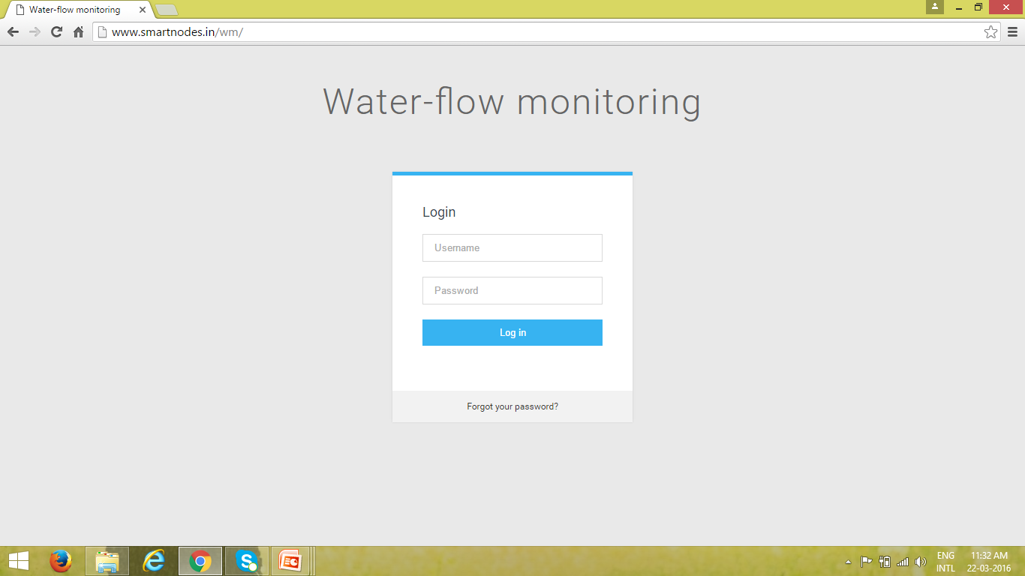

DASHBOARD
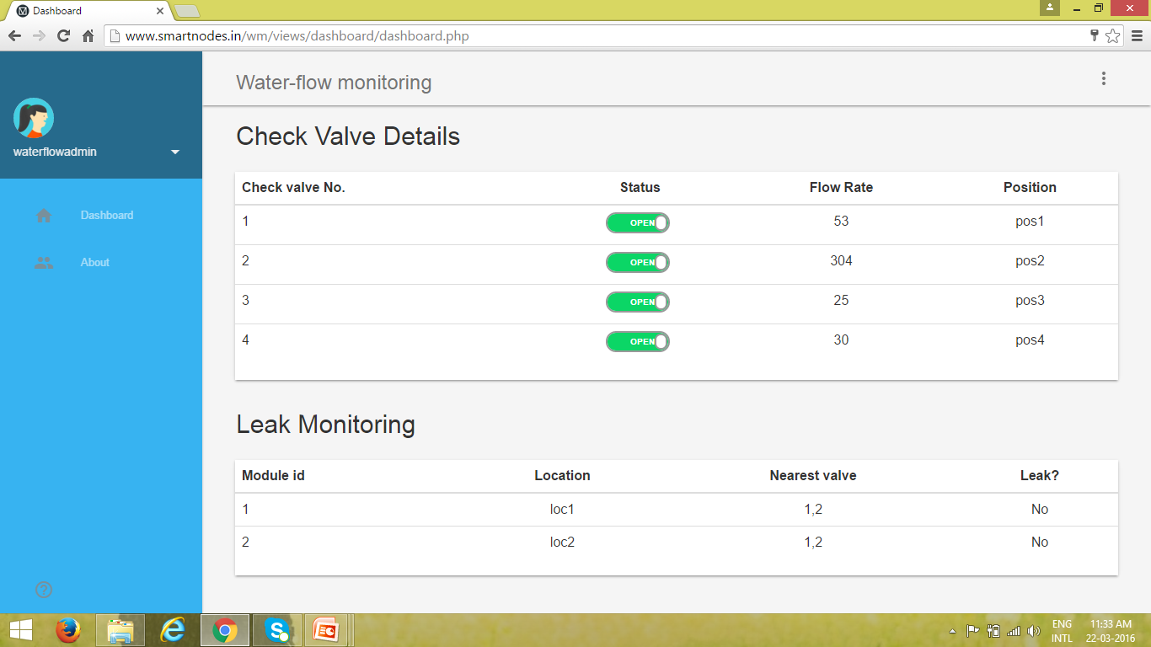
AUTOMATION
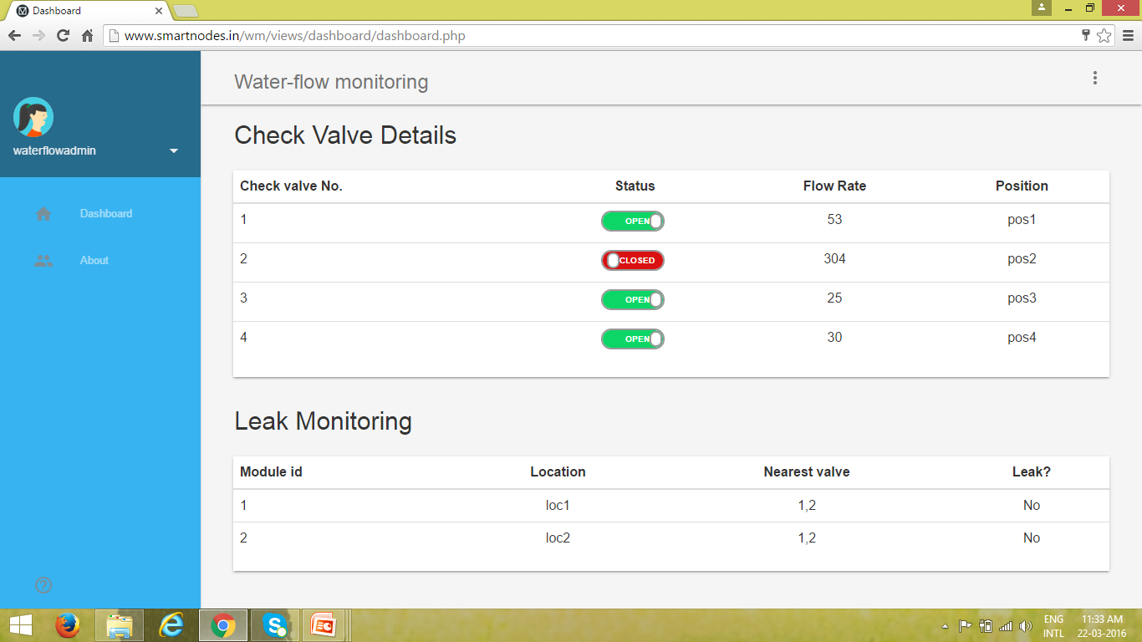

CONCLUSION
Pipeline connections can have cracks and litres of water get wasted every year and is a major source of loss for the government these days. This project aims to develop a product which effectively identifies the leakage with the help of sensors and notifies the authorities about the leakage so that effective measures can be taken by them to stop the leakage.
It also takes measures to store all the information regarding the leakage in the cloud so that this information can be fetched as and when necessary to know the frequency of leakage or crack in a pipeline in a particular location.
The check valves are automated so that flow control is achieved within the pipeline and when monitoring the flow, if there is difference found between the check valves, then the leakage is confirmed with the help of different sensors.
Together with this, it automates the valves near a point which has an intense leakage and provides check valve automation to control the water flow so that there is no manual interference and can bring greater ease at work.

REFERENCE
[1]apco-automatic-control-check-valves-cac-8000.pdf
[2]Technical Review of Leak Detection Technologies, Volume I,Crude Oil Transmission Pipelines
[3] Waspmote Plug & Sense,Sensor Guide and Flow Monitoring Product Guide
[4]Virtual DMA Municipal Water Supply Pipeline Leak nDetection and Classification Using Advance Pattern Recognizer Multi-Class SVM
[5]4th DAAAM International Conference onAdvanced Technologies for Developing Countries,September 21-24, 2005Slavonski Brod, Croatia LEAK DETECTION IN UNDERGROUND PIPELINES OFMUNICIPAL WATER DISTRIBUTION
[6]http://www.alphaleak.com/leak-detection-on-buried-pipelines/
[7] Remote Sensing Methods for Leak Detection in Water Transmission
Pipelines
[8] SmartPipes: Smart Wireless Sensor Networks for Leak Detection in Water Pipelines
[9] Leakage Detection using Fibre Optics Distributed Temperature Sensing
Ashim Mishra, Ashwani Soni ,Engineers India Limited, New Delhi, India
[10] http://bv.com/Projects/Kerala-Water-Authority-India-Water-Supply

