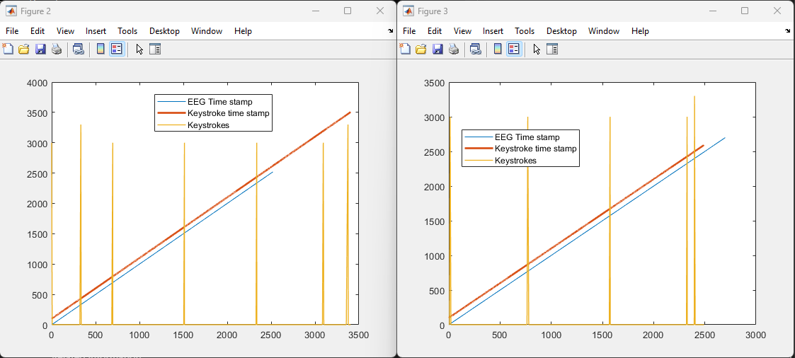

Before Experiment Break After Experiment Break

I ran into a bit of a problem with one subject, 70928. In the figure on the left, I am plotting the LSL timestamps for EEG and Keystrokes as well as F2 and F11 markers. The blue line is much shorter than the red line by almost 10 minutes. I was really puzzled by this (right plot is what I want). I did quite a bit of experimentation to see why is this happeneing, it turns out that LSL recorder keeps recording even if one of the streams has stopped midway. My conclusion is that for some reason, the emotiv stopped broadcasting over LSL towards the end. However, after the break when I restarted emotiv broadcast, it recorded everything. We are losing 1 trial in this experiment.