APPENDIX I (A typical Specimen of Cover Page & Title Page)

# StayFit

**A Project Report**  ***Submitted by***

## Arunim Debnath, Divyam Sharan Gupta, Vishal Jain

***Under the Guidance of***

## Prof. Snehal Karia ***in partial fulfillment for the award of the degree of***

## Master of Business Administration in Technology Management

**(Computer Engineerieng)**

## At



**MUKESH PATEL SCHOOL OF TECHNOLOGY MANAGEMENT AND ENGINEERING**

**March,2019**

**Annexure-II**

## DECLARATION

I Arunim Debnath, Divyam Sharan Gupta, Vishal Jain, Roll No. N010, N013, N018 MBATech IV semester understand that plagiarism is defined as anyone or combination of the following:

1. Un-credited verbatim copying of individual sentences, paragraphs or illustration (such as graphs, diagrams, etc.) from any source, published or unpublished, including the internet.
2. Un-credited improper paraphrasing of pages paragraphs (changing a few words phrases, or rearranging the original sentence order)
3. Credited verbatim copying of a major portion of a paper (or thesis chapter) without clear delineation of who did wrote what. ( Source:IEEE, The institute, Dec. 2004)
4. I have made sure that all the ideas, expressions, graphs, diagrams, etc., that are not a result of my work, are properly credited. Long phrases or sentences that had to be used verbatim from published literature have been clearly identified using quotation marks.
5. I affirm that no portion of my work can be considered as plagiarism and I take full responsibility if such a complaint occurs. I understand fully well that the guide of the seminar/ project report may not be in a position to check for the possibility of such incidents of plagiarism in this body of work.

Signature of the Students:

Names: Arunim Debnath, Divyam Gupta, Vishal Jain

Roll Nos. N010, N013,N018

Place: Mumbai

Date: 29/03/2019

Annexure-III

## CERTIFICATE

This is to certify that the project entitled “StayFit” is the bonafide work carried out by *Arunim Debnath, Divyam Sharan Gupta, Vishal Jain* of MBATech, MPSTME (NMIMS), Mumbai, during the IV semester of the academic year *2018-19*, in partial fulfillment of the requirements for the Course Programming Laboratory II/ Implementation of Technology.

___________________

<Name of the Mentor>

Internal Mentor

_______________________ ________________________

Examiner 1 Examiner 2

Annexure IV

## Table of contents

**CHAPTER NO. TITLE PAGE NO.**

1. INTRODUCTION 5
2. SOFTWARES AND API USED 5

WITH DESCRIPTION

1. METHODS IMPLEMENTED 6
2. SCREENSHOTS 7
3. CONCLUSION & FUTURE SCOPE 12
4. SOCIETAL APPLICATION 12

**INTRODUCTION**

Fitness has become a major trend these days. People have become more health conscious and as a result, the number of fitness apps in the market has increased. Majority of these app users are working class people. As one app is solely dedicated for one purpose, it becomes inconvenient for the working class to manage between multiple apps.

StayFit is designed in a way where it gives an individual’s complete fitness study, combining the best of multiple apps that exist in the market today.

**SOFTWARES AND API USED**

**SOFTWARES USED:**

* **ANDROID STUDIO**

The application is made on Android Studio using activities, layouts and icons.

**API USED:**

* **Google Maps API**

This API provides the implementation of google apps on the app.

* **Charts**

This API creates graphical charts.

* **Pedometer**

Counts the number of steps.

**METHODS IMPLEMENTED**

* **Dialog Fragment**

A DialogFragment is a fragment that displays a modal window, floating on top of the current activity window.

* **Set Date**

Get the latest system date.

* **Show Toast**

To show the various pop up notifications.

* **Change tabs**

To interchange between fragments.

* **Handle Result**

To make decisions based on real time user data fetched from database.

* **Set onClicklistener**

To perform certain actions when the button is pressed.

* **Button Click**

To specify the action of button press.

* **On Create View**

To setup the format of view

* **Find View by id**

To setup which view is to be shown upon the action taking place.

**SCREENSHOTS:**

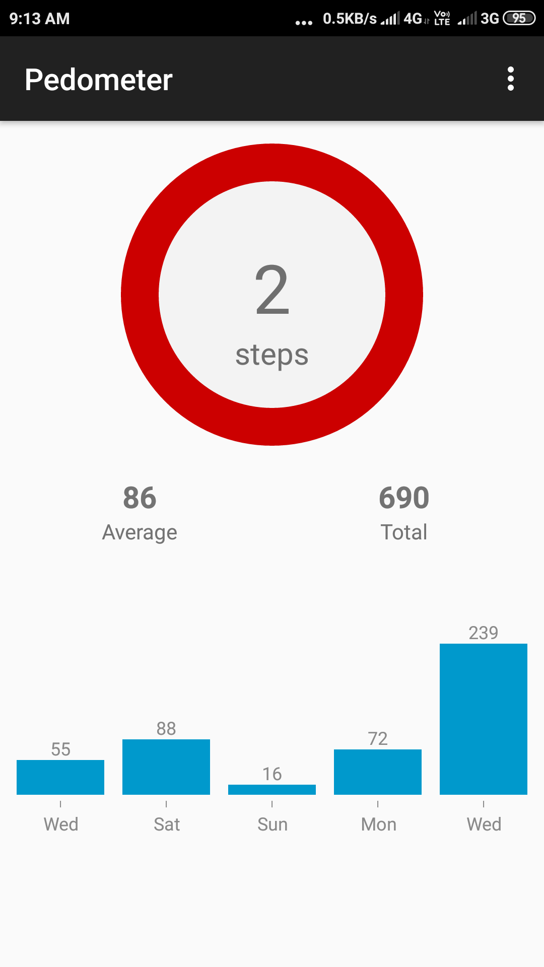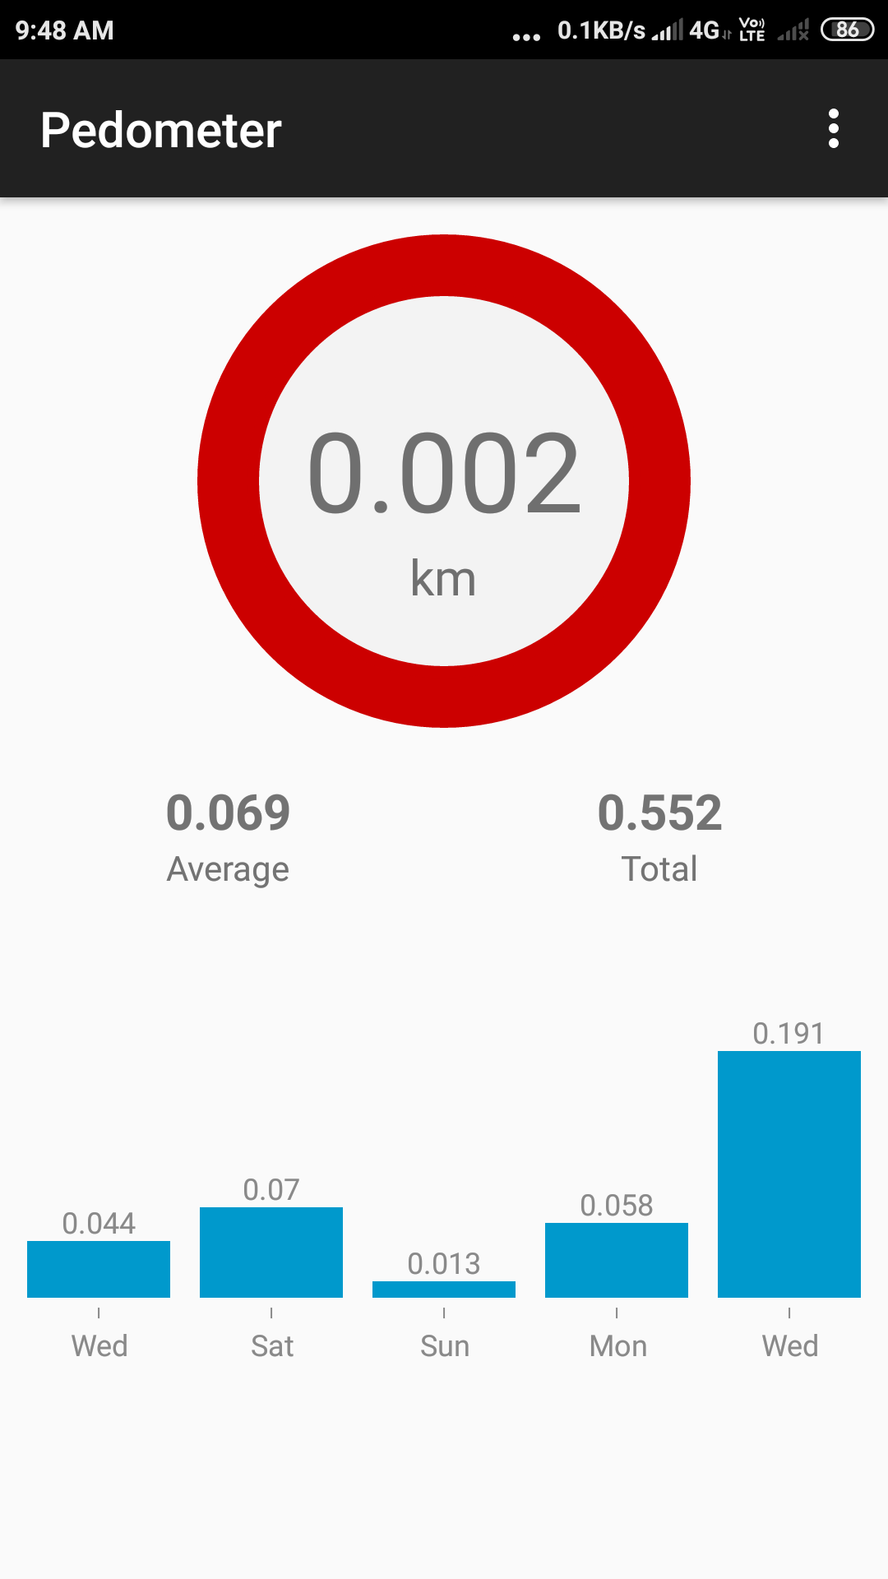

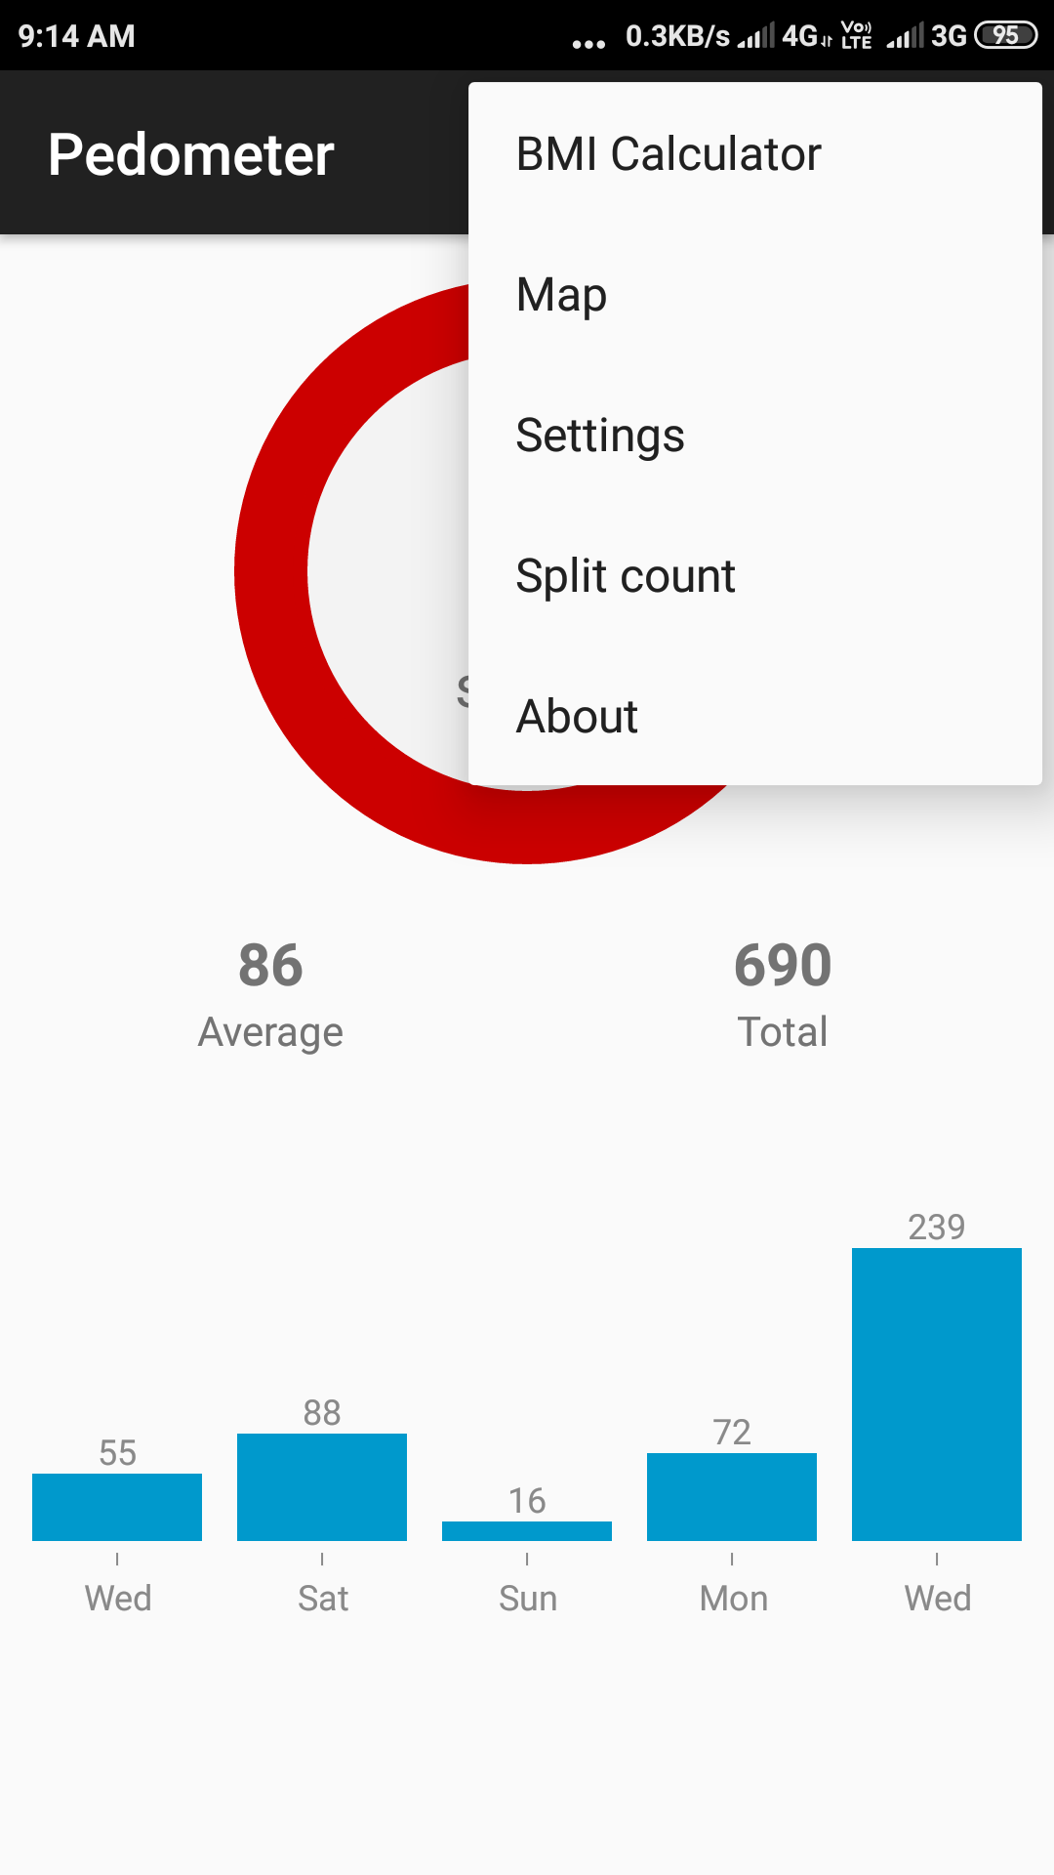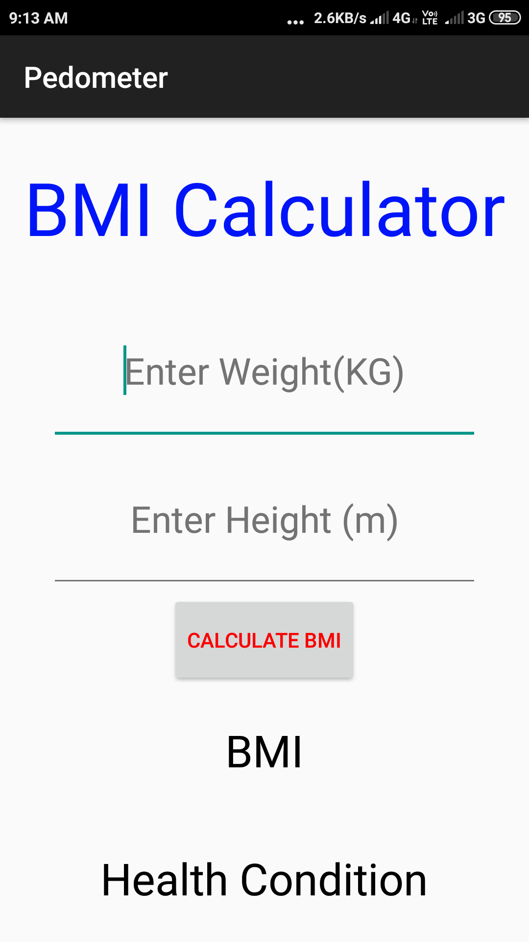

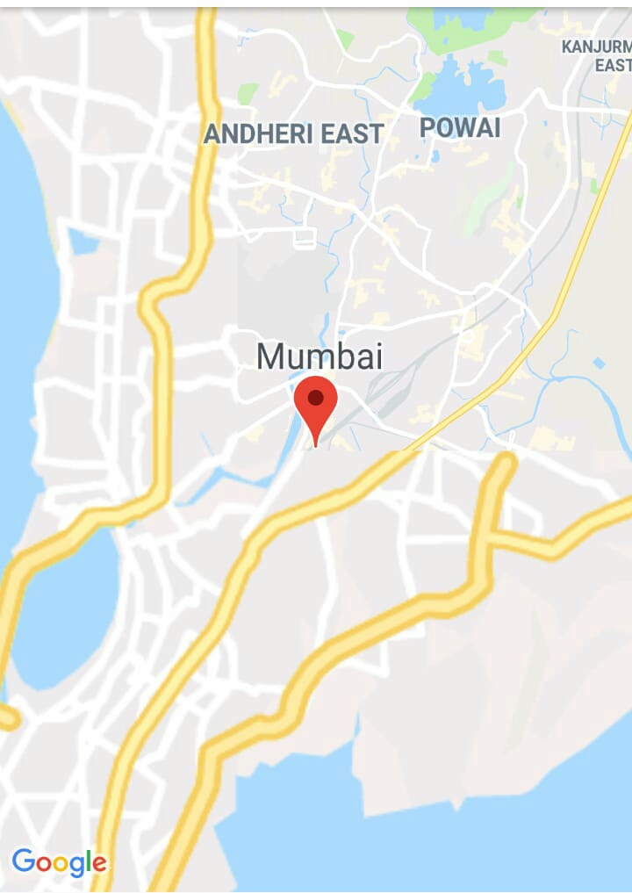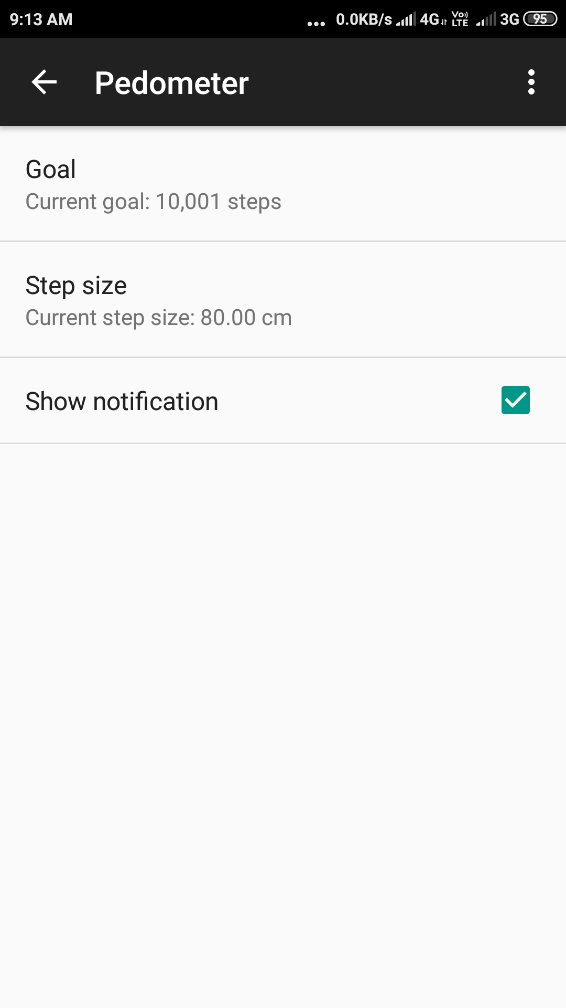

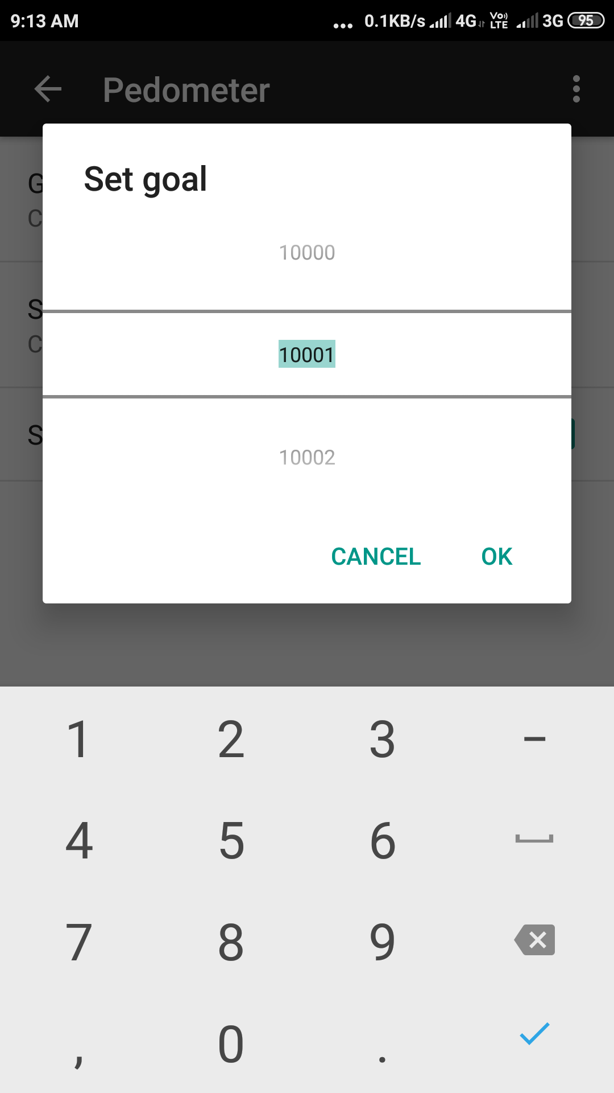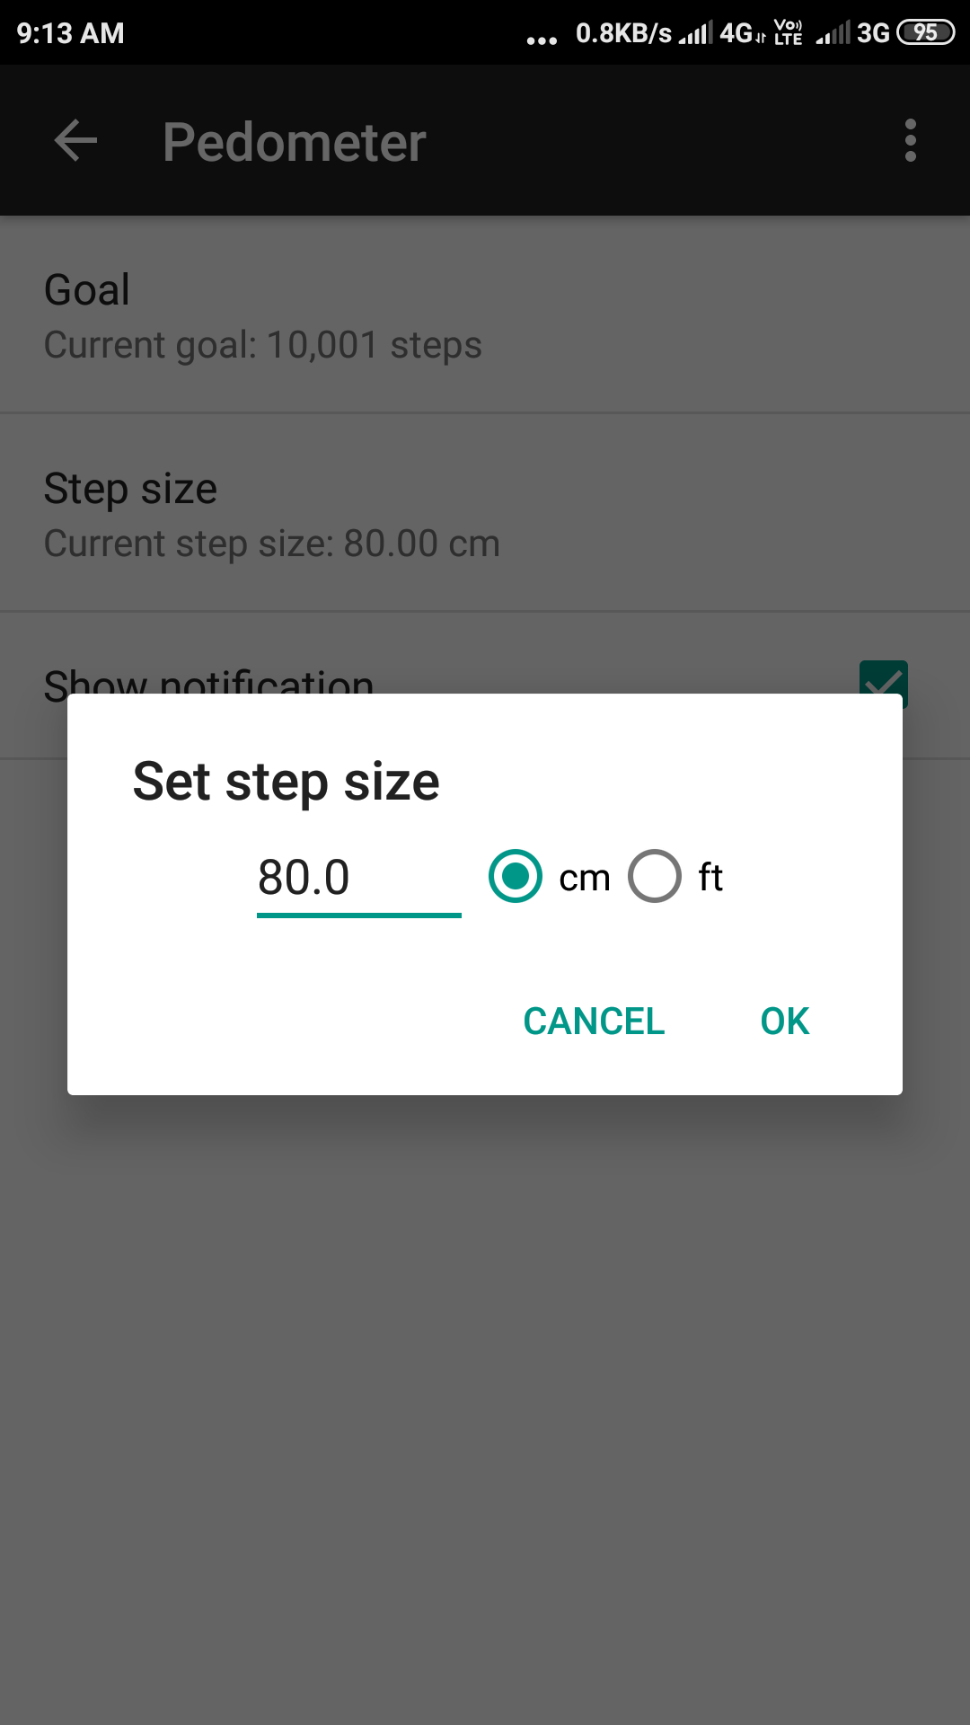

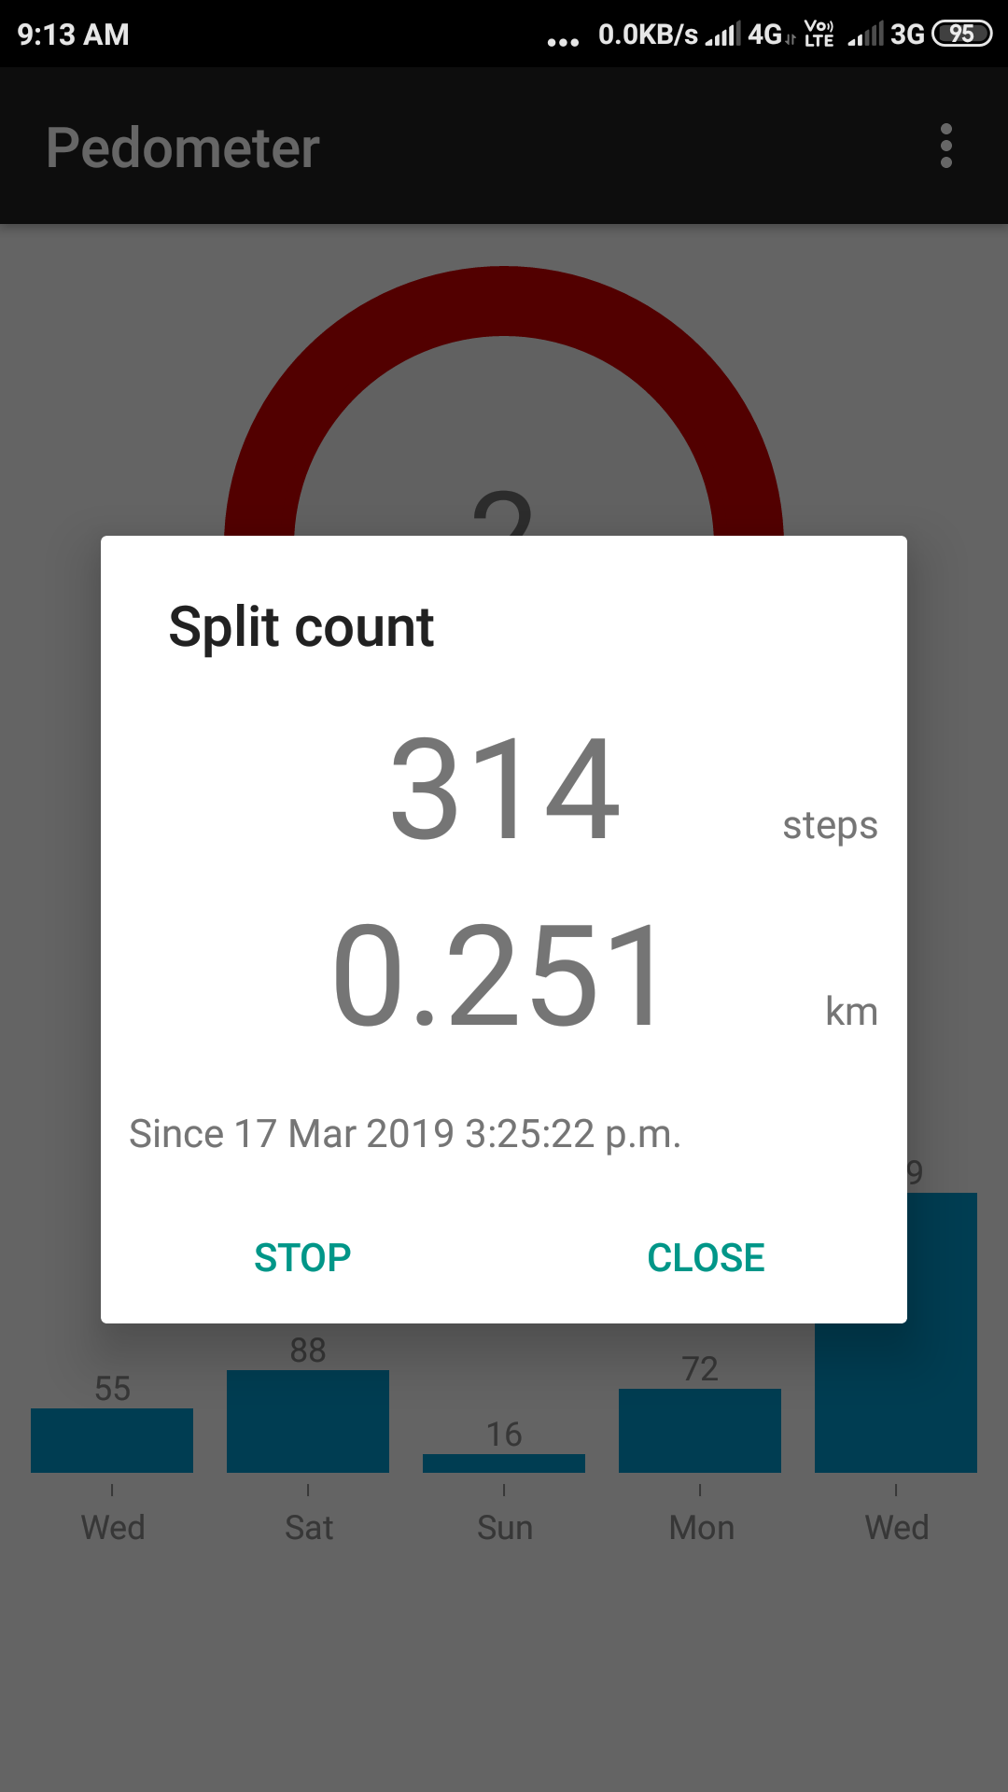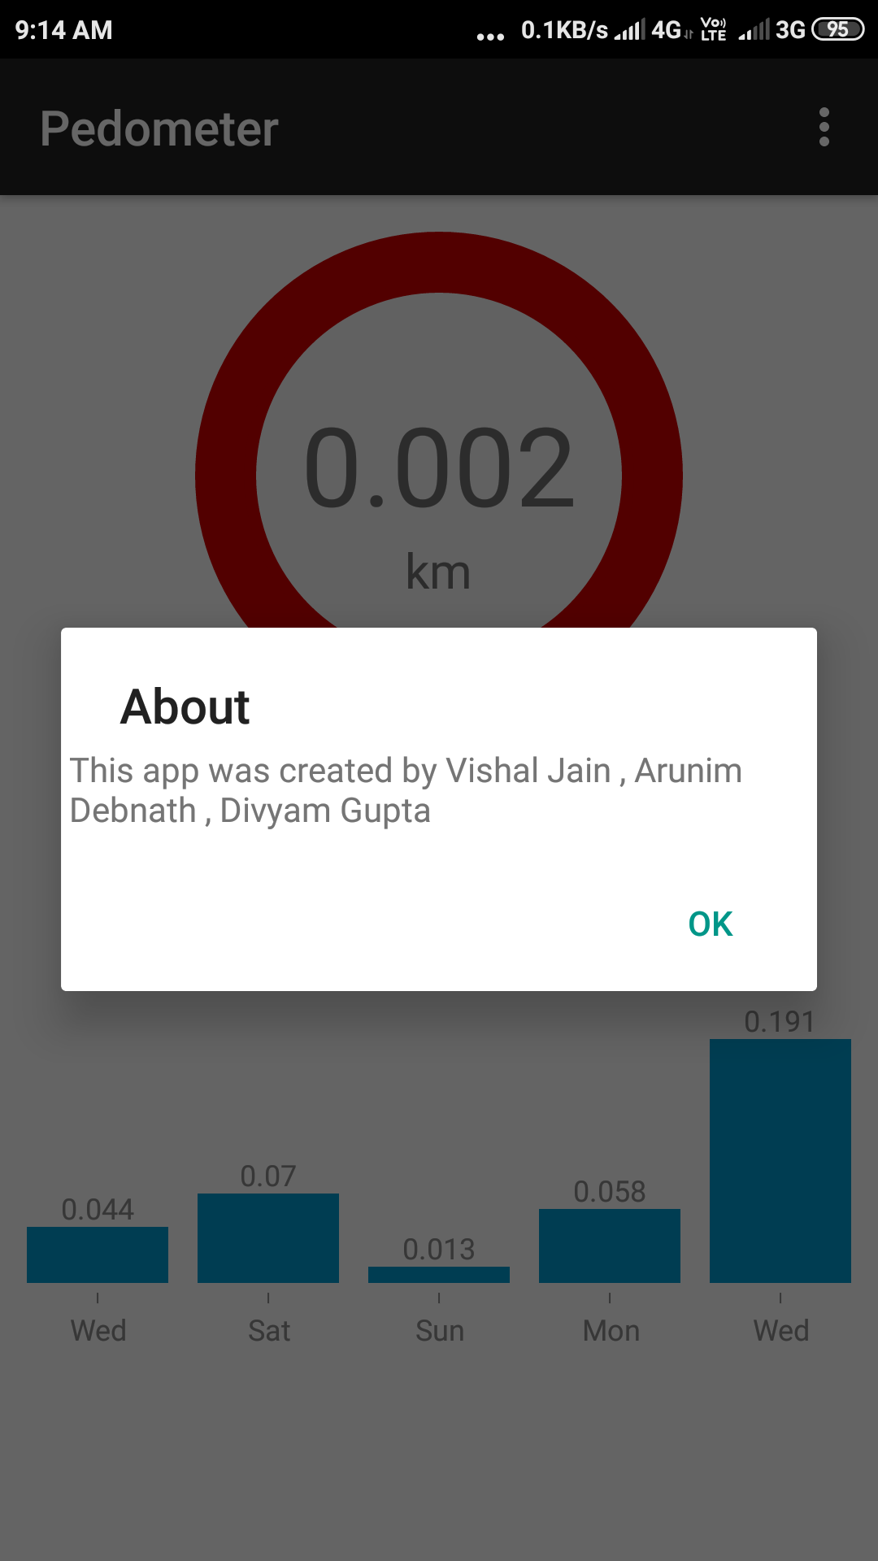

**CONCLUSION:**

We designed a complete fitness app with the pedometer and BMI calculator included. We intend to add various new features to the app in the future. The features are given below

**FUTURE SCOPE:**

There are various aspects that we intend to explore in the future:

* Intent to reflect the status of weight based on BMI.
* Intent to calculate the calories burnt based on the number of steps taken.
* Intent to reflect the health status based on BMI and calories.
* Listen to music on the go and stay motivated.
* Health tips based on the user’s performance.

**SOCIETAL APPLICATIONS:**

With this app, the user will no longer have to switch between apps dedicated to different fitness aspects, as a result, it will be a matter of convenience. Also, the people going to the gym need to keep track of their BMI and calories burnt. As they have a strict schedule, they tend to stick to a single app.