Launchpad Short Proposal
Newpage Platform & Delivery · September 2026

In one sentence Launchpad is an internal self-serve launcher that turns “new app idea” into a deployed, CI/CD-connected GitHub repo in about two minutes — on Cloudflare or AWS.

What it is
- Launchpad is an internal self-serve platform for scaffolding apps and deploying them to Cloudflare (Workers and Pages) or AWS (Lambda + API Gateway via SAM, and Amplify).
- The whole flow is one guided launcher: sign in → pick language and template → configure deployment → and Launchpad scaffolds the project, creates the GitHub repo (under the user’s account or the configured org), sets provider credentials as encrypted repo secrets, and pushes the code.
- A GitHub Actions workflow then deploys to the chosen provider — so every project ships with CI/CD attached, and the deploy is visible on the launch page.
- It is deliberately not a PaaS or hosting platform. Launchpad owns the path from “I want to ship this” to “it is live, versioned, and wired to CI/CD” — and nothing after. Teams keep owning the runtime.
- It also adopts code that already exists: paste a GitHub repo URL, Launchpad analyzes the framework and build steps, plans the move, and deploys it — usually to Pages — without moving the repo out of the owner’s account.

Who it is for
- Individual engineers who need a service, API, worker, or site up fast — without filing a platform ticket or remembering how the last repo was wired.
- Tech leads and project owners who onboard teammates, rotate access, and need deploy history, environment, bindings, and activity for the projects they own.
- Platform, delivery, and security teams who want every project to start from maintained templates, with consistent secrets handling, invite-based collaboration, and a complete audit trail.

Why it should exist
- Speed over hand-rolled setup. Scaffolding a repo, wiring CI, and adding secrets costs an experienced engineer 30–60 minutes per project — and the result differs every time. Launchpad collapses that to roughly two minutes of guided clicks, identically every time.
- Consistency beats tribal knowledge. Templates, workflows, and config live in one reviewed, versioned place. Update a template once and every future project inherits the fix.
- Security by default. Least-privilege tokens, credentials encrypted at rest, provider keys stored as GitHub repo secrets (never returned by the API), invite links with expiry instead of ad-hoc access, and a tamper-evident audit log.
- One surface for Cloudflare and AWS. Workers/Pages and Lambda/Amplify side by side, so teams pick the runtime that fits the job — not the one someone remembers how to wire up.
- It removes an entire class of onboarding churn. New starters don’t guess “how we did it last time” — they launch it.

How it works — the process
- Sign in with the shared org password and a username. The first user (or the configured admin) becomes the global admin.
- Choose “Launch”: pick a language and one of the 15 maintained templates across 5 categories (built-in, or scaffolded live from create-cloudflare).
- Configure: project name, visibility, GitHub org target, AWS region and credentials, environment variables, and bindings; preview deployments and provisioning-from-code are one toggle each.
- Launchpad does the plumbing: scaffolds the project, creates the GitHub repo under the org, encrypts any per-project tokens at rest, sets provider credentials as GitHub repo secrets, and pushes to main.
- GitHub Actions deploys — wrangler deploy for Workers, Pages build + publish, SAM build/deploy for Lambda, Amplify for static/Next sites. The run is visible live on the launch page.
- Collaborate: owners send single-use invite links (7-day TTL). Accepted invites grant Launchpad access and, with a GitHub handle, repo collaboration — admins get push, members get collaborator.
- Day to day: redeploys, env vars, bindings, live logs and preview branches (Cloudflare), and a full audit of every sign-in, launch, redeploy, and delete. Deleting tears down infra per provider.
Deploying an existing repo uses the same plumbing and skips the scaffolding: paste a GitHub URL → Launchpad analyzes the framework and build steps → you review the plan (what it will do, build and deploy commands, env vars to fill) → deploy, usually to Pages. Repos that aren’t deployable get a guided fix list instead of a rejection — fix, push, re-analyze.

Architecture
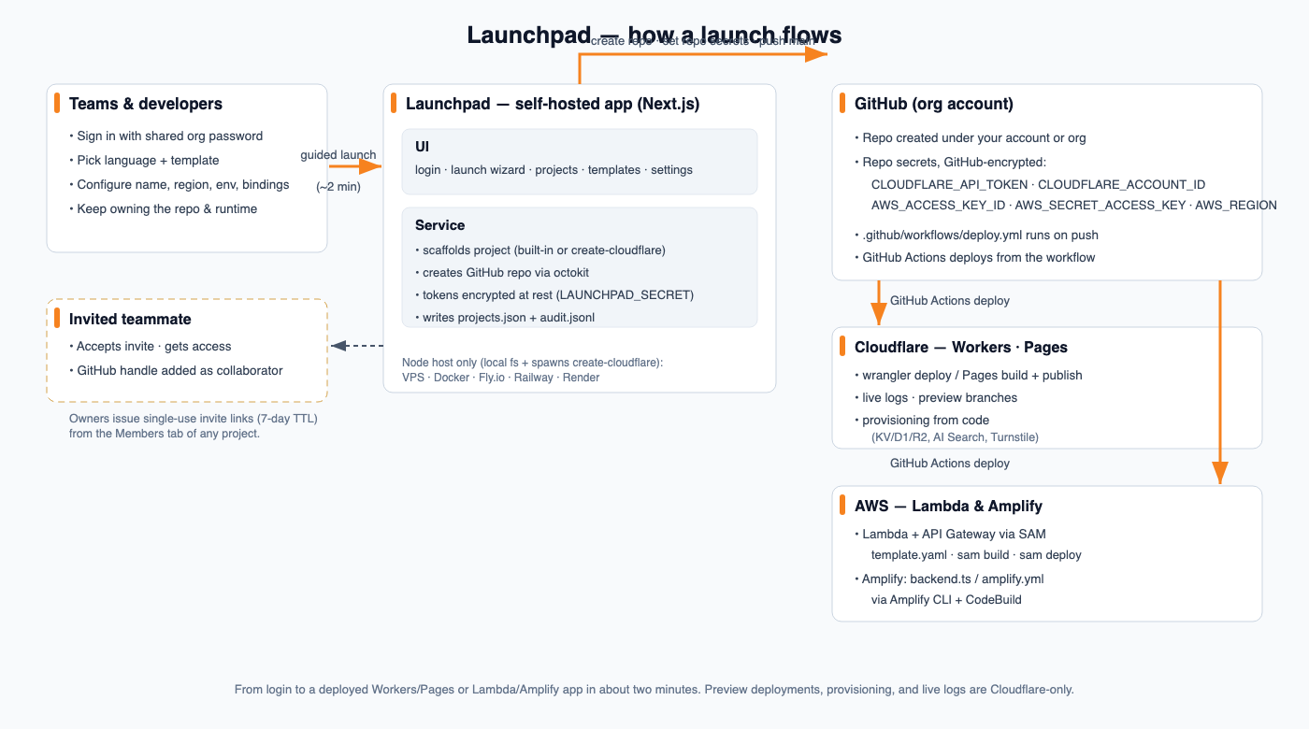
How a launch flows — from sign-in to a deployed Cloudflare or AWS app. Importing an existing repo runs the same plan and deploys it to Pages. Preview deployments, provisioning, and live logs are Cloudflare-only.

What’s in scope
- 15 maintained templates across 5 categories, plus live scaffolders (create-cloudflare).
- Launch wizard with per-project deployment options: bindings, environment variables, AWS region and credentials, preview and provisioning-from-code toggles.
- Deploy an existing project: paste a GitHub URL, Launchpad analyzes it and plans the deploy — ready repos get a deploy plan, not-ready repos a guided fix list; the repo stays in place and deploys to Cloudflare.
- Projects table with search, filters, bulk actions, delete-with-confirmation, and per-project status.
- Project page with seven tabs: Overview, Deploy History, Environment, Bindings, Members, Access, Activity.
- Live logs (Cloudflare), Worker preview branches, and provisioning from code — KV / D1 / R2, AI Search, and Turnstile widgets created on push.
- Single-use invite links (7-day expiry) that grant Launchpad access and repo collaboration.
- Settings: provider security status, org & AWS configuration, and a full audit log of sign-ins, launches, redeploys, and deletes.

