# Database Diagram:

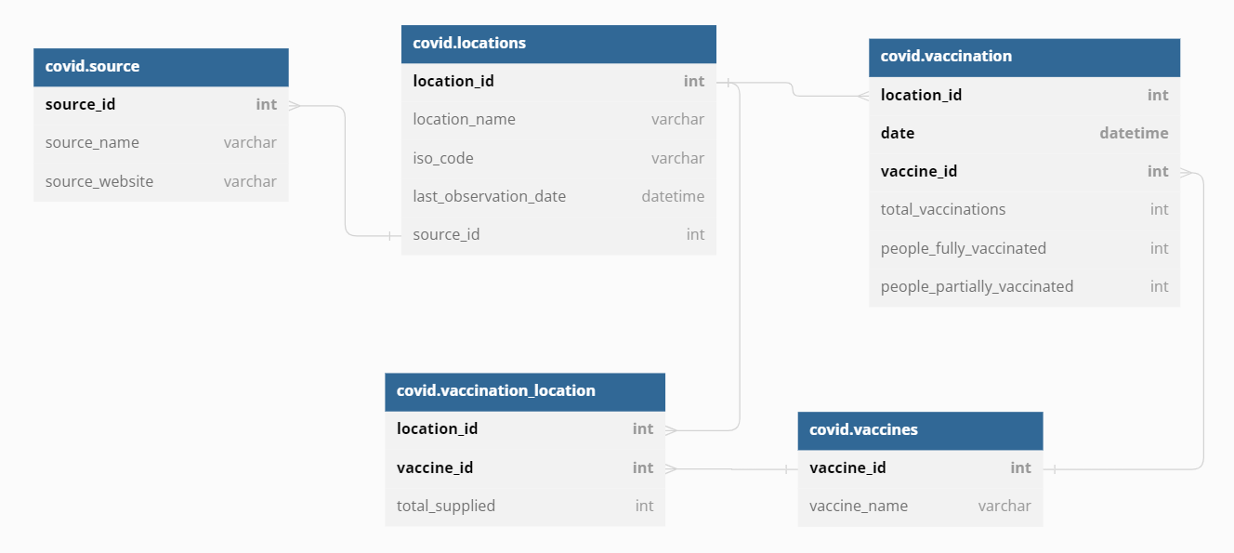

# Database Created:

# Inserted Data to Table:

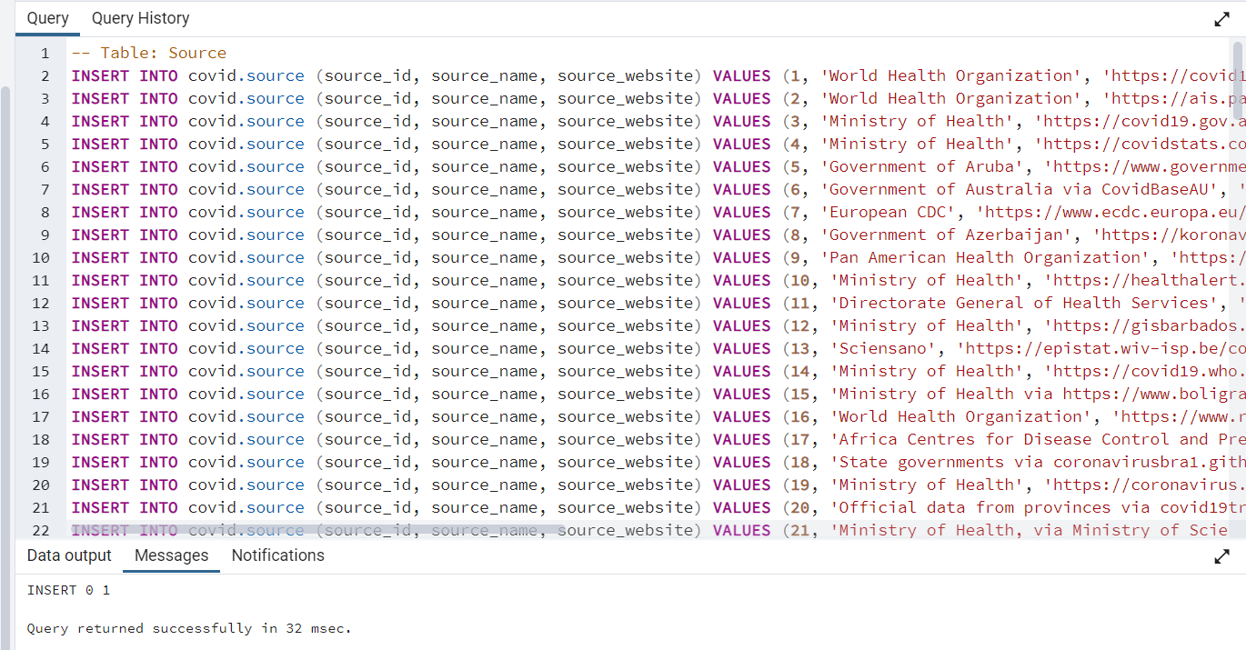

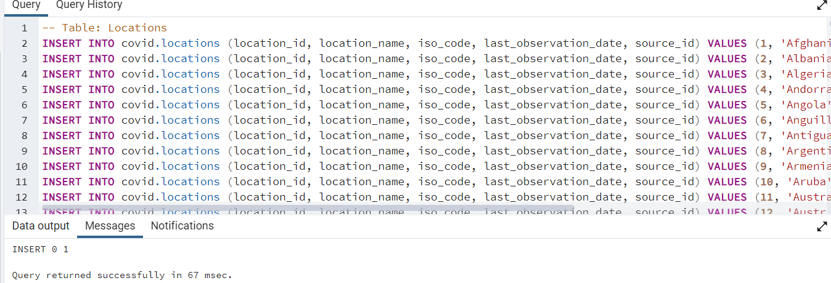

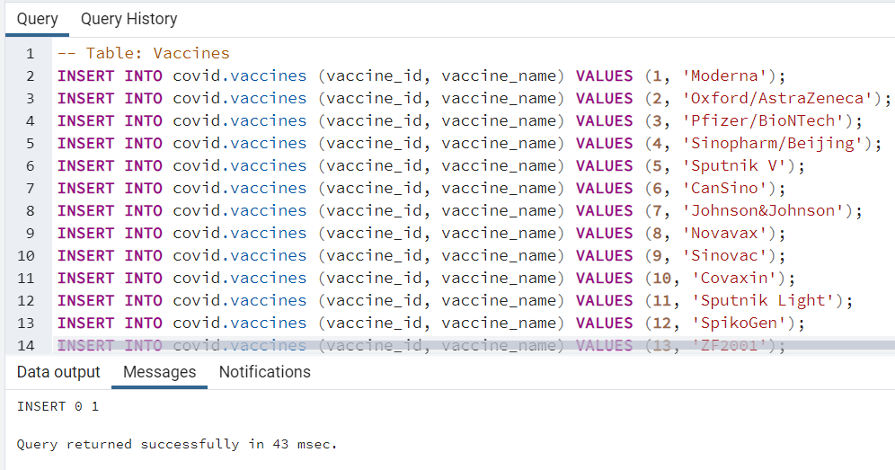

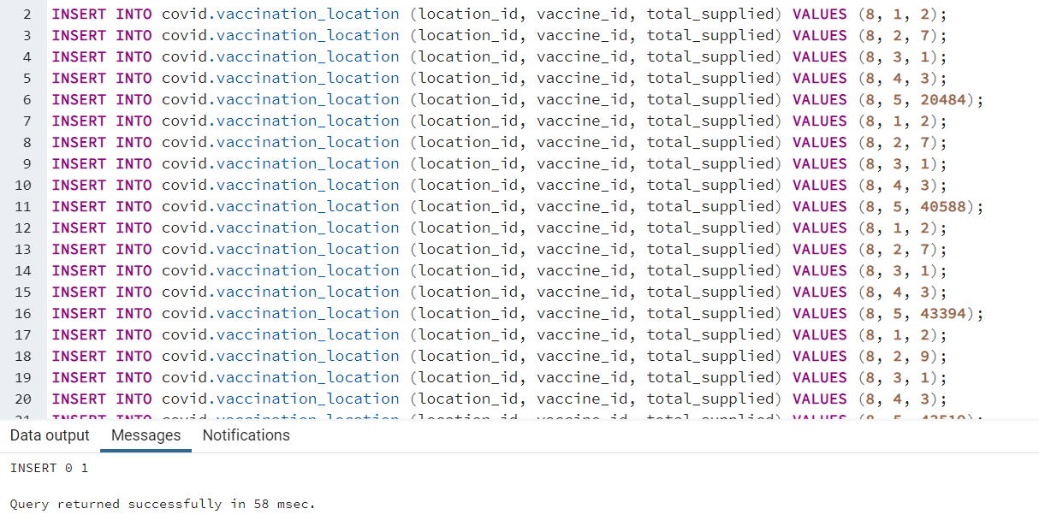

**Queries Executed on the above tables:**

Query 1:

Query 2:

Query 3:

Query 4:

Query 5:

Query 6:

Query 7:  
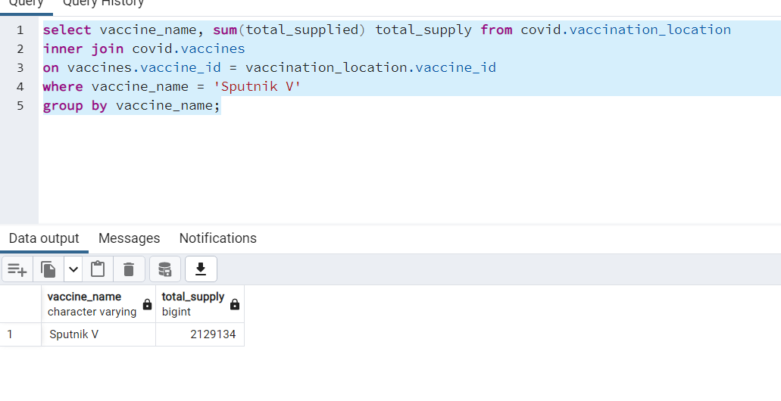

Query 8:

Query 9:

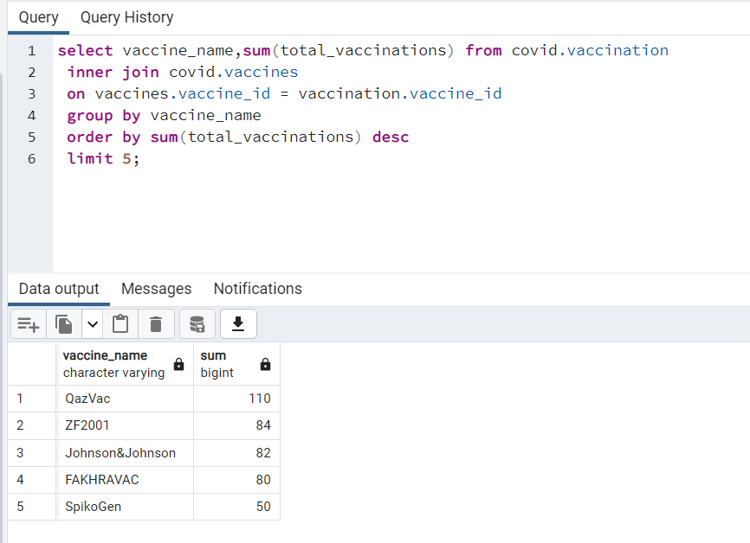

Query 10:

