CDK Deploy
Detailed steps when we run CDK deploy can be found below. Refer below diagram:
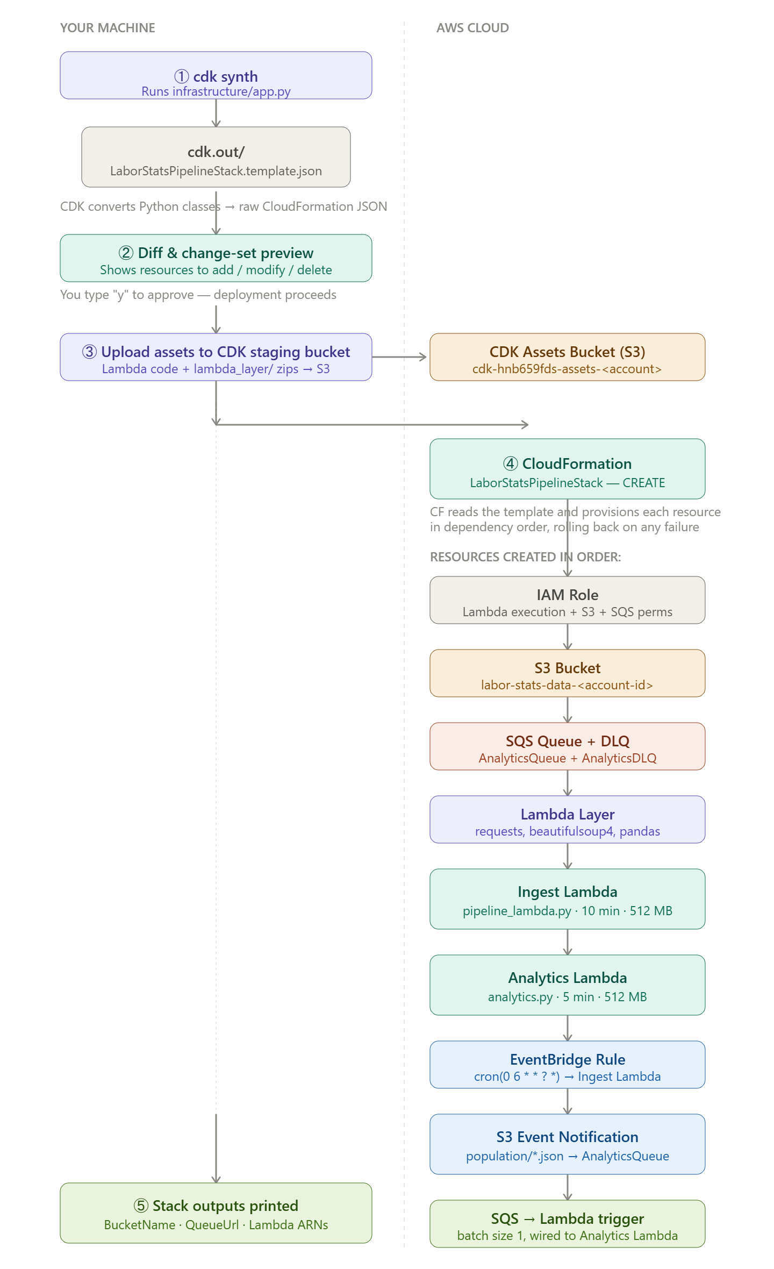
Here's a detailed walkthrough of exactly what happens in this repo when you run cdk deploy:

① cdk synth — Python → CloudFormation JSON
CDK first runs infrastructure/app.py through the Python CDK library. Every construct you wrote — s3.Bucket(...), sqs.Queue(...), lambda_.Function(...) — gets converted into raw CloudFormation JSON and written to cdk.out/LaborStatsPipelineStack.template.json. This file is a complete description of every AWS resource you want.

② Diff and change-set preview
CDK compares the synthesized template against what's currently deployed in your AWS account. It prints a list of additions, modifications, and deletions. You'll see something like [+] AWS::S3::Bucket LaborStatsBucket, [+] AWS::Lambda::Function IngestLambda, etc. You type y to approve and deployment begins.

③ Asset upload to the CDK staging bucket
Before CloudFormation can create your Lambdas, it needs the code to exist in S3. CDK automatically zips your src/ directory (the Lambda code) and the lambda_layer/ directory (the pre-built Python dependencies from build_layer.sh) and uploads them both to a CDK-managed staging bucket named cdk-hnb659fds-assets-<your-account-id>. This is why running ./build_layer.sh first is critical — without the layer directory, this step fails.

④ CloudFormation creates resources in dependency order
CloudFormation reads the template and figures out the correct creation order automatically by following the DependsOn and Ref relationships that CDK wired in. In this repo the order ends up being:
IAM Role first — both Lambda functions depend on it, so it must exist before them.
S3 Bucket — the Lambdas need its name as an environment variable (S3_BUCKET_NAME), and the S3 event notification target (SQS) must also exist first.
SQS Queue + Dead Letter Queue — the DLQ is created first since the main queue references it.
Lambda Layer — both functions declare it as a dependency, so it's published before either function.
Ingest Lambda — created with the S3_BUCKET_NAME env var pointing at the bucket, the layer attached, 10-minute timeout, and 512 MB memory as defined in infrastructure/app.py.
Analytics Lambda — same wiring, 5-minute timeout.
EventBridge Rule — the cron rule cron(0 6 * * ? *) (06:00 UTC daily) is created and wired to invoke the Ingest Lambda. Lambda resource-based policy is automatically updated to allow EventBridge to invoke it.
S3 Event Notification — CloudFormation configures the S3 bucket to fire an event to the SQS queue whenever an object is created under population/*.json. This is the trigger chain for Part 4.
SQS → Lambda Event Source Mapping — finally, an event source mapping is created so that messages arriving on AnalyticsQueue automatically invoke the Analytics Lambda with batch size 1.

⑤ Stack outputs are printed to your terminal
Once all resources are green, CloudFormation emits the four CfnOutput values defined at the bottom of infrastructure/app.py:
Outputs:
LaborStatsPipelineStack.BucketName = labor-stats-data-123456789012
LaborStatsPipelineStack.QueueUrl = https://sqs.us-east-1.amazonaws.com/...
LaborStatsPipelineStack.IngestLambdaArn = arn:aws:lambda:us-east-1:...
LaborStatsPipelineStack.AnalyticsLambdaArn = arn:aws:lambda:us-east-1:...

What happens the first time EventBridge fires (06:00 UTC)
The Ingest Lambda runs pipeline_lambda.py, which calls sync_bls_to_s3() (Part 1) and fetch_and_store() (Part 2). When fetch_and_store() writes population/us_population.json to S3, the event notification fires a message to the SQS queue, which in turn invokes the Analytics Lambda. The Analytics Lambda runs all three reports from Part 3 and logs the results to CloudWatch Logs — which is the Part 4 requirement

