**Deposit** – Added additional validation in currency denomination for non-negative validated against the deposit amount

**Withdraw** – Added additional validation against withdrawal amount is not zero or non-negative and validated amount against available currency denomination

**How to Run the code**

1. Install Java in your machine
2. Download the code in to your machine
3. Open command prompt and change directory to Atm.java folder where it is downloaded
4. Execute below commands to compile and run the code

javac Atm.java

java Atm

**Test execution results:**

**Happy Path:** Multiple deposit

**Scenario Input:** First Deposit Input: User select 1 to deposit and enters deposit amount $10 with $5’s=1 and $1’s=5.

Second Deposit Input: User select 1 to deposit and enters deposit amount $398 with $20’s=5, $10’s=15, $5’s=25 and $1’s=23.

**Expected Result:** First Deposit Output: Print message “Amount deposited successfully” and print balance as $20's= 0, $10's= 0, $5's= 1 and $1's= 5 Total= 10

Second Deposit Output:

Print message “Amount deposited successfully” and print balance as $20's= 5, $10's= 15, $5's= 26 and $1's= 28 Total= 408(398+10)

Screenshot attached for the same.

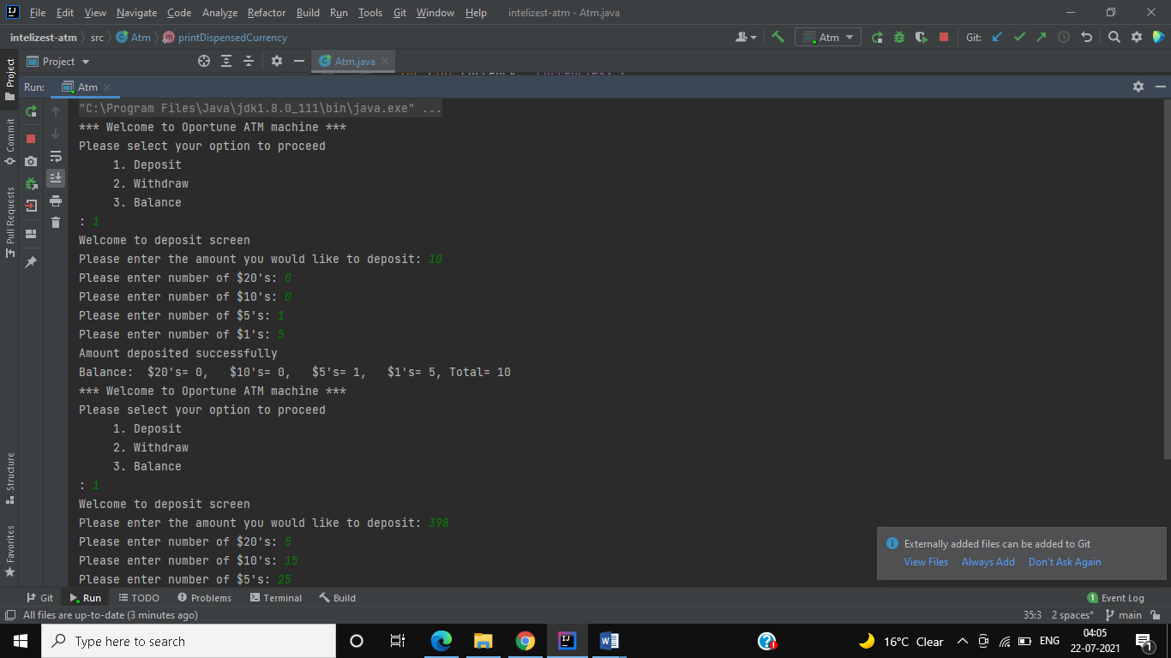

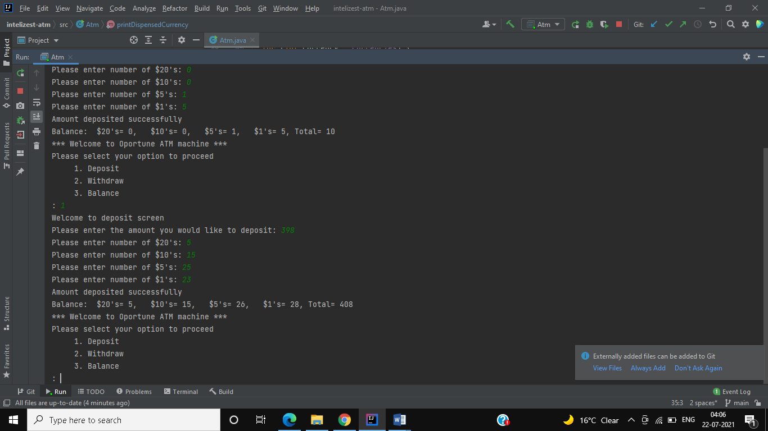

**Happy Path:** Multiple Withdraw and deposit

**Scenario Input:** First withdraw: User select 2 to withdraw and enters $240

Second Withdraw: User select 2 to withdraw and enters $79

Deposit: User select 1 to deposit and enter $150 to deposit with $20’s=6 and $10’s=3

**Expected Result:** First withdraw output: should show amount dispensed as $20's= 5 and $10's= 14 total 240.

And balance as $20's= 0, $10's= 1, $5's= 26 and $1's= 28 Total= 168(408-240)

Second withdraw output: Should show$10's= 1, $5's= 13 and $1's= 4 total 79.

And balance as $20's= 0, $10's= 0, $5's= 13 and $1's= 24 Total= 89(168-79)

Deposit output: Print message “Amount deposited successfully” and print balance as $20's= 6, $10's= 3, $5's= 13 and $1's= 24 Total= 239 (89+150)

Screenshot attached for the same

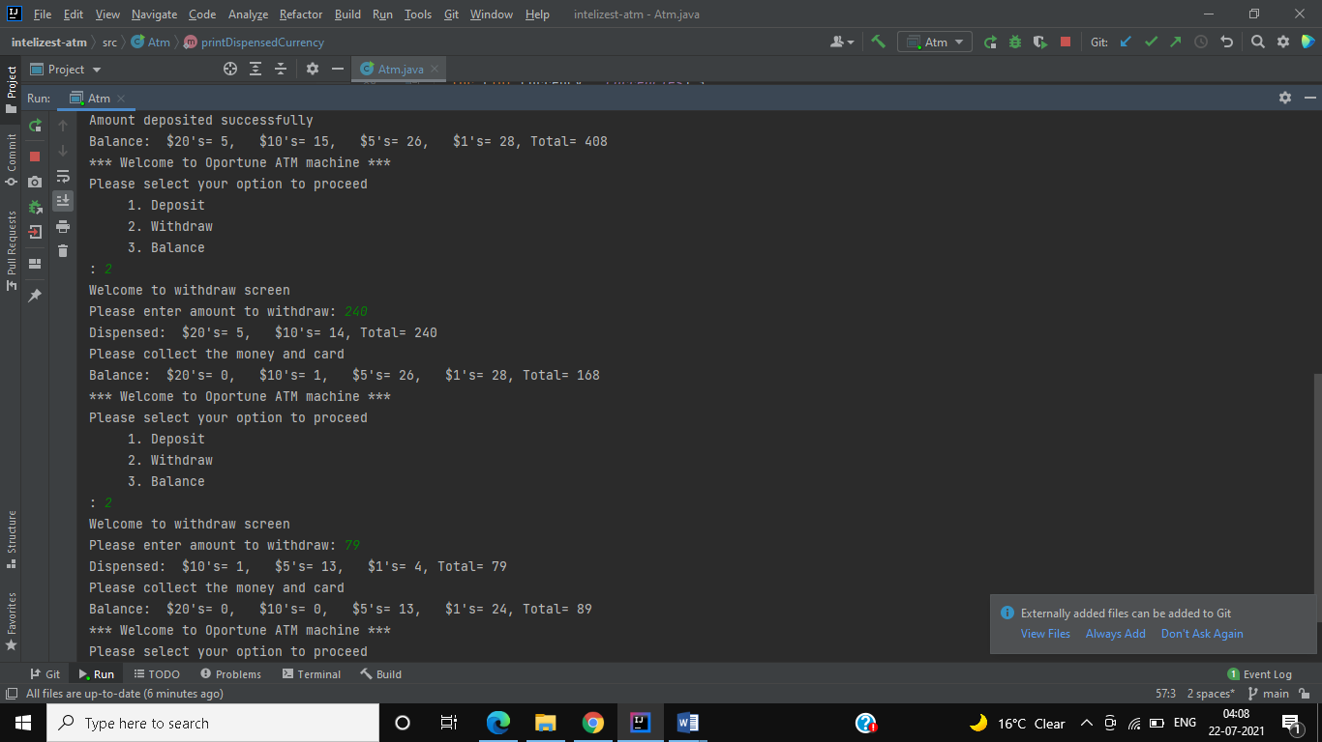

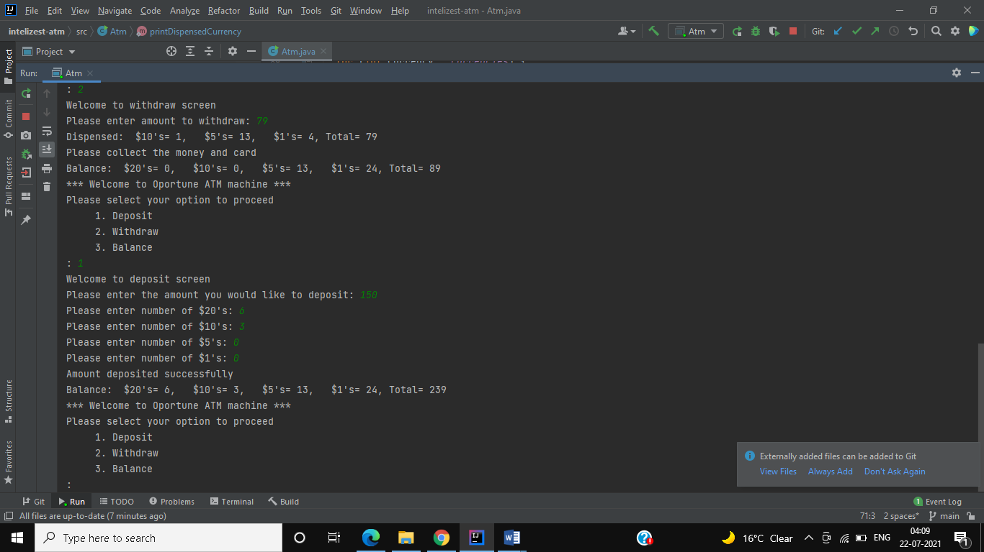

**Deposit amount validation: (non-zero)**

**Scenario Input:** User select 1 to deposit and enter $0

**Expected Result:** print “Incorrect deposit amount”

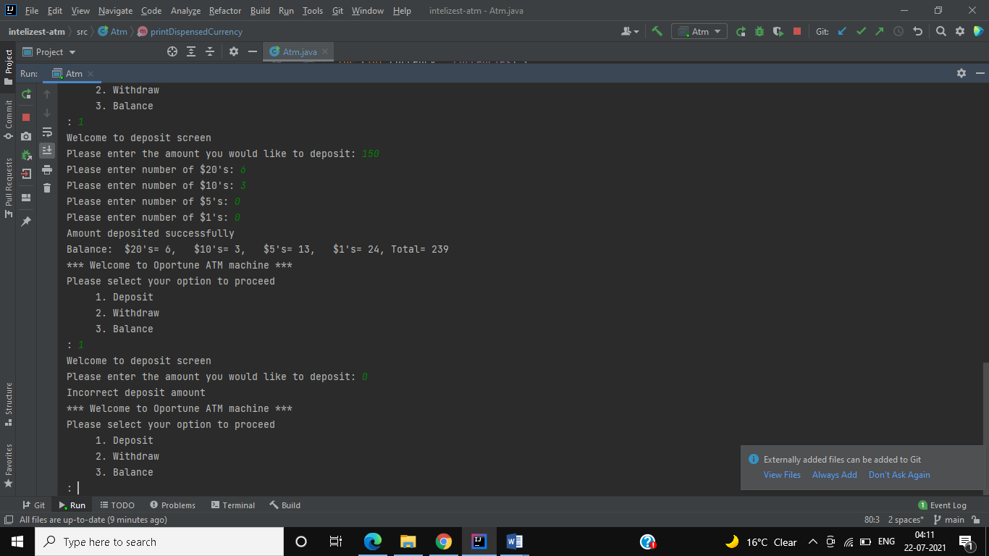

**Deposit amount validation: (non-negative)**

**Scenario Input:** User select 1 to deposit and enter $-1

**Expected Result:** print “Incorrect deposit amount”

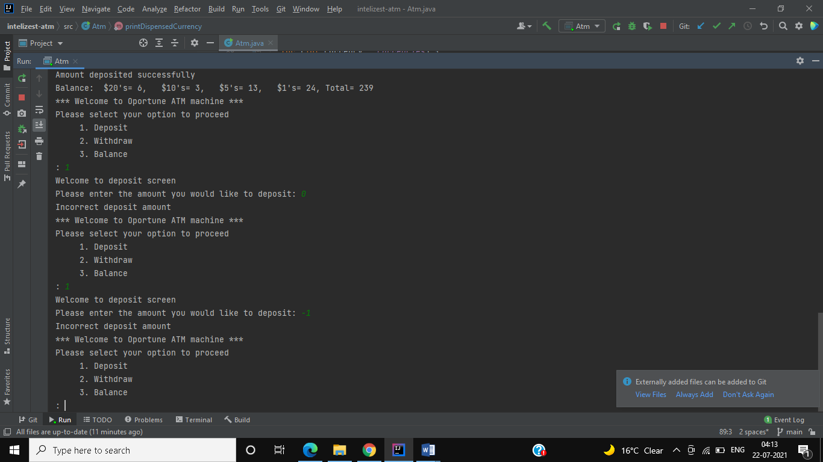

**Deposit currency validation (negative currency value)**

**Scenario Input:** User select 1 to deposit and enter $10 with $20’s=0, $10’s=-1, $5’s=0 and $1’s=0

**Expected Result:** print “Incorrect currency”

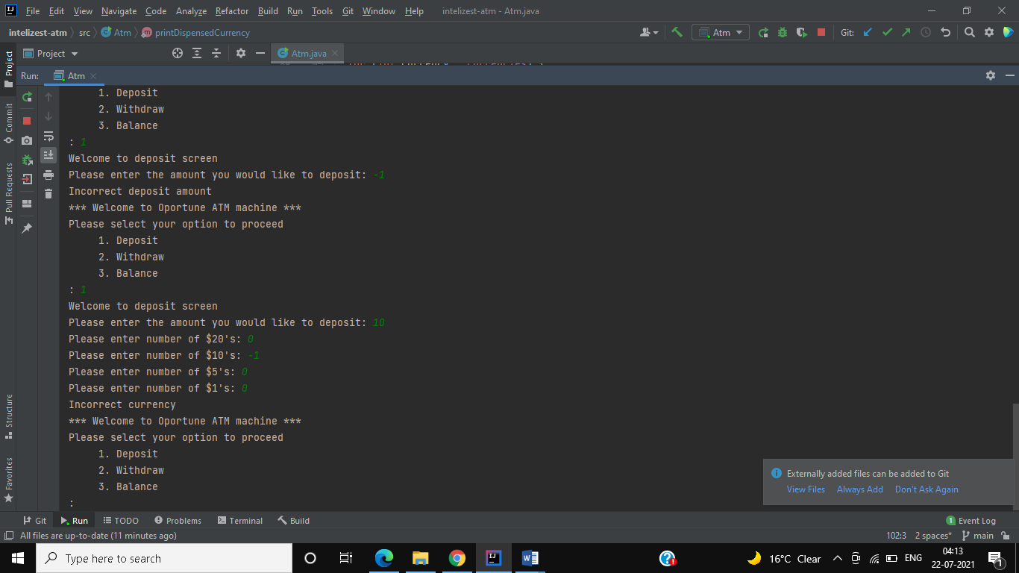

**Deposit currency validation (deposit and total value of currency not matching)**

**Scenario Input:** User select 1 to deposit and enter $100 with $20’s=5, $10’s=1, $5’s=0 and $1’s=0

**Expected Result:** print “Incorrect amount or currency” (total value of currency provided is 110, So this fails)

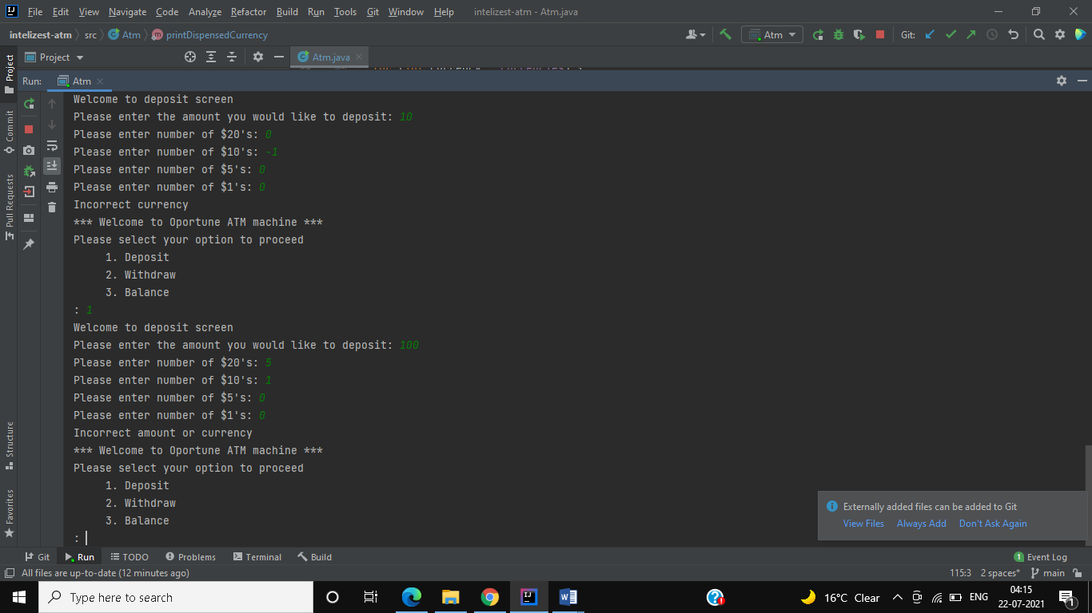

**Withdraw amount validation (non-zero)**

**Scenario Input:** User select 2 to withdraw and enter $0

**Expected Result:** print “Incorrect or insufficient funds”

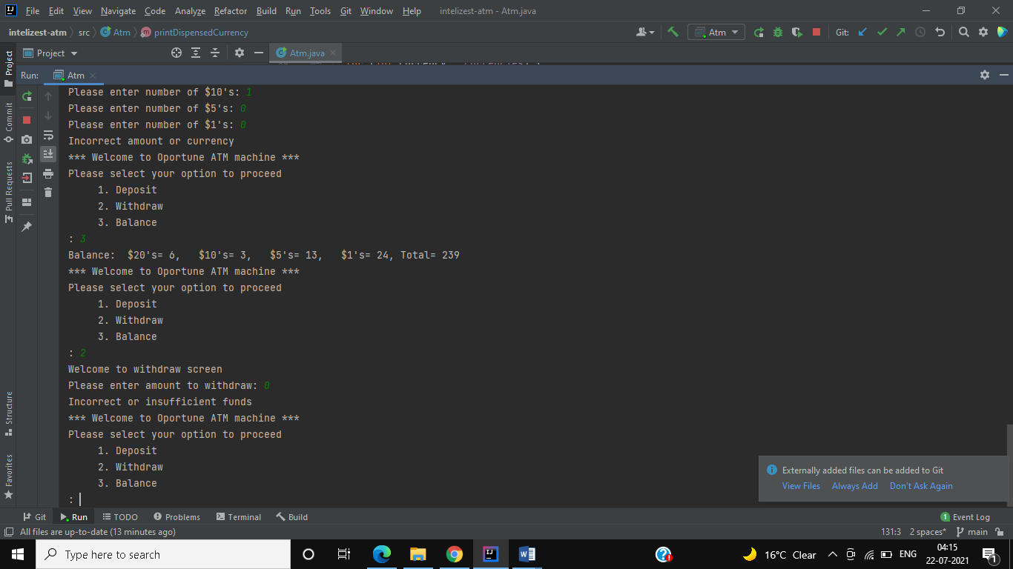

**Withdraw amount validation (non-negative)**

**Scenario Input:** User select 2 to withdraw and enter $-1

**Expected Result:** print “Incorrect or insufficient funds”

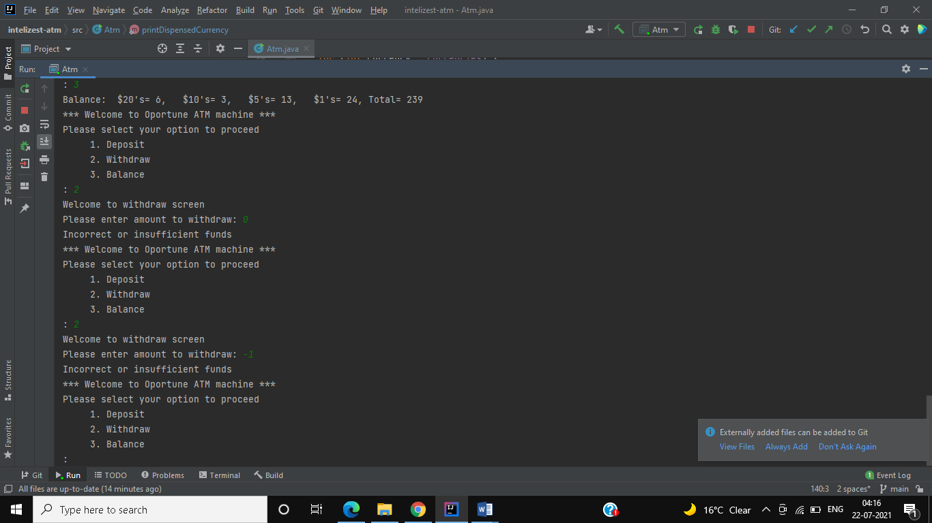

**Withdraw amount validation (not greater than balance in ATM)**

**Scenario Input:** User select 2 to withdraw and enter $240(here we have only 239 in ATM, so it fails)

**Expected Result:** print “Incorrect or insufficient funds”

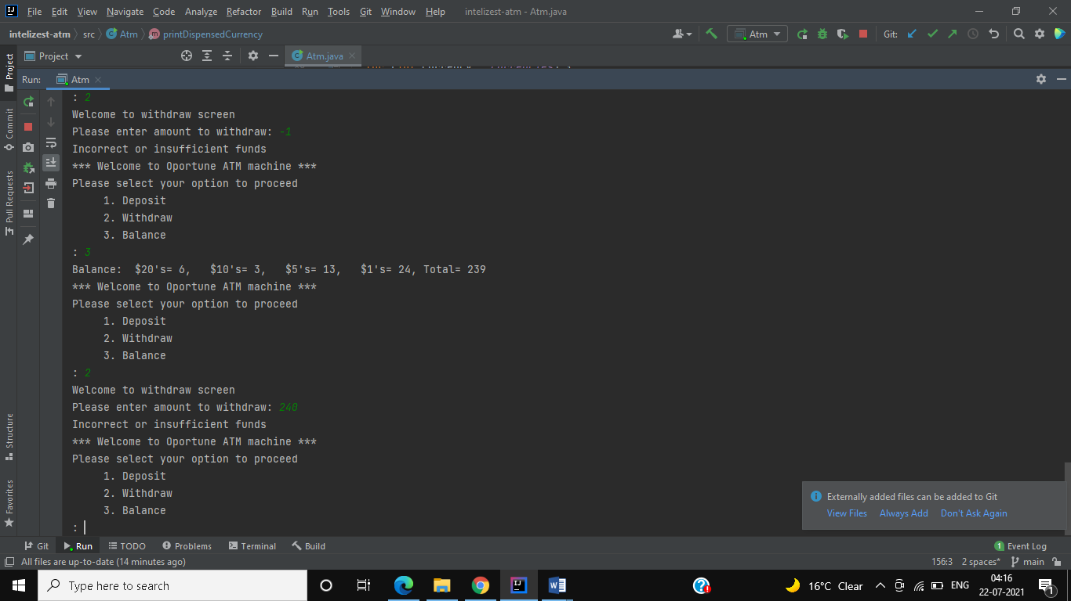

**Withdraw amount validation (amount can’t be dispensed as we don’t have currency to dispense exact value)**

**Scenario Input:** User select 2 to withdraw and enter $78 (Here balance is 217 and $1’s we got only 2 but to dispense we need 3 $1’s which is not available in ATM. Withdrawn some $1’s from ATM to meet scenario, attached PDF contains withdrawal history of execution)

**Expected Result:** print “Requested withdraw amount is not dispensable”

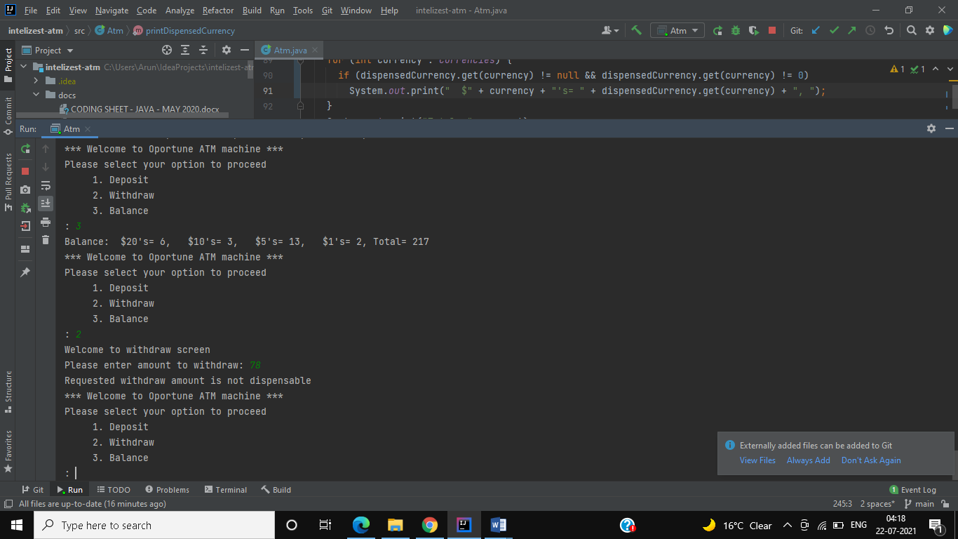

**Withdraw all money to make balance zero:**

**Scenario Input:** User select 2 to withdraw and enter $217

**Expected Result:** it should dispense everything we got in ATM and show dispensed message like $20's= 6, $10's= 3, $5's= 13 and $1's= 2 Total= 217 and balance as 0 in all denomination

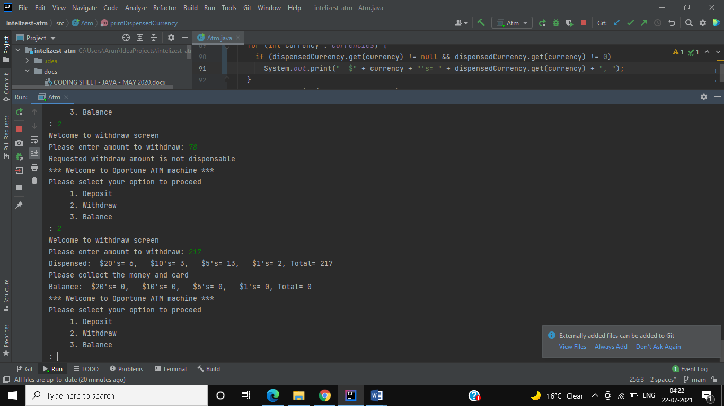

**Console Output as PDF:**

