Test document
2017/11/21
By RUAN LINXIANG

User story 1: login.php
Task | Work well | Commendation | Action
A entrance to login page | No |  | Added to navigation bar (waleed)
click login button show the google login page | Yes | Can login with google account
Register google account | Yes | In the google login page can find the button to register a google account but the register button is not easily to find.  suggestion:  1- adding a button to google.com to register a account
User data insert into database | Yes | Can find the user data in database
A log out button | Yes | Suggestion:  1- add a log out button in navigation bar

User story 2: profile page
Task | Work well | Commendation
A entrance to profile page | No
After logging in show profile of user | Yes
Add/Change the profile | Yes | It can change the profile data in database
Styling profile page | Not finished | There are some issue in the task now,  cursor missing like following picture.  suggestion:  1- if the information is Not Specified, system should delete this information in test box.  2- add button to index.php  3- Birthday need more message for input: format of the Birthday, and the calendar is from the day of input date, so it difficult to go through to the 20 years ago like following picture.


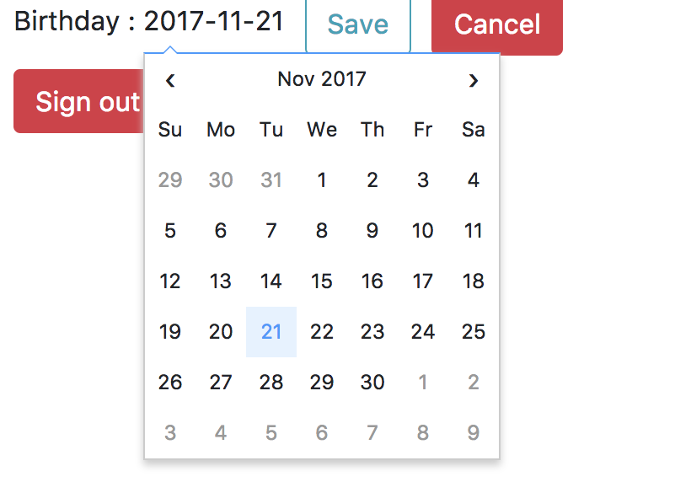
Issues screen cut:

User story 3: Plan diet
Task | Work well | Commendation
A entrance to diet page | Yes
Without logging and click Dietary to go to login page | Yes
Click lose button | Yes
Click keep button | Yes
Click gain button | Yes
 |  | Suggestion: 1- need to show more information to tell user whether this operation is successful.

User story 8: like/dislike button
Task | Work well | Commendation
Without logging, show amount of like/dislike rating in view viewRecipe page | Yes
Without logging, click like/dislike button to go to login page | Yes
After logging, view viewRecipe page show user’s choice(like or dislike) | Yes
After logging, click like/dislike change the choice of user | Yes
After logging, click like/dislike button to change rating data in database | Yes
Show like/dislike rating bar | Yes

User story 15:view Rcipe
Task | Work well | Commendation | Action
An entrance to viewRecipe page | No | Just can view recipe by changing url | To be fixed when the search function is ready (Waleed)
Show name, serving, meal, tags, ingredients list, description, picture | Yes | Show the information we needed from database
Styling | Not finished

User story 10: recommend recipe
Task | Work well | Commendation
Show recommend recipe picture and basic information on viewRecipe | Yes | Show name and picture
Click recommend picture to view the details | Yes
Styling | Yes
Good recommend | TBD | It works but just one tags relieved

User story 5: add/edit recipe
Task | Work well | Commendation
ADD:
An entrance to addRecipe page | Yes
Without logging, click add recipe button, go to login page | No
After logging, click add recipe button, show addRecipe form | Yes
Update picture | Yes
Add row | Yes
Delete row | Yes
Insert recipe information into database | No | It cannot add the ingredients into database
Edit:
An entrance to editRecipe page | Yes
Without logging, transfer to login page | No
After logging, search own recipe | No
Show recipe details correctly | No | Cannot show description correctly(following picture)
Change recipe details correctly | No | 1- serving can be -8(shown in follow picture)  2- same problem in Calories  3-

