Arun karthikeyan B
251901019
COMPUTER NETWORKS
Ex.No.11 | STUDY OF SOCKET PROGAMMING IN PYTHON
Date: | STUDY OF SOCKET PROGAMMING IN PYTHON
Aim:
To study the concepts of socket programming in python.

STUDY OF SOCKET PROGAMMING IN PYTHON

A network socket is one endpoint of a two-way communication link between two programs running on a network. It is a software-based handle combining an IP address and a port number, allowing different processes to send and receive data across a device or the internet
Socket programming in python
- Python's core networking library is Socket Module.
- Python's socket module has both class-based and instances-based methods.
- Class-based method is an intuitive approach which doesn't need an instance of a
- socket object.
- For example, in order to print a machine's IP address, you don't need a socket
- object. Instead, just call the socket's class-based methods.
- In instance-based method, if some data needed to be sent to a server application,
- it is more intuitive to create a socket object to perform that explicit operation.
- This module has everything you need to build socket servers and clients.

Algorithm 1: TCP Server
Input: Client message
Output: Response message to the client
- Start
- Import the socket module.
- Create a TCP socket using socket().
- Bind the socket to the IP address localhost and port number 5000.
- Put the server socket into listening mode using listen().
- Wait for a client connection using accept().
- Receive the message from the client using recv().
- Decode the received message.
- Display the client's message.
- Create a response message.
- Encode and send the response to the client using send().
- Close the client connection.
- Close the server socket.
- Stop

TCP Client
Input: Message to be sent to the server
Output: Response received from the server
- Start
- Import the socket module.
- Create a TCP socket using socket().
- Connect to the server using connect() with localhost and port 5000.
- Create a message to send to the server.
- Encode the message.
- Send the message to the server using send().
- Wait for the server's response using recv().
- Decode the received response.
- Display the server's response.
- Close the client socket.
- Stop

PROGRAM(Server):
# TCP Server Program
import socket
# Create a socket
server_socket = socket.socket(socket.AF_INET, socket.SOCK_STREAM)
# Bind IP address and port
server_socket.bind(("localhost", 5000))
# Listen for client connection
server_socket.listen(1)
print("Server is waiting for connection...")
# Accept client connection
conn, address = server_socket.accept()
print("Client connected:", address)
# Receive message from client
message = conn.recv(1024).decode()
print("Message from client:", message)
# Send response to client
response = "Hello Client! Message received successfully."
conn.send(response.encode())
# Close connection
conn.close()
server_socket.close()

PROGRAM (CLIENT):
# TCP Client Program
import socket
# Create a socket
client_socket = socket.socket(socket.AF_INET, socket.SOCK_STREAM)
# Connect to server
client_socket.connect(("localhost", 5000))
# Send message to server
message = "Hello Server!"
client_socket.send(message.encode())
# Receive response from server
response = client_socket.recv(1024).decode()
print("Message from server:", response)
# Close connection
client_socket.close()

SAMPLE OUTPUT:
Server Output
C:\Python> python server.py

Server is waiting for connection...
Client connected: ('127.0.0.1', 54321)
Message from client: Hello Server!

Client Output
C:\Python> python client.py

Message from server: Hello Client! Message received successfully.

OUTPUT:

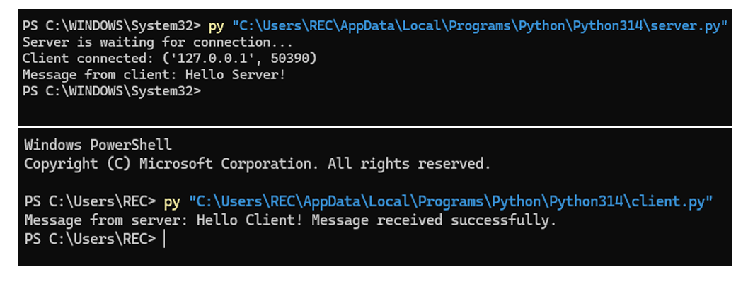

RESULT: Python socket programming was successfully studied and implemented.
Client-server communication was established successfully using TCP/IP sockets.

