Ex.No.5 | Experiments on Packet capture tool: Wireshark
Date | Experiments on Packet capture tool: Wireshark
Arun karthikeyan B
251901019

AIM:
To understand the features of wireshark as a packet capture tool and understand encapsulation of information at various layers of a Protocol stack.
WIRESHARK
Wireshark is a free, open-source network packet analyzer used for network troubleshooting, analysis, and security auditing. It lets you capture and interactively browse live data traffic passing through a network interface:
Workdone by Wireshark:
- Capture network traffic
- Decode packet protocols using dissectors
- Define filters – capture and display
- Watch smart statistics
- Analyze problems
- Interactively browse that traffic
Wireshark used for:
- Network administrators: troubleshoot network problems
- Network security engineers: examine security problems
- Developers: debug protocol implementations
- People: learn network protocol internals
Getting Wireshark
Wireshark can be downloaded for Windows or macOS from its official website. For Linux or another UNIX-like system, Wireshark will be found in its package repositories. For Ubuntu, Wireshark will be found in the Ubuntu Software Center.

Download Wireshark from the following link
https://www.wireshark.org/download.html
Procedure to Capture Packets Using Wireshark
Step 1: Download and install Wireshark on your computer.
Step 2: Open the Wireshark application.
Step 3: From the home screen, select the network interface (e.g., Wi-Fi or Ethernet) through which your computer is connected to the network.
Step 4: Click the Start Capturing Packets button (blue shark fin icon) or double-click the selected interface.
Step 5: Generate network traffic by opening a website, sending a ping, or browsing the Internet.
Step 6: Observe the captured packets appearing in real time in the Packet List pane.
Step 7: To view only specific packets, enter a display filter (e.g., http, tcp, udp, icmp, dns) in the filter bar and press Enter.
Step 8: Click on any packet to view its detailed information in the Packet Details pane.
Step 9: Expand the protocol layers (Ethernet, IP, TCP/UDP, etc.) to examine packet contents.
Step 10: Click the Stop button (red square) to stop packet capture.
Step 11: To save the captured packets, go to File → Save As, choose a location, and save the file in .pcapng (or .pcap) format.
Sample Capturing Packets from Wireshark: Sample output
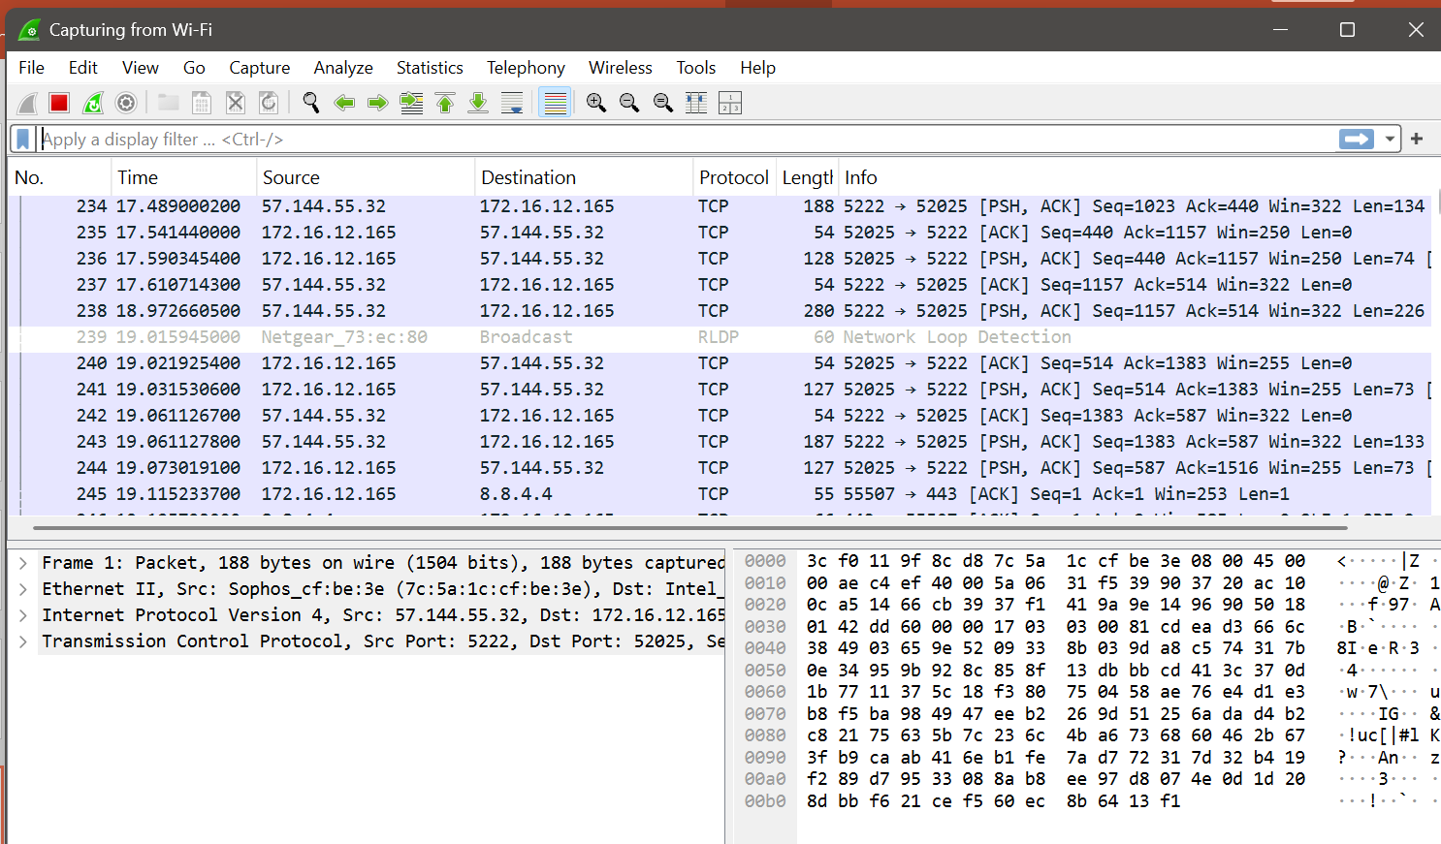

Different Panes in Wireshark:
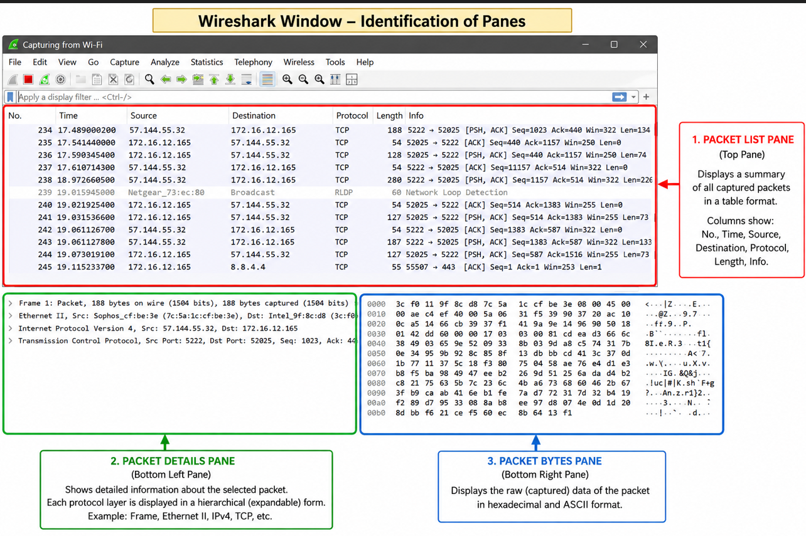

1. Packet List Pane (Top Pane)
- Displays a summary of all captured packets.
- Each row represents one captured packet.
- Shows details such as Packet Number, Time, Source, Destination, Protocol, Length, and Info.

2. Packet Details Pane (Middle Pane)
- Displays detailed information about the selected packet.
- Information is organized into protocol layers such as Frame, Ethernet, IP, TCP/UDP, etc.
- Each protocol layer can be expanded to view more details.

3. Packet Bytes Pane (Bottom Pane)
- Displays the raw data of the selected packet.
- Data is shown in hexadecimal format on the left.
- The corresponding ASCII representation is shown on the right.
Note: These three panes work together to help users analyze captured network packets efficiently in Wireshark.
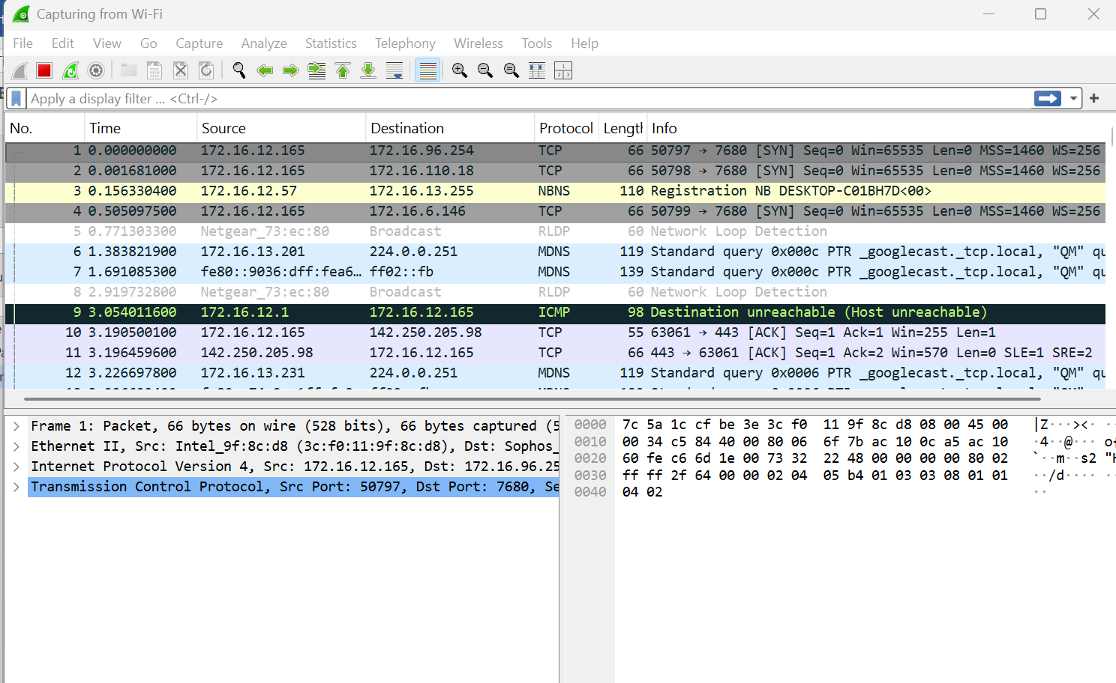
Color Coding:
In Wireshark, packet colors help you quickly identify different types of network traffic. Based on your screenshot, the colors indicate the following:
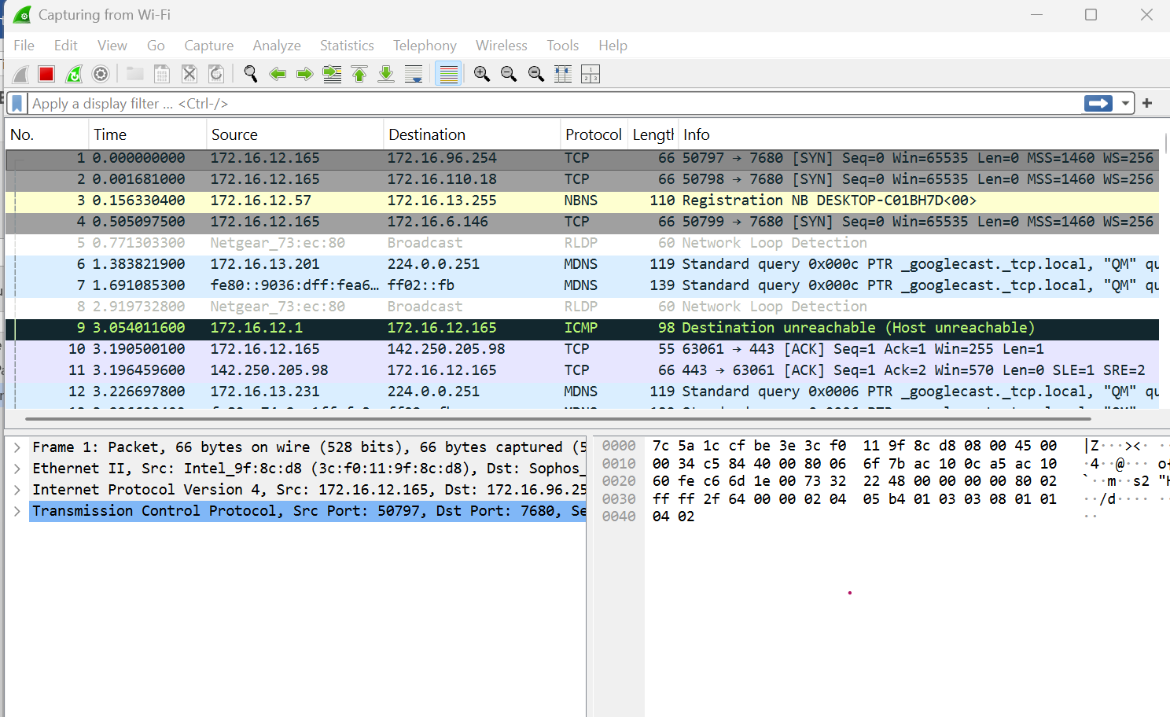
Color | Protocol/Traffic | Description
Light Gray | TCP | Indicates normal TCP packets such as SYN and ACK packets.
Light Yellow | NBNS (NetBIOS Name Service) | Used for NetBIOS name registration and name resolution on a local network.
White | RLDP (Network Loop Detection) | Represents Network Loop Detection Protocol packets used by network devices.
Light Blue | MDNS (Multicast DNS) | Used for local network service discovery (e.g., Chromecast, printers, Apple devices).
Dark Green / Black with Green Text | ICMP | Indicates Internet Control Message Protocol packets such as Destination Unreachable, Ping Request, or Ping Reply.
Light Purple / Lavender | TCP | Represents another category of TCP packets (e.g., ACK or established connection traffic) based on Wireshark's default coloring rules.

To view exactly what the color codes mean, click View > Coloring Rules. You can also customize and modify the coloring rules from here, if you like.
Sample Output:
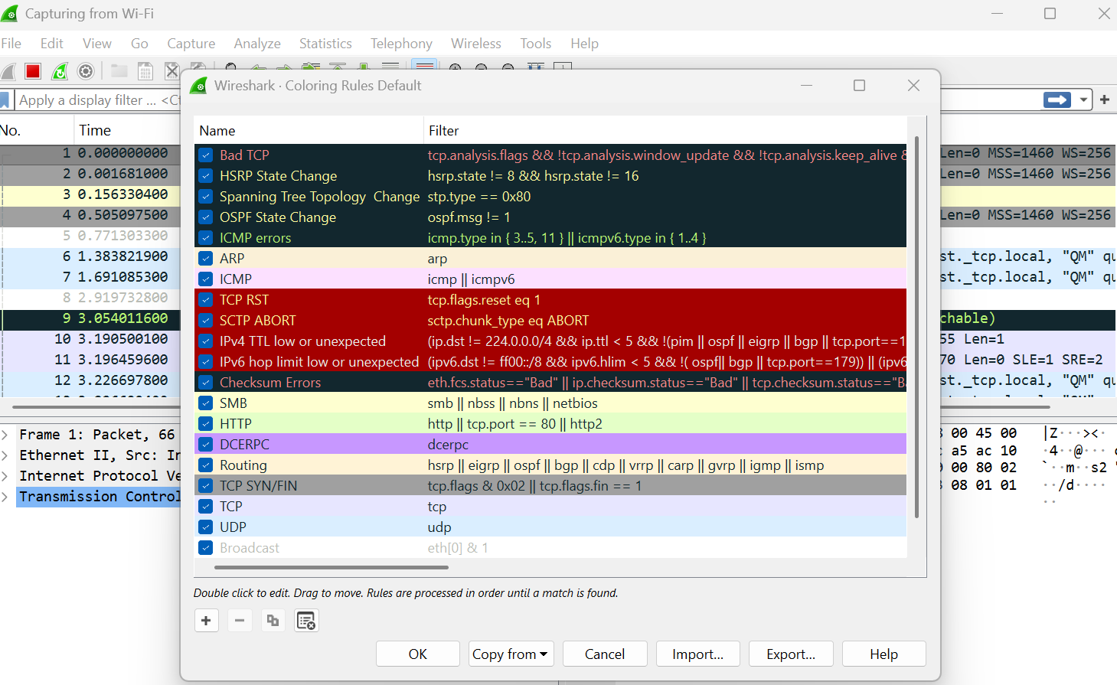

Sample Captures:
- If there is no interesting network traffic on your own network, you can use sample capture files.
- Download a sample capture file and open it by selecting File → Open in Wireshark.
- Browse to the downloaded file and click Open to analyze the captured packets.
- You can also save your own captured packets for future analysis by selecting File → Save.
- Wireshark saves capture files in .pcap or .pcapng format.
Simple Procedure:
- Download a sample capture file.
- Open Wireshark.
- Click File → Open.
- Select the sample capture file.
- Analyze the captured packets.
- To save your own capture, click File → Save.
You can also save your own captures in Wireshark and open them later. Click File > Save to save your captured packets

Filtering Packets:
• Close unnecessary applications before capturing packets.
• This reduces unwanted network traffic.
• Capture only the traffic related to the program you want to analyze.
• Without filters, thousands of packets may be captured.
• Filters help narrow down the packet list.
• This makes packet analysis faster and easier.
• Wireshark provides Capture Filters and Display Filters to simplify traffic analysis.
Sample filter applied for TCP:
Filtered Packet List
No. | Time | Source | Destination | Protocol | Length | Info
1 | 0.001 | 192.168.1.10 | 142.250.183.78 | TCP | 74 | 50234 → 443 [SYN]
2 | 0.005 | 142.250.183.78 | 192.168.1.10 | TCP | 74 | 443 → 50234 [SYN, ACK]
3 | 0.006 | 192.168.1.10 | 142.250.183.78 | TCP | 66 | 50234 → 443 [ACK]
4 | 0.020 | 192.168.1.10 | 142.250.183.78 | TCP | 1514 | HTTP GET Request
5 | 0.055 | 142.250.183.78 | 192.168.1.10 | TCP | 1514 | HTTP 200 OK

Display Filters in Wireshark:
• Click Analyze → Display Filters to open the list of available display filters.
• Choose a predefined filter from the default list.
• You can create your own custom filters.
• Save custom filters for future use.
• Display filters make it easier to find specific packets.
• For advanced filter syntax, refer to the official Wireshark Display Filter documentation.

Example: Create and Save a Custom Filter
Suppose you frequently analyze DNS packets.
- Click Analyze → Display Filters.
- Click the + (Add) button.
- Enter:
  - Filter Name: DNS Packets
  - Filter Expression: dns
- Click OK.

Follow TCP Stream in Wireshark
- Right-click on a TCP packet.
- Select Follow → TCP Stream.
- Wireshark displays the complete conversation between the client and the server.
- This helps you understand the data exchanged during the communication.
- You can also choose Follow → UDP Stream or other available protocol streams, if supported.
- This feature is useful for analyzing web requests, application data, and troubleshooting network communication.
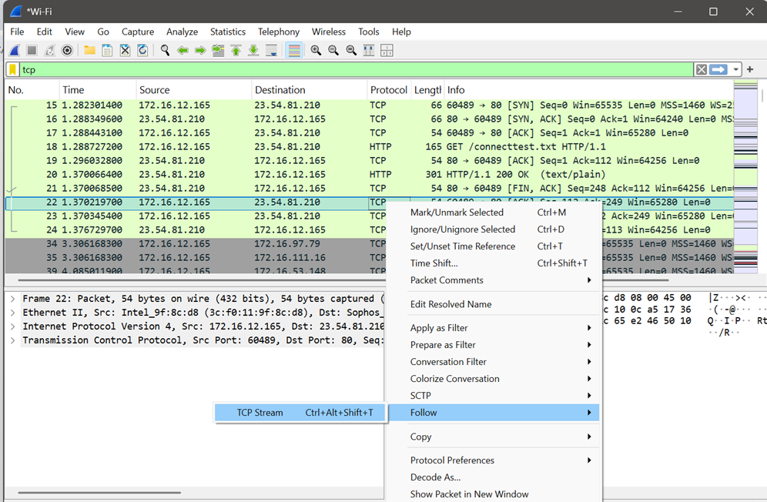

Sample Output:
No. | Source | Destination | Protocol | Info
35 | 192.168.1.10 | 93.184.216.34 | TCP | 50321 → 80 [SYN]
36 | 93.184.216.34 | 192.168.1.10 | TCP | 80 → 50321 [SYN, ACK]
37 | 192.168.1.10 | 93.184.216.34 | TCP | 50321 → 80 [ACK]
38 | 192.168.1.10 | 93.184.216.34 | HTTP | GET /index.html
39 | 93.184.216.34 | 192.168.1.10 | HTTP | HTTP/1.1 200 OK

Inspecting Packets:
• Click a packet in the Packet List pane.
• The packet details are displayed in the Packet Details pane.
• Expand each protocol layer (Ethernet, IP, TCP/UDP, etc.) to view more information.
• View the raw packet data in the Packet Bytes pane.
• Inspecting packets helps analyze source and destination addresses, protocol information, ports, and packet contents.

Sample Output:
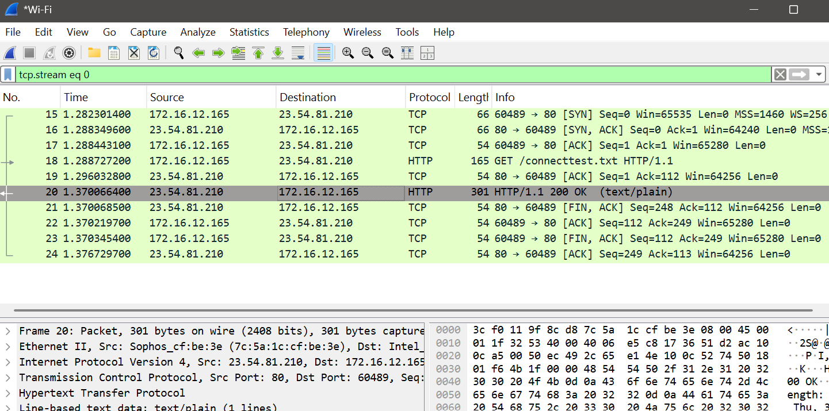

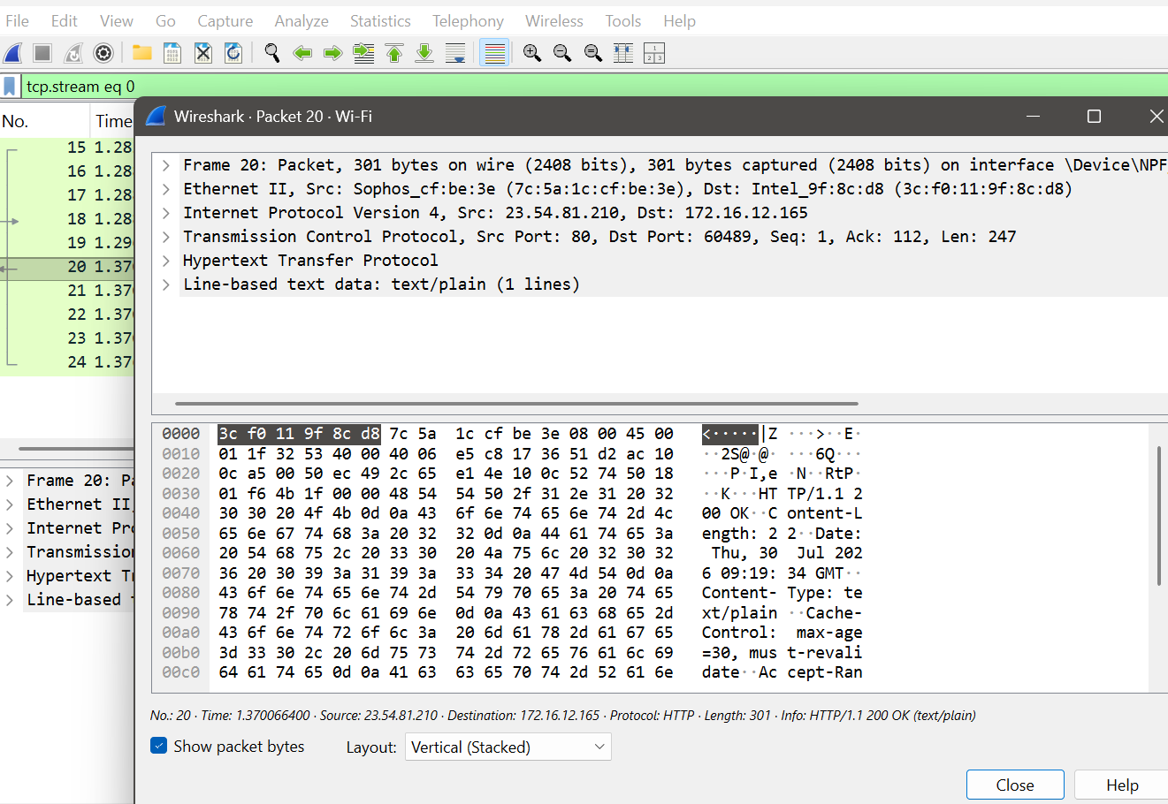

Flow Graph in Wireshark
Definition:
A Flow Graph visually represents the sequence of communication between different devices (hosts) in a network. It makes it easier to understand how packets are exchanged.

How to Open Flow Graph
- Open a packet capture (.pcap) file.
- Click Statistics → Flow Graph.
- A Flow Graph window appears showing the communication between hosts.

What the Graph Shows
- Vertical lines represent different network devices (hosts).
- Horizontal arrows represent packets sent between hosts.
- Time is shown from top to bottom.
- Each arrow is labeled with the protocol and packet information.
Example:
Yes. Below is a sample Flow Graph output similar to what you would see in Wireshark after selecting Statistics → Flow Graph.

Sample Output: Flow Graph
Time Client (192.168.1.10) Server (93.184.216.34)

0.000 |--------------------------->| DNS Query
0.015 |<---------------------------| DNS Response

0.030 |--------------------------->| TCP SYN
0.035 |<---------------------------| TCP SYN-ACK
0.040 |--------------------------->| TCP ACK

0.050 |--------------------------->| HTTP GET /index.html
0.120 |<---------------------------| HTTP/1.1 200 OK
0.125 |<---------------------------| HTML Page Data

0.150 |--------------------------->| TCP FIN
0.155 |<---------------------------| TCP ACK
0.160 |<---------------------------| TCP FIN
0.165 |--------------------------->| TCP ACK

Wireshark Capture Options:
  - Go to capture → option
  - Select stop capture automatically after 100 packets.
  - Then click Start capture.
Step 1: Select the Active Interface
In your screenshot, choose the interface that is currently connected to the network.
- If you are using Wi-Fi, click Wi-Fi.
- If you are using a LAN cable, click Ethernet.
Tip: The active interface usually shows a moving graph or increasing traffic. In your screenshot, Wi-Fi is likely the correct choice if you are connected wirelessly.
Step 2: Go to the Options Tab
Click the Options tab at the top.
You will see settings similar to this:
☑ Stop capture automatically after

Step 3: Set the Packet Limit
Check the option:
☑ Stop capture automatically after
Select:
100 Packets

Creating a Filter to display only DHCP packets and inspect the packets.

Procedure
- Open Wireshark.
- Select the Ethernet (Local Area Connection) or Wi-Fi interface.
- Click Capture → Options.
- Select Stop capture automatically after 100 packets.
- Click Start to begin packet capture.
- Generate DHCP traffic by disconnecting and reconnecting the network, or by running:
- ipconfig /release
ipconfig /renew
- After the capture stops, type the following in the Display Filter bar:
dhcp
(If dhcp does not work, use bootp.)
- Press Enter or click Apply to display only DHCP packets.
- Click any DHCP packet to inspect its details.
- Click File → Save As, enter a filename, and save the captured packets as a .pcapng file.
Create a Filter to display only IP/ICMP packets and inspect the packets. Procedure
Step 1: Check if ping is working
- Press Windows + R.
- Type cmd and press Enter.
- Type:
ping 8.8.8.8
- Press Enter.
What do you see?
- If you see:
Reply from 8.8.8.8...
then the ping is working.
- If you see:
Request timed out
or
Ping request could not find host...
tell me exactly what message appears.

Step 2: Check whether Wireshark is capturing
When you click Start Capture, do you see the packet count increasing continuously?
- Yes → Wireshark is capturing.
- No → The wrong network interface is selected.

Step 3: Verify the filter
After capturing packets, clear any existing filter and type:
icmp
If the filter bar turns green, the filter is valid.
If it stays green but shows 0 packets, then no ICMP packets were captured.

Step 4: Easier alternative
Instead of using ping, try this:
- Start Wireshark.
- Open Google Chrome.
- Visit www.google.com.
- Stop the capture.
- In the Display Filter, type:
dns
or
tcp
- Press Enter.
These filters almost always show packets because web browsing generates DNS and TCP traffic.

Sample Output (ICMP Filter)
Display Filter:
icmp
Packet List
No. | Time | Source | Destination | Protocol | Length | Info
15 | 2.345 | 192.168.1.10 | 8.8.8.8 | ICMP | 74 | Echo (ping) request
16 | 2.356 | 8.8.8.8 | 192.168.1.10 | ICMP | 74 | Echo (ping) reply
17 | 3.347 | 192.168.1.10 | 8.8.8.8 | ICMP | 74 | Echo (ping) request
18 | 3.359 | 8.8.8.8 | 192.168.1.10 | ICMP | 74 | Echo (ping) reply
19 | 4.351 | 192.168.1.10 | 8.8.8.8 | ICMP | 74 | Echo (ping) request
20 | 4.362 | 8.8.8.8 | 192.168.1.10 | ICMP | 74 | Echo (ping) repl

OUTPUT:

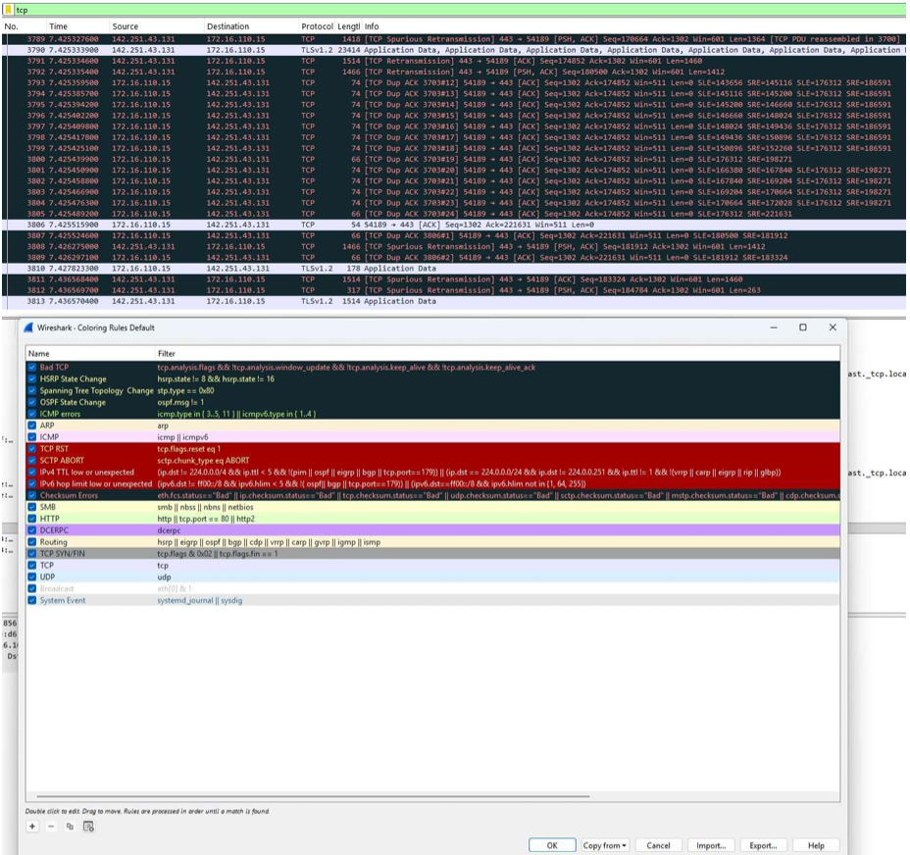
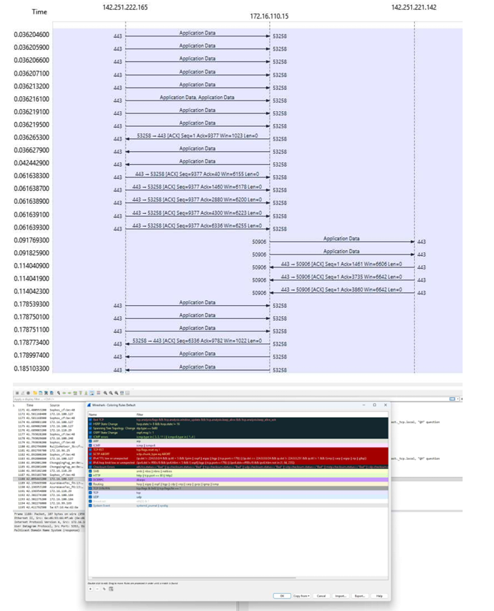

RESULT:
Wireshark was successfully used to capture and analyze network packets.
The captured packets were studied to understand different network protocols and communication behavior.

