Arun karthikeyan B
251901019
Ex.No.9 | Develop a program to create reverse shell using TCP sockets
DATE: | Develop a program to create reverse shell using TCP sockets
COMPUTER NETWORKS

AIM :
To write a program to create reverse shell using TCP sockets
ALGORITHM:

Server:
Algorithm: TCP Socket Server
- Start the program.
- Import the required modules.
- Create a TCP socket.
- Bind the socket to the host address and port number.
- Listen for incoming client connections.
- Accept the client connection.
- Receive the command from the client.
- Check the received command:
  - If hello, send a greeting message.
  - If time, send the current time.
  - If date, send the current date.
  - If exit, send a closing message and terminate the connection.
  - Otherwise, send "Invalid Command".
- Repeat Steps 7 and 8 until the client exits.
- Close the client connection and the server socket.
- Stop the program.
Client:

Algorithm: TCP Socket Client
- Start the program.
- Import the socket module.
- Define the HOST address and PORT number.
- Create a TCP socket.
- Connect to the server using the specified HOST and PORT.
- Display the list of available commands.
- Repeat the following steps until the user enters exit:
  - Read a command from the user.
  - Send the command to the server.
  - Receive the response from the server.
  - Display the server's response.
  - If the command is exit, terminate the loop.
- Close the client socket.
- Stop the program.

PROGRAM:
SERVER:
import socket
import datetime
HOST = "127.0.0.1"
PORT = 5000
server = socket.socket(socket.AF_INET, socket.SOCK_STREAM)
server.bind((HOST, PORT))
server.listen(1)
print("Server is listening on", HOST, PORT)
conn, addr = server.accept()
print("Connected by:", addr)
while True:
data = conn.recv(1024).decode()
if not data:
break
print("Client Command:", data)
if data.lower() == "hello":
response = "Hello from Server!"
elif data.lower() == "time":
response = datetime.datetime.now().strftime("%H:%M:%S")
elif data.lower() == "date":
response = datetime.datetime.now().strftime("%d-%m-%Y")
elif data.lower() == "exit":
response = "Connection Closed"
conn.send(response.encode())
break
else:
response = "Invalid Command"
conn.send(response.encode())
conn.close()
server.close()
CLIENT:
import socket
HOST = "127.0.0.1"
PORT = 5000
client = socket.socket(socket.AF_INET, socket.SOCK_STREAM)
client.connect((HOST, PORT))
print("Connected Successfully")
print("Available Commands")
print("1. hello")
print("2. time")
print("3. date")
print("4. exit")
while True:
command = input("\nEnter Command: ")
client.send(command.encode())
response = client.recv(1024).decode()
print("Server:", response)
if command.lower() == "exit":
break
client.close()

SAMPLE OUTPUT:
Connected Successfully

Available Commands
1. hello
2. time
3. date
4. exit

Enter Command: hello
Server: Hello from Server!

Enter Command: time
Server: 10:35:42

Enter Command: date
Server: 09-07-2026

Enter Command: test
Server: Invalid Command

Enter Command: exit
Server: Connection Closed

OUTPUT:

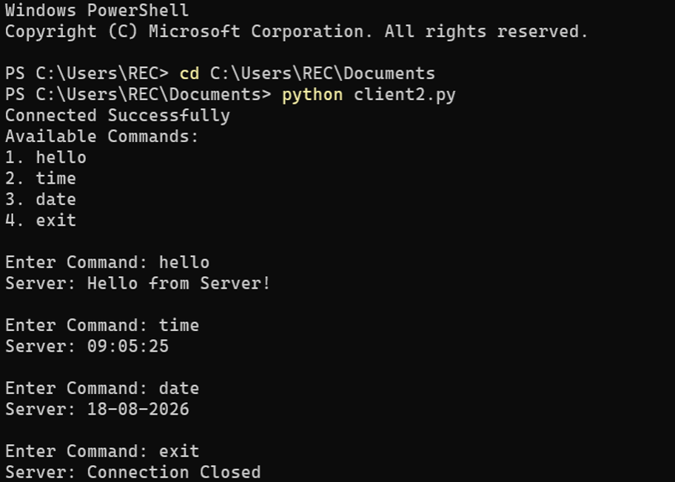

RESULT:
A TCP socket-based reverse shell program was successfully developed and tested in a controlled environment.The communication between the client and server was established successfully using TCP sockets.

