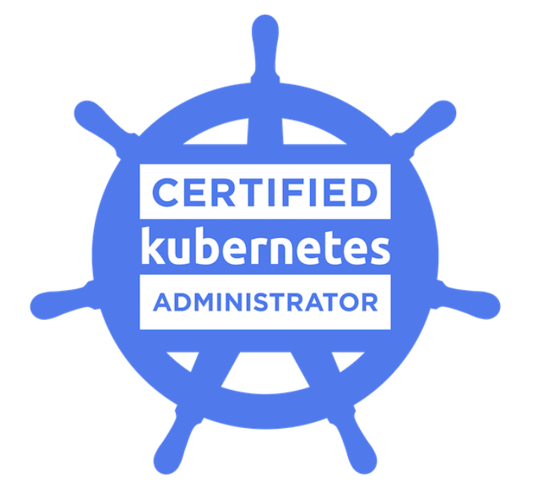
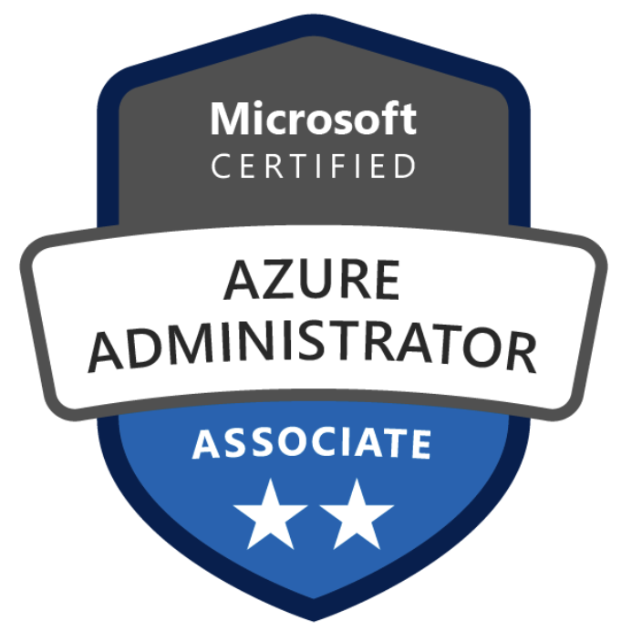
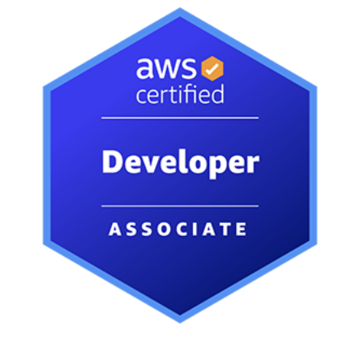
BATHINI ARUN KUMAR
Cloud DevOps Engineer

Contact No: 9728366480
Email ID: bathiniarunkumar525@gmail.com

PROFESSIONAL SUMMARY:
- Overall 10 years of experience in IT industry in that as a DevOps Engineer having 6 years of professional Experience with AWS and Azure cloud services. 4 years of experience into Build and release engineer.
- Experience in IT comprising of Designing, Development, Integration of DevOps tools with Cloud platforms, Configuration Management, Build and Release, Continuous Integration/Deployment, Delivery management, system administration, and Cloud Migration.
- Expertise in Systems Administration, Upgrades, Automation, Performance Tuning, Capacity Planning, Contingency Planning, Disaster Recovery and Fault Tolerant Planning in WINDOWS and Linux Environments.
- Good Experience in automation and securing the infrastructure on AWS using Cloud Formation, Terraform and AWS Lambda and building CI/CD on AWS environment using Jenkins Pipeline.
- Technical expertise in facilitating Cloud Infrastructure Management for entire company’s set-up; experienced in Amazon Web Services like Elastic Cloud Compute (EC2), Auto Scaling, AWS Simple Storage Services (S3), Glacier, Elastic Block Storage (EBS), Virtual Private Cloud (VPC), Route 53, Identity and Access Management (IAM), Amazon RDS, Cloud Watch, Cloud Formation, SQS.
- Wrote python scripts to manage AWS resources from API calls using BOTO SDK and worked with AWS CLI.
- Wrote Terraform scripts to launch AWS instances and used Ansible to manage web applications, configuration files, used mount points and packages.
- Deployed Azure IaaS virtual machines (VMs) and Cloud services (PaaS role instances) into secure VNets and subnets.
- Used Terraform scripts to provision and manage infrastructure for Go applications on cloud platforms.
- Administrating and supporting Azure Kubernetes infrastructure, ensuring it is secure, resilient and performance and responsible for complete DevOps activities and coordinating with development team.
- Implemented monitoring with Grafana visualization infrastructure in Azure Kubernetes cluster.
- Configuration Management using Ansible (writing ad-hoc queries and play books).
- Worked with Ansible Playbooks for virtual and physical instance provisioning, Configuration management, patching, and software deployment.
- Implemented Terraform modules for deployment of various applications across multiple cloud providers and managing infrastructure.
- Experience with container-based deployments using Docker, working with Docker images, Docker hub and Docker registries, installation and configuring Kubernetes and clustering them.
- Designed and implemented IAM user policies to control and secure AWS service and resources.
- Implemented and deployed Access Gateway to provide secure and remote access to AWS resources.
- Consulting in the areas of Continuous Integration, Build Automation, DevOps, Deployments, VM Ware, UNIX/LINUX, Jenkins, Subversion, Git, GitLab, GitHub, Java, and related tools/technologies.
- Expertise on Version Control Administration with GITHUB.
- Experience in integrating Jenkins with various tools like Maven (Build tool), Git (Repository), SonarQube (code scanning), Nexus (Artifactory) and implementing CI/CD automation for creating Jenkins pipelines.
- Installing, configuring and administer Jenkins CI tool on Linux machines.
EDUCATION
- Bachelor of Engineering in Computer Engineering from JNTUK, India.

TECHNICAL SKILLS:
AWS Services | RDS, EC2, VPC, IAM, Lambda Functions, Cloud Formation, EBS, S3, ELB, Auto Scaling, Cloud Trial, SQS, SNS, SWF, Cloud Watch, WAF, ECR, EKS.
Cloud Platforms | Microsoft Azure, AWS Cloud, Google Anthos.
Azure Services | App Services, Key vault, Function App, Blob storage, Azure Active Directory (Azure AD), Service Bus, Azure Container Registry (ACR) and Azure Kubernetes service (AKS), Azure SQL, Azure Cosmos DB.
Version Control Tools | GIT, Bitbucket
CI/CD | Jenkins, Azure DevOps Pipelines, GitLab, CircleCI
Configuration & Automation Tools | Ansible
Container Platforms | Docker, Kubernetes, OpenShift.
Monitoring Tools | Nagios, Splunk, Prometheus, Grafana, DataDog.
Languages | Python, Shell scripting, Golang.
Artifactory | Jfrog and Nexus
Web Servers | Nginx, Tomcat, IIS
Documentation | Confluence
Operating Systems | Microsoft Windows, Linux, UNIX.
Tracking Tools | Jira, ServiceNow, Azure Boards.
Code Scanning | SonarQube, Jfrog, X ray, ECR Inspector
Databases | RDS, Cosmos DB, MySQL, Aurora DB, MongoDB.
Logging | CloudWatch, CloudTrail, Azure App Insights, Azure Monitor

CERTIFICATIONS
- Certified Azure Administrator Associate.
- Certified AWS Developer Associate.
- Certified Kubernetes Administrator.
PROFESSIONAL EXPERIENCE
Client: Sentara HealthCare, USA Feb 2024 - Present
Role: AWS DevOps Engineer
Roles & Responsibilities:
- Implemented GitHub Action pipelines to drive all microservices builds out to Amazon ECR (Elastic Container Registry) and then deployed to Amazon EKS (Elastic Kubernetes Service).
- Experience in working with AWS key features such as Infrastructure as Code using CloudFormation, Execution plans, and Change Automation.
- Migrated SQL Database from On-Premises to Amazon RDS (Relational Database Service) using AWS Data Lake as a staging area and AWS Glue as the Orchestration Tool.
- Implemented AWS Hybrid integration to integrate the applications, data, and processes using Amazon API Gateway.
- Implemented CI/CD pipelines for Go applications using Jenkins and GitHub Actions, ensuring rapid and reliable deployments.
- Set up AWS Elastic Beanstalk for Blue/Green Deployments and deployed serverless AWS Lambda functions with EventBridge and S3 triggers.
- Created and maintained containerized microservices and configured/maintained Amazon ECR for hosting images.
- Built and deployed scalable microservices in Go, improving application performance and reliability.
- Managed servers on the AWS platform using EC2 instances and created Ansible Playbooks, tasks, and roles to automate system operations.
- Worked with AWS (IaaS) services such as creating EC2 instances, S3 buckets, EBS volumes, and migrating on-premise servers to AWS, including creating availability zones and performing hardening of the VMs and disk encryption using AWS KMS (Key Management Service).
- Worked with Docker and Kubernetes on AWS, helping developers build and containerize their applications (CI/CD) and deploying them on either public or private cloud.
- Experience in installing, configuring, supporting, and troubleshooting Unix/Linux Networking services and protocols like NIS, LDAP, DNS, NFS, DHCP, and Samba on AWS instances.
- Created various services like EKS, ECR, VPC, and EC2 using Infrastructure as Code (CloudFormation) and developed custom modules as per project needs.
- Architected, designed, implemented, and managed AWS virtualization components (EC2, VPC, IAM). Experience with regulatory compliance standards (HIPAA, PCI, etc.).
- Responsible for configuring networking concepts like NIS, NFS, LDAP, SSH, SFTP, SNMP, DNS, DHCP, and troubleshooting network problems such as TCP/IP, supporting users in solving their problems.
- Created, managed, and performed container-based deployments using Docker images containing Middleware and Applications together and evaluated EKS for Docker container orchestration.
- Utilized Kubernetes and Docker for the runtime environment for the CI/CD system to build, test, and deploy. Created GitHub Action pipelines to deploy applications to EKS clusters.
- Created different GitLab pipelines for different services like infrastructure provisioning, code deployment, and configuration management.
- Designed and implemented scalable microservices using Golang, improving application responsiveness and fault tolerance.
- Extensively worked with the LAN/WAN, firewalls, and routing for Internet and Intranet connectivity using different protocols like TCP/IP, DHCP, HTTP/HTTPS, FTP, SMTP, and SSH.
- Installed and deployed Amazon EC2 instances and managed the AWS cloud environment.
- Managed AWS EC2 instances in a high availability environment with Elastic Load Balancing and Auto Scaling. Experience working with production servers in multiple AWS regions.
- Migrated data centers and converted physical servers to virtual servers (P2V) using AWS Application Migration Service.
- Created Amazon EC2 instances and installed Red Hat Linux on the VMs and standalone Dell servers.
- Knowledgeable in AWS hardware server management.
- Hands-on experience building, patching, and maintaining Linux systems in a highly virtualized (AWS) environment.
- Worked on AWS services like Amazon EMR for big data processing and configured network security group (NSG) rules to specify egress traffic restrictions.
- Managing AWS VPC components like route tables, security groups, and VPN connections.
- Migrated AWS EC2 instances from one region to another using AWS migration tools.
- Troubleshot issues related to AWS EC2 instances, Elastic Load Balancers, and AWS CloudFormation.
- Deployed Kubernetes (K8s) clusters with Amazon EKS using AWS CLI and utilized Kubernetes and Docker for the runtime environment of the CI/CD system.
- Created Ansible roles in YAML and defined tasks, variables, files, handlers, and templates. Configured Ansible files for parallel deployment to automate the Continuous Delivery process.
- Excellent hands-on experience working with monitoring tools such as Amazon CloudWatch, ELK Stack, and working with load balancing, integrating, and monitoring with these tools.
- Developed Python scripts to fetch necessary information from AWS services and automate routine tasks when applicable.

Client: Lowe’s, charlotte, NC, USA Sept 2021 – Feb 2024
Role: DevOps/SRE Engineer
Roles & Responsibilities:
- Configured and automated the Jenkins Pipelines/Build jobs for Continuous Integration and Deployments Dev to Production environments for Tomcat applications using Jenkins Groovy Scripting.
- Designing, deploying, and maintaining the application servers on AWS infrastructure, using services like AWS EC2, S3, Glacier, VPC, Lambda, Route53, SQS, IAM, Cloud Front, RDS, and AWS CloudFormation etc.
- Involved in deploying and managing applications using Elastic Beanstalk, including setting up environments, configuring deployments.
- We have used AWS CLI to automate patch management tasks and create scripts that check for available patches on EC2 instances and apply them as needed. AWS Config rules can ensure that instances are regularly scanned for missing patches, helping to maintain security and compliance.
- We have used AWS Config rules to detect resource configuration drift, which occurs when a resource's actual configuration diverges from its expected configuration.
- Wrote Terraform scripts to deploy different AWS Infrastructure components related to the respective services, managed various resources and data elements defined in the scripts.
- AWS Config rules can verify that backup policies are adhered to, ensuring data resilience and compliance.
- Extensive hands-on experience in developing complex Amazon Connect Contact Flows and utilizing the Connect Console designer to design and customize customer interactions seamlessly.
- Proficient in using developer tools such as Connect CLI, Postman, and others to streamline development processes, troubleshoot issues, and ensure the optimal performance of Amazon Connect solutions.
- Solid working knowledge of Python, leveraging it for scripting, automation, and custom functionality within Amazon Connect projects.
- Successfully designed and implemented reporting solutions using tools like QuickSight, providing valuable insights into customer interactions, agent performance, and overall contact center efficiency.
- Actively involved in the end-to-end development lifecycle of Amazon Connect projects, from requirements gathering and design to implementation, testing, and deployment.
- Developed and maintained custom integrations with third-party applications and services, ensuring seamless connectivity and data synchronization.
- Implemented and optimized Amazon Connect Contact Flows to enhance customer experience, incorporating dynamic prompts, decision trees, and personalized interactions.
- Utilized Amazon Connect features like contact attributes, queues, and routing profiles to design and implement efficient call routing strategies.
- Played a pivotal role in Agile methodologies, contributing to cross-functional teams, participating in sprint cycles, and promoting iterative development for faster and more responsive project delivery.
- Successfully designed, implemented, and maintained REST services, facilitating seamless communication and data exchange between systems in various projects.
- Applied QuickSight for dynamic dashboard creation, enabling stakeholders to visualize and interpret data trends, facilitating data-driven decision-making processes.
- Actively participated in Agile ceremonies, including sprint planning, daily stand-ups, sprint reviews, and retrospectives, fostering collaboration and adaptability in project execution.
- Integrated RESTful services into diverse applications, ensuring interoperability and efficient data communication across distributed systems.
- Played a key role in the Agile development process, contributing to backlog refinement, story estimation, and sprint execution, aligning development efforts with business priorities.
- Employed Connect CLI for efficient management of Amazon Connect resources, scripting repetitive tasks, and maintaining consistency across configurations.
- Championed Agile principles, emphasizing customer collaboration, responding to change, and delivering functional software in incremental iterations.
- Applied Connect CLI for version control and configuration management in Amazon Connect projects, ensuring a structured and organized development environment.
- Actively participated in Agile ceremonies, contributing to sprint planning, backlog grooming, and sprint retrospectives, promoting continuous improvement.
- Implemented REST services with a focus on scalability and performance, addressing business requirements for efficient data retrieval and updates.
- Embraced Agile methodologies to respond to changing project requirements, fostering a collaborative and adaptive development culture.
- Utilized Connect CLI for automating repetitive tasks, ensuring consistency and reducing manual effort in the management of Amazon Connect configurations.
- Implemented RESTful web services, adhering to REST principles, to enable seamless communication and data exchange between different software components.
- Creating and managing S3 buckets and implemented access controls for S3 buckets, like bucket policies, ACLs, and IAM roles.
- Worked on the AWS IAM service and creating the users & groups defining the policies and roles and Identify providers.
- Using AWS Config rules we enforce network security policies, ensuring that the network configuration remains compliant and secure.

Environment: Azure, Terraform, Chef, Ansible, Docker, Kubernetes, Jenkins, GIT, Maven, SPLUNK, Nagios, Python Scripts, AWS CLI, KICKSTART, Java/J2EE, Linux.

Client: Home Depot, Atlanta, GA, USA March 2020 – Sept 2021
Role: Azure DevOps Engineer
Roles & Responsibilities:
- Creating and maintaining containerized micro services and configuring/maintaining private container registry on Microsoft Azure for Hosting Images and using Windows Active Directory.
- Planning and implementation of data and storage account solutions for azure files, Queue storage and blob storage.
- Designed and created Azure cosmos DB for MongoDB in testing, and production environments by setting up replica sets, sharding.
- Involved in Atlas MongoDB migration into Azure Cosmos DB for MongoDB where I have created collections and databases.
- Designed and implemented database schema, created tables and indexes, and configuring security settings for Azure SQL DB
- configuring database-level security settings, creating users and roles, and implementing access controls to ensure that only authorized users have access to correct schema.
- Monitored Vault performance and made optimizations, such as fine-tuning storage backends, to ensure rapid secret retrieval and service resilience.
- Regularly updated Vault to ensure that the latest security patches were applied and the newest features were available for use.
- Managing and monitoring Azure SQL DB instances troubleshooting issues and optimizing performance of SQL Managed Instances.
- Writing and executing queries using the Cosmos DB Query API and creating stored procedures to automate repetitive tasks.
- Managed servers on the Microsoft Azure Platform Azure Virtual Machines instances using Ansible Configuration Management and created Ansible Playbooks, tasks, and roles to automate system operations.
- Hands on experience on using Terraform for infrastructure provisioning.
- Integrated these services seamlessly with existing infrastructure, simplifying deployments and maintenance.
- Designed and implemented CI/CD pipeline for Azure app services and responsible for monitoring the performance and availability of Azure App Services and troubleshooting any issues that arise.
- Extended working knowledge in azure networking services, Configured VNETs and subnets as per the project requirement. created and maintained NSG rules.
- In cloud environments using GRPC we can facilitate real-time communication between load balancers and application instances.
- Created Ansible roles in YAML and defined tasks, variables, files, handlers, and templates.
- Process and Implementation - Extensive experience implementing software throughout the SDLC process, deep hands-on experience of networking, migration, and implementation in Azure.
- Worked on creating, configuring, and managing AKS clusters in Azure, including managing node pools, configuring networking, and setting up load balancing.
- Anthos Migrate to seamlessly transform and migrate legacy applications into containerized, Kubernetes-orchestrated applications without code changes, resulting in a 15% improvement in deployment efficiency and application performance.
- Managing the Azure Kubernetes Services (AKS) policies, providing access to different Azure resources and developing and improving the workflows that govern access.
- Monitoring and troubleshooting Kubernetes clusters using Prometheus Grafana.
- Developed and implemented processes and procedures for Linux OS patching.
- Collaborated with other teams to ensure patching activities do not impact critical business operations.
- Configured monitoring tool Azure monitoring to setup the desired alerts for servers.
- Created and deployed Python Flask REST APIs into Azure functions using azure Devops pipeline.

Client: Urban Outfitters, Philadelphia, PA, USA. July 2018 - Feb 2020
Role: DevOps Engineer
Roles & Responsibilities:
- Worked on Azure services such as Azure Repos, Azure Pipelines, Storage accounts, Active directory, Azure Cosmos DB, AKS, App services and EventHubs.
- Designed and created Azure cosmos DB for MongoDB in testing, and production environments by setting up replica sets, sharding.
- Involved in Atlas MongoDB migration into Azure Cosmos DB for MongoDB.
- Restricted network access to MongoDB by configuring firewall rules and RBAC rules for user access.
- Managing repositories and branches on Azure repos and collaborating with developers to resolve merge conflicts.
- Involved in Azure Functions where I created and configured HTTP Triggers in the Azure Functions with Application insights for monitoring.
- Designed and configured Azure Virtual Networks (V-Nets), Subnets, Azure Network Security Groups, DNS Settings, Security policies and Routing.
- Created and configured Azure Front Door for content delivery network (CDN) and Load Balancing for app service which are in multiple regions.
- Wrote Ansible playbooks for Configuration management, patching, and software deployment on On-prem environments.
- Created Terraform Modules to automate AKS cluster creation, VM creation, storage account creation and integrated with Azure pipelines.
- Created azure private end points and private DNS zones in vnet to access different azure services.
- Created and configured azure Devops pipeline to deploy containerized applications into azure Kubernetes services and implemented Rolling updated deployment strategy.
- Created custom alerts and notifications in Prometheus and Grafana based CPU or memory usage thresholds, error rates, and latency for AKS clusters.
- Created shell scripts and configured crontabs to archive Kubernetes logs into azure blob storage.
- Created and deployed Python Flask REST APIs into Azure functions using azure Devops pipeline.
- Provisioned azure file share and mapped them worth persistent volumes to consume Kubernetes application logs.
- Created Azure Databricks notebooks using python scripts and mounted storage into blob storage for data manipulation using ETL.
Client: HDFC Bank, Bangalore, India June 2016 – Sept 2017
Role: DevOps Engineer
Roles & Responsibilities:
- Experience in Software Integration, Configuration, building, automating, managing, and releasing code from one environment to another environment and deploying to servers.
- Working on multiple AWS instances by setting services like Route53, SES, SQS, SNS and created and administered DNS system using Route53.
- Worked with full AWS stack (Lambda server-less, IAM, Blue-Green deployment).
- Provisioned the highly available EC2 instances using Terraform and Cloud Formation and wrote new plugins to support new functionality in Terraform.
- Managed AWS infrastructure as code using Terraform.
- Researched and developed scalable Linux deployments on AWS via CoreOS and Docker and used Docker Compose to develop dependent instances to be deployed in the EC2 platform.
- Used Terraform in AWS VPC to automatically setup and modify settings by interfacing with control layer.
- Installed Redshift on AWS and imported the legacy data from Oracle to Redshift. Participated in integration of applications with existing API’s.
- Implemented and maintained Ansible configuration management spanning several environments in VMware and AWS cloud.
- Responsible for Continuous Integration (CI) and Continuous Delivery (CD) process implementation using Jenkins along with PowerShell to automate routine jobs.
- Developed shell scripts for automation of the build and release process, developed Custom Scripts to monitor repositories, Server storage.
- Created Ansible playbooks to automatically install packages from a repository, to change the configuration of remotely configured machines and to deploy new builds and various automation purpose, file copy, permission changes, configuration changes, path specific folder creation.
- Performed and deployed Builds for various Environments like QA, Integration, UAT and Productions Environments.

Client: Selectsys Pvt Ltd – Hyderabad, India Nov 2012 – May 2016
Role: Build and Release Engineer
Responsibilities:
- Collaborate with developers, testers, and other stakeholders to ensure successful builds and deployments.
- Assisted in migrating applications from customer on-premises datacenter to the cloud (AWS).
- Worked on vagrant for configure lightweight, reproducible, and portable development environments.
- Implemented Chef Recipes for Deployment on build on internal Data Centre Servers. Also re-used and modified same Chef Recipes to create a Deployment directly into Amazon EC2 instances.
- Used Chef and other configuration management tools to deploy consistent infrastructure code across multiple environments.
- Integrated GIT into Jenkins to automate the code checkout process. Used Jenkins for automating Builds and Automating Deployments.
- Monitored & troubleshoot Network, Linux, and Windows servers using Splunk.
- Used ANT and MAVEN as a build tool on java projects for the development of build artifacts on the source code.
- Installed and Configured Continuum jobs for automating some build Processes.
- Installed and Configured Nexus to manage the artifacts in different Repositories.
- Used Apache Tomcat as application server for deploying the artifacts.
- Worked on the Microsoft Release management server for maintaining the release management activities.
- Experience with writing Perl, PowerShell, shell scripts.
- Deployed the Java applications into web application servers like Tomcat.
- Comfortable and flexible with installing, updating, and configuring various flavors of UNIX and Windows.

