PRACTICAL FILE
Advanced DBMS and Administration
(Paper 1T4)

First Year M.C.A. — Semester I (CBCS)
RTM Nagpur University

Name: ____________________________
Roll No: _________________________

INDEX
Sr. No. | Practical | Date | Sign
1 | Create a new user & grant privileges of creating session, table & view to this new user also check connect or not.
2 | Connect to the new user, assign a tablespace, verify it works, create a table, and insert data.
3 | Create a new role named manager with same privileges. Grant this role to new user. Then change the password of newly created user.
4 | Revoke the privileges from role manager. Revoke role from user then delete that user.
5 | Create a tablespace named “P_student” with file name “Stu_datafile.dbf” having size of 10mb.
6 | Create a tablespace named “ts_mydemo” with two datafile named “ts_mydemo01.dbf” & “ts_mydemo02.dbf” having size of 50mb and 64mb respectively. Make the tablespace auto extendable and limit auto extending to size of 2048mb. In auto extending, next extend should of 32mb.
7 | Alter the last datafile “ts_mydemo01.dbf” so that its size will automatically extend by 5mb & limit its size to 500mb.
8 | Create temporary table space with size of 5mb which will be automatically increase on demand.
9 | Add new Redo log file of size 10mb to existing database.
10 | Display the list of all Redo log files and Control files.
11 | Display the list, datafiles, tablespace names & size in MB.
12 | Create rollback segment in separate tablespace with proper storage option.
13 | Create a 3 new abstract datatype as given below: 1. NAME_TYPE(F_NAME, M_NAME, L_NAME) 2. POST_TYPE(MAIN, SFX) 3. ADDR_TYPE(STREET, CITY, STATE, POSTCODE)
14 | Create a table stud_info having column name, rollno, phy, maths, comp, total and percentage. Write a trigger to automatically calculate students total marks and percentage of students while insertion.
15 | Write a SQL query to display the following data information: a. Name of database b. Database startup time c. Database size information (database size, used space, free space)

Practical No. 1
Aim: Create a new user & grant privileges of creating session, table & view to this new user also check connect or not.
Run as SYSTEM (DBA) user in SQL*Plus.
Algorithm:
Step 1: Start.
Step 2: Login to SQL*Plus as SYSTEM (DBA) user.
Step 3: Create a new user Prerna with password prerna123 using CREATE USER.
Step 4: Grant CREATE SESSION, CREATE TABLE and CREATE VIEW privileges to the user using GRANT.
Step 5: Connect as the new user using CONNECT Prerna/prerna123.
Step 6: If the message "Connected." is displayed, the user is created and working properly; otherwise check the privileges.
Step 7: Stop.
Flowchart:
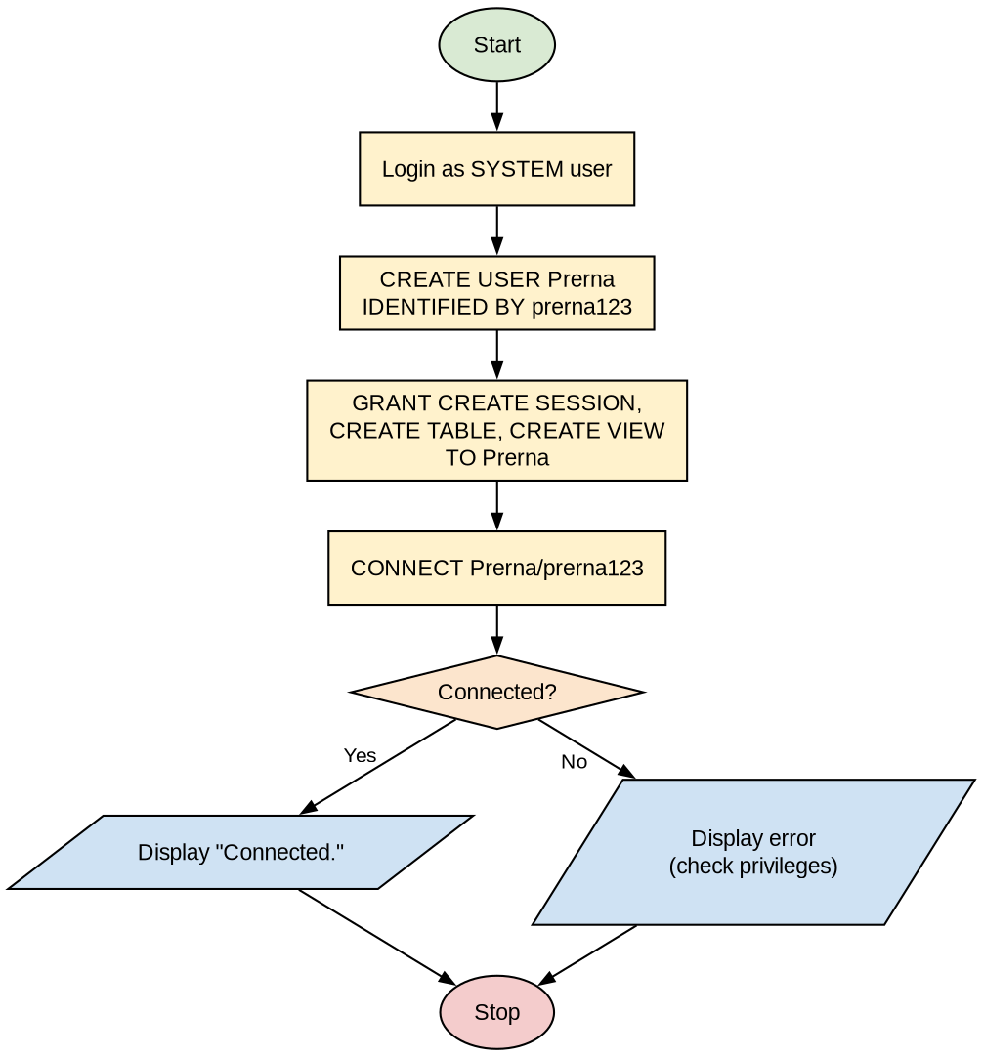
Program (SQL Queries):
-- Create user
CREATE USER Prerna IDENTIFIED BY prerna123;

-- Grant privileges to user
GRANT CREATE TABLE, CREATE SESSION, CREATE VIEW TO Prerna;

-- Connect user
CONNECT Prerna/prerna123;
Output:
-- Create user
SQL> create user Prerna identified by prerna123;

User created.

-- Grant privileges to user
SQL> grant create table, create session, create view to Prerna;

Grant succeeded.

-- Connect user
SQL> CONNECT Prerna/prerna123;

Connected.

Practical No. 2
Aim: Connect to the new user, assign a tablespace, verify it works, create a table, and insert data.
Algorithm:
Step 1: Start.
Step 2: As SYSTEM user, assign DEFAULT TABLESPACE users, TEMPORARY TABLESPACE temp and QUOTA 10M on users to user Prerna using ALTER USER.
Step 3: Connect as user Prerna.
Step 4: Create table employees (emp_id, emp_name, salary).
Step 5: Insert records into the employees table using INSERT INTO.
Step 6: Display the data using SELECT * FROM employees to verify the tablespace works.
Step 7: Stop.
Flowchart:
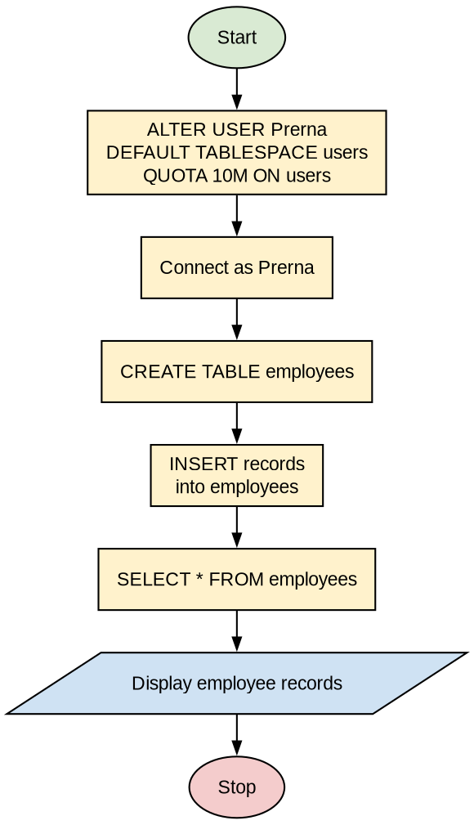
Program (SQL Queries):
-- Tablespace privilege
ALTER USER Prerna
DEFAULT TABLESPACE users
TEMPORARY TABLESPACE temp
QUOTA 10M ON users;

-- Connect user
CONN Prerna/prerna123;

-- Create table
CREATE TABLE employees (
emp_id NUMBER PRIMARY KEY,
emp_name VARCHAR2(50),
salary NUMBER(10,2)
);

-- Insert data in table
INSERT INTO employees VALUES (1, 'John Doe', 50000);
INSERT INTO employees VALUES (2, 'Jane Smith', 60000);

-- Show data
SELECT * FROM employees;
Output:
SQL> ALTER USER Prerna
2 DEFAULT TABLESPACE users
3 TEMPORARY TABLESPACE temp
4 QUOTA 10M ON users;
User altered.

SQL> conn
Enter user-name: Prerna
Enter password:
Connected.

SQL> CREATE TABLE employees (
2 emp_id NUMBER PRIMARY KEY,
3 emp_name VARCHAR2(50),
4 salary NUMBER(10,2)
5 );
Table created.

SQL> INSERT INTO employees VALUES (1, 'John Doe', 50000);
1 row created.
SQL> INSERT INTO employees VALUES (2, 'Jane Smith', 60000);
1 row created.

SQL> SELECT * FROM employees;

EMP_ID EMP_NAME SALARY
---------- -------------------- ----------
1 John Doe 50000
2 Jane Smith 60000

Practical No. 3
Aim: Create a new role named manager with same privileges. Grant this role to new user. Then change the password of newly created user.
Algorithm:
Step 1: Start.
Step 2: Create a role named manager using CREATE ROLE.
Step 3: Grant CREATE TABLE and CREATE VIEW privileges to role manager.
Step 4: Grant the role manager to user Prerna.
Step 5: Change the password of user Prerna using the PASSWORD command (enter old and new password).
Step 6: Stop.
Flowchart:
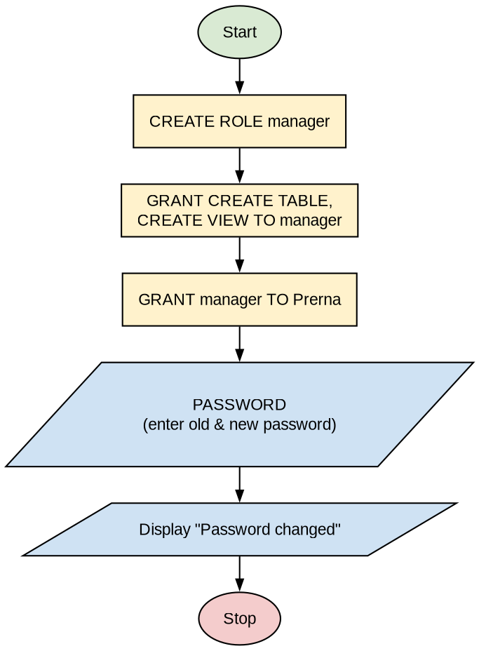
Program (SQL Queries):
-- Create role
CREATE ROLE manager;

-- Grant privileges to role
GRANT CREATE TABLE, CREATE VIEW TO manager;

-- Assign role to user
GRANT manager TO Prerna;

-- Change password
PASSWORD
Output:
-- Create role
SQL> create role manager;

Role created.

-- Grant privileges to role
SQL> grant create table, create view to manager;

Grant succeeded.

-- Assign role to user
SQL> grant manager to Prerna;

Grant succeeded.

-- Change password
SQL> password
Changing password for PRERNA
Old password:
New password:
Retype new password:
Password changed

Practical No. 4
Aim: Revoke the privileges from role manager. Revoke role from user then delete that user.
Algorithm:
Step 1: Start.
Step 2: Revoke CREATE TABLE and CREATE VIEW privileges from role manager using REVOKE.
Step 3: Revoke the role manager from user Prerna.
Step 4: Delete the user Prerna using DROP USER.
Step 5: Stop.
Flowchart:
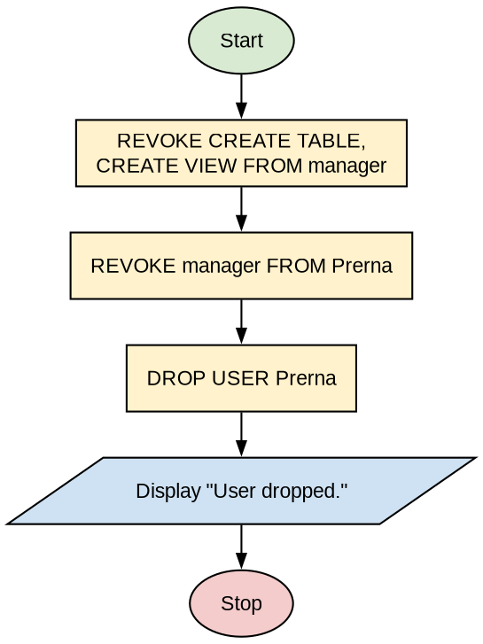
Program (SQL Queries):
-- Revoke privileges
REVOKE CREATE TABLE, CREATE VIEW FROM manager;

-- Revoke role from user
REVOKE manager FROM Prerna;

-- Delete user
DROP USER Prerna;
Output:
-- Revoke privileges
SQL> Revoke create table, create view from manager;

Revoke succeeded.

-- Revoke role from user
SQL> Revoke manager from Prerna;

Revoke succeeded.

-- Delete user
SQL> drop user Prerna;

User dropped.

Practical No. 5
Aim: Create a tablespace named “P_student” with file name “Stu_datafile.dbf” having size of 10mb.
Algorithm:
Step 1: Start.
Step 2: Grant the CREATE TABLESPACE privilege to the user.
Step 3: Create tablespace P_student with DATAFILE 'Stu_datafile.dbf' of SIZE 10M using CREATE TABLESPACE.
Step 4: Display the message "Tablespace created."
Step 5: Stop.
Note: The answer is corrected here: the tablespace name is changed from Std_student (answer sheet) to P_student as given in the practical list. Please test and run it yourself before writing.
Flowchart:
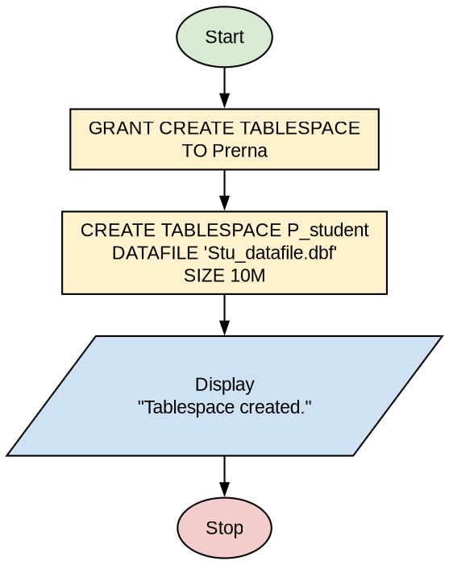
Program (SQL Queries):
-- Grant privilege
GRANT CREATE TABLESPACE TO Prerna;

-- Create tablespace
CREATE TABLESPACE P_student
DATAFILE 'Stu_datafile.dbf'
SIZE 10M;
Output:
-- Grant privilege
SQL> GRANT CREATE TABLESPACE TO Prerna;

Grant succeeded.

-- Create tablespace
SQL> CREATE TABLESPACE P_student
2 DATAFILE 'Stu_datafile.dbf'
3 SIZE 10M;

Tablespace created.

Practical No. 6
Aim: Create a tablespace named “ts_mydemo” with two datafile named “ts_mydemo01.dbf” & “ts_mydemo02.dbf” having size of 50mb and 64mb respectively. Make the tablespace auto extendable and limit auto extending to size of 2048mb. In auto extending, next extend should of 32mb.
Algorithm:
Step 1: Start.
Step 2: Use CREATE TABLESPACE ts_mydemo.
Step 3: Specify the first datafile of SIZE 50M with AUTOEXTEND ON NEXT 32M MAXSIZE 2048M.
Step 4: Specify the second datafile of SIZE 64M with AUTOEXTEND ON NEXT 32M MAXSIZE 2048M.
Step 5: Execute the statement and display "Tablespace created."
Step 6: Stop.
Note: The answer is corrected here: the datafile names are changed from mydemo01.dbf / mydemo02.dbf (answer sheet) to ts_mydemo01.dbf / ts_mydemo02.dbf as given in the practical list. Please test and run it yourself before writing.
Flowchart:
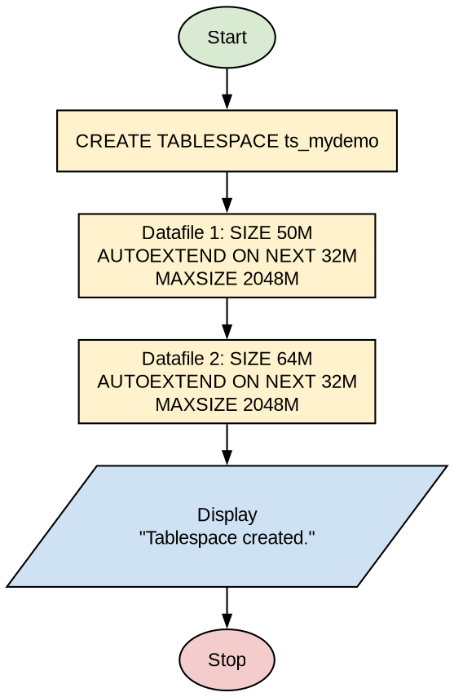
Program (SQL Queries):
-- Create tablespace with two datafiles
CREATE TABLESPACE ts_mydemo
DATAFILE 'ts_mydemo01.dbf' SIZE 50M
AUTOEXTEND ON NEXT 32M
MAXSIZE 2048M,
'ts_mydemo02.dbf' SIZE 64M
AUTOEXTEND ON NEXT 32M
MAXSIZE 2048M;
Output:
SQL> CREATE TABLESPACE ts_mydemo
2 DATAFILE 'ts_mydemo01.dbf' SIZE 50M
AUTOEXTEND ON NEXT 32M
MAXSIZE 2048M,
3 'ts_mydemo02.dbf' SIZE 64M
AUTOEXTEND ON NEXT 32M
MAXSIZE 2048M;

Tablespace created.

Practical No. 7
Aim: Alter the last datafile “ts_mydemo01.dbf” so that its size will automatically extend by 5mb & limit its size to 500mb.
Algorithm:
Step 1: Start.
Step 2: Find the full path of the datafiles of tablespace TS_MYDEMO from dba_data_files.
Step 3: Use ALTER DATABASE DATAFILE '<full path of TS_MYDEMO01.DBF>'.
Step 4: Set AUTOEXTEND ON NEXT 5M MAXSIZE 500M.
Step 5: Display the message "Database altered."
Step 6: Stop.
Note: The datafile name/path is corrected to TS_MYDEMO01.DBF to match Practical 6. The full path depends on your Oracle installation. Please test and run it yourself before writing.
Flowchart:
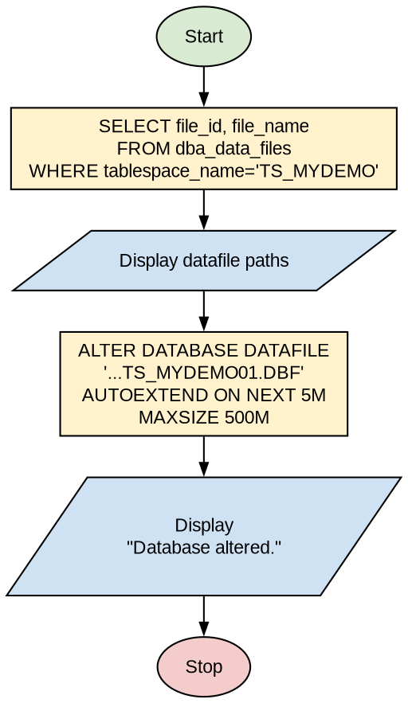
Program (SQL Queries):
-- Find datafile path
SELECT file_id, file_name
FROM dba_data_files
WHERE tablespace_name = 'TS_MYDEMO';

-- Alter datafile
ALTER DATABASE
DATAFILE 'C:\ORACLEXE\APP\ORACLE\PRODUCT\11.2.0\SERVER\DATABASE\TS_MYDEMO01.DBF'
AUTOEXTEND ON
NEXT 5M
MAXSIZE 500M;
Output:
SQL> SELECT file_id, file_name
2 FROM dba_data_files
3 WHERE tablespace_name = 'TS_MYDEMO';

FILE_ID FILE_NAME
---------- ---------------------------------------------------------
10 C:\ORACLEXE\APP\ORACLE\PRODUCT\11.2.0\SERVER\DATABASE\TS_MYDEMO01.DBF
11 C:\ORACLEXE\APP\ORACLE\PRODUCT\11.2.0\SERVER\DATABASE\TS_MYDEMO02.DBF

-- Alter Datafile
SQL> ALTER DATABASE
2 DATAFILE 'C:\ORACLEXE\APP\ORACLE\PRODUCT\11.2.0\SERVER\DATABASE\TS_MYDEMO01.DBF'
3 AUTOEXTEND ON
4 NEXT 5M
5 MAXSIZE 500M;

Database altered.

Practical No. 8
Aim: Create temporary table space with size of 5mb which will be automatically increase on demand.
Algorithm:
Step 1: Start.
Step 2: Use CREATE TEMPORARY TABLESPACE temp_demo.
Step 3: Specify TEMPFILE 'temp01.dbf' of SIZE 5M.
Step 4: Set AUTOEXTEND ON so that the size increases on demand.
Step 5: Display the message "Tablespace created."
Step 6: Stop.
Note: The answer is corrected here: "temp file" and "auto extend" are written as TEMPFILE and AUTOEXTEND (correct Oracle syntax). Please test and run it yourself before writing.
Flowchart:
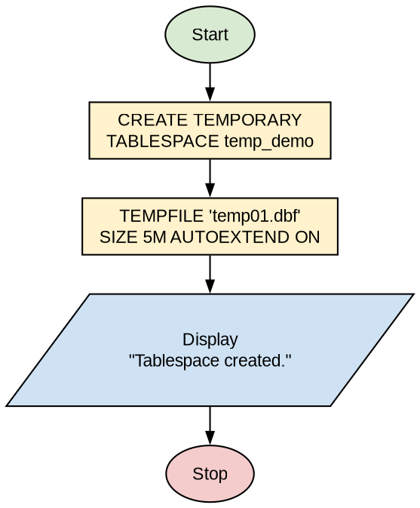
Program (SQL Queries):
-- Create temporary tablespace
CREATE TEMPORARY TABLESPACE temp_demo
TEMPFILE 'temp01.dbf' SIZE 5M AUTOEXTEND ON;
Output:
-- create tablespace
SQL> create temporary tablespace temp_demo
2 tempfile 'temp01.dbf' size 5m autoextend on;

Tablespace created.

Practical No. 9
Aim: Add new Redo log file of size 10mb to existing database.
Algorithm:
Step 1: Start.
Step 2: Login as SYSTEM (DBA) user.
Step 3: Use ALTER DATABASE ADD LOGFILE with the file path and SIZE 10M.
Step 4: Display the message "Database altered."
Step 5: Stop.
Flowchart:
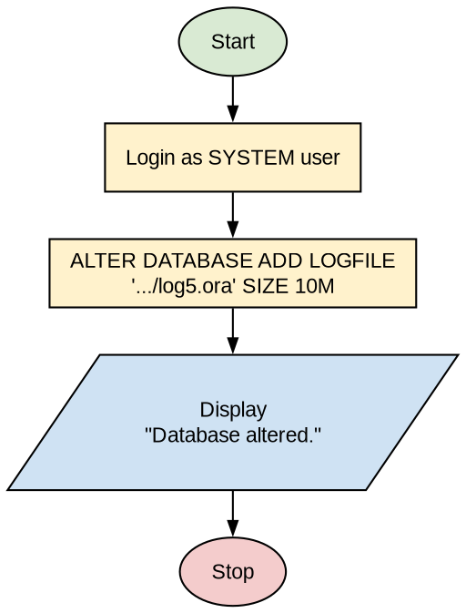
Program (SQL Queries):
-- Add new redo log file
ALTER DATABASE ADD LOGFILE 'c:/program files/oracle/log5.ora' SIZE 10M;
Output:
SQL> alter database add logfile 'c:/program files/oracle/log5.ora' size 10m;

Database altered.

Practical No. 10
Aim: Display the list of all Redo log files and Control files.
Algorithm:
Step 1: Start.
Step 2: Login as SYSTEM (DBA) user.
Step 3: Query the dynamic view v$logfile to display all redo log file members.
Step 4: Query the dynamic view v$controlfile to display all control files.
Step 5: Stop.
Note: The output of v$controlfile was not given in the answer sheet; a typical Oracle XE output is added here. Please test and run it yourself before writing.
Flowchart:
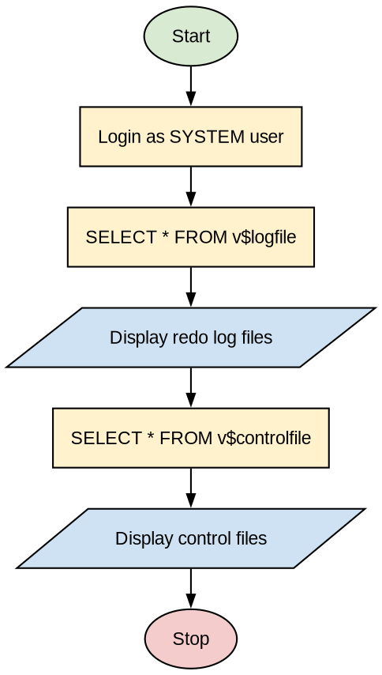
Program (SQL Queries):
-- List of redo log files
SELECT * FROM v$logfile;

-- List of control files
SELECT * FROM v$controlfile;
Output:
SQL> select * from v$logfile;

GROUP# STATUS TYPE MEMBER IS_
---------- ------- ------- ----------------------------------------------------------------- ---
2 ONLINE C:\ORACLEXE\APP\ORACLE\FLASH_RECOVERY_AREA\XE\ONLINELOG\
O1_MF_2_MM8H1MLH_.LOG YES
1 STALE ONLINE C:\ORACLEXE\APP\ORACLE\FLASH_RECOVERY_AREA\XE\ONLINELOG\
O1_MF_1_MM8H1MHF_.LOG YES

SQL> select * from v$controlfile;

STATUS NAME IS_ BLOCK_SIZE FILE_SIZE_BLKS
------- ---------------------------------------------- --- ---------- --------------
C:\ORACLEXE\APP\ORACLE\ORADATA\XE\CONTROL.DBF NO 16384 594

Practical No. 11
Aim: Display the list, datafiles, tablespace names & size in MB.
Algorithm:
Step 1: Start.
Step 2: Login as SYSTEM (DBA) user.
Step 3: Set the SQL*Plus display format using SET LINESIZE, SET PAGESIZE, BREAK and COLUMN commands.
Step 4: Query dba_data_files to select file_name, tablespace_name and size in MB (bytes/1024000).
Step 5: Display the result ordered by file name.
Step 6: Stop.
Flowchart:
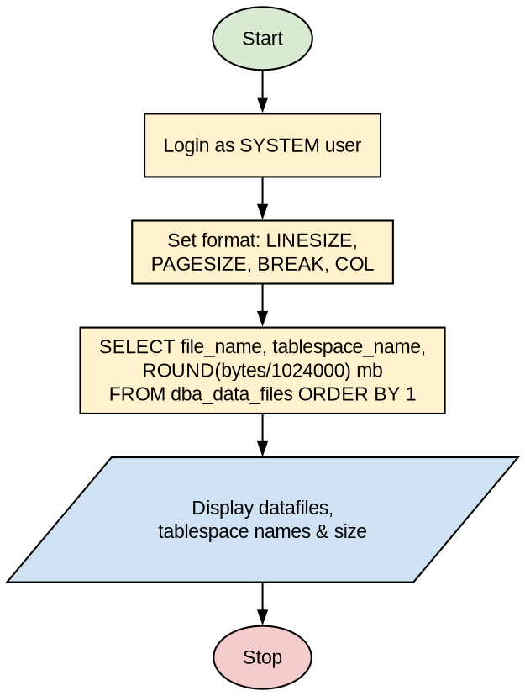
Program (SQL Queries):
CLEAR BREAKS;
SET LINESIZE 130
SET PAGESIZE 60
BREAK ON tablespace_name SKIP 1
COL tablespace_name FORMAT a15
COL file_name FORMAT a50
COL tablespace_kb HEADING 'TABLESPACE|TOTAL_KB'
COL kbytes_free HEADING 'TOTAL FREE|KBYTES'

SELECT file_name, tablespace_name, ROUND(bytes/1024000) mb
FROM dba_data_files
ORDER BY 1;
Output:
SQL> select file_name,tablespace_name, ROUND(bytes/1024000) mb
2 from dba_data_files order by 1;

FILE_NAME TABLESPACE_NAME MB
------------------------------------- --------------- ----------
C:\ORACLEXE\ORADATA\DATAFILE.DBF TESTING 10

C:\ORACLEXE\ORADATA\TS_MYDEMO01.DBF TS_MYDEMO 51
C:\ORACLEXE\ORADATA\TS_MYDEMO02.DBF 66

C:\ORACLEXE\ORADATA\XE\DATAFILE.DBF DBA_TABLESPACE 10

C:\ORACLEXE\ORADATA\XE\SYSAUX.DBF SYSAUX 451

C:\ORACLEXE\ORADATA\XE\SYSTEM.DBF SYSTEM 348

C:\ORACLEXE\ORADATA\XE\UNDO.DBF UNDO 92

C:\ORACLEXE\ORADATA\XE\USERS.DBF USERS 102

8 rows selected.

Practical No. 12
Aim: Create rollback segment in separate tablespace with proper storage option.
Algorithm:
Step 1: Start.
Step 2: Create a separate tablespace small_rollbacks with a datafile of size 20M and DEFAULT STORAGE (INITIAL 250K NEXT 250K MAXEXTENTS 20).
Step 3: Set undo_suppress_errors = true for the session.
Step 4: Create the rollback segment small_rollbacks in tablespace small_rollbacks with the same storage option.
Step 5: Display the message "Rollback segment created."
Step 6: Stop.
Flowchart:
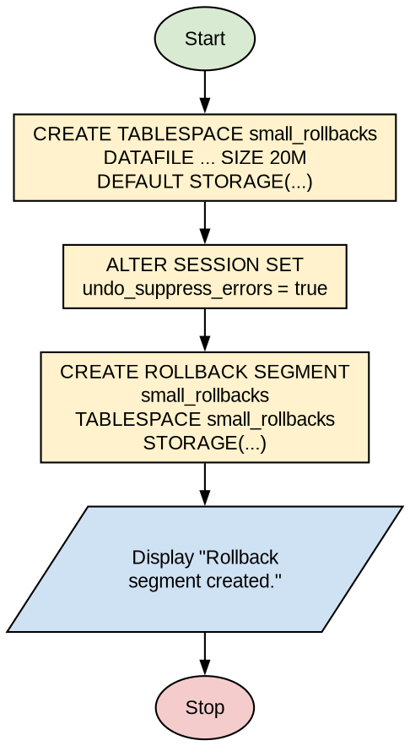
Program (SQL Queries):
-- Create separate tablespace
CREATE TABLESPACE small_rollbacks
DATAFILE 'c:program files/oracle/small_rollbacks.dbf' SIZE 20M REUSE
DEFAULT STORAGE (INITIAL 250K NEXT 250K MAXEXTENTS 20);

ALTER SESSION SET undo_suppress_errors = TRUE;

-- Create rollback segment
CREATE ROLLBACK SEGMENT small_rollbacks
TABLESPACE small_rollbacks
STORAGE (INITIAL 250K NEXT 250K MAXEXTENTS 20);
Output:
SQL> Create tablespace small_rollbacks
2 datafile 'c:program files/oracle/small_rollbacks.dbf' size 20m reuse
3* default storage(initial 250k next 250k maxextents 20)

Tablespace created.

SQL> alter session set undo_suppress_errors=true;

Session altered.

SQL> create rollback segment small_rollbacks
2 tablespace small_rollbacks
3 storage(initial 250k next 250k maxextents 20);

Rollback segment created.

Practical No. 13
Aim: Create a 3 new abstract datatype as given below: 1. NAME_TYPE(F_NAME, M_NAME, L_NAME) 2. POST_TYPE(MAIN, SFX) 3. ADDR_TYPE(STREET, CITY, STATE, POSTCODE)
Algorithm:
Step 1: Start.
Step 2: Create object type name_type with attributes f_name, m_name and l_name using CREATE TYPE ... AS OBJECT.
Step 3: Create object type post_type with attributes main and sfx.
Step 4: Create object type addr_type with attributes street, city, state and postcode, where postcode is of type post_type.
Step 5: Display the message "Type created." for each type.
Step 6: Stop.
Note: The answer is corrected here: the attribute m_init (answer sheet) is renamed to m_name and add_type is renamed to addr_type, as given in the practical list. Please test and run it yourself before writing.
Flowchart:
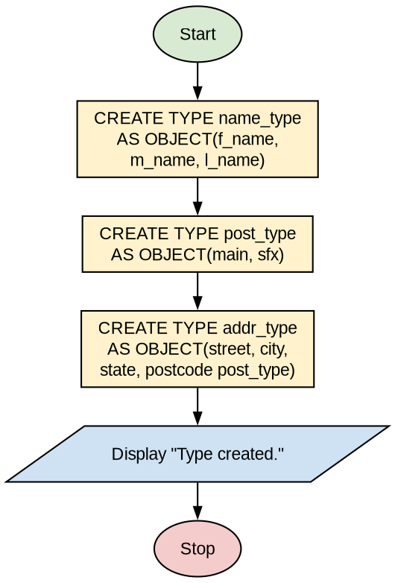
Program (SQL Queries):
-- 1. Name type
CREATE TYPE name_type AS OBJECT (
f_name VARCHAR(15),
m_name CHAR(1),
l_name VARCHAR2(20)
);
/

-- 2. Post type
CREATE TYPE post_type AS OBJECT (
main INTEGER,
sfx INTEGER
);
/

-- 3. Address type
CREATE TYPE addr_type AS OBJECT (
street VARCHAR2(35),
city VARCHAR(15),
state CHAR(2),
postcode post_type
);
/
Output:
SQL> create type name_type as object(f_name varchar(15),
2 m_name char(1),
3 l_name varchar2(20));

Type created.

SQL> create type post_type as object(main integer,sfx integer);

Type created.

SQL> create type addr_type as object(
2 street varchar2(35),
3 city varchar(15),state char(2),postcode post_type);

Type created.

Practical No. 14
Aim: Create a table stud_info having column name, rollno, phy, maths, comp, total and percentage. Write a trigger to automatically calculate students total marks and percentage of students while insertion.
Algorithm:
Step 1: Start.
Step 2: Create table studinfo with columns name, rollno, phy, math, comp, total and per.
Step 3: Create trigger totper BEFORE INSERT ON studinfo FOR EACH ROW.
Step 4: In the trigger body calculate :new.total = :new.math + :new.phy + :new.comp.
Step 5: Calculate :new.per = (:new.total / 300) * 100.
Step 6: Insert a record with only name, rollno, phy, math and comp; the trigger fills total and per automatically.
Step 7: Display the table using SELECT * FROM studinfo.
Step 8: Stop.
Note: The answer is corrected here: "endtotper;" is written as "end totper;" and the INSERT statement ends with ";". Please test and run it yourself before writing.
Flowchart:
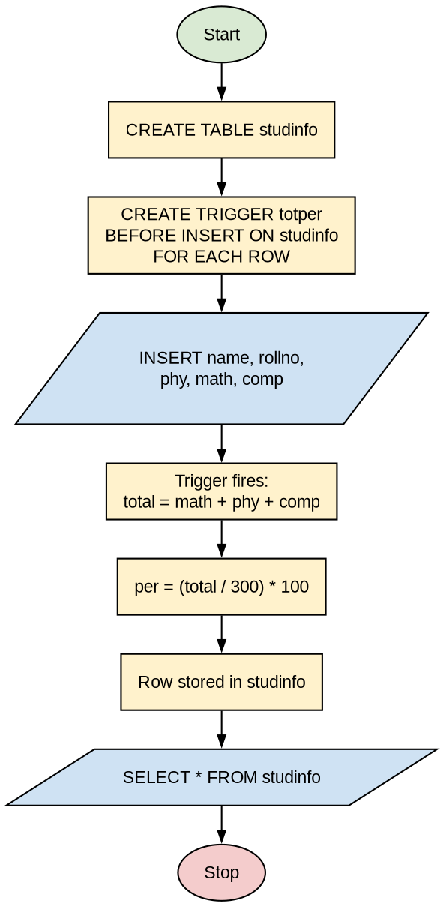
Program (SQL Queries):
-- Create table
CREATE TABLE studinfo (
name VARCHAR2(20),
rollno NUMBER(3),
phy NUMBER(3),
math NUMBER(3),
comp NUMBER(3),
total NUMBER(5),
per NUMBER(3,2)
);

-- Trigger to calculate total and percentage
CREATE OR REPLACE TRIGGER totper
BEFORE INSERT ON studinfo
FOR EACH ROW
BEGIN
:new.total := :new.math + :new.phy + :new.comp;
:new.per := (:new.total / 300) * 100;
END totper;
/

-- Insert record
INSERT INTO studinfo (name, rollno, phy, math, comp)
VALUES ('sid', 1, 7, 7, 7);

-- Display data
SELECT * FROM studinfo;
Output:
SQL> create table studinfo
2 (name varchar2(20),
3 rollno number(3),
4 phy number(3),
5 math number(3),
6 comp number(3),
7 total number(5),
8 per number(3,2));

Table created.

SQL> create or replace trigger totper
2 before insert on studinfo
3 for each row
4 begin
5 :new.total:=:new.math+:new.phy+:new.comp;
6 :new.per:=(:new.total/300)*100;
7 end totper;
8 /

Trigger created.

SQL> insert into studinfo(name,rollno,phy,math,comp)
2 values('sid',1,7,7,7);

1 row created.

SQL> select * from studinfo;

NAME ROLLNO PHY MATH COMP TOTAL PER
-------------------- ---------- ---------- ---------- ---------- ---------- ----------
sid 1 7 7 7 21 7

Practical No. 15
Aim: Write a SQL query to display the following data information: a. Name of database b. Database startup time c. Database size information (database size, used space, free space)
Algorithm:
Step 1: Start.
Step 2: Login as SYSTEM (DBA) user.
Step 3: Display the name of the database from v$database.
Step 4: Display the database startup time from v$instance using TO_CHAR(startup_time, 'hh24:mi dd-mm-yy').
Step 5: Calculate the database size and used space as the sum of bytes from v$datafile, v$tempfile and v$log.
Step 6: Calculate the free space as the sum of bytes from dba_free_space.
Step 7: Display database size (GB), used space (MB) and free space (MB).
Step 8: Stop.
Flowchart:
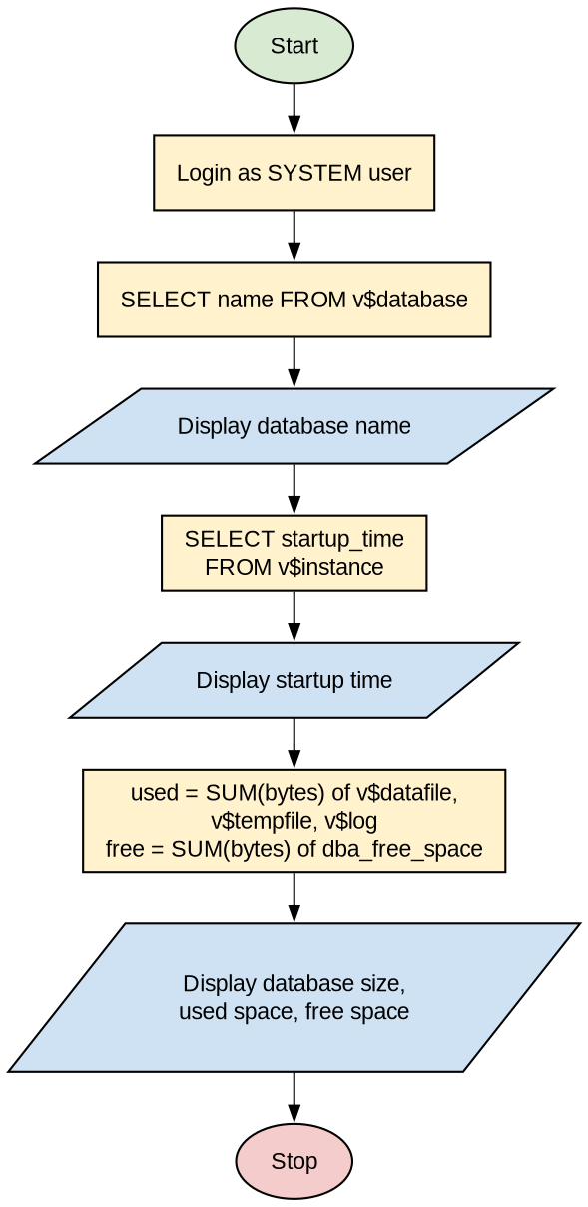
Program (SQL Queries):
-- a. Name of database
SELECT name FROM v$database;

-- b. Database startup time
SELECT TO_CHAR(startup_time, 'hh24:mi dd-mm-yy') "startup time"
FROM v$instance;

-- c. Database size information
SELECT ROUND(SUM(used.bytes)/1024/1024/1024) || 'gb' "database size",
ROUND(SUM(used.bytes)/1024/1024) || 'mb' "used space",
ROUND(free.p/1024/1024) || 'mb' "free space"
FROM (SELECT bytes FROM v$datafile
UNION ALL
SELECT bytes FROM v$tempfile
UNION ALL
SELECT bytes FROM v$log) used,
(SELECT SUM(bytes) AS p FROM dba_free_space) free
GROUP BY free.p;
Output:
SQL> select name from v$database;

NAME
---------
ORCL

SQL> select to_char(startup_time,'hh24:mi dd-mm-yy') "startup time"
2 from v$instance;

startup time
--------------
11:10 06-10-18

SQL> select round(sum(used.bytes)/1024/1024/1024)|| 'gb' "database size",
2 round(sum(used.bytes)/1024/1024) || 'mb' "used space",
3 round(free.p/1024/1024) || 'mb' "free space"
4 from (select bytes
5 from v$datafile
6 union all
7 select bytes
8 from v$tempfile
9 union all
10 select bytes
11 from v$log) used,
12 (select sum(bytes) as p
13 from dba_free_space) free
14* group by free.p

database size used space free space
--------------- -------------- ------------
1gb 1104mb 186mb

