PRACTICAL FILE
Open Source Web Programming using PHP
(Paper 1T3)

First Year M.C.A. — Semester I (CBCS)
RTM Nagpur University

Name: ____________________________
Roll No: _________________________

INDEX
Sr. No. | Practical | Date | Sign
1 | Write a PHP program that Process a Form.
2 | Write a PHP script to create, retrieve and deleting the Cookies data.
3 | Write a PHP script to create, retrieve and deleting the Session data.
4 | Write a PHP Script to define the Class and instantiate the Object of that class.
5 | Write a PHP program to create a table, select data and show into table format in MySQL.
6 | Write a PHP program to update table using MySQL.
7 | Write a PHP program to insert XML file in PHP.
8 | Write a program in PHP that include another file into current file using include and require function.
9 | Write a program in PHP to demonstrate the Types of Arrays.
10 | Write a program in PHP to search an element in an array.
11 | Write a program in PHP to create and print the elements of an array using different Array Printing functions.
12 | Write a program in PHP that Sorts the given Array using different array sorting functions.
13 | Write a program in PHP that Chunkify the given string.
14 | Write a PHP script to check that email id is valid or not.
15 | Write a PHP function calculateGST($amount) that returns the GST (18%) of the given amount. Call the function with a sample value and display the result.

Practical No. 1
Aim: Write a PHP program that Process a Form.
Algorithm:
Step 1: Start.
Step 2: Display an HTML form with fields Name, Email and Course and a Submit button (method = POST).
Step 3: User enters the data and clicks Submit.
Step 4: Check whether the form is submitted using isset($_POST['submit']).
Step 5: Read the values from $_POST and clean them using trim() and htmlspecialchars().
Step 6: If Name or Email is empty, display an error message.
Step 7: Otherwise display the submitted details.
Step 8: Stop.
Flowchart:
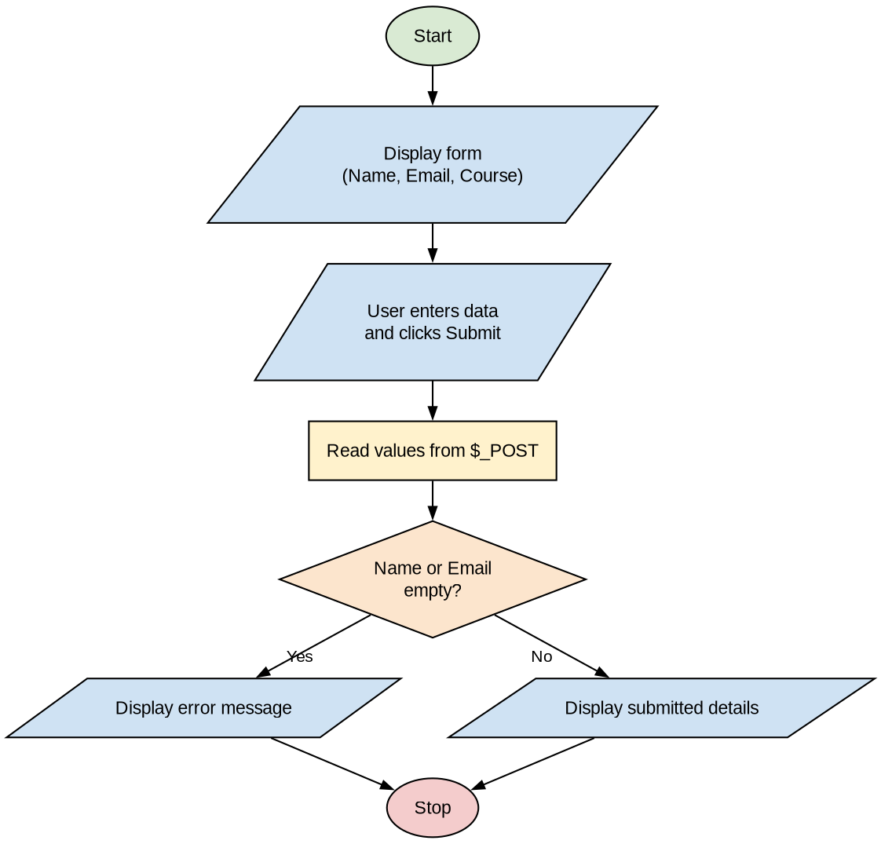
Program:
<!DOCTYPE html>
<html>
<head><title>Form Processing</title></head>
<body>
<h2>Student Registration Form</h2>
<form method="post" action="">
Name: <input type="text" name="name"><br><br>
Email: <input type="text" name="email"><br><br>
Course:
<select name="course">
<option>MCA</option>
<option>MBA</option>
</select><br><br>
<input type="submit" name="submit" value="Submit">
</form>

<?php
if (isset($_POST['submit'])) {
$name = htmlspecialchars(trim($_POST['name']));
$email = htmlspecialchars(trim($_POST['email']));
$course = $_POST['course'];

if ($name == "" || $email == "") {
echo "<p style='color:red'>All fields are required!</p>";
} else {
echo "<h3>Submitted Details</h3>";
echo "Name : $name <br>";
echo "Email : $email <br>";
echo "Course : $course <br>";
}
}
?>
</body>
</html>
Output:
Student Registration Form
Name: [Rahul Sharma ]
Email: [rahul@gmail.com ]
Course: [MCA v]
[Submit]

Submitted Details
Name : Rahul Sharma
Email : rahul@gmail.com
Course : MCA

Practical No. 2
Aim: Write a PHP script to create, retrieve and deleting the Cookies data.
Algorithm:
Step 1: Start.
Step 2: Display three links: Create Cookie, Retrieve Cookie and Delete Cookie.
Step 3: Read the action selected by the user from $_GET['action'].
Step 4: If action = create, create the cookie using setcookie("username", "Rahul", time() + 3600).
Step 5: If action = retrieve, check isset($_COOKIE['username']); if set display its value, else display "Cookie not found".
Step 6: If action = delete, delete the cookie by calling setcookie() with an expiry time in the past.
Step 7: Stop.
Flowchart:
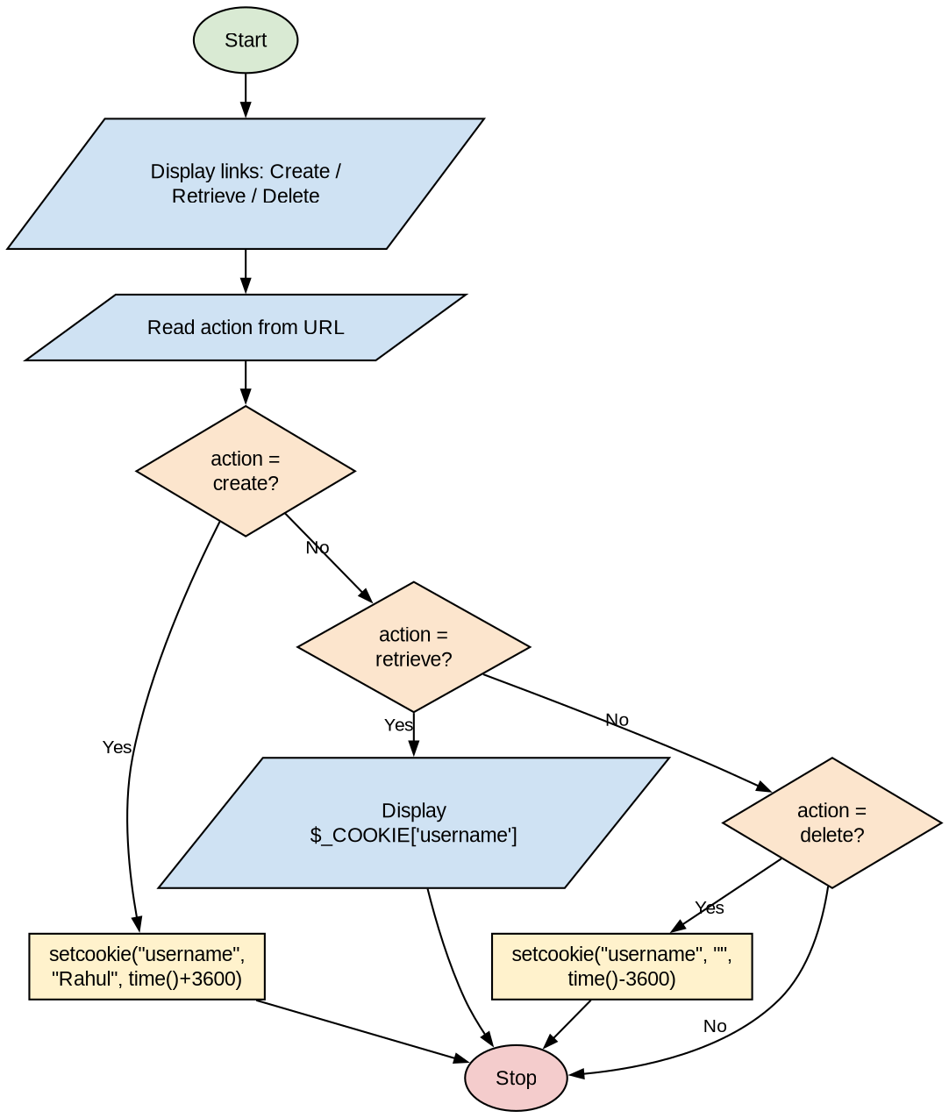
Program:
<?php
$msg = "";
if (isset($_GET['action'])) {
if ($_GET['action'] == "create") {
// Create cookie valid for 1 hour
setcookie("username", "Rahul", time() + 3600);
$msg = "Cookie 'username' created successfully.";
} elseif ($_GET['action'] == "delete") {
// Delete cookie by setting expiry time in the past
setcookie("username", "", time() - 3600);
$msg = "Cookie 'username' deleted successfully.";
}
}
?>
<html>
<body>
<h2>Cookie Demo</h2>
<a href="?action=create">Create Cookie</a> |
<a href="?action=retrieve">Retrieve Cookie</a> |
<a href="?action=delete">Delete Cookie</a>
<hr>
<?php
echo $msg;
if (isset($_GET['action']) && $_GET['action'] == "retrieve") {
if (isset($_COOKIE['username'])) {
echo "Cookie value of username: " . $_COOKIE['username'];
} else {
echo "Cookie not found.";
}
}
?>
</body>
</html>
Output:
Cookie Demo
Create Cookie | Retrieve Cookie | Delete Cookie
-----------------------------------------------
(Click Create Cookie)
Cookie 'username' created successfully.

(Click Retrieve Cookie)
Cookie value of username: Rahul

(Click Delete Cookie)
Cookie 'username' deleted successfully.

(Click Retrieve Cookie again)
Cookie not found.

Practical No. 3
Aim: Write a PHP script to create, retrieve and deleting the Session data.
Algorithm:
Step 1: Start.
Step 2: Start the session using session_start().
Step 3: Display three links: Create Session, Retrieve Session and Delete Session.
Step 4: Read the action selected by the user from $_GET['action'].
Step 5: If action = create, store data in $_SESSION['user'] and $_SESSION['course'].
Step 6: If action = retrieve, check isset($_SESSION['user']); if set display the session data, else display "No session data found".
Step 7: If action = delete, remove the data using session_unset() and session_destroy().
Step 8: Stop.
Flowchart:
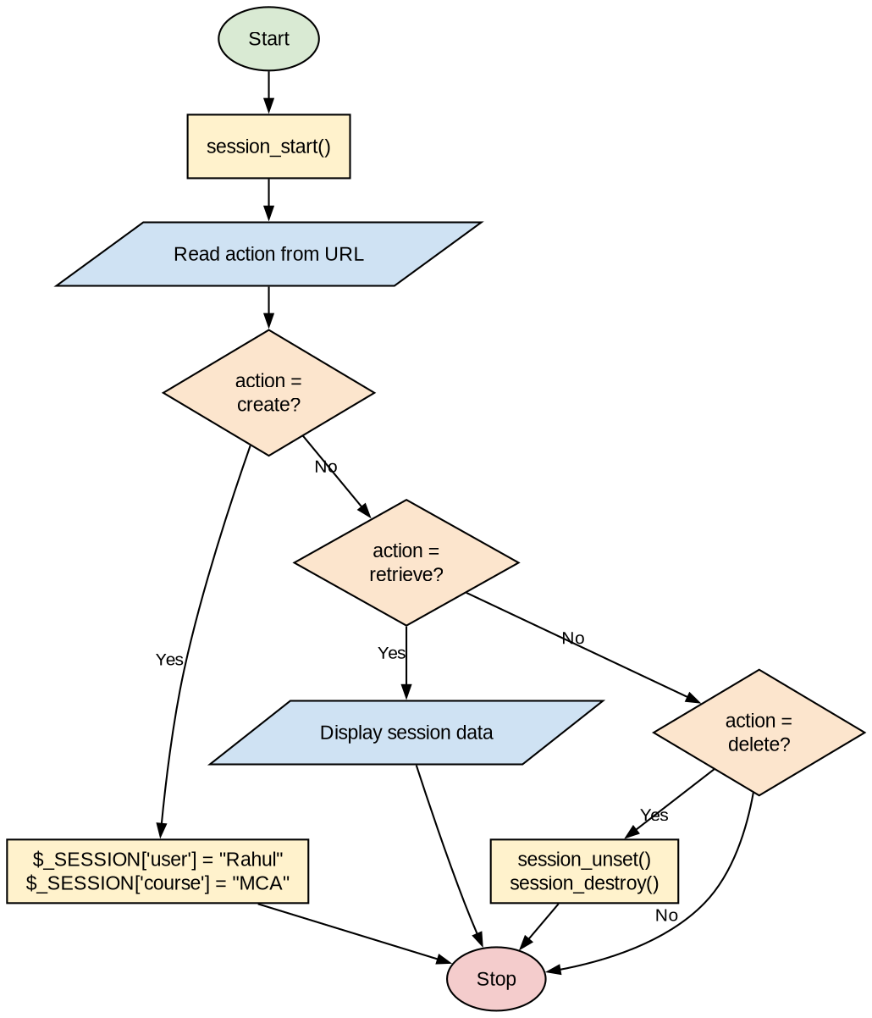
Program:
<?php
session_start();
?>
<html>
<body>
<h2>Session Demo</h2>
<a href="?action=create">Create Session</a> |
<a href="?action=retrieve">Retrieve Session</a> |
<a href="?action=delete">Delete Session</a>
<hr>
<?php
if (isset($_GET['action'])) {
$action = $_GET['action'];

if ($action == "create") {
$_SESSION['user'] = "Rahul";
$_SESSION['course'] = "MCA";
echo "Session data created successfully.";
} elseif ($action == "retrieve") {
if (isset($_SESSION['user'])) {
echo "User : " . $_SESSION['user'] . "<br>";
echo "Course : " . $_SESSION['course'];
} else {
echo "No session data found.";
}
} elseif ($action == "delete") {
session_unset(); // remove all session variables
session_destroy(); // destroy the session
echo "Session data deleted successfully.";
}
}
?>
</body>
</html>
Output:
Session Demo
Create Session | Retrieve Session | Delete Session
-------------------------------------------------
(Click Create Session)
Session data created successfully.

(Click Retrieve Session)
User : Rahul
Course : MCA

(Click Delete Session)
Session data deleted successfully.

(Click Retrieve Session again)
No session data found.

Practical No. 4
Aim: Write a PHP Script to define the Class and instantiate the Object of that class.
Algorithm:
Step 1: Start.
Step 2: Define a class Student with properties $name, $roll and $course.
Step 3: Define a constructor __construct() to initialize the properties.
Step 4: Define a method display() to print the student details.
Step 5: Create objects $s1 and $s2 of class Student using the new keyword.
Step 6: Call the display() method using each object.
Step 7: Stop.
Flowchart:
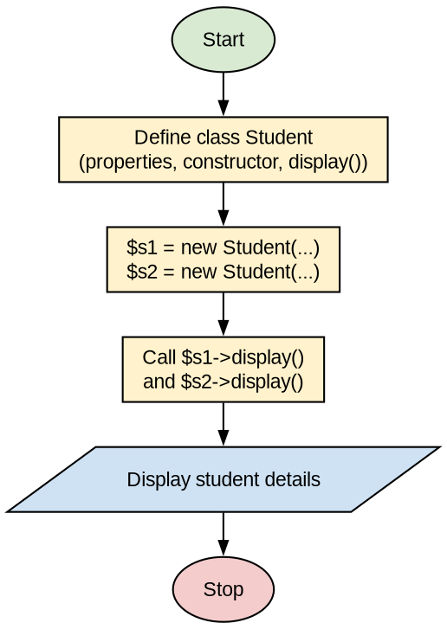
Program:
<?php
class Student {
public $name;
public $roll;
public $course;

// Constructor
function __construct($name, $roll, $course) {
$this->name = $name;
$this->roll = $roll;
$this->course = $course;
}

// Method
function display() {
echo "Roll No : " . $this->roll . "<br>";
echo "Name : " . $this->name . "<br>";
echo "Course : " . $this->course . "<br><br>";
}
}

// Instantiate objects
$s1 = new Student("Rahul", 101, "MCA");
$s2 = new Student("Priya", 102, "MCA");

echo "<h3>Student Details</h3>";
$s1->display();
$s2->display();
?>
Output:
Student Details
Roll No : 101
Name : Rahul
Course : MCA

Roll No : 102
Name : Priya
Course : MCA

Practical No. 5
Aim: Write a PHP program to create a table, select data and show into table format in MySQL.
Pre-requisite: Start Apache and MySQL (XAMPP/WAMP) and create the database using: CREATE DATABASE college;
Algorithm:
Step 1: Start.
Step 2: Connect to the MySQL database "college" using mysqli_connect().
Step 3: If the connection fails, display an error and stop.
Step 4: Create the table student (id, name, course, marks) using CREATE TABLE IF NOT EXISTS.
Step 5: Insert sample records into the table.
Step 6: Execute the query SELECT * FROM student.
Step 7: Fetch each row using mysqli_fetch_assoc() and display it as a row of an HTML table.
Step 8: Close the connection.
Step 9: Stop.
Flowchart:
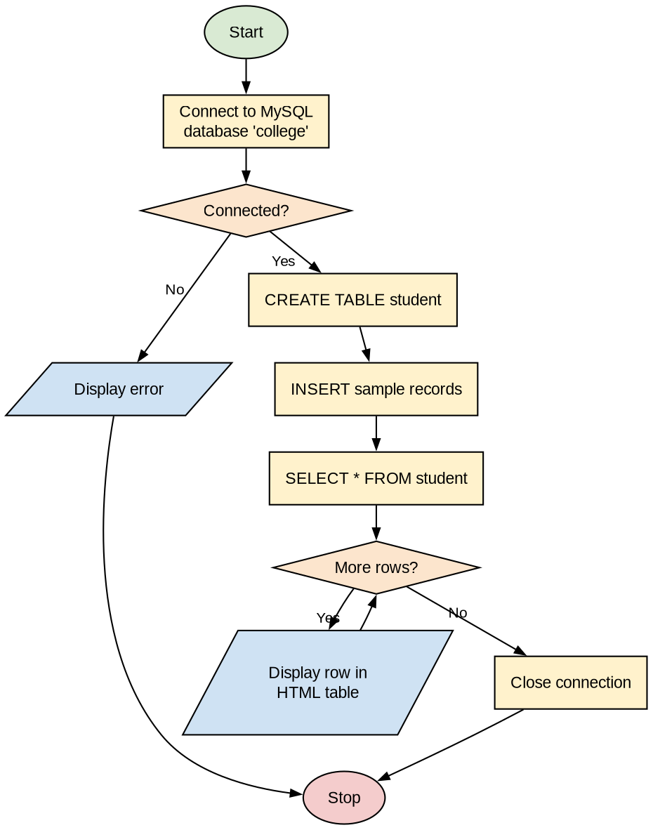
Program:
<?php
$conn = mysqli_connect("localhost", "root", "", "college");
if (!$conn) {
die("Connection failed: " . mysqli_connect_error());
}

// Create table
$sql = "CREATE TABLE IF NOT EXISTS student (
id INT PRIMARY KEY,
name VARCHAR(50),
course VARCHAR(20),
marks INT
)";
if (mysqli_query($conn, $sql)) {
echo "Table 'student' created successfully.<br><br>";
}

// Insert sample records
mysqli_query($conn, "INSERT IGNORE INTO student VALUES
(1, 'Rahul', 'MCA', 82),
(2, 'Priya', 'MCA', 90),
(3, 'Amit', 'MCA', 76)");

// Select and display data in table format
$result = mysqli_query($conn, "SELECT * FROM student");

echo "<table border='1' cellpadding='6'>";
echo "<tr><th>ID</th><th>Name</th><th>Course</th><th>Marks</th></tr>";
while ($row = mysqli_fetch_assoc($result)) {
echo "<tr>";
echo "<td>" . $row['id'] . "</td>";
echo "<td>" . $row['name'] . "</td>";
echo "<td>" . $row['course'] . "</td>";
echo "<td>" . $row['marks'] . "</td>";
echo "</tr>";
}
echo "</table>";

mysqli_close($conn);
?>
Output:
Table 'student' created successfully.

+----+-------+--------+-------+
| ID | Name | Course | Marks |
+----+-------+--------+-------+
| 1 | Rahul | MCA | 82 |
| 2 | Priya | MCA | 90 |
| 3 | Amit | MCA | 76 |
+----+-------+--------+-------+

Practical No. 6
Aim: Write a PHP program to update table using MySQL.
Uses the student table created in Practical 5.
Algorithm:
Step 1: Start.
Step 2: Connect to the MySQL database "college".
Step 3: Set the id of the record to update and the new marks.
Step 4: Execute the query UPDATE student SET marks = new_marks WHERE id = id.
Step 5: If the query is successful, display the success message and the number of rows affected; otherwise display the error.
Step 6: Select all records and display the updated table.
Step 7: Close the connection.
Step 8: Stop.
Flowchart:
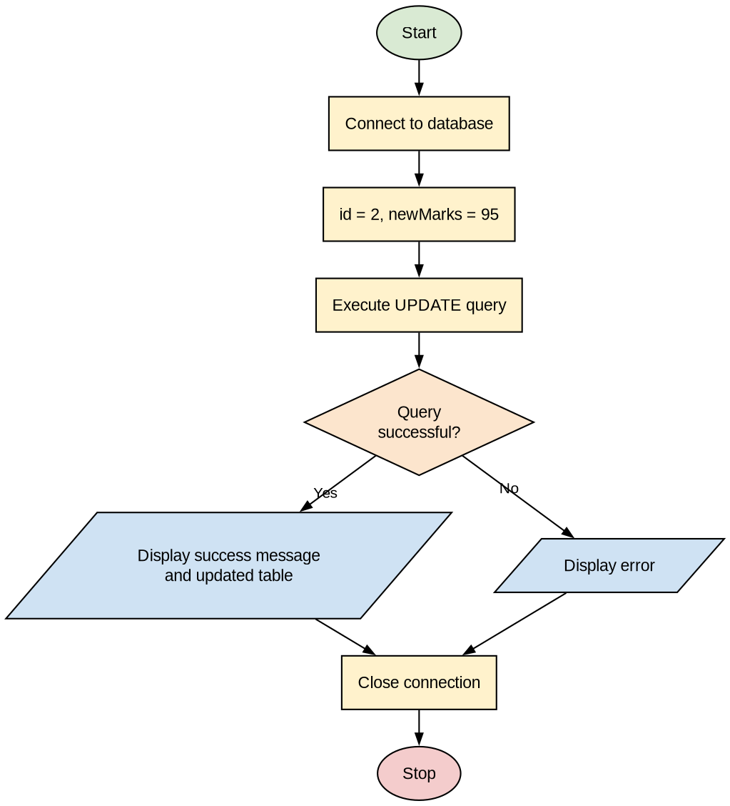
Program:
<?php
$conn = mysqli_connect("localhost", "root", "", "college");
if (!$conn) {
die("Connection failed: " . mysqli_connect_error());
}

$id = 2;
$newMarks = 95;

$sql = "UPDATE student SET marks = $newMarks WHERE id = $id";
if (mysqli_query($conn, $sql)) {
echo "Record updated successfully.<br>";
echo "Rows affected: " . mysqli_affected_rows($conn) . "<br><br>";
} else {
echo "Error updating record: " . mysqli_error($conn);
}

// Display updated table
$result = mysqli_query($conn, "SELECT * FROM student");
echo "<table border='1' cellpadding='6'>";
echo "<tr><th>ID</th><th>Name</th><th>Course</th><th>Marks</th></tr>";
while ($row = mysqli_fetch_assoc($result)) {
echo "<tr><td>" . $row['id'] . "</td><td>" . $row['name'] .
"</td><td>" . $row['course'] . "</td><td>" . $row['marks'] . "</td></tr>";
}
echo "</table>";

mysqli_close($conn);
?>
Output:
Record updated successfully.
Rows affected: 1

+----+-------+--------+-------+
| ID | Name | Course | Marks |
+----+-------+--------+-------+
| 1 | Rahul | MCA | 82 |
| 2 | Priya | MCA | 95 |
| 3 | Amit | MCA | 76 |
+----+-------+--------+-------+

Practical No. 7
Aim: Write a PHP program to insert XML file in PHP.
Algorithm:
Step 1: Start.
Step 2: Create an XML file students.xml containing student records.
Step 3: Load the XML file into PHP using simplexml_load_file().
Step 4: Insert a new <student> element using addChild() and save the file using asXML().
Step 5: Traverse each <student> node using foreach and display its name and course.
Step 6: Stop.
Flowchart:
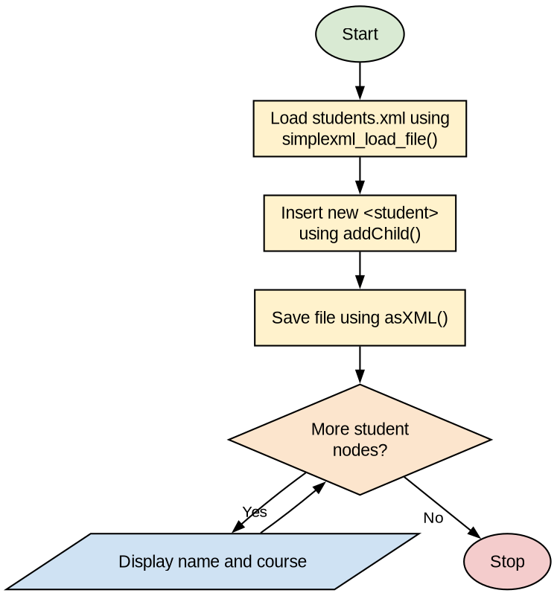
Program:
students.xml
-------------
<?xml version="1.0" encoding="UTF-8"?>
<students>
<student>
<name>Rahul</name>
<course>MCA</course>
</student>
<student>
<name>Priya</name>
<course>MCA</course>
</student>
</students>

xml_demo.php
------------
<?php
// Load XML file into PHP
$xml = simplexml_load_file("students.xml") or die("Error: Cannot load XML file");

// Insert a new record into the XML
$new = $xml->addChild("student");
$new->addChild("name", "Amit");
$new->addChild("course", "MBA");
$xml->asXML("students.xml");

// Display all records
echo "<h3>Students from XML file</h3>";
foreach ($xml->student as $s) {
echo "Name: " . $s->name . " | Course: " . $s->course . "<br>";
}
?>
Output:
Students from XML file
Name: Rahul | Course: MCA
Name: Priya | Course: MCA
Name: Amit | Course: MBA

Practical No. 8
Aim: Write a program in PHP that include another file into current file using include and require function.
Algorithm:
Step 1: Start.
Step 2: Create header.php containing the page heading.
Step 3: Create footer.php containing the footer text.
Step 4: In main.php, include header.php using include().
Step 5: Display the main content of the page.
Step 6: Include a non-existing file using include() — PHP gives a warning and continues execution.
Step 7: Include footer.php using require() (require() stops the script with a fatal error if the file is missing).
Step 8: Stop.
Flowchart:
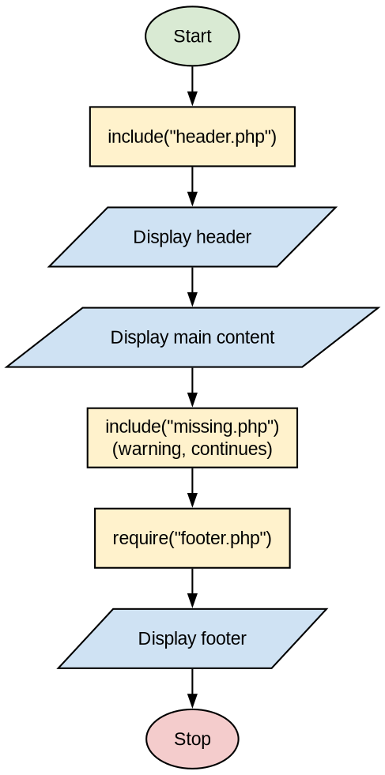
Program:
header.php
----------
<?php
echo "<h2>Welcome to PHP Practical</h2><hr>";
?>

footer.php
----------
<?php
echo "<hr><p>&copy; 2026 MCA Department</p>";
?>

main.php
--------
<?php
include("header.php");

echo "<p>This is the main content of the page.</p>";

// include() gives only a warning if the file is missing
include("missing.php");
echo "<p>Script continues after include() warning.</p>";

// require() gives a fatal error if the file is missing
require("footer.php");
?>
Output:
Welcome to PHP Practical
-------------------------------------------
This is the main content of the page.

Warning: include(missing.php): Failed to open stream:
No such file or directory in main.php on line 7

Script continues after include() warning.
-------------------------------------------
© 2026 MCA Department

Practical No. 9
Aim: Write a program in PHP to demonstrate the Types of Arrays.
Algorithm:
Step 1: Start.
Step 2: Create an indexed array $colors and display its elements using a for loop.
Step 3: Create an associative array $marks (key => value) and display it using foreach.
Step 4: Create a multidimensional array $students and display it using nested foreach.
Step 5: Stop.
Flowchart:
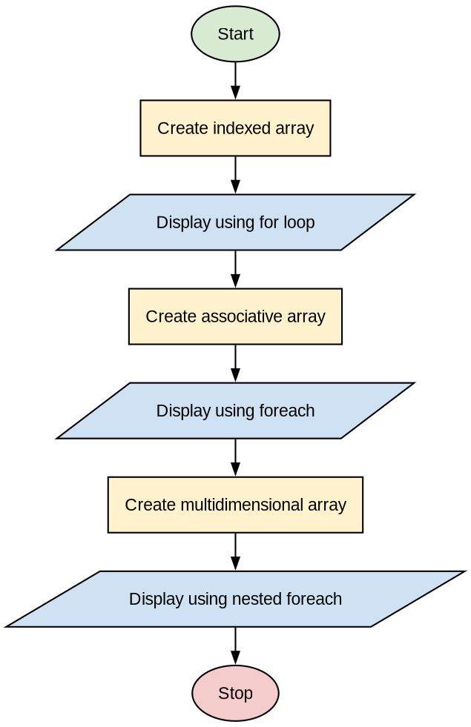
Program:
<?php
// 1. Indexed Array
$colors = array("Red", "Green", "Blue");
echo "<h3>1. Indexed Array</h3>";
for ($i = 0; $i < count($colors); $i++) {
echo "colors[$i] = " . $colors[$i] . "<br>";
}

// 2. Associative Array
$marks = array("Rahul" => 82, "Priya" => 90, "Amit" => 76);
echo "<h3>2. Associative Array</h3>";
foreach ($marks as $name => $m) {
echo "$name => $m <br>";
}

// 3. Multidimensional Array
$students = array(
array("Rahul", "MCA", 82),
array("Priya", "MCA", 90),
array("Amit", "MBA", 76)
);
echo "<h3>3. Multidimensional Array</h3>";
foreach ($students as $row) {
foreach ($row as $value) {
echo $value . " ";
}
echo "<br>";
}
?>
Output:
1. Indexed Array
colors[0] = Red
colors[1] = Green
colors[2] = Blue

2. Associative Array
Rahul => 82
Priya => 90
Amit => 76

3. Multidimensional Array
Rahul MCA 82
Priya MCA 90
Amit MBA 76

Practical No. 10
Aim: Write a program in PHP to search an element in an array.
Algorithm:
Step 1: Start.
Step 2: Initialize the array $arr and the element to search $key.
Step 3: Set found = false and i = 0.
Step 4: Repeat while i < count($arr):
If $arr[i] == $key then set found = true, pos = i and exit the loop.
Otherwise i = i + 1.
Step 5: If found = true display "Element found at position pos + 1", else display "Element not found".
Step 6: Stop.
Flowchart:
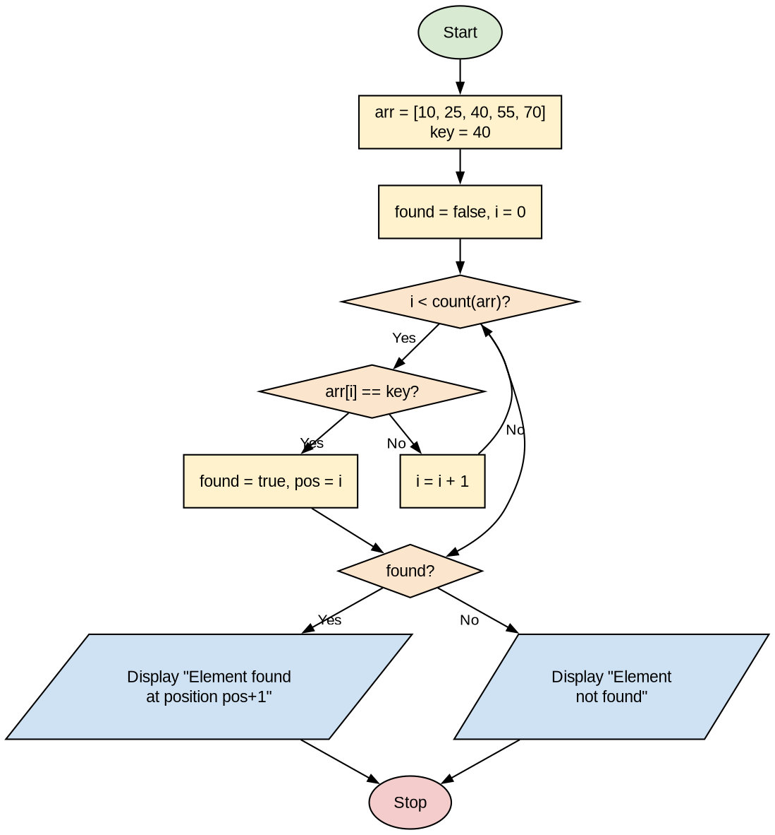
Program:
<?php
$arr = array(10, 25, 40, 55, 70);
$key = 40;
$found = false;

echo "Array: " . implode(", ", $arr) . "<br>";
echo "Element to search: $key <br><br>";

// Linear search
for ($i = 0; $i < count($arr); $i++) {
if ($arr[$i] == $key) {
$found = true;
$pos = $i;
break;
}
}

if ($found) {
echo "Element $key found at position " . ($pos + 1) . " (index $pos)";
} else {
echo "Element $key not found in the array";
}

// Using built-in function
echo "<br>Using array_search(): index = " . array_search($key, $arr);
?>
Output:
Array: 10, 25, 40, 55, 70
Element to search: 40

Element 40 found at position 3 (index 2)
Using array_search(): index = 2

Practical No. 11
Aim: Write a program in PHP to create and print the elements of an array using different Array Printing functions.
Algorithm:
Step 1: Start.
Step 2: Create an array $fruits with elements Apple, Banana, Mango.
Step 3: Print the array using print_r().
Step 4: Print the array using var_dump().
Step 5: Print the array using var_export().
Step 6: Print the array using implode() with echo.
Step 7: Print the array using json_encode().
Step 8: Stop.
Flowchart:
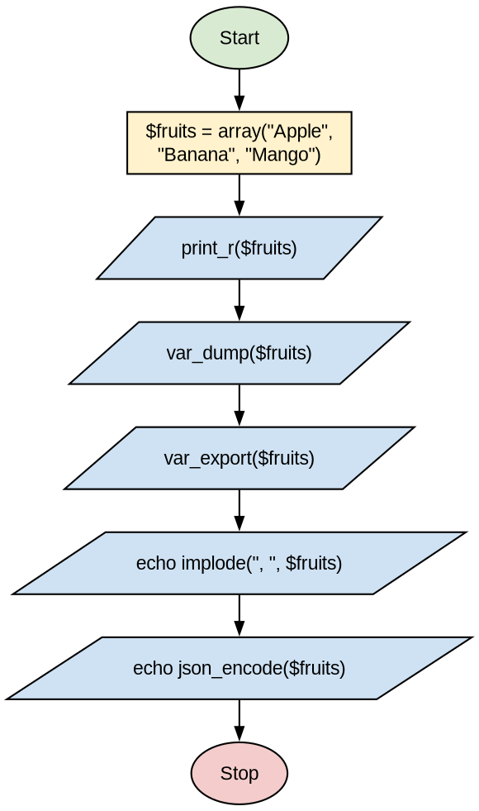
Program:
<?php
$fruits = array("Apple", "Banana", "Mango");

echo "<pre>";
echo "1. print_r():\n";
print_r($fruits);

echo "\n2. var_dump():\n";
var_dump($fruits);

echo "\n3. var_export():\n";
var_export($fruits);

echo "\n\n4. implode():\n";
echo implode(", ", $fruits);

echo "\n\n5. json_encode():\n";
echo json_encode($fruits);
echo "</pre>";
?>
Output:
1. print_r():
Array
(
[0] => Apple
[1] => Banana
[2] => Mango
)

2. var_dump():
array(3) {
[0]=>
string(5) "Apple"
[1]=>
string(6) "Banana"
[2]=>
string(5) "Mango"
}

3. var_export():
array (
0 => 'Apple',
1 => 'Banana',
2 => 'Mango',
)

4. implode():
Apple, Banana, Mango

5. json_encode():
["Apple","Banana","Mango"]

Practical No. 12
Aim: Write a program in PHP that Sorts the given Array using different array sorting functions.
Algorithm:
Step 1: Start.
Step 2: Create an indexed array $nums and an associative array $marks.
Step 3: Sort $nums in ascending order using sort() and display it.
Step 4: Sort $nums in descending order using rsort() and display it.
Step 5: Sort $marks by value in ascending order using asort() and display it.
Step 6: Sort $marks by value in descending order using arsort() and display it.
Step 7: Sort $marks by key using ksort() and display it.
Step 8: Stop.
Flowchart:
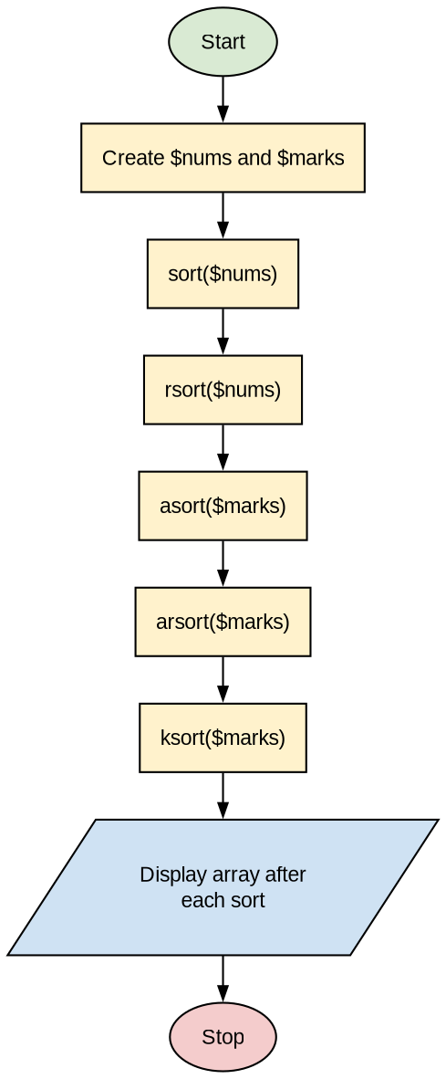
Program:
<?php
function show($arr) {
foreach ($arr as $k => $v) {
echo "[$k] => $v &nbsp; ";
}
echo "<br><br>";
}

$nums = array(40, 10, 50, 20, 30);
$marks = array("Rahul" => 82, "Priya" => 90, "Amit" => 76);

echo "Original nums: "; show($nums);
echo "Original marks: "; show($marks);

sort($nums);
echo "1. sort() - ascending: "; show($nums);

rsort($nums);
echo "2. rsort() - descending: "; show($nums);

asort($marks);
echo "3. asort() - by value ascending: "; show($marks);

arsort($marks);
echo "4. arsort() - by value descending: "; show($marks);

ksort($marks);
echo "5. ksort() - by key: "; show($marks);
?>
Output:
Original nums: [0] => 40 [1] => 10 [2] => 50 [3] => 20 [4] => 30
Original marks: [Rahul] => 82 [Priya] => 90 [Amit] => 76

1. sort() - ascending: [0] => 10 [1] => 20 [2] => 30 [3] => 40 [4] => 50

2. rsort() - descending: [0] => 50 [1] => 40 [2] => 30 [3] => 20 [4] => 10

3. asort() - by value ascending: [Amit] => 76 [Rahul] => 82 [Priya] => 90

4. arsort() - by value descending: [Priya] => 90 [Rahul] => 82 [Amit] => 76

5. ksort() - by key: [Amit] => 76 [Priya] => 90 [Rahul] => 82

Practical No. 13
Aim: Write a program in PHP that Chunkify the given string.
Algorithm:
Step 1: Start.
Step 2: Initialize the string $str and the chunk size $size.
Step 3: Split the string into an array of chunks using str_split($str, $size).
Step 4: Display each chunk using foreach.
Step 5: Display the chunked string using chunk_split($str, $size, "-").
Step 6: Stop.
Flowchart:
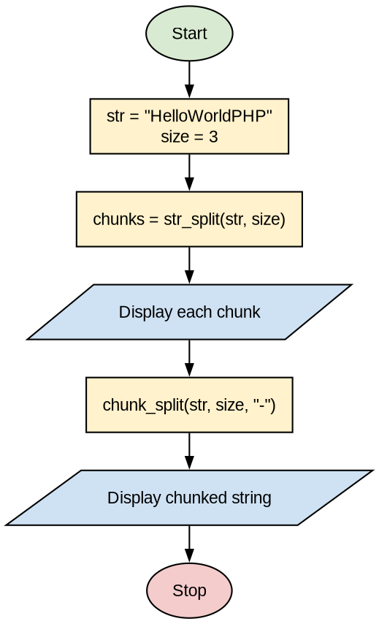
Program:
<?php
$str = "HelloWorldPHP";
$size = 3;

echo "Original String: $str <br>";
echo "Chunk Size: $size <br><br>";

// Method 1: str_split() returns an array of chunks
$chunks = str_split($str, $size);
echo "Chunks using str_split():<br>";
foreach ($chunks as $i => $c) {
echo "Chunk " . ($i + 1) . ": $c <br>";
}

// Method 2: chunk_split() returns a string with separator
echo "<br>Using chunk_split(): " . chunk_split($str, $size, "-");
?>
Output:
Original String: HelloWorldPHP
Chunk Size: 3

Chunks using str_split():
Chunk 1: Hel
Chunk 2: loW
Chunk 3: orl
Chunk 4: dPH
Chunk 5: P

Using chunk_split(): Hel-loW-orl-dPH-P-

Practical No. 14
Aim: Write a PHP script to check that email id is valid or not.
Algorithm:
Step 1: Start.
Step 2: Display a form to enter an email id.
Step 3: User enters the email id and clicks Check.
Step 4: Read the email from $_POST['email'].
Step 5: Validate it using filter_var($email, FILTER_VALIDATE_EMAIL).
Step 6: If valid display "is a valid email id", else display "is NOT a valid email id".
Step 7: Stop.
Flowchart:
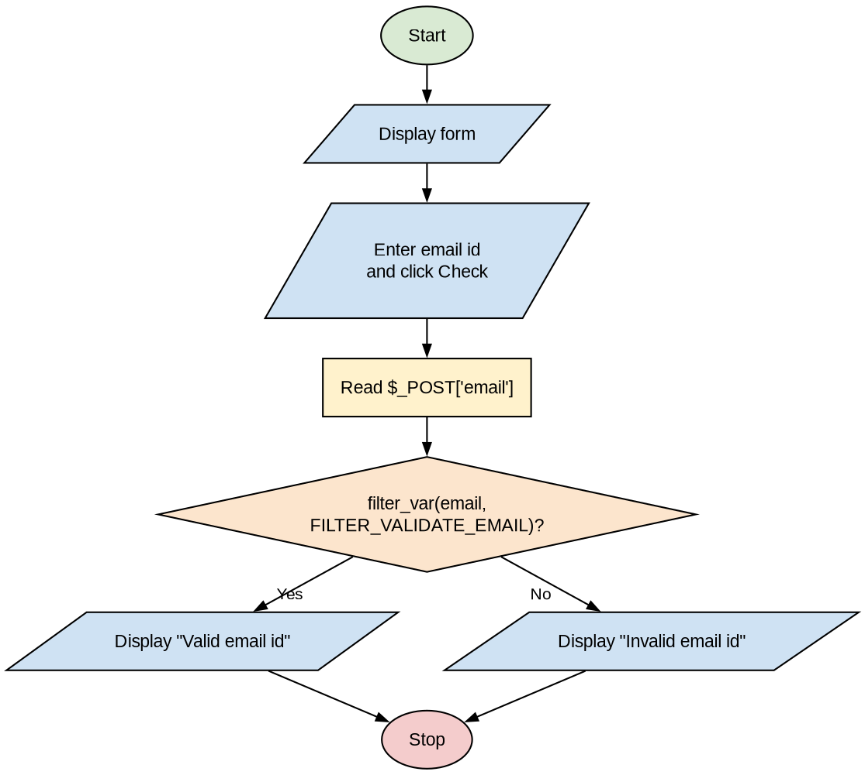
Program:
<html>
<body>
<h2>Email Validation</h2>
<form method="post">
Enter Email: <input type="text" name="email">
<input type="submit" name="check" value="Check">
</form>

<?php
if (isset($_POST['check'])) {
$email = trim($_POST['email']);

if (filter_var($email, FILTER_VALIDATE_EMAIL)) {
echo "<p style='color:green'>$email is a valid email id.</p>";
} else {
echo "<p style='color:red'>$email is NOT a valid email id.</p>";
}
}
?>
</body>
</html>
Output:
Email Validation
Enter Email: [rahul@gmail.com ] [Check]
rahul@gmail.com is a valid email id.

Enter Email: [rahul.gmail.com ] [Check]
rahul.gmail.com is NOT a valid email id.

Practical No. 15
Aim: Write a PHP function calculateGST($amount) that returns the GST (18%) of the given amount. Call the function with a sample value and display the result.
Algorithm:
Step 1: Start.
Step 2: Define function calculateGST($amount) which returns $amount * 18 / 100.
Step 3: Set $amount = 1000.
Step 4: Call $gst = calculateGST($amount).
Step 5: Calculate $total = $amount + $gst.
Step 6: Display Amount, GST and Total Amount.
Step 7: Stop.
Flowchart:
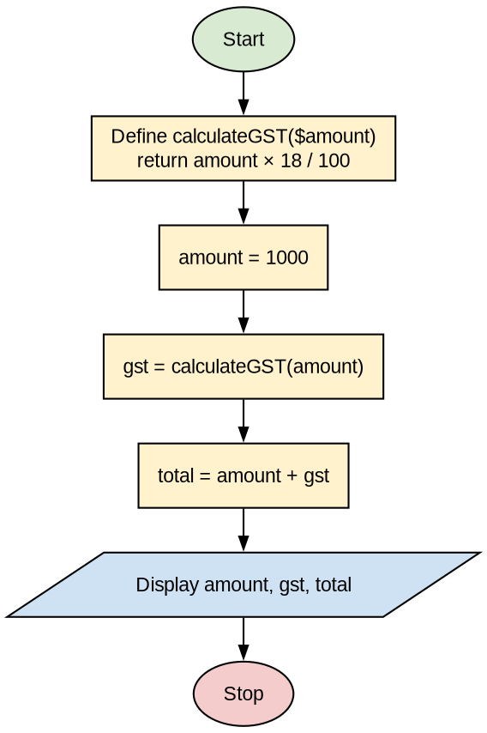
Program:
<?php
function calculateGST($amount) {
$gst = $amount * 18 / 100;
return $gst;
}

$amount = 1000;
$gst = calculateGST($amount);
$total = $amount + $gst;

echo "<h3>GST Calculation</h3>";
echo "Amount : Rs. $amount <br>";
echo "GST (18%) : Rs. $gst <br>";
echo "Total Amount : Rs. $total <br>";
?>
Output:
GST Calculation
Amount : Rs. 1000
GST (18%) : Rs. 180
Total Amount : Rs. 1180

