Singleton Object example.
Whenever create an object for Accounts class if the object is alive then it will not create any new object. Will return the object which is already created.
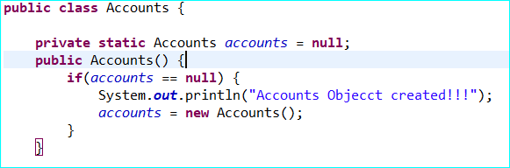
Deposit Account will create whenever you used new keyword. This is for Prototype example.
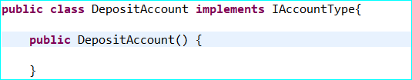

Dependency Injection example below.
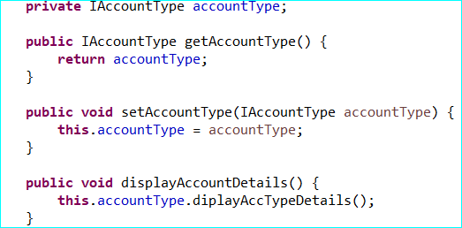
The class Accounts setAccountType() method used Interface type and based on the object set from calling class, it will call the necessary methods from a class.

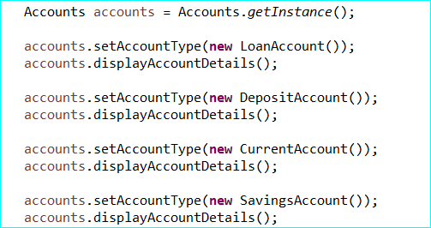
So based on the setter class, it will call the particular calss method.

